**Lab Practical #04:**

Installation of Network Simulator (Packet Tracer) and Implement different LAN topologies.

**Practical Assignment #04:**

1. **Create a simple network with switch and two or more pc. Also check connectivity between them using ping command or PDU utility.**
2. **Implement different topologies in packet tracer.**
   1. **Bus**
   2. **Ring**
   3. **Star**
   4. **Mesh**
   5. **Tree**
3. **Bus**

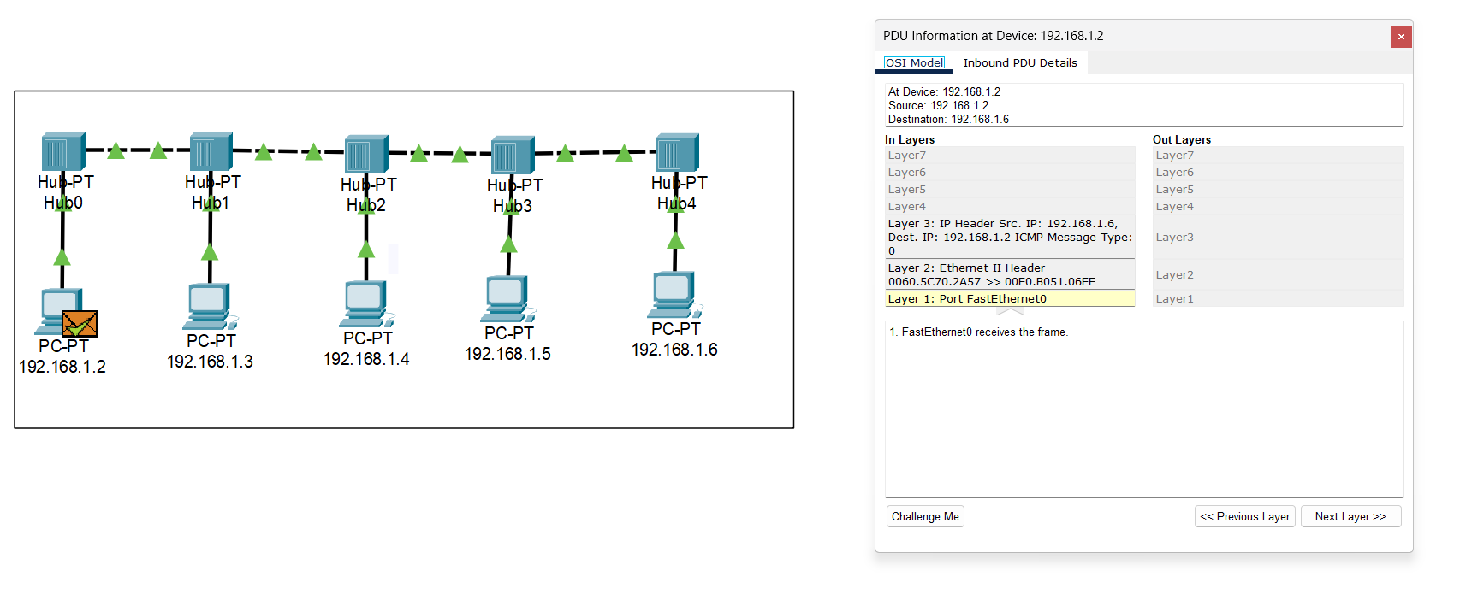

* 1. *Bus Topology OSI Model*

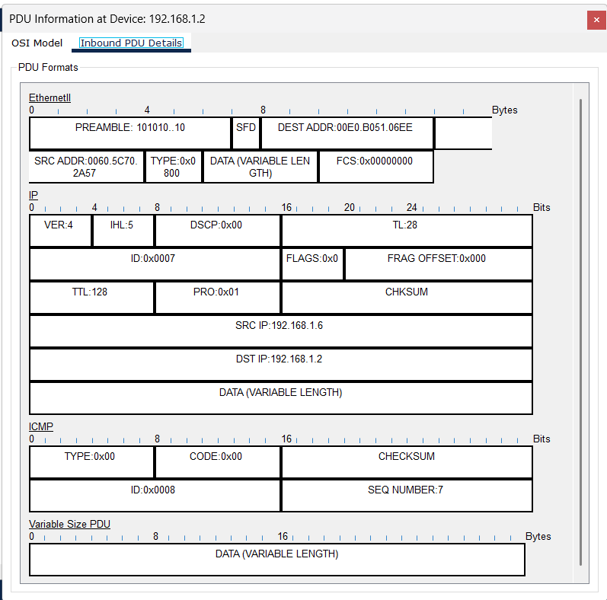

* 1. *Bus Topology PDU Screenshot*

1. **Ring**

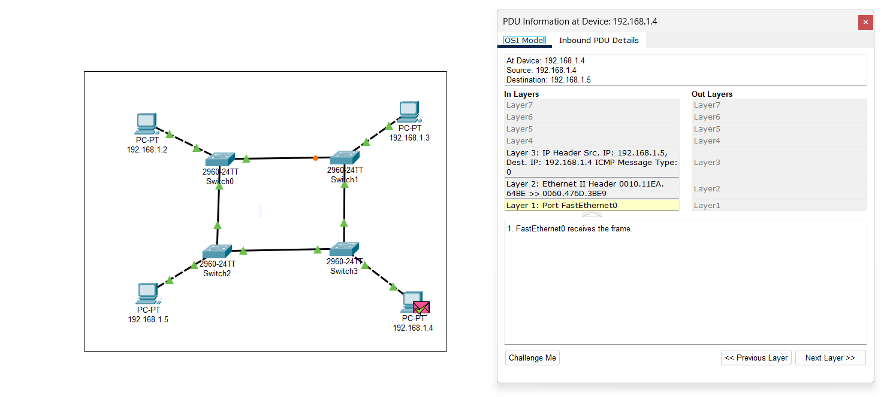

* 1. *Ring Topology OSI Model*

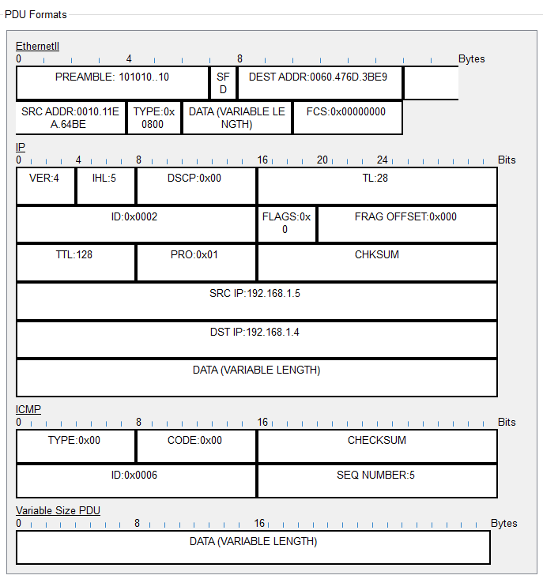

* 1. *RIng Topology PDU Screenshot*

1. **Star**

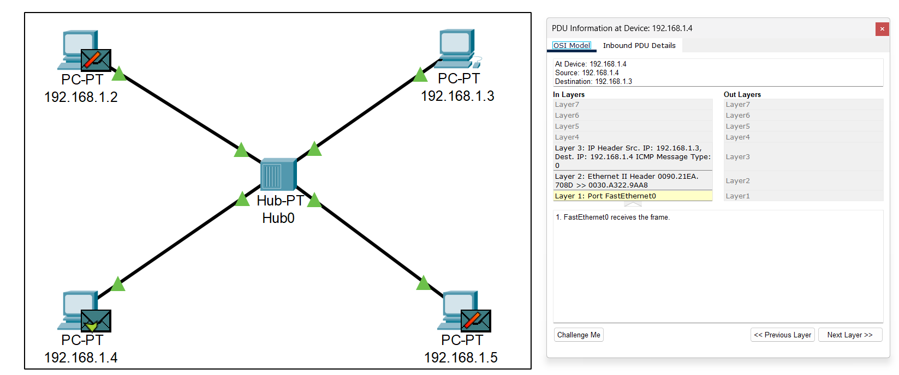

* 1. *Star Topology OSI Model*

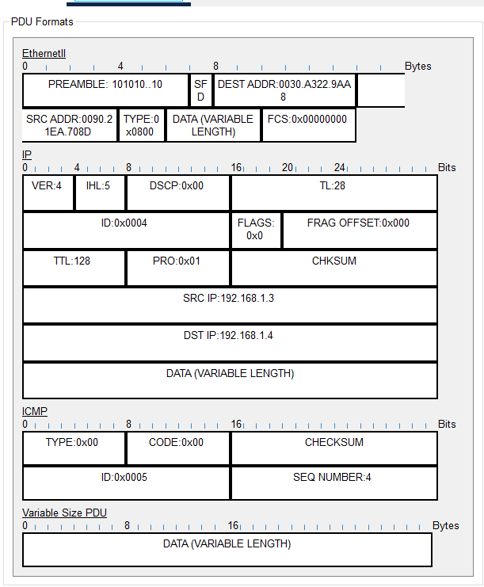

* 1. *Star Topology PDU Screenshot*

1. **Mesh**

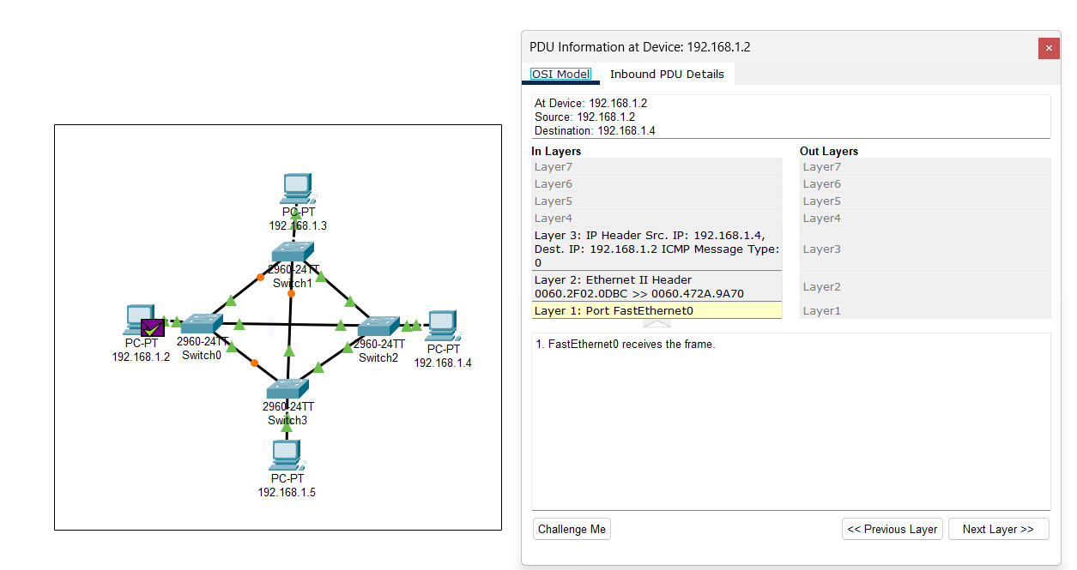

* 1. *Mesh Topology OSI Model*

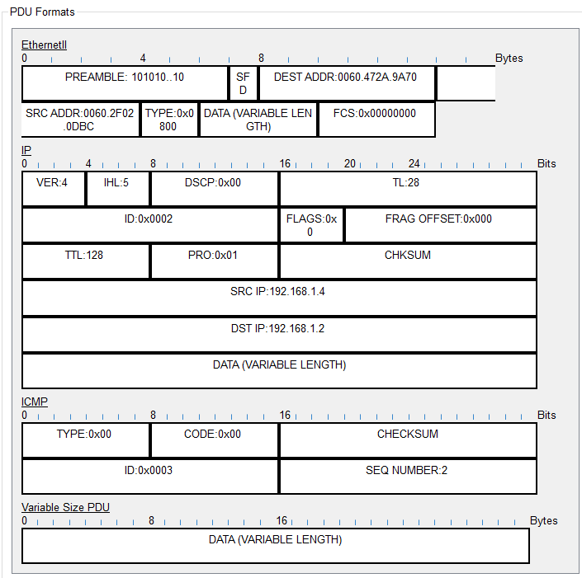

* 1. *Mesh Topology PDU Screenshot*

1. **Tree**

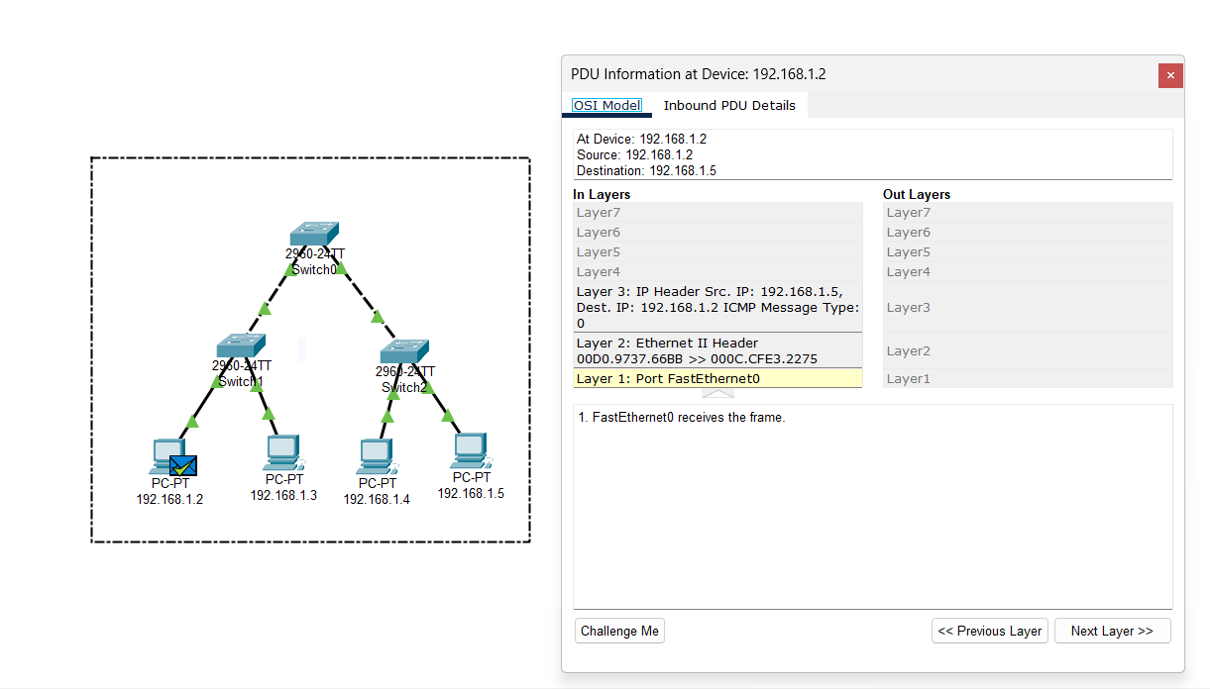

* 1. *Tree Topology OSI Model*

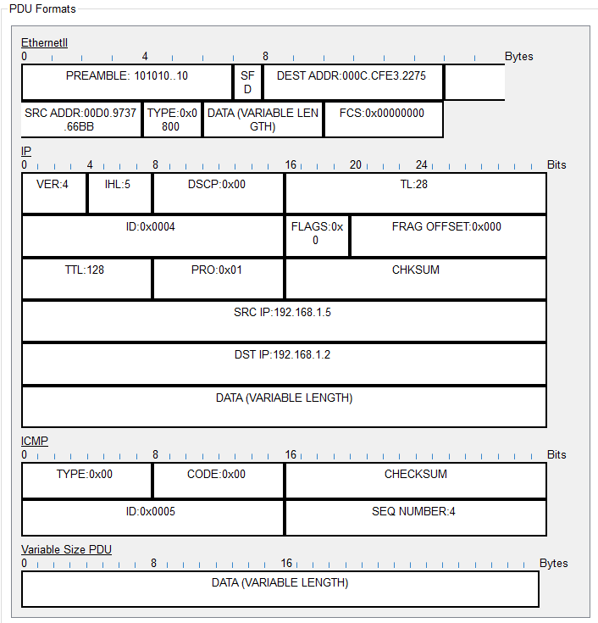

* 1. *Tree Topology PDU Screenshot*