**Lab Practical #07:**

Study the application layer protocol DNS, DHCP, FTP.

**Practical Assignment #07:**

1. **Implement the application layer protocol DNS, DHCP, and FTP. Also check connectivity between them using ping command or PDU utility.**
2. **DNS**

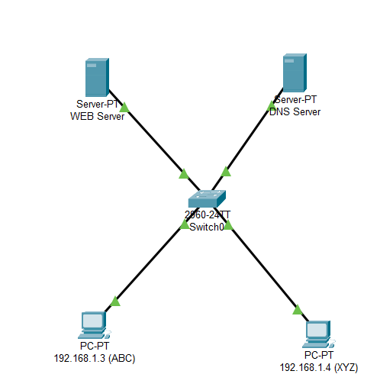

* 1. *Circuit Design of DNS*

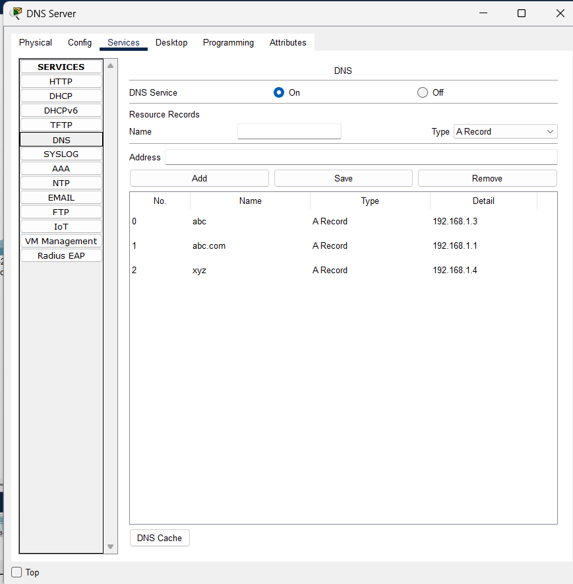

* 1. *DNS Server Service*

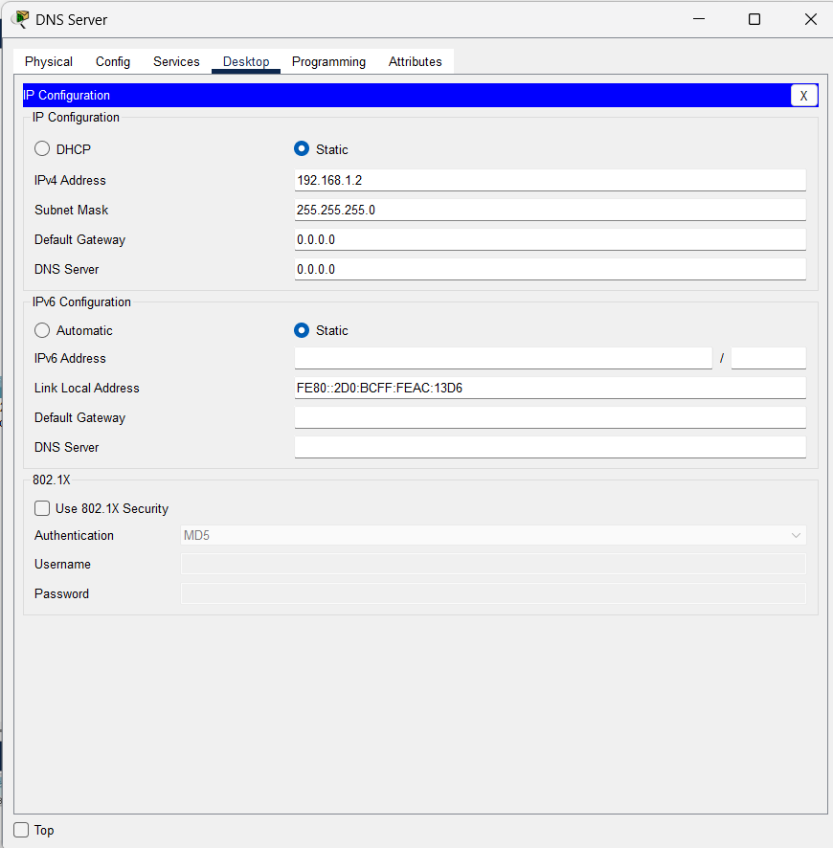

* 1. *DNS Server IP Configuration*

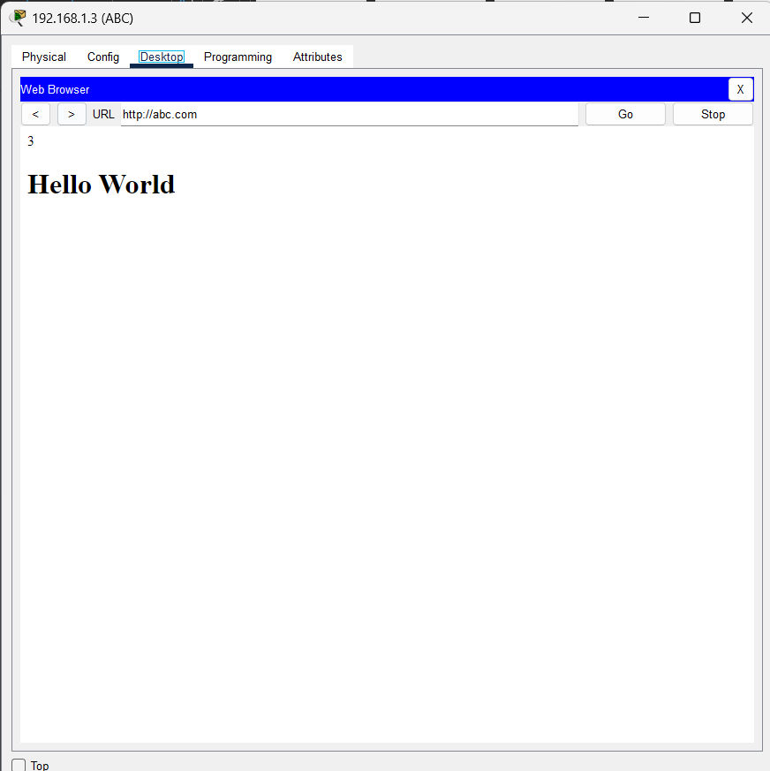

* 1. *Domain Name through access site*

1. **DHCP**

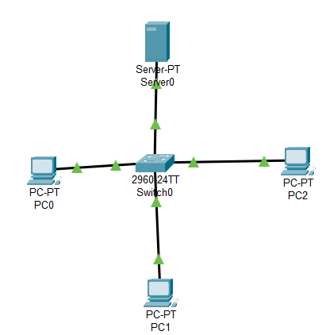

* 1. *Circuit Design of DHCP*

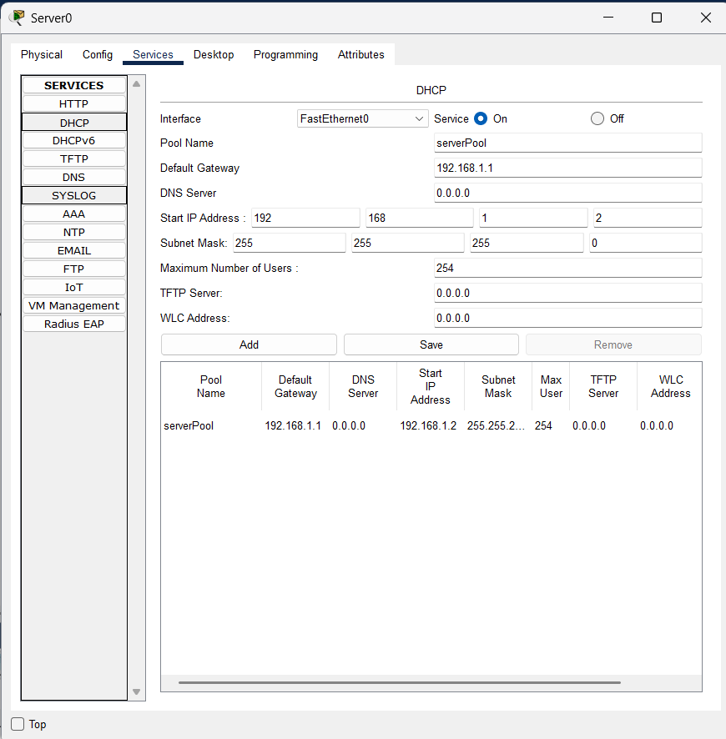

* 1. *DHCP Server Service*

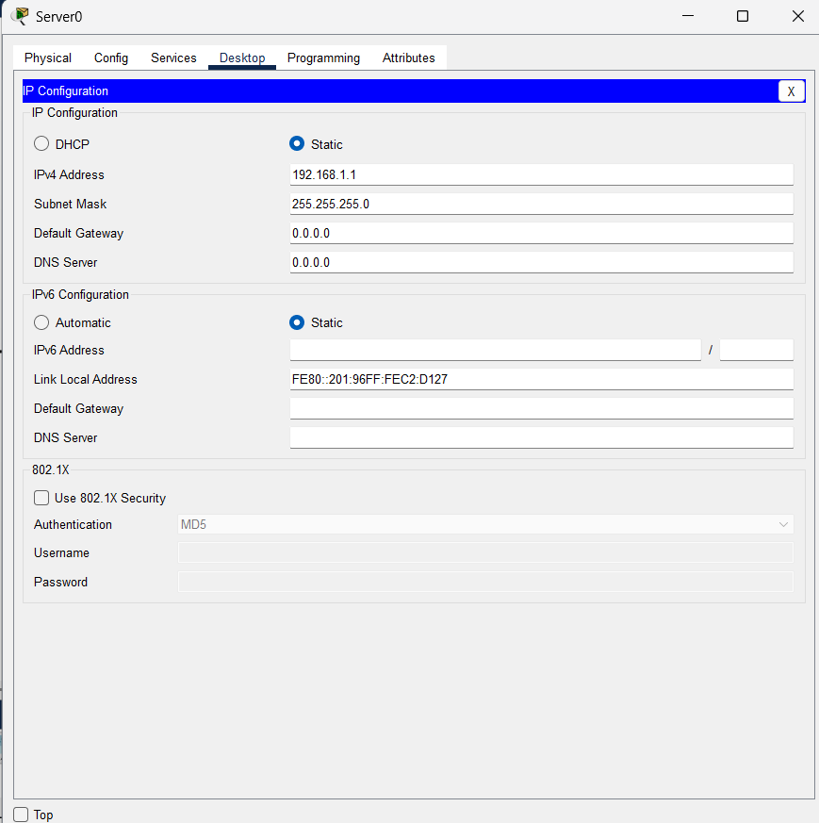

* 1. *DHCP Server IP Configuration*

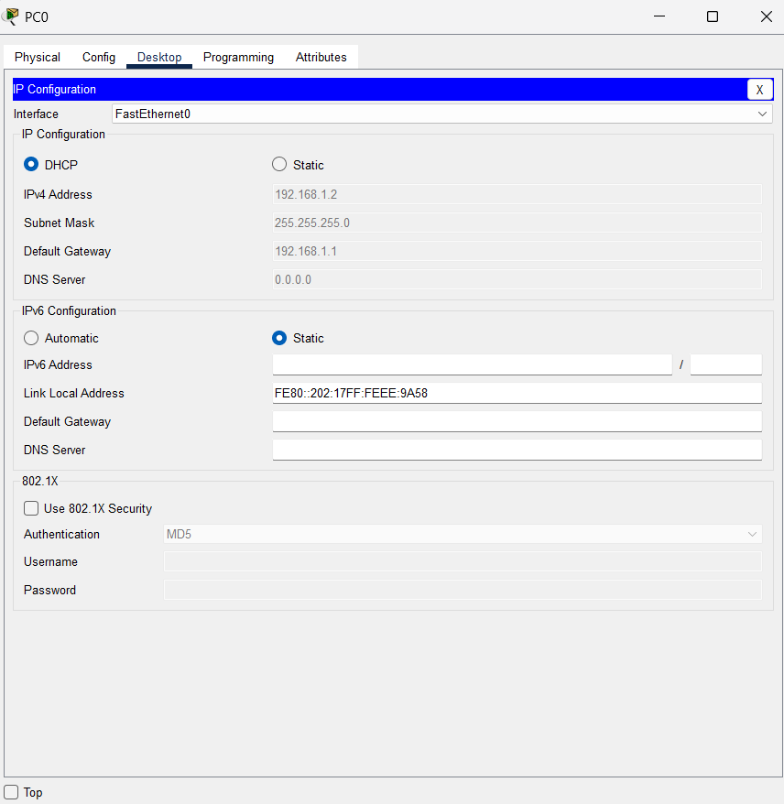

* 1. *DHCP Devices IP Configuration*

1. **FTP**

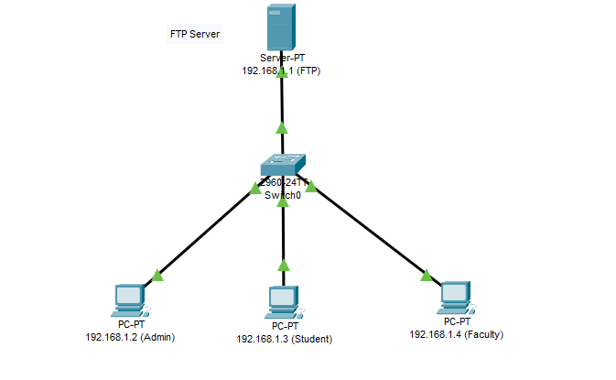

* 1. *Circuit Design of DHCP*

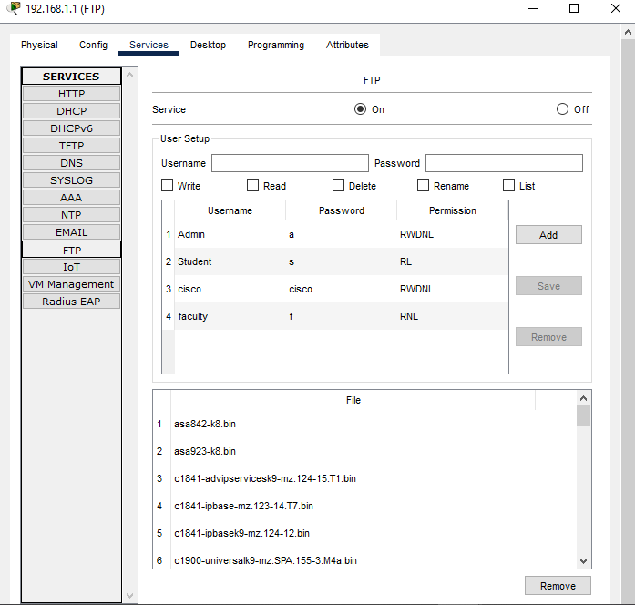

* 1. *FTP Server Service*

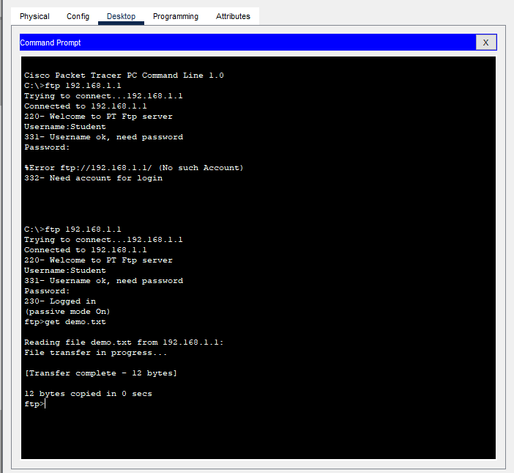

* 1. *Login User in FTP Server*

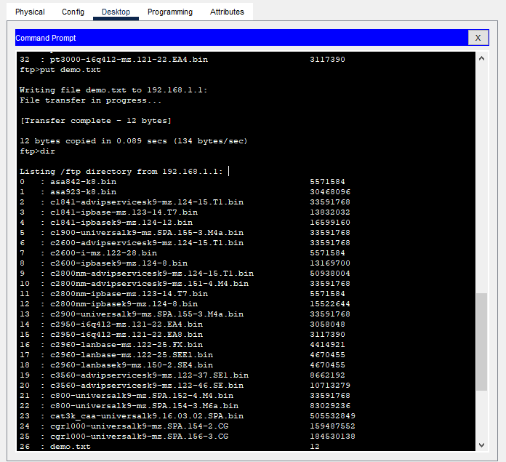

* 1. *Put and view Directory*