**Lab Practical #8:**

Study & Survey of Institute organization network infrastructure.

**Practical Assignment #8:**

1. **Identify type of network in your institute. Draw a design of network in your institute (Any Lab/Floor/Building).**

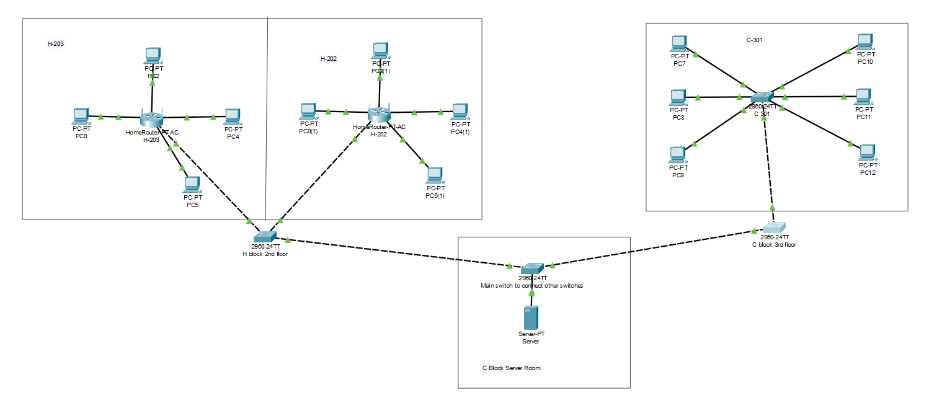

1. **List how many network devices and types of cable used and give its details.**
2. **Visit Overview**

* We visited the server room of Darshan University, Rajkot, to learn about its network infrastructure and how the campus network is maintained.

1. **Firewall**

* The staff explained how the firewall protects the university network from unauthorized access and outside threats.
* It monitors incoming and outgoing traffic to ensure secure communication.

1. **NAS (Network Attached Storage)**

* We saw the NAS system, which is used for storing and managing a large amount of academic and administrative data.
* It provides easy access to data for authorized users while keeping it organized and secure.

1. **Switches**

* Multiple switches are used to connect computers, servers, and other devices within the campus.
* These switches help manage network traffic and ensure smooth data transfer between different sections.

1. **VLAN (Virtual Local Area Network)**

* VLANs are configured to separate the network for different building blocks.
* This helps in reducing unnecessary data traffic and improves network performance.

1. **Network Devices Used**

* **Firewalls** – For network security and threat prevention.
* **Managed Switches** – To control network flow and configure VLANs.
* **Routers** – To manage communication between external internet and internal network.
* **Servers** – To host applications, websites, and databases.

1. **Types of Cables Used**

* **Cat6 Ethernet Cables** – Used for connecting most network devices and providing high-speed LAN connections.
* **Fiber Optic Cables** – Used for high-speed and long-distance connections between main network switches and different building blocks.