**Lab Practical #11:**

Study the concept of routing using packet tracer. (Dynamic Routing)

**Practical Assignment #11:**

1. **Connect the two different networks based on the calculated IP addresses and subnet using a packet tracer.**

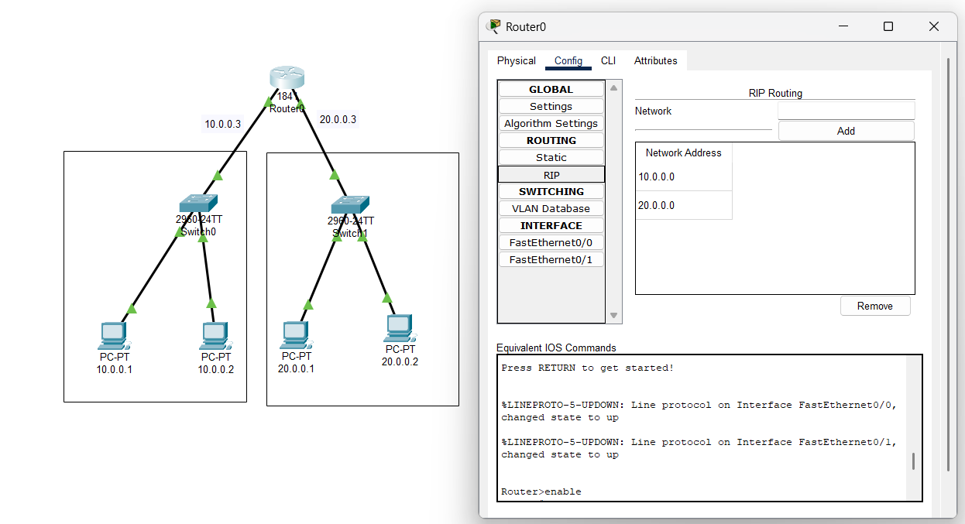

* 1. *RIP Configuration for a Router Connecting Two Different Networks*

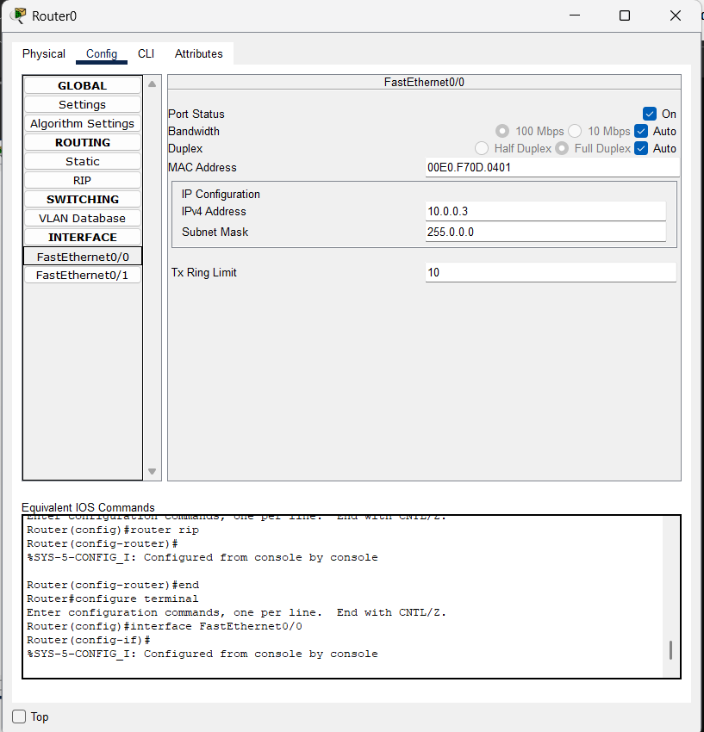

* 1. *FastEthernet Configuration for a Router Connecting Two Different Networks*

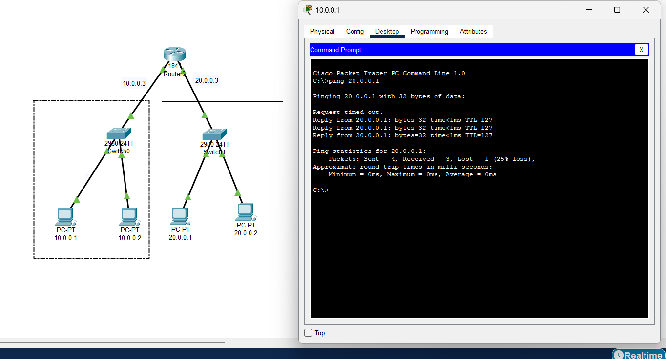

* 1. *Ping Command to Verify RIP Between Two Different Networks*

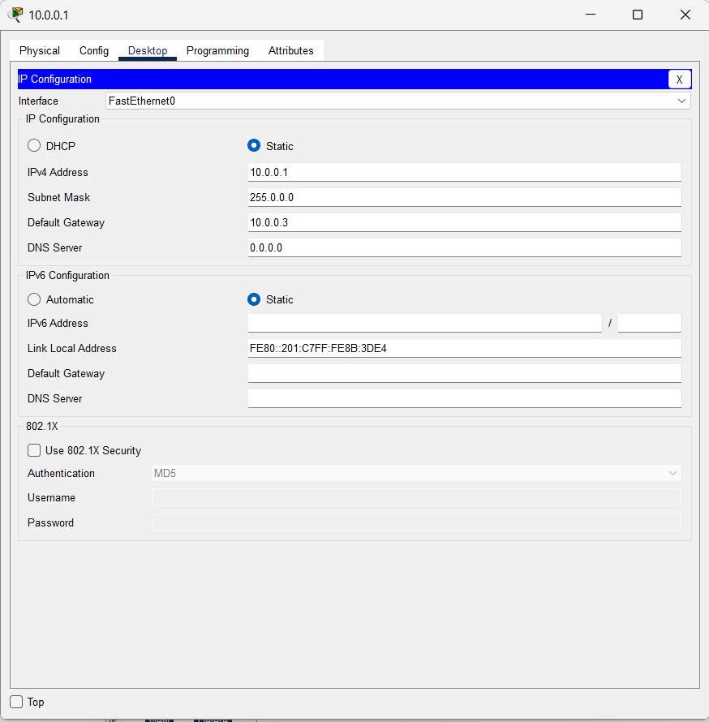

* 1. *PC IP Configuration for RIP Between Two Different Networks*

1. **Connect the three different networks based on the calculated IP addresses and subnet using a packet tracer.**

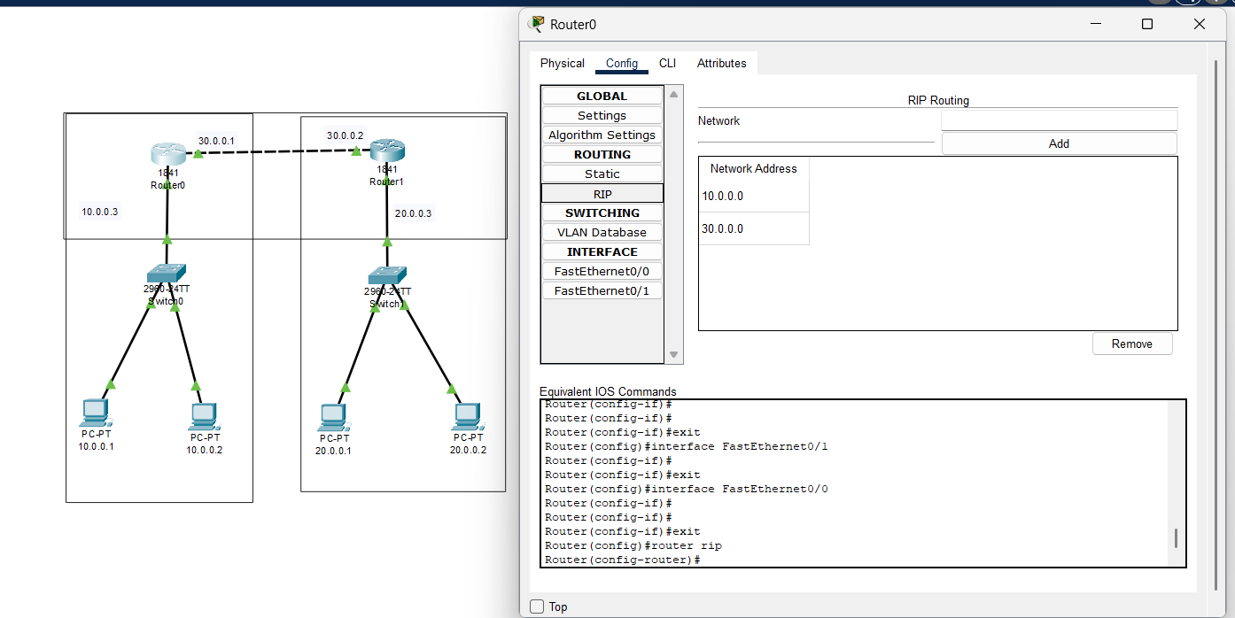

* 1. *RIP Configuration for a Router Connecting Three Different Networks*

s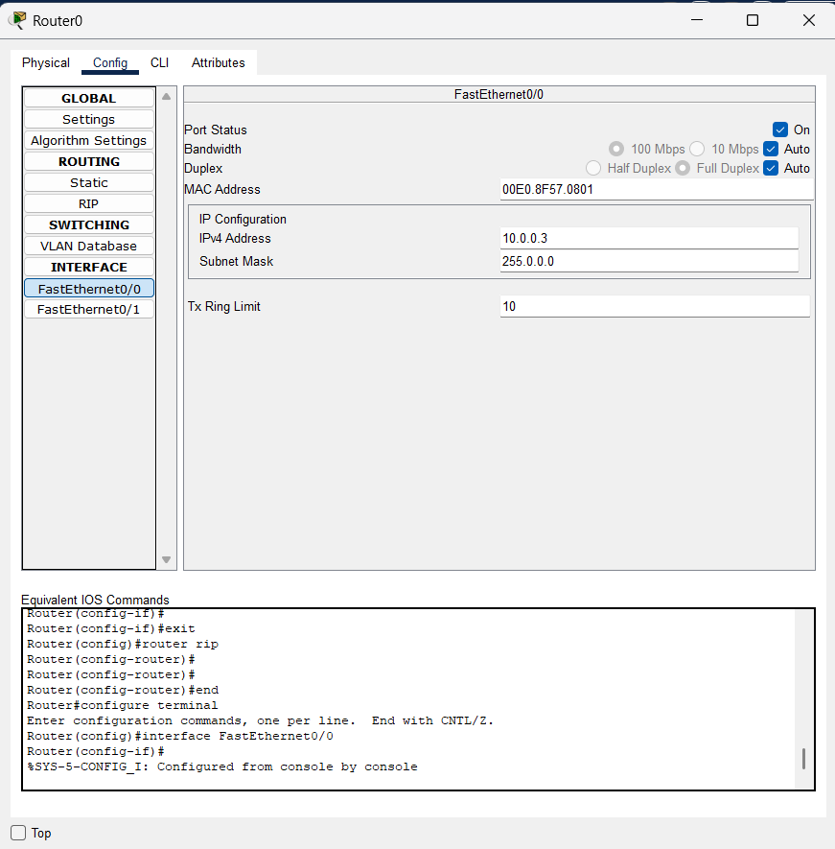

* 1. *FastEthernet Configuration for a Router Connecting Two Different Networks*

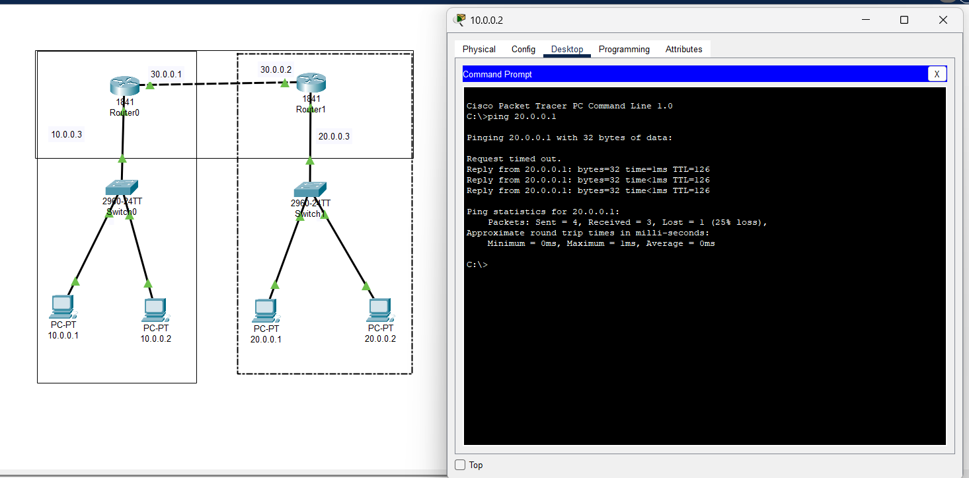

* 1. *Ping Command to Verify RIP Between Three Different Networks*

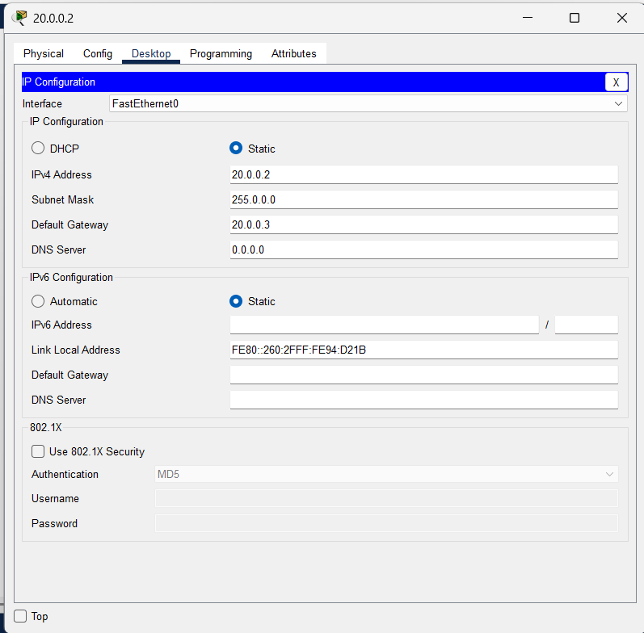

* 1. *PC IP Configuration for RIP Between Three Different Networks*