**Lab Practical #12:**

Study the concept of routing using packet tracer. (Static Routing)

**Practical Assignment #12:**

1. Connect the two different networks based on the calculated IP addresses and subnet using a packet tracer.

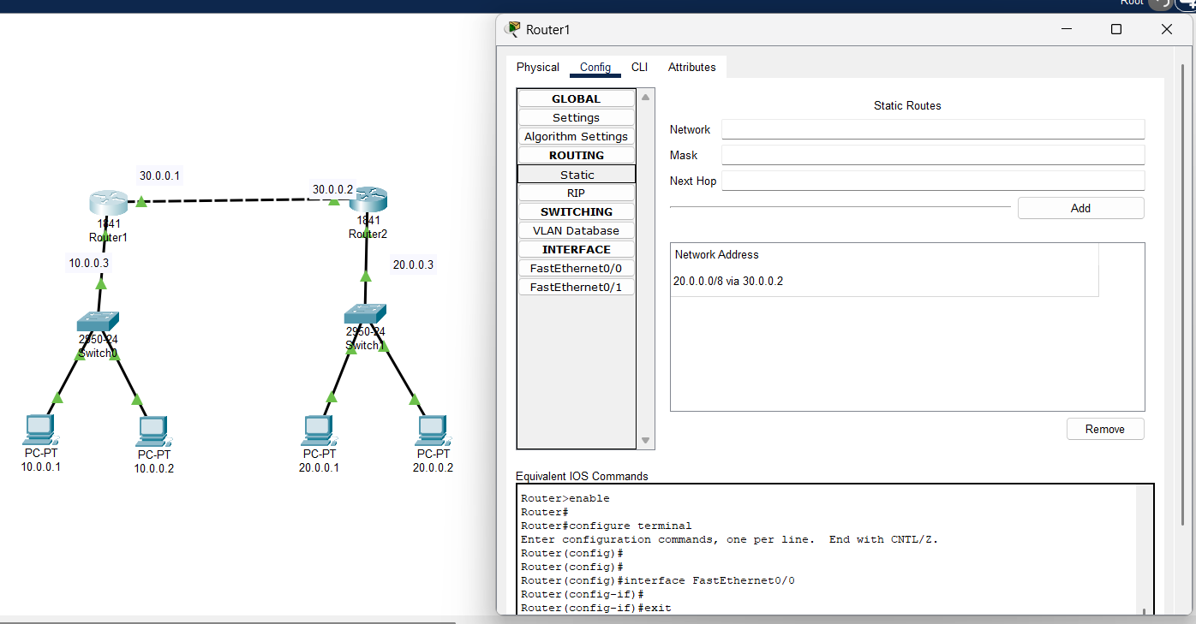

* 1. *Static Routing Configuration for a Router1*

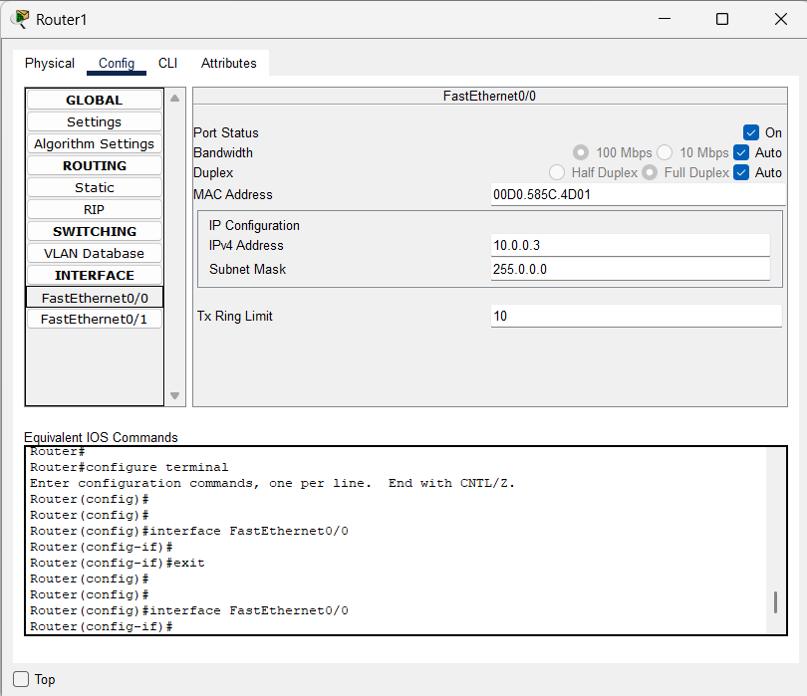

* 1. *FastEthernet Configuration for a Router1*

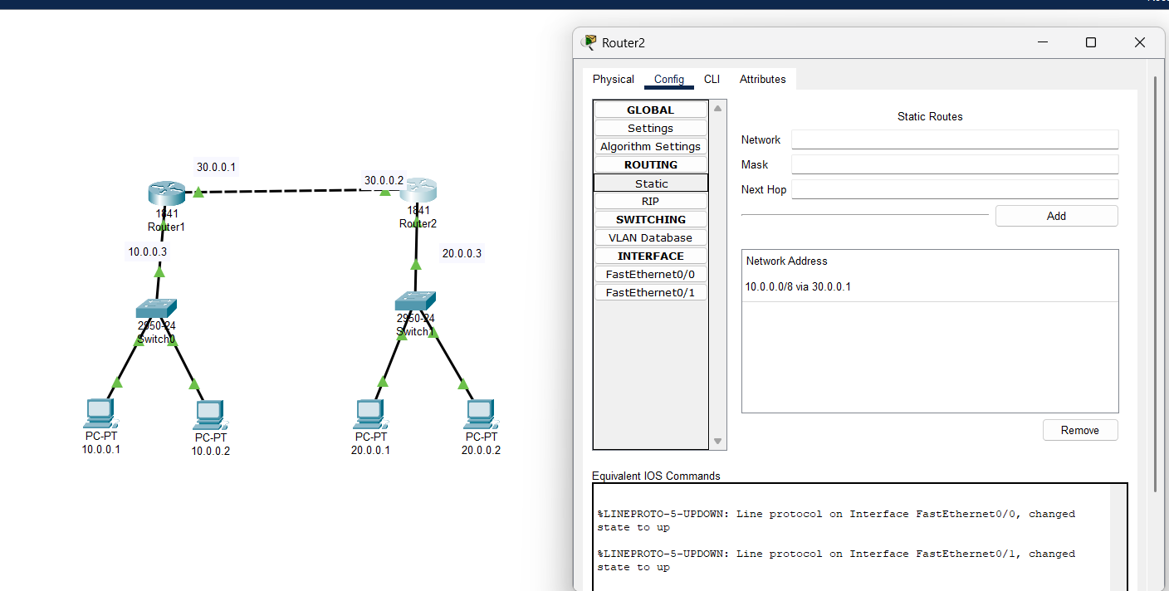

* 1. *Static Routing Configuration for a Router2*

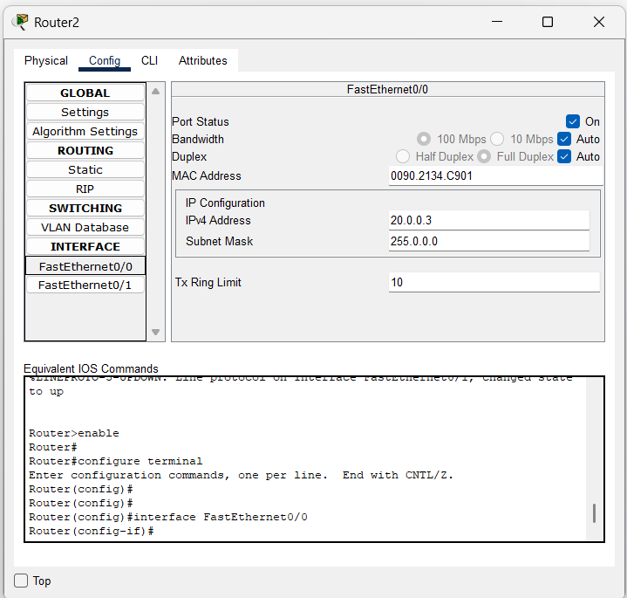

* 1. *FastEthernet Configuration for a Router3*

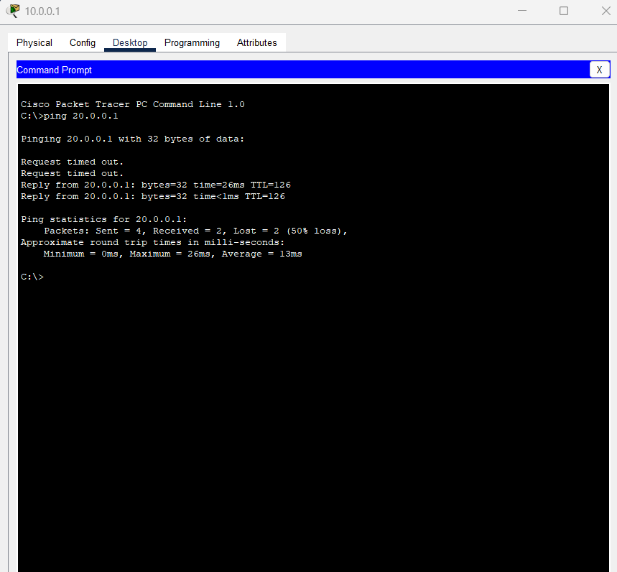

* 1. *Ping command through check*

1. Connect the three different networks based on the calculated IP addresses and subnet using a packet tracer.