UCS503 - Software Engineering

Digital Deception Detection Suite
A Multi-Signal Machine Learning Approach to Detecting Phishing Messages, Malicious Links, and QR Code Scams
Submitted by:
1024030503 Aman Bansal
1024030502 Vardaan Jain
1024030522 Harmilan
1024030519 Siddharth
1024030515 Yashvir Singh
Group: 3C34, BE Third Year, CSE
Submitted to:
Ms. Nisha Thakur
Mid-Semester Evaluation
Computer Science and Engineering Department
Thapar Institute of Engineering and Technology, Patiala

Contents
1 Introduction 3
1.1 Background and Context 3
1.1.1 Problem Statement 3
1.2 Project Objectives 3
2 Methodology and Design 5
2.1 System Architecture 5
2.1.1 High-Level Design 5
2.1.2 Technical Stack 5
2.1.3 Development Methodology 5
2.2 Implementation Details 6
2.2.1 Module 1: Message Analysis 6
2.2.2 Module 2: Link and Domain Analysis 6
2.2.3 Module 3: QR Code Phishing Detection 6
2.2.4 Risk Engine and Deployment 6
2.3 System Design Diagrams 7
2.3.1 Use Case Diagram 7
2.3.2 Activity Diagram 7
2.3.3 Swimlane Diagram 8
2.3.4 Data Flow Diagrams (DFD) 8
Level 0 DFD (Context Diagram) 8
Level 1 DFD 9
Level 2 DFD 9
2.3.5 Class Diagram 9
2.3.6 Sequence Diagram 10
2.3.7 Collaboration Diagram 10

Chapter 1

Introduction

1.1 Background and Context
Phishing and social-engineering-based scams have grown into one of the most persistent digital threats faced by individuals today. Attackers no longer rely solely on email; a large and growing share of scam attempts now arrive through SMS (“smishing”), instant messaging platforms such as WhatsApp and Telegram, and increasingly through malicious QR codes (“quishing”) placed on posters, payment counters, and forwarded images. These attacks are designed to create urgency, impersonate trusted entities such as banks or government bodies, and extract sensitive information such as OTPs, passwords, or payment details.
Most existing protective tools rely on static, rule-based detection: blocklists of known malicious URLs, keyword filters, or signature matching against previously reported scams. While effective against known threats, such approaches are inherently reactive — they fail against newly registered domains, freshly worded messages, or QR-code-based redirection, all of which are trivial for attackers to generate at scale. This creates a genuine gap for a detection approach that reasons about the intent and structure of a message or link rather than matching it against a fixed list.

1.1.1 Problem Statement
There is no lightweight, unified system that combines multiple independent detection signals — semantic message analysis, domain/link legitimacy analysis, and QR code verification — into a single, explainable risk assessment that a normal user can access directly within the platforms they already use (browser-based messaging clients such as WhatsApp Web and Telegram Web). Existing tools typically address only one of these vectors in isolation, offer no explanation for their verdicts, and are not evaluated rigorously against adversarially crafted or evolving attack patterns. This project addresses that gap by designing a multi-module deception detection suite that combines classical machine learning, semantic embeddings, and large language model (LLM) reasoning into a single, benchmarked, and explainable risk-scoring system.

1.2 Project Objectives
The following SMART (Specific, Measurable, Achievable, Relevant, Time-bound) objectives guide the development of this project over the course of the semester:
- Design and implement a Message Analysis module that combines rule-based heuristics, a classical machine learning classifier (TF-IDF with Logistic Regression/SVM), semantic embedding similarity, and LLM-based reasoning to assess the phishing/scam intent of a message, evaluated on a labeled public dataset by the mid-semester milestone.
- Develop a Link and Domain Analysis module capable of detecting lookalike/typosquatted domains and assessing domain trustworthiness using registration-age lookups, integrated with the Message Analysis module's output by the mid-semester milestone.
- Implement a QR Code Phishing Detection module that decodes embedded URLs and routes them through the existing Link Analysis module, extending coverage to physical and image-based QR scams by the end of the semester.
- Build a unified Risk Engine that combines all module outputs into a single Low/Medium/High risk verdict with a human-readable explanation, and deploy the system as a Chrome browser extension usable on WhatsApp Web, Telegram Web, and other web-based messaging clients.
- Rigorously evaluate the complete system against curated and public phishing datasets, benchmark it against a naive keyword-matching baseline, and conduct an adversarial robustness round to document real-world failure modes by the end of the semester.

Chapter 2

Methodology and Design

2.1 System Architecture

2.1.1 High-Level Design
The system follows a modular, service-oriented architecture. A user-facing client — primarily a Chrome browser extension, with a manual paste-in tool as a fallback for platforms the extension cannot access — captures a message, link, or QR code and forwards it to a central backend service built with FastAPI. The backend routes the input to one or more of three independent analysis modules: the Message Analysis module, the Link/Domain Analysis module, and the QR Code Phishing Detection module. Each module returns an independent risk signal with supporting evidence. These signals are combined by a central Risk Engine, which produces a single consolidated verdict (Low / Medium / High risk) along with a human-readable explanation, which is then displayed back to the user inline within the client interface.
This modular design was chosen deliberately so that each of the three detection modules, and the Risk Engine that combines them, could be developed and tested independently and in parallel by different members of the team, consistent with the Agile/Scrum development methodology adopted for this project (see Section 2.1.3).

2.1.2 Technical Stack
Category | Technology / Tool
Backend Language & Framework | Python 3, FastAPI
Browser Extension | JavaScript, HTML, CSS (Chrome Extension APIs)
Classical Machine Learning | scikit-learn (TF-IDF, Logistic Regression, SVM)
Semantic Embeddings | Pretrained sentence-transformer models
LLM Reasoning | Google Gemini API (free tier)
Link/Domain Analysis | WHOIS lookup APIs, string-similarity libraries
QR Code Processing | Python QR decoding libraries (e.g., pyzbar / opencv)
Version Control | Git and GitHub (feature-branch and pull-request workflow)
Project Tracking | GitHub Projects (Sprint / Agile board)
CI/CD | GitHub Actions
Development Environment | Google Colab (model prototyping), VS Code

2.1.3 Development Methodology
The project follows an Iterative and Incremental development approach, structured using Agile/Scrum practices, rather than a Waterfall model. This choice was made for three concrete reasons specific to this project. First, the performance of the machine learning components (the classical classifier, embedding similarity, and LLM reasoning) cannot be fully known until they are built and evaluated against real data — a Waterfall process, which assumes requirements and design can be finalized upfront, does not accommodate this kind of empirical uncertainty well. Second, the system's four major workstreams (message analysis, link analysis, QR detection and extension, and risk-engine integration/evaluation) can proceed largely in parallel across the four team members, which Agile's sprint-based structure supports naturally. Third, given the team's limited weekly time budget, small, trackable two-week sprints — each with a defined sprint goal, a sprint review/demo, and a brief retrospective — allow progress and blockers to be identified early rather than discovered only at the end of the semester.

2.2 Implementation Details

2.2.1 Module 1: Message Analysis
The Message Analysis module assesses the phishing/scam intent of a given message using four complementary signals rather than a single detector, so that no single point of failure determines the verdict:
- Rule-based features: presence of urgency language, requests for sensitive information (OTP, password, PIN), impersonation cues, and unrealistic offers.
- Classical machine learning classifier: a TF-IDF vectorizer (unigrams and bigrams) feeding a Logistic Regression / SVM classifier, trained on a labeled SMS phishing dataset, with class-weight balancing applied to counteract the dataset's inherent class imbalance.
- Semantic embedding similarity: comparison of an incoming message against a curated set of known scam-message patterns using pretrained sentence embeddings, to catch semantically similar but differently worded attacks.
- LLM-based reasoning: a structured prompt sent to the Gemini API that returns a risk level, the specific signals it detected, and a natural-language explanation, used as one signal among several rather than as the sole detector.
These four signals are combined into a single structured output (a risk score together with the contributing signals) that is passed on to the central Risk Engine.

2.2.2 Module 2: Link and Domain Analysis
For any URL found within a message, this module assesses the likelihood that the domain is malicious or impersonating a legitimate brand, using: (i) string-similarity analysis against a reference list of well-known brand domains to catch typosquatted/lookalike domains (e.g., “paypa1.com”), and (ii) domain registration-age lookups via WHOIS, since newly registered domains are disproportionately associated with scam campaigns. The module returns a link-level risk score together with the specific checks that were triggered.

2.2.3 Module 3: QR Code Phishing Detection
This module decodes a submitted QR code image to extract its embedded URL, which is then passed directly to the Link and Domain Analysis module (Section 2.2.2) for evaluation, avoiding duplication of detection logic. As a planned extension, the module will also examine the visual region surrounding the QR code for signs of physical tampering (e.g., a sticker pasted over an original code), addressing a real-world attack vector that purely code-based QR checks cannot detect.

2.2.4 Risk Engine and Deployment
The Risk Engine consolidates the outputs of all three analysis modules into a single Low/Medium/High risk verdict, using a weighted combination of the individual module scores, tuned against the project's evaluation dataset. The primary deployment surface is a Chrome browser extension: since platforms such as WhatsApp Web and Telegram Web render messages as plain, decrypted text within the page's DOM once received, the extension's content script can read this text directly and request an analysis without requiring the user to manually copy and paste content. For messages originating outside the browser (e.g., desktop messaging applications), a manual paste-in tool is provided as a fallback, ensuring the system remains usable regardless of platform.

2.3 System Design Diagrams
The following diagrams illustrate the system's structure and behaviour from complementary perspectives: user interaction (use case), process flow (activity and swimlane), data movement (DFD levels 0–2), and structural/behavioural object-oriented design (class, sequence, and collaboration diagrams). Diagram images are to be inserted in the marked spaces below.

2.3.1 Use Case Diagram
Illustrates the primary actors (End User, Browser Extension, Backend System) and their interactions with the system's core use cases: submitting a message/link/QR code for analysis, viewing the risk verdict and explanation, and (optionally) reporting a false positive/negative.
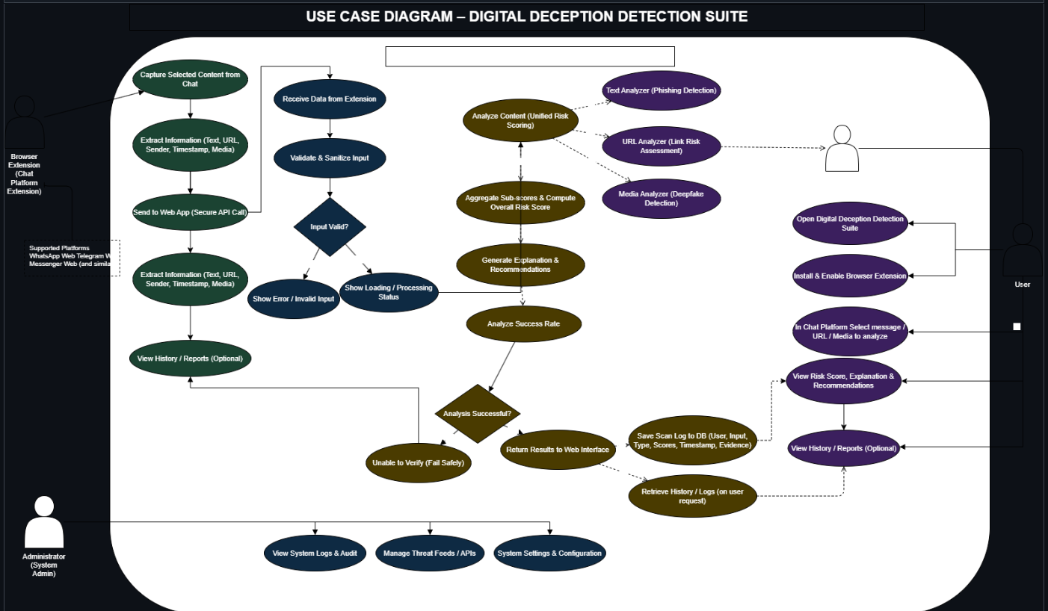
Figure 2.1: Use Case Diagram

2.3.2 Activity Diagram
Depicts the end-to-end flow of a single analysis request — from message capture at the client, through routing to the relevant analysis module(s), combination at the Risk Engine, and display of the final verdict to the user, including decision points such as which modules are invoked based on input type (text, link, or QR code).
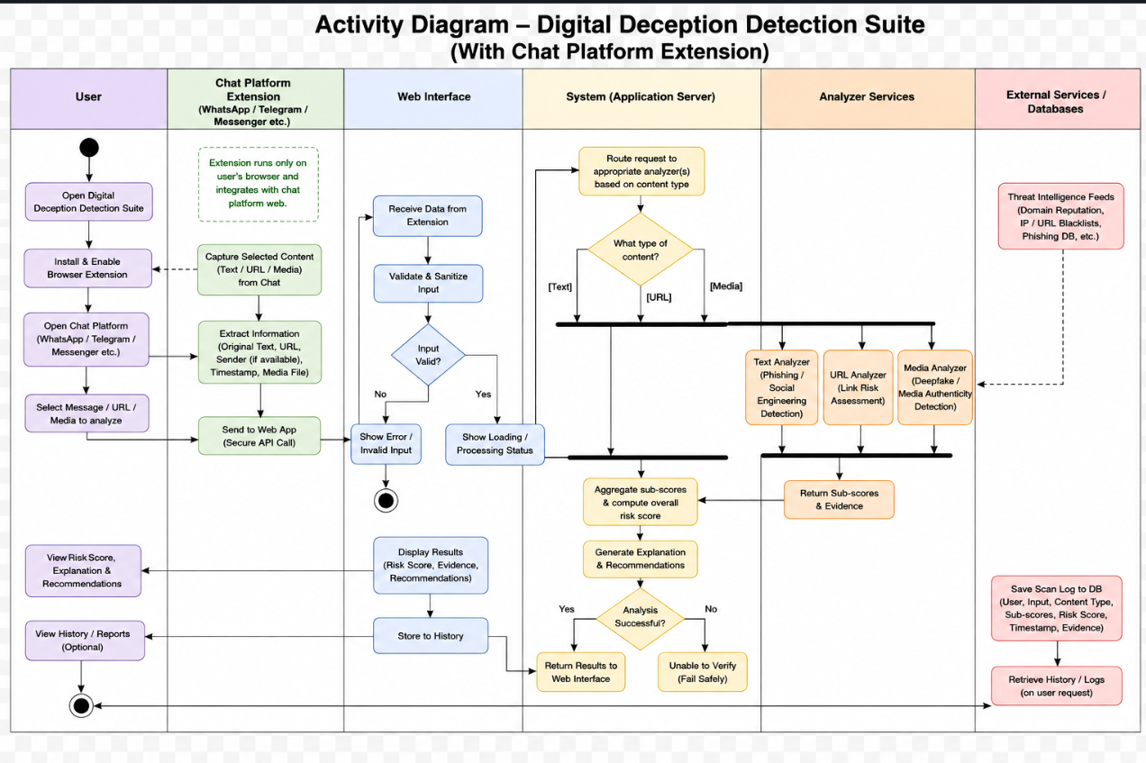
Figure 2.2: Activity Diagram

2.3.3 Swimlane Diagram
Presents the same end-to-end process as the Activity Diagram, partitioned into lanes for each responsible component (Client/Extension, Backend API, Message Analysis Module, Link Analysis Module, QR Module, Risk Engine), clarifying ownership of each processing step.

Figure 2.3: Swimlane Diagram

2.3.4 Data Flow Diagrams (DFD)
The Data Flow Diagrams below present the system at increasing levels of decomposition, from a single external-facing process down to the internal data flows of each analysis module.

Level 0 DFD (Context Diagram)
Shows the system as a single process, with the End User as the sole external entity, and the two primary data flows: a submitted message/link/QR code, and the returned risk verdict with explanation.
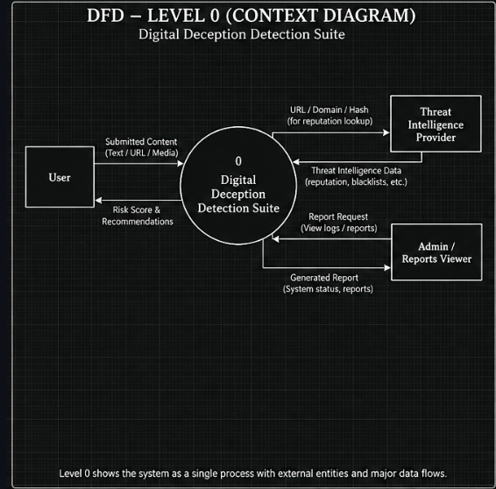
Figure 2.4: Level 0 DFD

Level 1 DFD
Decomposes the system into its major processes — Message Analysis, Link/Domain Analysis, QR Detection, and Risk Engine — along with the data stores they read from or write to (e.g., the labeled training dataset, the known-brand domain reference list, and the scam-pattern embedding database).
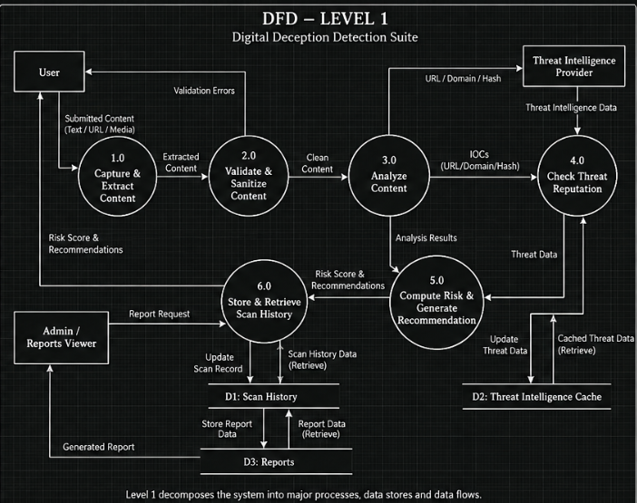
Figure 2.5: Level 1 DFD

Level 2 DFD
Further decomposes the Message Analysis process specifically, showing the internal data flow across its four constituent signals (rule-based features, classical ML classifier, embedding similarity, and LLM reasoning) and how their outputs are aggregated before being passed to the Risk Engine.
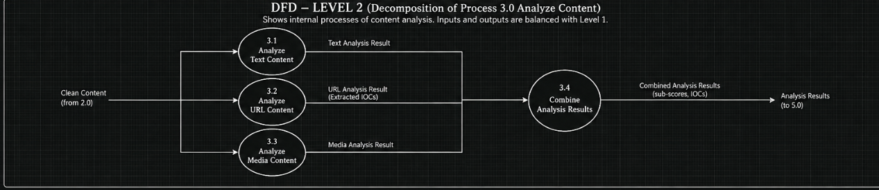
Figure 2.6: Level 2 DFD

2.3.5 Class Diagram
Captures the system's core classes (e.g., MessageAnalyzer, LinkAnalyzer, QRDetector, RiskEngine, RiskVerdict) along with their key attributes, methods, and relationships (association, composition) between them.
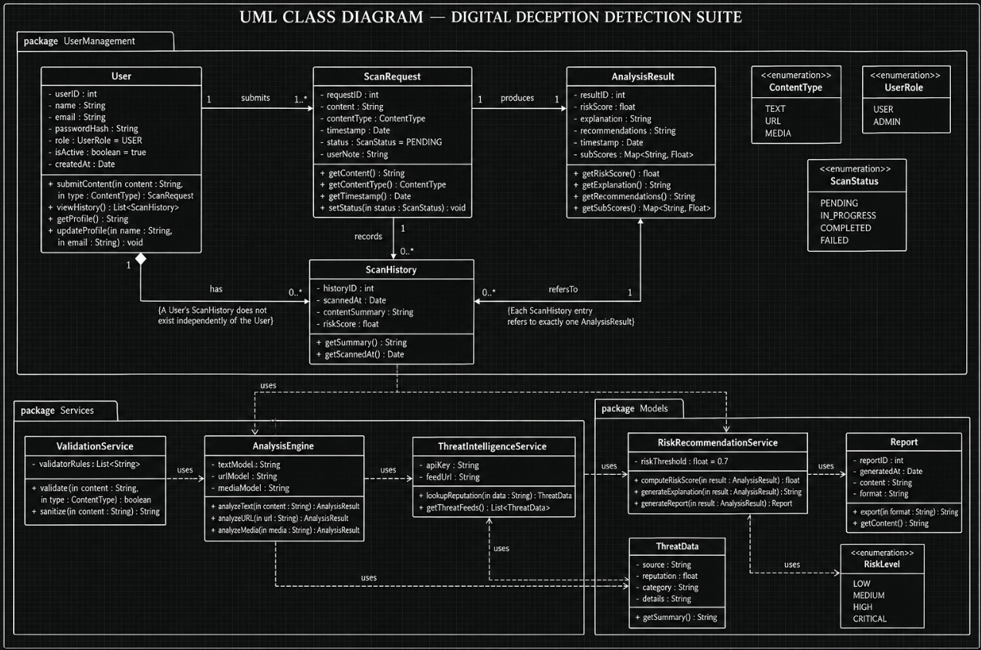
Figure 2.7: Class Diagram

2.3.6 Sequence Diagram
Traces the time-ordered sequence of method calls and messages exchanged between the Browser Extension, Backend API, the three analysis modules, and the Risk Engine for a single end-to-end analysis request.
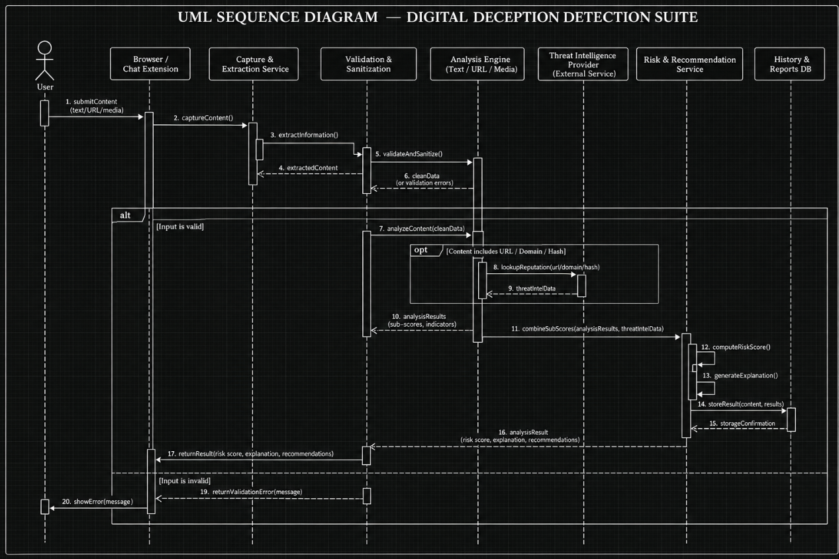
Figure 2.8: Sequence Diagram

2.3.7 Collaboration Diagram
Presents the same set of interactions as the Sequence Diagram from an object-collaboration perspective, emphasizing the structural links between participating objects over the strict time ordering of messages.

Figure 2.9: Collaboration Diagram

