We're Halfway There
Friday was rough. I'm not gonna lie. But most of my emotions had already leaked out of my eyes before that day even arrived. The leakage started the previous weekend when I woke up at 7 a.m. with Scott turned over in bed looking at me with love in his eyes. And then when he said, "I love you," that's when I lost it.

We have done deployments before, so this is nothing new to us. But then, because it's nothing new, we knew what was coming. The beauty of a deployment - (I can't believe I'm even saying this) - is that when you're apart, then the other person becomes your main focus like never before. When we're under the same roof, we spend time together occasionally, while we each do our own thing for the most part. We go on dates, we eat together, pray together, sleep together, etc. But when we're apart like this, suddenly our prayers become more focused, our hearts become more focused, and our thoughts become more in tune with our other half. It's really a beautiful thing.

Friday looked like this.

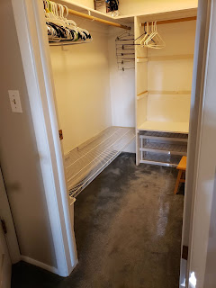

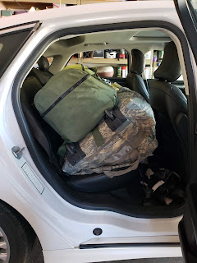

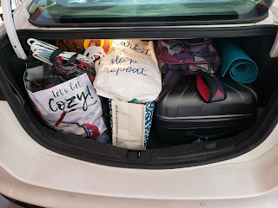

And then this.

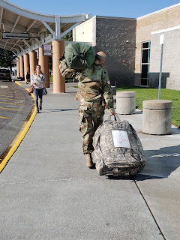

For more pictures and a video of Scott waving goodbye, you can go here:

https://photos.app.goo.gl/VSQi2YYjuB3SizBZA

Then it was me hitting the road. I drove to Boise on Friday and spent a lovely evening with my sister-in-law, Carol Whitten. We went out to dinner, ran some errands, and visited her daughter Heather, whom I hadn't seen in years! Plus, my solace for the day was found in the Boise shopping mall. :) Earlier this past week, someone noticed my "To-Do" list on the kitchen counter. For Friday, my list was simply:

Airport

Sadness

Shopping in Boise to alleviate sadness

Happy to report
that Scott made it to his first duty station safely in Fort Bliss, Texas (El Paso). He has met up with his comrades and says they're "good dudes". He spent several hours yesterday getting equipment issued for the deployment: gear, gun, etc. Today he is in briefings and shoots me a text with information he's getting from time to time. :) It's just nice to be in communication!! Keep those texts coming!! And I did get to talk to him on the phone yesterday too, so that was rad.

Saturday looked like this:

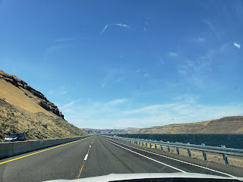

Yes, I did take a couple of pictures while driving. I'm sorry!!!!

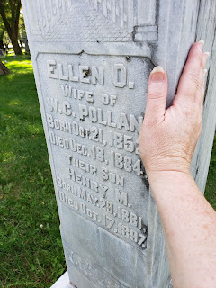
Found my 2nd great grandmother's grave in Goldendale, WA.

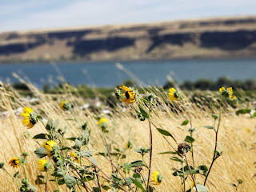

View of the Columbia River from the Goldendale, WA side - looking across to Oregon.

For more photos of the day, including my stop in Goldendale (at the foot of Mt. Hood), you can go here:

https://photos.app.goo.gl/FkA1Mp1zZd5oteQu5

I made it safely to my Grandma Lillian's house yesterday around dinnertime. She lives in Salem, Oregon. We went out to our traditional sushi dinner together - at her request. She hasn't had sushi in 3 months, she said, and was really craving it! We talked and talked until bedtime and then we went to sleep. Today, I depart at 4:00 to head down to Grants Pass, OR to stay with some friends, Josh & Kelly Richardson. And tomorrow: I arrive at my mom's house!! Hooray!!

Hope all is well where you are. You are in our thoughts and prayers!! XOXO

