Mom Says To Call It The Grind
I couldn't think of a fitting title for this post, so my mom said, "Just call it The Grind!" Very appropriate. That's about all I've been doing for the past several days.

Besides helping my mother around the house and yard, and shadowing my "elderly-with-balance-issues-but-wants-to-be-independent-grandmother", I just brought my mom home from the surgical center yesterday for a lengthy recovery following hand surgery. They reconstructed the bone at the base of her thumb, using some extra ligament from her wrist. It will be about a solid 12 weeks with minimal (at best) use of her right hand and wrist. She is doing quite well so far, and is proud of the fact that she has two strong legs as well as the use of her left hand. She has been cheerful about any challenge that appears daunting with just her lefty, and surprisingly has only needed me minimally so far. I did help her put on her deodorant this morning though!

Before surgery:

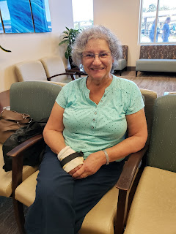
Home after surgery:

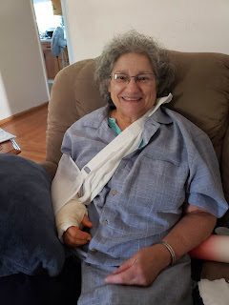
After dinner we each practiced writing with our left hand - mine is at the top, then mom's attempt, then Grandma at the bottom

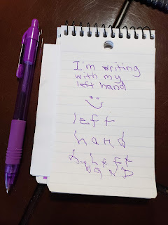

Side note: During quiet time this afternoon, I tried to sleep while in the same room as Grandma Doris. Not much of a success. She is over there in the recliner alternating between watching a travel show with closed captioning (on mute) and then dozing off. She makes these little sounds with her lips: puh. puh. puh. And occasionally: psh. psh. psh. It's hard to get irritated though when she's just so cute.

So this is my basic schedule right now:

7:00 am: Wake up. Most of the time I wake up on my own, but sometimes I set my alarm so I can do my own stuff while the house is quiet

7:10 am: Yoga in the living room - current favorite is Senela on YouTube

7:40 am: Shower, get dressed, eat breakfast & read scriptures

9:00 am: Everyone else is up by now, so it's time to "clock in" for the day - help Grandma go potty, make her coffee & breakfast, and make a plan for the day

9:45 am: Try to help out in the garden, or do some house cleaning while Grandma is occupied at the table with Mom

The whole middle part of the day is just basically:

Follow Grandma everywhere

Take her potty, feed her, visit with her and keep her entertained

Prepare meals, clean up the meals

Sit on the swing on the back patio for a while with her

Try to come up with things Grandma can do to "help" - such as carting over dinner dishes & food on her walker seat to the dining table or putting away the silverware from the dishwasher

Assist my mother with opening things she can't do one-handed, fetch things for her, make sure she's staying up on her pain medications, prepare her meals, be her go-fer

Early this morning while cleaning up chicken poops . . .

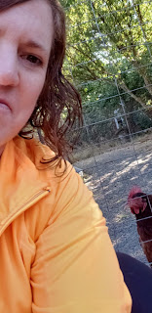
And after lunch, while sitting on the swing outside with Grandma we saw THREE hummingbirds all on the bird feeder at the SAME TIME. We have been watching them every day and have noticed that there is never more than one bird on the feeder at any given time. But THREE? Mom said later that this past spring they counted 15 on the feeder at one point - including BABY hummingbirds. How cute! I would have loved to see that.

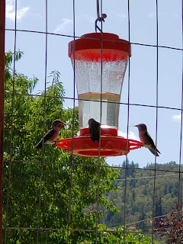

Evenings:

Clean up the kitchen, help the ladies get settled in the living room - they like to watch recorded tennis matches on Direct TV

Try to have a quiet minute for my own thoughts

And try to come up with a clever way to get Grandma to be willing to start getting ready for bed at 9:00 pm. Only because I'm dying by this point. I'm so tired in the evenings. I am so mentally drained it's just pitiful. And it takes about 45 minutes just to get her all taken care of. My favorite trick so far was this one:

"Hey Grandma, are you ready to get pajamas on?"

"No, I'm not tired yet."

"Okay, how about this. We can do Part One (brush teeth, get pajamas on, wash face) and then you can come back in and watch TV with Mom for a bit. Then we'll go do Part Two (go potty) and then you're all ready for bed."

"Okay, that sounds good." (so off we go)

5 minutes into TV time after Part One - she says:

"I'm just so tired. I think I'll just go to bed."

Yasssss. That's what I was hoping for. I think I won that round.

Night Time:

Up until my mother's surgery, we would alternate night shifts with taking care of Grandma. Whoever had that night would take the baby monitor to listen for anything she might need. Most nights she just gets up twice to go to the bathroom, but some nights it's more often. Sometimes I wake up because I can hear her coughing and she needs a drink. Most nights she talks in her sleep. And sometimes I hear her trying to get up without calling for assistance and I can hear her walker scooching across the hardwood floor with the brakes still engaged. So I jump up and dash down the hall to help her with whatever she needs. But now, because of mom's surgery, I am on night shift duty every night indefinitely. I have been very sleep deprived to say the least.

And then there are other things that can affect my sleep. The cat, for instance.

I dislike cats. I mean kittens are cute, but I'm just not a cat person. So my mom's cat likes to roam/prowl/investigate/get into mischief during the night. One night I woke up with a start because she came into my room and attempted to jump up onto my windowsill right close to my face. At that very same moment I sat up in bed with a crazed gasp, which in turn freaked the cat out and she (probably) did a front flip into a barrel roll mid-air as she leaped from the windowsill and streaked out of my room. This all happened in about 1-2 seconds. Heart pounding, I tried to go back to sleep.

Other times, I hear people outside talking or locking their car across the street at midnight or 1:00 am. (chirp chirp) And then, sometimes I just can't sleep because I wonder and worry if my Grandma is going to try to get up all sneaky-like without my help. I hear all of these things even while wearing my EAR PLUGS every night!! Crazy, right???

So that's my life. Sorry if this post seems a bit dreary. I'm just tired. But life really is pretty good overall. All is swell. Hope you're all doing well. :)

