So Now I'm a Roofer
First off, I want to share some pictures that
Scott
has sent me while he's on Fort Bliss. His barracks are way out in the White Sands area of the base - over the border into New Mexico, but meals and classes are on the main part of the base - closer to El Paso. So he and his comrades spend a lot of time on the bus going to and fro. He says it's about a 25 minute ride each way and at times I think they are bored and just tired of all the driving.

One morning he sent me a text with a picture of him on the bus and simply said, "Guess where I am."

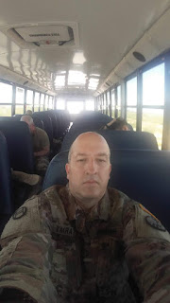

He also said his buddies on the bus decided to play a trick on the bus driver one day (apparently because the bus driver is somewhat of a grumpy guy). When the driver picked them up or dropped them off - not sure which - they discovered they could push a button that made the big arm in front of the bus swing out with the stop sign and all. The driver could not for the life of him figure out how to retract it! He even called the other bus drivers on the radio to ask for help in getting the arm put back. Meanwhile, the boys (not Scott) had a good laugh. :)

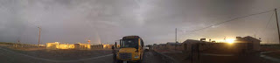

This picture was sent early this morning after a good rain. There's a nice hint of a rainbow on the left if you can see it.

Scott is doing well out on the shooting range with expert marksmanship and spends a lot of time in classes during the day on a variety of subjects. He's also just finished a classroom course with a nice certificate to prove it. He is happy and enjoying his new comrades from North Carolina, Ohio & Pennsylvania.

Meanwhile,
my mom and I feel that finding a care home for Grandma Doris is the next step. It is taking all of our time and energy and patience 24 hours a day, and that is not good. I'm here in CA to help in more ways than one - at least that's what I intended. But it's really hard to slip out and do anything else when someone needs to be with Grandma constantly. Some things I've been concerned about: I have only seen my Dad for about one hour so far, even though I've been here for 3 weeks; I would love to help my sister Charmaine with some things; and I would also like to do something fun with my mom once in a while. When I leave here in December, what will my mother do without the extra help? If we're both drowning as we work together constantly, then that's not a good scenario for when I leave.

So, this week, research will begin in earnest for a good place for Grandma to be happy, but also affordable. In CA, Medicare is not as generous as in other states we're learning. It's a tricky and sometimes downright frustrating walk to figure out insurance, as I'm sure you are fully aware. We are praying for a miracle. Grandma only makes so much money a month, and only has a very small savings amount. We want a reputable care home, but one that is also affordable with whatever Medicare and/or MediCAL will help cover. I know, we're asking for a lot, but miracles have
not
ceased and we are hopeful.

When I mentioned to my mom that I hadn't spent any time with my dad since arriving here, she quickly worked to set something up so that I could get away and spend some time with him yesterday. She invited her grand-niece, Lynette, to come over and help for half the day and spend time with her. Lynette arrived with a GORGEOUS bouquet of flowers from her own garden and spent a lovely several hours with my mom and Grandma.

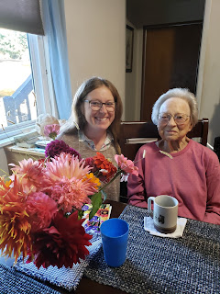

So this freed me up to then go hang out with my Dad for a while yesterday. I drove up to Willits (about 30 minutes north of Ukiah) and met my Dad and step-mom Michelle at the small home they have been slowly building for Michelle's son, Troy. Troy has had a history of mental illness and this was a good solution for housing for him to keep him safe and secure, but it has been a very slow pace at best. My dad has a bad back, Michelle is still busy teaching at the local community college, and they both help care for Michelle's 93 year old father, Glen. So to have me fresh on the scene was very exciting!! There was somewhat of an urgency to get the roof ready before rain hits on Monday, so I put in several hours with the prep work for that.

First, I had to climb up onto the roof and sweep off all the debris from nearby trees. Just stepping out onto the sloped roof from a ladder that's 13+ feet off the ground was a bit terrifying. And I don't consider myself afraid of heights! But with Dad's encouragement, I was able to get off the ladder and into almost a fetal position on the roof, ha ha. After I got up a moment later, I gradually gained more and more confidence as I swept along. But the same terror crept back in when I had to leave my new friend, The Roof, and get back on that ladder for the descent. Again, after some encouragement from Dad, I was able to get on the ladder successfully. As soon as I started going down, I was fine. It was just the dismount onto the roof and the stepping onto the ladder that threw me for a loop. When I got down to the ground, however, I found that I was shaking, ha ha. But, ever eager for an adventure, I got back up again for Round 2 a short time later.

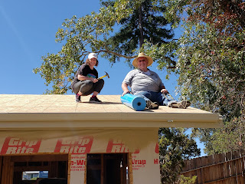

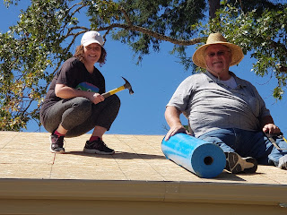

We laid all the waterproofing material and secured it with roofing nail screws. It was so fun!! Even though it was hot (around 90 degrees), we made a good team. Roll the material across the roof, cut it to hang slightly over the edge of the roof, then tack it down. The trick was to make sure we laid it straight, that the overlap was good, and that we got rid of any slack along the way. I did some yoga plank poses as I hammered in some places that were a bit more tricky. It was actually easier that way, if you can believe it! Then just move along and do the next nail screw, ha ha.

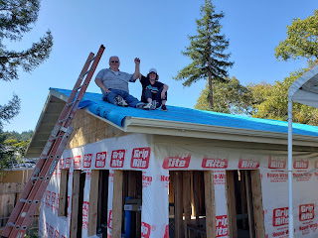

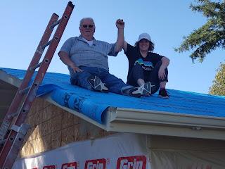

After a few hours, we got it done. I'm shocked I didn't get sunburned to a crisp! And I'm grateful that I didn't get poison oak - since there was a big tree just a few feet off the north end of the house. And I'm grateful I didn't fall off the roof. And I'm just super happy that I could go and spend time with Dad and do something physical and satisfying in a different way.

Well, that's about it for the week. Life is good, even when it's hard. And joy can be found along the way, even in small and simple things.

