Downs &amp; Ups, Ups &amp; Downs
First off, I would like to express my love and appreciation for my sweet husband,
Scott
. He is my lifeline, my uplift, and my best friend. We talk on the phone almost every day and it is the thing I look forward to the most each day. Sometimes we have connectivity issues with cell reception, but we recently found a way to overcome the issue. Take that, cell towers!!

Scott is learning a lot about the Middle East and things going over there as part of his preparation to go over soon. He is the only married guy in his small group of 8 that he will be working most closely with, so I'm sure he will provide a light in the darkness to his comrades and demonstrate the joys of being married and its eternal purposes. He got permission from church leaders to bless the Sacrament for himself every week, which he faithfully administers. He is the only member in his smaller circle of Army guys. He reports that he is reading his scriptures and listening to conference talks regularly, which boosts his spirit and makes him happy. He is very happy in all that he's doing, though, and says that this deployment will be the "coolest thing he's ever done in the military." I am so proud of him.

Here is a photo of him from a few days ago. He was in a long line for the chow hall for dinner one night, and they noticed another guy in the line that looked a lot like Scott. So he went over and got his picture taken with him and then he sent it to me. I didn't think they looked alike at all, but some of the other Army guys thought it was Scott's doppelganger, ha ha.

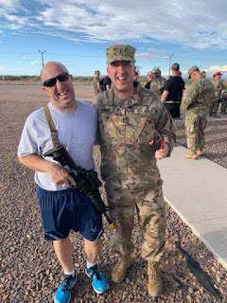

And speaking of long line for dinner, Scott said that there were about 700 Air Force personnel that arrived on Fort Bliss that night, so that made for a longer line than usual. And he also relayed that the Air Force get paid an extra $700 or so per month just for having to be on an
Army Base
. LOL Apparently this is compensation for the trauma of it all, ha ha. He texted Benson about it and Benson said, "Yeah, that sounds about right."

As for Downs & Ups, Ups & Downs . . . .

Up: My mom had a good checkup following her surgery this past week, got a shorter splint on and some finger exercises to do for improved strength and mobility. She gets her stitches out in 2 days. Hooray! We went out to lunch at a lovely Thai restaurant following her appointment in Santa Rosa.

Down: I got a weird case of hives that have lasted for 2 weeks now. I think it's from the seafood soup that I had on the day of my mom's surgery at a Vietnamese restaurant. That's all I can think of. I've never had anything like this happen before. The hives didn't ever itch, except maybe once or twice. But they are all over my core section - both front and back, even a few on my upper thighs. They are fading for sure, but it's just taking forever!!

Down: Grandma Doris has been quite moody and difficult to deal with lately. She really wants more independence, but the cost is safety. It's hard to navigate a good balance between giving her more independence while making sure she is safe, but we are sure trying. She hurt my feelings profoundly this past week and caused me to cry more tears than I would care to admit.

Up: We finally had a "family council" discussion with Grandma, my mom and me, where we discussed our feelings and got some things straightened out. Grandma was quick to take my hands into her own and apologize, as I explained my hurt feelings to her. She was very gracious and humble and wanted to make it right. I appreciated that so much.

Up: My Uncle Wayne (mom's older brother) decided to come down and spend a week helping us out. He lives in Brookings, Oregon (just north of Crescent City, CA). He's been a huge help because he's spending all kinds of time with Grandma Doris and taking care of her so that we can have a break. He sleeps on an air mattress at the foot of her bed, so he's been getting up in the night with her. This is a HUGE break for me and I am getting some amazing nights of sleep because of it. Here are a couple of pics - one that shows him sleeping on the floor by her bed (but all I can see is the beautiful sky outside in the background!!) and one of them enjoying the back patio swing together and watching the chickens one evening.

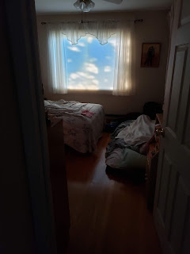

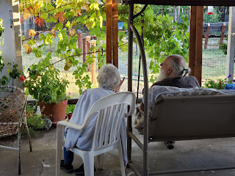

Up: I went up to Willits (about 30 minutes north) to help my Dad with some roofing and construction work. This has been SO.MUCH.FUN!! It allows me to step away from the mental and emotional fatigue and do something physical instead. I'm learning new things, and conquering fears and anxieties about stepping off a ladder onto a roof at 13 feet up. I can honestly say it makes me feel empowered and filled with joy. My sister, Charmaine, had to laugh the other day because she called me while I was working up there with Dad. I told her at one point, "Hold on a sec, sis." And then she heard me drill in a roofing screw to secure a metal roofing panel. She said, "That was so cool!!"

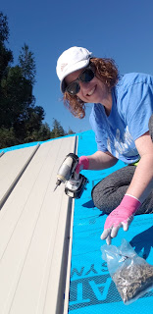

You can see pictures here of my construction adventures.

https://photos.app.goo.gl/8BH7qodG5hQzmfqr5

Down: Two days ago, I got a call from Jasmine, my dear friend and former foster daughter. She had been in a horrible car accident!! They had gone to SLC for a concert and were returning late at night back up to Idaho Falls. Her brother, Blayden, and his girlfriend, Trisha, were in the front seat, with Trisha driving. Jasmine was in the back seat adjusting her seatbelt and was just in the process of clicking it back in when they hit a deer or an elk just north of Malad Pass. They rolled and landed upside down, while Jasmine was tossed around like a rag doll in the back seat and was partially ejected through a back window. She had to be cut out of the vehicle and then life-flighted to EIRMC in Idaho Falls. She was in the ICU with a laceration to her spleen, kidney, a possible hernia on her stomach, cuts and other issues. But she somehow had the presence of mind to call me and let me know! Bless her heart! That was such bad news for her and yet I'm so grateful that she's in good hands and being cared for. I just wish I were there so I could go see her and carefully hug her.

Up & Down: Yesterday we (my mom, sister Charmaine & me) went over to the Coast to run away from our responsibilities. But Charmaine got really sick as we drove over - she had chills, body aches, and by the time we arrived for lunch she threw up in the bathroom!! It took forever (2 hours from start to finish) to get our food at the restaurant - one that my mom had eaten at several times before but never had this slow of service - so Charmaine just bailed and walked back to the car for a nap (and barfed again on the way). She got a little snooze while Mom and I got our food eventually, and decided she wanted to find a beach and just take another nap out in the sunshine on her beach towel. So we drove to the Big River Beach near Mendocino just a few minutes south of Fort Bragg. It was GORGEOUS!! I took a walk by myself and enjoyed some quiet time alone, something much needed. Later, on our drive home, we pulled off alongside the road and took a short walk in the Redwoods. The lighting was PERFECT for pictures!! It was right about 6:00 pm and the sun was streaming through the leaves, trees and branches.

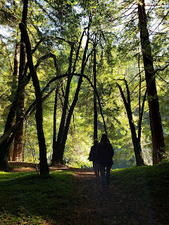

Here is a link to the photos from yesterday: (I also took pictures of some framed "art" in the restaurant bathroom - with references to BYU of all things!!)

https://photos.app.goo.gl/GAphV1LQDiFJSQVF9

Final UP: Attending church today. I've been praying to know what Heavenly Father wants me to learn while I'm out here. It has been really, really hard on me. I've had more lows than highs and it's been taking a toll on my spirit. Today I heard many things that the Holy Ghost pointed out to me that I needed to hear and be aware of. I'm so grateful that my Father hears me, knows me, understands me, loves me, and wants me to learn and grow in new ways. And I'm grateful for this opportunity to develop parts of myself that were previously (or currently) underdeveloped.

Hope you're all doing well! XOXO

