Bats, Cats & Tourniquets
Scott has been taking several classes down in El Paso, some of which are more interesting than others, and some he just dreads because he says they are just painfully boring. Currently, he is in the middle of a Combat Lifesaver Course, something standard to anyone in the military. Yesterday he reported learning the difference between a tourniquet and a pressure dressing. And yes, they got to practice the techniques on each other.

He calls me nightly, and this past week he has been calling me as he sets out on his evening run. We talk about the events of the day and get caught up while I listen to his heavy breathing as he runs. If there is any weather-related wind at all, it just sounds like he's trying to talk from within a jet engine, ha ha. He will say, "Hang on about 30 seconds and then I'll be changing direction!" And then, like magic, it is quiet and calm and I can hear him again. Last night, I asked him to send me a picture of him in his running gear, so here he is for your enjoyment. He set up his camera on a timer, so this is why he looks like a deer in the headlights, ha ha.

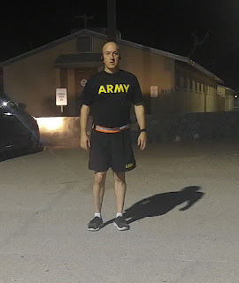

I forgot to share what happened on the night my Uncle Wayne arrived last week. We were all seated down for dinner and then all of a sudden, a black bird appeared out of nowhere and started flying in circles around the living room, adjacent to the dining room where we were. Startled, I said, "Hey! There's a bird in the house!" My mom leapt up from her chair and we quickly opened the front door and the sliding door that goes out to the back yard, in the hopes of the bird recognizing freedom and fresh air. As it just circled around and around FOREVER, my Uncle Wayne said, "I don't think that's a bird. I think that's a BAT." Oh. My. Gosh. A Bat?? In the house? What in the world? After what seemed like an eternity, but in actuality was probably about 2 full minutes, it finally flew out the front door and we shut all the doors muy rapido. Then came the discussion: A bat? Where did it come from? How did it get in the house? My mom had never seen a bat or known of any in the neighborhood before. But Uncle Wayne had talked about having bats up at his place in Brookings, Oregon. So we quietly drew our own conclusions that maybe the bat somehow hitched a ride down with Wayne's sleeping bag and other gear, and then had come into the house too. That was a story for the books for sure. And thankfully we didn't see any other bats. One was plenty.

As for cats, I can't believe I'm even writing about this, ha ha. Sorry for all you cat lovers out there, but I am not a cat person. I don't love them, I don't really like them, I am wary of them, and allergic to them, so I try to steer clear of them. But the other morning, I was the only one awake thus far and was getting my breakfast in the kitchen. In walks Taffy, my mom's cat, mewing insistently and loudly, over and over. At first I ignored her, but after repeated meows, I succombed to talking to a cat. I asked her, "What. What do you need." She meowed several more times, somewhat urgently. I knew she had food, and the other basics for a cat, so I had no idea what else to do. So I hesitantly reached down and I PETTED THE CAT. She instantly stopped meowing and switched over to contentedly purring. I petted her about twice before I stopped our "session". She moved closer to rub against my legs before peacefully walking away. And that's it. I talked to a cat. I petted a cat. And she liked it. Can't say I loved it, but I did marvel that my half-hearted two pets seemed to do the trick. Good. Because that's about all I could muster anyway. :)

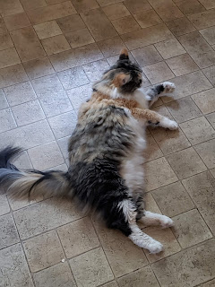

As for other news of the week:

I took my niece, Mari, to get her nails done for a birthday gift. She turned 24 on Thursday. I've never seen nails done in a salon before, so I sat close by and enjoyed watching them work on her nails. She chose an image on the internet prior to her appointment, and then they made it happen. Perhaps she's all ready for the Halloween season now. I'm not into Halloween either, but I do like spending time with family and I really enjoyed the outing with her that afternoon. We had a family birthday party for her as well. She is an amazing young lady that has overcome some huge obstacles in her life, including death of loved ones and subsequent drug addictions. She is much happier now (rehab has been amazing for her) and I am so happy for her.

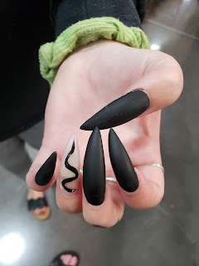

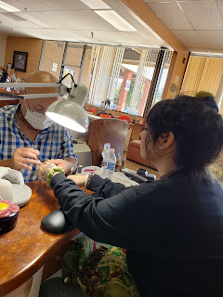

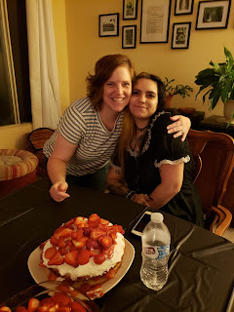
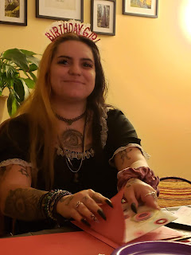

Still picking produce from the garden out here. We had outrageous temperatures on Tuesday and Wednesday - 102 and 104 degrees respectively. And even though it's taken a serious nosedive down to 64 today, along with some rain, we are still picking eggplant, lemon cucumbers and cherry tomatoes.

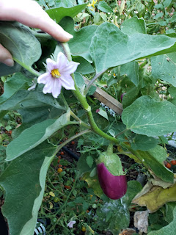

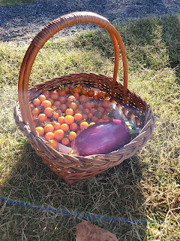

I took Grandma Doris to the physical therapist this week. She's getting some exercises to do in order to increase mobility in her hip following her surgery in July, but she's also got a cranky shoulder. So he gave her some exercises to do for that, too. I was excited to see them loan her some resistance bands, and joyfully told her how much fun we'll have doing similar exercises with our "stretchy bands" each day!

I know, I know. This blog is pretty boring. But my life isn't very exciting right now. Excitement comes in the form of my mother suggesting that next time we go into town, maybe I could pick up this or that at the store. I leap into action and come up with any justification to head into town ASAP. Just to do something. Anything. And I also do cleaning. If I'm bored, I'll sweep. Or mop. Or clean my bathroom. Or vacuum. Or wash the dishes. Etc.

I live to hear from my family on the phone, especially Scott each night. And I did hear from Benson the other day - which was AWESOME!! I've been trying to connect with him for about 3 weeks or more. He's working 12 hour days and is very tired when he gets home each evening. So to hear from him and that's he's doing well was very reassuring. He will be moving off the base soon into a house, because there's just not a lot of housing on the tiny base of Aviano. When I go visit him next spring, we are planning for me to just stay there with him - which will be so nice. It will save me a ton of money, so in exchange, I told him that any travels we do together will be on my tab. We are excited to visit Rome as one of our first stops.

Right now I'm dreaming about Europe and all the delights I'm sure to discover one day. I hope you have a dream on your horizon, too, and that perhaps you can facilitate that dream to come true.

Happy Sabbath Day everyone!

