The Ocean & San Francisco
This week has been more fun, with some nature outings and family time. This *should* be a shorter post tonight because I'm pretty beat from staying out too late last night, ha ha. (update: it's not shorter.)

Monday:
I took my niece, Mari, over to Fort Bragg and Mendocino on the coast. She needed a day in nature (as did I) to just see and hear the waves crashing repeatedly.

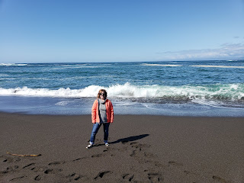

It is so relaxing to just stand there and be one with it all.

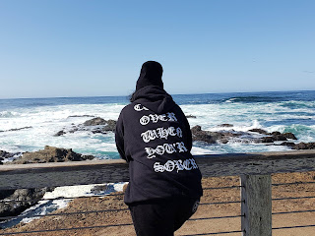

For more pictures and videos, click here:

https://photos.app.goo.gl/oyHzgqWxsKhgkUjAA

You'll see the eclectic brunch restaurant we chose, called Eggheads. I chose the Glinda Omelette with fresh crab in it, and it was amazing!! Everything in the restaurant, even the potty out back, was themed with Wizard of Oz decor. Our waiter, Alphonso, was so cheery and heartwarming as he served us. He would always chuckle, smile and then wink every time he came to check on us! The last couple of pictures were taken in Mendocino where we stopped at the Chocolate Company. This town was the setting for Cabot Cove with Angela Lansbury back when she starred in "Murder, She Wrote." Look closely at the names of the chocolates and you'll see one named after her.

Tuesday:
I got the best massage - even though she did a number on me. I even had some bruising on my right wrist for a few days! I told her to work on my carpal tunnel issues and boy, did she! Usually I don't get a "therapeutic" massage, but Shona decided I needed some work. I have felt much better. So there's that.

Wednesday:
My mom celebrated her 70th birthday!! She'd been under the weather for several days, and that day was sadly no better. When I asked her what type of cake she might like, she indicated she'd prefer a nice fruit pie - even blackberry! So I pounced on that and spent some time baking her a birthday pie - which turned out quite lovely!

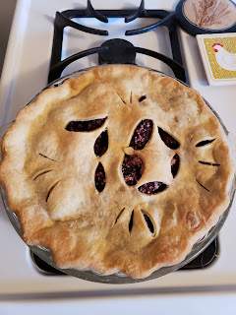

My favorite part was that as I was rolling out the top crust and free-handing the "70" for some slits in the dough, my son, Jacob, called. He was also baking in his kitchen back in Provo, Utah - for him, though, it was banana bread. So we talked and chatted away as we baked in separate kitchens. It felt like we were just side by side baking together and it was lovely.

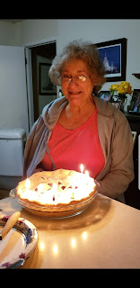

Friday:
A miracle happened. At dinnertime, it was my turn to bless the meal. As I prayed, I asked for my mother's health to improve. She had been sick with a cough and cold, as well as a horrible acid reflux issue that kept her up most of the night before her birthday and left a raw, miserable throat as a souvenir. She was living on cough drops and "Throat Coat" tea for 2 days, but wasn't improving at all. She mentioned that afternoon that the cough and misery felt like it was moving down into her chest. I was very concerned since I would be gone much of the day on Saturday, and then I would be out of town this whole next week. I asked Heavenly Father to heal her throat and bless her with better health so that she would be okay in my absence (remember she is still healing from her surgery and is also trying to care for 98 year old Grandma) and be able to fulfill the responsibilities that she longed to do. I was very specific, as I usually try to be.

Later, after dinner, as I was cleaning up the kitchen, all of a sudden I felt soft yet piercing words come into my mind: "Your request shall be granted." I stopped and immediately questioned where that came from. Right away, I knew it had to do with my mother and that Heavenly Father would bless her and heal her. As I pondered this briefly, a powerful reassurance flowed into my heart, letting me know that this was true and that yes, Mom would be taken care of. I immediately went in to share what happened with her, and as I recounted my experience, that same warmth and powerful spirit filled my entire being, making tears flow down my little cheeks. Within a couple of hours, my mom's entire demeanor improved. Instead of being in the lowest of lows, she was perking up and using less cough drops. She slept well through the night and now, two days later, she is almost 100% healthy again. She told me today, that to her, it felt like a miraculous healing - almost as if I had given her a priesthood blessing. Now that's something to reflect on.

The power of prayer is real. If we ask for something Heavenly Father has ready and waiting to give to us, then the gift is ours. The task is to ask for the right things. In this case, apparently I did. Wow. Just wow.

Skip to Saturday:
My sister, Charmaine and I drove her two daughters (Mari, 24 and Ana, 19) down to San Francisco for a music concert. (Marina and the Diamonds, in case you were wondering) I offered to accompany them down so that Charmaine didn't have to spend several hours by herself in the big city while waiting for the girls. We visited Chinatown, Coit Tower, and Little Italy. We put in several miles on foot last night, mostly uphill - with steep inclines of 45 degrees and on our way up to Coit Tower, Charmaine estimated it was probably a 60 degree incline at one point. Dang. We had a ton of fun, got fit and sweaty, and ate some delicious cardemom gelato in Little Italy. I fell into bed last night at 1:00 a.m.

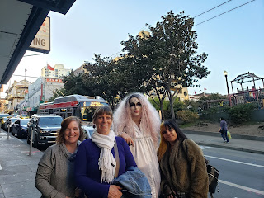

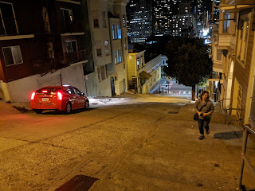

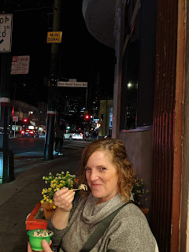

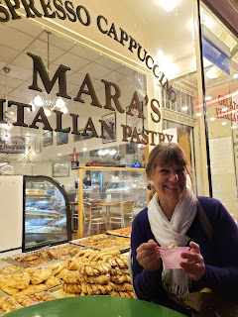

For more photos of San Francisco adventures, click here:

https://photos.app.goo.gl/GYagc2sg8EaqTnRv7

I was able to watch General Conference this weekend - all but the Women's Session, due to our trip down to San Fran. But I will get caught up real quick! I was very grateful for the spirit of the entire conference. I picked up on the need to focus on our Savior, Jesus Christ, and to make him our primary focus. I also heard several mentions of the phrase "personal holiness", and that as we increase in personal holiness, we qualify for and can receive greater and lasting happiness. This is something I am actively striving for while I'm serving my family out here in CA, so this was exactly what I needed to hear.

I'm off for some far away adventures this week - so stay tuned!!

