God Bless Our Troops
This week I was able to fly down to El Paso to visit my
best friend
in the whole world!! We just barely made these plans 2 weeks ago and what a blessing, what a privilege it was to go and spend precious time with him before he leaves the country!!

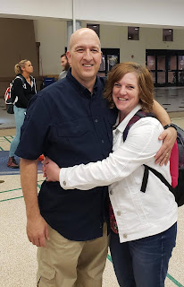

So
OFFICIALLY
I can tell you that Scott's assignment over in the Middle East is this:

He will be
advising
and
assisting
a foreign military. I'm not allowed to know where he will be, but he is confident that he will be safe. He is a targeting officer, so he will be giving them targeting advice. And he is SUPER excited about this! He will be part of 2 small teams that will be doing the same "advising and assisting" efforts. I'm just happy that he is so happy.

During our 3 days together this week, we were able to do some fun things in addition to just "vegging out" and getting caught up on our favorite shows. Some highlights were:

Tuesday
we went out to dinner with
Bob Hoffenbacker
(from Idaho Falls), who is currently doing a Tour of Duty down in El Paso. Bob has a "customer service" military assignment by working with the Wounded Warriors on Fort Bliss, making sure they are being taken good care of and getting what they need to not just survive, but to also thrive. Bob and Scott have been friends for over 20 years and have been deployed to Iraq twice together.

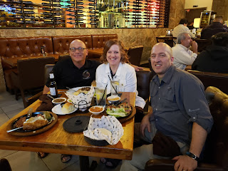

NOT
a coincidence, Bob came over to our house to visit Scott several months ago (April I think it was) when he came home briefly to visit family. He just "happened" to stop by because he wanted to share with Scott what he was doing down in El Paso and how great it was and to see if Scott might be interested in doing something similar. He told Scott how to check the military website for job listings throughout the world, and that many of the jobs would allow for me, his lovely wife, to accompany him.

Naturally we were very interested, and so the very next day Scott applied for a Tour of Duty. Within about a week, he hooked up with the North Carolina National Guard. There was excitement about the pay that was being offered, as well as the retirement benefits. It wasn't until a few days later that we learned that the NC Brigade would be heading overseas and that unfortunately I wouldn't be allowed to go with him. *Sigh*

Even though my heart aches because Scott is leaving the country soon, and we will be apart for the longest period of time in all of our 27 years of marriage, there have been so many blessings given to us with this employment opportunity. But all of these blessings began with the day that Bob came over to talk with us. So we are extremely grateful to him and were so happy to go out to dinner with him in El Paso!!

More about Scott:
He will be leaving the United States of America next Friday, October 18th to head to Kuwait. After getting set up there for a brief stint, he and those of his comrades that have this military assistance assignment will be flown to their new home for the next several months. He says that this will be the greatest thing he's ever done in the 33+ years of military service he's given to our country. We are blessed and honored beyond words, and we are humbly grateful.

Wednesday
, we did a little bit of shopping and took a lovely walk around the neighborhood where we were staying. This was our little AirBnB house.

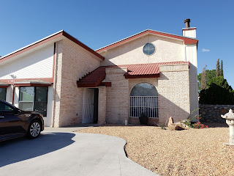

On our walk we enjoyed looking at all the Spanish style influences for the homes in the neighborhood. Here are a couple of pictures we took:

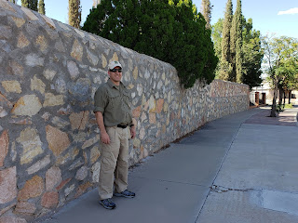





And my personal favorite: my short little friend - a cute Palm Tree that was just my size!!

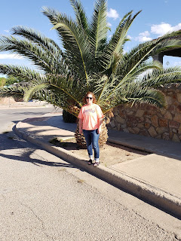

Here is a mature tree - with what looked like berries or grapes hanging from underneath the branches. But when we squeezed the "berries", it just felt like we were squeezing something slightly rubbery with nothing on the inside. Very strange.

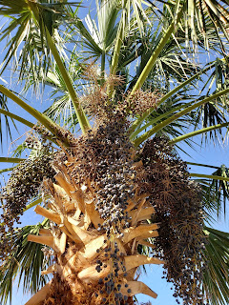

Wednesday night
, we went out to dinner with the 16 soldiers that Scott has been training with. We went to a tasty Mexican Restaurant (family owned for over 65 years).

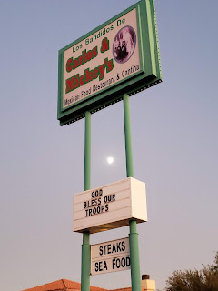

This was probably the highlight of the entire week for me - besides spending every minute with Scott of course! As we waited for our food (no small task for a table of 16 hungry men and one dainty lady), Scott suggested that I get up and visit around the long table to get to know the guys that he will be serving with. There are 2 groups of 8 soldiers, so he pointed out the other 7 that he will be serving with so that I could spend more of my time getting to know them. They are just the BEST!! I have a lot of love in my heart for them and I'm just so grateful that I could put names to faces, and get a feel for their personalities.

Here is a picture of the whole group of 16:

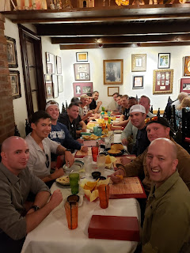

Now with me added in:

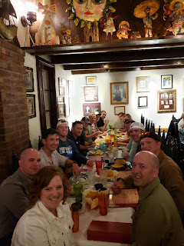

And after dinner, I got a couple of group photos with just the EIGHT that really mattered, ha ha.

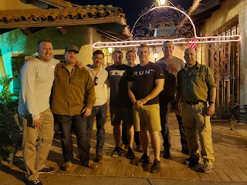

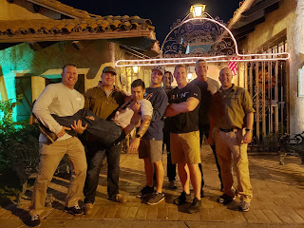

These are all boys from North Carolina, some having grown up out in "the sticks". Their professional jobs outside the military include: FBI agent, physical therapist, EMT, law enforcement, IT/computer guy, welder, and a recent college graduate who is also engaged. They are fun, funny, smart, caring, hard working, devoted, team players, and everyone gets along really well. They are such good guys. I made sure I hugged each one individually after dinner and told them "Thank you for your service".

Scott is the oldest at 50 years old. The next oldest is 39, and the rest are in their mid-30s except for the one that is engaged. He is 25 years old. They have dubbed me "Team Mom", and as such, I have already sent them some homemade cookies a couple weeks ago. During dinner, several guys were quick to politely request more cookie shipments once they get overseas. Scott said it would take about 4 weeks to get a package from the U.S., so the youngest soldier made a brilliant suggestion: use a Food Saver (to vacuum seal the cookies) so that they will still be fresh even after that long. Rest assured, I am looking into making this purchase very soon! :)

Thursday
, Scott and I went on a grand adventure over to the Carlsbad Caverns. It was about two and a half hours of driving each way, but it was worth it! It was a beautiful drive and we had fun singing and talking and even listening to conference talks.

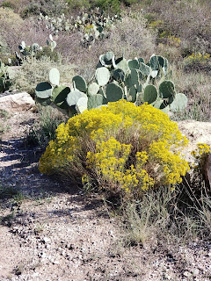

Here are a couple of photos from the Caverns: (I will include a link below to the whole week of photos and videos)

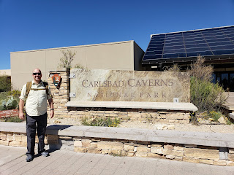

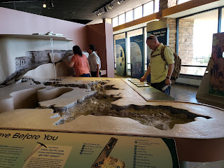

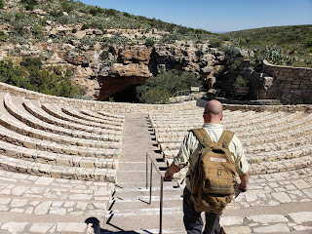

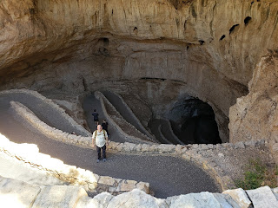

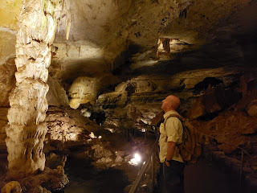



Once we got back to El Paso, we quickly picked up some Japanese takeout and drove up to Scenic Drive in the mountains above the city to watch the sunset together. It was super windy but gorgeous!! We got there with just about 10 minutes to spare. There were several other people that came up for the same reason, so we all just quietly and happily watched the sun go down and then the entire valley light up.
Click on my link below
and look for the video I took after it was dark where I'm just panning and panning forever across the valley. Amazingly, this is only about half of the city because of where we were on the mountain. In the not-too-far distance is Mexico's border and Ciudad Juarez.

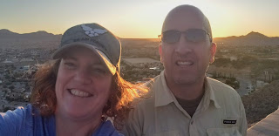




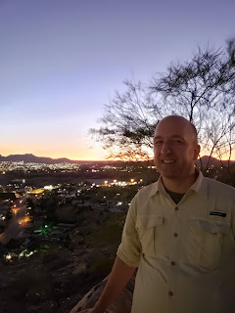

Overall, this week was very therapeutic for me. To be reunited with my sweetheart, even if only briefly, was wonderful. I tried to focus more on being in the present instead of worrying about the future. It helped. I loved being with someone who loves me unconditionally. I loved seeing how much he loves me in his eyes. I loved having a hand to hold. I loved laughing, talking, and just sitting close by each other without even talking. I loved every single minute.

Link to photos and videos:

https://photos.app.goo.gl/xgdBvgEHHSgqt8x17

Marriage is so many things. But one thing I want to share here is that marriage does not mean that one spouse should force their own expectations on the other person. When Scott went to Iraq the first time back in 2004, it was hard. But we did it! We thrived and we were blessed. We came back together after 18 months of being apart, yet stronger than ever. Some wives hated it the whole time. And when their husband returned, they informed him that he needed to exit his military service because they couldn't handle this ever again. They told their husbands to quit something they loved because it was too hard. I could never do that!! Scott is so good at what he does in the military. He is SO SMART. And the military needs intelligent and capable soldiers!! He is good at his job and he loves his job. So why would I want to tell him he can't do that?!? I would never. It's my job, my duty, and my privilege to allow him to thrive, to succeed, and to help our country be safer. No matter how hard it is. It's all worth it. And Heavenly Father is blessing us. Again.

