And The Middle East Begins
Scott made it safely to Kuwait yesterday.
He flew from El Paso to Maine, then on to Ireland, and eventually to Kuwait. Today he was able to attend church for the first time since he left home in August! He really enjoyed it, saying that there were 11 attendees in total. In his words, "I like how they did church. Imagine taking the 2 hour block and crunching it down to 1 hour." He explained that they had Sacrament meeting first, then had a group discussion on 2 general conference talks.

A little bit later, when I asked for a photo of him doing something in Kuwait so far, he immediately sent me a picture of him having dinner at the Chow Hall. :)

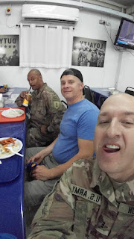

This week I could feel the anxiety creeping up mid-week as thoughts would pop into my mind about Scott leaving the country. I had to fight back the tears when it was T minus 3 days, T minus 2 days, etc. Thankfully, the greatest blessing and the greatest help came when my mother and I went to the Oakland Temple on Thursday. We each had a different purpose for going on that specific day, and we each had tender reassurances and a peaceful calm come over us by the time we left. (For my mom, it was Frank's birthday that day. He would have been 96.)

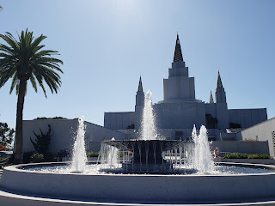

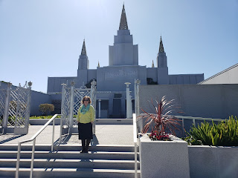

Taking turns posing - first me, then my mom. :)

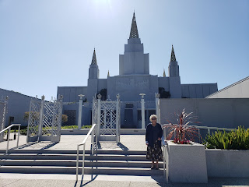

I had a special experience in the temple where some of Scott's ancestors let me know that they are watching over him and will be helping him as he serves overseas. It was probably the most special spiritual experience I have had to date. I have had several experiences over the years that have all helped to solidify my knowledge of the hereafter and what our purpose really is while we're here on the earth. I am so grateful for the Gospel of Jesus Christ, for His Atoning Sacrifice in my behalf, and for the Great Plan of Happiness to bring all of God's children back together again to joyfully live with our Heavenly Father and our Heavenly Mother.

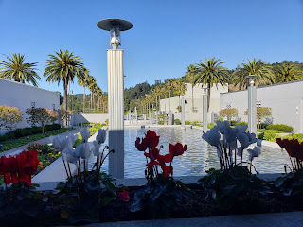

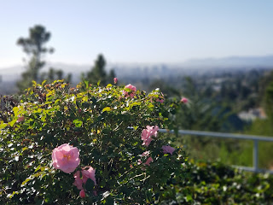
It was such a beautiful day overlooking the Bay Area - blue skies with a bit of a breeze. Definitely the highlight of the entire week.

Backtracking to Wednesday, I went up to Willits to help my Dad put up some doors in the house he is building for his step-son, Troy. We did more visiting than working this time, but that's okay with me! I enjoyed every minute of it. It's a great change of pace for me and I love learning new things. My Dad is so smart and so capable; it's an honor for me to be his humble assistant.

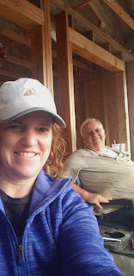

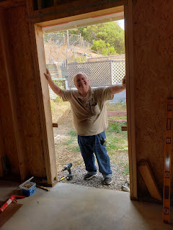

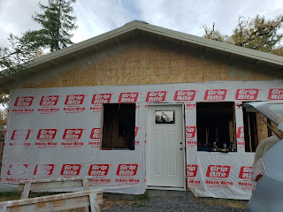

The rest of the week was a blur of hanging out with Mom and Grandma...

(Here Grandma Doris is holding one of the many orange cherry tomatoes that we are STILL picking!!)

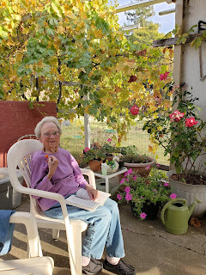

Grandma and Mom hanging out on the swing together...

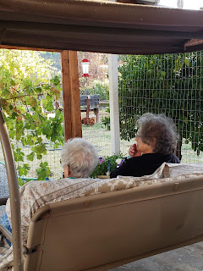

Picking pomegranates from the tree out back...

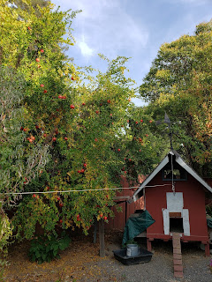

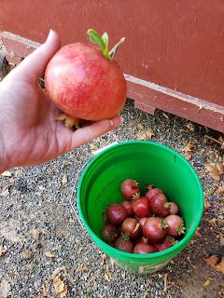

And I also talked Grandma Doris into taking a DNA test!! I'm so excited to see what results come back. I already posted this on Instagram, but her grandparents immigrated from Germany in 1880 to settle in Ohio. I'm planning to visit Germany in the spring as part of my adventures with Benson in Italy. Something I learned at the RootsTech Conference is that whatever your family history question is, find the oldest living relative on that line and have them DNA tested. Questions will be answered!! Clues and new information will be discovered!! I'm so excited!!

Here she is with her "live" spit ---

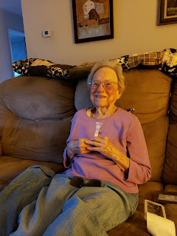

And I've sure been enjoying all the fall colors that are at their peak right now in Northern CA. (This vineyard is across the road from my mom's subdivision.)

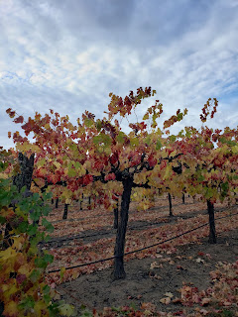

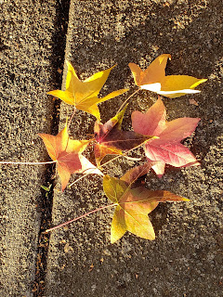

I also started on another quilt. It just wouldn't be Fall without making something beautiful with fabric. This one is a gift for a friend of the family. Chelsea, my daughter that I placed for adoption 30 years ago, received her special quilt last October for her birthday. But since then, her boyfriend Garrett has loved it so much that there's been a little bit of dissension in the home, ha ha. I offered to make him his own quilt to help keep the peace. I had to rearrange my little room so that I could have enough space to lay all the pieces. :)

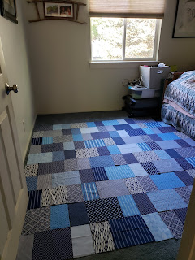

And one last thing:

My kids are all doing great in their corners of the world. Amber and Weston are happily and sleep-deprivedly plugging away through his Optometry School in San Antonio. I really enjoy when I call to talk to Amber, I always end up chatting away with 4 1/2 year old Abby. She can really hold a conversation now and she just cracks me up! Here's Abby and Gwen at the DoSeum (Children's Museum) in San Antonio:

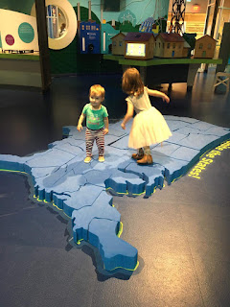

Jacob and Hannah are happily living in Provo, Utah going to school and working. They are so cute and in love that it just brings joy to my heart whenever I think of them. Here they are at a recent BYU game.

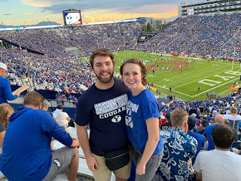

And Benson is doing wonderful things in the Air Force over in Aviano, Italy. He is making some big decisions about his future, both in a career path and some discussion of getting married. More on that later . . .

Here he is on top of the world. Or at least on top of the Dolomites (Italian Alps). He enjoys hiking, both with friends or by himself.

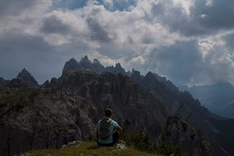

And here he is with some friends. (He's on the far left)

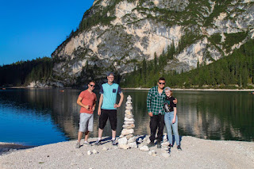
And he just sent this yesterday - he and some friends carved their pumpkins for Halloween. His is the 2nd from the right.

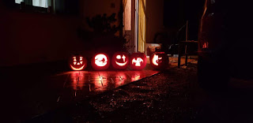

And that's it. Hope you're all having a great week. It's been a roller coaster week for me, but now it's over. And Scott made it. And now our 10 month countdown to seeing each other again begins.

