Enough With The Power Outages
Even though it's late in the season, fires still broke out all over California in the past couple of days. I've learned that the recipe for disaster begins with a forecast for extremely low humidity (like 4% or 10%) and a change from the norm in wind direction. If you add above-normal temperatures, such as the mid-90s that we've had the past few days, then that REALLY gets everyone on edge.

The Kincade Fire broke out about 30 minutes south of here on Wednesday night and quickly exploded to 10,000 acres by the next morning. My mom had an appointment in Santa Rosa on Thursday afternoon, so we ended up driving right past the fire area. It is located near Geyserville, CA - aptly named for the natural geysers that are nearby.

I took this photo looking south from the vineyard right behind my mother's house before we left for her appointment. You can see the smoke in the distance - that's from the Kincade Fire on Thursday.

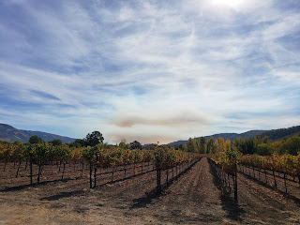

Then, on the drive home from Santa Rosa, I asked my mom to take some pictures since I was behind the wheel. She got a really good one here. Geyserville is such a cute little area - I always love driving past this section on the freeway because someone made all these cute little artistic creations for all to see. I know this picture is going to be tiny, but she even captured a helicopter with its water bucket above the smoke and fire area.

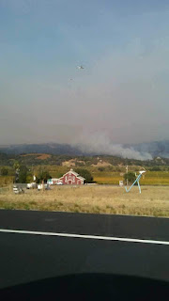

Also, PG&E, the major utility company for the entire state of CA, has been in hot water for several months, and is still making decisions that are frustrating to all the residents here. It was determined that the Paradise Fire up north that leveled an entire community last year was caused by something faulty with PG&E's line up there. So then they declared bankruptcy in January. And now, they're trying to be proactive by shutting off power to entire cities as a way to prevent being the ones to "cause" a fire. Every time there is something questionable in the weather forecast, they are planning to shut off the power. So everyone out here is outraged because we only get less than 24 hours notice of a mandatory power outage that will last approximately 48 hours or more if needed.

It pains me to think about the elderly who live alone, the families with very limited income, and a hundred other scenarios where this can be quite a hardship. Last time they shut the power off, I was in El Paso with Scott. My mom did pretty well holding down the fort with Grandma, but that is because she was prepared ahead of time with an expensive generator that can power the fridge, freezers, fans, etc. Not everyone can afford a $900 generator. A lot of people lost everything in their fridge and freezer.

And now today there is another mandatory power outage scheduled for sometime before this evening. It's supposed to last until Monday. Church has been canceled throughout the stake, and my mother already got a call last night to verify this. So we're just making small preparations and discussing meal options to get us through where we will only open the fridge minimally. Plus I'm strategically doing things early this morning like typing my weekend blog (you're welcome), washing a couple loads of laundry, and working on my quilt.

Here's a quick rundown on the rest of the week.

Monday, I took Grandma Doris to physical therapy. Kip, the PT assistant, was super nice and Grandma did a great job closing her eyes and trying to balance on a foam mat while he kept a close watch.

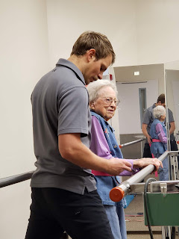

Tuesday, I went on an early morning walk and listened to several conference talks while enjoying the beautiful fall colors. Incidentally, the grapes that I photographed ended up being harvested later that SAME DAY! I caught them just in the nick of time!

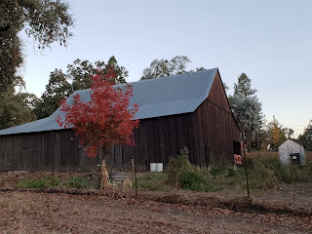

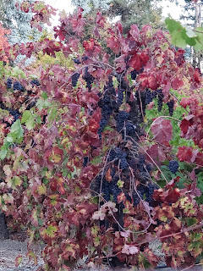





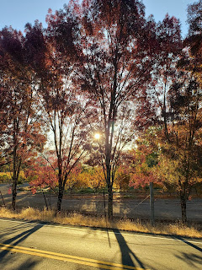

When I got back to my mom's house, I noticed this creepy site next door. Ugh. Halloween. I'm sorry that this "holiday" was ever created.

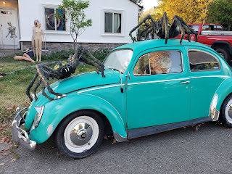

I've been talking to Scott every day - sometimes twice a day. Morning and night are the best times because he's 10 hours ahead of CA time. One of us is waking up while the other one is winding down and almost heading to bed, ha ha. When he did a video call with me a couple nights ago from Kuwait, I figured out how to do screenshots during our conversation. So that was fun. Here are a few pictures for your enjoyment. :)

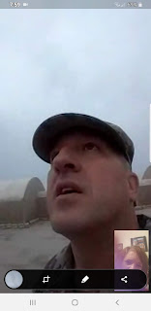



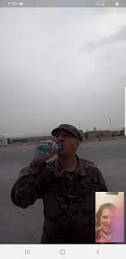

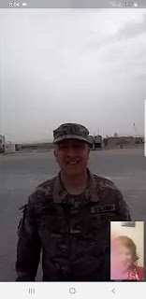

And then lastly, I went up to Willits yesterday and helped my Dad again on the house. This time my job was to put insulative (?) strips around all the windows and doors on the outside of the house. The next step is putting expanding foam around the windows & doors on the inside.

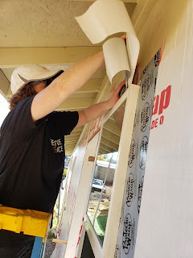

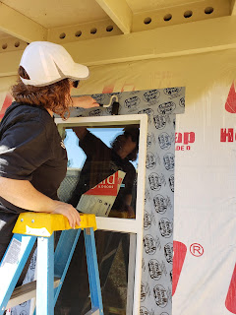

This one is my Dad sitting and very seriously contemplating a technical issue with the front door that we just put in. I love watching him figure things out and coming up with a brilliant solution! ha ha

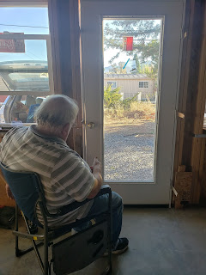

And as I left the job site yesterday, all was well.

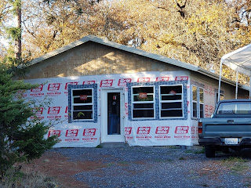

Well, since the power is due to go out sometime today, I'd better get cracking on my other tasks while I can! Hope you all have power, good food and good company for the weekend! XOXO

