Survival of the Fittest
After I wrote my post last Saturday, the power went out a few hours later. For
FIVE DAYS
. I've never been without power in my life for more than maybe 12 hours. As I said previously, this was a scheduled and mandatory power shutoff (PG&E refers to it as PSPS - Public Safety Power Shutoff) due to extreme weather conditions and a red flag warning for fires. It just so happened that after the first PSPS expired and could have been lifted, there was another high wind forecast for Tuesday night into Wednesday, so they just left everything off through Round 2. That's why it turned into 5 days straight, instead of shorter periods.

There was a brief scare on Sunday afternoon when my mother received a notification of an evacuation warning, due to a fire that popped up north of us near Potter Valley. (The Burris Fire) As we began sorting through her 72 hour kit and discussing which direction we would even go if we had to evacuate, I felt a little bit of panic. Just a little bit. We couldn't go south with the Kincade Fire, couldn't go NE due to the Burris Fire, so we figured we'd head for the coast and maybe north from there if needed. After helping to check through my mom's stuff, I spent some time organizing my own things so that if the order came to evacuate then I would be ready!!

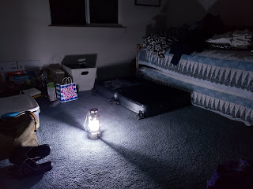

I called my mother in law, Coy, because I was unable to get ahold of Scott with my cellphone. (T-Mobile is extremely weak in this rural subdivision) As soon as I heard her voice, I choked up. Kind of like when I was young and had to call home from school because I was sick. Back then, as soon as my mother's voice said "Hello?", I would break down crying. Something about a mother's voice is so melty and reassuring. Anyway, when I called my mother-in-law I felt some of that same melty reassurance. :) I was able to get information to her about what was happening so that she could relay the info to Scott for me.

As it turned out
- and I didn't fully believe it at first because everything was just so chaotic that afternoon - the evacuation warning wasn't for US,
it was for my sister Charmaine and her family instead
! My mom is the homeowner for the house where Charmaine lives, so my mom got the warning as well as my sister.

Well, at least we were prepared
. "If ye are prepared, ye shall not fear."

During the power outage, we found ways to make do. We would make the most of daylight to get things done around the house or in the yard. (Yes, the tomatoes are still producing out here - it's been upper 70's during the day and upper 20's at night) My mother bought a generator during the summer because PG&E had predicted some shutoffs in the near future. She spent about $900 for hers. It's a good one for sure! It was able to power the fridge and a deep freezer, as well as the heat for Grandma's room to keep her warm in the wee hours of the morning and at bedtime. Grandma usually sleeps with her electric blanket to stay warm, but none of that was available,

We had to refill the propane tanks daily in order to have enough and to spare. Mom uses propane for the generator instead of gasoline because it burns cleaner and therefore is less hassle in the long run for her to use. I bought her a 3rd propane tank before the power went off, and what a blessing it turned out to be because one of the other two ended up with a faulty valve and we couldn't even use it. So we'd rotate between the two good ones.

By lamplight every evening, we would:

Cook our dinner & eat it
Clean up the kitchen & wash the dishes together
Play games, visit, or write letters
Try to go to bed earlier than usual, but didn't always work ha ha
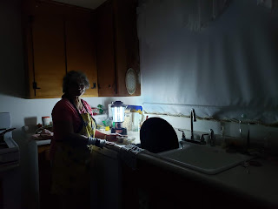

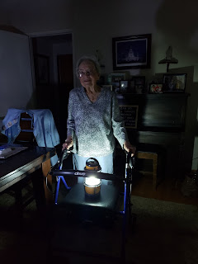

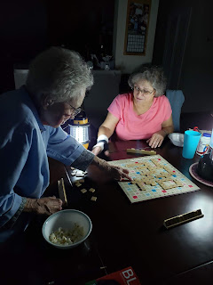



Charmaine and her girls came over one night and we played Candyland - BACKWARDS. (My favorite way to play it)

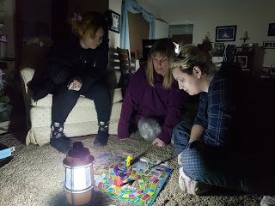

Some important things I learned during the power outage:

72 hour kits are important, with detailed inventory lists (my mother's collection is amazing!!)
Make sure your car has a full tank of gas in case you need to evacuate
Have plenty of cash on hand, especially with some small bills (when the power is out, no one can run your card for a purchase)
If you were not prepared with flashlights, lanterns or candles (and if the stores are all out), a great substitute is a strand of
battery-operated Christmas lights
. Grandma's caregiver, Jennifer, found that this worked wonderfully with her little family. It provided enough light so that they could even read at bedtime together. It would also make an awesome
nightlight
for children or elderly family members. Grandma Doris got SUPER disoriented on the 2nd night, even though she had a flashlight right next to her. I was up with her at 1:00, 3:30, 4:30, and at 5:30 I went in to find her on all fours on TOP of her bed, facing the wrong direction with her blankets in a tangled mess. She could not for the life of her figure out which way was up or down, left or right in her bed. The strand of lights would have been a good fix. Instead, we turned her lantern on low after that, using up expensive "D" batteries.
Have a crafty project to do - for me it was working on my quilt. But you could do something artsy or build something with your hands to keep busy.
Plan your meals carefully so the food doesn't go to waste or spoil. Thankfully the generator saved our food supply. But we were careful to plan simple meals, visualize where every item was in the fridge before opening the door, hurry and grab it all, then SHUT the door!!
Be polite in the stores or in town if you go for supplies. I stood in line for some butane at a local store one morning. Their generator was powering the cash registers up front, but the internet was still having issues processing purchases. A store worker came up to me and started chatting with me, asking how I was doing, etc. He apologized for the long wait and seemed worried that I was about to CRACK. I quickly told him, "I'm perfectly fine, I promise. I'm not cranky. I can wait." He was visibly reassured. Just be nice. Everyone is trying the best that they can. Some more than others, of course.
Be sure to thank all the workers in the stores that DO happen to be open. Here, in a town of about 16,000 people, the main stores that were open were: Costco, Walmart, and Safeway. Most places don't have a generator to be able to open to the public. Costco was kind enough to post signs leading up to the gas pumps that EVERYONE was welcome to fill up, member or not. And if I had to venture into Walmart or Safeway for some supplies, I was always sure to thank the clerk for BEING THERE and for helping all of us to get what we needed. They are exhausted too and I'm sure would much rather be at home with their families.
When the power did finally come back on (Wednesday), it was definitely a Hallelujah moment!! I am so grateful for basic electricity, for the internet, for a way to stay connected with family and the outside world. I am grateful for warm blankets, for my curling iron, for cozy lighting in the evenings. I'm grateful that we were safe during the fires and that we didn't have to evacuate. And I'm grateful for all that I learned during this power outage. I feel that I am changed.

Here's my quilt that I finished on the last day of the power outage:



Also, last Sunday prior to all the fuss over a possible evacuation, my mother plugged in her stereo to the extension cord going out to the generator and we had MUSIC!! It was so beautiful!! Church had been canceled throughout the entire stake, so to have sweet, beautiful music in the home . . . it brought tears to my eyes. Then my mom began to play the piano, accompanying the beautiful music on her CD. It was the absolute highlight of the entire day for me. And to see her be able to play with both hands was a happy moment, too, since this was the first time she'd tried to play after her surgery 2 months ago. Here is a photo, but click on the link below to see some sneaky videos that I took while she played and sang.

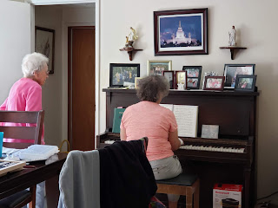

Link:

https://photos.app.goo.gl/z7RKy4MNLR3bPGaS8

I enjoyed some beautiful fall colors in the nearby vineyards on a walk with my sister, Charmaine, one afternoon during the power outage. Here are a couple pictures for your enjoyment.

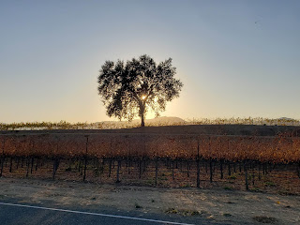

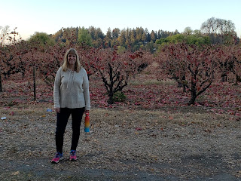

And the day after the power came back on, it was Halloween. Normally I can't stand that holiday. Well, let me rephrase that. I enjoy Halloween when it comes to little children because they're SO CUTE.
Especially my granddaughters
. But the older people get, the worse their costumes get. I don't enjoy creepy, gross or sleazy costumes. BUT, this Halloween was different for me. I took my niece, Mari, downtown that afternoon for some sushi, and there was quite a festival going on for all the trick-or-treaters. The sun was shining, it was pushing 80 degrees, and to see all the families out with their little ones and the joy on their faces was just so precious. I felt joy. I felt happy to be out and about with other joyful people. Here are a couple of my favorites.

Amelia Earhart:



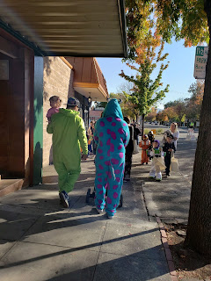

And a link to a short video I took of this guy:

https://photos.app.goo.gl/eLvRQddMMr8DBfACA

In other news,
while we were powerless in Northern CA,
Scott
was traveling from Kuwait to his country of destination. And a miracle occurred the night before he left. I was over at my sister's house, lamenting that I had no contact with Scott for a few days and I wondered how soon he might be leaving the safety of Kuwait. She popped to attention and said, "I have an idea!" She had a different cellphone provider and was able to use a mobile hotspot on her I-phone to create some internet for me. I was able to call Scott and talk to him on the phone! Not only that, but we were able to do a VIDEO call too! And as it turned out, it was his last day in Kuwait and he would be leaving sometime in the next 24 hours. What a special treat that was to talk to him before leaving into the UNKNOWN.

He made it by the way. He is settled in his new home. I got to talk to him on a video call yesterday and got a "private tour" of his surroundings, both inside the house and out. I even met one of their interpreters and had a very nice, but brief, conversation with him.



So far in the last couple of days when I ask him how his day went, he answers, "Wonderful!" So whatever he's doing, he is very happy. He's also learning some Arabic and shared some phrases with me this morning. I'm glad he is so happy. :)

Finally, today I went up to Willits again to help my Dad on the house. My task this time was to install light boxes on the trusses in all the rooms throughout the house. It wasn't difficult, but after hammering off and on during the day, my right forearm starting protesting, ha ha.

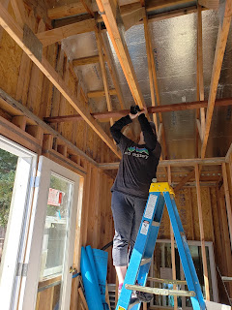

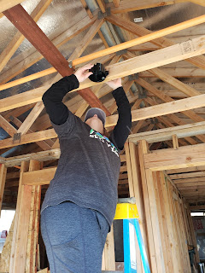

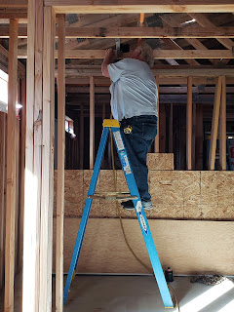

It was fun as usual, as we worked, rested, chatted, and worked some more. At one point I even worked in some family history to our day by having my Dad record a story on the Memories app (FamilySearch). We titled it, "The exploding paint can." It was a story about his friend back when they were 12, who rigged a homemade contraption using a paint can, spark plugs, and a train transformer for voltage. Nutshell summary: Big boom, 25 foot flames, nothing caught on fire, then repeat.

All is well out here. And thank goodness.

