Applesauce & Dirt Roads
This past week wasn't the most exciting week on record, but there were some fun field trips that took place.

Monday:
I took Grandma Doris over to Boonville (about 25 minutes over the mountain from my mom's house) so we could get some favorite apples at Gowan's Oak Tree. This place has been there for 3 generations and is just so charming. My Grandma Zoe's favorite apple was always their Sierra Beauty that became available in the late fall. Apparently she would always order a full box to be sent over to Ukiah each year so she didn't have to make the drive over the mountain. Incidentally, Grandma Zoe (my dad's mother) was also born in Boonville, so maybe she knew about the special apple her whole life. Not sure!

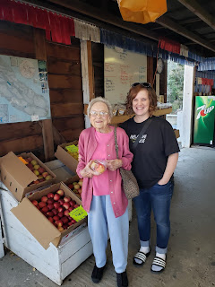

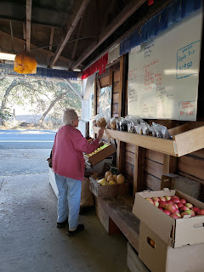

That's my box of Sierra Beauties on the lower right . . .

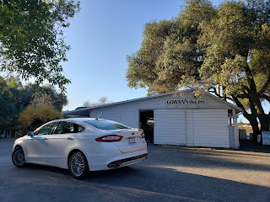

I bought 20 lbs of the Sierra Beauties and 10 lbs of a new kind I've never heard of before - called Newtown Pippen. It is amazing! Sierra Beauties are mostly red, with a little bit of green streaks, nice and tart as well as juicy. Newtown Pippens are mostly green, and kind of taste like if you married a Granny Smith with a Golden Delicious and they had a baby. More on the tart side though. So the 2 apples made for some DELICIOUS applesauce!!

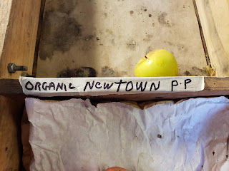

I emptied out the entire bin of Newtown Pippens - all except for this one. It didn't look as good, ha ha.

Tuesday:
I made 10 quarts of applesauce!! The house sure smelled amazing!!

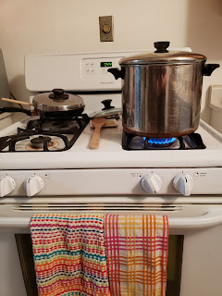

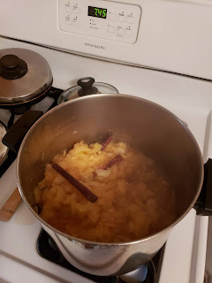

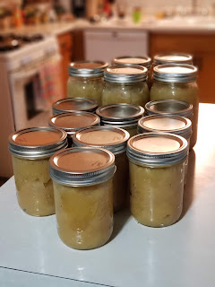

Wednesday:
I went up to Willits to help my Dad again. During one of our breaks, I mentioned how I had been reading his mother's journal the night before (Grandma Zoe). She had referred to an area called Hell's Delight Canyon - in between Redwood Valley and Potter Valley, where she lived for a time when she was 8 years old. I told him I would love to find that place sometime with him. He said, "Well why not today?" So we hustled to put up the trim around all the windows so we could go on an adventure!!

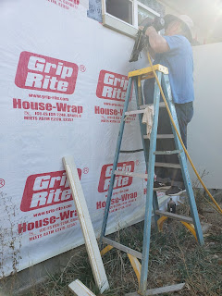

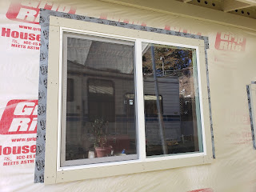

We went off-roading in the back (aka very redneck) country roads between Redwood Valley and Potter Valley. We're talking dirt roads only, with plenty of potholes and "Oh my, watch out for --" moments!! But my Dad did an excellent job in his little Prius and did not disappoint.

There were some amazing vistas out there.

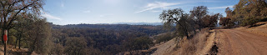

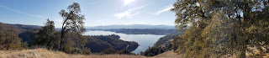
Lake Mendocino is what you see in the distance. It's a man-made lake, but before it was created, my Grandma Zoe walked through the hills and across part of the lake to get to school and back.

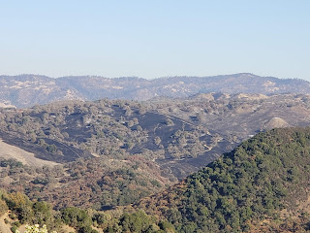

We saw the remnants of the Burris Fire from a week ago . . .

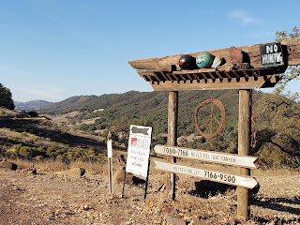

And then we found it! Hell's Delight Canyon to the left. Potter Valley to the right.

This is what Grandma Zoe wrote in her journal about how the area got its name. I cropped the page - but it's missing 2 words that were on the next page. " . . . her geese."

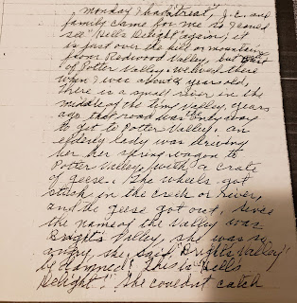

It says:
"Monday I had a treat, J.C. (my Dad, John Carlton) and family came for me so I could see "Hell's Delight" again; it is just over the hill or mountain from Redwood Valley, but west of Potter Valley. We lived there when I was about 8 years old. There is a small river in the middle of the tiny valley. Years ago that road was the only way to get to Potter Valley."

(Then, she tells the story of how it got its name)

"An elderly lady was driving her spring wagon to Potter Valley with a crate of geese. The wheels got stuck in the creek or river, and the geese got out. Since the name of the valley was Bright's Valley, she was so angry. She said, "Bright's Valley be damned! This is Hell's Delight!" She couldn't catch her geese."

Here is the infamous Hell's Delight Canyon:

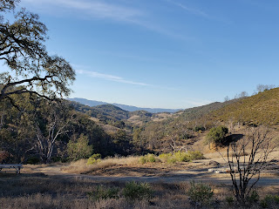

We aren't sure exactly where the old house was, but interestingly across the road from the canyon was the charred mountainside from the Burris Fire! I'm just surprised that people still live out here - it's so far away from civilization.

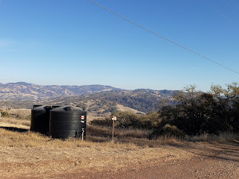

(Burris Fire remains off in the somewhat near distance)

And here's a map of where we drove - beginning at Road B in Redwood Valley and ending at Potter Valley.

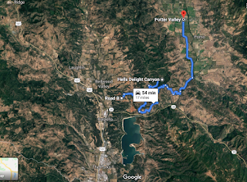

This is one of my very favorite things in the whole world to do. Learn about an ancestor or family member and then go visit a place associated with them. Take pictures, stand where they once stood, see it with my own eyes, breathe the air that is there, and just soak it all in. I'm looking forward to squeezing in more of these adventures here before I leave CA.

Thursday:
I worked on my Christmas project for my two little nephews up in Northern Idaho. I'm making them a race car playmat with an entire town. It will be named, "Sniderville", since that is our family surname and my nephews' last name. (Snider) I still have a ways to go, but it is definitely taking shape and keeps me busy when I need something to do with my hands.

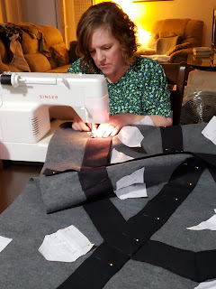

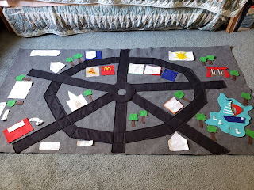

Friday:
Charmaine and I had lunch together out at Fetzer Vineyards where she works in the HR Department. It was a lovely view and a relaxing hour of time. Later that evening we also drove to Santa Rosa to get some fabric for some other Christmas projects. (Top Secret) We also had a fun video call with Chelsea as we drove, and got all caught up with her and Garret who is happily enjoying his new birthday quilt!

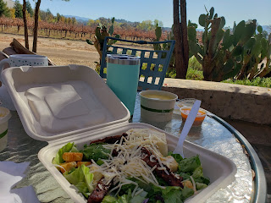

Saturday:
I worked on the car playmat most of the day, and then in the evening I went with Charmaine to a local concert - "Guitars for the Troops". With the money raised, they purchase guitars for local veterans among other services. (see below) I had the opportunity to wear my necklace with Scott's picture on it - even though it's old (from 2010). It's an oldie but goodie. :)

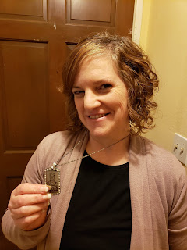

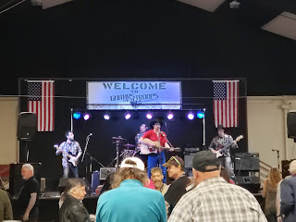

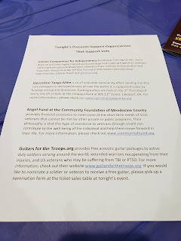

The music was really good - 3 bands in all: country/rock, a throwback to the 80's band, and a rock/blues band. For videos and a sneaky 5 second video of Charmaine dancing, click here:

https://photos.app.goo.gl/i2YmLrcQGHfCfsVq9

Not much to report about Scott this week.
But all is well there. I keep asking him for photos, but I think it's a little low on his list of priorities, ha ha. He did send me this one of his little bedroom area.

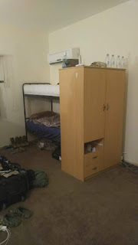

I sure love that guy though!
And Happy Veteran's Day to him, to my Dad, my brother Michael, my father-in-law and all the other veterans out there! I am so grateful for all of their selfless service to our country. Without them, we would be in a much larger pickle for sure! We owe so much to the service men and women past and present. THANK YOU!!!

I'm going to go eat some chocolate ice cream now and then go to bed. Two late nights in a row are two too many for this old grandma. Looking forward to a good week ahead!! XOXO

