Birthdays, Burnt Cheesecake, and Meeting Baby Jack
The highlight of this entire week was meeting Jack IN PERSON and holding him for the first time!! What a TREAT!!
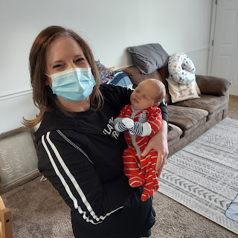

Scott and I drove down to Provo, Utah on Saturday morning, arriving just in time for lunch with Jake and Hannah and little Jack. He is the CUTEST and absolute SWEETEST little guy. I am completely in love! :)

Scott holding his little grandson for the first time

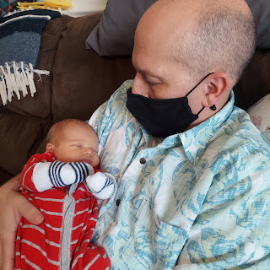

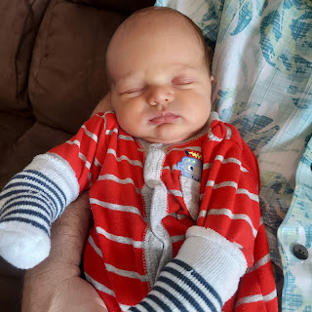

This is Jack pretty much 99% of the time. So chill. He likes to sleep in his bassinet on his back, with his arms up above his head, all sprawled out, ha ha. But he does like a good snuggle in the crook of your arm, too. And in case you're wondering why he always has socks on his hands, it's so he doesn't scratch his own face with those newborn dagger fingernails!

His newborn skin is shedding a little at a time and what you see on his cheek below is some of that. His new skin is so soft and perfect.

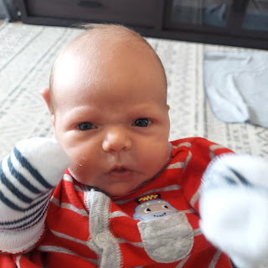

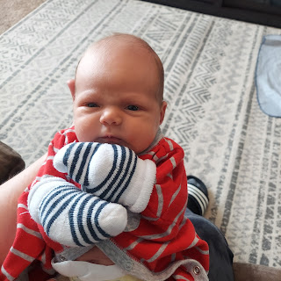

Hannah is working diligently to increase her milk supply and she is just about there! Jack eats around 3-4 oz. per feeding when they can measure it. When Hannah pumps, she is able to get about 3 oz., so that is exciting! She had quite a bit of trauma after Jack's delivery, when the Dr. tried to get her placenta out. So they think that's why she's been a little bit behind in the milk production line. But she's pretty much caught up now!

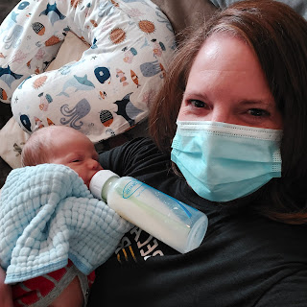

Sometimes she nurses him, but sometimes she pumps so she can measure what is happening. And that means Jacob, or myself, have the glorious pleasure of feeding him from a bottle.

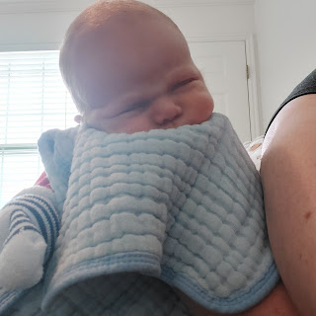

Once in a while, he opens up those peepers and stares into our soul.

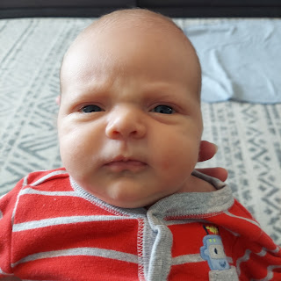

Not sure what he thought of me here. I hope it was all good . . .



We brought down a box of baby books that Amber was looking to hand off, instead of packing them up to haul to Louisiana. So Jake and Hannah sorted through the stash and picked out the ones they like.

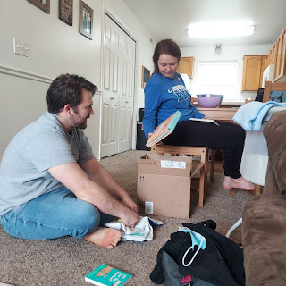

At one point, they put Jack on the floor for some "tummy time". They want his little neck to get strong you know. He didn't like it too much, though, because it was time to nurse. But they gently cheered him on for a couple minutes. "You're doing so great! Keep going!"

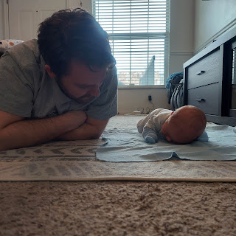

Yay - he was able to lift up his head pretty far a couple of times.

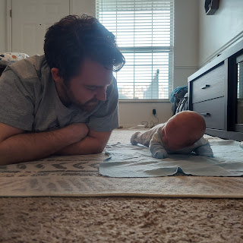

I was perfectly content to just hold Jack for hours, even if it meant I had to wear a mask -- and get warm and sweaty -- and my arm felt like it wanted to fall off. It was all worth it.

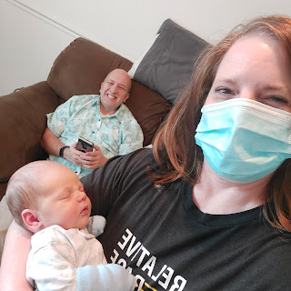

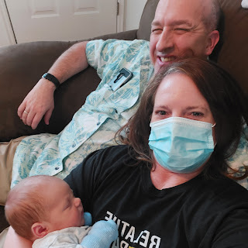

I finally got a couple pictures of Hannah and Jack. She is a wonderful mommy. :)

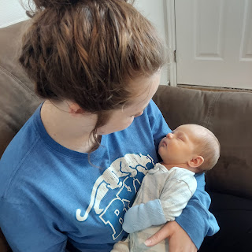

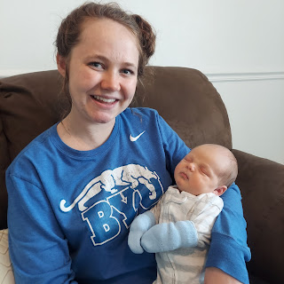

More time with Papi.

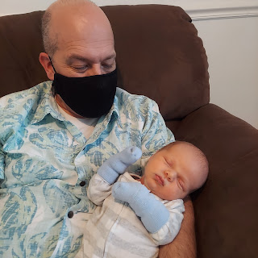

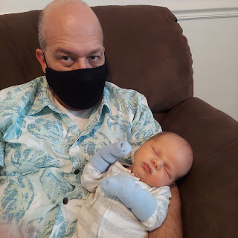

Jacob was Mr. Mom this past week, taking care of Jack from 7:30 a.m. to roughly 1:00 p.m. every day Monday-Friday. Hannah had some student teaching hours to take care of in order to graduate. Her supervisor at the middle school was the most lenient and merciful one of all, telling Hannah that she could come in late and also leave early if she wanted to. So she did just that. :)

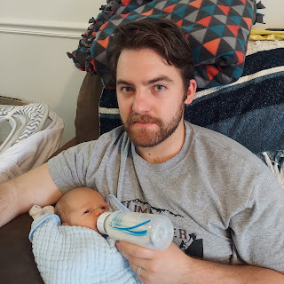

Jacob really bonded with little Jack though. He had a great system each day, noting on the white board what the feeding schedule would be. (roughly every 3 hours during the day, and closer to 4 hours at night - just depending on how Jack ate and felt). Jacob said that on Wednesday, when he was getting ready to take his last test before graduation, he found out the testing schedule had changed. It was an online test with a very clear start and end time. He had to hurry and feed Jack, and then set him up in the bassinet right next to the kitchen table where the laptop was ready for him to begin. And then, of course, Jack pooped. So he quickly stopped what he was doing to change the messy diaper and then hopped right back into taking the online test. All it took from that point on was to occasionally pop the binky back into Jack's mouth when it popped out. He was able to finish the test on time and he did great!

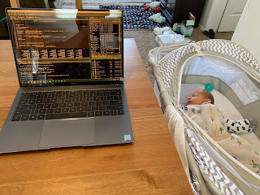

Jacob says that this is Jack's favorite burping position. Mostly upright, but leaning against whoever is doing the burping.

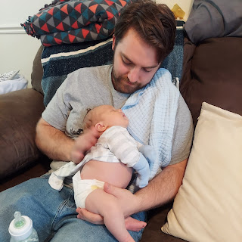

I think he just likes a comfy spot to sprawl out and go to sleep again, ha ha! (*Note: the reason why Jack is half-undressed or 100% undressed in most of his photos is because he is just so sleepy all the time and they need to do whatever is necessary to help him stay awake!)



They are certainly doing a great job as new parents!! I love their team work. Everything is a team effort. If it's time to change Jack's diaper, they are both there, working on it together. If it's feeding time, they are both getting things ready together. And I can't think of any other devoted dad out there that is doing half as great a job as Jake is. He loves his wife and baby so much, and it was so evident during our visit. While we are sad that they will be moving so far away in June, we know that they are doing a great job and we won't need to worry about them too much. They will be just fine.

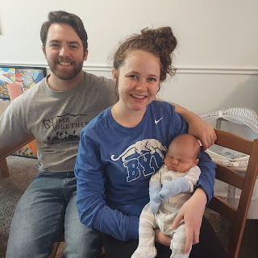

One last holding session before it was time to say good night at the end of the day. Until we meet again, my little Jack. I love you so much!!!

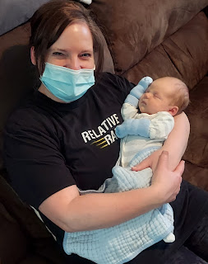

Backing up to the beginning of the week . . .

Monday:
We got a little spring snow storm. It didn't last very long, and it didn't even stick to the grass. It just looked like we were in an Idaho Snow Globe. :)

Click here to see: (11 seconds)
https://photos.app.goo.gl/Kmy9cjDuhWZrxfgf7

Amber also finished the dresser she was working on for the girls. She's not sure yet whose room it will go into, but she wants to makeover a second dresser for whoever doesn't get the first one. It turned out SO CUTE!!

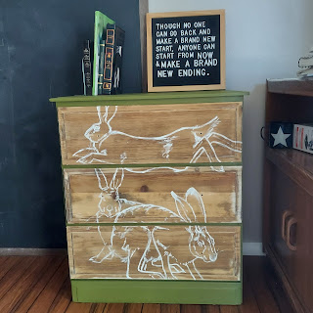

Tuesday:
We started the day with Abby joining me for exercises in my room. Seriously, this is one of the top 3 things that I will miss when they move away.



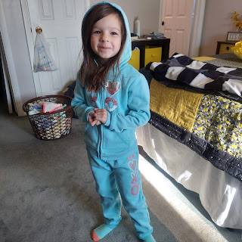

For lunch, we picked up Scott's favorite burrito for his BIRTHDAY!! We had a little picnic in his classroom, and even brought cookies to share with his next class. (He says that his 6th hour class is his favorite) 😊

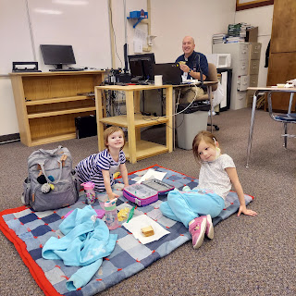

After we got home, I started to work on making his birthday dessert. Basque Burnt Cheesecake. It's the same cheesecake that Jacob made for Hannah's birthday last April, and Weston made it soon after for Amber's birthday last May. It is SO GOOD!!

Here is the recipe that Jacob gave me:
https://www.bonappetit.com/recipe/basque-burnt-cheesecake

After mixing all the ingredients, it goes into a springform pan lined with 2 sheets of parchment paper.

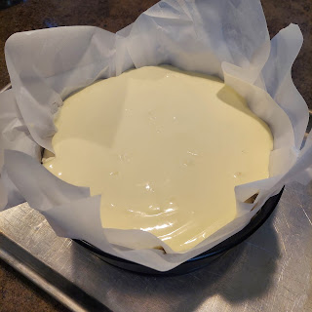



And comes out looking like this.



Nicely browned on top. Burnt. But not so much burned. If ya know what I mean.

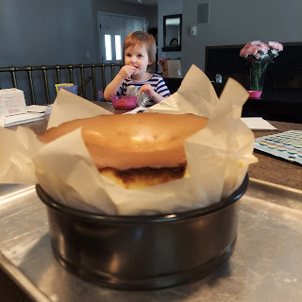

Due to all the goings on with packing and errands, etc., we decided to go out to dinner with Scott's parents instead of making dinner at our house. We opted to go to Sizzler, just down the road, so that there were options for all of us. Coy and I chose the all-you-can-eat salad bar. Scott selected steak and malibu chicken - a favorite of his, while Phil ordered shrimp. I was surprised that the salad bar was open, and even called ahead to double check if it would be! They said as long as we wore a mask each time we approached the salad bar area, then great. They also came behind the patrons OFTEN to change out all the serving tongs, and other utensils, wiping surfaces as they went. They did a great job trying to keep things sanitary. The food was great, but the company was even better!

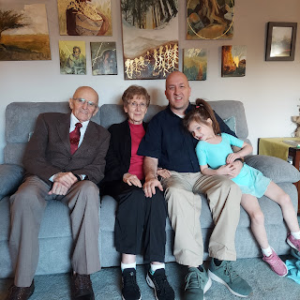

Amber took Abby to her weekly dance class, hauling Gwen with her so that the rest of us could go to Sizzler together. But we all met up afterward for that yummy cheesecake dessert. I sliced up some fresh strawberries and served each slice with some fresh blueberries as well. It was perfect!

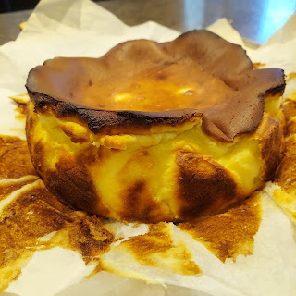

Except for when we tried to sing happy birthday to Scott, ha ha. I chose some random candles that we had from previous grandchildren's birthdays, grabbing a "5" and a "2" because Scott turned 52, and a few other filler candles. As I carried it into the living room from the kitchen, the candles were melting like crazy onto the cheesecake! I was like, "hurry up - we gotta sing!" at the same time that Scott had a sneezing fit, hahahaha.

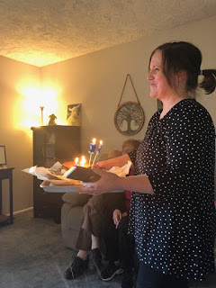

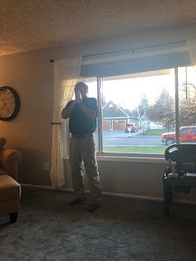

All was well in the end.

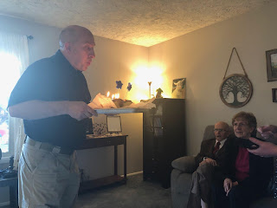

Wednesday:
This
. My new favorite picture of Jack. So much so, that it's now the new home screen on my cellphone. :) Feel free to come up with your version of what he's thinking about.

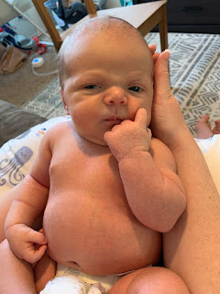

Thursday:
Scott's dad, Phil, went in to have a surgical procedure done: removing a squamous cell carcinoma from his cheekbone area on his left cheek. He forgot to ask Scott to give him a priesthood blessing when we saw them on Tuesday, and being anxious about the procedure, mentioned it when he arrived at the doctor's office. It turned out that the nurses helping him that morning were members of the church and were able to give him a priesthood blessing!

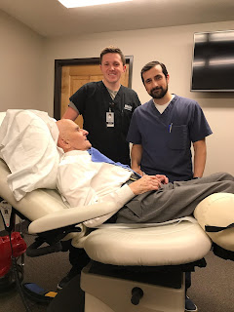

Everything went just fine, and the Dr. was able to remove all the cancer from the area successfully. He came home shortly thereafter, and once his anesthesia wore off, he was able to smile quite handsomely.

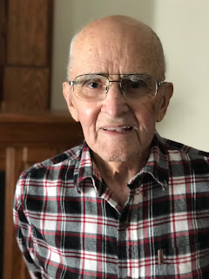

Friday:
Jacob shared a delightful video with us. It's sort of a montage of video clips that he put together of Jack, with all the sounds that he makes, ha ha. From the day he arrived, through the next 2 weeks of his little life thus far.

Click here to watch: (2 minutes, 35 seconds)
https://photos.app.goo.gl/pMJYSQ65rXN99pfT8

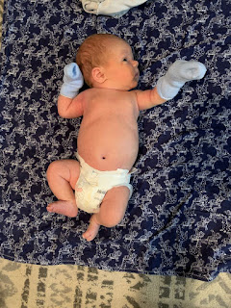

Also, in the middle of many days' worth of packing, Amber had the wisdom to just slow down and hop into bed with the girls to snuggle and spend a few minutes together. She has been put through the wringer for quite a while now, and it has been taking a toll on her. The day that she and Weston are finally together again will be a wonderful day, indeed.

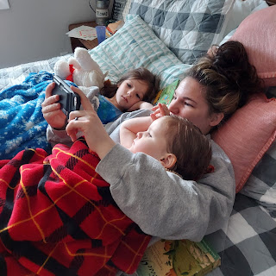

Also, Abby has been learning tutorials and practicing her chess skills lately. We played a game on Friday and I noticed that her grasp of the rules for each chess piece has really come a long way since our first game a week ago. While she did get down to just her king, her queen, and a pawn near the end, and soon it was just the king + a pawn, she learned a LOT! And she didn't melt into tears at any point either, as her pieces were taken out of play by the "ruthless" Mimi. I wasn't really ruthless, though. I made sure that as she moved her pieces, I would say things like:
Are you sure?
Who can come and capture your guy?
Where can your king safely move?
What's your goal again? (to capture my king)
Where can you move that will get you closer to my king?
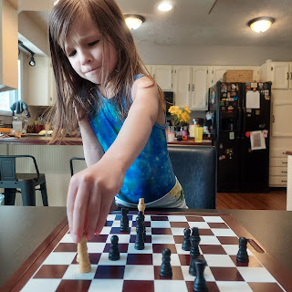

She was a really good sport! We were close to the end of the game when Amber and Gwen got home from a doctor's appointment. They joined us for a bit, watching every move closely.

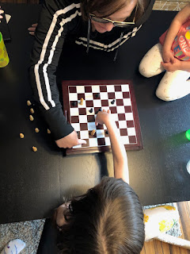

And then, within less than 5 minutes of this photo that Amber took, Gwen couldn't stand it any longer (the patiently watching part) and decided to take matters into her own hands. She suddenly swooped in, scattered all the last remaining pieces, and said crazily, "Now all the battle is KILLED!!" And that was the end of our game.

Abby, unfazed by her sister's precociousness, is trying to teach Gwen how to play chess. This afternoon, we stayed home from church and watched it on Zoom instead. (Gwen's had several days of diarrhea and we didn't want any accidents at church) During one of the talks, Abby (in whispers) was teaching Gwen what each piece can do. (Gwen had just gotten out of the bath after an accident, so was just wearing a pull-up and her bath towel, ha ha)

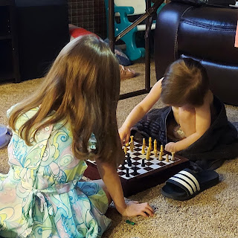

Saturday:
Besides our trip down south to meet Jack for the first time, it was also our youngest son, Benson's birthday. He is now 21 years old! He messaged us all the day before and shared something really special that happened to him in Greece at the end of his training there.

"Just got coined by a four star"

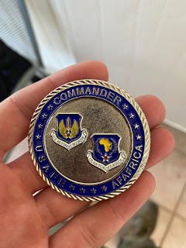

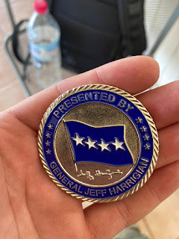

When pressed for more details, he added:

"Apparently I’ve been killing it this TDY and supervision selected me and 2 others from the whole 31 FW (fighter wing) that came to Greece to meet the USAFE Commander. We toured his private jet and chatted for a bit then I got coined.

"I’m one of few guys in the ACE force (agile combat expeditionary force) where we’re trained in all AFSC’s (Air Force Specialty Codes - aka job assignments) and I’m one of the only fully qualified guys. I’ve been helping the other shops a lot. Playing crew chief and launching my own jets, helping weapons load bombs, all while doing engine stuff."

So WOW! That's pretty awesome! We are so proud of him! Scott marveled at what a big deal that was to conversate with a 4-star general, get a special coin from him, AND tour his private jet!

Benson returned home Friday night to Italy and was able to spend the day with Kylie to celebrate his birthday. We spoke to him briefly on the phone while we were down at Jacob and Hannah's place, but with the time difference, they were heading off to bed and were super tired. I'm just glad he was home safe and sound and that Kylie doesn't have to be alone anymore. :)

And lastly, . . .
some additional photos and videos of Jack. Because he's that cute. And you're welcome.

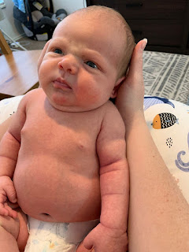

Jacob, ever so clever, found this photo of Jack below to "salute" Benson for earning the special coin :)

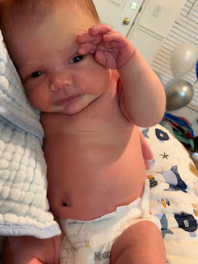

Video of Jack trying to eat his hands: (36 seconds)
https://photos.app.goo.gl/A57kQQCvDQDjhpeWA

Video of Jack drinking out of his bottle - best baby sounds ever: (25 seconds)
https://photos.app.goo.gl/zX3PAcMX6htvsqwj7

