Assalamualaikum!
I'll explain what Assalamualaikum means in a minute. :)
FIRST, I just want to say how happy I am that we got this picture of our Italian kids during the week!!


Benson got back from Greece just in time for his birthday last weekend, and even though he is back to work, they found some time to get away and do something fun together. XOXO

Kylie also got her first ultrasound on Thursday and met with an Italian doctor. They are having just ONE baby! There was some concern & excitement about the possibility of twins, since there are twins on both sides of Kylie's family. Thankfully - and I say thankfully because they are on the other side of the world - we are just having one healthy baby later this fall. Her due date is officially November 22.

Kylie shared with me that at the doctor's office, some of the people don't speak any English, but the doctors do pretty well! I think she has been worried about how it would all play out with a potential language barrier. I tried to reassure her early on that at least she has expertly trained doctors nearby, and a hospital to give birth in, unlike the olden days where they didn't have those kinds of luxuries. But we are grateful that they can, in fact, communicate! I can't even imagine being on the other side of the world, away from family, and having my first baby in a foreign country! Bless her little heart. 💗

As for the rest of the week . . .

Monday:
U-Haul arrived early in the morning to drop off Amber's two shipping containers. Cecilia, the driver, arrived with a flatbed semi truck across the street.

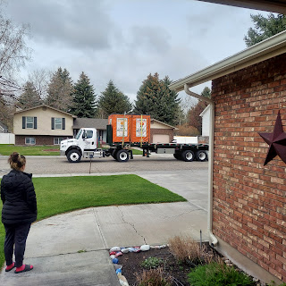

After unloading the forklift, she brought over one container at a time to park them on our driveway.

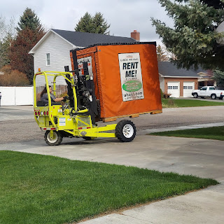

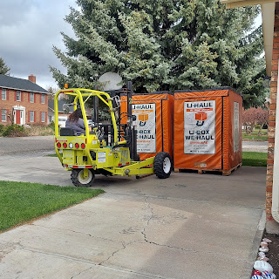

Cecilia was an amazing and adept driver of that 3-wheeled forklift! I took a little video before she loaded it back up onto the truck, just to capture a tiny morsel of the fun she had while driving that thing! ha ha

Video of Cecilia - check out the last few seconds especially: (39 seconds)
https://photos.app.goo.gl/XPUqB5JpYhnRbjuo9

After she left, we opened them up just to see the insides. They were surprisingly roomy!

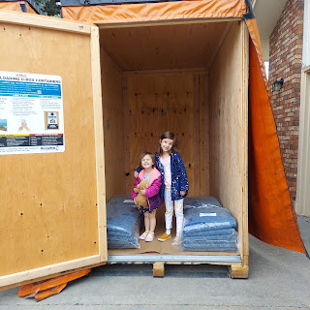

Also, for our daily photo allotment, we got this cute picture of Jack meeting his cousin for the first time. His little cousin (I don't know his name!) was born last fall to Hannah's sister, Megan.

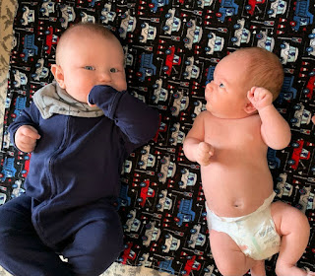

Tuesday:
I took the girls on a shopping adventure at the Army Surplus Warehouse just south of Idaho Falls. It's a huge store and you could literally wander around for hours if you wanted to. I figured that it would give us an opportunity to kill some time and also have some fun at the same time! In addition, it would give Amber some peace and quiet to do some packing and organizing back at the house.

We saw an old Army jeep.

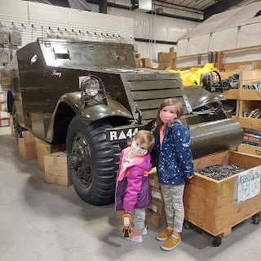

We hung out NUMEROUS times in this canvas Army tent, decked out with a cot, camp chairs, a cooking stove, and various animal pelts. Gwen also found a cool flashlight that she could not part with.

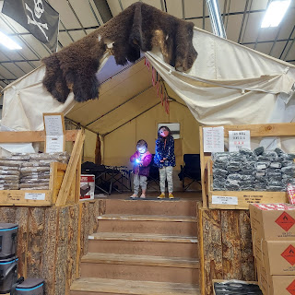

Abby and Gwen found some interesting places to rest.

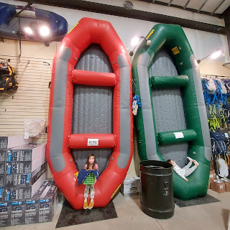

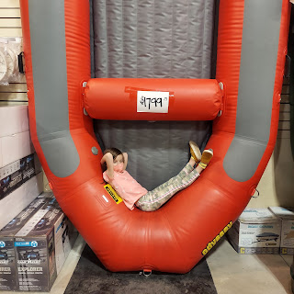

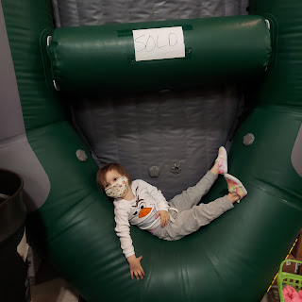

At one point, the girls saw some cute and smallish shopping baskets. Gwen said emphatically, "I got ALL my stuff to buy!!" And then she'd march off down an aisle.

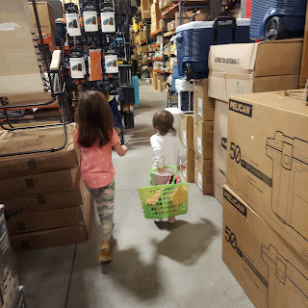

Near the end of our mini shopping spree, Gwen found this cute little baby deer. She REALLY wanted me to buy it for her. I told her we couldn't because we already packed up all their stuffed animals and we just didn't have room for any more. Surprisingly, she was willing to just hug it and then put it back.

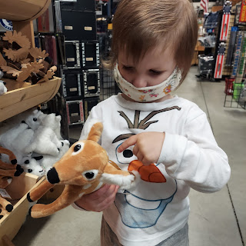

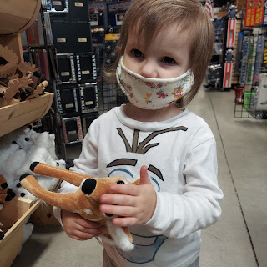

All in all, we purchased two 9-feet lengths of colorful paracord that the girls picked out and I cut for them, two pocket-sized flashlights, a cool but random metal circular ring, 2 polished bright pink rocks, and a small red cup that goes into a camping mess kit. Total price? $9.00. A little over an hour of fun with the girls? Priceless.

I took them to McDonald's to pick up happy meals and then we headed home. It was really fun!!

Tuesday evening, Weston's dad, Mike, and his brother, Caleb, came over to help Scott and Amber pack up the storage containers. They made several truckloads back and forth to the storage unit to clear it out, as well as load up all the boxes that Amber had packed up inside the house.

They made use of every possible inch of space when packing the containers. Like in this dollhouse, for example.

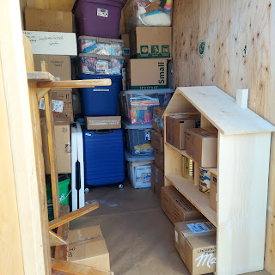

Wednesday:
Got a couple of sweet photos of Jack and his beautiful momma.

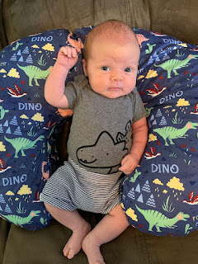

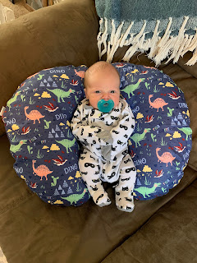

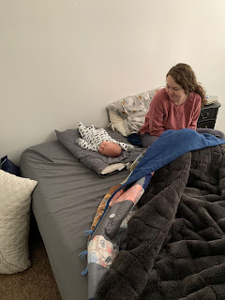

And we did more packing that evening. (By "we", I mean Amber) Here, Scott is helping Amber to gage what might fit in the LAST bit of space. The container on the right was already full to the brim and was all closed up.

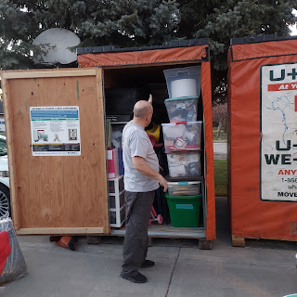

Thursday:
Amber shoved any and all last minute things into the second container before Cecilia came to pick them all up. At one point, I found a short piece of scrap wood in our garage so that Amber could use it to shove things further back. There was quite a bit of wasted space up on top of everything. We used it to our advantage by shoving vacuum-sealed space bags of clothes, bedding, etc. as far back as we could.

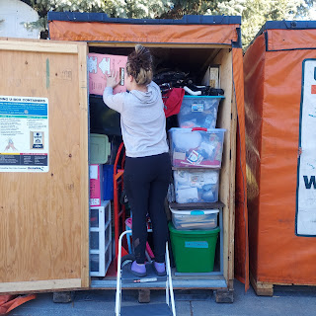

While I didn't do a whole lot of actual packing, I helped to gather items from peripheral places around the house to box up. (i.e. office closet, kitchen drawers & cupboards, the girls' room, etc.) Amber did the bulk of the boxing up herself while I did my best to help with the girls.

Finally, Cecilia arrived to pick everything up.

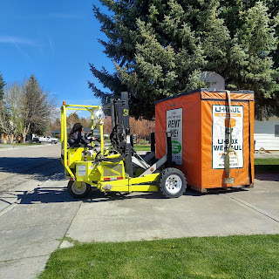

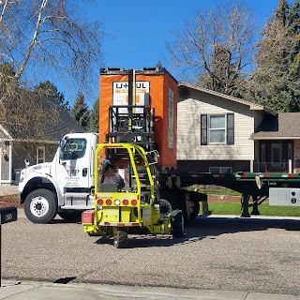

I chatted with her for a little bit, and to my amazement I noticed her long nails!! I asked her if she had ever broken them in this line of work. Shockingly, the answer was NO!! She is even more amazing now in my opinion.

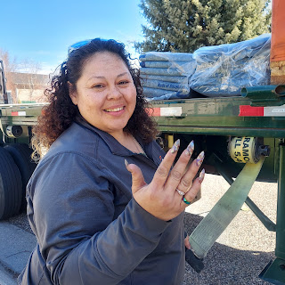

Thursday was also my dear friend and neighbor Kim's birthday. She always loves it when I bake her something, claiming that she is horrible at baking things. I'm sure she is not as horrible as she thinks she is, but I happily baked her a loaf of chocolate zucchini bread. We took it over in the afternoon, while it was still warm from the oven, and sang her happy birthday. Notice her birthday crown that she was already wearing, ha ha.

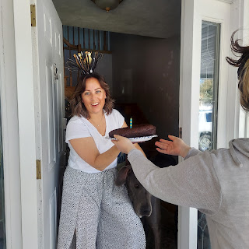

It took a little bit of convincing, especially for Gwen, to come over and pet their giant moose, Cleo.

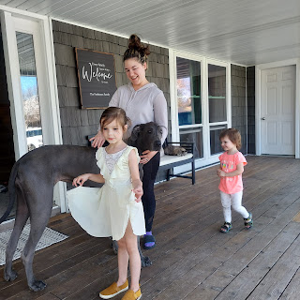

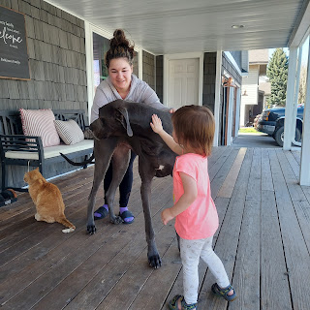

Cleo, a Great Dane, is actually very well-mannered. Her size is quite intimidating though. :)

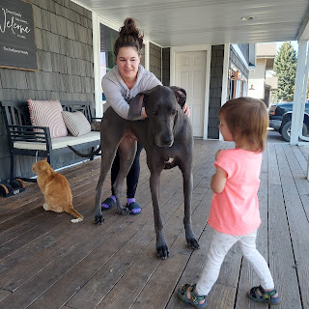

As we crossed back over to our house, I noticed the beautiful contrast of the brilliant blue skies with our apricot trees that were bursting with blossoms!

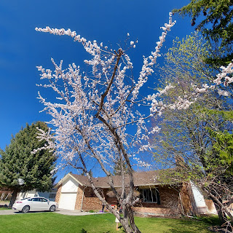





Scott sneered in jest yesterday, "I hope a good freeze comes and then we won't have any apricots to pick this summer!" While it is a chore to take care of the apricots, I do recognize the blessing of having fresh fruit on our property. Over the years we have planted strawberries, raspberries, a peach tree, an apple tree, a cherry bush, and 2 apricot trees. If push comes to shove and we have to live off our land someday, I do NOT want a freeze to come and kill the potential fruit!!

Friday:
We prepped and served up an Egyptian Ancestor Night! It's so strange to me, but I have 0.8% of Coptic Egyptian DNA. Coptic Egyptian just means Coptic Christian, which is an "ethnoreligious group indigenous to North Africa who primarily inhabit the area of modern Egypt. Most ethnic Copts are Coptic Orthodox Christians. These are the largest Christian denomination in the country and in the Middle East." Copt = Christian. (source = Wikipedia) I just have no idea where this DNA came from on my family tree! I don't know anyone from that area at all! Some day I will figure it all out . . .

Assalamualaikum = Peace be unto you

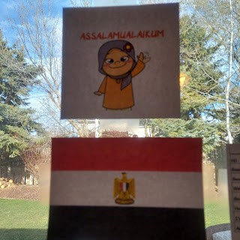

I found some basic Arabic phrases to share, and Scott shared some of his expertise in speaking Arabic as well, from his service in Saudi Arabia last year.

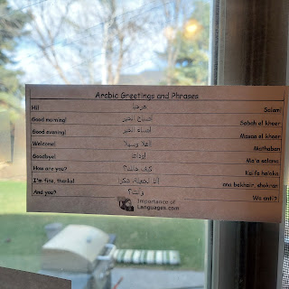

The girls helped me color some pages for our "decorations"

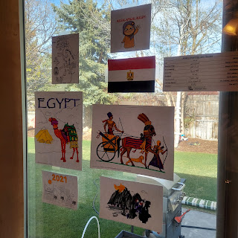

Assan and Marissa came with their daughter, Azure. We hadn't seen them in quite a while! It was so nice to spend a little time with them again. Assan loves Shawarma Chicken - he told me it's one of his favorite things to eat! So he jumped right in to help cut up the chicken after Amber's wrists were getting tired.

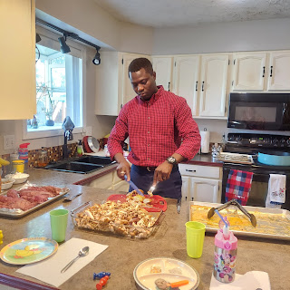

Table all set and ready

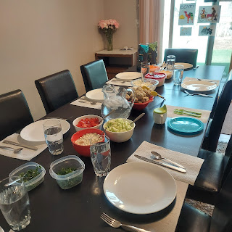

My plate:
Falafel (the little balls - made of fava beans, parsley, red onion, garlic, and other herbs and spices all ground up and then rolled in toasted sesame seeds and fried in oil), pita chips and hummus, and the chicken shawarma is more like a salad shown here. You can also wrap up the fixings in a tortilla or serve over rice. I just had chicken, cucumbers, tomatoes, feta cheese, herbs, and tzatziki sauce.

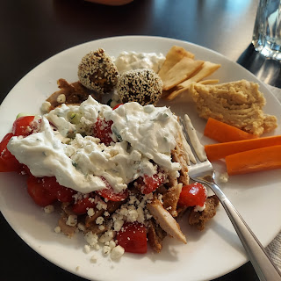

Here are the recipes that I used:

Ta'ameya (Falafel)
https://www.allrecipes.com/recipe/254743/taameya-egyptian-falafel/#

Chicken Shawarma
(Amber had made this recipe back in February so we chose to do it again)
(This is just for the marinade. Basically you cook the skinless, boneless chicken thighs for about 45 minutes at 425 degrees, then you can either shred it and broil it for a couple minutes to crisp it up, or just slice it up and serve it. We chose to slice it up and serve it this time.)
https://hungryhobby.net/chicken-shawarma-marinade/?utm_source=pinterest&utm_medium=social&utm_campaign=social-pug
(**Sorry - it wouldn't let me set it to open up in a new tab. I tried.)

I used this page to get ideas - including the baked sweet potatoes for dessert - a locally common thing:
https://www.cleopatraegypttours.com/travel-guide/egyptian-culture/top-10-egyptian-food/

After dinner, we went out back to visit for a bit. The weather was so nice! It was almost 80 degrees that day!!

Here is Azure running all around having the time of her life with a little grocery cart.

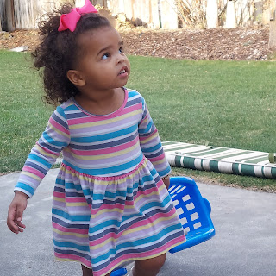

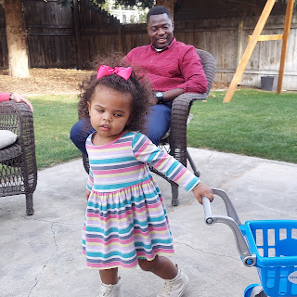

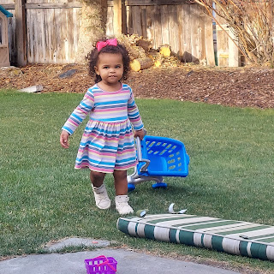

Scott's mom snuck a picture of Scott and me relaxing after dinner.

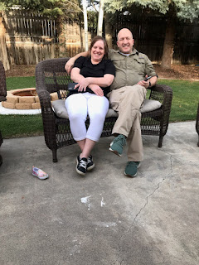

I put together my first video montage, using a new app. It's longer than I would have liked (2 min, 20 seconds), but I will figure out how to slim it all down for next month's Ancestor Night.

Click here to watch:
https://photos.app.goo.gl/7LTitvKRKADnsLLJA

It was fun to have everyone there. We had the 5 of us (Scott, me, Amber, Abby & Gwen), plus Coy and Phil, along with Assan, Marissa and Azure. The food was great. The company was great. :)

Saturday:
I was babying the heel of my foot most of the day. I let my heel get a little too cracked from going barefoot and wearing sandals all last week. It was in pretty bad shape after standing in the kitchen all afternoon on Friday, so it felt best to just do some misc. work on my computer while sitting down. I've been putting some powerful ointment on my heel for the past 3 days and today (Sunday) it is finally feeling a little better.

I had a church leadership training meeting Saturday afternoon - for almost 3 hours. But I'll tell you what, it was the BEST long meeting I've ever been to! It was online, which was super convenient for me.

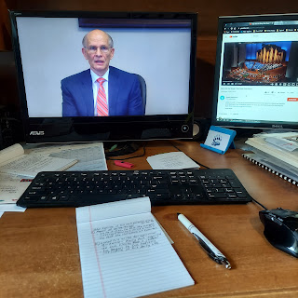

The 5 presenters were Elder Renlund and his wife, Elder Eyring (president of BYU-Idaho) and his wife, and the Area 70 Elder Gifford Nielsen. The first half of the meeting they did some role playing and then asked for feedback and discussion. The second half was them answering questions that had been submitted by the 800+ participants. Obviously they couldn't answer all of the questions, but they spent about 90 minutes doing their best.

I learned so much!! I felt the spirit very strongly numerous times as I listened and learned. Here are a few snippets of what I wrote in my notes:
Our prophet, President Russell M. Nelson's mindset is this: his primary audience is literally the Lord Jesus Christ. And yet he (our prophet) serves all of us as members of Christ's global church at the same time. With the pandemic putting our "normal lives" on hold, he is in anguish over our happiness and welfare. Elder Gifford Nielsen repeated more than once that Pres. Nelson doesn't want us (as members of The Church of Jesus Christ of Latter-day Saints) to "besmirch the reputation of the church" by refusing to wear masks. He wants us to follow the laws of the land and local regulations cheerfully and set a good example within our communities. As we obey the local regulations, then progress will come faster - meaning temples re-opening, church services going back to normal, etc.
When Elder and Sister Renlund were living in Baltimore, MD early in their marriage, he was serving as the bishop and was also in medical school at the same time. Sister Renlund decided she wanted to go to law school.
And
they had a 3 year old. Life was hectic and therefore time as a family was minimal and sporadic at best. So they invented a Time Budget. Just like a financial budget, they discussed what is a reasonable amount of time for each category of their life. And then they set up a schedule with time frames. It created a sense of continuity and consistency for the family, along with a trust that they would be home by a certain time. Their 3 year old daughter would ask on Tuesday nights, "Is Dad bishoping tonight?" Yes, he was. So Sister Renlund would sit down with her to figure out what they could plan to do as a family on Friday night during family time.
From Elder Gifford Nielsen: We aren't expected to work harder. Just more inspired.
Elder Eyring shared of a time when he had a personal crisis of faith years ago. He felt a darkness in his life for a time. He decided to do some repenting. As he did so, he felt the weight lifting from his mind and his heart and he felt the influence of heaven in his life. He also felt inspired to ask his wife, Kelly, for spiritual guidance. She felt inspired to ask him to start keeping a journal. He did so, and began to see heaven's influence and God's hand in his life as he recorded daily happenings.
The whole meeting felt like an intimate "sit down" in our living room. It felt like they were talking to me directly and teaching me through their experiences and examples. It was very powerful.
And to end the night, Jacob shared this handsome picture of Jack. I just love him so much!!

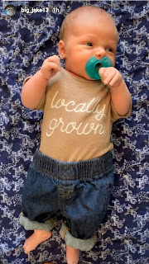

And finally, a photo and video of Jack so you will have happy dreams tonight.

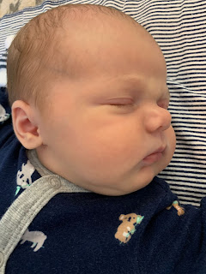

Video of Jack: (41 seconds)
https://photos.app.goo.gl/V8vUUD2VKDyaL1Gu6

