Trying to Find a New Normal
Very first thing:
a handsome picture of little Jack. He is just so darn cute!
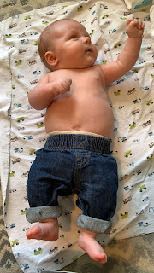

This week has been a blur of chores and activities, cleaning and errands. And not a lot of photos to include this time, which can be a good thing I suppose.
I've been adjusting to the quietness and emptiness of our house, now that Amber and the girls have moved out. I am enjoying the solitude where I can think my own thoughts and get a lot more things accomplished each day, and the house stays clean, too! ha ha But I also miss giggling granddaughters and their sense of adventure. Most of all, I miss Amber. She is my dear friend and confidante.
But - life must go on. And on it shall go! I am facing forward, with great eagerness to spend more time with my dear husband. Every day is a date, we tell ourselves. It doesn't matter if we go to the grocery store, go for a walk, or just stay home and eat grilled cheese sandwiches for dinner while we watch a show. It's all time well spent together. :)
Monday:
First thing in the morning, I hit the ground running to clean up and organize the downstairs after all the kids left. Things got a little crazy in those last couple of days before hitting the open road, and we just had to walk away (or drive away), knowing that it wasn't perfect.
I cleaned up the girls' room first, and then I tackled Amber's room. I've been washing bedding all week long, and have finally gotten all the rooms put back in order (including the guest room upstairs).
I chatted with Kylie as well, and we were able to buy her airline ticket for September so we could be sure to be on the same flight and sitting right next to each other! It was a fantastic sale that I saw in my inbox (I subscribe to Pomelo Travel - best $35 per year I've ever spent!), so we jumped on the computers at the same time on opposite sides of the world. She is still figuring out when she's flying over here to the U.S. because it's all dependent on Benson's schedule for his training in Utah and Nevada later this summer. So we just focused on getting her a one-way ticket back to Italy in September (with me) for now. It feels good to know that we will be together, especially since she will be about 7 months pregnant around that time.
Tuesday:
My sweet daughter, Amber, turned 27 on Tuesday! I can't believe she's that old!! It doesn't feel real, to be honest. She spent part of her day cleaning up areas in the kitchen and pantry that still had roach feces. Gross!! What a sad state the homeowner left the house for my kiddos. Weston decided that it would be better to just call pest control so that they could be more aggressive in eradicating those horrible roaches. Hopefully the bait and strong (but safe) chemicals will do the trick so that they can actually start moving in and enjoying their new home.
In the meantime, all of their kitchen items are currently in the office, waiting until it's safe to move everything into the kitchen drawers and cupboards.
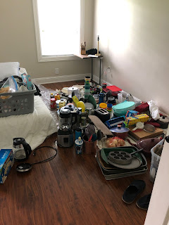
Amber also shared that as she and the girls went on a little adventure around the yard, they found a cool (but rusty) zipline in the trees, plus two random cast iron skillets that were just sitting there full of water and all rusted, ha ha. She also sent this picture to us with several cute little baby praying mantises standing guard on their mailbox. :)
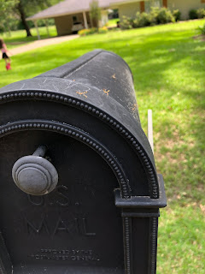

Tuesday evening, I was in charge of a young men and young women's activity centered on Family History. It was a smaller group of youth, but with a handful of adult leaders sprinkled in, we had 21 in attendance. Scott helped me teach a couple of research techniques on FamilySearch, showing the kids how to navigate on the site. I taught them how to slow down and really dissect the records, such as a census record, looking for all the clues that it contains. We gave them plenty of free time to explore and to try completing a task or two, with assistance available if needed. We finished up by serving some homemade brownies that I had made earlier that afternoon. It felt like a very successful activity - which is good, because I worked really hard in the days leading up to it so that it could be as successful as possible!!

Amber also shared on her Instagram account somewhat of an explanation of what synesthesia is and how she sees letters and numbers in very specific colors. Scott also has synesthesia, which I never knew about until Amber starting mentioning that she saw things in color as a teenager.



She created the alphabet on her iPad as she sees it, since she needed to be able to draw from a lot more color choices than what the keyboard in Instagram offered.



Very fascinating stuff. You should look it up. :)

Wednesday:
The girls enjoyed carefully venturing out into the Louisiana rainstorm that left some measurable water and an opportunity to wear their galoshes outside.

Click here to watch the video: (32 seconds)
https://photos.app.goo.gl/6ozTeyipDpX1A1WBA

With so much rain in Louisiana this week, there were some reports of flooding and even the potential for flash flooding in DeSoto Parish - which is where Amber and Weston are. When I called them Saturday night to check on them, Amber told me that their neighborhood is up on a little hill and therefore they will be safe. Sometimes when Weston is driving into Shreveport for work or other errands, he does have to be careful and watch for flooding on the roads or even take another route if necessary.

The girls have been playing well together and even got all tangled up in a knot while playing Twister. :)

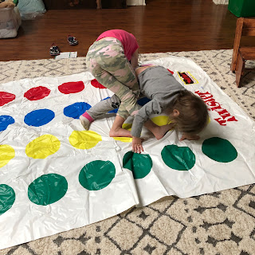

I also went in to get my second dose of the COVID-19 vaccine. I didn't even feel it at all when the nurse poked me!

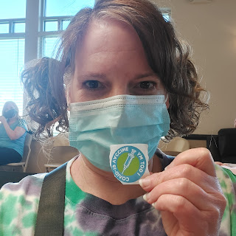

Soon after I left the vaccine clinic, I had a couple errands to run up in the Rigby area, so I hurried to get those done before I had an important service commitment to hurry home for (making dinner for a friend in the ward). I dropped off some of Weston's things to his brother, Caleb, who lives in Rigby. Then I stopped by a wood mill just north of Rigby so that we can get a load of firewood ordered. (We are fresh out!) It should have plenty of time to weather and dry out before cold sets in again this fall. And lastly, I stopped at a place called The Prepared Pantry to pick up a few items I ordered online and were now ready to be picked up.

They have the best pancake mixes and syrup mixes!!

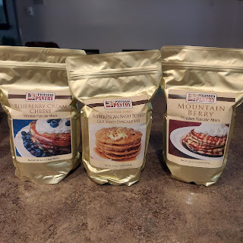

In just over one hour, I drove up to Rigby, completed all 3 errands, and returned home again! I only spent about 2 minutes at each place. Then I hurried home to start making dinner for my friend, Amanda, who just had wrist surgery the day before. I made her family some homemade macaroni and cheese casserole (my childhood favorite), along with a loaded green salad, and the last of the brownies still leftover from the night before. She was extremely grateful for the help and was doing pretty well in her recovery.

By that evening, I started feeling a little bit tired, but nothing extreme. After one final meeting for the day, a family history committee meeting, I got into my pajamas and clocked out.

Thursday:
I had already anticipated not feeling well from getting the vaccine, so I made sure to clear my calendar for this entire day so that I could rest. I stayed in bed almost the entire day! I slept in until 10:00 a.m., and it felt like my body was made out of lead pretty much all day. My brain was sleepy and foggy, which made it hard to focus on anything, even movies. I spent a portion of the afternoon in silence with my eyes closed in bed, just resting. That helped. My throat was also just a little bit swollen, so cold things felt good going down the hatch. And my brain cleared up a little more by the evening, which was nice.

All in all, there were no major symptoms to report. A hint of achiness, but mostly just feeling lethargic with a slightly swollen throat.

Friday:
I woke up feeling quite a bit better. I still felt a little tired and had some brain fog, but nothing too worrisome. I had several things to hurry and get ready for that day, so I couldn't stay in bed again.

First, I had a young women's presidency meeting at 9:30 a.m. to discuss our upcoming girls camp, scheduled for the first week of August. I was a little overwhelmed with the 9 page email from the day before, loaded with details and responsibilities that I thought I had to take some role in. But as we met with the girls camp leaders, I was reassured to know that we were dividing up the responsibilities and therefore my load would be significantly lighter. Whew! Thank goodness.

From there, I went directly over to begin my
NEW JOB
!!! I have been asked to help as a receptionist at the Idaho Falls Miracle Ear office. I went in to shadow one of the main girls for a couple hours, but right away I got put to work making phone calls to confirm Monday's appointments. It felt pretty comfortable, and I recognized that a lot of that comfort came from my previous experience working for Dr. Elison for 2 1/2 years. I liked the girls and and I feel like I will also really like the job itself. This upcoming week I will shadow another girl on Thursday, and then after Memorial Day weekend I will start working on Tuesdays and Fridays. The extra money will help a lot as I have a lot of travel plans coming up!! :)

After I finished up my time at the office, I met up with two friends for lunch. My friend, Jen Anderson, had a birthday on Monday, so going to lunch together was a great way to celebrate! We went to the Thai Kitchen in Idaho Falls. I ordered the Tom Yum soup with shrimp, along with a cucumber salad. It was delicious!! I forgot to get a picture of us. Whoops!

By the time I got home around 3:30 p.m., I was bushed. I climbed onto my bed, snuggled under a blanket, and turned on the TV while I waited for Scott to get home. We ordered some burritos for dinner and just watched a movie and relaxed for the night. It felt amazing.

Saturday:
We woke up bright and early and started planning out our day. We ended up going to Lowe's together to pick out two new ceiling fans - for the office and the guest room. They had definitely seen better days! We found two that were on clearance (50% off) and also had good reviews, so we decided to give them a try.

Out with the old klunky one in the office that made way too much noise over the years . . .

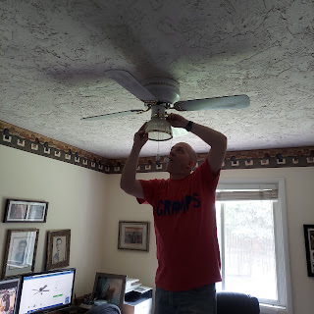

And in with the new! It's very efficient and super quiet as well.

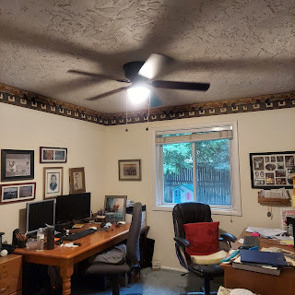

The one in the guest room was broken, so to have one that works now is fantastic! Bring on the summer heat! We are ready for you!

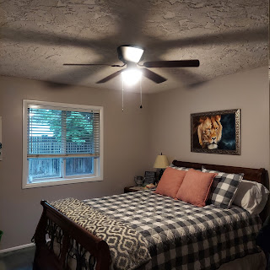

We also made a stop at Home Depot so that I could use up my gift card from Jacob and Hannah that they gave me last Christmas. I knew even in December that I wanted to use the money to get some flowers and plants in the spring.

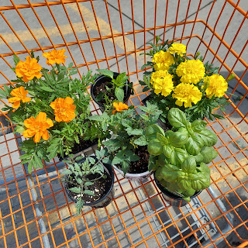

I got some orange and yellow marigolds, basil, a Roma tomato plant, a sun sugar cherry tomato plant, and a yellow sweet pepper plant. I plan to keep my garden simple this year, since I have so many trips planned and so much going on. I already have several fruit trees to maintain: apricot trees, strawberries, raspberries, a peach tree, a cherry bush, and an apple tree. That is plenty for us!!

After we got home, and after I helped Scott with the first ceiling fan installation, I went outside to pull some weeds. A lot of people hate to pull weeds. I find it somewhat relaxing. I take some music outside with me, in the form of a small but very effective speaker, and I just roll up my sleeves and get to work. Eventually my lower back starts signaling that it's time to stop (after a couple hours), but I have a hard time actually stopping. My OCD says, okay - just work until you get to that window well. But when I get to the window well, my OCD says, well, maybe just get those couple right there. And then I just keep going and going and have a hard time walking away from any imperfection. :)

Scott has also been dabbling in epoxy lately again, trying to experiment with a variety of techniques leading up to when we do our kitchen counter tops. I think we are definitely narrowing down the field of opportunities in designing what ours will look like and that is very exciting!!

Lastly,
here are some highlights of Jack from the week. My sweet and chubba wubba little grandson.





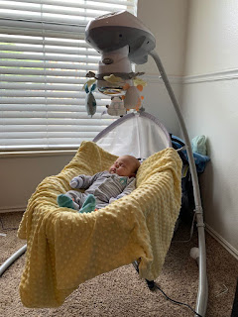

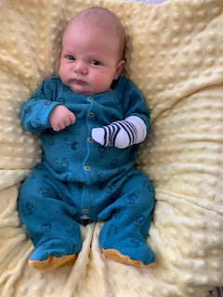

And a couple of delightful videos of Jack smiling and almost cooing at his parents. He is just the greatest and most bestest thing in the whole world right now . . . in my opinion. :)

Smiling video #1: (27 seconds)
https://photos.app.goo.gl/nAHZDJdkW45dehZi9

Smiling video #2: (24 seconds)
https://photos.app.goo.gl/ZLfSLpHVPVir5feE8

