On the Road Again (in a U-Haul)
We are halfway across the country at this point, in Nauvoo, Illinois, and are just preparing to take a walk down Parley Street before we head east once again. It's been a wonderful stay here, especially since we got to slow down and spend an extra day. We've been sleeping in a different hotel every night since last Thursday so far . . .
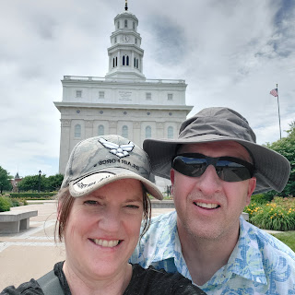

**UPDATE: We left Nauvoo this morning, and are halfway across Ohio tonight (Tuesday, June 15th). It's been difficult to find time to write, and to also have the energy to do so. I hope you enjoy all the photos below!!

I'll back up a bit and share what we've been up to for the past several days.
Monday (June 7):
Jack spent some time with his sweet little cousins on his momma's side.
Jack (2 months), Boone (8 months), and Calvin (3 weeks)
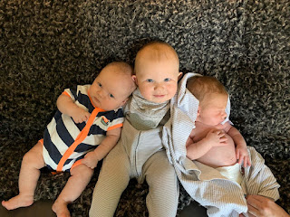

He played so hard that he needed another good nap.

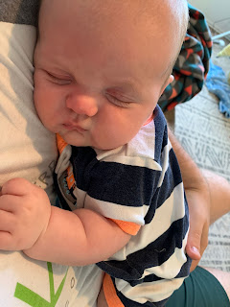

I planted my very small garden: basil, orange cherry tomato, sweet yellow pepper, and a Roma tomato plant. And I've heard that marigolds accompany tomatoes nicely.

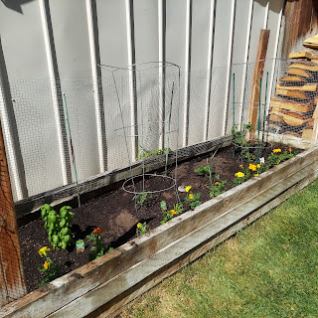

And then there's a random garlic plant that came up on its own this year.

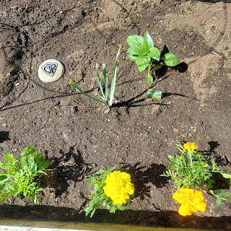

At the end of the day, Scott (or should I say Sven - my stylist) colored my hair. :)

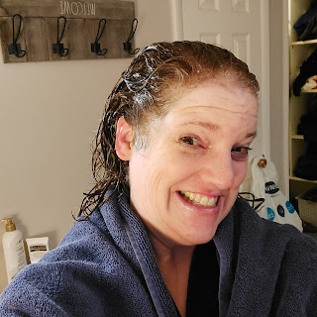

Nice job Sven! :)
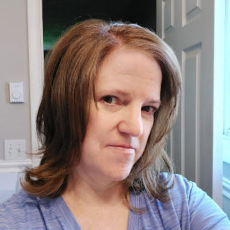

Tuesday:
Scott did his best to work on our squeaky brakes. Yes, he replaced them not very long ago, but for some reason they still squeal when I brake and also as soon as I begin to accelerate. After discussing the issue with my Dad, the guru of all things automotive, he suggested that Scott go into brake surgery again and clean out any old crusty grease around the bolts. So he did just that.

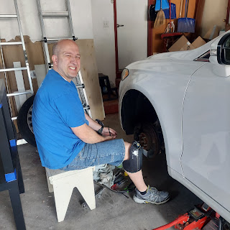

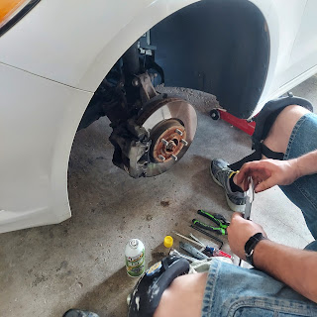

And while I cleaned around the house, baked cupcakes, and other miscellaneous tasks, Jack was heading to the pediatrician for his 2 month check-up. Little did he know he would be getting 5 shots in just a few minutes.

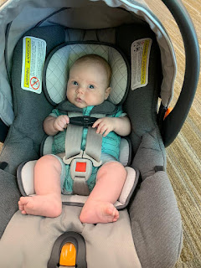

Jacob sent us this little video immediately after the nurses were done poking him. As I watched it, my heart just broke in half seeing Jack cry like that! I had never heard him cry once in all the times I've been around him. But this, this was an anguished cry, a heartbreaking cry. I started crying just watching him cry! But then, I was also prone to tears when my own children got their shots. It was hard to see them suffer like that, even though I knew it was for a good cause.

If you're up for seeing Jack cry - and it is a very sweet cry - proceed with caution. (15 seconds)
https://photos.app.goo.gl/DLhcbKTrReADegp67

At least he was peaceful soon after. :)

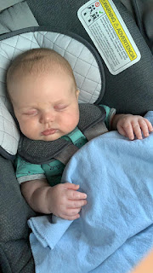

Turns out he was in the 88th percentile for weight at 14 lbs and 4 oz.
And he's been growing! He's at 23 inches now and in the 30th percentile! (At his last checkup he was in the 12th percentile for height) Good job Jack!! Keep drinking all that milk!

Tuesday evening, I went to the Girls Camp Orientation for all the young women in our stake. Several fun skits were performed to present what each ward chose for their "Hero". The theme this year up at girls camp is, "The Hero Within". Our ward chose Esther from the Old Testament as our hero. As young women leaders, we will be planning activities, fun, and spiritual opportunities centered around Esther for our camp later in the summer. (August 3-7)

I caught just a little portion of one of the skits - this was the last one of the night, performed by all the stake leaders (youth leaders and adult leaders). They rewrote one of the tunes from Sound of Music.

Click here to watch the little snippet: (52 seconds)
https://photos.app.goo.gl/FKh6TePqPFnxHYkr7

Wednesday:
After a young women's leadership meeting in the morning, I began decorating the cupcakes that I had baked the day before. I chose a summertime theme.

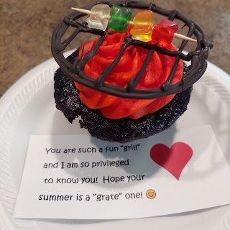

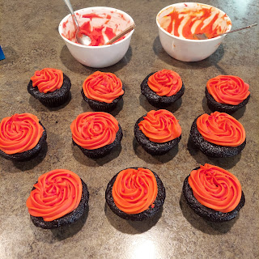

I divided up the buttercream frosting and made a bright red and a bright orange to look like fire.
Then I used a cup to trace circles on wax paper to make the grills out of chocolate.

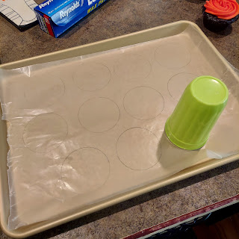

I melted some almond bark (a melting chocolate basically) and added a little bit of black food coloring gel to darken it, then put it in a squeeze bottle to make it easier to "draw" the grill grates.

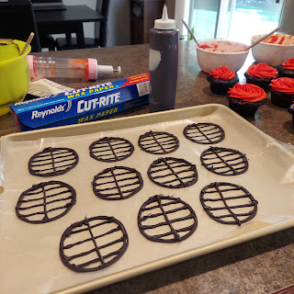

The last step was to cut up some gummy bears and thread them onto the kabob sticks. :)

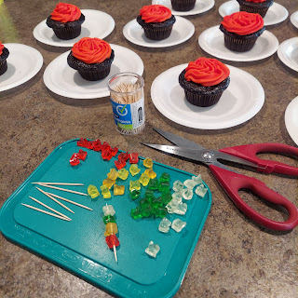

Voila! Soon after I finished, I got them all safely delivered to my young women girls and a few other ladies that I check in on regularly in our ward.

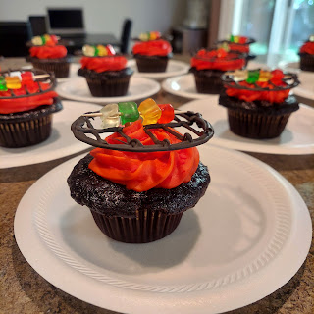

At the end of the afternoon, we drove up to Rigby to have dinner with Scott's parents. She made a homemade version of a beautiful Sizzler salad bar and man was I hungry! I piled my salad nice and high and I ate every last bite. After sharing a lovely meal, we visited for a bit and took a tour of their yard and gardens.

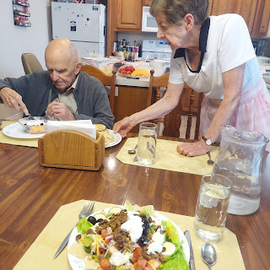

We didn't stay too long, since we had some packing to get done. With happy tummies, we headed home.

Thursday:
In between packing up and getting the house ready to drive away, I went to visit my dermatologist. I've been having a puberty era acne outbreak for several months that I could not explain or correct. He prescribed a couple things for me, so hopefully my skin will improve quickly! I also had him look at at couple tiny spots on the crown of my head, because they are reminiscent of when I had a squamous cell carcinoma 2 years ago that we treated successfully. He looked closely at them and agreed that they are pre-cancerous. The plan is that as soon as I get back from the east coast, he will freeze them and kill them once and for all.

Leaving our home and yard in the capable hands of our good friends and neighbors across the street, we headed south to Salt Lake City. We made good time and arrived mid-afternoon at our hotel. Date Night #1 consisted of a trip to Walmart, dinner from a Mexican food truck, and a movie in our hotel room.

In Walmart, we searched patiently and carefully for just the right card to mail to my Grandma Doris. Her 100th birthday is on June 26th!! I was hoping to find a GIANT card to mail, but I didn't find any such thing. I did, however, find her a beautiful card that I think she will really like. She enjoys cards, letters, and anything she can read and re-read as often as she likes.

As you can see, there were a lot of cards to choose from.

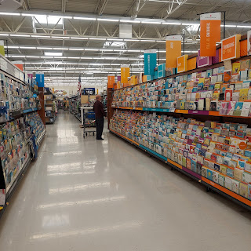

Friday:
We picked up the U-Haul moving truck, dropped our car back off at the hotel (for when we fly back in later), and drove down to Provo to help get our kids moved out.

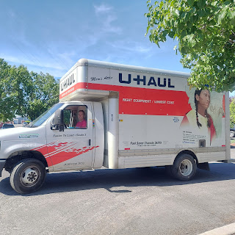

In between naps, Jack was very encouraging to the small moving crew.

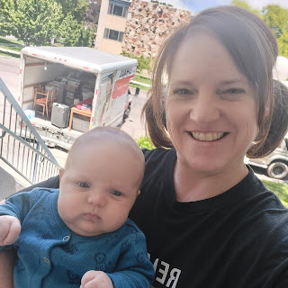

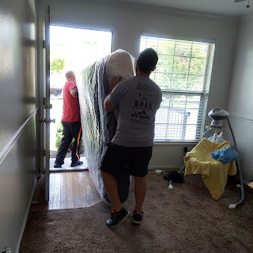

All this moving stuff up and down the stairs proved to be too exhausting for little Jack.

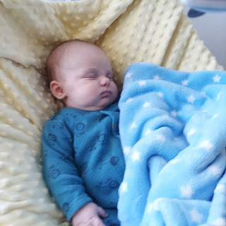

We did it! The 15 foot moving truck was loaded up, and still had a little room to spare! Our own personal luggage is at the back, making it easy to load and unload on our way across the country.

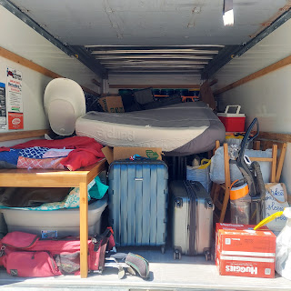

One sleepy boy . . . who was having trouble waking up.

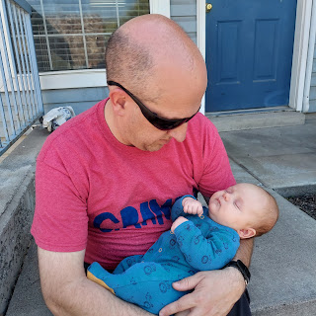

There he is! The sun is very bright and he's a little squinty, he's really not mad . . .

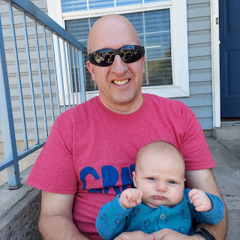

We left late afternoon-ish from Provo, with a 3+ hour drive to Rock Springs, Wyoming.

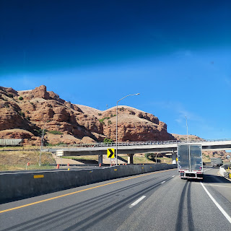

Welcome to Wyoming!!

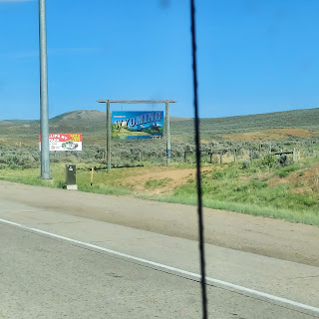

The truck was comfortable, although very loud. We tried to listen to music through my hub speaker that I brought, but it didn't do the job as well as we thought it would. If we really wanted to hear the music, we had to use our own noise-canceling headphones. But then that meant we couldn't really communicate very well either . . .

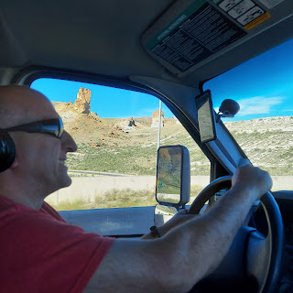

After settling in at our hotel, we walked to a nearby restaurant for dinner, then stopped at the grocery store for a few things. Jacob asked if we could pick up some celery for him to munch on the following day. I went the extra mile and set up a celery-cutting station in our hotel room. He was very grateful.

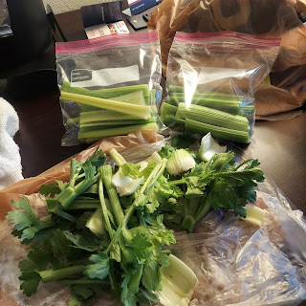

We had a late night, waiting up for Jacob to catch up to us. He stayed behind to help clean their apartment, as well as taking care of a couple important things, like turning in the keys. He finally arrived at our hotel around 11 p.m.

Saturday:
The long day of driving across Wyoming began early. Way too early if you ask me! I set my alarm for 6:00 a.m., but instead woke up around 5:30. Blech.

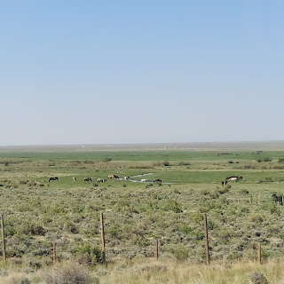

The landscape looked like this for most of the day. Once in a while we had something exciting to look at, like these windmills.

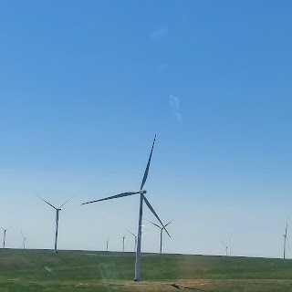

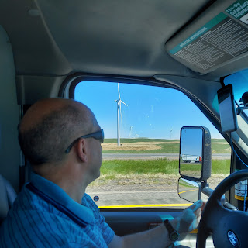

For lunch, I prepared PB&J sandwiches on my lap, bouncing along in a very suspension-less truck.

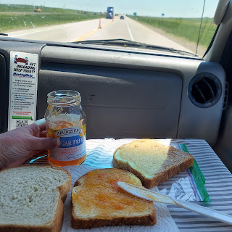

Finally we made it into Nebraska.

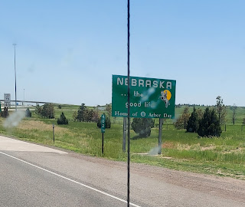

The wind really blows in these here parts. :)

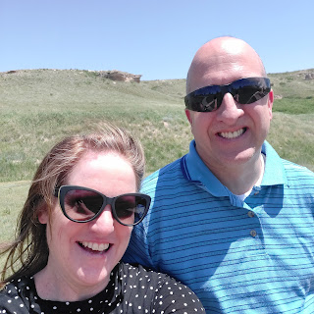

We had a special meeting scheduled for 6:00 p.m. and that's why we were trying to hustle that day. I had coordinated with Chelsea, my daughter that was adopted, to meet up with her and her mother that evening! Paula, her mom, grew up in Giltner, Nebraska, which was just a few minutes away from our hotel in Grand Island, Nebraska. So we decided to meet for dinner.

I was really nervous to meet Paula for the first time! I had spoken to her on the phone a long time ago, but haven't had any direct contact with her in probably 2 years.

We arrived at the designated restaurant in Grand Island, Nebraska at 6:00 pm. First hug was for Chelsea. She was trembling and nervous as well, bless her heart.

Then I got to hug Paula for the first time. I got a little teary, as did she. ❤ After a little bit of small talk, we sat down to order and then visit some more.

Jacob, who was driving separately, was able to meet up with us for dinner, so he got to join in all the fun too!

From the left: me, Scott, Jacob, Lori (Paula's sister visiting from Bend, OR), Chelsea, and Paula.

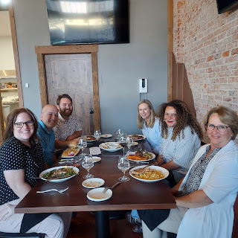

After a nice long dinner and wonderful conversation, we headed outside for a few pictures.

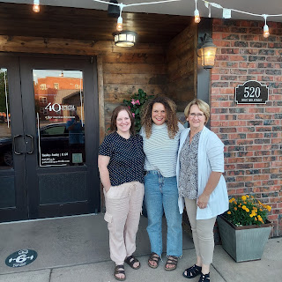

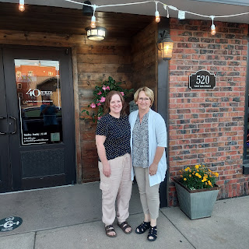

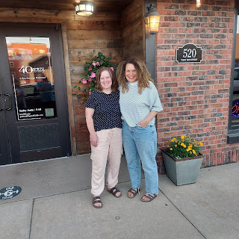

As I was hugging Paula for the last time, I said to her, "Thank you for doing such a wonderful job raising her." She responded, "Oh, now you're going to make me cry!"

Meanwhile, Chelsea was wisely taking pictures.

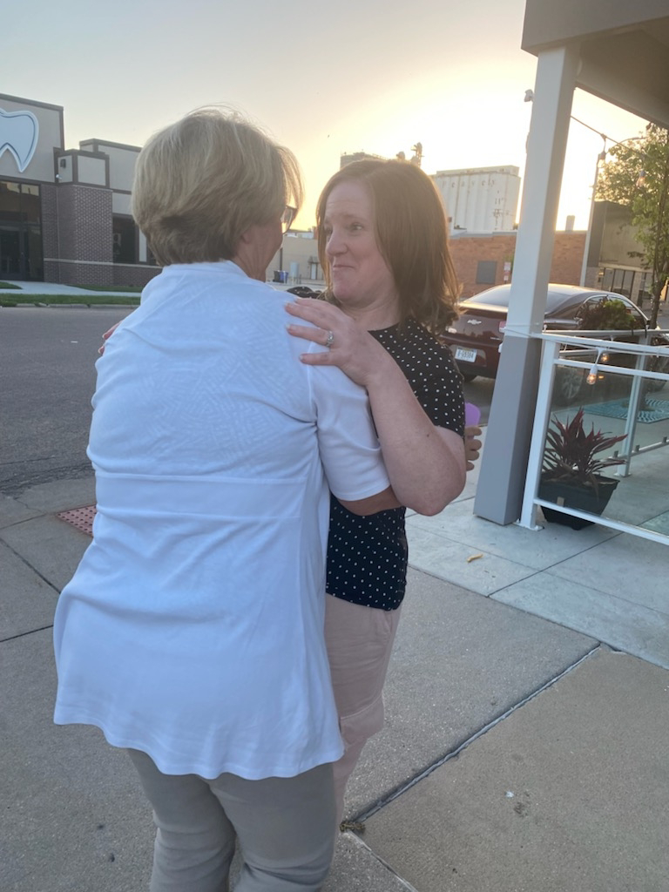

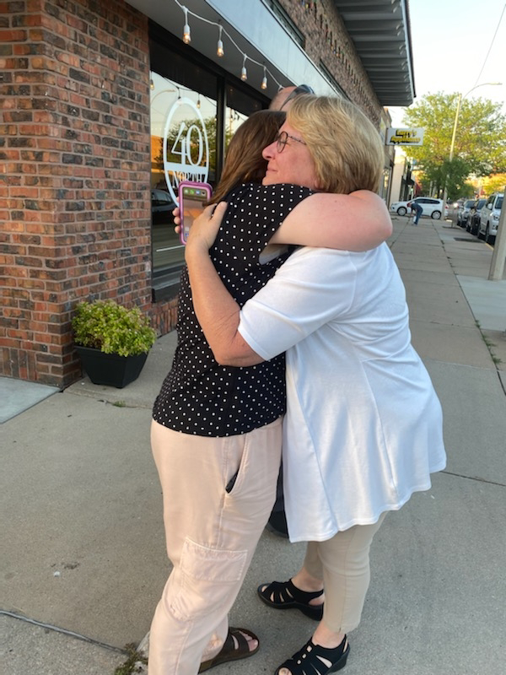

It was hard to say goodbye, but it had been such a joyful and meaningful time well spent. On the way to our hotel to tuck ourselves in for the night, the sunset seemed to agree.

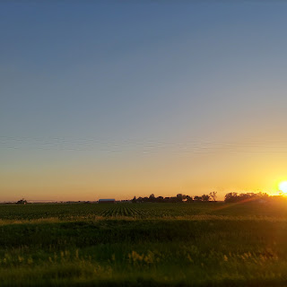

We kept in regular touch with Jacob on the last few hours of his travel for the day. When he was about 20 minutes out from his hotel near Des Moines, Iowa, he texted us to let us know his tire popped on the interstate and he was getting ready to replace it!! I had just finished praying for him, and was worried because of the lateness of his drive. Apparently he saw what looked like a board or a shelf laying on the road right as he drove over it. Turns out it punctured the side wall of his back right tire, so it drained very quickly. He pulled over - it was about 11:30 p.m. at this point - in the dark, on the interstate, and began preparing to fix it. That's when he noticed something dripping from underneath the car! He texted us about that, which we later determined to just be condensation from the A/C, thank goodness!

Scott did a little research on his computer and found that there was a Sam's Club really close to Jacob's hotel, and that he could get the tire replaced in the morning. (We got the tires at Sam's Club originally and they were still under warranty) Jacob took care of the fix quickly, and got back on the road within a short time. We waited up to make sure he got there safely, which was around 12:30 a.m. before we tried to get some rest. What a night!

We are so grateful that angels were watching over our son that night. I try not to think about how if that thing in the road had punctured the front tire, it would have been a lot different outcome. I'm glad he was able to maneuver the car to the side of the road safely, that he was protected in the dark while he changed the tire, and that nobody attacked him while he was pulled over by himself. My goodness he was lucky!

Sunday
: We woke up bright and early once again (sigh), because we had another long day ahead of us. Destination: Nauvoo, Illinois. Occasion: Our 29th wedding anniversary!!

I ironed Scott's white shirt while he grabbed us some breakfast from the hotel lobby. We then had a short sacrament service in our hotel room together before packing up and heading off.

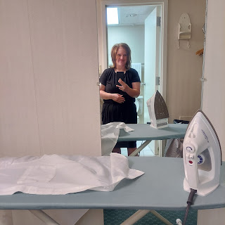

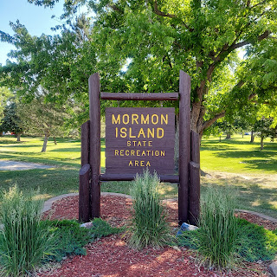

We made a couple stops along the way, beginning with a Mormon Pioneer place of interest: Mormon Island State Recreation Area, a stone's throw from our hotel across the Platte River. It got its name because the Mormons passed over the river in multiple places, trying to find the best spots to cross with all their wagons and livestock in the late 1840's and early 1850's.

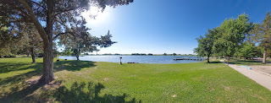

Next, we stopped to visit Winter Quarters and the Mormon Trail Center in Florence, Nebraska (just outside Omaha).

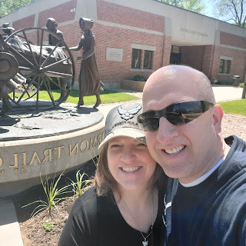

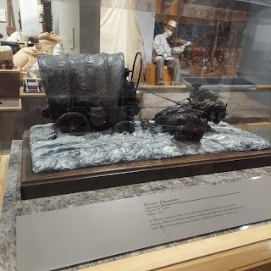

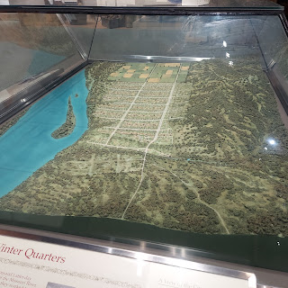

Here, Scott is standing next to the first odometer that his ancestor, Appleton Milo Harmon, built as the pioneers crossed the plains to Salt Lake City. The old method was to have someone count how many times the wagon wheel turned, and when they reached a certain number, they knew they had traveled one mile. Well, I can't imagine doing that for the thousand or so miles it took to get to Salt Lake. It would have made me dizzy, not to mention a little crazy as well.

Orson Pratt designed the odometer, and Appleton Harmon built it.

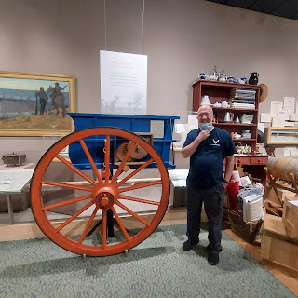

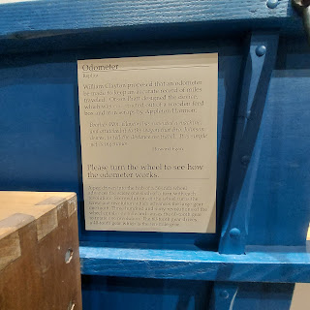

Here is a video I took of how it works: (33 seconds)
https://photos.app.goo.gl/HtzQ4nd3SaLoDXpx9

Amazing!!

Some other interesting exhibits in the visitor center:

Think about what YOU would pack if you had to walk across America to your new home, location unknown. And you had to carry everything with you.

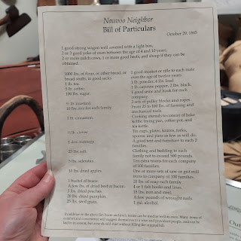

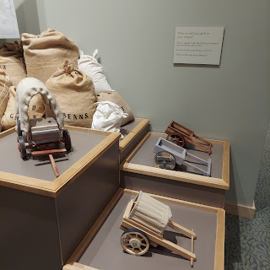

More pictures of the cemetery in just a minute . . .

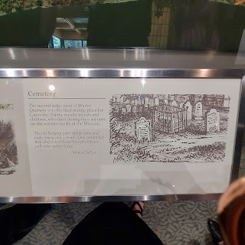

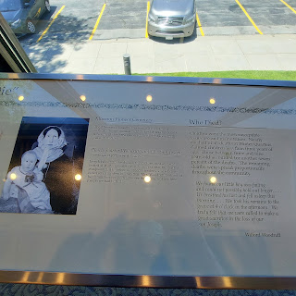

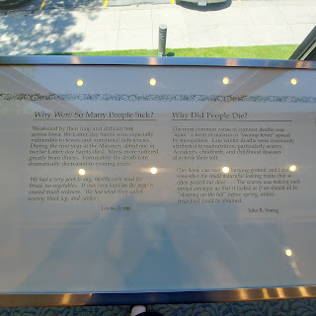

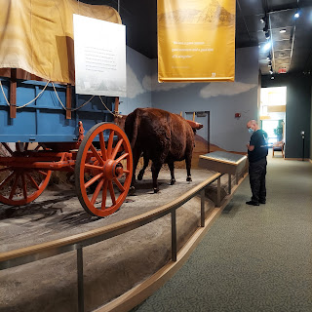

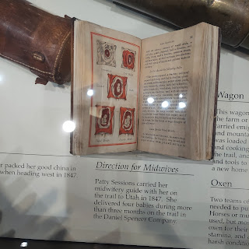

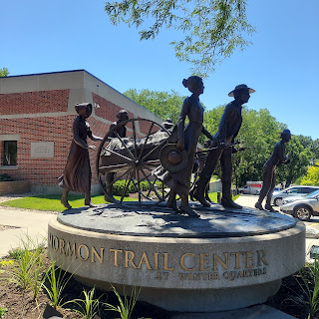

Next we headed across the street to the pioneer cemetery, where two of Scott's relatives are buried.

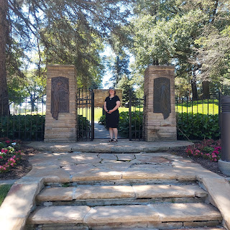

There is also a beautiful Winter Quarters Nebraska Temple

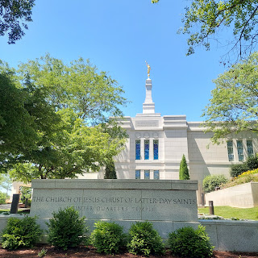

This is where his 4th great grandmother, Anna Barnes Harmon is buried: (mother to Appleton Harmon)

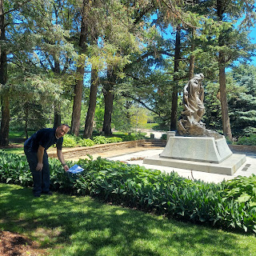

And this is where Appleton Milo Harmon Jr. is buried: infant son to Appleton Harmon

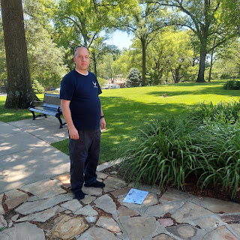

Appleton was away serving as a ferry operator near Cheyenne, Wyoming, per request of the prophet, Brigham Young, when his mother and his own baby died. But he didn't even know about it until he returned in the spring to collect his family to finish the trek west.

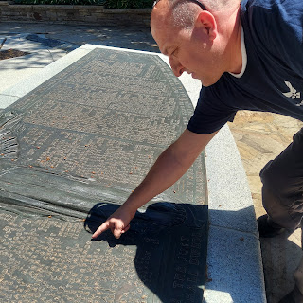

We found their names on the plaque in the cemetery. "Annie" Harmon was just 48 years old (one year younger than I am currently), and Appleton was 1. Another report said that he was just 11 months old.

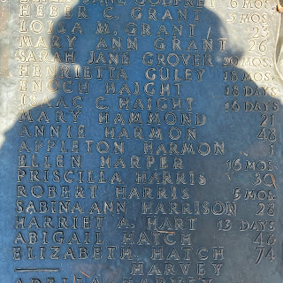

This is the system that we used to determine the old burial location. Through sonar detection and sexton's records, they pieced together each person's burial plot with a grid system.

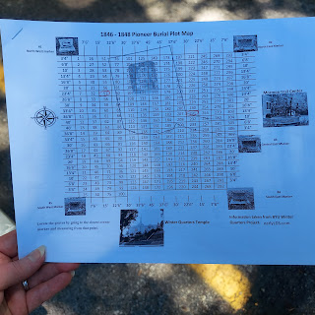

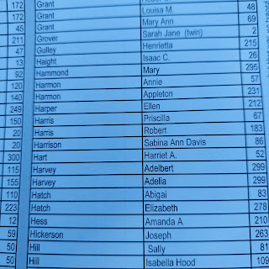

Next, we crossed the river into Iowa and over to Glenwood, Iowa so that I could do a little family history for my Rawles family. My 3rd great grandfather, Thomas Edward Rawles, was born in tiny Glenwood, Mills County, Iowa in 1848. He also had two younger siblings that were born there as well. I had been coordinating with Stephen Hunt, director for the Mills County Museum, to find out more about the Rawles Township that is just outside the town of Glenwood.

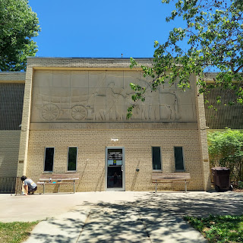

He had already found a few references to either a Rawles person or the Rawles Township in the county history book from 1880. He made a list for me of the pages, and then I took pictures of each page.

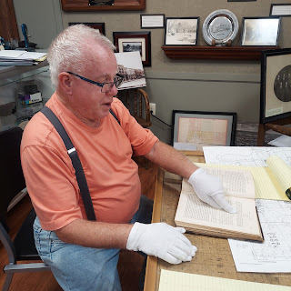

Here is an old map of the Rawles Township area

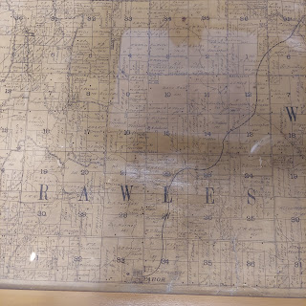

We looked through a couple old books, and then he turned me loose to take my own photos.

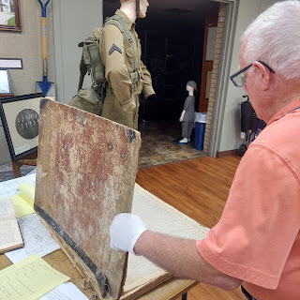

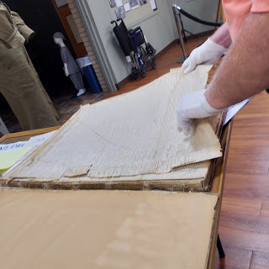

What a treasure! My first time having to "white-glove" it during my research!

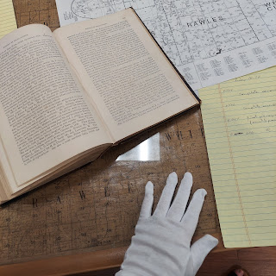

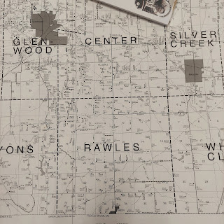

When we were eventually ready to leave, he went into the back of the museum and came out with a giant framed copy of the old Rawles Township map!! He gave it to me for free!! I need to figure out how to get it back to Idaho, since we're flying home, but I'll figure out a way. Do not doubt me. :)

Next, we took a little drive out to the Rawles Township to get some photos.

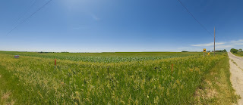

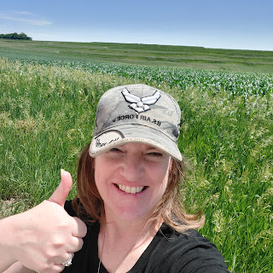

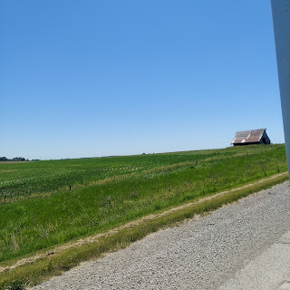

Click here to see a video of us driving out there: (46 seconds)
https://photos.app.goo.gl/AoEXVSvfcUigYE4v6

And where I stood in the center of the Rawles Township: (11 seconds)
https://photos.app.goo.gl/noyBE7WapHtveBYm8

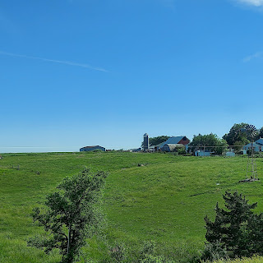

Such beautiful farm country out there.

We drove along. And drove along. And drove along, across Iowa for the rest of the day.

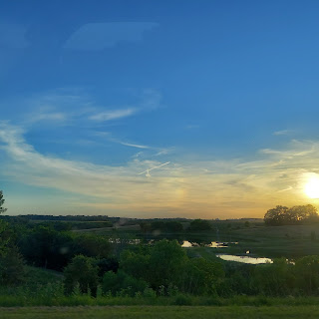

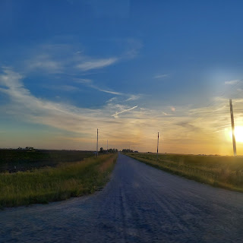

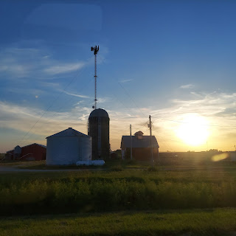

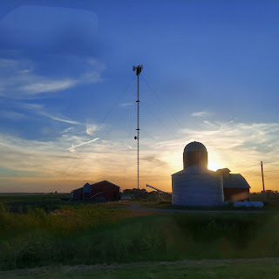

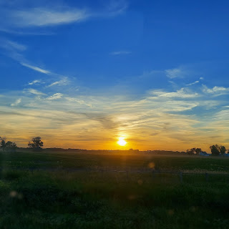

Meanwhile, Jack had his first plane ride and loved it apparently! Hannah flew with her mom, Michelle, to Michigan and arrived safely late that evening.

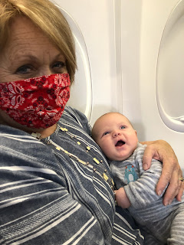

FINALLY we crossed the Mississippi River into Illinois.

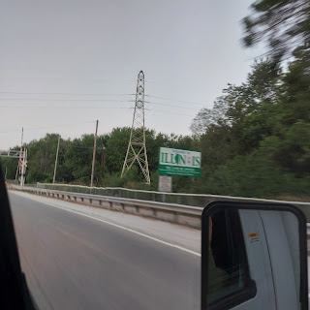

As we drove the last few miles into Nauvoo, the sun was setting in a spectacular way over the Mississippi.

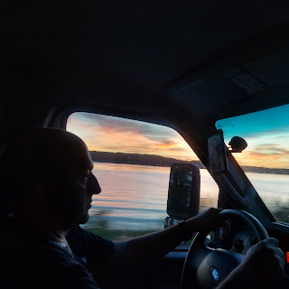

Follow our drive along the river for a minute: (16 seconds)
https://photos.app.goo.gl/4HR4HH2pLtgLv7aaA

And then, after a crazy long day, we arrived in Nauvoo around 9:00 p.m. We chose to stay at the Willard Richards Inn. Willard Richards served with Joseph Smith in a variety of ways, including as a scribe and historian. The Inn was beautiful and very welcoming after our long day.

Turning around the corner and seeing our lodging: (21 seconds)
https://photos.app.goo.gl/RS8QCQzRfKAwmEaA6

Scott running down the 3 flights of stairs to get my suitcase for me while I took a video of our room. :) That's love.
Click here to watch: (36 seconds)
https://photos.app.goo.gl/8kscLMc3VdsJBqiP8

And that is the end of a very long week. So much more to share in next week's post! Stay tuned!!

