Italy Predicted to Add Another Female Citizen
YAY!!!
We got to find out the gender of Benson and Kylie's baby a little early!! It's going to be a
GIRL
!!!!! Surprise!!!
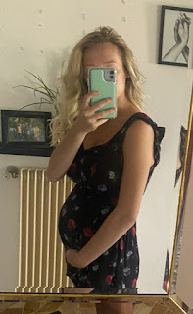

There were a few details that were making it tricky, and even difficult, to plan a Gender Reveal Party in August with all of the most important people in attendance. So, as any good parent would do, they peeked in the secret envelope . . .

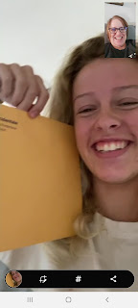
We are super excited!! Everyone thought it was a boy, except for Nicole, Kylie's step-mom. She knew it was a girl, and she was right. :)

Plans are changing frequently with all the comings and goings to and from Italy this year. Benson and Kylie will be, after all, having their baby in Italy instead of here in the United States. They didn't know, at first, that if their baby is born outside of Italy, where Benson's military orders are, it takes about 5-6 months to get all the paperwork in order for the baby to become a sponsored dependent. That means that if Kylie has the baby in the U.S., she would be stuck here until the baby can legally come and join them in Italy. And because Benson cannot sit out on vacation for 5-6 months, he would have to return without his family and then be separated for several months. Not an ideal situation for them at all. So they are back to the original plan to just have the baby in Italy.

That meant that my plans to travel over there this fall have now changed as well. I have decided to split up my previous 7 weeks of travel into two separate trips. I will still fly over at the end of September to accompany Kylie back to Italy safely, since she will be about 7 months pregnant then. I will stay for about a month, dividing my time between visiting Benson & Kylie, and taking some family history side trips on my own.

And then, the most exciting plans took hold yesterday (Friday): Scott and I bought tickets to fly out to Italy in December to see the new baby and spend Christmas over there as well!! I am so stinkin' excited I can hardly keep it in!! It just works out so well for Scott to come with me then, since he will have more time off from school over the Christmas break. This might end up being one of the best Christmas presents ever!! :) And the ticket prices were JUST PERFECT. We spent $700 each to fly from IDAHO FALLS to VENICE
round trip
!! Google Flights showed us that prices would normally be $1700 more than what we just spent, so that was pretty lucky. I subscribe to Pomelo Travel (about $34 annually) to get the heads up on all the travel sales throughout the world. I got an email from them Friday and we jumped on it right away, thankfully getting 2 out of the last 4 seats on the flight that we chose!! (For December!!)

As for the rest of the week . . .

Sunday:
We got this beautiful photo of Benson and Kylie in Italy as they celebrated Independence Day together overseas.

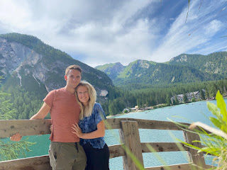

Benson likes to build little stacked cairns in nature. He didn't build all of these, but he did build a few.

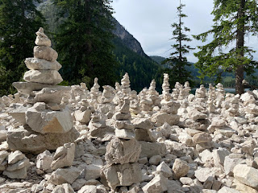

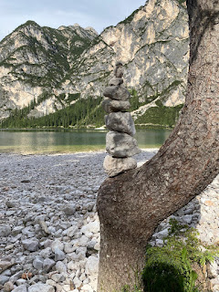

And this was their joy ride - in Kylie's car. :) Super cute!

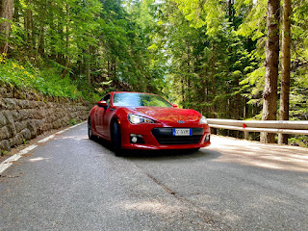

Meanwhile, Jacob and Hannah and Jack all arrived safely back to Utah late Saturday night. They are staying with Hannah's family for part of the summer, and will come stay with us for a bit - probably in August. Jack, true to form, slept through all the hub-bub of traveling across the country all day long.

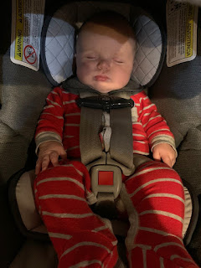

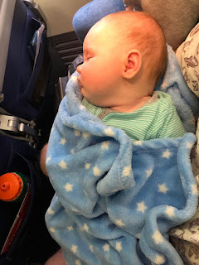

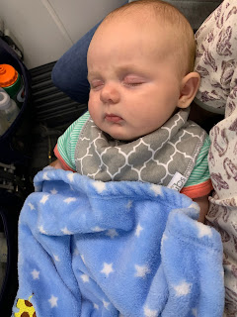

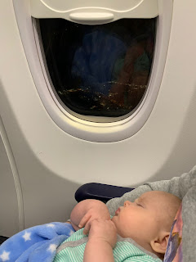

What a sweetie. :)

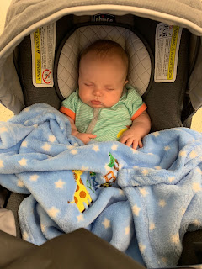

The missionaries came over to join in our little BBQ for dinner, and we played some cornhole as well. We got crushed by the elders, much to their glee!!

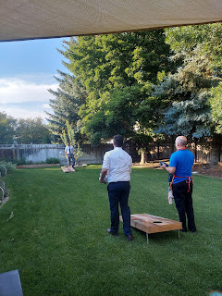

Charmaine and Scott had fun competing against each other, too.

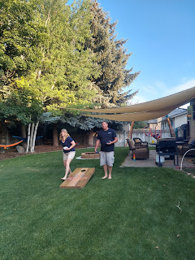

And at the end of evening, we went out front to sit back and enjoy all the neighborhood fireworks.

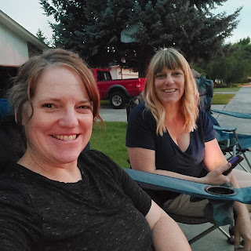

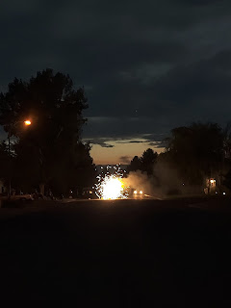



The Parkinsons always drive over to Alpine, WY each year to get the "good stuff" as far as fireworks go. We couldn't believe how many of the big ones they got this year! And their setup was very professional looking. They used plastic bins full of sand to anchor the launching tubes, and were very careful to do it all in a responsible way. Ben Parkinson is on the right in the photo below, prepping the next round alongside various family member and friends of theirs.

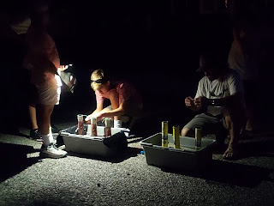

We saw and heard so many big fireworks going off in the neighborhood, that Charmaine, her Scott and I decided to go on a walkabout. We met several friends of ours sprinkled around the block with their families. And as we rounded the corner back to our house, we could see the City of Ammon fireworks above the rooftops about 4 miles east of us. They put on a spectacular show that lasted about 20 minutes long. It was a great weekend with lots of patriotic celebrations and fun times with our family and friends!!

Monday:
I started the day by having a fun conversation with Amber and the girls down in Louisiana.

Here is Gwen with her Cheetos-covered fingers

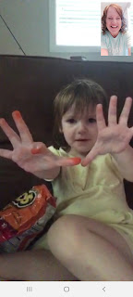

Abby showed me her new trundle bed with several stuffed animals stashed underneath from where she sleeps.

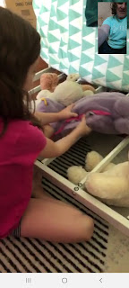

Amber's hair is looking super gorgeous - I bet the humidity down there helps with the curls. She says it's so hot down there that the AC has a hard time keeping up. Her DIY trick to cool off is to wet down her shirt and put it back on, letting the fans everywhere blow on her and cool her off. :)



She recently organized her bathroom cupboard with all the medicines, nail painting supplies, etc. I think it looks beautiful with all the matching bins from Walmart.

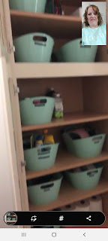

I had a nice chat with Abby, too. She sure is growing up! She will start 1st grade on August 4th - that's just around the corner!!

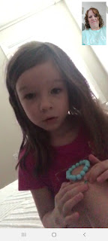

And then Amber showed me how Gwen is so capable of getting her hands washed all by herself, even though she can't reach the faucet very well. Here's what she does:

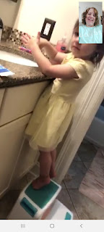

She channels her inner monkey to climb up, using the cupboard handle as her foot peg stronghold.

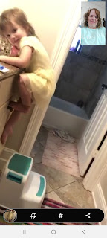

Now she can reach the faucet to turn it on.

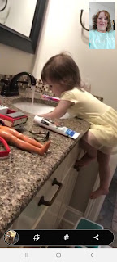

And then she just lets her legs dangle while she washes. What an independent and smart girl she is at 3 years old! ha ha

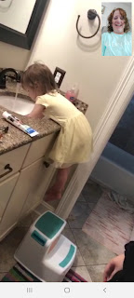

After my visit with the Louisiana crew, I took Charmaine and her Scott on a loop around some highlights in Eastern Idaho for the rest of the day.

We drove up to Mesa Falls first, about an hour north of our home, near Ashton, Idaho. Charmaine LOVES all the wildflowers and stops to take pictures of each one. So I took a picture of her just for fun.

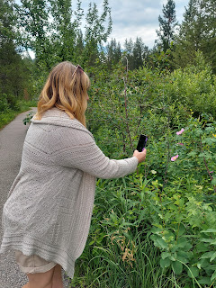

Here she is again, way back behind Scott and me on the trail. Scott laughed and told me that so many times when they are hiking, he'll be talking to her and all of a sudden he'll realize that she isn't there anymore. She's way back behind him taking pictures of wildflowers instead! ha ha ha ha

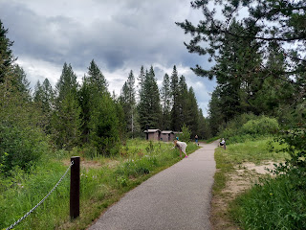

There is a beautiful boardwalk trail that leads down toward the overlook area of the upper falls. It's only about 1/4 mile or so. Easy peezy.

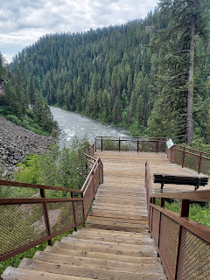

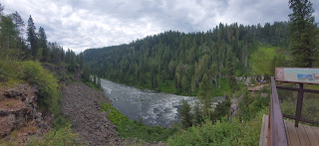

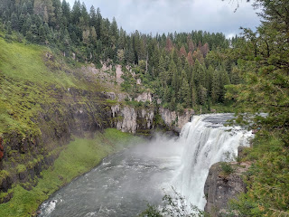

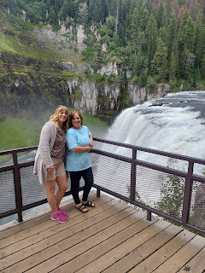

I love how you can stand right at the edge of the roaring waterfall and feel like you're part of the majesty and wonder.

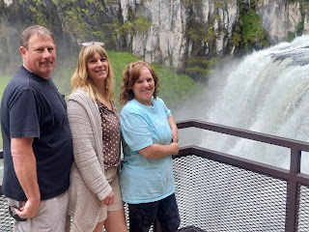

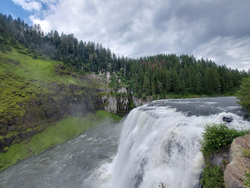

Click to watch the waterfall in action: (16 seconds)
https://photos.app.goo.gl/F2xsM5XFveJJPiim6

There is a 100 year old lodge on the property, used by the State Park employees for educational purposes. We spent a couple minutes browsing inside to see what they had. Charmaine found a wildflower identification display, so naturally she had to take a picture of that to compare with her earlier photos. :)

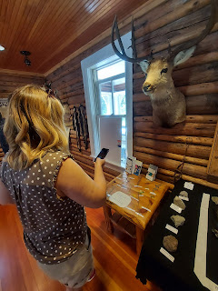

We saw a very intellectual and spectacled raccoon on display . . .

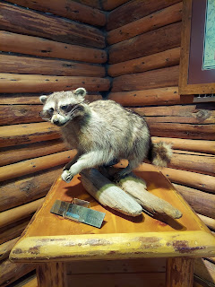

Next, we drove south to Driggs, Idaho, an area that Charmaine and her Scott wanted to explore as a future place to retire to. We had lunch at a tasty Mexican restaurant called Agave. I ordered the seafood chimichanga, Charmaine had a chipotle burrito, and Scott ordered pork street tacos.

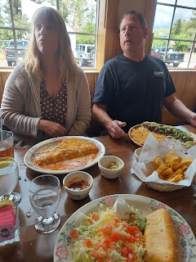

Once our bellies were nice and full, we drove up the hill to Grand Targhee Ski Resort, hoping to ride the chairlift up to the top of Fred's Mountain (elev. 9885 feet). But because of the stormy afternoon, the chairlift was closed. Darnit pants. The rain started pummeling as soon as we pulled into the parking lot for lunch, but ended by the time we were done eating. However, because lightning and thunder were present with the rain, the resort was being appropriately cautious, which meant no ride up the mountain for us.

So we pulled over to take pictures of the valley on our way back down to Driggs instead.

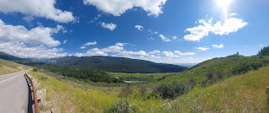

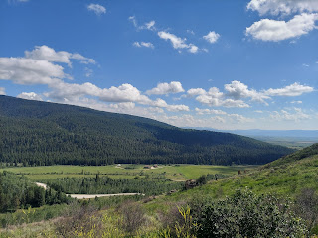

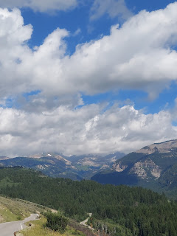

Coming back into town, we stopped at the Driggs Airport so that Scott could get a feel for the area as a pilot. There was a Warbirds Museum at the airport, so while we browsed the interesting planes, Scott got a lot of great info from the crew chief working there.

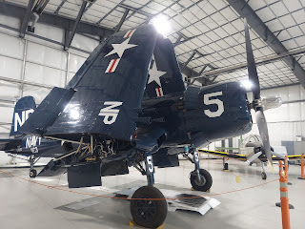

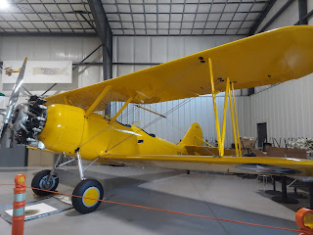

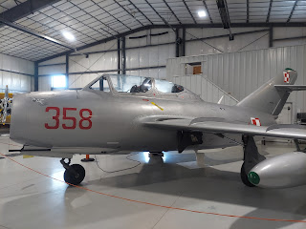

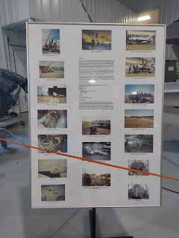

These next 2 photos are of a Russian airplane engine - from WWII I think??

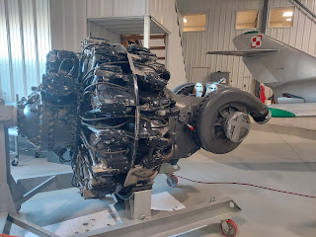

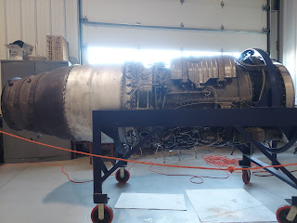

Scott learned a lot here, from dealing with the weather and climate as a pilot, to the housing market for pilots in Driggs. I didn't know that it's a "thing" to have pilot's housing next to an airport, whether it's a condo, an apartment, or otherwise.

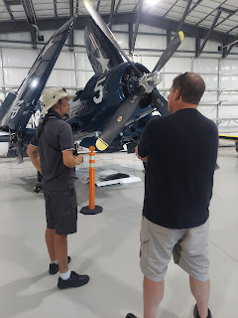

As we left the hangar, we could finally see the Tetons peeking out from all the clouds that had been surrounding them all day.

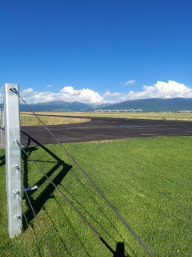

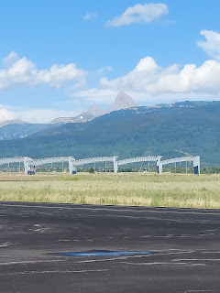

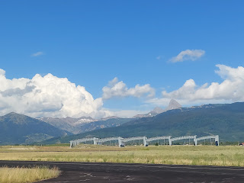

Having learned a great deal about the housing market, land for sale, the beautiful scenery, etc. in Driggs, we headed toward home, driving up and over Pine Creek Pass to Swan Valley and then on into Idaho Falls. We stopped in Swan Valley at the famous square ice cream store to get a treat. Technically it's just a gas station, but in the back they have the square ice cream shop and lines are typically quite long. My, the ice cream was good. As always. :) It's just ice cream, but when they serve it in a square brick, that makes it quite unique.

Between Swan Valley and Idaho Falls there are many, many fields of potatoes, barley, and even canola! The canola has really bright and beautiful yellow flowers. I asked Charmaine to try to get a picture out the window on my left as I drove, but she was only able to catch the tail end of the yellow majesty. It was quite striking to see the beautiful yellow flowers against the backdrop of such a bright blue sky.

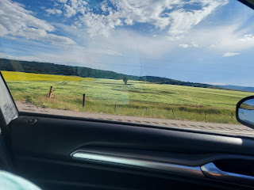

Our last stop was along the Snake River at the scenic overlook east of Ririe . . . and then we arrived home soon after.

For some reason, I like taking pictures of Charmaine taking pictures, ha ha.

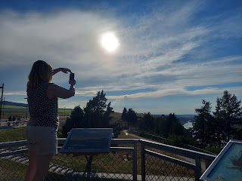

Tuesday:
After a big day of driving and sight-seeing the day before, we brought it down a notch or two for the next day. We slept in a little bit, and then while I did some laundry and yard work, Charmaine and her Scott borrowed our car to have a little fun in downtown Idaho Falls. They walked along the greenbelt of the Snake River and waterfalls, they explored the Japanese Friendship Garden that I love so much, did some window-shopping downtown, and had lunch in a tasty pub called The Celt.

We watched some TV in the afternoon and rested, and then at 6:00 p.m. we went to a Neighborhood BBQ, sponsored by our ward at church.

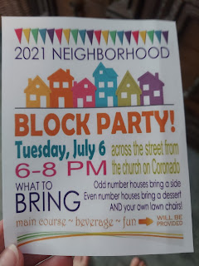

I tried a new recipe called:
Easy Keto Low-Carb Cauliflower Potato Salad
. It was DELICIOUS!! It tasted just like a perfect potato salad, only it was made with cauliflower!! I added some sliced boiled eggs on top, with a sprinkle of paprika. Sorry I didn't get a picture of it! But it disappeared really fast at the BBQ - maybe because I brought a little sign telling what it was and people were curious.

Here is the recipe:
https://www.staysnatched.com/keto-potato-salad/

I snuck a picture of my sweetheart while we stood in the long line leading up to the food area. The BBQ was held in the grassy area of EIRMC (our regional hospital), which is just around the corner from our house. "Spitting distance" as they might say in the south. We probably saw 150 people there from all around our neighborhood and we had fun visiting with everyone.

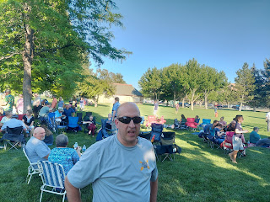

Meanwhile, Jack and his little cousin Boone were having the best buddy time down in Tooele, Utah.

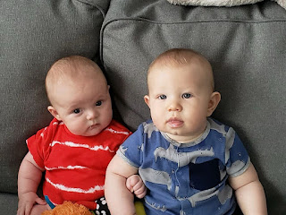

Wednesday:
We took Charmaine and Scott up to the Rigby Airport bright and early in the morning, leaving here around 7:30 a.m.

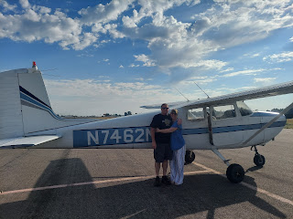

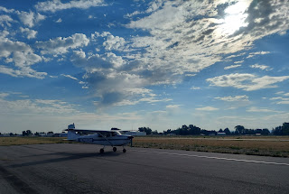

Click here to see the video of them taking off: (27 seconds)
https://photos.app.goo.gl/R7FLoJWv1sC4miuS9

They were off to a good start as they headed north, but things soon took a turn for the worse. Up in several areas of Montana, there were storms brewing left and right, forcing them to turn back at one point and land in Deer Lodge, Montana. (Photo below: the black marker is Deer Lodge)

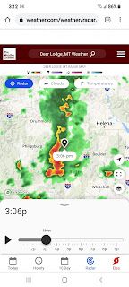

They thought it might be just a brief stop, maybe an hour or two, but they ended up spending about 5 hours in the tiny little town while waiting for the weather to improve. Thankfully, the airport had a courtesy van which allowed Charmaine and Scott to go into town to get some lunch.

MUCH later than anticipated, they finally arrived at the Coeur d'Alene Airport around 7:00 p.m. We were all so relieved!!! Thank goodness Scott is a wise and cautious pilot who took everything into consideration and made good decisions for their well-being. Prayers were also answered in their behalf, and for that I am so, so grateful!!

Meanwhile, back in Idaho Falls, I picked another round of rhubarb to make some ice cream. Scott helped get it all sliced up using the mandolin slicer again.

The recipe I chose to try is from this website:
https://www.chatelaine.com/recipe/desserts/rhubarb-ice-cream/

It only calls for 3 ingredients and that was intriguing to me. I followed the recipe all except for the rhubarb amount. I doubled it to 2/3 cup of rhubarb per batch and I also made a double batch. I liked it a lot more with the extra rhubarb - I can't imagine it with only having half that amount.

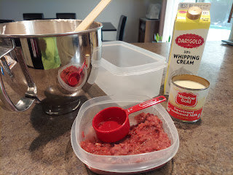

After beating the whipping cream and adding in the sweetened condensed milk and rhubarb puree, it looked like this.

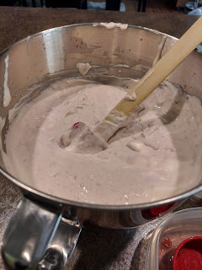

I transferred all of it into a sturdy Tupperware container with a good-fitting lid so that it could freeze and set up overnight. By the next day, it had set up very nicely. We had our back yard neighbors, Don & Helma Blatter, over to visit and eat some ice cream with us. We all thought it tasted lovely, and everyone agreed that the amount of rhubarb was just right. I would still like to experiment with a few other rhubarb ice cream recipes to see what they're all about. I'll let you know if I find a new favorite. :)

Thursday:
We got really, really brave and decided to try our hand with some epoxy on a small section of kitchen countertop.

First, Scott prepped the area really well. He painted primer on the edges and also on the laminate surface. (the edges have a dark charcoal primer, while the surface is just a light grey) He also taped on some plastic sheeting to protect the lower cabinets and flooring below the work station.

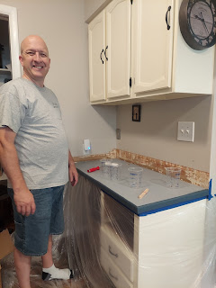

Mixing cups, stirring sticks, and foam roller are all ready to go.

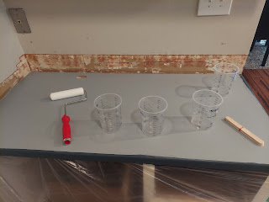

Using a drill with a stirring attachment, he mixed the resin with the hardener to form the epoxy.

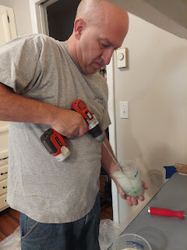

Then he added in the metallic black powder to get it nice and dark for our countertop surface.

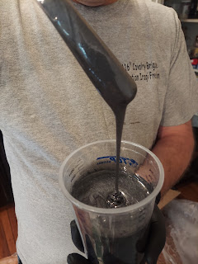

Pour it out on the countertop . . .

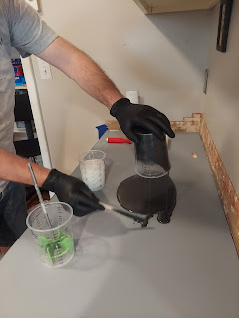

And spread it out evenly using the foam roller.

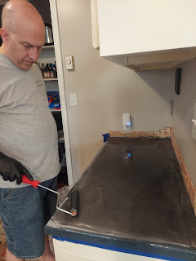

It was a little thin as far as overall coverage of the countertop surface, so he mixed up another batch and poured it out on top of the first batch. It takes hours to set up, so there was no urgent panic as we made batch #2.

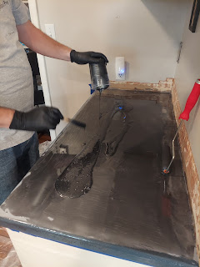

This was our first time really working to make sure the edges were all prettied up, but we knew what we needed to do. (all the YouTube videos from Stonecoat Countertops are awesome) The foam roller does a good job at evenly distributing the epoxy. And then every few minutes we took one of the popsicle stirring sticks to scrape underneath the edge so it didn't form permanent epoxy "drips".

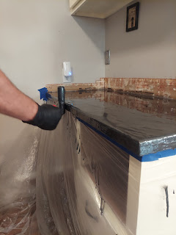

Using a blow-torch is important because it dispels all the little bubbles on the surface of the epoxy and helps to create a smooth and shiny surface.

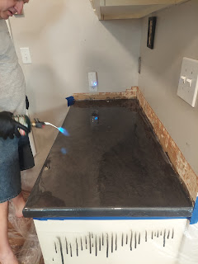

I took a short slow-mo video of what he was doing with the blow-torch.
Click to watch it here: (25 seconds)
https://photos.app.goo.gl/rs2ZasVS4qVygxvS7

Next comes the more artistic portion of the process: adding veins or other notable features. We like to keep it simple, so we opted for just a couple of white veins on this smaller section of countertop.

Video #1: Scott cutting in the first vein. (20 seconds)
https://photos.app.goo.gl/XeJXbRF5DjKfbpsm6

Video #2: Scott cutting in the second vein. (28 seconds)
https://photos.app.goo.gl/7qzMiCDpLyb6zVhW7

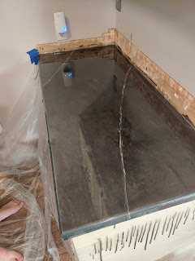

Inevitably there will be something you don't like as you go along. The good news is that because it doesn't set up and harden right away, you have plenty of time to tinker with it and fix the problems. In the photo below, I didn't like the little fingerprint marks to the right of the vein.

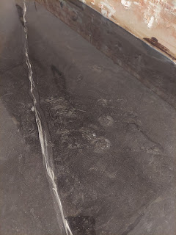

I used a heat gun to gently blend the marks into the surface within a matter of a few seconds. I liked the results below a lot better.

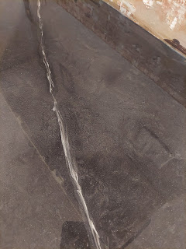

And here is what it looks like after a minimum of 24 hours to dry/harden and set up.

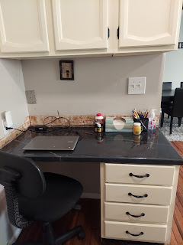

Soon we'll have a beautiful backsplash to pull it all together . . . but until then, just use your imagination. :)

Later this same day is when we found out that we're having another granddaughter!!! I talked to Kylie multiple times on Thursday and we had a good time. :)

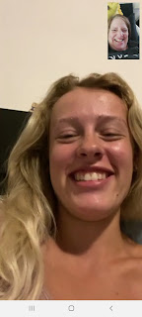

Friday:
A few fun texts came in from the family throughout the week, some of which took place on Friday. Here are some highlights:

From Amber:
"Gwen stole a quarter from Abby and wouldn't give it back. Abby the Entrepreneur set up a Fairyland attraction in her room, once in a lifetime, never before seen, and is charging 25 cents for admission."

Amber also shared this photo as part of Abby's school application process:

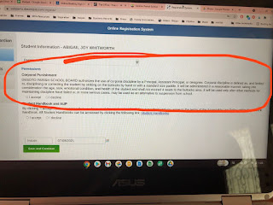

In case you can't read the small print, it says:

Corporal Punishment (Permissions)
"DeSoto Parish School Board authorizes the use of corporal discipline by a Principal, Assistant Principal, or designee. Corporal discipline is defined as, and limited to, disciplining or correcting the student by striking on the buttocks by hand or with a standard size paddle. It will be administered in a reasonable manner, taking into consideration the age, size, emotional condition, and health of the student and shall not exceed 4 swats to the buttocks area. It will be used only after other methods for maintaining discipline have failed or, in more serious cases, may be used as an alternative to suspension from school."
Amber had to choose whether to give permission for Abby to potentially be spanked or not. She declined. But she also added, "This is legal in Louisiana. They tried to outlaw it last year but the vote didn't pass." And later in the conversation, "I'm sure there's a bunch of moms who are like, 'yeah if my kid ain't mindin', you give him a swat', especially as an alternative to suspension."

Amber ALSO got an art teaching job!!
This is what she shared:

"The lady that Weston rented from earlier this year, Janice, owns and runs a tutoring center. She has art and music and after-school tutoring there. One of her art teachers wants to retire, and Weston told her that I would be a good fit. We talked on the phone this morning about mild scheduling and stuff I'm excited to teach and my credentials and the pay. They have about 70 kids that go to the center full time, plus way more wanting to join this year.

"If I teach 10 kids at $25/kid twice a week, and two or three classes like that, minus supplies, I'll be bringing in some good side money! Abby will be in school so we talked about the schedule I can teach, and then go pick her up. I just need to figure out childcare for Gwen this year . . . ."

We also got this cute picture from Amber - with the following caption:
"Gwen didn't feel like watching the movie today, so I said, "You could go watch Daddy mow the lawn. Or maybe he needs some help." And she LEAPT off the couch and put on her shoes and now she's riding around."

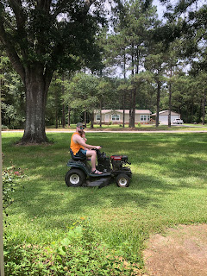

Jack is getting SO BIG!! He almost looks like he's too big for his carseat, ha ha. This is Jack (on the right) with his "little" cousin Calvin, who was born at the end of May.

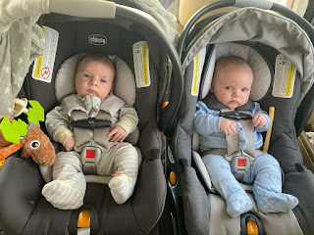

And he's still just as chill as ever, and so cute with all his expressions.

Click to watch Jack being his usual cute self: (25 seconds)
https://photos.app.goo.gl/AqLBzwbPdE4DDNcM6

Friday, we also moved on to the next small piece of countertop in our kitchen: in between the stove and the fridge.

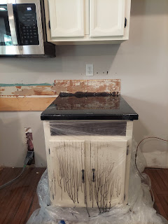

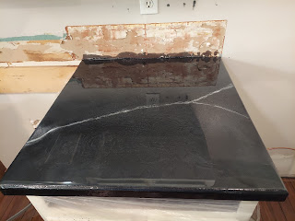

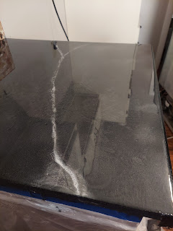

It's hard to see the beauty in the details because it's SO SHINY and reflects EVERYTHING around it, but here is another photo showing everything put back into place after it sat for 48 hours.

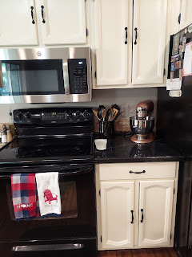

So, slowly but surely, the kitchen is making some amazing progress. In the next week, we are going to summon all the courage we can muster in order to remove the kitchen sink and epoxy the biggest section of countertop thus far . . . from the far left all the way around to the stove. A big U-shape. Deep breaths . . . deep breaths . . . where's the paper bag . . .

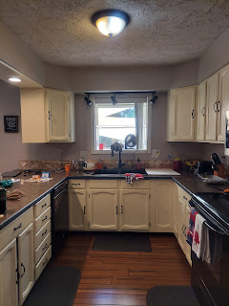

Friday evening, we invited our friends, Bob and Kim Hoffenbacker, over for some rhubarb ice cream and a nice visit on the back patio. Bob is who helped us learn about Tour of Duty which then allowed for Scott to serve in Saudi Arabia for a whole year. Bob just finished up his Tour of Duty a few weeks ago down in El Paso, Texas, and is now home in Idaho Falls. We had a great time catching up on life and all the happenings.

Scott and Bob - we call him "Hoffy"

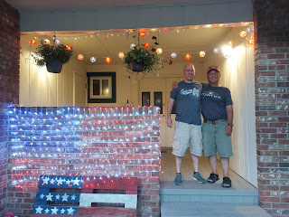

And me with Kim (below). She was my first friend when Scott left for his first deployment to Iraq back in 2004. She would come over and just give me a hug whenever I needed one. I am forever grateful for her friendship over the years. :)

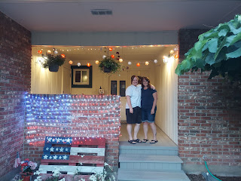

Saturday:
In looking through our camping supplies out in the garage, I came across a storage bin full of photos that I didn't know was sitting out there! A garage is not the best place for photos, especially as a long-term storage location. I brought it inside to see what kind of treasures it held within.

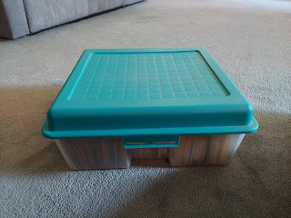

It consisted of photos primarily from 1991 - 1999.

Me, with little Amber in 1995

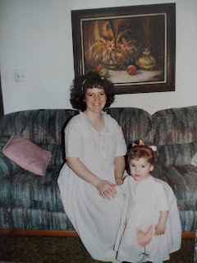

Amber, up in a tree in the side yard of Phil & Coy's house up in Rexburg. This is the house that Scott grew up in. Amber was about 1 1/2 or 2 years old here.

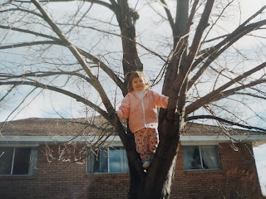

Scott and me - either while we were dating, or soon after we moved into his parent's house in Rexburg while they served a mission in Dublin, Ireland. We dated in 1991-1992. But they served in Ireland in 1995-1996. Not sure exactly when this was taken . . .

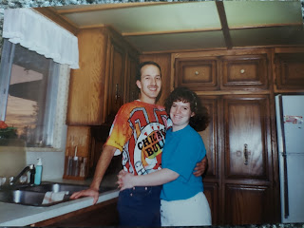

Great-Grandma Helen Harmon holding Amber - early 1995

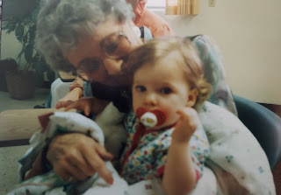

Amber (left) and her cousin Marissa Harmon (right) - about 1996 or 1997

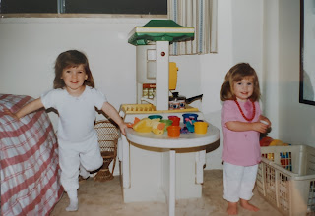

Jacob - his face reminded me a little of Jack in this photo

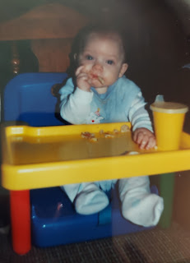

Great-Grandma Helen Harmon with little Benson - late 2000

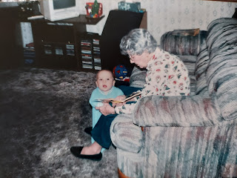

Great-Grandma Helen Harmon with Amber - probably around 2000

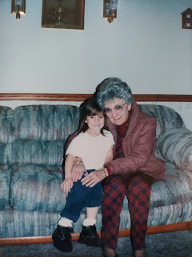

Jacob and Amber on the deck of our Michelle Street house in Idaho Falls - circa 1999

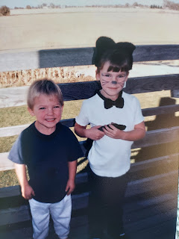

And this sultry photo was one of our attempts to get a good engagement picture, ha ha

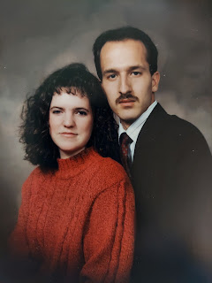

Scott - in his earliest years of service in the U.S. Army - circa 1988

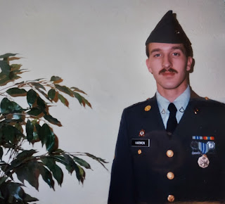

Me (red shirt) with my siblings in downtown Salt Lake City as we headed from CA to Rexburg for my first year of college. 1991

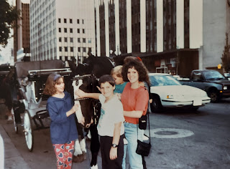

Me, trying on my veil - spring 1992

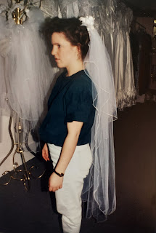

Scott (bottom right) during basic training at Fort Leonard Wood, Missouri - circa 1987/88

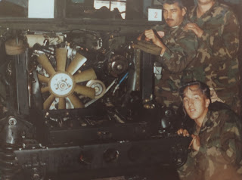

I think Scott was taking this photo below - I don't think he is IN it - basic training

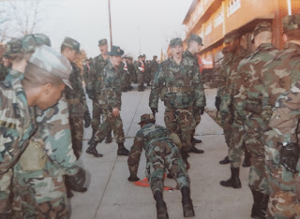

Right before we got married in June 1992 - sipping cider through a straw - or something like that
(There's a girls camp song called Sipping Cider - look it up)

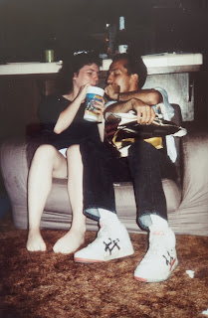

Amber doesn't look too happy in this next one ha ha, but then I think she could barely hold her own head up since she was only about a month old. 1994

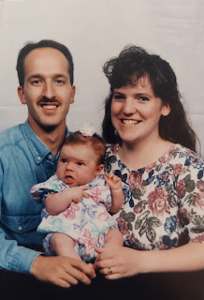

So yeah, that was pretty fun to take a walk down memory lane. I shared several photos throughout the afternoon with our kids so they could join in the fun. They loved seeing their dad in a mustache.

I also laid out all the new quilting fabric that I've been preparing for a living room quilt. I have been collecting fabrics in this color scheme for years, and now I am finally going to build us a beautiful quilt!

From this:

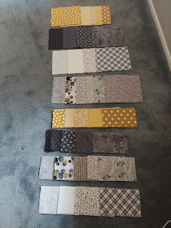

To this:

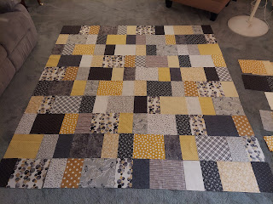

This coming week, I will sew it all together.

To end the day, I had a little video chat with Jack. :)

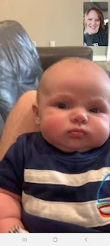

He had just woken up and was happily chewing on his little hand mitt teething toy while we chatted.



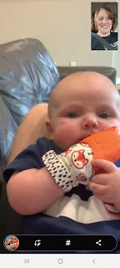

But eventually he got sad because his tummy was getting a little rumbly. So we had to say goodbye.

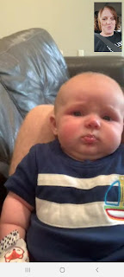

I can't wait for him to be here at our house in a few weeks!! I need to squish him and hug him and we will play.

Sunday:
I had the last-minute opportunity to teach our young women class today at church. My assistant, or advisor, has been under a lot of stress because she is working full time and is entering finals week for her BYU-Idaho classes right now. So with only a few minutes to prepare, I put together a short video on the Plan of Salvation, along with a colorful chalkboard discussion. We ate some broccoli with ranch dip, and had some Kit-Kat bars on the side. LOL

One of the things I learned when I served as the ward primary president a few years ago, is that some of the best lessons can just be impromptu instead of having weeks of pre-planning. I am a plan-ahead gal, but learning to go with the flow and just let the Spirit teach was one of the best lessons I could ever possibly learn. So that's what I did for today.

We generated a wonderful discussion about the purpose of life: where did we come from, why are we here, and what comes next?

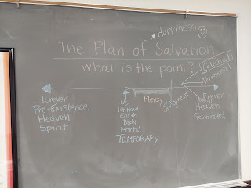

We are children of Heavenly Parents who love us very much. They taught us and prepared us to come to earth to learn many important things through having a body and having a mortal experience. They want more than anything for ALL of us to return to live with them again in heaven, and we have our Savior Jesus Christ to help us get there. Through following Jesus' perfect example and using his loving Atonement to repent of our sins, we can make it back to our heavenly home and there we can have our "happily ever after".

