It's Been a Painful Week . . . for Scottie
My sweetheart has been in excruciating pain for the past week. The culprit: sciatica. What an evil and conniving ride it has been for him, too.
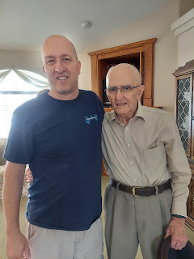

We went up to Rigby on Monday so that Scott's dad could give him a priesthood blessing to help with the pain and discomfort. We think it all started as we came home from Washington DC a couple weeks ago. His lower back was achy and cranky for several days, in spite of him exercising daily by bicycling and running. About a week ago, it got really bad in his left buttock/hip area, and then it's been a shooting-down-the-entire-leg sort of pain ever since.

We looked online to find home remedies and Scott faithfully tried almost every single one. He did all kinds of stretches to relieve the pinched nerve, he used heat, ice, took warm baths, cold baths, took ibuprofen, used essential oils (at my insisting), and we even used our massage drill. He went to the chiropractor, but couldn't get in to a physical therapist until this coming Monday, even though we called them last Tuesday. At times his pain was at an "8" on the scale from 1-10, so eventually he went to the urgent care near our house on Wednesday. They took an x-ray and said everything looked "fine". They couldn't give him a shot for the pain, but they gave him a referral to a local spine/pain specialist to schedule a steroid shot. Sadly, they couldn't get him in until this coming Monday either!!

After 2 more days of horrible pain every time he stood up, I reached out to a friend in our ward and neighborhood, Joel Whiting. He's a P.A. and has a specialty in sports medicine. We've reached out to him a few other times when our kids had a sports injury, and he would give us some stretches or exercises to try and they always helped. This time, however, he said he would call in a prescription for an oral steroid to help calm things down while we wait to get in to the 2 appointments on Monday. It's a steroid called Methylprednisolone. And it worked a miracle by the end of Day 1. WOW. Scott stood up Friday night around dinner time and cautiously acknowledged that he wasn't in excruciating pain for the first time. His bottom and hip were okay. His upper leg was okay. His shin area just below his left knee still hurt, but he could finally see the light at the end of all the pain he had been in.

For the past couple of days, his knee and just below his knee, have continued to hurt profoundly when he stands and tries to walk, but he's feeling better overall, which is quite encouraging!! We are so grateful that Joel called that prescription in for us and that it worked!

**Important to note: a priesthood blessing can be a great way to bless someone who is sick, suffering, or might be otherwise impaired. It's not guaranteed to be miraculous, but it certainly can be in many instances. Just like prayer, we can ask for a blessing for something we are in need of, and it's up to our loving and all-knowing Father in Heaven to determine how best to answer that prayer and in what time frame. We know that our Father in Heaven has a great amount of love for my husband and does not wish for him to suffer. We also know that sometimes we need to go through hard things so that we can learn something during the process. We acknowledge God's hand in helping us to find a small miracle through Joel Whiting, and that better days are coming for my sweetheart.

As for the rest of the week . . .
Monday:
Scott drew up a rough sketch of what our kitchen countertops could look like with the "veins" in the epoxy - - - when we're ready to dig in again once he's not hurting anymore, that is!!
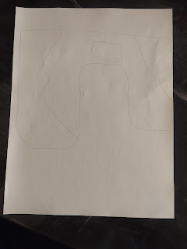

We sent it off to Amber to get her stamp of approval. She gave us 2 big thumbs up! So now we know what to do when the time comes.
I also went to visit my friend, Sharina Beutler, and more specifically, her son, Nathan. Nathan was in a horrible motorcycle accident last week here in Idaho Falls, and is lucky to be alive! I baked him some jalapeno cheese bread and took it over to pay him a visit. The Beutlers used to live around the corner from us for many years, and whenever they left town for a period of time, they would call on us to check on their chickens each day, as well as their cute bunny. It was always a treat to collect fresh eggs and bring them home to wash and use.
I didn't expect that Sharina had somehow tracked down some video camera footage of the accident and that I would actually watch what happened to Nathan! Apparently it happened in front of a bank, therefore the bank had surveillance footage. Nathan said he saw the oncoming car slowing down and assumed that they were slowing down for him to continue on. But he was mistaken. They turned right in front of him! Thankfully he had a helmet on, but only had a split second to slow down before impact. Sharina even showed me a slow-motion version where you could see his back tire going up in the air because he was braking so hard just before he hit. He did 2 complete revolutions in the air before landing on the pavement. Again, it is incredible that he is as okay as he is. He had a couple of surgeries mid-week (his arm/wrist and his foot). Sharina reports that he is stir crazy and she can't keep him off his feet! I guess that's a good sign that he's doing well. :)
If you are brave enough to watch this video, go ahead. (25 seconds) No blood and no gore. Just scary!
https://photos.app.goo.gl/fh32hxH5CiXzEn7r8
Tuesday:
I actually can't remember if this happened Monday or Tuesday, but I remember feeling prompted to pray and ask for guidance on what my Heavenly Father wanted me to do. Not specifically, but in general. The answer I got through the Holy Ghost was to find more ways to minister. I took that to mean I should look for ways to serve and reach out to more people in my circle of existence. So I did.
I don't want to list all the people I reached out to, or the things I did to serve and minister to each of them, because I don't want this to be a public tally board of how awesome I am. I will, however, share my methodology on how I went about trying to meet that spiritual invitation.
I made phone calls. To people I hadn't talked to in a while. To some that I was worried about. To a few that I felt prompted to call, just to check on them and make sure they were doing okay. In some cases, I sent texts out, trying to get some indication of how those individuals were doing. I baked bread and delivered it. (I used our bread machine so it didn't heat up the entire kitchen during this heat wave, ha ha). I sent off a few letters and postcards to a few family members that I knew would bring some sunshine into their day. I prayed for specific people in their trying circumstances. And you know what happened? The more I did, the more I felt prompted to do!! It wasn't hard and it didn't take a whole lot of time per person. I did try to act as quickly as I could when someone popped into my head so that I didn't have a big long list of people to reach out to at the end of the day. I tried to sprinkle sunshine a little at a time throughout the day, and then at the end of the day, I could fall into bed properly and happily exhausted. Like I had done what I was supposed to do. And that felt really good.
I just need to keep that up. :)
Wednesday:
I had a fun and lengthy video chat with Amber and the Louisiana crew. Amber showed me some of the math problems that Abby is cranking out at lightning speed.


I read Abby a story over the video chat, and then off she went, dancing in her leotard and leggings. :)

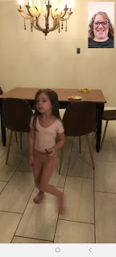

Amber and Weston both gave some insight and advice for Scott with his sciatica pain.

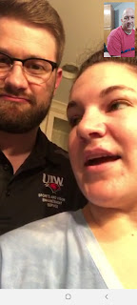

And this is Gwen when she is "hangry." (A combination of hungry and angry)

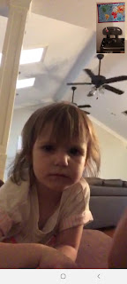

After she got a little dinner in her belly, she was in a better mood.

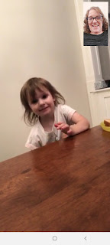

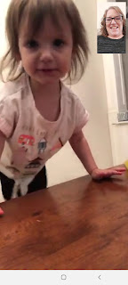

While Amber and I were happily and endlessly chatting away, Gwen came in to say that she was still hungry.

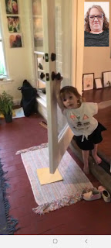

So Amber, bless her sweet little mommy heart, offered to make Gwen a smoothie.

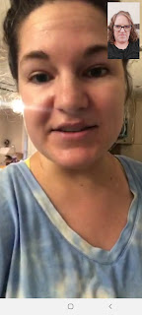

Happy day for Gwen!

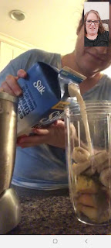

Meanwhile, in Italy, Kylie sent me this photo with a very polite, yet specific request: please let all the family and friends know that their baby will NOT need any newborn baby clothes. I repeat: NO NEWBORN CLOTHES, please. :) She got this entire amount (below) for about $50 and there are more clothes than what their baby could ever possibly need. If anyone wants to buy them some baby clothes, please aim for bigger sizes. Gracias. 💗

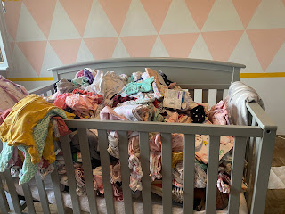

We also got this super cute video of Jack. (25 seconds)

https://photos.app.goo.gl/xztqCL9TTxg3tZgVA

I couldn't help but to try to add to the cuteness by creating an embellished video of Jack. (25 seconds)

https://photos.app.goo.gl/2AneL13nSPND1krL7

Thursday:
I loved this thought that Hank Smith, a motivational speaker, shared on Instagram.
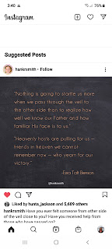

It says: "Nothing is going to startle us more when we pass through the veil to the other side than to realize how well we know our Father and how familiar His face is to us."

"Heavenly hosts are pulling for us - friends in heaven we cannot remember now - who yearn for our victory."

Both quotes are from Ezra Taft Benson, a former prophet of our church, who passed away in 1994 at the age of 95. He also served as the U.S. Secretary of Agriculture under President Eisenhower. He was a good man, as well as a powerful and inspiring speaker.

The main reason I don't have many photos from this past week is that I have spent OODLES of hours sitting at my computer, researching what to do, where to go, where to stay, etc. for my trip to Europe this fall. While it may sound like a long time away, it's actually in just 9 weeks!!! And since I have no idea what I'm doing, I thought it would be a good idea to sit down and start figuring all of that out.
So far, I've got plans for Venice, Florence, the Bern and Zurich areas of Switzerland, a quick stop in Strasbourg, France (on the German border), and then a few days in Germany. Most of these places I'm planning to visit because either I have family history in that area, or I have DNA from there and I just want to soak some of it in. Take Florence, for example. I don't know who in my family tree is from that area, but my DNA says I have 15% from Tuscany, which includes Florence. So my goal is to go and have some local experiences that help me connect to the history of the area.
AirBnB has lodging all over the world, but they also offer "Experiences". Tour guides in each specific locale offer something unique for you to do: walking tours, biking tours, behind-the-scenes tours, food sampling tours, etc. In Florence, I found an opportunity to take a cooking class with a local expert, and I'm really excited to participate!
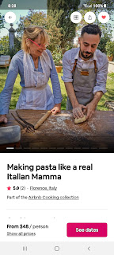
The 4 experiences I saved on my Wish List for Florence include: a Segway tour of the old town areas, a craft class to create my own marbled scarf, a guided tour on bicycle around Florence, and a cooking class listed as "Making pasta like a real Italian Mamma". I will have to choose which ones I actually have time to do. I thought it was interesting that in the cooking class, for the description of the host, here is what he said:
"Hello everyone! I'm Stefano, 36 year old Florentine man who lives for work reasons between Finland and Italy since 10 years. In this period I should have been in Finland, but being in Italy at the time of lockdown made me unable to leave, so I found myself trapped at home with my mom Daniela. :) The obligation to spend time together and our passion for cooking has encouraged us together to launch this experience. We love to meet people from all over the world with whom to share our knowledges. (this is exactly what he wrote, lol) I'm really proud of my Florentine roots, and our goal is to make my guests live a real local experience."
The class is 2 hours and we will prepare 2 traditional pastas: "Tortelli di patate" and "Gnocchi", with corresponding sauces of "Ragu" and "Burro e Salvia". After we prepare it all side-by-side, we will sit down to eat our creations together in their 16th century Tuscany garden. All for just $48.00. Amazing.
So this is what I've been researching for the past 3 days. And my lower back hates my guts right now too. Too much sitting!! I get lost in my research, sometimes for hours, and I forget to get up and move around. Right now I am typing this while standing in the kitchen and using the countertop as my desk, just to give my back a different position for once. Sigh, the symptoms of getting old . . .
Friday:
I got a haircut in the morning, and then spent most of the day researching on my computer. Scott was also deep into his online Army course that he started on Wednesday. He set up a computer desk down in the craft room so that it's nice and cool all day long, as well as quiet and away from any ruckus that I might be the culprit of upstairs. Friday evening was also when Scott finally found some relief from his pain, having taken the first steroid pills that Joel prescribed. That was a hallelujah moment for sure!!
I also mowed the lawns since my dear husband was out of commission. I really like our lawnmower, so it was an enjoyable 45 minutes for me to do that chore. :)
Amber sent us the cutest video of what the girls were up to. Amber was painting up a storm, as she put it, Gwen was having fun with play-doh, and Abby was reading a Magic Treehouse book. Apparently, Abby read 5 Magic Treehouse books in ONE DAY!!
Click here to see the girls: (24 seconds)
https://photos.app.goo.gl/hG4JhwCuJLvY2Fci9
I had a super fun video chat again with the kids down in Louisiana on Friday. Weston gave us some additional medical background on what Scott's been dealing with. He is enjoying his job down there and they are settling in quite nicely in the South.
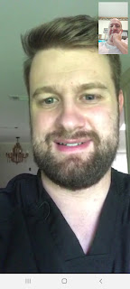

Amber was working on putting together a special collage wall in their living room. They plan to get a piano at some point to add to the ambiance in that corner of the room.

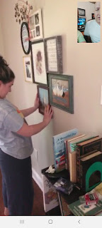

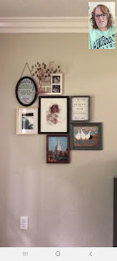

And here is a glimpse into the silliness of Gwen. Prepare yourself! ha ha

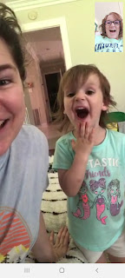

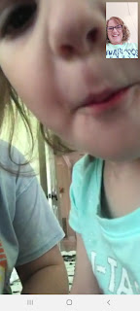

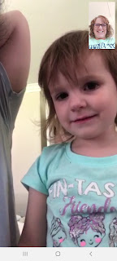

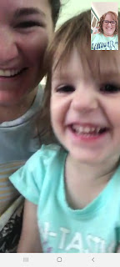

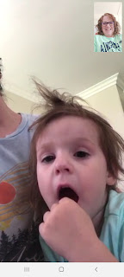
Saturday:
Scott was headed up to Rigby to take something to his dad, when he got in a minor fender bender. He was at a bigger intersection (still in Idaho Falls), waiting for the light to change to green. When it did finally change, he jumped into action, hitting the accelerator, only to realize too late that it wasn't HIS green light (to go straight). It was only green for the left turners. He bonked into the guy in front of him, doing a bit of damage to our car, but not much happened to the rear end of the other guy.
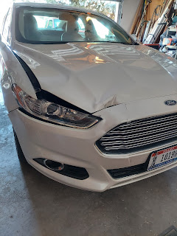

He called me right away, embarrassed, after he called the police. I'm just glad he was okay! When he described it to me, I thought at first that he had entered the intersection and got hit! That would have been much worse, and with the pain that he's been in - that could have been disastrous. But he's fine and everyone is fine. Except for his ego. But he'll be okay. Sometimes he just has so much going on in his mind that his driving becomes secondary . . .

Here's a deep thought: Could our grandson Jack be any more perfect?

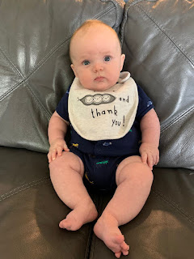

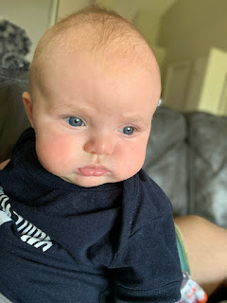

I love this next one - look at him holding his belly like, "Oof, I think I ate too much!"

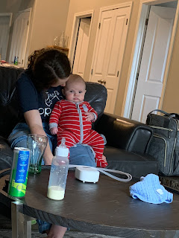

I got a text from my cousin Loreena yesterday with a picture of a family heirloom that she had framed and set up in her living room.

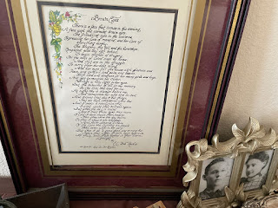

My great grandfather, Eugene Carlton Rawles (known as "Bob"), wrote this poem called Brown Eyes for his wife, Kate Lee Orr Rawles. It is just the sweetest poem!! (Sad and sweet all mixed up in one) In the bottom right of the photo above, you can see the two of them in the little frames next to the poem. When Loreena shared this with me, it truly inspired me to want to do something similar here in my home. I have my own copy of the poem and I could just as easily frame it and place it somewhere special.

Here is the poem: Brown Eyes

There is a face that comes in the evening,
A face with the warmest brown eyes.
The friendliest eyes in the universe,
Expressing her love of mankind, and her love of everything earthy.
The drugery, the toil and the hardships, (spelling left as original)
Completed each day left behind
To begin another of drugery.
For the sake of loved ones at home
And that are in the struggle
To carry their burdens along.
And her eyes fill the house with gladness and
Peace and comfort, and poise and beams.
With love and kindness for her many girls and boys.
And just to mention her Savior
Brings a holy light to her eyes.
But the sweetest of all to my memory
Is the look she kept for me.
At night she is always before me
And sometimes her eyes are so sad.
And I know that day I did things
That we both considered were bad.
And I make a resolution that
I won't cause that sadness again.
But when the day is ended
And I meet those eyes once more,
I find I have made them sadder
Than they were the day before.
So then I know I am shiftless,
And never deserve a share
Of the love she lavished on people
Who came within her care.
But when I do a good deed and I meet her again that night,
Brown eyes approve me truly,
And I am bathed in their warm lovelight.

By E.C. "Bob" Rawles, written for Kate Lee Orr Rawles

Sunday:
As I came home from an early morning meeting at the church, I saw that our first lily popped open, and my goodness it's a gorgeous bloom!

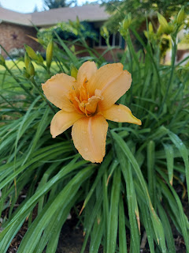

And then I heard my phone ringing with a video call - it was my sweet little bubba Jack!

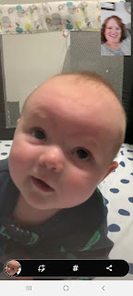

He is SO CLOSE to rolling over! I predict he will be rolling from tummy to back this week! He was super close when we were on the phone - he was leaning pretty far to look up at Jacob above him, and his back leg was lifting off the mat too. It's only a matter of time now.

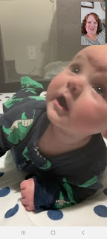

As Jacob and I chatted a bit more, Jack needed something to chew on.

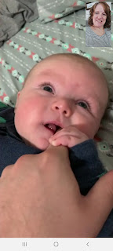

And then his eyelids started getting sooo heavy . . .

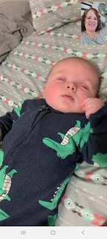

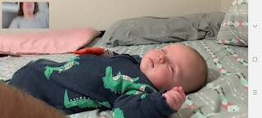

What a sweet angel. He really is perfect.

