Crikey! Blessings & Curses of the Military Life....
This week kicked off with some devastating news from Italy. Kylie found out that the process for getting a passport and Visa right now is much longer than previously anticipated. She has been in close contact with someone at Hill Air Force Base (AFB) to make sure she has all her paperwork in order and brings what she needs to her appointment in the United States this coming week. It was through this communication that she found out how slow everything is going right now.
Basically, she is living illegally in Italy right now (
NOT
on purpose - and covid certainly contributed to her getting stuck over there!), and needs to get her paperwork completed in order to appease all the European Border gods. All roads begin with Kylie getting a government issued passport, which can take from 4-10 weeks, and in some cases up to 12 weeks. Once she has that document back, it will get sent off with her Visa application. That could take up to another 12 weeks before she gets those two critical documents back. Meanwhile, she is due to have a baby in November, so time is of the essence. If she doesn't have those two documents, she cannot travel back to Italy to have the baby and would end up having the baby here. While that doesn't sound like a bad thing (to have the baby right here in town!), it will turn into a lengthy process of paperwork to get the baby approved to go back to Italy. (Baby needs a birth certificate, SS#, passport/Visa, sponsorship through the Air Force, etc.) That whole process for the baby takes between 4-6 months. Benson cannot hang out here in the U.S. endlessly, as much as he might like to, since family and friends are here. That means that Benson and Kylie (and the new baby) might be separated for several months . . . unless the passport and Visa can get taken care of a little faster. If they come back to her in a timely fashion, then Kylie can get back to Italy by October before she is too pregnant to fly, and then have the baby overseas where Benson's military assignment actually exists. Then at least they would be together while they wait for the baby's sponsorship to take place.
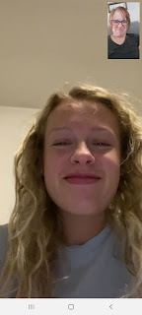

When we first spoke on a video call last Monday, we were both so in shock from the news, that we ended up in tears. I started crying first, which made her cry too, although she looked like she had already done some crying of her own prior to our call, bless her heart. After we hung up, I immediately texted several family members to ask them to pray for Kylie in these stressful circumstances. I got positive responses back right away from every single person, including these precious comments:

From Amber: "Absolutely. Kneeling to pray right now."

From Jacob's wife, Hannah: "Oh my goodness! We will definitely pray for them!"

And from my mother-in-law Coy: "Yes! I will pray for her. If Heavenly Father can help me find lost items and help me remove damaged carpet, I know He can help a little mother who turns to Him for help with a BIG problem if she asks.

While within an hour it looked like we might have another possible option to speed things up, it turned out to be a dead end. Kylie heard back from her contact at Hill AFB that if she could get a signature from a General on a specific form, that it could potentially expedite the process of getting her government-issued passport, which could be an amazing boost to the overall lengthy process. We quickly turned to our nephew, Brendon Dever, a Lt. Colonel in the US Army, for advice. After some discussion, we ended up encouraging Benson to reach out to the General in charge of his base in Italy, or at least the General's executive assistant for an appointment. If they had more time, it could have worked. But because they only had a few days before Kylie flies out, and because it's not a life-or-death situation, it didn't work out. So now we're just relying on the power of prayer and hoping that it lines up with God's loving kindness and we will just trust in His plan and in His timing. :)
Monday:
So that all happened on
Monday
- and what a crazy way to start off the week! Also, on the same day, Jacob and Hannah thought that their DC apartment had sold. Things were hopping with details and I was on the phone most of the day, trying to help out in a variety of ways. It turned out that the prospective tenants signed a lease with another apartment instead, so now they are back to square one. Hopefully the right person will come along soon and take over their lease so they can move to a different neighborhood. In the meantime, Jacob and Hannah are still happily staying with family down in Utah. Jacob works remotely M-F and is enjoying the projects they have him working on. Jack is getting bigger and cuter every day!
Here's a video of him just talking up a storm: (47 seconds)
https://photos.app.goo.gl/z4SwnerE8mYRnwUa9
Later that afternoon, Scott had two doctor's appointments for his ailing back and leg. While he headed out to go take care of business, I had to pretend that I was him for an hour with his online Army course. Tee hee.
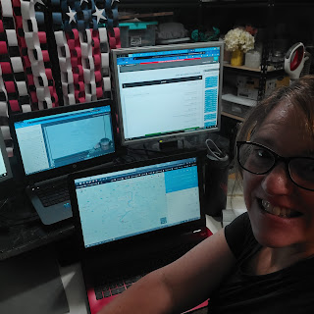

Nobody could see or hear me, I just had to be there in case something important was said. I took a few notes, but it was a pretty laidback class and the instructor just talked and talked about nothing mostly. Well, technically he was teaching a class on Creative Thinking, but instead, he got WAY off topic talking about psychopaths and how you can't predict or explain their behaviors. Eventually he moved on to the Critical Thinking portion of the course, and taught everyone his theory of perception vs reality. In this photo below, he was talking about how when something undesirable happens, we tend to
react as we stand on our "Mound of Perception". What we need to do is get to our "Mountain of Truth" to understand why the undesirable thing happened, or to put it in perspective, or to lower our blood pressure, etc. It's when people get stuck on their "MOP", due to fear, anger, complacency, etc. that it becomes a real problem. He taught that if we are humble, then we can begin to understand more and gain a better perspective on the issue and transition to the "MOT". (i.e. the offending person was tired or had something else going on and we could try to be compassionate instead of just reacting to their undesirable behavior)

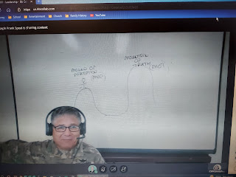

It really wasn't bad to sit and listen for an hour while Scott was at the doctor. I know he doesn't always enjoy sitting there listening to the instructors droning on and on for hours, but I didn't mind it for the hour that I participated. :)

What he learned at his two appointments is that they think he has a mild bulging disc in his back. They are working on getting our insurance to approve an MRI so they can verify their theory. But in the meantime, he has been working on several stretching exercises and is going to physical therapy to try to get stronger. We have learned that every single medication prescribed to him lately hasn't worked one little bit. He seems to be immune to muscle relaxants, nerve blocking medication, and prescription strength Naproxen. Weird, I know. They just haven't done anything for him. How sad.

Monday evening, I made yet another loaf of jalapeno cheese bread to take to our friends, the Vances. They have been such wonderful friends to us over the years. Everywhere we go, if we see any small bottles of local honey, we always buy one for Peter. He loves to sample honey from all over the world. He tried his hand at being a beekeeper for a couple years, but when he started having some pretty extreme allergic reactions to the occasional bee sting, he thought it best to retire from the business. He still loves honey though, and appreciates the art and joy of beekeeping. We had purchased a small bottle of honey from upstate NY for him, and decided to bake them some bread at the same time. We did NOT intend for the honey to go on the jalapeno cheese bread . . . just two separate gifts . . .

I love having a bread machine. It's so nice on a hot summer's day to just throw all the ingredients in the bucket and then it turns out perfectly without heating up my kitchen. And yes, you literally just dump all the ingredients in and the machine will take it from there. Pretty cool!

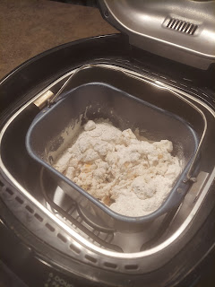

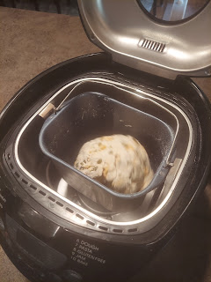

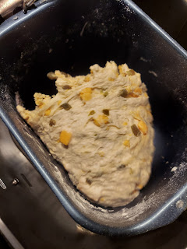

Tuesday:
Jacob and Hannah celebrated their 2nd wedding anniversary! This photo was taken just before they moved away from Provo in June, and Jacob used it to post a very sweet tribute to his wife on social media.

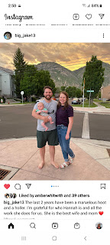

They went out to dinner together - with Jack, whom they lovingly dubbed the "chaperone."

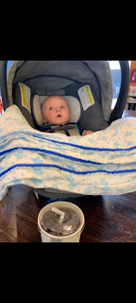

Later that evening, I participated in a huge young men/young women activity by very responsibly sitting on the edge of the pool with my legs in the water to monitor all the fun. It was really nice to just relax and socialize at the end of the day. There were about 30 youth that came, along with about 10 adults. Our neighbors, the Burtenshaws, have been trying to get this pool built and ready for over a year, and this was Opening Day! They said that the process was worse than a snail's pace because of Covid and the lack of materials being available. But it's here now! And it is so beautiful! They even had a diving board installed at the far end of the pool where it's 11 feet deep.

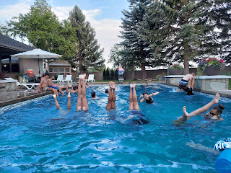

The kids played the "toothpick game" for the longest time! Basically, someone would jump off the diving board, toothpick in hand, and deposit it somewhere down below, or just let it sink. It takes a while for it to fully sink down to rest on the bottom of the pool. Meanwhile, all the participants line up along the edge of the pool to try to locate the toothpick with their eyeballs. As soon as someone spots it, they try to jump in and grab it before anyone else. It had me worried a few times that they were going to knock heads as they jumped in simultaneously, but man, they sure had fun playing this for about 45 minutes!

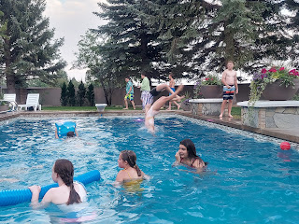

Wednesday:
I ignored my household chores and went shopping instead. Sometimes a girl just needs to shop! I found a couple of great clothing items for two upcoming and important events: Girls Camp and my trip to Europe in September. I wanted something comfy and appropriate for dirt immersion and mountain living during girls camp, yet I also wanted something classy and versatile for my other trip.

I've been reading and trying to prepare for what to pack for Europe. I don't want to look like an obvious traveler because I would be more of a target for pick-pocketing. I'd rather just blend in as best as I can with the locals. That means dressing like they do. Thus the research.

I've also been thinking and researching about how to pack as light as possible, which includes having just a few interchangeable clothing items that can be mixed and matched over the course of several days. I have a few things already that can work, but I needed a pair of black jeggings (jeans + leggings in one) that could be used in a variety of outfits. I found success at Old Navy. Yay!

Meanwhile, Jack needed a form of entertainment in the grocery store down in Utah.
Enter a green bean. (14 second video)
https://photos.app.goo.gl/jgVCoiGQB7CtRDbNA
Thursday:
I spent some time tailoring my new black jeggings to fit my very short body. First, I folded some cuffs to mark where I wanted the shortened length to end up. Then I took them off and laid them inside out on my cutting mat. I drew a chalk line to help taper the width down to where I had trimmed the length of each pantleg. This gradual tapering helped to make it look professional from the outside.
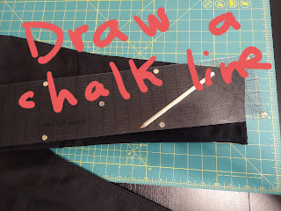

I sewed a double seam down the chalk line, checking after each seam to make sure I could get the pants over my feet easily, which I could. :) Then I folded the bottom hem over a couple times and sewed around the leg openings to finish the job. Voila! They turned out great!

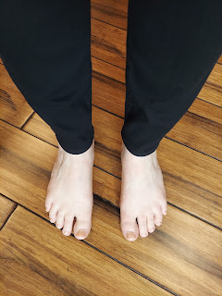

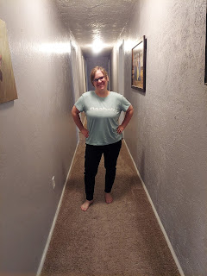

Jack gave his approval as well. (He was trying out his new swim suit for the first time)

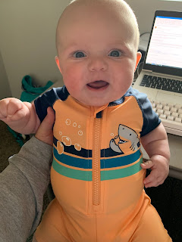

I visited with Kylie again, discussing her upcoming travels and the latest on their paperwork process.

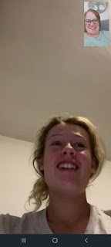

She will be 23 weeks into her pregnancy as she arrives in the U.S. this week. I can't wait to see her and hug her! It's been way too long. :)

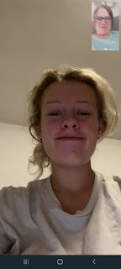

For dinner, I made a homemade tomato soup that was super delicious! I want to make it again soon! The recipe included making homemade croutons as well, which was fun. We had grilled cheese sammies on the side. A simple, yet very filling meal for the two of us.



Here's the recipe that I used:
https://www.foodandwine.com/recipes/creamy-tomato-soup-buttery-croutons

While I was having fun in the kitchen, Abby and Gwen were having fun with their parents while making their way across the country to Idaho! They drove to Dallas to catch a flight to SLC, and then met up with all the Whitworth Family in Malad, Idaho for a big family campout.

Gwen looks all vogue here, while sipping her Icee drink.



And Amber posted this photo on Instagram. "Thanks @Delta" for helping to keep Gwen so entertained on the flight to Salt Lake. Gwen watched Raya and the Last Dragon, and a little of Beauty and the Beast before landing.

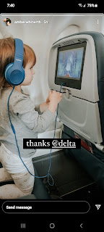

I have yet to get the details on their camping adventures, but they made it safely home to Stonewall late last night (Saturday night). I can just imagine the "how was your weekend" chatter when Weston goes back to work on Monday. "So, what did you do this weekend?" "Oh, we went camping . . . in IDAHO."

Friday:
While Scott was deep in his online Army course, I decided I'd better try to get out of my mental funk. My plan: to just dig in and start on my living room quilt. I got all 5 rows sewn and laid out on the floor. This coming week, I will put the rows all together so the whole top of the quilt will be done. I'll need to get some fabric for the back side and then I can finish it up.

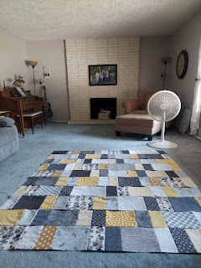

Let me talk for a minute about my mental funk from this past week. I don't really know where it came from or why it happened. I just know that for a few days, I didn't have much motivation to do much of anything. I had a list of things that I could - or SHOULD - do. But my brain just said, "Meh." And I would just walk away from my list. I'd like to think it was the summer heat that drained my usual motivation. More likely it was just me being more tired than usual. I'm okay with having
A
day of the blahs. But if it carries over into the second or third day, I'm starting to panic a little on the inside. Like, what is wrong with me? Am I a lazy butt or what? I am hugely driven to be productive as a human being on this planet. So when I'm not being productive, I feel lost. I know, I know. Resting IS being productive. It's conserving energy for upcoming tasks. But I still felt lost. And guilty. But I couldn't shake the slump I was in. I just had to ride it out. My strategy was to slow down and just roll with it, yet try to do at least ONE thing each day that I could be proud of. It seemed to work because after a few days, I felt better. I felt rested. And I felt motivated again.

As the Olympics have gotten underway this weekend, I love what our prophet had to say about it on Instagram.

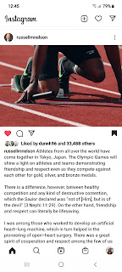

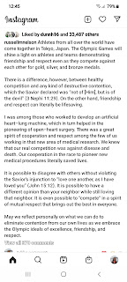

Scott decided to pay for a month of Peacock premium on our smart TV so that we can watch the Olympics whenever we want to. It's been great! ($5/month - and we'll stop once the Olympics are done) He's definitely the ring leader in this house as far as who is watching the Olympics, and he gets pretty pumped as he's watching too, ha ha. I'm excited for all the athletes to finally get their chance to shine!! And I love when the world comes together for a great cause!! GO TEAM USA!!

Jack-Jack is growing up. I am really looking forward to squishing him and playing with him when they come up to Idaho in a couple weeks. I love this picture of him: he just looks so big!! And his expression . . . I love him SO MUCH!!

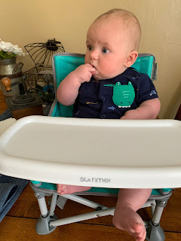

Scott and I went out to dinner Friday night. We used half of the gift card that I got for Mother's Day from our thoughtful children and went to Outback Steakhouse. It's the first time either of us has ever eaten here. I thought it was a little pricey, but we both agreed that the food was outstanding! Scott ordered the Outback Burger with fries, while I ordered the Alice Springs Chicken (with mushrooms, bacon and cheese with a honey-mustard dip) along with a sweet potato and caesar salad on the side.

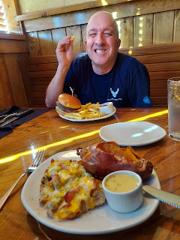

After we ate, we hit the greenbelt on the Snake River to help our food to digest. I pulled out my roller skates . . .

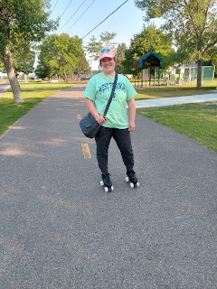

While Scott hopped on his bike to do some cross-training. Bicycling is a great way to stay physically fit when you need something super low impact. He says that when he rides, it helps tremendously to unkink his back. So he rode, while I skated. It was great!

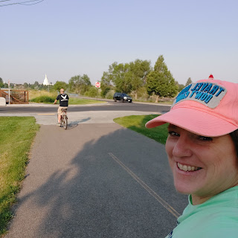

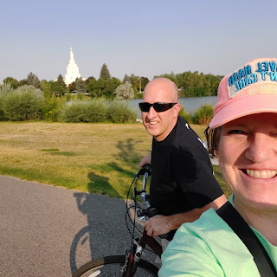

Click to watch a short video that I took while skating past the waterfalls. (10 seconds)
https://photos.app.goo.gl/Rq2WHSvFf5SzJVq56

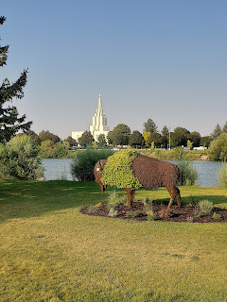

Saturday:
I finally felt like my motivation was back at full capacity, so I dug into some chores around the house (sweeping, mopping, dusting, etc.). It felt awesome. I listened to some inspiring songs while I cleaned - to get me in the right frame of mind to go to the temple later in the afternoon. I listened to "Scars in Heaven" by Casting Crowns, and "Your Love is Strong" by Cory Asbury, among others.

I signed us up for a temple session several weeks ago - which was such a joyful thing to do after the temples have been closed for so long. We enjoyed our date in the House of the Lord. It was quiet, peaceful, and heavenly.

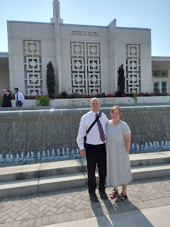

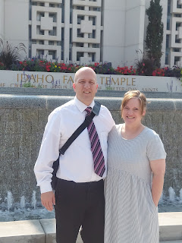

After we got back home, Scott settled in to watch the Olympics while I settled in to make a phone call to my friend Jenn. We had some catching up to do. OBVIOUSLY!! ha ha ha


It's always great to chat with Jenn. She is such an amazing woman, is an amazing mom to her kids,

and is an amazing human being. She has good morals and standards, she has a kind heart, she is forever the optimist, and she is such a good listener. I really love sharing things with her, knowing that she really, truly cares about whatever I am talking about. It could hypothetically be me talking about boring grilled cheese sandwiches, but she will still find a way to ask poignant questions and convey her sincere interest in whatever matters to me. She is a true friend. :)

Lastly, here are some Jack-Jack highlights. You're welcome.

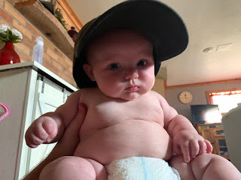

Out on the golf course with the other Grandma Michelle. (Hannah's mom)

Hole 1

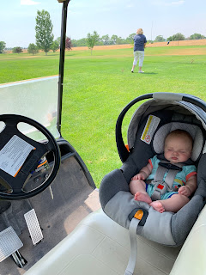

Hole 7

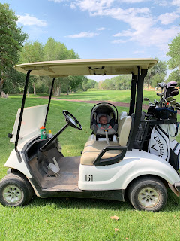

Video #1: Jack is just so excited he can hardly stand it! (15 seconds)

https://photos.app.goo.gl/B8sqbADxvppoMfHq7

Video #2: Mr. Smiley (22 seconds)
https://photos.app.goo.gl/PKbLpPNqYbhEw7Wt9
Video #3: Jacob sent this, calling it his "favorite video of Jack". Jack is laying on his daddy's tummy (1 minute, 9 seconds)
https://photos.app.goo.gl/gLLCVoSkVuqjY69j6

