Ice Cream, Apricots, and New Kitchen Countertops!
Jack says hello to everyone. In the most angelic way possible. :)


He has had a great week down in Utah with his parents and maternal grandparents.

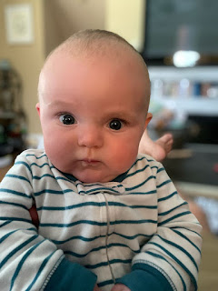

He even got to go golfing again! This time it was a little stormy and rainy at one point. He looked a little concerned in this video.

Jack at the golf course in the rain (12 seconds)
https://photos.app.goo.gl/KhBwVoaEkW2Y8yxVA

But he eventually went back to sleep, as usual.
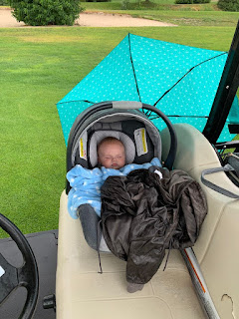

He is getting more and more chatty lately, which leads to some really delightful videos that his parents share with us regularly.

Video #1: Learning about all the ways he can test out his voice (1 min. 11 seconds)
https://photos.app.goo.gl/mgzXw4hDFbny47aVA

Video #2: Beating his bare chest as he practices the Haka dance (39 seconds)
https://photos.app.goo.gl/L4jMXCQFGwwxBvNT9

That little boy is such a joy! He is such a blessing to our whole family and we are grateful that he is such a wonderfully happy personality.

In Other News . . .

Monday:
Abby received the collection of Magic Treehouse books that I ordered for her - a set of 28 in all. She was so thrilled!! This picture is a little blurry - but Amber tried to share with me how happy Abby truly was while she hugged several of the books to her heart. :)



Gwen was pretty silly at one point during a Marco Polo video this week. I tried to get a couple of screenshots.



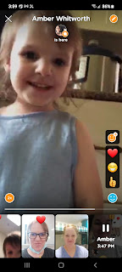

It's apricot season again. Yay?? That means that every day of the week, about a gallon of apricots drop to the ground and need to be picked up or cleaned up. I don't like to do this chore in the heat of the day, so I try to go out in the evenings when it's cooled off a bit. But once they hit the ground, they are on the clock, counting down to their demise. They get a bruise once they hit the sidewalk, and then the heat of the sun beats down on them all afternoon. Sometimes I'm throwing away equal amounts of good ones and bad ones by the time I get out there. Luckily some of them fall onto the softer grass or into the mulch below the tree.

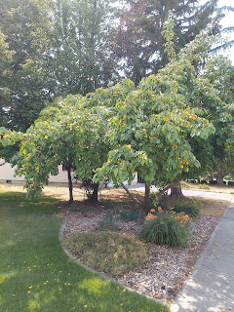

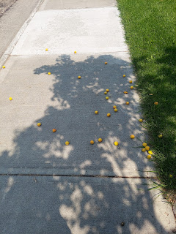

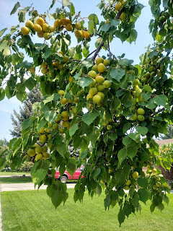

SO. MANY. OF. THEM.

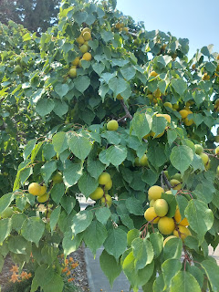

I made some homemade strawberry ice cream, using my new ice cream maker. I haven't had homemade ice cream in YEARS!!

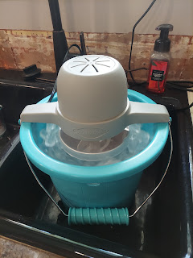

Video #1: Churning in my kitchen sink (26 seconds)
https://photos.app.goo.gl/89dGptPG9XSue7wD8

Video #2: The ice cream is all done. Yumm!! (13 seconds)
https://photos.app.goo.gl/b7wjAXXfGxdbFCpJ9

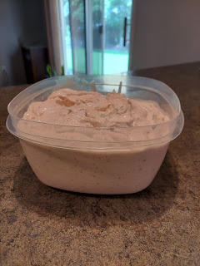

Here is the basic recipe that I followed:

https://suebeehomemaker.com/very-berry-strawberry-ice-cream/
I couldn't find any pasteurized eggs in the grocery store, so I used Egg Beaters (original style) instead, because the internet said they are safe to use as a replacement. Apparently, Egg Beaters can be used in cookie dough recipes that you want to eat in raw form and then you don't have to worry about getting salmonella. Good to know!
The ice cream was DELICOUS!! I love how simple it was to make, and I will be using that recipe many times in the future as well.
We were supposed to have some friends over for dinner that evening, which is why I was making homemade ice cream, but the wife ended up getting sick with the flu and they couldn't make it. So I decided to share some ice cream with Jasmine since she would be moving down to Salt Lake City the following morning.
I drove out to her house and got the full story of what had happened to her the week before. She had been packing up their belongings when she tripped over her son, Luke, who recently turned 3. She broke her ankle in 5 places and the tibia in her lower leg became completely unattached!! Holy smokes.
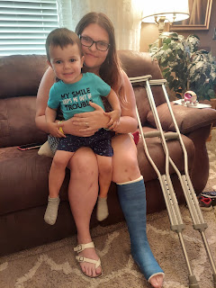
The orthopedic surgeon thinks that the tibia will re-attach on its own over the next 6 weeks, so they are hoping that she won't need surgery later on. In the meantime, she has this beautiful cast to protect it. She also has a knee scooter to get around, which is the recommended mode of transport, with crutches only to be used as a last resort. Not the best time to break your ankle, if there ever is a good time . . .
They moved down to Salt Lake City so her husband, Brandon, could be closer to all the treatments that he needs for his seizures. He was in a horrific car accident several years ago that took the lives of his 2 sisters and his mother, and has suffered with his own health issues ever since. Their life is not easy, but they are figuring it out and finding joy in being a family together.
Tuesday:
The Vances brought over their Maltese doggy, Sophie, whom we love as if she were a member of our own family. She is literally the most perfect dog in the world. She loves people, and loves to meet everyone she possibly can. She is content to just be near us in whatever we are doing, and usually ends up just finding a comfy place to lay down and sleep nearby.
She even kept me company outside as I picked up another couple gallons of apricots.
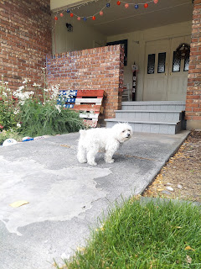

That little white object way off in the distance is Sophie, licking something interesting in the grass.

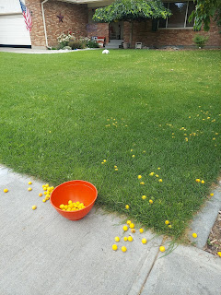

We also took Sophie with us to the store, much to her delight.

Video of Sophie basking in the breeze out the car window. (7 seconds)
https://photos.app.goo.gl/9fh4tMnJTPmnyDcY9

Scott felt well enough to change out our rear brakes again, with a semi-metallic version this time. (Different than what he previously installed, which were ceramic I believe) They've been squeaking and squealing so annoyingly for weeks. But now they are magically quiet! How nice. :) And how nice that his back was feeling better to be able to do that.

Later that evening, my young women's class came over to decorate cute jars for girls camp as a gift for their "secret sister". They drew names recently for a girl that they can do something nice for each day up at camp anonymously. On the last day, they will reveal themselves.

I wanted them to have at least one nice thing that they could give as a gift, so we made a "tent light". I ordered plastic jars and small strands of "fairy lights" from Amazon.

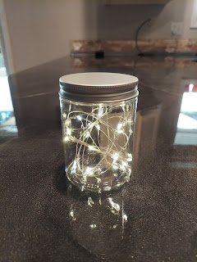

Then the girls decorated them with colored Sharpie markers, or with gold paint, like Mercedes in the middle. When the switch is turned on, it makes a really nice nightlight for use in the tent, or even for their room when they get home from camp. Mercedes and Mara, on the right, had a small paint fight while decorating, ha ha.

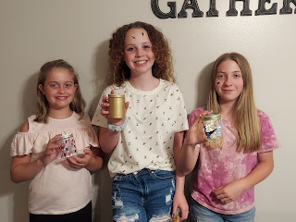

Wednesday:
I can't even remember what I did that day, LOL. But Amber sent this darling picture of Abby, curled up on her bed while reading a Magic Treehouse book. :)

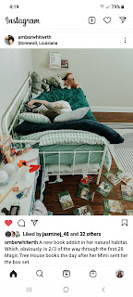

The small print that Amber shared on Instagram says: "A new book addict in her natural habitat. Which, obviously, is 2/3 of the way through the first 28 Magic Tree House books the day after her Mimi sent her the box set."

Also, Kylie landed safely in Salt Lake City the night before. She stayed the night in a hotel with her step-mom Nicole, hoping to allow Kylie an opportunity to rest. Even though she woke up at 2 a.m. and couldn't get back to sleep, they had a good appointment on the Air Force Base down there on Wednesday morning, getting her government-issued passport started. Now, we wait.

Thursday:
I had a video chat with Kylie from across town. She has a good plan in place for the next few months. In September, she can use her regular passport to travel back to Italy for a "visit", as long as it's less than 90 days. She can have her baby in Italy, and the hope is that the borders will stay open so that Nicole can bring Kylie's gov't - issued passport and Visa in November when the baby is born. Then, when Kylie is feeling up to traveling (as soon as possible) after the baby comes, she will need to travel back to the U.S. to get her new passport and Visa stamped. She can then return immediately to Italy and live happily ever after. This is the HOPE anyway!



There are reports of the Delta Variant (of Covid-19) spreading like wildfire across the globe, which is a huge cause for concern! Some countries have implemented mask mandates again, and Italy is already bracing for another painful round of the pandemic with their elderly and fragile population. I'm hoping (and praying) that other precautionary measures will suffice instead of closing the borders and locking everything down. I'd be happy to wear a mask if it meant that I can still travel this fall, and also in December when we want to go see our new granddaughter. I'm already vaccinated, so that means that I am protected from any horrible symptoms if I should happen to get the coronavirus. What they are finding though, is that because so many people have opted out of getting vaccinated, it is still spreading. I can inadvertently share the virus even if I'm vaccinated. It protects
me
from getting really sick, but I can still spread it. We just need more people to get vaccinated!! If more people are vaccinated, then we can slow this whole pandemic down and bring it to its knees. If we want to have a semi-normal life, being able to go shopping, enjoy forms of public entertainment, allow our children to attend school in a normal and reliable way, etc. - then we have to be willing to do our part by getting the vaccine. I hope that record numbers of people get out there in the coming weeks to get their shots!! I want to be able to travel and see my family around the globe!!!!!!

Sophie decided to lay down in the hot sun, in the moist dirt of my strawberry patch, for a little rest. Weirdo! She didn't seem to notice the more reasonable patio that was cooler because of the sun shades hanging above.

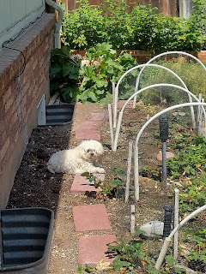

I finally had the gumption to finish the quilt for the living room. First I sewed the rows all together, then added the batting and backing. I like the method where you sew right sides together, all except for about 18 inches on one side. Then I turn it all right side out and finish sewing up the 18 inch opening.

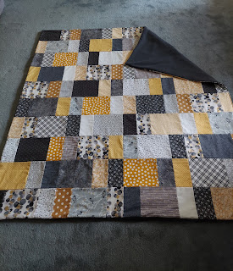

Next up it was time to tie the quilt. I chose black yarn for the job. :) You can see Sophie helping substantially on the couch. She was quite the cheerleader.

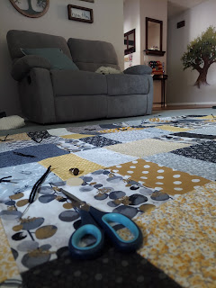



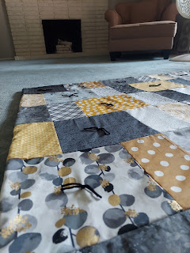

All done! Now it's hanging on my quilt rack in the living room, just waiting for cooler and crisper days in the fall and coming winter.

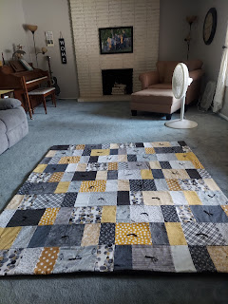

That evening, Scott and I changed out the guest bed upstairs to a new frame. The old bedframe was having some structural issues, plus it was so low to the ground that we couldn't put much of anything underneath for storage. The new bedframe is much taller, which allows for storage totes to fit underneath.

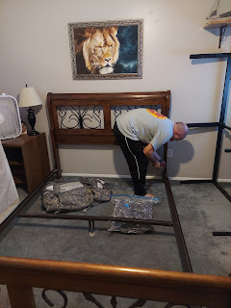

And then we ate our favorite dinner as of late. We grill some type of meat, such as pork or carne asada, and then put it on top of a nice chef salad. It's very filling and very healthy, as well as an easy dinner to prepare on a hot summer's night. Scott asks me every day, "Are we having steak salad tonight? Because that's my favorite!"

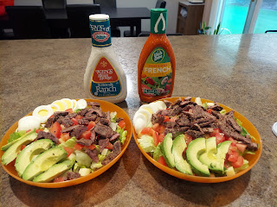

Here's Gwen out in Stonewall, our little cutie patootie, with a beautiful sunset behind her.

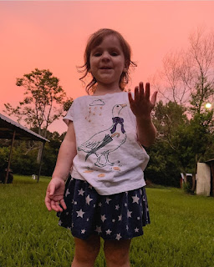

Friday:
I headed out mid-morning to pick up 2 days' worth of apricots. Sigh. There was a lot of cleanup to be done. After I cleaned up the ground, sorting the good ones from the bad ones, I decided it was time to take a preemptive strike. I grabbed our tall ladder and set it up under the apricot tree to start picking the fruit FROM the tree, instead of bending over picking them up off the ground.

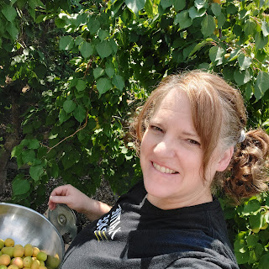

THREE hours later, I had gotten all that I could reach. Scott came out to check on me around that same time, saying emphatically, "OKAY, you're done young lady." He was worried I was going to get heat stroke because it was getting so darn hot out there!

I loaded all the fruit into boxes to take over to our Community Food Basket, our local food bank. Interestingly, they weighed all the boxes upon arrival, so they could record what the amount was for donation. Guess how many pounds of apricots I picked. GUESS!! I'll tell you in a minute how many pounds. Here is the picture of the boxes stashed in my trunk for transport.

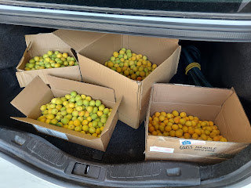

Later that day, after Scott was done with his online Army classes, we started on our kitchen countertops!! First, we had to get the kitchen sink out of the way.

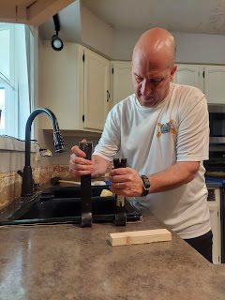

And we had to get all the plastic sheeting secured so we didn't damage the cabinets and floors.

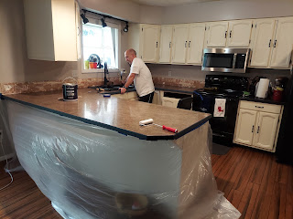

When it came time to lift the sink out, Scott grabbed one side and I grabbed the other. I was lifting with ALL MY MIGHT but it only came up about 2 inches on my side. Meanwhile, Scott had his side up about 10 inches. He wisecracked, "Are you even lifting??" I retorted back, "Are you calling me WEAK?!!" But seriously, it was too much for my short stature. I didn't have enough height to get any torque. He somehow managed to get it up and turned slightly so that it was cocked at an angle, and resting on the edges of the cutout for the sink. Once it was at that point, up out of the hole, I could heft it just enough to get it over to a temporary resting place on the floor. It's made out of cast iron, and it probably weighed about 200 lbs. Maybe not quite that much, but it was probably the heaviest thing I've ever had to lift.

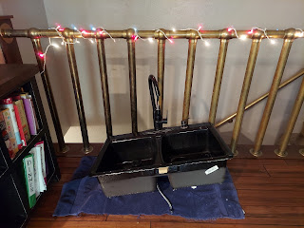

Next, I had the privilege of painting the bonding primer on all the countertops. A bonding primer allows us to add the epoxy layer on top without having to sand the surface first.

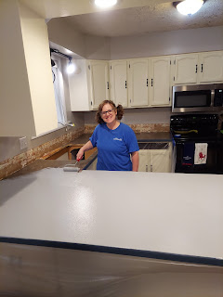

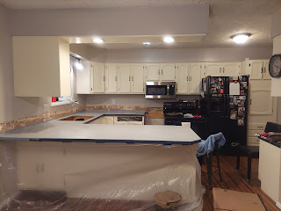

Then I painted all the edges black. This isn't necessary, but it sure helps because the epoxy drips down the sides and gets thin at times. It helps to have the edges painted the same color as what the countertops will be, just in case it gets a little too thin.

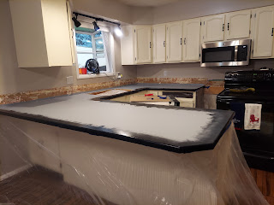

Scott mixed up the epoxy with the resin in an old ice cream bucket that we had in the garage. A perfect size for this job!

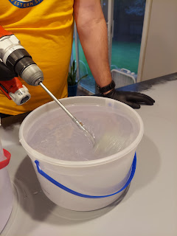

It was mesmerizing to watch, so I took this short video. (4 seconds)
https://photos.app.goo.gl/ydbz8keZkaAtojLc8

Next, he added several "spoonfuls" of black metallic mica powder. He was scooping with a small stirring stick. (tongue depressor size)
Video: (33 seconds)
https://photos.app.goo.gl/hTRPQeAZETXTnGQY9

Video of him stirring the mica powder into the "goo": (21 seconds)

https://photos.app.goo.gl/KX1FhPLfDK3SNv9H6

Then it looked like this after a couple minutes of stirring.

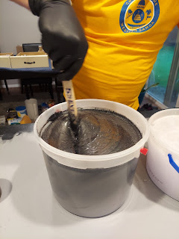

Time to pour it out on the first section of countertop, the section next to the oven. (which we pulled out from the wall to get it out of the way)

Video of the 1st pour: (10 seconds)
https://photos.app.goo.gl/KkN93JbMjk6DS6jS8

Between us both, we used a foam roller to push the epoxy around and even out the layer. It doesn't dry fast, so we weren't too stressed at this point.

After the first section of countertop was satisfactorily spread out, Scott poured out the 2nd batch onto the bigger section of counter where we do all the food prep.

Video of the 2nd pour: (13 seconds)
https://photos.app.goo.gl/p5JEkagk2nkbroMJ8

The bottom half of the bucket had a weird reaction at this point. We noticed that when we poured out the second half, it was very hot and turned thick really fast. It was like trying to roll out bread dough instead of a thick glue-like consistency. We began to panic at this point! I kept rolling it out as thinly as possible while Scott hurried and made another batch of epoxy. When we added the 3rd batch, it began to settle down a little bit and we worked hard to blend the two distinct consistencies. We have no idea what happened or why that middle batch had a chemical reaction like that!

But what ended up as the final result was some texture interest and dynamic that we wouldn't have had otherwise. It's not something we'd want to repeat necessarily, but at least it turned out okay in the end.

Video Tour #1: (one minute, 24 seconds)
https://photos.app.goo.gl/oRHe5dWTpx8JuFCZ9

Video Tour #2: (13 seconds)
https://photos.app.goo.gl/Lri2LZmCcBuFEXvi8

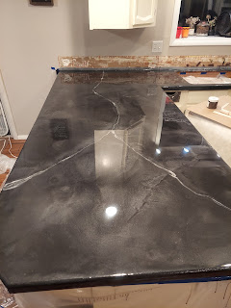

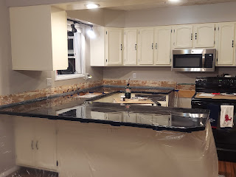

We spent another couple hours that evening coming back to check on it every 15 minutes or so, to scrape underneath the edges to clean up any drips. Otherwise it would become a permanent stalagmite!

The miracle of this whole adventure, is that WITH all the practice boards and experimenting that we did, our new kitchen countertops cost us less than $200 with all the supplies we have purchased!! We also still have plenty left over . . . so that's pretty amazing when you consider the alternatives and how pricey they can be!!

Saturday:
It was nice to wake up to a pretty solid countertop that had set up overnight. That's the main reason we decided to do it Friday night, instead of Saturday morning.

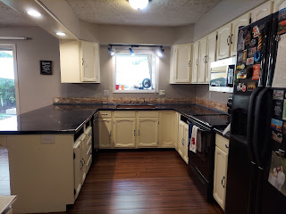

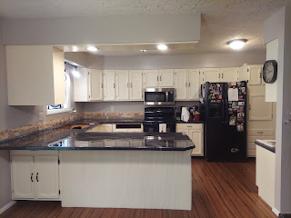

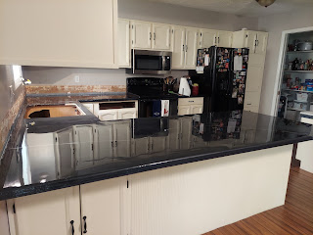

Later in the afternoon, we had a friend, Stephen Blatter, come over with his strong back and shoulder muscles to help get the kitchen sink back in.

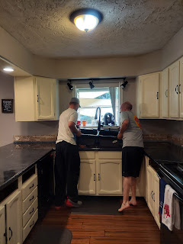

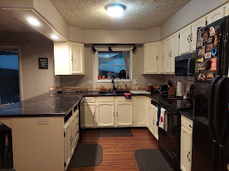

You may notice that some of the drawers are missing still. That's because I took the time to touch up some dings on the drawer fronts while they were moved out of the kitchen for 2 days. We figured it would be wise to take the most commonly used drawers and lay them over on the dining table while all the plastic sheeting was blocking us from using them. So now, any and all dings on the cabinets have all been touched up and updated with a fresh coat of primer and paint. The kitchen is looking ship shape again! Yay!

Sunday:
Things are starting to pick up the pace - now that it's August 1st. There are a lot of things on deck, with a multitude of details to keep track of. I hope I don't forget anything important! Bright and early on Tuesday morning, I head up into the mountains for girls camp. There will be about 225 campers total, including the adult leaders. Approximately 45 are from our ward, including the adults. We will be camping in tents, but there is a big lodge on the property for dinners and other gatherings. I hope all goes well and that we return home safely on Saturday.

We also have a lot of family coming and going in the coming weeks. I will make a spreadsheet soon to hopefully keep all the details straight, per my younger sister's suggestion. We have babies coming this month, weddings, baby showers, big church activities that I'm in charge of, etc. And we'll finally get to see our son Benson in a couple weeks!! I can't wait!

Final two bits:

We had a lovely family dinner at Scott's parents' house this afternoon, along with Marissa, her daughter Azure, her sister Jessie, and us. It was great to hang out and visit together, and entertain little Azure outside in the back yard. She had a great time playing in the rock fountain for a really long time.

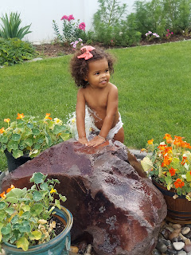

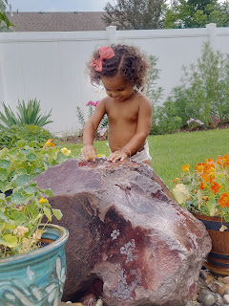



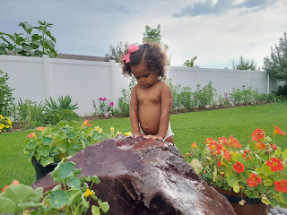

While we were there in Rigby, Kylie texted me saying that her dad was in a dirt bike accident today that left him with several broken ribs and a collapsed lung. He headed into surgery soon after she texted me. I know she is worried, and I would be too! If you are the praying sort, please pray for him. His name is Todd. Thank you in advance. :)

# of pounds of Apricots = 44

