I Survived a Week of Girls Camp!
Girls Camp is all done! Hooray - now I can get a little more sleep! ha ha But seriously, it was really fun! The girls are amazing and I really enjoyed spending 5 days with them in such a beautiful setting.
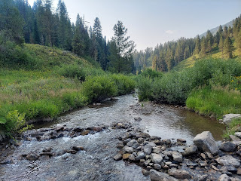

Monday:
I finally got to see Kylie!!!! She looks so beautiful and amazing as she progresses in her pregnancy. I hugged her for a long time and suggested that we just hug the entire time of our visit and never let go, ha ha.
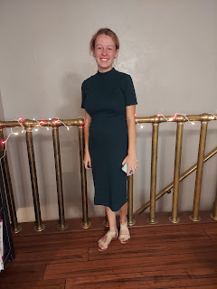
She is trying to do a gluten-free diet lately to see if that is the culprit for her internal issues. Instead of gaining weight during her pregnancy, she is still losing weight. It's a hard dietary experiment to conduct. I don't know if I could do it! Anyway, hopefully she will be blessed with good health for herself as well as good health for the baby.
The rest of the day, I packed. And packed. And packed. And packed.
Tuesday:
Bright and early (7:30 a.m.), I headed up to West Piney Girls Camp with a handful of adult leaders and about 8 youth leaders. The camp is located about an hour east of Idaho Falls, in between Swan Valley and Victor, Idaho, and just east of Pine Creek Pass. It's up in the glorious mountains where the temperatures are a little cooler and the water is clear and fresh.
There was a light fog on the drive to West Piney, blanketing the farmer's fields along the way.
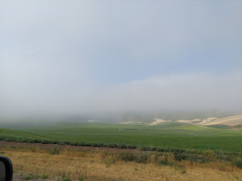

Lingering fog along the Snake River in Swan Valley

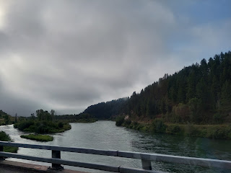

We arrived into camp, with a long string of other arrivals. (About 225 campers total by the time everyone arrived) The camp missionaries directed us where to go and even provided someone to back in the trailer that Barb Vance was hauling up (full of camp gear, food for the week, and all the kitchen items you could ever want out in the wilderness!).

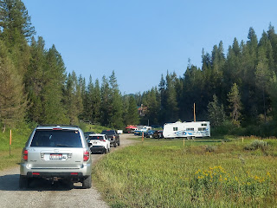

They had everyone park in the lower parking lot (seen above) once everything was unloaded. The rule was that we had to park backed in. This was just in case at any point we might need to leave in a hurry, such as a forest fire. It's just much faster to jump in and immediately drive off, instead of having to wait for each person to back up and then go. Very smart!

First order of business: Set up the tents. The youth leaders were in charge of this, but we had a handful of adults (including a couple of adult men from our ward) to help them. At one point, we noticed that a hummingbird was stuck in one of the tents, fluttering around trying to find its way out. One of the girls, McKenna, was brave enough to gently and patiently wait for the right moment to cup it in her hands and help it get out safely. Somehow I was able to get my phone out just in time and click the button right before the bird was free and gone!! This was just the first of many experiences with hummingbirds this past week. :)

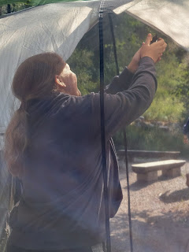

These two tents are where all the adult women leaders slept each night. Mine was the one on the left. I was very comfy each night as I slept on my army cot with a nice thick foam pad on top. :)

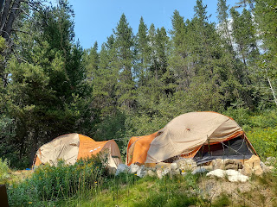

We had several bushes of berries all around our camp. At first, I thought they were huckleberries, and I even ate one because I was so sure! But it had seeds in it, so I knew it couldn't be a huckleberry. I looked it up today (we had zero internet or cellphone reception up there) and I'm pretty sure they were serviceberries. Apparently, it is a very good berry with an abundance of nutrients.

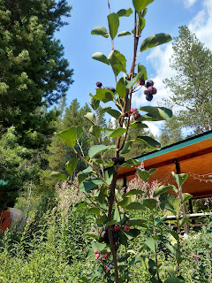

Down the hill from our camp site, there is a beautiful meadow with several games and activities (giant sized chess, archery, a rock climbing wall, outdoor bowling, a swing-set, and a giant alpine slide! The West Piney Lodge sits at the top of the stairs, alongside the slide.

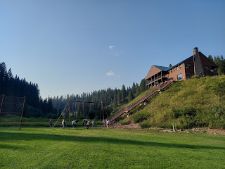

Here is a video of Mercedes going down the slide for the first time: (7 seconds)
https://photos.app.goo.gl/hnQMeaBW1vfPo3LS7

That same evening, after camp had been set up, after the girls all arrived and got settled in, and after a nice dinner, we all hung out down in the meadow and had some fun.

Aari, one the girls in my class (11 years old), loved hanging out by the creek. I sat on the little bridge over the creek and just dangled my legs and supervised, taking in all the beauty around me.

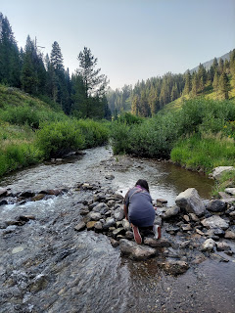

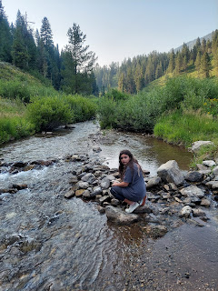

That night, I got 4.5 hours of sleep. I mean, let's face it, the girls love to giggle into the wee hours of the morning! Even with my ear plugs, it was hard to sleep. But I still love them.

Wednesday:
I got up extra early because my girls were in charge of the breakfast prep. I had to get up early enough to get myself ready for the day first - so that I was in a good position to then get them out of bed and help them get into gear. Lucky for me, these girls are amazing! Even though they laughed and partied late into the night, as soon as I knocked on their tent at 7 a.m. and told them it was time to wake up, they woke right up and within a couple of minutes they were over in the "kitchen" area to lend a hand. Wow. Amazing.

Later that morning, we had a special "class" to attend, called Hilltops. It's usually in a serene setting, away from any hustle and bustle of camp, where a handful of youth leaders take turns speaking to the girls and teaching them a gospel principle from personal experience. It's quite impactful for the girls to hear from an older peer, because whatever they say is very relatable.

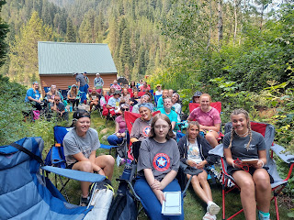

I took a few notes myself, and learned a lot from the 4 girls who spoke. The first girl taught that even when you are in a dark place in your life, you can be positive and look to the light - the light of the Gospel, the light of the holy temple, and even the light of our Savior Jesus Christ.

The second girl taught that heroism is humble and quiet, such as sending an inspired text to lift someone up, or delivering a loaf of warm bread.

Our theme for girls camp was "The Hero Within", so each day there was a focus on what that means:
Who am I?
Finding Your Inner Hero
True Greatness
Finding Joy in the Small and Simple
A Hero's Journey

I REALLY loved what the third girl taught. She asked the girls to picture themselves at 75 years old, and asked us, "What might a gallery of picture frames hold that tells the story of your life?" In other words, what have my priorities been throughout my life?

She handed out a worksheet for them to doodle on during her talk (something that a lot of the girls love to do!). She had them draw some simple items in the picture frames on one side of the worksheet, to represent what their life's priorities will have been by the time they reach 75.

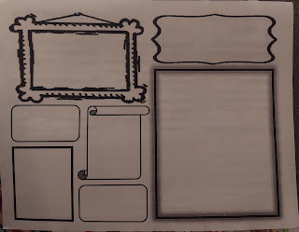

Then she had them list on the other side what are some of their life mottos, what do they spend their time on, and a list of 5 things they are great at. I thought it was fabulous, and very applicable. At the end of Hilltops, I was able to get my own copy of the worksheet and have been thinking a great deal about my own life, what are my priorities, and do they matter as much as I think they should.

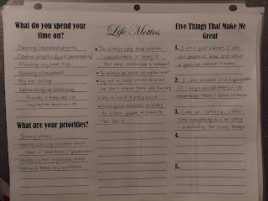

The fourth girl taught that "Bravery is not a lack of fear, it's continuing on in spite of your fear."

I was moved to tears at one point, realizing just how wonderful these young ladies truly are. They are strong, they are articulate and full of faith, they are authentic as they share raw and tender moments of their life's journey and how they worked to overcome something, and they try really hard to just keep going. I know that our Heavenly Parents are so proud of them and love them so very much.

After the presentation was over, I captured this beautiful hillside trail on our way back to our camp.

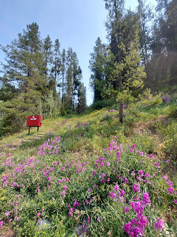

Later that evening, after another filling dinner, the girls did their first cleaning assignment. They had to help clean the bathrooms: empty garbage cans, clean sinks and surfaces, and sweep and mop the floors. They did it all with a smile! :)

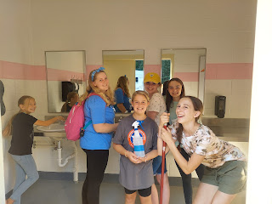

When they were done, they spent several minutes trying to gain the trust of the dozens of hummingbirds that hang out in front of the camp missionaries' trailer.

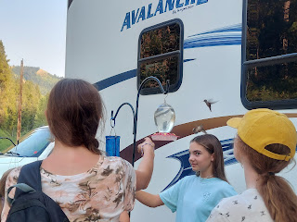

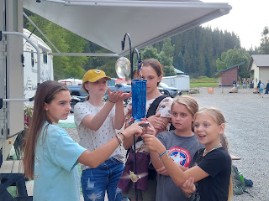

They really enjoyed it when the hummingbirds would eventually land on their hand or on their finger.

Each day, morning and night, we would have Roll Call and Flag Ceremony. Roll call was a chance for each ward to sing or say a little ditty for fun. Here is an example of what another ward did one night. They went way above and beyond what we normally do, but it was hugely entertaining!!

Click to watch their "ditty": (1 min, 39 seconds)
https://photos.app.goo.gl/tv9MCS4BpQfXDDuK8

After flag ceremony, there were a couple of devotionals by some of the stake youth leaders. One girl, Madi Tolson, shared how she lacked confidence in herself for a few years, which caused her to be angry and frustrated all the time, and she even began eating less and less, causing a whole new set of problems for herself. Eventually, she began to recognize that Satan was getting into her head and into her soul. She decided that she wanted to reclaim her life so she could have joy and peace and contentment. She has come a long way in the past several months, sharing that she was grateful for Covid-19 because it pulled her out of school (when the schools went online) and away from the friends that were a negative influence on her. She spent more time with her family who loved her and tried to build her up. She spent more time on her knees and more time reading scriptures and listening to God's voice telling her that she is enough and that she is loved.

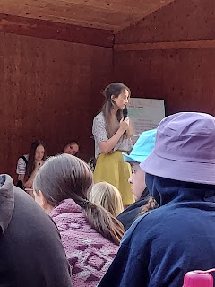

She eloquently taught that: "Satan works hard to get into your head. Don't let him! If you let him tell you that you're not good enough, then he wins. Don't let him win!!"

The other talk that I really liked that evening was by Kira Musingi. She encouraged us to find out what our strengths are. She said, "It's okay to discover what our weaknesses are, but don't let that become our focus. Just find out where you're uncomfortable and then focus on improving that thing." She also taught, "Don't try to be famous in the world's eyes. Just focus on being famous in God's eyes."

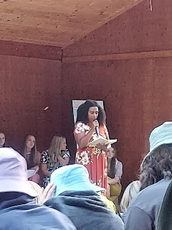

Later that night, after dark had settled in, all the wards quietly assembled down in the meadow. We were able to walk - one group at a time - down a lighted path and over to our assigned location for "Singing Trees." (more on that in a second)

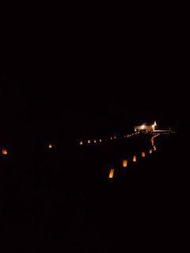

Along the lighted path, there were multiple white paper bag lanterns with what we had written earlier in the day. The prompt was: I feel the love of my Heavenly Father when . . .

At one point as we quietly walked along, I found MY lantern!! Here's what mine said: I feel the love of my Heavenly Father when - I feel comforted during a difficult struggle. I feel like if He could put His arms around me to hug me, He would. :)"

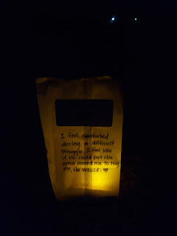

So, Singing Trees is when each ward gathers in a spot a little ways away from everyone else. When it's our turn, we turn our flashlights on and sing a sacred song together. When we're done, we turn our flashlights off, and then it's the next group's turn. It can be done in the forest, or in this case, we did ours in the meadow. A couple of the groups were lucky to be under an actual tree, such as this group. I thought it was really beautiful how the lighting underneath the tree complimented their group.

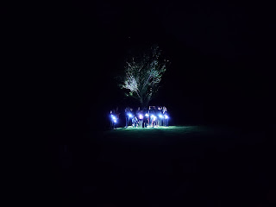

I video'd the first verse of our ward singing "If the Savior Stood Beside Me".

Click here to watch: (48 seconds)
https://photos.app.goo.gl/W1MqQfHaYpjq9PLD6

I got 4 hours of sleep Wednesday night. :)

Thursday:
We had a little camp mascot that we dubbed, "Chubby". It was a little marmot that liked to come and nibble on any droppings from the cooking area. We were happy to have him around, cleaning up after us, because it was better to have him in our camp than to have a bear in the middle of the night!

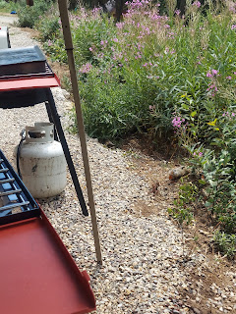

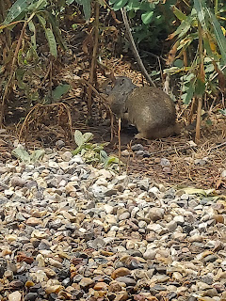

On our first day, I noticed that these 3 Porta-Potties were closer to our camp than the flushing toilets were down the hill and down by the meadow. Sometimes you just need convenience, but sometimes you'd rather have something classier. As I went to use a Porta-Potty for the first time, I noticed that the one on the left said "First Class". I decided that whenever I had to choose proximity over pristine, I would use the First Class Potty. :)

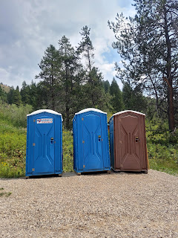

A couple of our older girls took some younger girls on a hike that afternoon. They took a walkie-talkie and one of my honking bike horns to help ward off any potential bears. They had a lovely time! (I brought 2 bike horns because they're great at letting everyone know it's time to gather, or even as a tool to get everyone up in the mornings, lol)

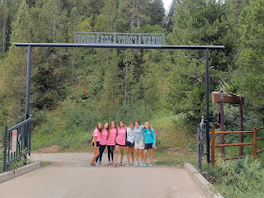

The stake set up some fun and games in the meadow for the afternoon, along with some learning activities. For this station, the girls wrote down their name and put it into a bowl. They drew a name out and that's who they would make and decorate a donut for. The donuts were handmade, and the girls helped to shape the dough and form the hole. After an adult leader fried it in the oil and placed it on the paper towels, each girl could decorate it with maple glaze or coconut glaze, sprinkles, slivered almonds, a chocolate drizzle, etc.

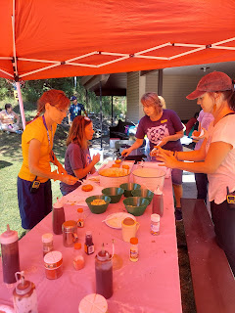

Here's mine. Best donut I've ever had in my life!!

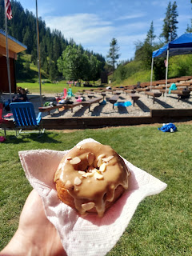

A member of our stake presidency, Nate Hunsaker, then taught the girls (as they ate) that the gospel of Jesus Christ is sweet and delicious. If it is so wonderful and delicious to US, then we should think about who we can share that with. It was a great message, and very poignant as they ate their sweet treat in the heat of the afternoon.

Just as we were getting ready to begin our evening flag ceremony, lightning and thunder began, and then shortly afterwards, a torrential downpour. We skipped taking down the flag and instead ran for cover. There are 3 covered pavilions next to the amphitheater, which is where we all huddled for about an hour.

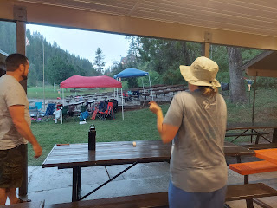

The girls could have been upset and bored, but instead, they began singing and even having a dance-off between the pavilion groups. It was super fun! Loud - but fun.

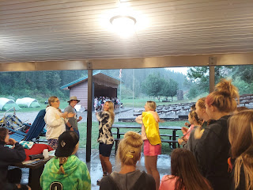

Eventually, the rain and bad weather cleared up enough for us to continue. We took down the flag and prepared to perform our skits.

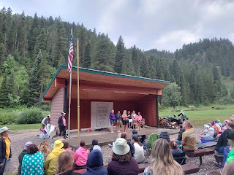

Our skit was based off of a Studio C skit where we reminisced back and forth from what camp used to be back in the olden days compared to now. The girls wrote it themselves. We are gathered around a "campfire", which is played by Brinlee in the center. At the end, they compared doing hard things at girls camp to how Esther in the Bible was brave and did hard things too.

You can watch it here: (I'm a "tree" in the back on the far right) (1 minute, 56 seconds)
https://photos.app.goo.gl/gCoNja49RbrxzzNN9

After our skits were done, we scurried back up to our camps to see if our tents had survived the rainstorm. Thankfully, we had done a good job securing the rain fly on each of the 8 tents in our camp, and I had dug a little trench behind the Level One tent on Tuesday when we were setting up, since it was right next to a hillside and we knew that we might get some rain later in the week.

I got a fabulous 6 hours of sleep Thursday night. It felt amazing! I attribute it to the fact that the weather corralled us in our tents. The girls were also keenly aware that in order to try to pull an all-nighter on Friday night, they'd better try to get some rest the night before. LOL I don't care the reasons, I just felt grateful that I got more than the 2 previous nights!

Friday:
We were supposed to go to the lake for boating, kayaking and paddle-boarding all day. But the weather was still cloudy and drizzly, it was
very
cold, and the Bishop drove out of camp far enough to get a signal so he could check the weather report. We were due for more rain and storms that afternoon. So we came up with a great Plan B: we'd drive instead over to Green Canyon Hot Springs (east of Rexburg) and go swimming for a while.

We packed up our lunch, which consisted of Walking Tacos (taco salad with all the toppings inside small individual bags of Doritos, along with cut up watermelon and pudding cups. Then we piled into all of our cars and drove to Green Canyon. The indoor hot pool was amazing - I got right in and it felt like luxury. I played water volleyball for about 2 hours with the girls - it was SO FUN!! I'm so glad we went there and had a relaxing time in the warm water, versus being out in the cold and rainy outdoors.

On the way back to camp, the girls in our car were having so much fun singing and dancing in the back seat. I had to take at least one video.

Click to watch their fun: (51 seconds)
https://photos.app.goo.gl/KvV54UeM9HFSiAjB8

The bishopric provided our dinner, which consisted of various pans of pasta (lasagna, penne with white sauce and broccoli, and a third one that I can't remember), Caesar salad, and a very unique dessert.

Look closely. It's hostess cherry and apple pies, heated in a roaster oven!! Genius, right!?! My cherry pie wasn't that tasty, but it was warm. We were all freezing, so that was nice.

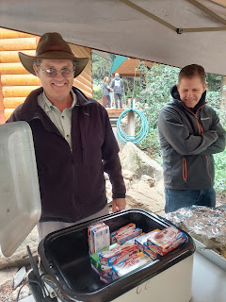

After dinner, McKenna got to work chopping some firewood for our campfire later that night. She was like a regular lumberjack, that one. :)

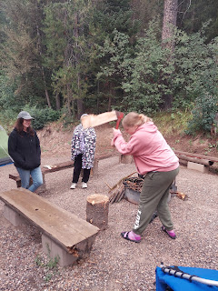

We had a special fireside up at the lodge, where we got to listen to our stake presidency share a message with us. It was long, but good. I loved how Brielle was leaning on Mercedes' shoulder at one point. So sweet, those girls of mine. :)

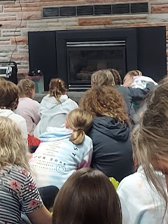

After two hours of listening to gospel messages up in the Lodge, it was time for the girls to let a little bit of their wild side come out, ha ha. Jessie and Abi prepped the fire and enjoyed tearing up leftover cardboard boxes from our afternoon snacks to throw into the flames.

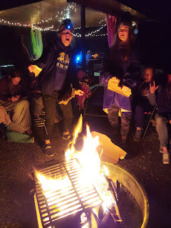

Eventually, they settled down around the comforting flames to share their heartfelt testimonies of what they learned and grew to realize about themselves during the week of girls camp. It was just lovely.

I went to bed around 2:00 a.m. and fell asleep sometime around 2:30. When I woke up at 6:45 a.m. I realized that I was in the exact same position as when I went to sleep. I didn't move once the entire time! ha ha ha ha

I got about 4.25 hours of sleep that last night.

Saturday:
We got up nice and early to start packing up and cleaning our campsites. Once that was all done, we took a group photo before leaving to drive home. This isn't everyone in the photo because a few girls had to leave early for sports team auditions or a family reunion.

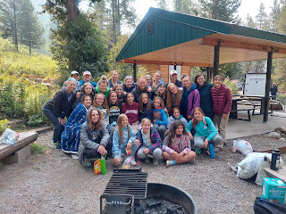

It was a great week, no sleep, but a great week! I'm glad it's over, too. I came home pretty tired. Because of the rain and subsequent messy tents, we all had to go over to our Young Women president's house (after we had a little bit of time to shower first at home), in order to get the tents all cleaned up for storage. I helped for about 2 hours in the heat of the afternoon and then came home and collapsed. I was toast for the rest of the day. I closed my eyes for about 45 minutes before dinner because I couldn't keep them open any longer. And I went to bed at 9:00 p.m., which is quite early for me. I felt like a zombie and was not capable of any conversation whatsoever.

I slept amazingly well for the first time in days. Go figure! I got about 9 hours of sleep. It was fantastic.

In Other News . . .

Abby started school this week! She's in the 1st grade and has done very well so far! She's much more advanced as a reader than the bulk of the class, so tends to get a little bored with the easier reading assignments so far. But she is making friends and enjoys eating in the cafeteria.

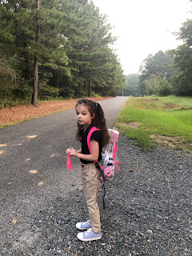

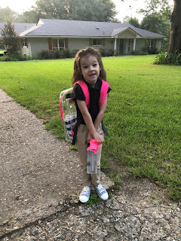

She has the lunch menu posted next to her bed at home, so she can see in advance what the next day's lunch will be.

She also shared with us that her favorite subject is MATH. She ran off to grab this cute worksheet that she did in class that demonstrates all the combinations of numbers that add up to 10. (We were on a group video chat, and I went and laid down on the living room floor partway in, because I was tired again.)

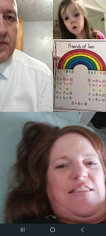

Amber and her family had a great weekend getaway up in Hot Springs, Arkansas at a beautiful home owned by a fellow ophthalmologist. It's basically a resort and is right on a lake. They had a wonderful time and made it home safely earlier today.

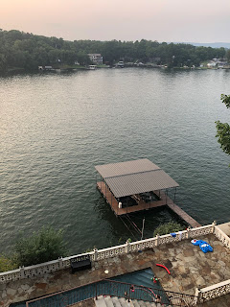

Gwen absolutely LOVES helping Weston when he mows the lawn. Just watch this darling video and see the perfect joy on her face when he lets her take the wheel.
(32 seconds)
https://photos.app.goo.gl/UP5MuPragXkRKz3F7

She also very proudly showed us the airplane she built out of magna-tiles. (on our video chat today - Sunday)

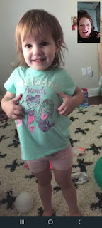

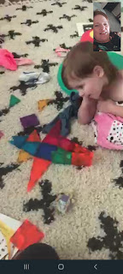

It was nice to have a little family chat again. We were just missing our Benson and Kylie.

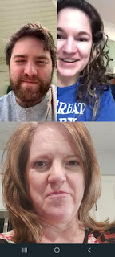

Jack is just as cute as ever! Here he is holding a bottle of Siracha sauce. Just because he can, I guess.

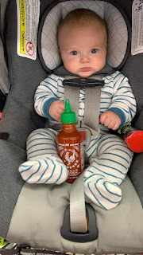

And some Jack videos for your watching pleasure.

Video #1: Jack telling us what he thinks about laying in the grass (16 seconds)
https://photos.app.goo.gl/Yt6HUyWjEXEtB9D1A

Video #2: Up close and personal, with lots of eyebrows (1 minute, 11 seconds)
https://photos.app.goo.gl/aCV5YYP9bM7ZiMWJ6

Video #3: Standing on his own - with a little help (5 seconds)
https://photos.app.goo.gl/uyrxme8rznW7SqBN7

Have a great week everyone! I know I will! :)

