The Fam is Gathering!!
When my children and grandchildren come to visit me, it makes me so happy!! No matter what else is going on in the world, if I can just see my children and hug them, then all is well.
I choose happy!!
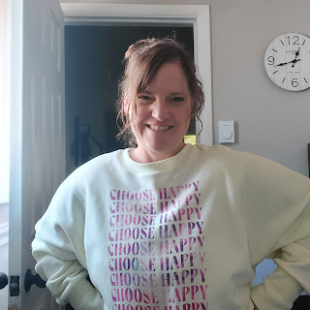

Monday:
I took Kylie out to lunch at the Black Bear Diner. Our server was from Tunisia and got super excited when he saw Kylie's hoodie with "Italia" and some of the regions from Italy on it! He said his favorite language is Italian, having worked on several cruise ships in the Mediterranean in recent years. When I asked how he ended up in Idaho Falls, he said it was because he followed his heart. Awwww.

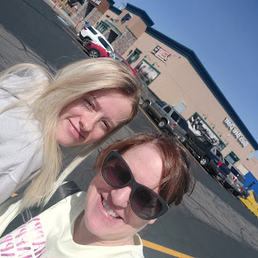

After our lunch at the diner, we went to the fabric store to pick out a few items so that I can begin working on a small baby rag quilt. I love the colors that she chose!

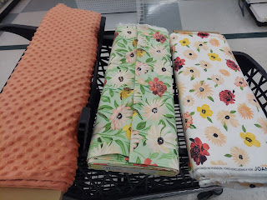

Scott also gave Sophie a bath. She is always so willing to just go along with whatever we ask of her. What a good doggie!



Tuesday:
While Scott worked on his online Army classes, I went and got a haircut. Later that evening, I helped the young women pass out fliers for an upcoming Neighborhood BBQ again. This time, I drove the truck slowly along with the tailgate down, which allowed the girls to happily hop in and out of the truck-bed as we drove through the neighborhood. As soon as we were done delivering fliers, we met up at the church to enjoy a post-girls-camp slideshow with all the other girls from our stake. It's ALWAYS great to look back and see the highlights of girls camp, especially once you're on the other side of it, ha ha.

Wednesday:
I went to my monthly massage, and wow it was such perfect timing! I got rid of all the stress of girls camp and everything else in my life. I felt like a limp noodle for much of the rest of the day, ha ha.
Scott went to his final physical therapy appointment and got the all-clear. He just needs to continue doing back exercises and stretches to strengthen his back on a regular basis so the problem doesn't happen again! (We think it really was a mild bulging disc, just as the PT theorized. We never got the MRI approved in a timely fashion, and by the time it got approved, the problem was resolved.)
The missionaries also came over at 4:00 to share a quick message with us and visit for a bit. It's always great to see them! The missionaries are fantastic young men and women who have saved up and paid their way to be assigned somewhere in the world so they can share uplifting messages about Jesus Christ and his joyful gospel. They like to "practice" their messages on us, and always ask us to think about who we can share the gospel with. I always have a few people in mind. :)
I drove over to Hobby Lobby around lunchtime to hunt down a few items for Kylie's upcoming baby shower. I found these beautiful flowers on sale at 50% off, and some lovely satin fabric to make a cute garland at some point within the next week.
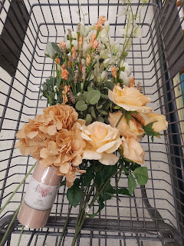

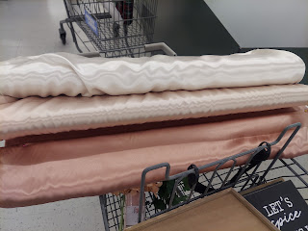

Kylie began her drive down to Utah in our red Ford Ranger truck, but alas, the years on the truck really showed . . . She got as far as Blackfoot (about 30 minutes south), and then texted me while I was in Hobby Lobby because she was having a couple of issues. The speedometer wasn't working - she was only going about 65 but it kept jumping all over the place - even jumping up to 85 mph. She was worried about keeping a good pace the rest of the way down to Utah. Then, the oil gauge began creeping up toward "H" (hot). She didn't have a good feeling, so I told her to just turn around and come back and that we'd figure something else out.

We had looked into so many options already for her to be able to go down and see Benson, who was due to land in the U.S. on that same day. No other cars were available for her to use, and because of her young age, she isn't able to rent a car.

Thank goodness for Grandpa Harmon and his willingness to let her borrow his truck. We already had it in our driveway because of our car still being in the shop (!), so I called him to get his permission, which he readily granted. Hooray! Kylie moved all of her belongings into the blue truck, and was able to get down to Layton, Utah in excellent time, arriving at her hotel by 4:00 p.m.

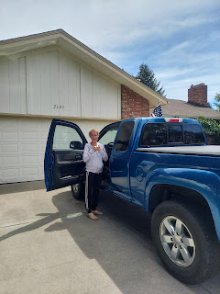

Benson landed later that night, and Kylie was able to see him and spend a little bit of time with him before he took off again. Apparently, Benson is so good at his job that they needed him to fly immediately to Missouri to fix a jet, with a handful of other airmen. But that turned into quite the fiasco! There was a big storm over Missouri, so the pilot had to re-route their flight to Minneapolis. They were stuck there for about 8 hours before heading BACK to Salt Lake City, where they sat for several more hours. Eventually they had a flight to Kansas City . . . but boy, oh boy, what a crazy 24 hours. I bet he had jet-lag on top of jet-lag! Flying in from Italy with all of those connections, then a few hours after landing, you start a new round of sitting in the airports and just waiting, waiting, waiting . . . Poor guy. I hope he doesn't get sick from all that lack of sleep!

We thought we were going to see him this weekend, but because of this last minute need for him to go to Missouri, we have to wait another week. At least Kylie got to see him! That's the most important thing of all. :)

Thursday:
Scott had no classes that morning, so he came out to help me in the yard for a few hours.

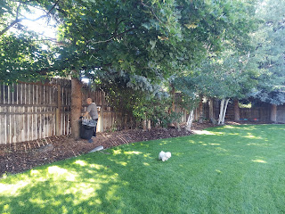

We pulled weeds, trimmed up a couple of trees, pulled out a poky bush that was trying to come back in again (after we had already yanked it out a year or two ago), and Sophie happily trotted around the yard with us, cheering us on.

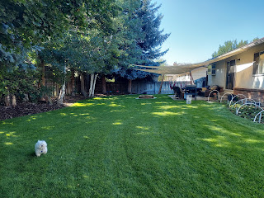

I cleared out all of the cilantro stalks that had gone to seed. I love having it all come up year after year, and when I clear out the dead stalks, I just make sure that I manually brush off all the seeds so they fall back into the soil for the next spring.

My rhubarb needs to be picked again . . .

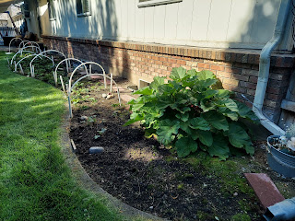

Then we hung up the outdoor lights that we had bought for Jacob and Hannah's wedding reception 2 years ago. It's nice that companies make them strong and safe to handle any outdoor weather, which makes it so that we can potentially leave them up year round.

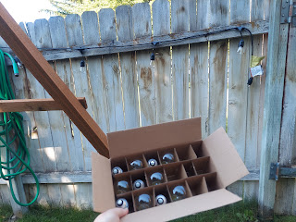

We also hung the hammocks back up after I had hauled them up to girls camp. They got rained on and a little messy, so I had washed them and let them air dry a couple days earlier. Now they're all fresh and ready for use!

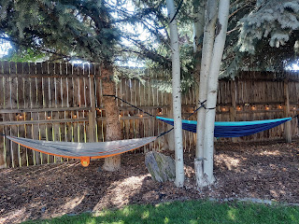

Amber sent us this photo of Abby, all drenched in sweat! She explained that because Abby has to wear her mask every day at school and on the bus ride home, and because it's Louisiana with all of its extreme humidity, this is how Abby arrives home every day. Amber said they pull the mask down and insert a popsicle into her mouth almost as soon as she walks in, ha ha. Poor honey! I'm glad Amber is such a good mommy though, and lovingly cares for my grandchildren. :)

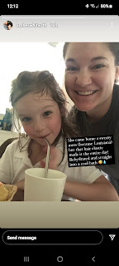

That evening, around 9:00 p.m., our home was the crossroads for lots of comings and goings. Kylie came home from Utah a couple days earlier than planned, since Benson had to head to Missouri. And soon after her arrival, Jacob and Hannah and Jack arrived.

From the left: Kylie, me, Scott holding Jack, Hannah and Jacob

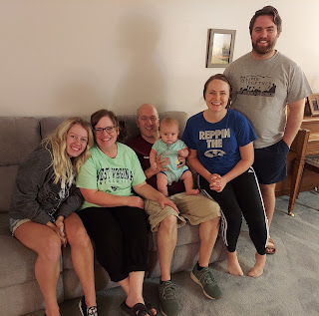

Kylie got to meet Jack for the first time. So precious!

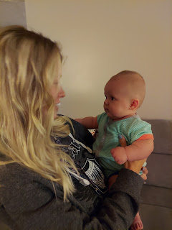

He gave her lots of smiles and didn't even cry once. He is just so chill and doesn't ever seem to mind being passed around from person to person.

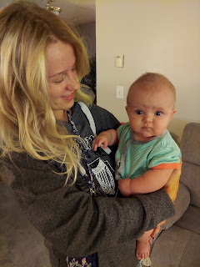

Soon it was time to get ready for bed. How fun! (That thing on his foot is a baby monitor that keeps track of his heart rate and oxygen levels. It's a great tool to help prevent SIDS.)

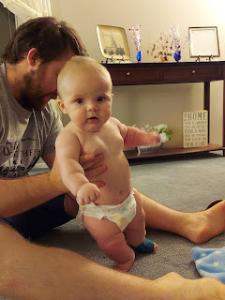

Friday:
As I began my exercises in the morning, Sophie decided to come lay next to me and "sleep". While it was okay for a minute, at some point I needed access to my entire yoga mat and had to nudge her off. But it was sweet of her to come and join me. :)

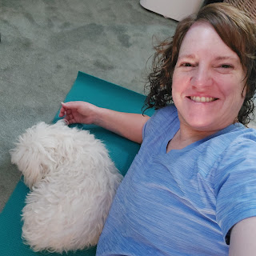

Throughout the day, I worked in stages to prepare another round of cupcakes to deliver. This time, I found a recipe for S'mores Cupcakes.

This is the recipe I followed to some extent.
https://houseofnasheats.com/smores-cupcakes-with-graham-cracker-frosting/

First, I made the graham cracker "crust".

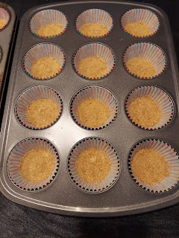

I followed the recipe to make the DELICIOUS dark chocolate batter.

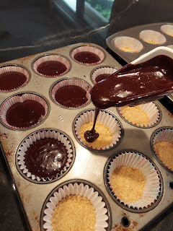

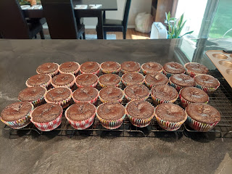

I skipped the part of the recipe where it called for making the frosting from scratch. Instead, I just used chocolate frosting from the can, and I piped a small amount on top of each cupcake.

Then, I put the marshmallows on a baking sheet under the oven broiler . . .

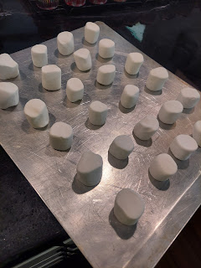

And Voila! They turned out amazing!!

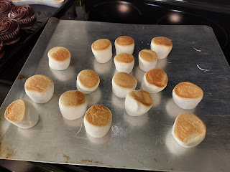

While they were warm, I plopped them on top of each cupcake, added a small Hershey's bar by pushing it down into the cupcake, and topped it all off with a Teddy Graham inside each marshmallow. :)

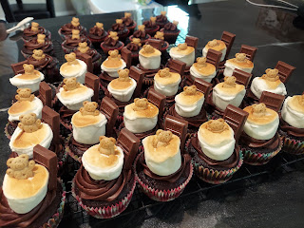

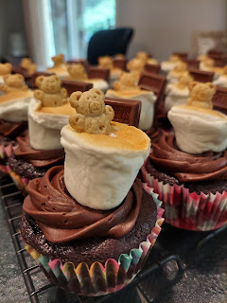

After I delivered them all on Friday night, we had a few cupcakes leftover, so . . . yeah, you know exactly what happened. It was super rich, ha ha, no shocker there, but wow, such a decadent cupcake. Sometimes you just gotta splurge!!

I added a little quote to go with each plate, just to spruce it up a bit. You know, add an uplifting thought to an already elevated cupcake, ha ha. It says:

Look for S'mores:
S'more opportunities to feel the Spirit
S'more ways to serve others
S'more hard things to accomplish
S'more experiences reading the scriptures
S'more ways to show love
S'more ways to follow the Savior

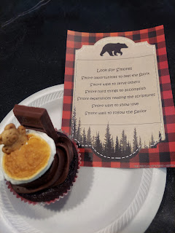

We also thoroughly enjoyed having Jack in the house. He is just THE BEST!!



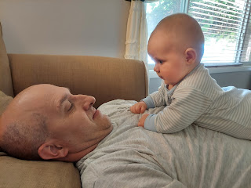

Saturday:
First, I need to catch up on a few random, but delightful, pictures of my grandchildren from this past week.

Jacob took this sweet photo of Hannah holding Jack when they were still down in Utah. I just love this so much!!

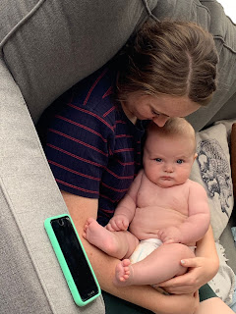

And the joy on his little face as he played with his toys . . .



Here's Gwen. She announced to her mother, Amber, "I'm a chair!"
She is certainly a very talented poser. :)

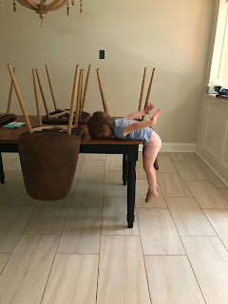

I bought Jack a little water-filled playmat for the floor. It's supposed to increase enjoyment for tummy time. He loves it!

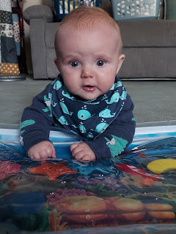

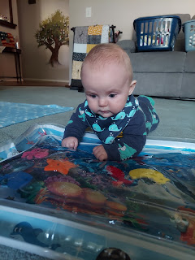

I also bought Jack some cute bibs recently, with a convenient teething toy that attaches to it. He loves those bibs, too!

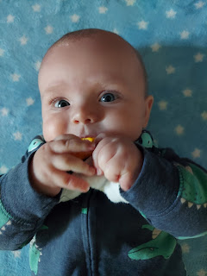



Here's a cute video of him going to town on that little yellow star teething toy at the end of his bib.
(39 seconds)
https://photos.app.goo.gl/na6Zbb7TiQ8bGBy18

Jack was also extremely helpful in folding laundry with me. He is the best supervisor there ever was!

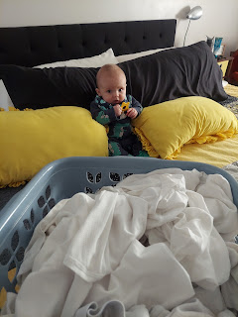

He is not shy with family, either. He is stoic at times, but easily smiles at everyone. Especially Pop Pop.

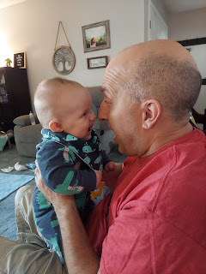

Jacob made Ooplick to show Hannah what it's like, since she was not familiar with what it is. It's just corn starch mixed with water, but it's a whole lot of fun! When you work it in your hands, it becomes a solid.

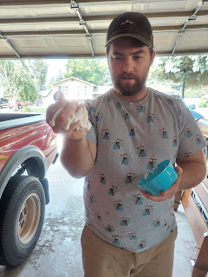

But as soon as you stop squishing it and working it, it turns to liquid and melts immediately.



We have used it for many-a-quick object lesson over the years. You can apply this concept to a number of scenarios, such as: working on your testimony. You have to constantly work on it, by praying and reading the scriptures, etc. As you do so, you gain a solid testimony of Jesus Christ and you feel grounded in the gospel. But as soon as you stop doing those things, you turn to mush. You lose your solid footing in the gospel and it feels like you're all over the place. But the beauty of repentance and the Savior's Atonement, is that the very moment you start working to grow your spirit again (prayer, scriptures, going to church, etc), you can feel that solid reassurance once again that you are on the right path to true happiness.

Mid-afternoon, I began making Cookies and Cream ice cream, a favorite of Kylie's. I recently discovered that Oreos came out with a line of gluten-free Oreos, which is fantastic for Kylie! She isn't religiously trying to be 100% gluten-free, but she is finding that it sure does help when she
can
avoid it, and thereby avoid the cramps and pain associated with eating it. I bought a package and we test-tasted a cookie. They taste exactly like the originals!! So that's what I used in making this ice cream. I put them in a ziploc bag and used my wooden rolling pin to mash them all up.

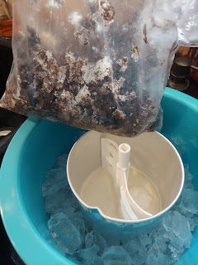

Here's the thick and gooey ice cream when it was done: (14 seconds)
https://photos.app.goo.gl/EqX5yVRGW4RCU2d1A

It was all hands on deck to prepare our dinner for company that night. Jacob was in charge of the main dish: Spiedies (chicken kabobs). Here he is, with Hannah, loading up the skewers with the chicken chunks that had been marinating all afternoon.

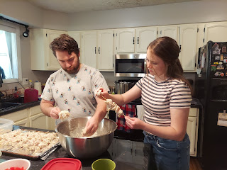

We enjoyed having Marissa and Assan and Azure, Grandma and Grandpa Harmon, and Natalie, my niece, over for dinner. Kylie was supposed to join us, but ended up being waylaid at her mom's house with all the company they had over there. Family is great! I'm glad she's able to spend time with all her loved ones here in the States whenever she can. We just missed her at our house . . . if only we could clone her. :)

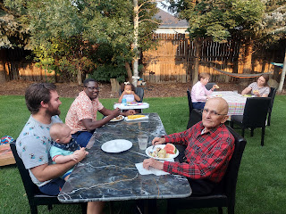

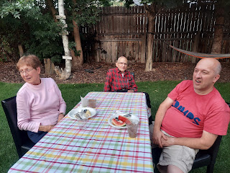

I think I'm getting shorter. My niece, Natalie, looks like she's towering over me!

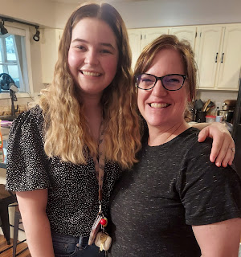

Natalie is also getting married in one week! We talked at great length about her plans and all the details. It sounds like everything is coming together! :)

Jack went down for bed around 7:30, which freed up his parents to enjoy the rest of their dinner. :)

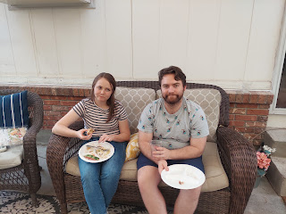

It's been a great week! And it will be another great week coming up. Lots of things on deck: a neighborhood BBQ, a big young women's activity here at my house, Marissa's baby is due, Natalie is getting married, Kylie will have a baby shower here at my house, and hopefully we will see our son BENSON!! As long as I can get a solid chunk of sleep every night, I should be in good shape . . .

