A Baby Shower and Family Times Galore
What a week!! I can't believe all the events that took place in such a short amount of time! Sorry for the delay in getting this published, but I was a little occupied with my family and having a whole bunch of fun this weekend! :)
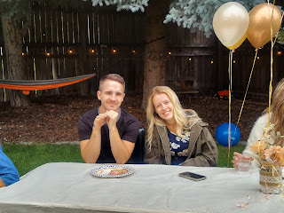
Monday:
I worked on a fabric garland for the upcoming baby shower. It turned out really pretty! To tie the fabric strips in a simple knot onto the twine seemed like a very simple task, but it turned out to be quite frustrating at first. I attempted several styles of loops and knots, but it just kept getting tangled up, or else nothing was secured by the time I was done. I went into the office and just stood there next to Scott in a frumpy mess of almost-tears. He came into the kitchen with me to try a couple of techniques to help me out, bless his heart. The technique that worked the best involved me using my stomach to pin the fabric lengths against the edge of the kitchen counter while I cinched the knot securely at the top. That gave me the torque that I needed to be successful. Yay for a patient and kind husband!!
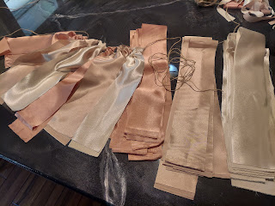

Once I had the technique down, I was able to plow through the rest of the garland length with no problems! Because of that, my mood also lifted as well, ha ha.

Later in the afternoon, Jack had his 4 month appointment to get a check-up as well as his routine immunizations. He was innocently oblivious as his daddy buckled him into his car seat to head over.

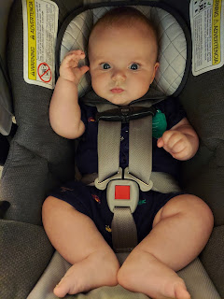

He did much better this time, his parents reported. He didn't cry as long, and was very happy to get a bottle afterwards.

Video of him in a drugged milk stupor: (25 seconds)
https://photos.app.goo.gl/ggCaoa4miYXuYC8U7

Amber also sent this creative food presentation photo that she saw on the internet:


Tuesday:
Jack was struggling because of his shots the day before. He had several distressed whimpers and even a few tears if he had to use his legs, or if someone moved his sore leg somehow. Oh, the goodness and sadness of immunizations! We need them, but they are not the funnest thing in the world! Especially with those tetanus shots.

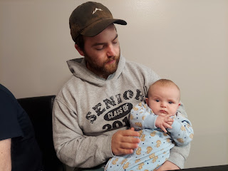

Later that afternoon, Jacob and Hannah put him in the bathtub for the first time. (Up until now, they just took him in the shower with them) He loved it!! I invited them to do what I used to do when my babies were little: lay a bath towel down in the tub, with the layers doubled up for cushioning, and then fill up the tub just enough that the baby will be comfortable and warm, but not too deep. Babies love to kick and splash, and Jack was no exception!

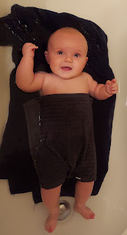

Cute (and modest) video of Jack having fun in the tub: (30 seconds)
https://photos.app.goo.gl/Fk4RR85dNBpbq3jp8

It seemed to help his mood and comfort his achy legs. He took a very nice nap afterwards. :)

Mid-day, Scott and I drove across town to pick up some lunch at Wendy's, where my niece Natalie and her fiancé Chance work. This was their last day of work prior to heading over to Twin Falls to get ready for the wedding. It was fun to see her at work! Unfortunately, since our car was still in the shop and we only had the red truck, we couldn't take everyone across town for lunch. So Scott and I picked up the food and brought it back for us all to eat at home together.

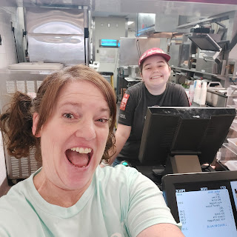

After Jacob's work shift ended for the day, he snuggled up with little Jack and they took a brief nap together. So sweet.

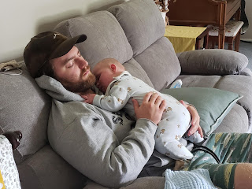

Meanwhile, Hannah helped me prepare the floral arrangements for the upcoming baby shower for Kylie. She hot-glued all the burlap ribbon onto some mason jars and tied on the tulle bows, and then I added the flowers. They turned out quite nice!

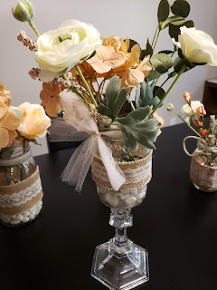

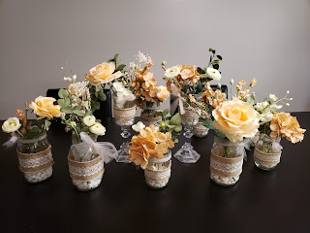

We were FINALLY able to go pick up our car at 5:00 p.m. It was in the shop for a little over TWO WEEKS!! It required over $6,000 of work and labor to get it taken care of. Sheesh!

Scott and I drove over in the red truck to pick it up. At first, it took a bit of time to get the final paperwork completed for us to drive away. And then, Scott noticed that the hood wasn't 100% lined up on one side. So they took it back into the shop and made a little adjustment...and
then
it was 100%. However, as I started driving the car home, I noticed right away that the AC wasn't working. I called the shop while I was driving and they told me to turn around and bring it back. I gratefully did!

It turns out that in Fords, there is a weird and rare thing that happens when they take the battery out or do extensive repairs. In order for the computer to fully reset, you have to drive it at least 45 mph for at least a mile, and then it will reset!! On my way home earlier, I had noted that the car thought the temperature outside was -40 degrees, which I knew most certainly was not the case. And then it was just blowing out really warm air even though I had it set to MAX AC. But after the head technician took it out on the freeway (adjacent to the shop) for at least a mile, he watched it immediately reset and register that the outside temperature was 86 degrees. The AC began working again, and all was well. :) Ha ha

So I was finally able to bring it home and park it in our garage. :)

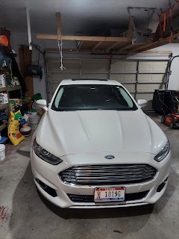

And the hood is all better now. And everything else underneath the hood is all better too. :)

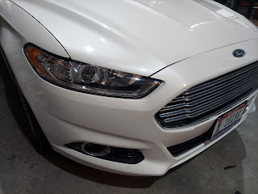

Relieved, I hurried over to meet up with the rest of the family over at the Neighborhood BBQ around the corner. We brought over a strawberry-rhubarb pie that I had made earlier this summer and put in the freezer. Jacob and Hannah heated it up for me and took it over while they waited for me to get back from the body shop across town. What good children!

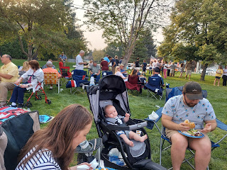

Wednesday:
The rains came. The End.

Just kidding! But it really did rain a LOT!! The high was maybe in the upper 50's for the day. This picture of Scott standing on our porch was taken in the morning.

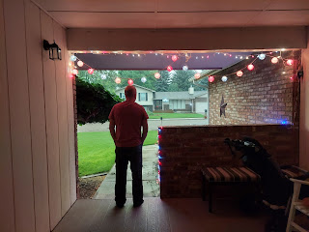

Jack. Handsome as ever. :)

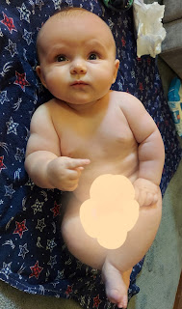

I prepped our living room for a young women's activity slotted for Wednesday evening. The original plan was to have a fire going in our firepit outside, let the girls make s'mores, and also watch a movie. But because of the rain and the cold weather, the movie came indoors and the firepit was canceled.

I rearranged a couple of things to create more floor space and laid down several quilts and pillows, while Scott set up the projector and hung a sheet over the fireplace to project the movie onto.

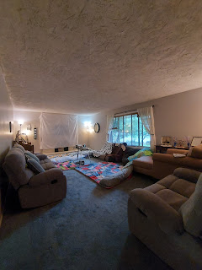

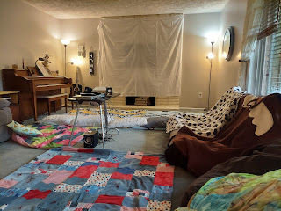

Sadly, I didn't get any photos of the girls during the activity, but we had a decent turnout. Maybe a dozen girls showed up, which was about half of the whole group. Instead of roasting s'mores outside in the drizzling and cold rain, I put them on a cookie sheet and under the oven broiler. It worked great! We had several roasted marshmallows within seconds, and then everyone could load up their plate with all the fixins. :) We nestled into the living room and watched "The Fighting Preacher", a true story about a world champion boxer and his wife being asked to smooth over some ruffled feathers in Palmyra, NY after the "Mormons" were asked to leave the area in the 1800s. It takes place in the early 1900's as the young couple have just recently been married and are starting their family together. It has comedy, along with several tender moments, as their little family tries in a variety of ways to make friends in an unfriendly town. It teaches us to never give up and that kindness really does win in the end.

While our dinner was cooking, prior to the girls arriving, Jacob was helping Jack to do the LT slide dance on the kitchen counter. If you're not sure what the LT slide is, you can watch the YouTube video here:
https://youtu.be/GExIu9-QXbI

The "LT" refers to LaDainian Tomlinson, a former San Diego Chargers football player. (Scott's favorite team)

So here is Jack - learning the LT Slide - Electric Glide: (25 seconds)
https://photos.app.goo.gl/wMUvEyMPj72etgrP6

"Wave to your mom!" ha ha

Thursday:
Jack helped me fold some laundry again. I gave him a package of Trident gum to crinkle and enjoy while he supervised.

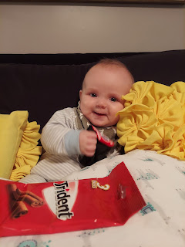

Then we had fun in front of the mirror together. :)

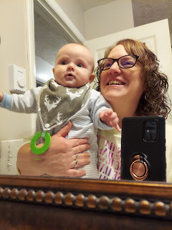

He is such a happy and snuggly boy.

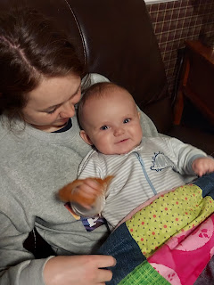

Later that afternoon, Scott went to the store and bought Jack a new package of binkies. It just seems like sometimes Jack wants to chew or slurp on something, but his chewy toys aren't satisfying enough, nor are his fingers or fists. He tends to get a little agitated. His parents tried a binky when Jack was much younger, but it wasn't received well, so they gave up on the idea. However, Jack seemed quite happy with his new toy that Pop Pop bought. :)

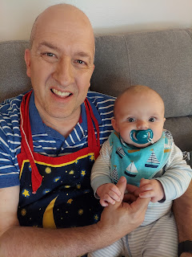

Late Thursday night, my sister Melanie and her family arrived at the Idaho Falls Airport. I went to pick them up and bring them back across town to our house. Their flight was significantly late, so by the time we got home and settled in, it was almost midnight. Yuck.

Friday:
Melanie was super happy to meet Jack and hold him for the first time. :)

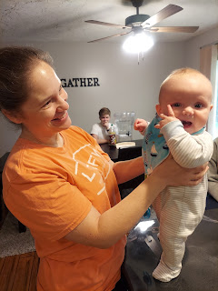

We ran a few errands together, shopping for some wedding supplies for their family and some baby shower supplies for my family. Around 1:00 p.m. the Schwendimans were all packed up and ready to drive themselves over to Twin Falls, which is where their daughter, Natalie would be getting married the next day.

From left to right: Me, Melanie, their son Caleb, and Mike Schwendiman

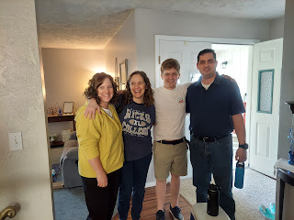

Their daughter, Mandie, (below on the right) was all buckled in and somewhat obligingly gave me a photo op. She is seated with her caregiver, Bethany, who is just a cheerful delight. Mandie has some autism, and Melanie felt it would be helpful to bring Bethany along during the stressful circumstances of traveling and setting up everything for a wedding. It proved to be a very good decision!

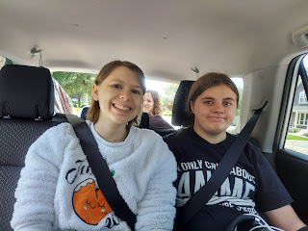

Squeezed into the busy morning, I worked on two chalkboard signs that Natalie (the bride) asked me to make. They were then carefully packed up for transport to Twin Falls.

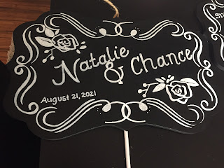

The Guest Book area would consist of a Polaroid camera to have a photo taken, then each person or group would insert their photo into the guest book and write a message on cardstock to insert next to their photo. I thought it was a very cute idea! This is what she wanted me to put on the sign:

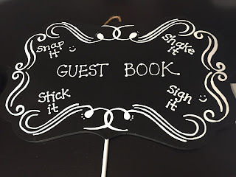

At the same that I was saying goodbye to the Schwendimans, the Whitworths were landing across town and I needed to hustle over there to pick them up! Scott got there ahead of me (because he was setting up his classroom at Skyline HS which is very close to the airport), but I joined him as quickly as I could.

I wish I had taken some pictures of the girls running into our arms, but how do you take the photos at the same time as opening up those same arms to scoop up your granddaughters??? Gwen hollered, "MIMI!!!" as she ran into my arms and wrapped herself around me, holding me tightly for several minutes, not even loosening her grip once that entire time. XOXOXO

Abby ran straight to Papi (Scott) and hung out with him while we waited for Amber and Weston to get their one checked bag from the luggage carousel inside. It was SO GOOD to see them again!!! Even though it's only been a few months, it felt like it had been much longer!

Soon enough, we drove back to our house to settle in, while Scott had to go back to attend a few more meetings at the high school. (School starts tomorrow - Aug. 25)

After we all had lunch, I took Abby with me to the party supply store (Zurchers) so I could pick up some balloons for the baby shower the following morning. While the workers busily filled 18 balloons for us, we wandered the store together, enjoying all the fun Disney characters on display.

Abby is standing next to Woody from the movie Toy Story.

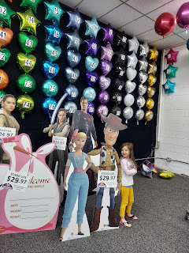

And here she found Mickey Mouse to be just about her same size. :)



That evening, she thoroughly enjoyed walking through the sea of balloons in the living room, while she waited for Gwen to fall asleep first in their shared bedroom downstairs.

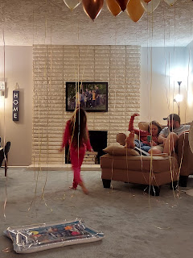

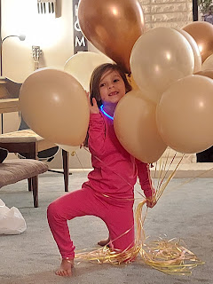

Saturday:
We got up bright and early to start getting ready for our big day with a baby shower. Everyone pitched in to help, which was so great!

Amber and Weston, along with Scott, helped to hang up the garland that I had put together earlier in the week.

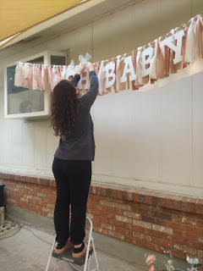

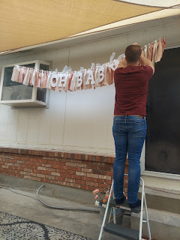

We set up tables and dressed them, Jacob made a huge batch of chicken salad with toasted baguette bread slices, Hannah prepared meat-wrapped cheeses with toothpicks, and I used a melon-baller to prepare a bowl full of watermelon. Most of the time it felt like I was here, there, and everywhere, but I had cheerful little minions to help me with everything, and I was so grateful.

Around 10:15 a.m., somebody hollered that Benson and Kylie had just pulled up out front. The front door opened and in walked my baby. I asked Amber ahead of time to please take a picture of me hugging him. What I didn't know then, is that the hugging would take a really long time. I did NOT want to let go!!

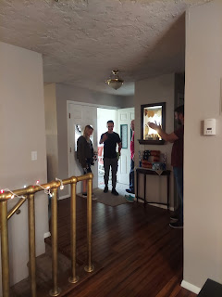

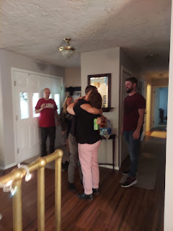

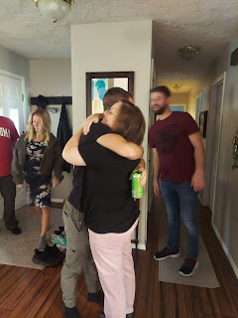

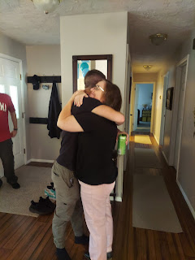

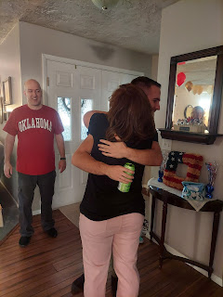

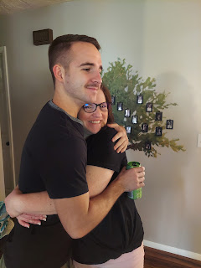

My first impression was that he was so skinny! I was worried that he wasn't getting enough to eat! My next impression was that he looked so handsome, even with his mustache, ha ha. It was so great to just hold him and feel the warmth of him close to me. It has been 1 1/2 years since I last saw Benson, and that felt like forever! However, Scott and Amber hadn't seen him for 25 months!! We calculated back to when we were all together last, and it was at Jacob and Hannah's wedding over 2 years ago!! Wow. That's way too long.

As the baby shower preparations were winding down, Benson and Scott sat down to visit for a bit (with little Jack Jack).

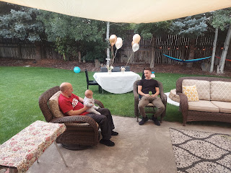

And eventually, Abby - who had been happily playing with some new toys I had set out for the girls - realized that Uncle Benson was here! She ran right into his arms to give him a big hug. :)

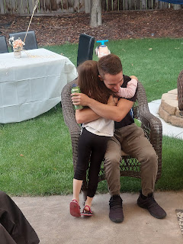

Kylie made herself comfortable under the baby garland. She has such a beautiful mommy glow and she wears it well!

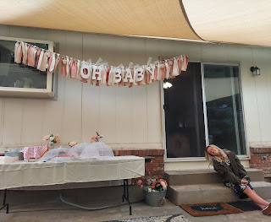

Tristyn, one of Benson's best friends from high school and also a close friend to Kylie, was one of the first guests to arrive. She is married and has a 3 month old of her own, sweet little Nora.

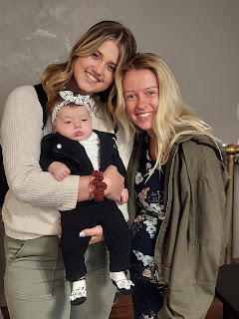

We had a really good turnout! I would say we had about 25 people - maybe even 30 - in attendance. It was a relaxed atmosphere, which was perfect. We visited, and ate food, and visited some more.

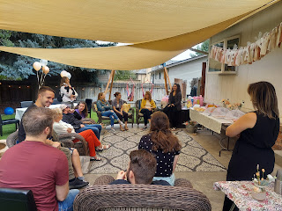

At one point, I noticed that all of my children were situated for a perfect photo! Could they have planned that any better?? ha ha

From the left: Hannah and Jacob, Weston and Amber, and Benson and Kylie

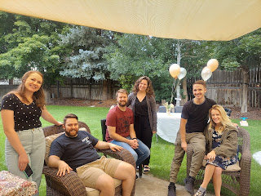

Soon, Grandma and Grandpa Harmon arrived. Coy made a direct beeline toward Benson - it was like no one else mattered, ha ha. She walked through all the sea of guests with great purpose: so she could hug Benson. I was like, "Where's my phone?!! I need a picture!!"

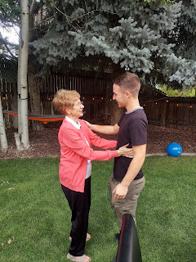

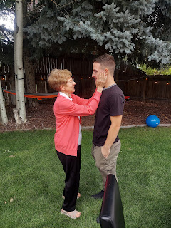

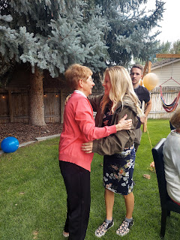

What a great moment together. You know, the best thing about family is that no matter how long you may have been apart, once you are together again, it's like you were never separated to begin with. It just feels so nice. What a beautiful thing.

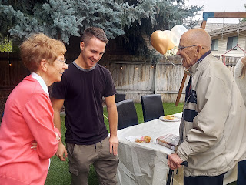

Jacob and Benson shared some laughter together as well. Always a beautiful thing.

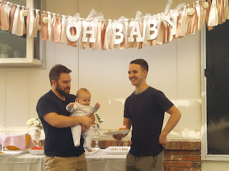

In addition to their Amazon baby registry, Kylie received several more gifts at the shower, which she happily unwrapped. It's just so fun to be a mom for the first time. Everything is so new and exciting! She loved all the cute baby clothes and other items that she received.

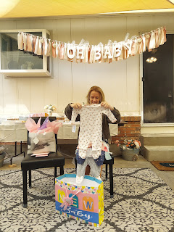

Below, Kylie is about to open a sage colored baby wrap from Amber and Hannah. In this case, it is a Solly baby wrap - Amber's favorite baby wrap brand. She loved hers so much that now, every chance she gets, she buys a Solly wrap for other new moms that are close friends or family members. They are so soft and comfortable, and most importantly - they are breathable. In hot and humid weather, it's no fun to feel like you're stuck together and bound by sweat. But with the Solly wrap, you don't have that problem. There are several cute fabric choices to choose from on their website.

https://sollybaby.com/?gclid=Cj0KCQjwsZKJBhC0ARIsAJ96n3VDPHVVK31bDp-vTAkNYtlG7muU5VRXgyfnyTEeNQ5Nr0KV9so4ReAaAgXREALw_wcB

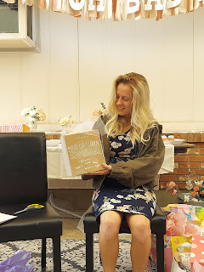

And our dear friends, the Vances, made Kylie a DARLING baby quilt!! It has minky fabric for the backing and the cutest little flannel squares on the front!

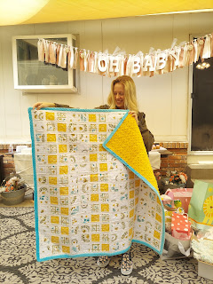

Scott had fun hanging out with Jack in the hammock after all the guests left and the yard was all cleaned up.

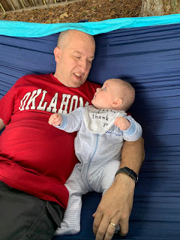

And he provided Gwen with a human airplane experience in the living room.

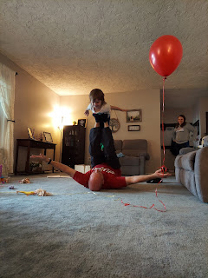

After we had a chance to rest for a BRIEF amount of time, way too brief if you ask me, we walked two doors down to our neighbor's back yard to play pickleball. Jacob and Hannah taught us how to play the game a couple days earlier. It is really fun!

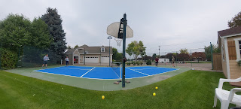

But I wasn't feeling up to playing this time. I was pretty trashed actually. So I was happy to just sit with Jack on the sidelines and supervise.

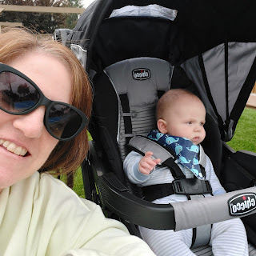

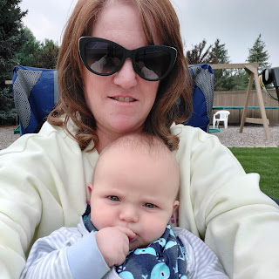

When I get really run down, my throat glands start to swell up and I feel like garbage. This was one of those occasions. So many things happened back to back in a very short span of time: the YW activity at my house, Melanie's family coming in late, baby shower prep, Whitworths' arrival, changing out bedding, preparing meals, cleaning up the meals, etc. I was flat out exhausted. But thank goodness for essential oils! I took some of my Thieves oil (from Young Living) and laid down for a few minutes before we went to play pickleball. Throughout the afternoon, I noticed that my sore throat improved and my energy level went up.
Every time
. I love Thieves. I think it supercharges my white blood cells to jump into action and kick out whatever sickness might be creeping in. Anyhow, it usually works within a few hours. If I feel lousy when I go to bed, I take some Thieves oil, and in the morning I feel much better.

Back to the Pickleball scene . . .

Hannah is a fantastic teammate! She and I played together when I first learned how to play the game. She is good at coaching and cheering you on, but she's also a formidable player herself! She's not afraid to get in there and be aggressive, ha ha.

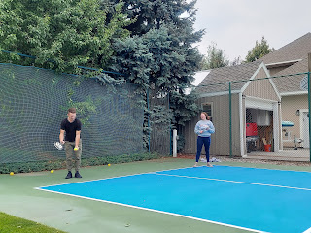

It took me a few tries to get a video of a good volley session, but I finally got one. (10 seconds)
https://photos.app.goo.gl/HHQnaPtyrpDLTQLm7

Even as Nathan Vance spiked it and Hannah hit it out, she can still be heard saying, "Good hit."

At one point, Jacob rotated out so that Scott could jump in to play. As Jacob was feeding Jack a bottle, Gwen came over and wanted to help. She really enjoyed holding and interacting with Jack throughout the weekend.

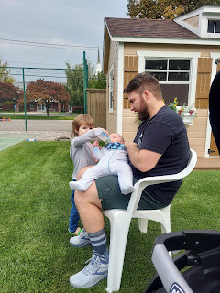

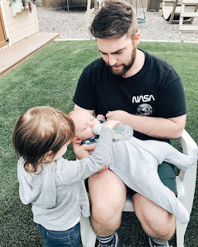

When I came home a short while later to prepare for our family photo session, Gwen hung out with us while I got Jack changed and dressed. She thought it was so funny that he would grunt and reach out to grab his toes and roll around in the process. She just giggled and giggled! :)

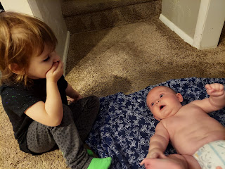

We all wore black for the photo shoot (at my choosing), because it's just so classy and handsome. We walked down the street to Sunnyside Park to meet up with our photographer, Eugene Engmann, a young man in our ward who is from Accra, Ghana. He is a nuclear engineering student, but his photography skills pay the bills and support his wife and 3 small children while he continues his education.

While we waited for Eugene to get everything set up, Amber was asked by Gwen to swing her around and around. So she did just that. :) What a good mommy!

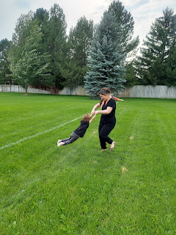

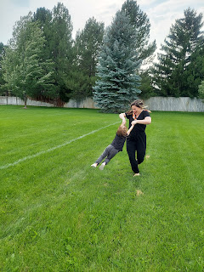

Amber grabbed this shot of us walking back down the street to our house together. I have Gwen up on my shoulders.

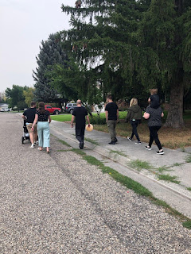

We will get the results of our photo shoot tomorrow (Wednesday) and I will share some pictures in my next blog post. I'm super excited!! I knew that we had to grab this opportunity for a family photo NOW, even though Kylie hasn't had her baby yet. When we have family living in Louisiana, Washington DC and Italy, and then you're all together in one place - - - you have to get a photo taken! You just gotta. Eventually, we will have Benson and Kylie's baby in a future family photo, but for now, we took a fantastic opportunity and just ran with it.

When we got back to the house, we noticed one of the million balloons was getting all tangled up in the dining room ceiling fan. Thankfully, we have skilled individuals who can fix the problem.

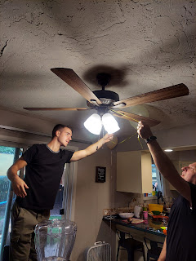

Benson and Kylie headed back to her family's house for the evening, Amber and Weston went out to dinner together for a much-needed date, and the rest of us cooked up some salmon and roasted vegetables for dinner at home. As much as we wanted to make the most of every moment before we parted ways the following day, we were all so bushed around 10:00 p.m. that we just headed to bed.

Sunday:
Rewind - as I went to bed the night before, I suddenly realized that I was supposed to teach my young women's class the next day! Oops. The advisor that usually teaches or leads the discussion with a couple of helpers from our class, had texted me a couple days earlier to inform me that she would be out of town. In all the hub-bub and excitement, I had completely spaced it and forgotten all about it!

So, as soon as I was showered and dressed, I put in a little bit of time to prepare something for the girls. It wasn't the greatest lesson I've ever spearheaded, but it certainly wasn't the worst one either.

Mixed in with preparing a lesson, Abby and Gwen wanted me to help them or play with them or spend time with them. In addition to that, Weston and Amber were trying to do a thorough check throughout the house to see if there were any more items that had been left behind when they moved out back in May, that maybe they might want to take home with them now. In addition to that, Benson and Kylie came back over mid-morning to hang out for a bit before the Whitworths flew out. I wanted to be in so many places all at the same time, and felt somewhat frustrated that I couldn't be as devoted to any one thing (or person) as I would have liked.

When it finally came time to say goodbye just before noon, I broke down in tears. It started when I hugged Benson. He would be driving the Whitworths to the airport for us while we went to church. I knew that I would see him again in one week, but it felt like I hadn't had any time to just sit and talk one on one during the hectic weekend. Then I cried even more hugging Amber and Weston goodbye. I tried to pull it together when I hugged the girls, and thankfully they were a little distracted and didn't seem to notice me falling apart. All of this took place at the same time that Scott and I were headed out the door to go to church. I have this little problem that when I cry, the whole world knows it because my face turns red and it takes a long time for my coloring to return back to normal. Even when I got to church, and Jacob and Hannah caught up to us after getting Jack ready, if I even thought for a second about how half of my family just left, the tears were right back there on the surface again. It was really, really hard.

I made it through my young women's class and I think it turned out pretty well. Soon after, as we walked home from church and turned the corner onto our street, Melanie and her family were just pulling in from their 2-hour drive from Twin Falls.

We raided the fridge and tried to do our civic duty by eating up as many leftovers from the weekend as we could. Then it was quiet time for a bit, which was absolutely heavenly.

Some people headed out to the back yard to relax on the patio or in the hammocks, while some found a quiet place indoors to take a nap.

Melanie shared all the details of the wedding with Scott and me on the back patio. All of them. ha ha

Here she is - talking animatedly about something that happened, while Caleb patiently listened next to her.

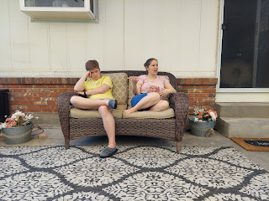

They had some issues with stormy weather and last-minute switcheroos by the wedding decorator that proved to be a little frustrating. But overall, it was a lovely wedding, and now Natalie and Chance are married and on their honeymoon to San Diego.

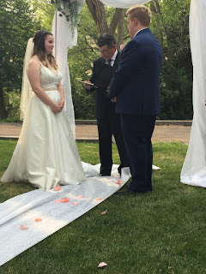

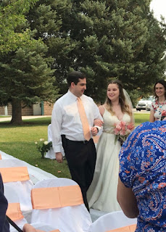

The Schwendimans hung out with us until about 8:30 p.m., when they drove their rental car back to the Idaho Falls Airport to head back home to Mesa, Arizona.

Melanie thoroughly enjoyed playing with little Jack every chance she got. He is a cute little guy, no arguments there.

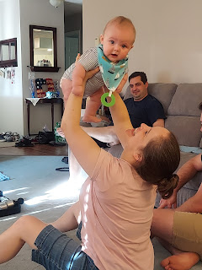

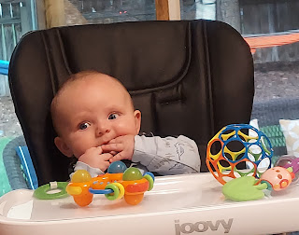

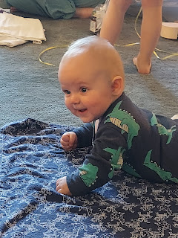

Now, part way into a new week, things are much quieter. While I love social occasions and family get-togethers, I also love some solitude, peace and quiet to balance it all out. Balance is good. And on that note of profound wisdom, I will sign off. The End.

