A Travel Agent and A Lockpick
Firstly: Jack and his parents have landed safely on the east coast this weekend. Here he is at his great-uncle Gordon's house on Sunday morning. I sure miss that little squishy boy.
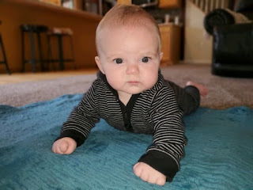
I hit the ground running at the start of this week, playing catch up from so much (precious) time spent with family members for the past several weeks. With some big things just around the corner, I needed to channel my Energizer Bunny and get cracking on my To-Do list!
The first two days of the week, it felt like I was running around like a chicken with its head cut off! I crammed way too many things onto my "catch-up list", and wasn't prioritizing them very well either. Thus, the frantic nature of my running around in a frenzy.
It took a very frank conversation with my dear husband on Tuesday night to diagnose my elevated stress levels and put things back into a healthy perspective. The power of prayer is also quite remarkable, too. Wednesday morning, I sincerely prayed and asked very specifically for help that I could prioritize my day, that I could focus and concentrate to make some important decisions, and that I could have the strength to accomplish much throughout the day. Well, it worked! I had a much more relaxing day because I was able to concentrate and focus on just one thing at a time, instead of all the additional 1,000 pending items on the invisible list in my head, ha ha.
Monday:
After more than an hour of looking online for a dress to wear to Chelsea's upcoming wedding, I saw a cute potential listed at our local JCPenney store, professing to have 2 of them in my size. So I headed to the mall, less than a mile away, and sure enough, there it was, hanging on the rack waiting for me.
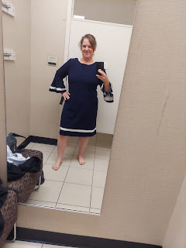
I tried it on and I really liked it! But I sent a picture to Amber, just to double check, since she is my personal fashion consultant. She said: "Absolutely stunning. 10/10. The bell sleeves were meant to be worn by you." Okay, so that was awesome. To walk into a store and try on just ONE DRESS, and then that's the one that works. And it was also on sale, so that's pretty awesome. :)
Meanwhile, Jack was down in Utah looking dashingly handsome as ever. Jacob and Hannah were visiting her family for a few more days before their departure back to Washington DC.
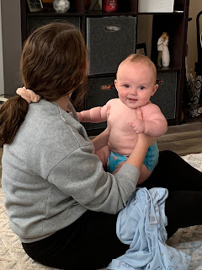

And Amber shared this hilarious explanation for how to escape a painful conversation: (click the photo to zoom in to see the smaller print)



Tuesday:
I woke up in a panic because I hadn't done any research yet for our young women's activity coming up that night: Air-drying clay. I found a few helpful websites and tips before I went out to get supplies. Turns out, air-drying clay is pretty sticky and is kind of difficult to work with, especially if you're trying to roll it out flat. I didn't have a metal or plastic rolling pin, and I didn't want to use my wooden rolling pin, so we tried a couple of alternative flops, such as: tin cans (i.e. can of green beans, etc) and glass jars. Neither worked. So we had to make do with whatever our own hands could shape and form into something desirable.

After several foiled attempts, I settled on just making a tic-tac-toe board. When the clay dries, it is supposed to be white. However, even a few days later, it's only about 65% white-ish, ha ha. (Photo below was while it was still drying)

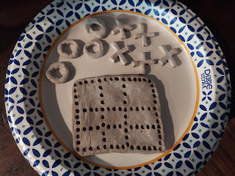

The girls had fun though! Linnea, on the left, carefully crafted a cute little fox. Allie, in the middle, created a mini cactus to hold her rings, and placed it into a hand-shaped bowl. Brielle, on the right, decided to just make some letters and basic shapes. This next week's activity will consist of us painting what we created and giving them some finishing touches.

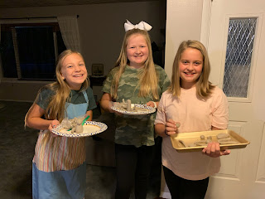

Sadly, Courtney, whom I have treasured working with for the past several months, is moving this weekend. She and her husband were lucky enough to get an apartment, which allows them the opportunity to move out of Grandpa's basement. The girls in our young women's class absolutely adore her and will miss her terribly, as will I. But I wish her the best in whatever her future holds. :)

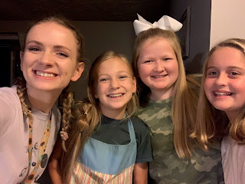

I also went to Costco for an eye exam earlier in the day, noting that it had been almost 2 years since my last appointment. I needed another pair of glasses, since my whole world relies on just ONE PAIR - and heaven forbid something should ever happen to that ONE PAIR!!

Thankfully, they have great prices there. To get a pair of progressive lenses, it was only $70, plus the cost of the frames. I narrowed the selection down to these two pairs, and ultimately chose the top pair (pictured below) with the help of the technician. They're pretty basic, but they're a good price and they're comfy to wear.

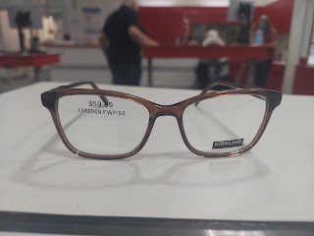

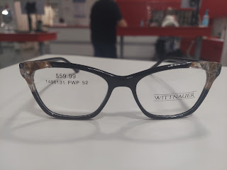

In about one more week, my glasses will be ready. Hallelujah!

Wednesday:
Scott ordered a set of lock-picking tools recently. I was a little surprised when he opened up the package, because he had never mentioned wanting anything like that before, ha ha. Apparently, he needed something to do when he's feeling bored or fidgety, as well as wanting something to satisfy his curiosity on something he knew very little about.

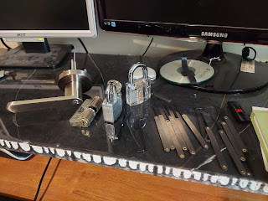

So, with all of his practice hours lately, he's gotten pretty good! If you, or someone you know, needs a lock-pick, now you know someone you can call! :)

I spent the bulk of the day researching for my upcoming trip. I was able to make several very important decisions and add critical information to my travel itinerary spreadsheet. That felt amazing!! After all, it's only a couple weeks away and I'm still figuring out where I'll be and what I'll be doing while there.

I have learned so much through planning all of my own trips over the years! If I could go back and start over with a career in mind, it very likely might be a travel agent. Some people are surprised when I tell them I plan out all of my own trips, saying that they are intimidated by all the details or they don't even know where to start. While I am still what I would call an amateur, I could pull off a pretty fantastic trip and itinerary for you if you ever need help. :) With the internet at my fingertips, along with Google maps, the world is our oyster!! :)

Thursday:
I have had numerous opportunities for recommending this book to friends and family over the past week. I received it last week (from Amazon) and have only read 2 chapters so far, but it is simply incredible.



In a nutshell: it's a book about how I can open my ears to listen and open up my heart to try to understand where someone is coming from, someone who is thinking about leaving the church, or who may have already left. What I have learned in just two chapters is that everyone has their own unique style of learning and absorbing information, and just because someone has doubts or questions doesn't mean I need to panic or freak out. I need to give them a safe space to talk it out, think it out, and work it out in their own way and in their own timeframe. And I can love them unconditionally throughout their process.

Sometimes, through tragedy, a person might become angry toward God, wondering how He could let something like this happen. They become bitter, and eventually walk away from church and much of what they used to embrace. It takes time to gain perspective, to heal, and to understand some of why the tragedy happened.

There are, of course, other reasons why someone might turn away from religion. I won't go into all of those here. The essence is that people suffer inwardly, and that usually affects their choices outwardly.

This book may sound like a familiar concept, I know. But the author lays out a few statistics that are fascinating, and comes from a standpoint of being a bishop, stake president and mission president, and who also has some of his own children who have questioned or left the church completely. He's had to learn how to navigate through many different situations, and now he is sharing his advice with all of us. I highly recommend this book, if for no other reason than to learn how to listen, to REALLY listen to our loved ones.

Gwen got the most darling haircut a couple days ago.

She went from this:

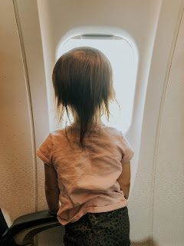

To this:

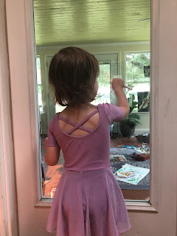

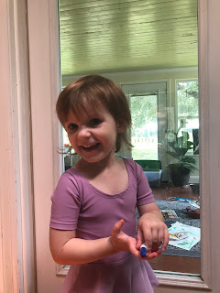



I love it! And I love that cute little girl in her purple leotard, riding down the street on her tricycle.

Friday:
This was my big baking day of the week! I baked 4 loaves of bread: one loaf of banana bread, and 3 loaves of jalapeno cheese bread. Below: the dough is mixed and ready to rise. I forgot to take a picture of the finished loaves . . .

We gave two loaves of the jalapeno cheese bread away to friends, leaving the other 2 loaves for us to munch on. :)
I also worked on some family history research (for my Tarwater ancestors), trying to establish a few more locations that I can potentially visit in Germany. I came across this hilarious sketch that my Grandma Zoe wrote up about my 3rd great grandfather, Robert Holt Tarwater, and I shared it with several family members. (Click on the photo to enlarge enough to read the smaller print)
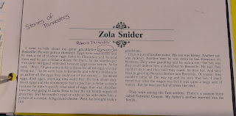

I also wrote a lengthy letter to my friend, Jill Henrie Millward, whose husband just passed away recently. We grew up together in Ukiah, CA and were close friends from the time I met her at 7 years old until we graduated high school and moved away to go to college. My heart aches for her loss, and it serves to remind me that life is fragile. Taking the time to appreciate our loved ones is so important - on a daily basis. I know that she will be with her dear husband again someday, and what a joyous reunion that will be!

Weston also signed up to help with the Hurricane Ida cleanup, south of them in New Orleans. Their stake in Stonewall/Shreveport asked for 100 volunteers to go down for the weekend and help. He packed all the supplies that he would need for his own comfort, including a tent and bedding, food, etc. He also packed up what he could from the list of suggested items for the cleanup, including power tools and a way to charge them up independently of any electrical source. There is no electricity down in New Orleans, and won't be for several weeks. Amber read that some of the necessary components for running electricity in the greater N.O. area actually floated away in the flooding from the hurricane! So now they are waiting for more parts to be sent, which takes time . . . how sad for all of those people down there!

After a long drive on Friday evening, Weston arrived as it was getting dark and hurried to set up his tent for the night. He sent this "pin" so family could know where he was.

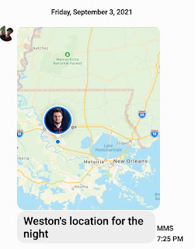

Saturday morning, he was able to get word out to family with an update:

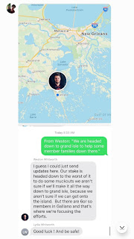

Sunday update: Weston made it safely home to his family. He sent a couple photos to us with this explanation -

"These are from yesterday (Saturday). We went down to the worst of it, probably a half hour from the coast." When I asked what he ended up doing, he said they mostly tarped a bunch of roofs and cleared debris.

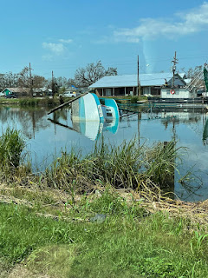

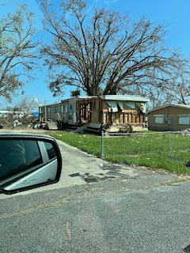

Saturday:
Jacob, Hannah and Jack made their way from Salt Lake City to Washington DC, via a layover in Orlando, Florida. Jack did great, as usual!

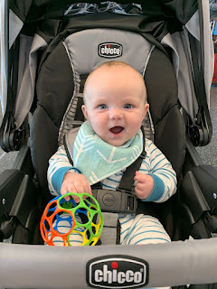

He reportedly slept like this for 2 hours of their 4 hour flight. Looks pretty comfy!

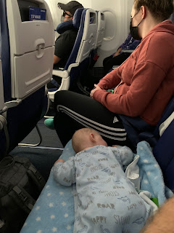

And at their layover in Orlando, Jacob sent these cute videos of Jack, just hanging out on the floor of the airport.

Video #1: waiting to get his diaper changed (20 seconds)
https://photos.app.goo.gl/23YNWXKvwJjkuvRaA

Video #2: in his chubby little birthday suit, looking like he's ready to just fall asleep, ha ha (9 seconds)
https://photos.app.goo.gl/E1vsCKbbmV4i69mV8

He even slept through the landing in DC. What a perfect child he is!

Back in Idaho Falls, Scott and I worked on several projects throughout the day. While he mowed the lawns and cleaned out the garage, I went in search of a few important items in town. I needed a basic silver necklace, because my two favorite necklaces that I wear all the time both have broken chains. I needed a pair of comfortable, yet stylish, shoes to wear for the wedding next weekend. And I needed supplies to make my own face lotion, using all natural ingredients. In just over an hour, I found everything I needed!

I decided to research a DIY face lotion because I have had breakouts on my face for the past year or so, and nothing seems to help. I've tried SO many products - each for a reasonable period of time - but my face is just so finicky! I'm tired of always having acne, especially at this stage in my life. I should have been done with that a long time ago . . .

This is the recipe that I settled on, after much perusing on the world wide web.

https://www.prettysimpleideas.com/2016/11/diy-face-lotion-sensitive-skin/

Scott volunteered to help make it for me, while I was working on dinner. What a guy! :)

First, here's what I brought home from Natural Grocers. The girl that helped me was amazing! And her name was Essence. :) She even donated a couple of jars from her collection that she keeps in the back room of the store, and was a wealth of knowledge with questions that I had. She looked like she was only in her early 20's.

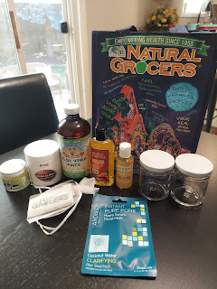

Here is our resident scientist, hard at work.

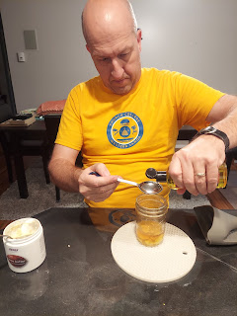

I changed one of the essential oils listed in the recipe, to personalize my own lotion. The recipe called for rose oil, which I don't have, and I only saw rose hip oil at the store. Instead, I had Scott add 3 drops each of myrtle and orange oils, to keep the number of drops equal to what the recipe said. I didn't want to mess up the consistency. Myrtle oil is wonderful for calming down acne and skin related issues, and orange is pretty gentle for the skin, and it adds a nice scent. Incidentally, I grabbed cocoa butter instead of shea butter - they were right next to each other on the shelf. Thankfully, though, cocoa butter is just as kind to the face as the shea butter would be. And who doesn't want to smell like chocolate?

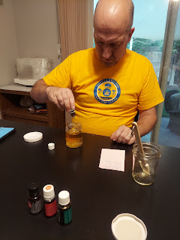

This is the finished product. While it turned into a very firm solid, as I dig out a tiny bit and rub it around on my fingers, it melts almost instantly and I can then apply it to my face. It's not greasy, which is nice. And my face felt really nice and smooth when I woke up this morning. It also smells uh-mazing!!

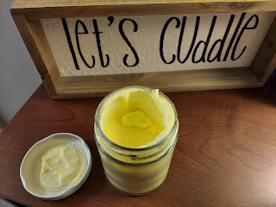

After making a tasty dinner (creamy garlic shrimp over steamed broccoli and cauliflower) -

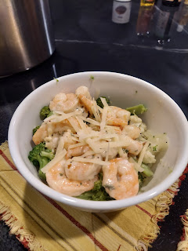

I folded several loads of laundry and then settled down to watch some House Hunters International while treating myself to a mask. :) Just trying to do all that I can to fix this dumb skin issue . . . I'm so over it.

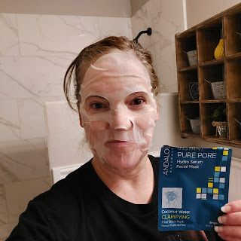

Sunday:
Last, but not least, we finally got to see Benson and Kylie again. We love to spend time with them, but so do about a hundred other people. We take what we can get, and we are grateful. :)

We enjoyed having the two of them, and Grandma and Grandpa Harmon over for dinner. We had mini meatloaves, mashed potatoes, and corn on the cob. Except for Kylie, ha ha. She was still full to the brim from the lunch they had with her family earlier, so she was happy to just nibble on the watermelon bowl that Peter Vance brought by before dinner. (Thanks Peter!)

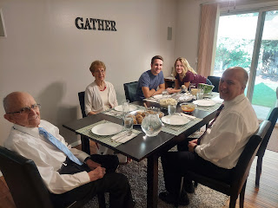

Above: (from the left) Phil, Coy, Benson, Kylie, and Scott (all Harmons!)
Below: The same arrangement, except now I'm in the photo, too!

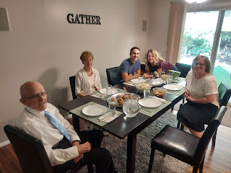

Benson was peppered with questions about his work on F-16 jets in the Air Force, and it was fascinating to learn more about what he does. He's so smart! And we are just so darn proud of him. :)

Here he is, showing Grandma a picture he took of an F-16 engine blade that had a ding in it. It's part of Benson's job to file down the ding so it doesn't turn into a bigger problem. It's called "blending". We thought it might be more suitable to call it "smoothing". But what do we know?

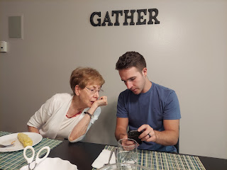

I have been saving this Scandinavian Happy Marriage Cake for several months (in the freezer), waiting for a chance to feed some to my Italian kids. We've already had an opportunity to share some with Jacob and Hannah, as well as Amber and her family. Today was a perfect day to eat some good luck together!

It's essentially a shortbread crust, with a rhubarb topping spread on top, and a few more dollops of shortbread dough on top. It's delicious!

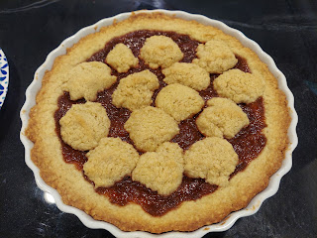

And then it was time for some goodbyes. Sad, sad, day . . . because we're not sure when we'll all be together again.

Phil, Coy, Benson, and Kylie

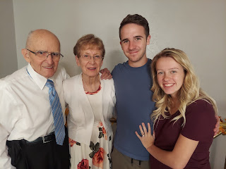

Well, this coming week has a pretty exciting event: one that is almost 32 years in the making. Chelsea, my daughter that was adopted, is getting married!! I'm so happy for her, that she has Garret to laugh with and be by her side through thick and thin. I'll have lots of pictures to share after we get back next weekend. :) I'm looking forward to dancing with my daughter and my mom on the dance floor, ha ha.

These are a few of their engagement photos that Chelsea recently shared with me. (Can't remember if I already shared these in another blog post . . .) (and if I did, sorry!)

