Idaho to DC to Venice
I made it! All the way to Venice, Italy. Finally! It feels amazing to be here and I am so grateful. This is the view out my window this morning. Notice the overly curious seagull on the rooftop across from me.
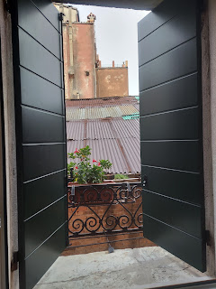

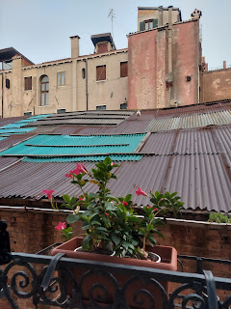

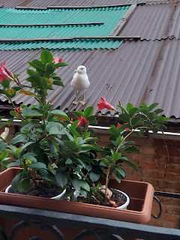

Here is the story of my week and how I got here.

Monday:
Stress, Stress, and more Stress. That's about all I did all day. I worked on packing my things a day early because Tuesday I had several commitments to fulfill outside of the home, so I knew that Monday was the better day to focus on getting ready.

The stress came in the form of 2 things mainly: trying to figure out where and how and how much to get a Covid test before flying out and in the correct time frame; and what pieces of luggage to use, knowing I would have to haul them all over Europe.

Deep in the middle of my stress over how and where to set up a Covid test, I had a prompting to stop and say a prayer. So I did. I asked my Heavenly Father to help me to find the answers I was looking for in the most efficient way possible so that I could move on to several other important tasks. (I had already spent hours researching this one thing) As soon as I finished my prayer, and typed my query into Google Search, I found the US Embassy website, which had not ever come up in my results previously. I clicked on it, chose Portugal as my destination country (because that's the first country I'd be landing in and the one that had the stiffest requirements - the airline I was using was Tap Air Portugal). Immediately, I had 100% of my answers. In one click. Amazing. Thank you Heavenly Father for caring so much about the things that matter to me.

The problem I was having was figuring out when to get the test: do I take it more than 72 hours ahead of the flight so that I have enough time to get the results back? How long is too long before the flight? And do I need the 72 hour window to count down to when I board the plane? Or do the 72 hours need to be for when I would I arrive in Portugal?

The other issue was where to get the test and not have it cost me an arm and a leg. The cheapest one was in Idaho Falls at $55. The tests, if I waited until I got to Washington DC, were around $139 - $204. Some places professed to perform the test for "free", but really they just don't charge you anything up front and will later bill your medical insurance. The problem is that my military health insurance won't cover the test unless it's actually for medical reasons, so the bill would eventually land in my lap.

The answers I got on the US Embassy website were these: get a PCR test AT LEAST 72 hours before BOARDING the flight, OR get a rapid antigen test WITHIN 48 hours of boarding my flight. Wow. See how simple it all is when you get simple and effective answers? The rat race before I said a prayer took me to way too many websites, many of them too vague, or several with conflicting information. All I wanted was succinct and simple information. It took a sincere and simple prayer to get what I needed. :)

Later that evening, Scott helped me consolidate my luggage in the simplest way possible: one larger suitcase, plus the carry-on size soft suitcase that I can wear on my back. This would also hold my day-pack inside, until I would need it later. It helped tremendously to get this figured out. I was hung up on Rick Steves' suggestion to only bring a small carry-on bag and a back pack. My things didn't even remotely fit into those perimeters, even though I had slimmed down everything to the barest of bare bones essentials. It's hard to be a girl and to need make-up, hair products, lotions, a curling iron, as well as all my vitamins and medications. My clothes were minimal, with only 2 pairs of shoes (shocker!), undergarments, and a couple of light jackets. I didn't want to have to haul a bigger suitcase all over Europe, getting on and off the trains every day, and having to lift a big suitcase up onto the storage shelves above my seat on the train. But at this point, I really didn't have much of a choice. I was deflated and disappointed. I wanted to be so minimalistic in my approach, but it just didn't work out like I thought it would. Scott tried to make me feel better. It helped.

Amber sent this precious picture of Gwen, who had fallen asleep while Amber was working on her computer. Oh, how little ones are just so darn cute!

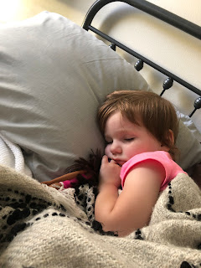

Tuesday:
I took my friend Amanda to the temple in the morning. She hadn't been to the temple in over a year, and as a new member of the church she had only been to the temple once so far! I picked her up and we went to the 10:00 a.m. session together. It was lovely. :)

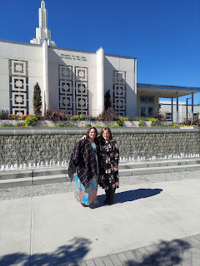

I also finished packing some last-minute things, got a haircut, got a massage, and did some cleaning before I would be leaving soon.

Later that evening, when I was supposed to go get my Covid test in Idaho Falls at the Sterling Urgent Care, they informed me that they had just run out of tests the night before!! (This was the place that only charged $55) I hurried and checked around to see where else I could get it done before I left, but no such luck. Either it was too expensive, or the place had closed for the night. Even Walgreens, who professes to test for free, couldn't do a test until the next business day. And they, like so many others, don't charge you up front, but instead send it to your insurance. The bill would eventually be $128 for the test if I went to Walgreens.

I decided to just keep my testing appointment for Thursday at 1:00 in Washington DC that Jacob had already set up for me as a backup. CVS Pharmacy charges $139 - after they bill your insurance first.

I was miraculously able to crawl into bed at a reasonable time, after skipping out on attending young women's that night. It was a group activity and I wasn't in charge, so it made it easier to just stay home and finish getting ready.

Wednesday:
I got up at 5:00 a.m. and was ready by 5:30 a.m. to have Scott drive me to the Idaho Falls Airport. I look like a hoodlum below because not only am I wearing a lot of black, but I put a hat on (because I didn't shower) and I also had a black face mask on. Ha ha

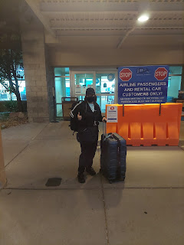

Below: The view coming into Reagan National Airport. Jacob lives over on the far right in this photo. Their new apartment is only about 2 miles from the airport, but it takes about 10 minutes to get there. Not bad, not bad.

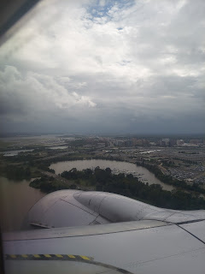

It was raining in torrential fashion by the time I got my luggage and headed outside to wait at the curb for Hannah to pick me up. In the 30 seconds it took me to load my 2 bags into the trunk and back seat of their car, I got so soaked that my hair turned from straighter-than-straight (from the way I styled it the day before) into Shirley Temple curls!!

Video of the downpour as I waited for Hannah: (12 seconds)
https://photos.app.goo.gl/ZkTfzs8rBxpoC9NN9

When I got back to their place, Jack was just waking up from his nap. He was a little out of sorts to see me in his groggy state, and it even made him cry for a second or two. But soon enough, he warmed up to me and we were buddies from that time forward.

Here he was, a short time later, having fun in his exercise chair: (25 seconds)
https://photos.app.goo.gl/7zwgRs2iTzcquyqn9

I got to feed him a bottle soon after that, which he was very grateful for. We snuggled in his minky blanket and were very content. :)

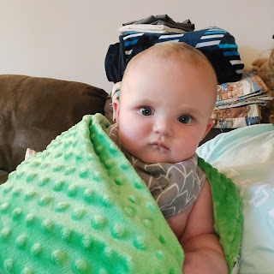

After another little nap, he was all smiles again. :)

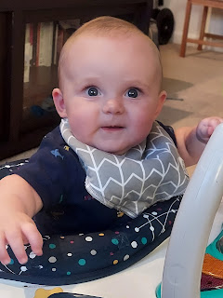

Short video of Jack doing "Superman": (15 seconds)
https://photos.app.goo.gl/owhVchbh1Wuz8DX8A

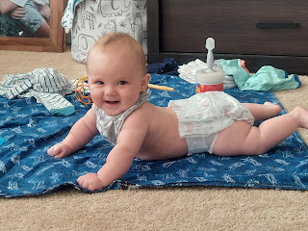

Below: Unimpressed. But still congenial.

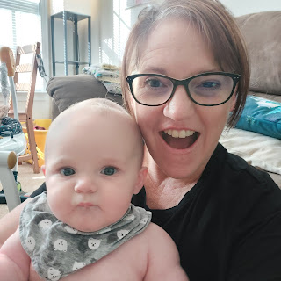

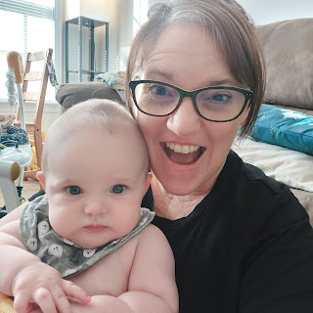

Thursday:
I helped take care of Jack while Jacob was doing his online work for the Feds, and while Hannah was away at her new job. She is using her Special Ed degree to work part time (M-F from 7:30 a.m. - 11:30 a.m.) at a local public school. Jack is young enough and a cheerful enough baby that Jacob comfortably takes care of him in the mornings until Hannah gets home. Jacob said that he is still able to work while he tends Jack, saving the more intense project work for when his wife is home. It was nice, too, that I could play with Jack and feed him while they worked. Hannah came home so tired on Thursday, that when Jack went down for a nap, she laid down to take a nap at the same time. She ended up sleeping for about 3 hours! She couldn't believe she had slept that long. I told her she must have needed it, and that I was happy she got to do it. :)

When she woke up, we went into DC to see the National Portrait Gallery and the American Art Museum that were housed together downtown.

Jack was a trooper riding on the Metro subway with us.

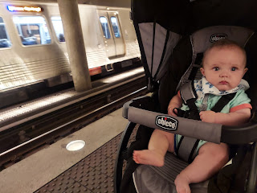

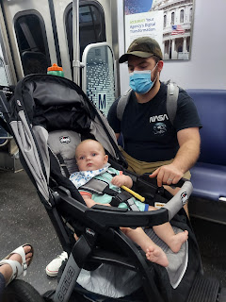

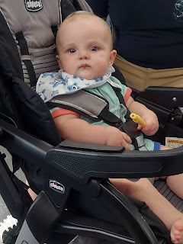

The artwork in the Gallery and Museum was incredible. I wish we had had more time to see it all.

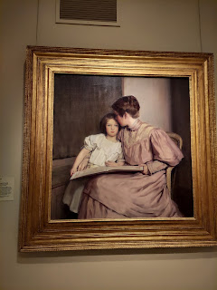

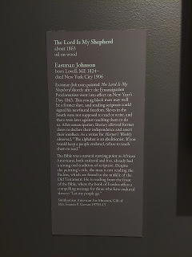

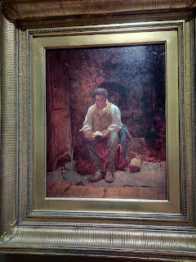

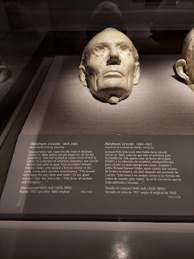

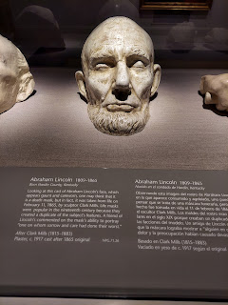

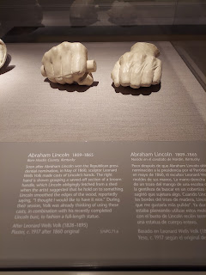

When the museum was ready to close at 7:00, we headed outside to change Jack into his pajamas and to go in search of food in the nearby Chinatown.

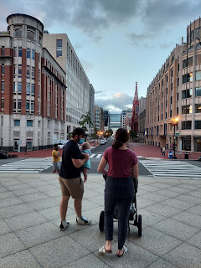

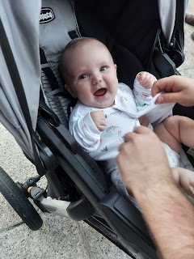

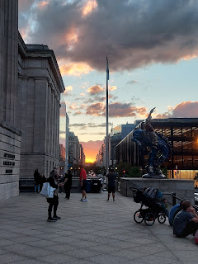

While Jack drank his bottle, I took a few minutes to check in with my sweetheart. He was just finishing up in his classroom back in Idaho.

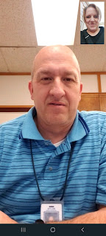

Then it was off to Chinatown to find a place to eat.

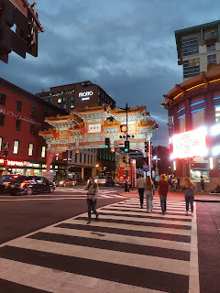

As we walked along, I just happened to see this plaque on the outside of one of the buildings. Wowza.
It says: Historical Landmark: Surratt Boarding House. "...is said to have been where the conspirators plotted the abduction of U.S. President Abraham Lincoln in 1865."

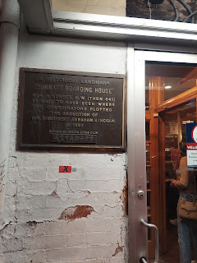

We settled on this place, called "Chinatown Express Restaurant." It was a winner of several awards, professing to have best homemade noodles and roasted duck soup. Funny story: I ordered Jumbo Sweet & Sour Shrimp. Yeah, the shrimp on the platter were jumbo all right. They were about the size of mini-corndogs. The only issue was that the actual shrimp inside were barely the diameter of a pencil, surrounded by 3 inches of corndog breading around each of the minuscule shrimp, ha ha. So yeah, they were jumbo. A jumbo farce perhaps. :) They tasted amazing. Just too many carbs. Not enough shrimpies.

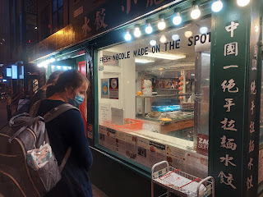

I got the cutest video of Jack giggling with his daddy while they sat next to me in the restaurant: (25 seconds)
https://photos.app.goo.gl/tYEGiafnaN7uMhcS7

Friday:
I took a much-needed walk in the early afternoon and talked to Amber for about 1.5 hours while I walked. Eventually, I sat down on the steps of Jacob and Hannah's apartment building to rest, while I continued chatting away with Amber and Gwen. (Abby was at school)
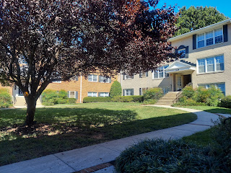

Gwen happily ate several strawberries during our conversation.

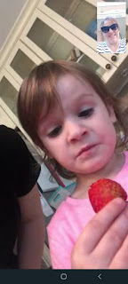

Amber showed me her recent haircut. It's such a cute length for her!

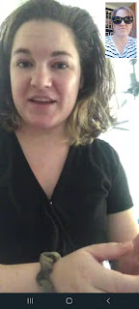

And Gwen, being her usual spunky self, gave me lots of expressions to have fun taking screenshots of.

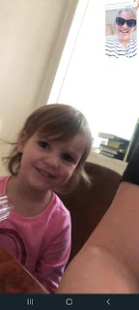

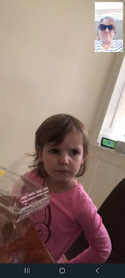

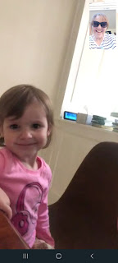

Once Jacob was done working for the day, we went out for one last adventure before my flight was due to leave later that night. We chose to go visit Alexandria, Virginia (about 15 minutes south of where they live in Arlington) and to see the waterfront area. It was really cool! Steeped with history, there's a huge area downtown called "Old Town".

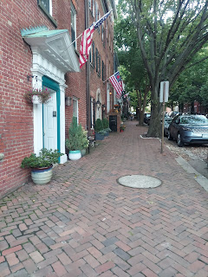

Below: Historical home that used to belong to Elisha Cullen Dick (1750-1825). It says: "Was consulting physician in Washington's last illness. At the moment of Washington's death, he stopped the bedroom clock, which can be seen in Alexandria Washington Lodge, and conducted the Masonic funeral at his grave."

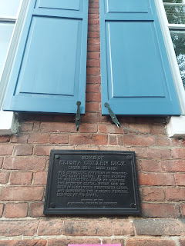

Halloween and Fall decorations were popping up in several places within the old historical district, too.

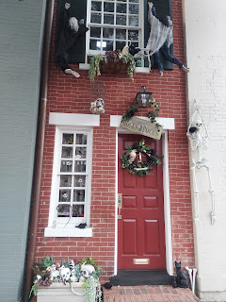

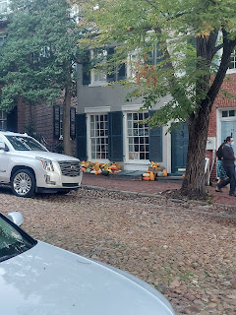

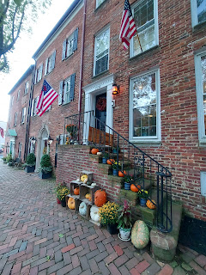

Some of the streets were blocked off from most vehicle traffic, only allowing a handful of cars to come through the semi-barricaded entrances to park. I love the old cobble stones in the road, a handsome relic of past days.

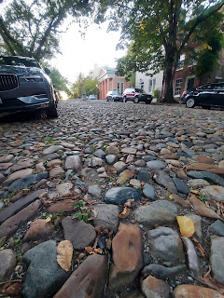

We had fun wandering around Old Town for a while, and even found a fun place to eat, called Nando's Peri-Peri. It is a combination of South African and Portuguese cuisine, based on a technique of making peri-peri chicken with choices of basting sauces that gradually get hotter and hotter.

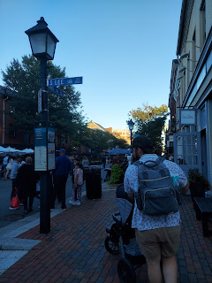

I chose the Lemon & Herb sauce, along with some fries and Macho Peas (mushy peas similar to England's style), but with a lot more flavors, including garlic, mint, and chili. It was delicious!

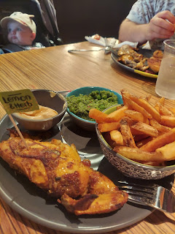

The waterfront park was huge, with docks, trails, and a whole lot of people on a Friday after work. :)

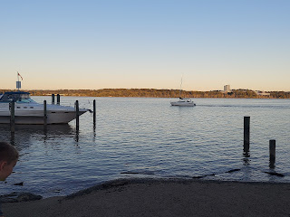

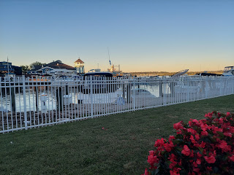

Jack turns into one curious little boy when he's in his stroller. He is very observant of everything going on around him, to the extent that he will skip a needed nap, and maybe even ignore the fact that he's hungry.

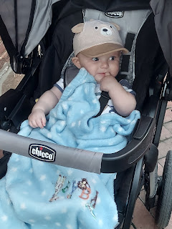

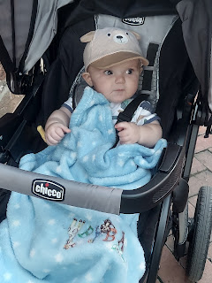

After we got back to the car, I think he realized just how hungry and tired he really was! Bless his cute little heart. I got to feed him a bottle in the back seat as we drove back to Arlington. He fell fast asleep, too. We dropped off Hannah and Jack at home, picked up my luggage, and then Jacob drove me to the Washington DC Airport (Dulles this time - about 30 minutes away from their house).

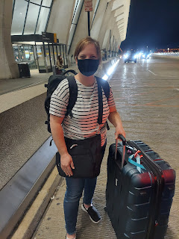

Scott had texted me a couple times over the last couple of days saying something like: "It's not too late to abort your plans." I think it means he's missing me already and would prefer to not miss me even more. :) But no, I cannot abort my plans. A) I would regret that immensely. B) I would lose a lot of $$ by canceling. It's better to just go and have all the adventures, and then catch up on being apart for a month when I get back. :)

After I got through security and found my gate, I called him to chat for a few minutes before I got on my plane.

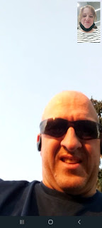

He was over at the Snake River Greenbelt on a bike ride when I called.

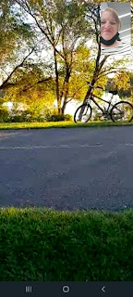

Well, even though I missed (and miss) him already, I did not want to turn back. This is something I have wanted to do for so long. Yes, I was a little nervous. But I swallowed the lump in my throat and held my head up high to board that plane that would take me across the ocean. And off I went.

Saturday:
My flight went pretty fast. It got into Lisbon, Portugal about 30 minutes early (10:20 a.m. local time), which was nice. It was just under 7 hours from DC to Lisbon. I didn't sleep a wink the entire night, though. First of all, it's hard to sleep when you're vertical and on a plane. Second, the older lady behind me did NOT have any clue as to what passenger etiquette is. Everything she did while seated behind me was over the top frustrating. If she needed to move or stand up, she'd grab the seat with all her might, like she was wrestling a bear. If she needed to get something out of the seat pocket, it was like she was trying to grab an elephant out of a kitchen cupboard or something. When latching the tray table back into place, it was like she was trying to slam the world's biggest tailgate on the world's largest truck. I peeked around my seat at one point, just to see what she was doing, and saw that she was trying to get comfy by pulling her knees up and shoving them into my back. Every movement was over-the-top ridiculous. The weirdest thing of all was that she appeared to be about 70 years old!! You'd think she would be more aware of herself and have more thoughtful manners. There was no way I would be sleeping during that flight. I watched "Oceans 8" with Sandra Bullock (always a good time), and the rest of the night I just tried to close my eyes and conserve energy, even if I wasn't technically asleep.

It took a while to go through customs in the Lisbon Airport. (Maybe 45 minutes?) There were a lot of people, but it went as efficiently as possible, I suppose.

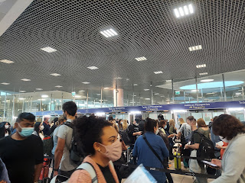

They wanted to see my passport and my negative Covid-19 test results. I also had to fill out an online form ahead of my flight, called a Passenger Locator Form. It wanted to know my date of arrival, which airline, what seat was I in, my contact information, etc. I guess they want to keep track of everyone if a passenger tests positive for Covid.

Eventually I was able to find a bathroom and some food to eat. Then I sat down to wait for another 90 minutes or so to discover where my gate would be for my flight to Venice. I think that's a thing in Europe, to only announce your gate one hour before your flight leaves. I'm not sure why that's a thing though . . .

But I found a lounge area next to the information screens and I think I fell asleep hard, leaning on my suitcase next to me, for about 30 minutes. It was amazing. Even though my mouth tasted disgusting from not brushing my teeth since the day before, and even though I was still super tired, I still wanted to continue on, ha ha.

The Lisbon Airport is really close to the water. And it looks like it's a beautiful city. I will see it a little more closely when I spend the night here in October on my way home to the U.S.

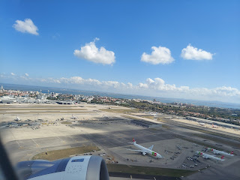

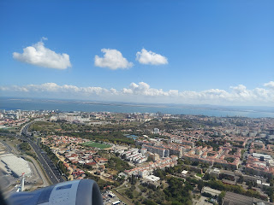

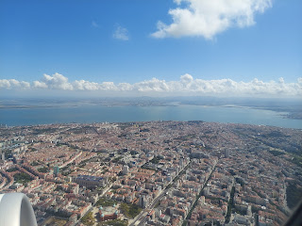

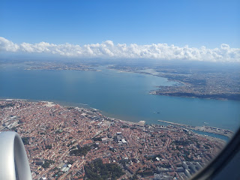

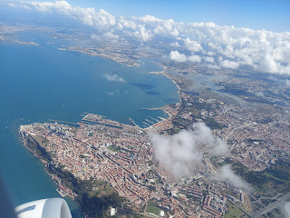

I had a window seat this time, which helped me to rest a little better on the last 2.5 hour flight. I was able to lean my head against the window with my travel pillow to get a bit more comfortable. Amazing.

Soon enough, we arrived in Venice, with all its beauty from the air.

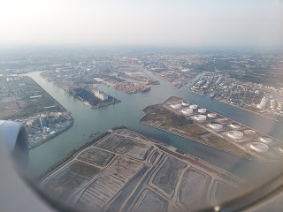

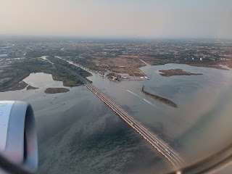

Notice the boats below in this next photo. In about an hour, I would be using this same canal lane to get out to the island of Venice.

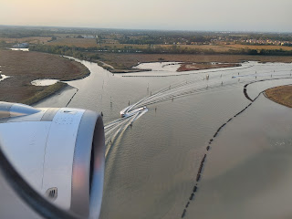

It was super simple to get my luggage, get a ticket for the Alilaguna Ferry Boat, and just follow the signs to get out to the ferry dock. I had just missed being able to take the 6:20 ferry, so I had to wait for the 7:20 one.

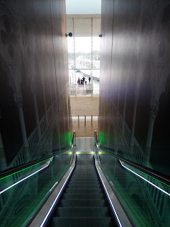

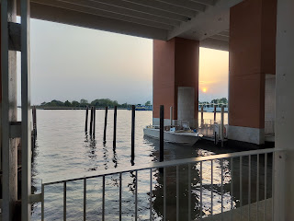

While I waited in line, I visited a little bit with an Italian lady next to me. I used Google Translate on my phone to help us communicate. What a little miracle that app is! I just type in what I'm trying to say, and then she can read it in her own language. :)

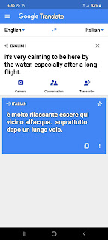

On the ferry, I chose to sit by the window to get some fresh air and to have an opportunity to take some pictures.

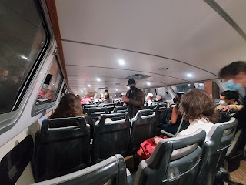

A short video of us leaving the main dock and heading out into the canal system: (18 seconds)
https://photos.app.goo.gl/pKfhKd73s4tSRbwU6

The views of the island of Murano at night were spectacular. It's a small island, but this is where the famous Murano glass is made. Murano was where the first couple of stops were, before we got to my stop in Venice: Fondamente Nove. (NW edge of Venice) It took about 45-50 minutes to get from the airport to my stop.

Murano:

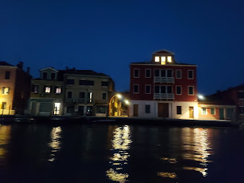

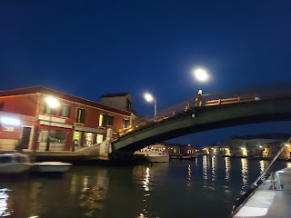

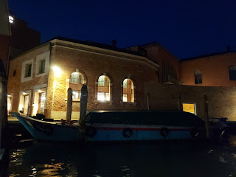

Here is a short video of me walking along the dock from the boat stop: (14 seconds)
https://photos.app.goo.gl/HwnVCQBq71oP94TGA

The AirBnB host gave me excellent instructions. Turn right and follow the dock until you get to the petrol station. Then turn left onto Calle Longa S. Caterina.

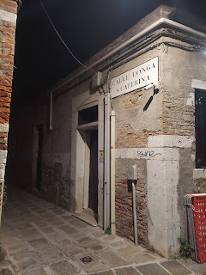

I didn't have to go very far at all down the alley. Everything in Venice is an alley, pretty much. It had decent lighting as well, which was nice. All except for the door where my lodging was. All I could see was the blue keypad for punching in the security code. (!)

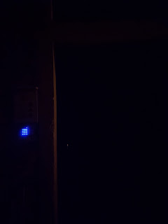

But once the door opened, it was very well lit within the lobby inside. Next, I followed the instructions to get my keys out of the lock-box on the wall.

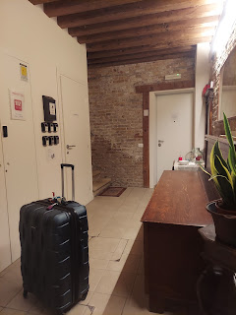

I hefted my suitcase up a flight of stairs . . .

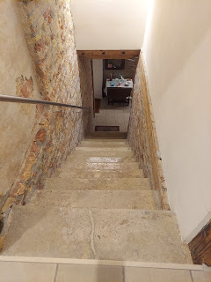

And finally I arrived at my home-sweet-home for 2 nights. :)

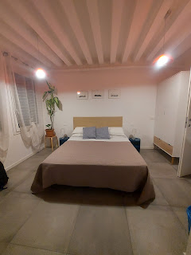

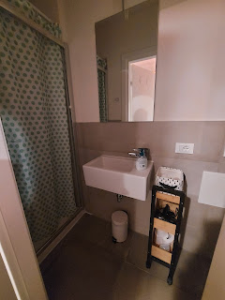

I called Scott to let him know where I was and that I had made it, and then I set out in search of something for dinner so that I could go to bed. At 9:00 p.m., it hit me that it had been quite a while since I had last gotten some good shut-eye.

Even though the AirBnB host had given me a few suggestions for dinner nearby, I didn't want anything I had to sit down and order and then wait for. I felt like I could just tip over from exhaustion. When I saw there was a McDonald's within a 6 minute walk, I decided that was the place for me! I haven't eaten at a McDonald's in forever, because it's just not my favorite. Now I know that I didn't fly all the way to Venice to eat at a McDonald's. But it never looked so good to me in my entire life!

On my short walk, I saw the first of many bridges over the canals. Even though it was dark, it was peaceful and calm. I did not feel afraid at all as I walked along. There were several other people out walking too. And even a few other women walking alone.

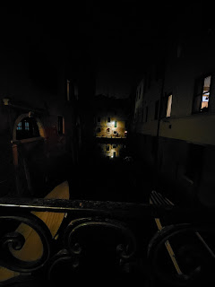

At the McDonald's, I used a kiosk to order my food, choosing English as my language, of course. Then I waited about 5-6 minutes and happily walked out with my Oreo blizzard and a grilled chicken sandwich with arugula and fresh herbs.

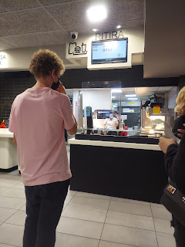

Venice is a hopping place late into the night. There were a LOT of people out and about - eating, visiting, walking, etc.

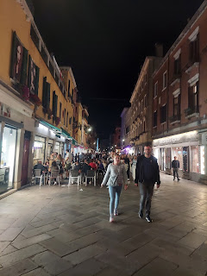

Below: Back to my home base for the night. Marveling at all the "oldness" along the way. The AirBnB that I'm staying in happens to be a 16th century building. Amazing.

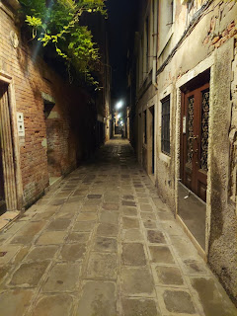

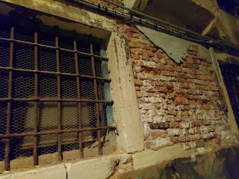

After I finished eating and got into my pajamas, I noticed just how swollen my ankles were from all the traveling and sitting, along with a lack of hydration.

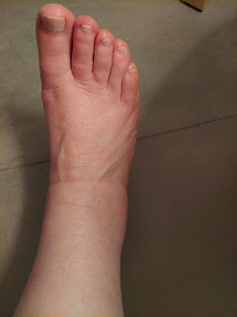

It felt so good to wash my face, floss and brush my teeth, and get freshened up to get into bed. Oh, the simple things in life . . .

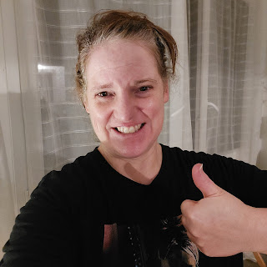

Sunday:
The internet is not that great in Venice tonight due to the rainstorms. It's really struggling to upload ANY of my photos from today into Google Photos so I can use them in this post. I will share one last photo that I took early this morning, and the rest will have to wait until I get better internet. Perhaps when I get to Florence tomorrow . . .

Below: Some local varieties of Italian pasta that I saw in a storefront window this morning. So sad I can't eat pasta. (carbs) I will probably give in at least once while I'm here. I'm just being honest.

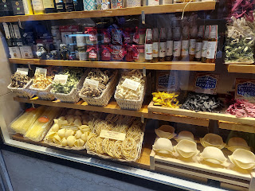

I am so happy to be here. I love Venice. I love the canals, the bridges, the open ocean, the ancient buildings, the people, and the language. I love hearing everyone speaking Italian. I love how it smells here. It smells so good! Even the people smell good! Everyone is super nice, and no one makes you feel bad when you ocan't speak their language. They are patient and gracious and helpful. I would love to come here again someday.

FANTASTIC!!
My photos caught up by uploading into Google Photos! I will quickly take you on ONE LAST ADVENTURE in photos from today. I went on a 4 hour walk all over Venice. My pedometer logged 11, 338 steps in 4 hours.

Here are the highlights of my walk. (Before the rains came)

Italian kids playing soccer as they walked home from church.

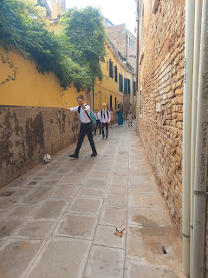

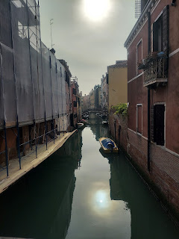

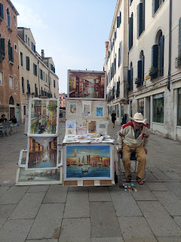

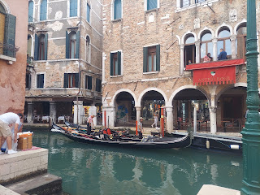

Gondoliers waiting for their next customer.

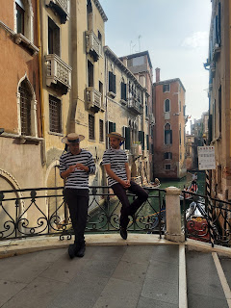

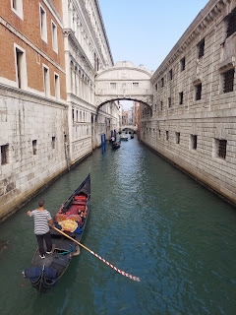

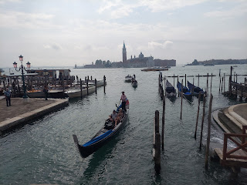

Looking across from St. Mark's Square toward San Giorgio Maggiore

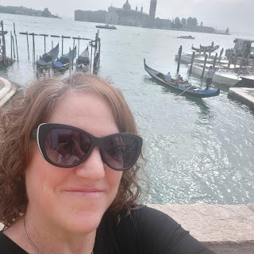

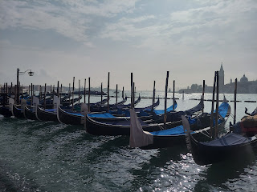

The Doge Palace. This is most likely where my ancestor, Jeronimo Bassano, would have played his musical instruments for the Doge. (pronounced: doh-ghee)

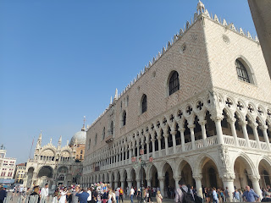

St. Mark's Basilica

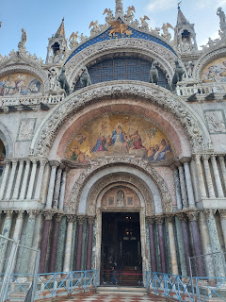

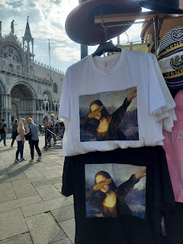

Me, in front of the Basilica in St. Mark's Square

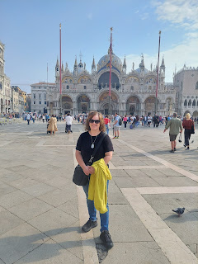

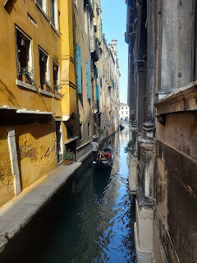

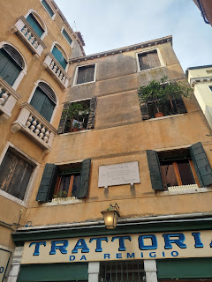

As I was purposely wandering and getting lost (per Rick Steves' suggestion - saying that you can't really get TOO lost when you're on an island), I found a free museum to go into. It even had a rooftop terrace where I could see a lot of Venice.

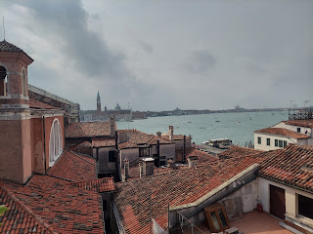

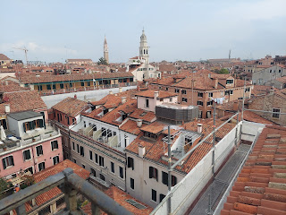

The museum itself was horrible. It was weird, and also very obscene. I hurried back to the elevator and got out of there as fast as I could. This was the only nice thing in there. :)

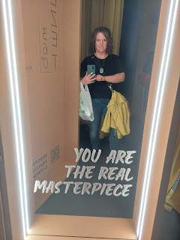

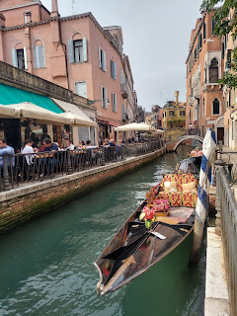

As I wandered and wandered, I finally saw a gondolier that I liked and that was available for hire. I had been watching all morning. This guy was fun, had a good sense of humor, and wasn't smoking.

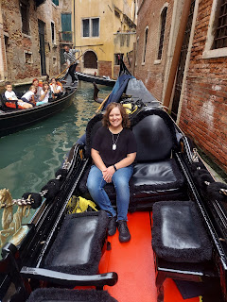

**When I get more internet, the videos I took will finish uploading and then I can share a link. I really want to share the videos from my gondola ride. Paolo was fantastic!

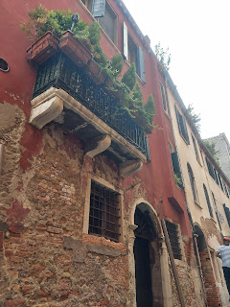

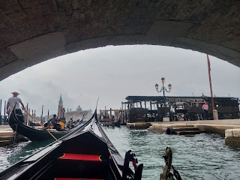

A waterfront view of the Doge's Palace.

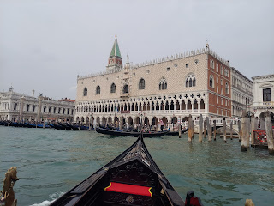

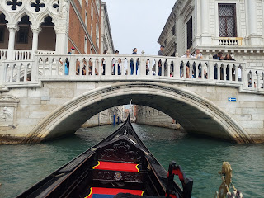

This is called the Bridge of Sighs. Legend has it that when a prisoner was taken from the Palace, they crossed the canal via this bridge. The prisoner would take a moment to enjoy the view, let out a sigh, and then continue on to the prison (on the right, below) where it was dark and dreary. This would have been their last scenic view for a while.

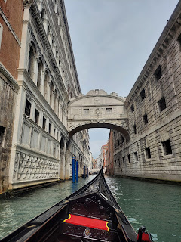

A closer view of the Bridge of Sighs

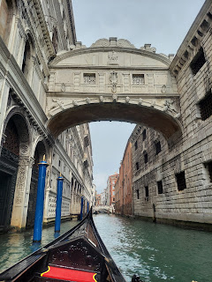

One of the palace doors on the left

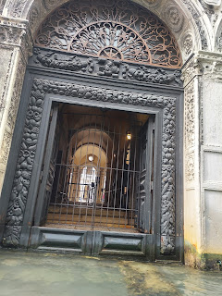

The prison windows and entryway on the right

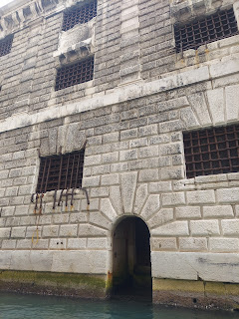

If you want a good workout, then come to Venice. There are many, many bridges going up and over the various canals.

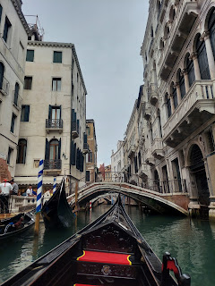

Lots of beautiful and very old things to take pictures of, too.

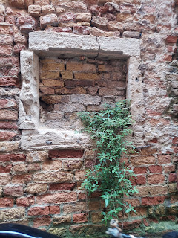

Paolo, my gondolier, told me that the water level rises by a meter every 6 hours, then recedes by a meter for another 6 hours. He also told me that the depth of the canals is about 2 meters.

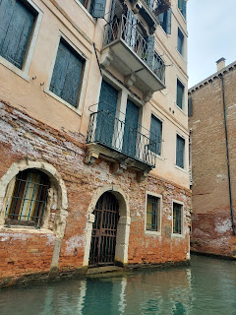

We passed by this young couple RIGHT as he was proposing to her! She said yes, and then was all giggly and in shock when I snapped the photo, ha ha.

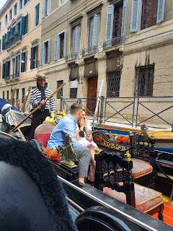

For lunch, I went to a nearby Trattoria, per Paolo's suggestion. I was seated alone for only a few minutes. Then this gentleman arrived, and because of the limited seating, the waiter asked if he could sit at my table. I said yes! What a treat it turned out to be! His name is Gino. He was a gondolier for 50 years and his family has been in Venice for about 400 years! His wife died 6 years ago, and now he spends most of the year in Costa Rica with one of his kids and their family. He said it's just too cold in Venice during December and January - and that it even snows here!

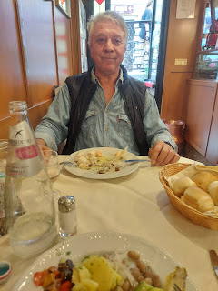

We spoke in very simple English, with a lot of gesturing. We showed each other photos of our family. A couple times I had to use Google Translate to ask him a question, because he didn't understand me. He was so nice. I'm glad I was able to share a meal with him.
As I continued on my "lost" journey, I found a shop that sells gelato. There are several gelato shops, but this one was off the beaten path, so I knew I'd get a good price. I chose Sicilian Pistachio and boy was it good! It was only 2 euros, too! Gelato is the BEST! Way better than ice cream. I'll need to eat gelato every day while I'm in Italy. Gotta get my fill while I'm here!

