Jack's Italian Adventures: Part Two
Jack's adventures in Italy continued into a second week, which was also a week of mixed feelings of highs, mediums, and lows. While we knew that Coy was about to leave this earth, we were mindful of her each day, even as we chose some special family activities to share together. It was on Saturday evening, May 6th that Scott's sister, Bev, called to ask us to come home as quickly as we could. We began making plans right away to get our flights lined up.

At first, Scott thought he should try to get home by Tuesday, but then after a little more research, he decided to wait until Thursday. By this point, the family back in Idaho were pretty sure there would be a funeral on the following Saturday, so it didn't make much sense to rush home in a panic. He had already confided in me a few weeks prior that he didn't feel comfortable seeing his mother when she was suffering at her worst. He felt it would be traumatic for him to do so. He was doing a wonderful job of calling his mother every day, up until she started declining and couldn't talk as much. He felt close to her, and she appreciated those calls very much.

This was one of those special moments when Scott called to share the beautiful sunset with his mom, while his brother Gordon was still with us in Italy.

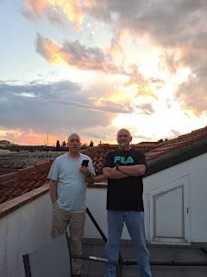

Monday, May 8th:
Scott woke up extraordinarily early because his brain knew he needed to be firing on all cylinders that day. Unfortunately, the other military personnel don't get up in the middle of the night to work, so he had to wait several hours until he could get the assistance that he needed to secure a flight home. He grew more and more impatient, he told me later, and got pretty cranky during the day as one thing or another threw a monkey wrench in his plans. Eventually, by the end of the afternoon, things were starting to work together in his favor and he was able to slow down the hectic pace of his day.

While Scott was working on all the chaos and jumping through all those military hoops, I spent a relatively relaxing morning with Jack and his parents. We went on a walk up to Monte Berico and had a great time, even though it was a little sprinkly and grey outside.

As we passed underneath the train tracks on our walk and came up on the other side, I picked a beautiful red poppy for Jack, knowing that it was Grandma Coy's favorite flower. Lucky for me, I got a darling photo half a second before he tried to eat it and then he chucked it on the ground . . . LOL

Oh . . . two year olds . . . :)

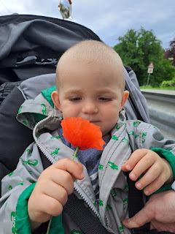

Three jovial old men on a walk together on a balmy Monday morning . . .

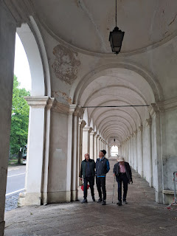

Views overlooking Vicenza from the parking lot at Monte Berico . . .

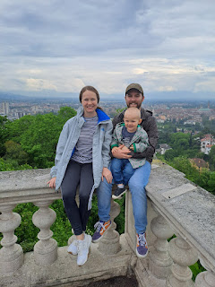

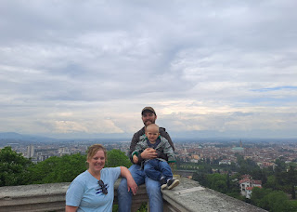

Jack playing peek-a-boo behind the large telescope . . .

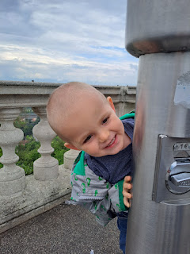

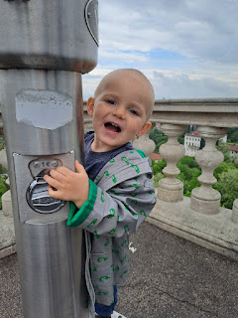

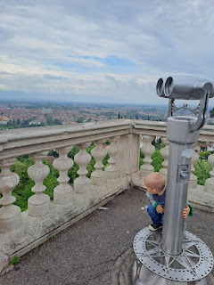

The streets were pretty quiet this time of the day, especially with the weather being a little iffy, so I was able to coax Jake, Hannah and Jack to stand in the middle of the street so I could take a couple of photos with the Basilica of Monte Berico behind them.

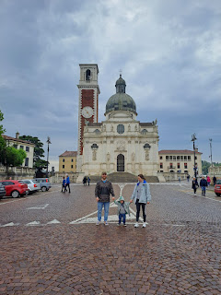

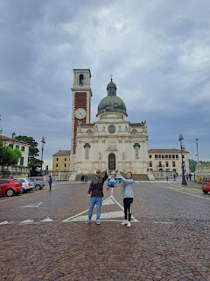

Next, we went inside the Basilica for the first time. It was very beautiful! The full name is Basilica of St. Mary of Monte Berico. Per Wikipedia:

According to the tradition, testified by several documents, the
Blessed Virgin
appeared on the hill twice to a peasant worker named Vincenza Pasini; the first time occurred on March 7, 1426, the second on August 1, 1428. At this time in
Veneto
, people and economy had been suffering from a terrible plague for years. Mary promised that if people of Vicenza built a church on the top of the hill she would rid them of the plague. People kept their promise and the church was built in 3 months.

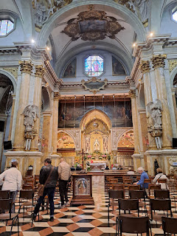

Jack liked to hear his voice making echo sounds in the quiet, yet spacious, chapel area.

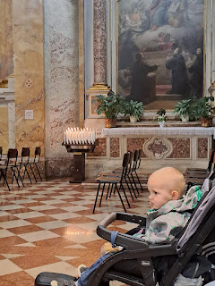

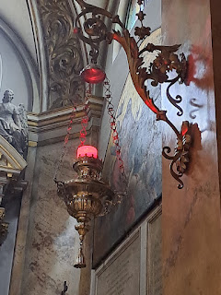

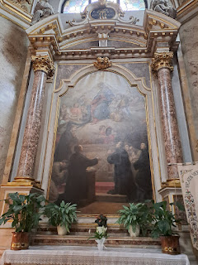

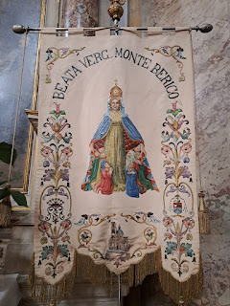

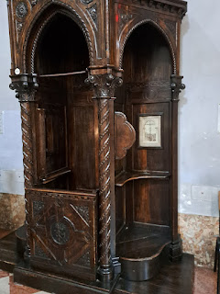

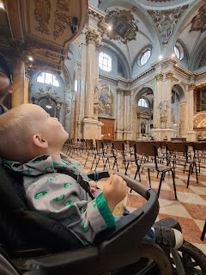

Our time inside the Basilica was time well spent. It was beautiful and peaceful, which was so helpful to us on such a busy day.

We stopped at the grocery store on our way back to the house and then Jack went down for his afternoon nap. During his nap, I began trying to line up some things for our travel on Thursday by going on base to set everything up. It was a bit of a rigamaroll and it took me no less than 3 trips to the base that afternoon.

First, I had to go get some forms for Jake and Hannah to fill out for a multi-day pass to come onto the base through Thursday. In the passport office, they needed copies of Jake & Hannah's passports, which thankfully I had with me and (double) thankfully I had the thought to have them make copies right then. Next, I went home to get Hannah and bring her back first, since both Jake and Jack were both napping. She needed her passport to get IN the gate to come on base, which is why it was so crucial that I got copies of their passports already taken care of. When a guest comes in through the security gate, they have to leave their passport in the security office until they are done with whatever business they needed to do on the base. On the way out, you pull over just outside the gate and then walk back to the security office to collect your passport again, and then you're on your way.

This happened first with Hannah, and then a short while later, we did it all over again with Jacob. But we did get their multi-day passes set up and everything was lined up for us all to ride the shuttle bus to the Venice Airport on Thursday. I had just left our house with Hannah, when Benson called with some worries on his mind. Somehow I was able to talk to him at the same time as driving stick-shift through the busy streets of Italy while holding the phone to my left ear the whole time. I'm so grateful that I was being blessed to do both at the same time.

By the time I got home with Jacob, Jack had woken up from his nap and he was ready to get back to work again.

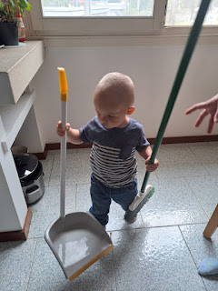

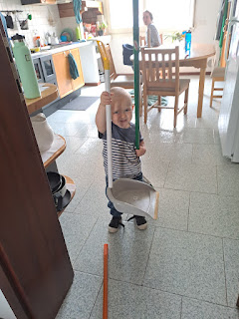

It wasn't long before Scott got home from work and was able to relay to us all the hoops he had to jump through and all the steps he worked through to get his plane ticket for Thursday. He also called Benson and had a wonderful visit with him, giving him some fatherly advice to help him make some important decisions. Within a few days, Benson was able to get reassigned to go to Mountain Home, Idaho as his next duty station (instead of Korea). We are very excited and happy for him, since this will allow him to be closer to family.

We decided to take Jack to see the same goats that we took Avery to see a while ago. They live next door to Veridia, a landscape and nursery store. We brought some long carrot sticks (so our fingers wouldn't get nibbled) and a quart-sized bag of oats.

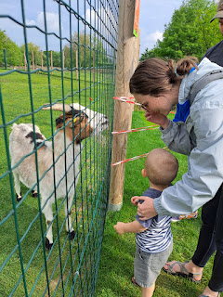

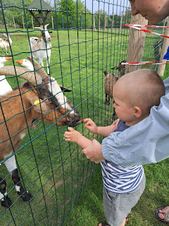

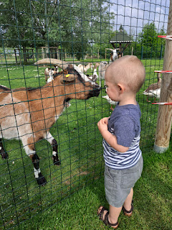

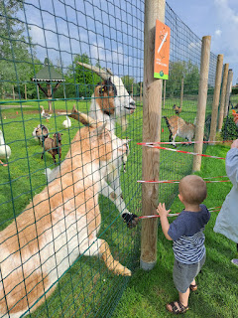

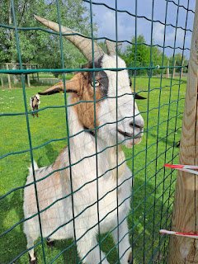

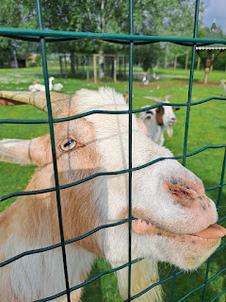

Video #1 of Bappa explaining to Jack the need to break the carrot in half - since Jack just wanted to eat the whole thing, ha ha (15 seconds)
https://photos.app.goo.gl/hodVRbztq6vhdSTbA

Video #2 of Scott feeding a handful of oats: (16 seconds)
https://photos.app.goo.gl/MpKbH4me9CANT62J7

Video #3 of Hannah and Scott talking about the goats all having crazy eyes, meanwhile Jack is trying to say "Hi" to them: (27 seconds)
https://photos.app.goo.gl/NyuGW1C4TdsN4oSz6

Video #4 of Jack feeding some oats to the goats: (23 seconds)
https://photos.app.goo.gl/ShaezaCqMaij8yRJ7

Those goats were hilarious! There was one who was definitely a Billy Goat, with bully tendencies toward the little goats. If he thought anyone was about to get some treats, he'd bump them out of the way with his horns . . .

Jack went up on the roof that same afternoon with his Ma and Pa to blow some bubbles off the terrace. It was a very bright and sunny day, though perhaps a little blinding, unless you had sunglasses on. He didn't seem to mind, though.

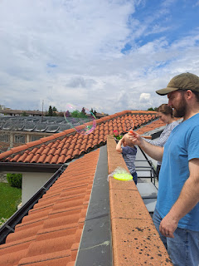

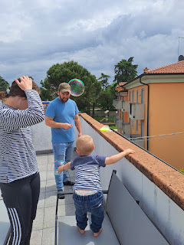

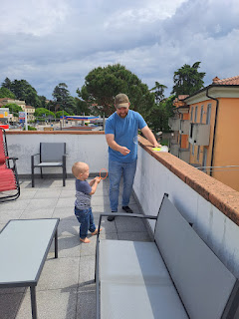

Video #1 of Jake blowing bubbles for Jack: (17 seconds)
https://photos.app.goo.gl/9DS4GPbN6NhcapVx5

Video #2 of Jack saying Bye Bye Bubbles . . . (21 seconds)
https://photos.app.goo.gl/KXe7fSm34aVxWgQX6

Video #3 of Jake finding a sweet spot in the breeze. (17 seconds)
https://photos.app.goo.gl/M3knWSLxPygkHTSGA

We took the kids to another new grocery store, Iper Rosetto, the largest of them all. We were on the hunt for something to cook up for dinner. While we hemmed and hawed over what to choose, Scott "Bappa" kept Jack entertained in the cart . . .

Video of the two of them: (21 seconds)
https://photos.app.goo.gl/q1Fzkyo1qY9qQ38R9

I can't remember now what we eventually settled on, but I'm sure it was good. :) I think it was some type of white fish that Jacob pan-seared with some broccoli on the side.

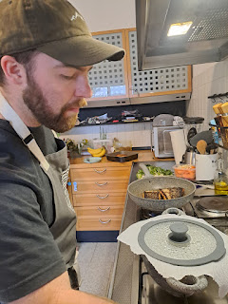

While dinner was cooking, these two cuties hung out on the roof together, watching for busses on the street below. ("BUS?!" "BUS?!")

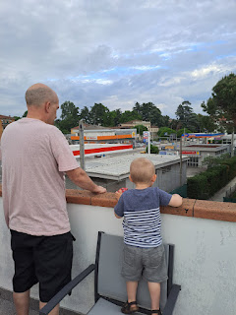

All that effort wore them out . . .

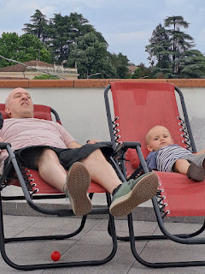

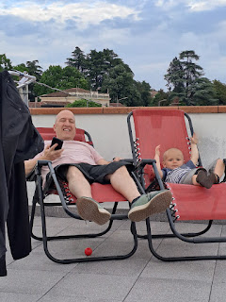

What a great way to relax at the end of a stressful day. XOXO

Our good friends, Bogdan and Andrea came to see us before we went to bed. They are so kind and caring, and we appreciated their effort in coming to see us before we left the country for a time. They are moving to Germany in June, before I will get back to Italy, so it was definitely hard to say goodbye. We enjoyed a nice visit for about an hour or so. They are some of the best people we have ever known!! We are hoping to be able to visit them in Wiesbaden at some point.

Tuesday, May 9th:
While we were sleeping, Amber called us in the middle of the night to let us know that Coy had passed away. She was surrounded by several family members and it was a peaceful and loving moment. Amber told us later that just before Coy passed, she opened her eyes and turned to look right at Phil (her husband). But Amber and Pam both noted that it appeared she was looking PAST Phil . . . they talked about it later, and even as Amber was telling me about it, I thought of Philip (her son) standing behind his father. Amber and Pam had thought the exact same thing! Coy had suffered so many years of guilt regarding Philip's suicide, thinking that if she had somehow put in a little more effort, then maybe he would still be here today. We have tried to convince her otherwise all these years, but she still struggled immensely with that guilt and remorse. I am convinced that Philip would have wanted to be one of the first to hug his mother when she made it to the "other side". He would want her to know that he is okay and that all is well.

We woke up with tender feelings, a mixture of tears and relief that it was finally over. I hugged Scott several times before he had to leave for work. He let everyone at work know that his mom had passed away during the night, and they were very kind and compassionate toward him.

I already had plans to go on one more adventure with Jake, Hannah, and Jack, so we decided to go ahead, knowing that Grandma would have wanted us to enjoy the day and not just sit and cry because she was gone.

I drove us about 45 minutes west to AquaGardens and it was so perfectly peaceful and relaxing. We practically had the whole place to ourselves, including a parking spot in the very first row closest to the entrance! Going first thing in the morning on a weekday sure makes a difference in how crowded (or not) the place is . . .

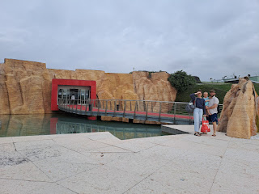

I had ordered a cute floaty toy for Jack from Amazon Italy the previous week, and he sure enjoyed it! We bought a 2 hour pass, which was just the right amount of time to float around and let the water relax us.

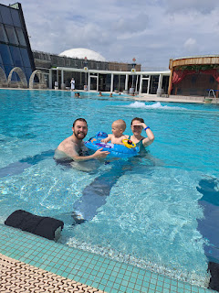

We rotated between the lazy river, the big outdoor pool, and the wading area for little ones, which included a couple of waterslides. Jacob took Jack down the slide with him once, and after a giant kersplash into the pool, he asked Jack if he wanted to go again. Jack shook his head no. So Jacob went without him a few more times, ha ha.

Eventually, Jack needed a snack, so we retired to the cabana that we had chosen earlier so he could eat a little something and get happy again. These two guys are just so handsome.

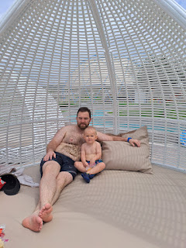

Our time in the pools went fast, but it was also slow and relaxing at the same time. We got dressed in our street clothes again and then we headed over to Lazise, a small town just 15 minutes west of AquaGardens. Lazise sits on the south-eastern shore of Lake Garda, and man was it charming and cute!! It was my first time visiting the town.

We parked at the Parcheggio (public parking) across the street from the church tower. Lake Garda is on the other side of the church. It was only $3 for 2 hours of parking.

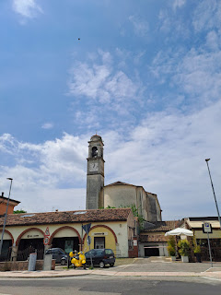

Just south of the church tower is this medieval entry arch that leads into several quaint streets with shops and restaurants near the water.

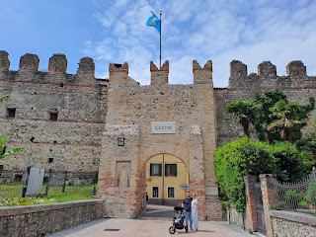

Click on the photo below to read the English explanation of the Port of Lazise and its history.

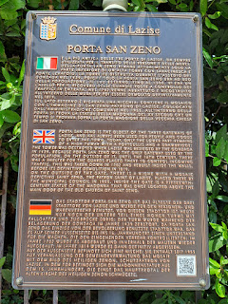

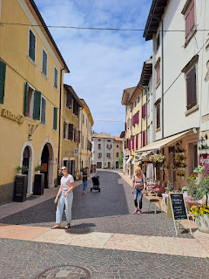

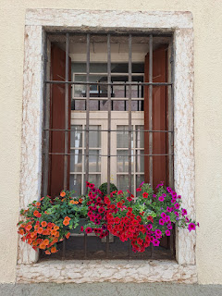

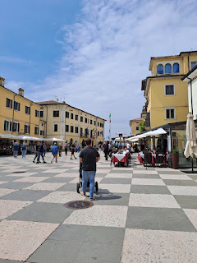

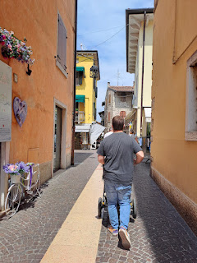

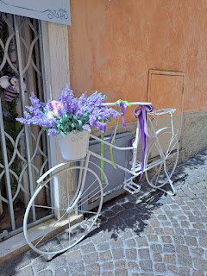

Jacob led us to George's Fish & Chips, a restaurant that he had found ahead of time (with really good ratings).

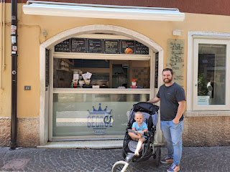

I ordered the fish and chips (of course) and this is how it came: fries were placed down in the bottom of the cone, then chunks of fried fish on top, with a lemon wedge, a large squirt of mayo, and a skewer to eat it all with. It was very tasty!

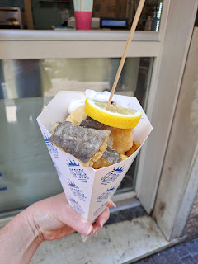

We walked a short distance from George's over to the edge of the lake and found a bench to sit on while we ate our lunch. Jack enjoyed the fries. :)

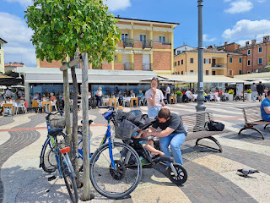

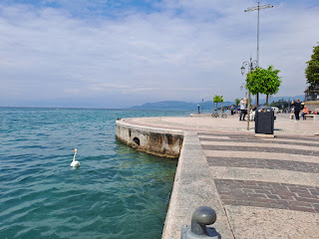

When he started getting really tired, he made the sign for milk. But we didn't have any . . . he started getting distressed, so Hannah went in search of some. There was a gelateria right behind us, so she inquired if they had any milk. At first they didn't understand, like why would she only want MILK?? But when she explained it was for her BABY, they said, "Ohhhhh...okay!!" The owner gave her some milk and a straw in the cutest darndest little pitcher you've ever seen. Jack was supremely happy and Hannah was the Hero of the Day.

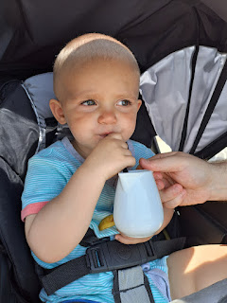

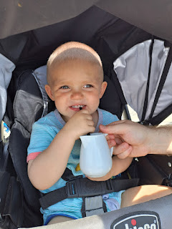

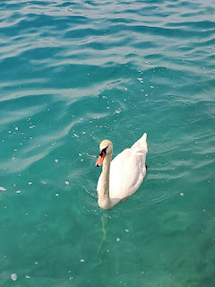

In the photo below, Jacob and Hannah are sitting on a bench way down at the far end. I walked a little ways to capture the whole ambience of where we ate our lunch.

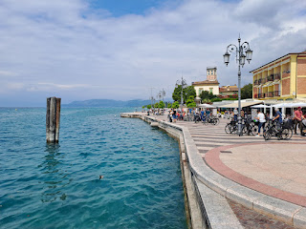

We bought some gelato at the same shop where they so graciously gave Hannah some milk for Jack (for FREE). We were so grateful for their generosity!!

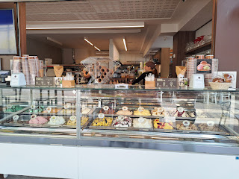

Time to walk off the calories again . . . this is the Lazise Harbor. The water color is so pretty!

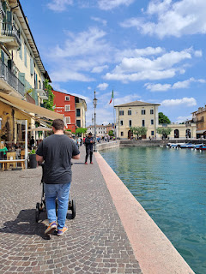

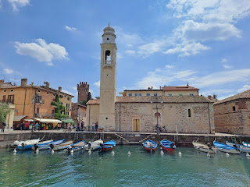

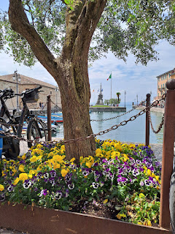

I got a kick out of this couple and their precious pet doggy. They were tenderly attending to his needs like he was a newborn baby.

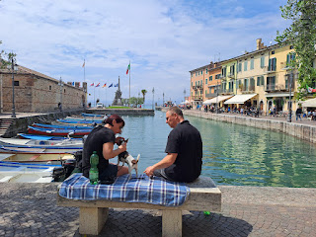

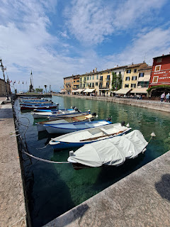

(Jack's pose . . . LOL)

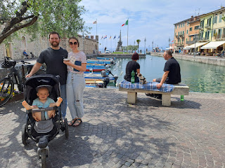

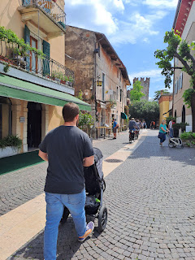

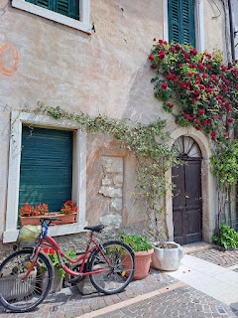

Jake, Hannah, and Jack

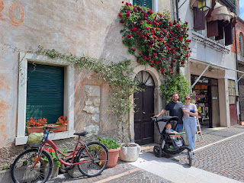

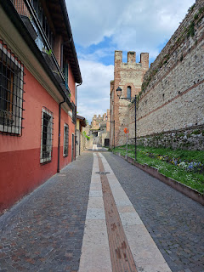

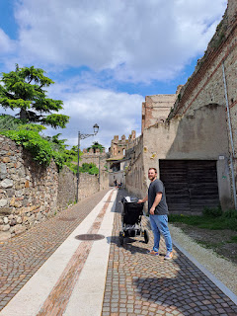

Video - come take a little stroll with us down this ancient alleyway toward the castle: (18 seconds)
https://photos.app.goo.gl/jGce1CvFSmW1AFUU9

We didn't actually get to see the inner workings of the castle, it is currently privately owned. On our way back to the car, we passed this same cute little Vespa rental shop again. I would love to rent one for an afternoon sometime . . .

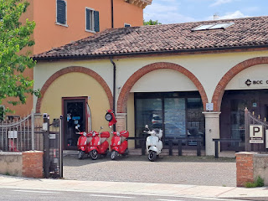

It was just over an hour to get back home. It was a really, REALLY nice day. It was peaceful, relaxing, and the right kind of pace after hearing the news that Mom had passed during the night. I was still seeing red poppies EVERYWHERE, reminding me of her, and of her loving personality and legacy that she has left behind. They were along the roadside, in fields, and everywhere. She will always be with us, everywhere.

After dinner that evening, Jack had some fun with the leftover dish soap bubbles from my sink. I kept plopping blobs of bubbles in front of him (and on his head) and he had a good ol' time.

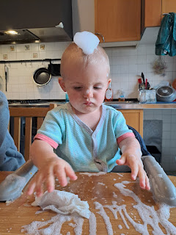

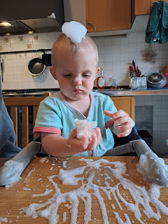

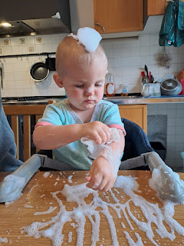

Wednesday, May 10th:
It was pouring rain when we woke up and it never stopped the entire day. (That's why we went to AquaGardens and Lake Garda the day before - - it was the last sunny day of the week before we left Italy.)

We spent the morning packing and getting the house ready to leave. Scott stayed home all day with us, which was so nice. During Jack's nap, I took Jake and Hannah shopping at the mall. First, we went to Kiabi, which is next to the mall. Surprisingly, Jake had the most success. He found several items, including a nice white dress shirt for church.

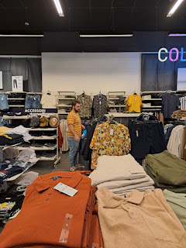

Hannah and I found a few cute outfits for Jack in Kiabi. Then we tried both malls, but didn't have as much success as what we found in Kiabi. I love that store!

As we emptied out the rest of the leftovers for dinner, Bappa and Jack watched out the window for more busses.

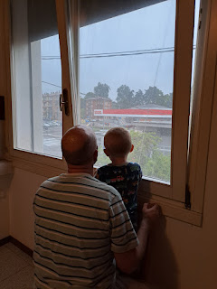

There's one! A big white one . . . Jack and Avery both love watching all the action out our kitchen window. I'm glad we live in town, as opposed to the country. Everything is just right there.

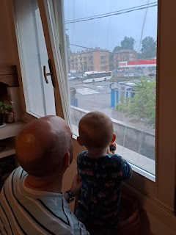

Scott was the first to be all packed and ready to go. He didn't need to pack very much, since he would only be gone for 2 weeks. Plus he has more clothes and supplies back home in Idaho.

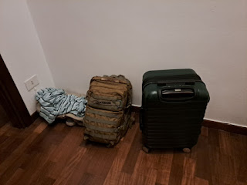

The last thing we did before we went to bed a little early, since we had a big day the next morning, was to have a little dance party with Jack. He gave it his ALL on top of the coffee table . . .

Video of Jack dancing: (1 minute, 22 seconds)
https://photos.app.goo.gl/uJ9kAW1sEiSf8HX17
Thursday, May 11:
I woke up early at 5:00 a.m. and started getting ready to go. There were some last minute details to attend to, such as emptying all the trash and cleaning out the fridge one last time. Scott had left in the middle of the night. His shuttle bus left at 3:00 a.m. to get him to the airport for his 6:00 a.m. flight. He had minimal packing to deal with, and Jake and Hannah just needed to pack up the things they had brought with them, so things were relatively easy for them, too. On the other hand, I was packing up all of my things to be gone for
4 months
, and since I was the last one to leave our house, I needed to be sure that everything was okay to leave behind for 2 weeks until Scott returned. (Crack a couple windows, partially close all the blinds, grab all the keys to hand off to Scott in Idaho for the car, house, etc. and take our precious Kevin the Kumquat Tree and Timmy the Tomato Plant to our next door neighbor, Zhanna, for watering in our absence.)
We managed to get ourselves over to the Ederle Inn on the base in time to catch the shuttle bus, which arrived just before 7:00 a.m. Scott had driven over with some of our luggage during the night, which was perfect because there's no way we could have fit everything into the little white car! (5 pieces of luggage plus the big stroller plus our backpacks)

It was so nice to ride the bus instead of me driving. Jack enjoyed being ON a BUS!! LOL

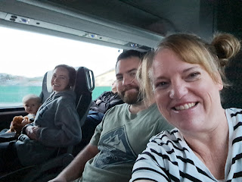

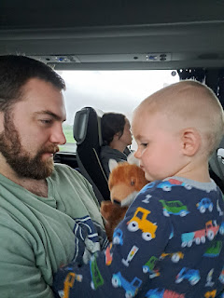

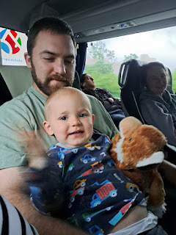

At the Venice Airport, we entertained Jack for a while by taking turns helping him to ride the escalator over and over and over. We eventually had a quick lunch together and then I had to dash off to catch my flight first.

I was supposed to leave at 11:35 a.m. but we ended up being delayed TWO and a HALF hours!! I heard something later about two passengers spitting on each other, which eventually necessitated having them deboard the plane. We had already pulled away from the gate when the trouble ensued, and it took an extraordinary amount of time to be able to pull up to the gate again. (Once you pull away from the gate and another plane pulls in, it's a good hour or more before another plane can pull up to that same spot.) The passengers' luggage underneath the plane needed to be located, as well, before we could leave, and then we had to wait to get back into the lineup for takeoff a second time . . .

Finally we left Venice for a 10+ hour flight to Atlanta. I knew that my next two flights would be long gone by the time I landed, so it was just a matter of waiting to see how they would take care of me overnight.

I watched Maleficent during the flight, and some episodes of Taste of Italy with Stanley Tucci (super fun!). My dinner was pretty good. It consisted of polenta, chicken with a vegetable marinara sauce, steamed broccoli, Greek salad, and some salted caramel ice cream.

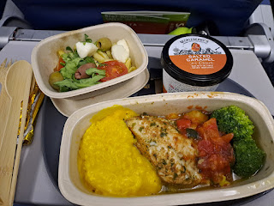

I tried to sleep, but had a hard time doing so because the flight was during the daytime. I do better if it's an overnight flight.

Once we finally landed in Atlanta, I had several more steps before I could get into a comfy bed for the night. I had to go through customs, which was approximately a 17 mile walk. Then I had to get in the Delta Airlines customer service line to verify my hotel and meal voucher. Next, I had to collect my two heavy suitcases and take them through security again. That's always such a weird step to me, why do we need to recheck our bags again?? I had to heft my heavy suitcases to go through the same security where you usually just have a backpack or a small carry-on suitcase to be screened, ha ha.

After I cleared security a second time, I walked another 18 miles or so to get to the airport exit. I caught a train to an area near the airport known as Gateway, with a cluster of hotels and a few other amenities. I finally got checked into my hotel room on the 5th floor and proceeded to order some food to be delivered.

The restaurant told me it would be about 45 minutes, so I decided to hop into the shower so I wouldn't have to shower early the next morning. Right as I was toweling off, the phone in my room started ringing. Turns out, the delivery guy came MUCH sooner than expected. He had already tried to reach me on my cellphone about 7 times while I was in the shower, and eventually asked the staff in the lobby to call my room. I told them I would be down ASAP . . . and very soon I dashed down the elevator in my pajamas (with pants) and my hair piled up in a big white towel, ha ha.

I was so tired by this point. I ate my dinner, called Scott and settled down to sleep around 11 p.m. It was 5:00 a.m. back in Italy, which meant that I had been awake for 24 hours by this point. Yuck.

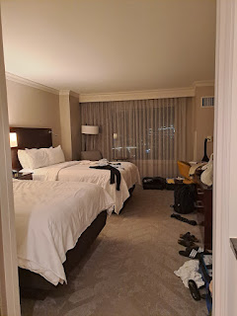

The bed was delightfully comfy and there was even a Book of Mormon next to the Bible in my nightstand drawer. Way to go Marriott! Those two books of scripture belong together. I love them both.

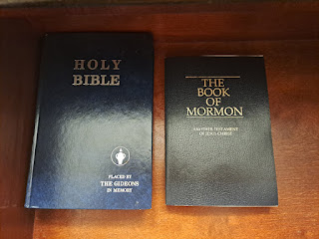

Sadly, I woke up at 2:30 a.m. after only 3.5 hours of sleep. And that is how Friday began for me.

Friday, May 12th:
I checked out of the hotel at 5:00 a.m. and made my way back to the airport. This meant a ride on the train first, then miles of walking again to get checked in and through security to my gate. Everything else went well the rest of the day.

I ate some spicy shrimp and grits for breakfast.

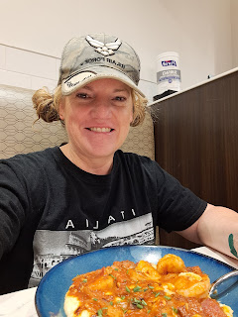

Sunrise in Atlanta . . .

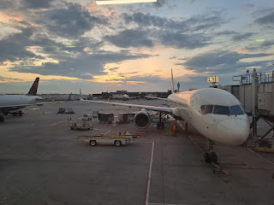

Snowy mountain peaks near Salt Lake City . . .

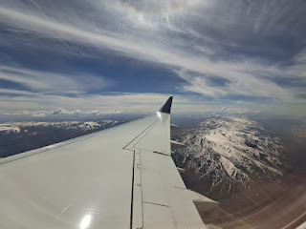

And, at last, the farm fields of Idaho . . .

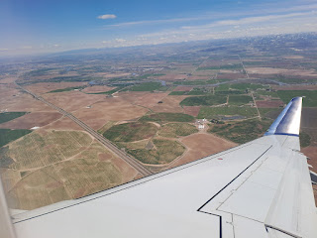

As I posted in my previous tribute to Coy, the rest of the day was pretty busy. I landed, met up with Scott, Weston and Amber, and later I helped dress my mother-in-law in her temple clothes for her casket. This was followed by the family viewing and a choir practice, too. I was exhausted by the time I got home and could put myself to bed.

The rest of the details of the weekend are included in my previous post, entitled Coy Michie Harmon.

A busy day, and a busy week. But ultimately one that brought the family together from far and wide. I am so grateful for my family. They mean everything to me!!

