Two Weeks With Scott in Idaho
It was so wonderful to have Scott with me for TWO WHOLE WEEKS. After the weekend with family surrounding Coy's funeral, life got pretty quiet once everyone went home. Bev's husband, Ken Vian, stayed on for an extra week to look after Scott's dad, Phil in Rigby. We drove up almost daily to visit and bring in a meal (mostly to keep Ken's tummy happy).

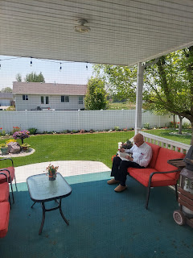

Dad sure likes his daily routine. Get up around 5:30-6:30 a.m.. Exercise on the treadmill downstairs for a few minutes, maybe lift a few weights. Go upstairs for a little nap. Get showered and dressed. Another little nap. Then it's time for breakfast anywhere from 7:15-8:00 a.m. (Breakfast consists of cream of wheat with a little sugar and a few raisins, a glass of apple juice, and one piece of toast with PB or jam on it.) This is typically followed by another little nap.

The day is a rotation between reading in the living room, his office, or out on the porch, with naps in between. By 3:00 in the afternoon, he is ready for his supper. It is always the same: either half a can of tomato soup or cream of mushroom soup, 7 wheat thins (I've tried setting up to 10 crackers on his plate, but he always leaves anything over 7 still on the plate), a small bowl of fruit (fresh strawberries or canned pears), and a glass of milk.

He has a secret stash of Oreos in his office desk, which he snitches from throughout the day. How do I know this? Because he tends to have little blackened corners of his mouth from biting into the Oreos. Tee hee. One day, he told Scott and me that he was running to get something at Broulim's, the only grocery store in Rigby. We didn't try to stop him, because it's Rigby, after all. Population is 3,000 and the streets are super wide, which is great for a 92 year old man with compromised eyesight. But the whole time he was gone, Scott and I kept looking at each other like - when is he going to come home? It was reminiscent of having teenagers out after curfew . . . But Phil did finally get home safe and sound. I could see through the white grocery sack that he carried into the house and straight into his office. It held a big blue package of fresh Oreos. :)

The late afternoon and evening usually consist of Dad watching several episodes of Adam 12, a cop show from the 1960s. He'll watch 2-3 episodes, then take a nap. Then maybe read a little, then more episodes. The TV is always on at 90% volume and he sits in a folding chair with a pillow on the seat, roughly 5 feet from the TV. Sometimes I can tune out the show at such a crazy volume, but sometimes I need to go downstairs or outside in order to hear my own thoughts.

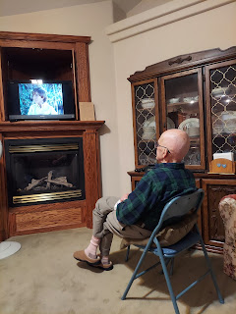

I can usually talk him into a snack of some sort in the evening, whether it's a slice of pie or a bowl of fresh cut up fruit, or a bowl of popcorn. And he's ready to get into his pajamas around 8:30 or 9:00 p.m., so I do the same. I slept downstairs when Scott was here with me for the first several days, with the initial plan to move upstairs once he left. But Dad likes the heat up higher than what is comfortable for me, so I prefer the downstairs still, where it's cooler. I can open up the window downstairs and turn on the oscillating floor fan to keep me nice and cool during the night. I have a bathroom all to myself down there, too, which is nice.

He checks the thermostat multiple times a day to make sure it's always at 75 degrees. If it's slightly lower, he'll turn on the fireplace under the TV. If it's higher, he'll turn the heat off for a while, and if it continues to creep up, he'll turn on the A/C. A few times, we talked him into opening up the front door and the back door (both have screens) in order to let a nice cross breeze flow through. But he's not a huge fan of that . . .

He is always very pleasant, but prefers only minimal conversation. He is mostly a solitary man, who likes his routine. He likes to feel like he's capable, so I have tried to find little ways to give him something to do to make him feel useful and important. For example, when Ken was staying here for the first week, Ken liked to hand-wash all the dishes, even though there is a dishwasher available. I prefer to just wash pots and pans, or items that shouldn't go in the dishwasher or are too big and would hog up too much space. While Scott and I have been here, I tend to load as much as possible into the dishwasher so we can wash a load every other day. Dad loves to be the one to empty the dishwasher and put everything away. It gives him something to do, which is important. I want him to feel like he can contribute, which elevates his mood.

I remember when I stayed in Ukiah, CA for 4 months with my mom and Grandma Doris (in the fall of 2019). We tried to find a few light chores for her to do so she, too, would feel useful and important and needed. I remember helping her get situated in her wheelchair in the kitchen so she could put all the silverware away into the drawer. Other times she could haul dishes and napkins to set the dinner table by using her walker as a transport vehicle. If she didn't have enough to do, she felt despondent and depressed. But then, she didn't read near as much as Phil, and she didn't have Adam 12 to watch every day . . .

While Ken was taking care of Dad, Scott and I had plenty to work on around our house in Idaho Falls. I look back now and I'm in awe of everything we were able to accomplish. Teamwork sure helps!!

We went to the Idaho Falls Temple on Tuesday morning, a few days after the funeral. It was so nice to have a temple closeby again, instead of driving 5 hours each way to get to the Rome Temple.



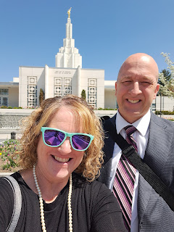

The session was peaceful, beautiful, and comforting. The flowers, mainly a variety of tulips at the end of their season, were especially pretty.

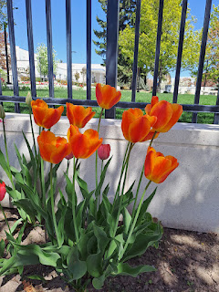





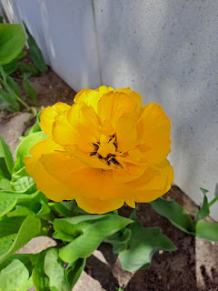

We spent 3 days cleaning out the basement and the garage. Why would we do that when we could be doing so many other things that are infinitely more fun? Because we had a terrible mice infestation downstairs and also in a couple spots in the garage and it just needed to be done.

They had a party in the bag of black sunflower seeds that were supposed to feed the birds . . .

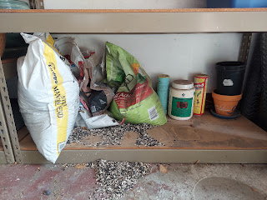

They made a nest in my Christmas Nativity stable down in my storage hall . . . disgusting. I threw the whole thing away.

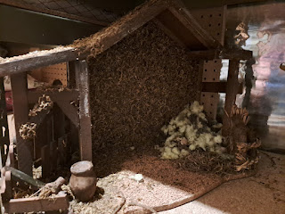

In fact, I threw several things away. Scott thought it was a little extreme, but when you're a germaphobe like I am, there is no perfect compromise. I wore gloves and used clorox wipes to clean all the salvagable items. We vacuumed up mice poops and swept and worked hard for hours. Scott even threw away about 100 lbs of rice because they had made a hole in two giant bags, which seemed to be their main source of food for who knows how long. It was so subtle and sneaky, but it just makes my blood boil . . . We ended up buying some 5 gallon buckets to get the rice and other grains into a more protected storage source for the future.

Pest control also came and set up some bait stations with a "slow kill" method. It consists of rectangular blocks of bait inside bait boxes, which are then placed in areas where we think the mice are likely to come taste it. The pest control guy told me that mice are super smart. (Gross. I didn't really want to know that.) If Scott and I were to set out traps with PB in it, and if a mice gets caught, then the other adult mice apparently teach the juvenile mice to not eat from that source. I can just picture it: "Hey kids, come see Uncle Billy. You see, he died all because he ate some of that peanut butter there. Don't eat from that source unless you want to end up like he did."

The bait blocks, on the other hand, are meant to take a while longer to take effect, which gives the mice a false sense of security. If they don't get sick right away, then they feel confident about the food source and encourage everyone else to come and eat some of it, too. Eventually, after a few days, they start to get loopy and they go in search of water outside to remedy how they're feeling on the inside. While they're searching for water outside, they die - AWAY from the house. And nobody is the wiser back at the homestead. They say that it only takes about 2 weeks to get rid of all the mice. I can't wait . . .

Okay, enough about mice . . . ugh.

We had some welcome company one day during that first week. Phil's niece, Dana, and Dana's son, Liam, were passing through and stopped by for an hour or so to visit in Rigby. Scott and I were able to be there as well. I didn't remember meeting Dana, but she remembered meeting me several years ago, back when Benson was a baby. Her son, Liam, sure is a nice young man. He was on his way up to Ann Arbor, Michigan, where he will start his junior year of college in the fall as a music major. He plays the piano and the keyboard and wanted a jump-start on securing a decent job for the summer, so that's why they were headed across the country now. They live in the Bay Area of CA, so that is a long journey, but what a fun road trip! I am always ready to explore new places, and I've never been to Michigan yet.

Liam and I exchanged info for our Instagram accounts and he also took note of Amber's art account, once I showed him all of the paintings she has done and recorded on social media. He likes to gig for weddings and other events, so it sounds like he has an exciting future as a jazz pianist. How fun! We talked a bit about how music is a Harmon trait that has been passed down. Phil was a musician in the US Navy Band for four years, playing both the clarinet and the saxophone. His father, Wesley L. Harmon, was a music teacher and could play just about any instrument. He played the piano, the french horn, the saxophone, the oboe, the flute, the violin, etc. Quite a wide range. Phil sings, Coy was a singer and a pianist, and many of their children have beautiful singing voices, too.

Dana Harmon Charron, son Liam Charron, and (Uncle) Phil Harmon

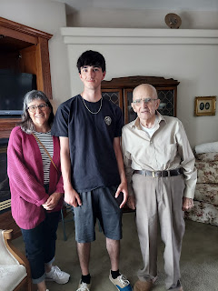

Me, Dana, Liam, Phil, and Scott

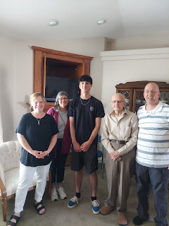

Dana, Liam, Phil, Ken Vian (Bev's husband), and Scotty

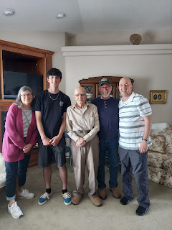

Scott asked Liam if he had heard of Brian Culbertson, one of our favorite jazz pianists who is very successful. We even attended one of his concerts in Clearwater, Florida a few years ago. Liam had not heard of him, but took note of the name for something to listen to on their long drive. Sure enough, I got a text from Dana two days later. She said they were listening to Brian Culbertson that day and enjoying his music on their drive. :)

As Scott and I left Rigby to drive back home, we saw a beautiful black horse trotting around the roundabout near Wendy's and close to the freeway entrance. A handful of people were trying to "corral" him and shepherd him off the roads and back to safety . . . I chuckled to see such a sight, since it's not something you see every day. He trotted across the main road and away from where I could get a video of him. I was worried that he was heading to the freeway and hoped that there was a fence that could prevent his certain death. Thankfully there was a fence, even though it was a bit wimpy looking. I was able to get a video of him as we entered the freeway behind where he was at that point.

Video of the horse thinking he's so free and in charge of his own destiny: (6 seconds)
https://photos.app.goo.gl/W1kHFnyoq7rDUGhHA

Speaking of wild and free, the next morning I was peeking out the dining room doors to relish in the beauty of the trees in my back yard. I slowly looked over to my right, and there was a giant squirrel sitting on the brick ledge along the back of the house. He, too, just stared at me. He was sitting on his back haunches, with his tiny T-Rex arms resting on his abundant belly, kind of like a mini-kangaroo or something. We stared at each other for almost a full minute. I softly asked him what he was doing there. He didn't answer. I casually added, "I hope you weren't thinking about digging into my cushions for some stuffing to build a nest . . ." Again, just a blank stare.

I slowly backed inside to grab my phone so I could take a video of him being so relaxed on my patio. I hoped that when I poked my head back out he wouldn't jolt and run away in a panic. Thankfully he didn't.

Video of the squirrel: (38 seconds)
*Note how slowly he sauntered back over to his territory in the trees. LOL (What a pill)
https://photos.app.goo.gl/BdZSZWpRu9nwhy617

Ken's oldest daughter, Sherra, and several of her children came into town for the weekend (May 19-22). I hadn't met some of her daughters, and some I hadn't seen in years! We put together a BBQ dinner at our house and Ken drove Dad down so he could join us (and eat something besides soup). I made an assembly line for making grilled personal pizzas.

Here is the assembly line of toppings: (with a handsome assistant)

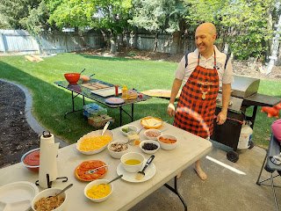

The instructions are basically this:
Prepare your pizza dough and have it rolled out and ready for use
Get ALL your toppings prepared and have them CLOSEBY to the grill
Lightly brush some olive oil onto one side of the dough and put that side down on the grill to cook that side first
When it is cooked sufficiently on the one side, you can either - A) brush olive oil on the 2nd side of the dough, flip it, and QUICKLY add all the toppings you want and then shut the lid to finish the cooking process, OR B) slide the half-cooked pizza dough onto a plate, lightly brush olive oil on the 2nd side, flip it, add your toppings, and then slide the entire thing back onto the grill, shut the lid, and finish the cooking process. We had always done it the "A" way in years past, but Scott suggested we try method "B" this time and it still worked just fine. The biggest difference is that it's not as stressful to add your toppings when it's away from the hot flames.
Have a large cutting board available with a pizza cutter to cut your personal sized pizza into more manageable slices and then slide them back onto your plate
Proceed to devour.
Sherra took some time showing Grandpa some pictures of her new home in North Carolina.

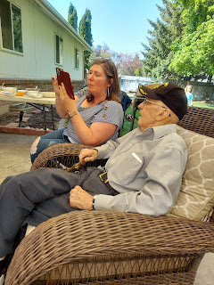

Sherra and Grandpa, with daughters Bree (L) and Kyla (R) in the background. Remmie can be seen on the far left behind the grill. She is 5 years old, while the other sisters are all 17 years old and up.

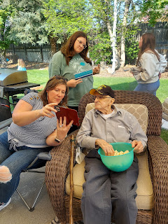

We had a good time and everyone loved how the pizzas turned out. Each person assembled their own and I just supervised to make sure they were successful, which they all were!

The following day (Saturday May 20th), Scott sold the camper shell for the old Ford Ranger pickup. As we were cleaning out the garage, he noticed that it was hanging up near the ceiling . . . We obviously don't need it anymore, since Weston had the truck shipped down to Louisiana a year or two ago. Too bad we didn't think about the camper shell then! Oh well. A lady came and bought it for her Chevy Colorado truck and it fit perfectly. She was so excited to have a place to sleep when they go camping as a family, without having to haul a camper. Scott sold it on Facebook Marketplace for $250. Marvelous!

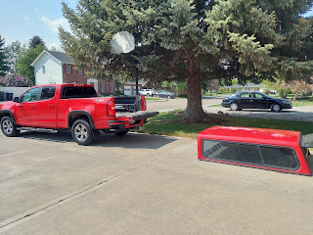

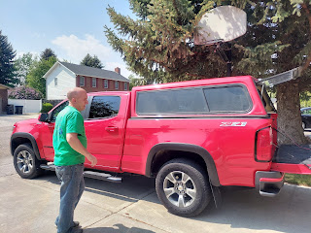

We went up to Rigby later that afternoon to have dinner again with Ken, Dad, Sherra and all her girls. I encouraged Scott to offer a haircut to his father, since his hair was looking a little too long as of late. Coy used to give Phil his regular haircuts, and I knew that Scott could do a good job with clippers since he uses them on his own head each week.

At the end of the haircut, Scott had me come in to inspect. I touched up a couple of places and then Voila. This handsome 92 year old man was now ready for church in the morning! :)

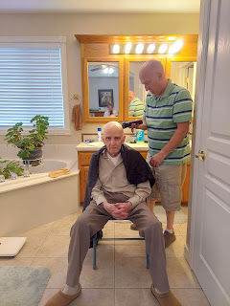

As we drove to Rigby that evening, I received a very troubling phone call. It was an Idaho number, and it said "Number Verified" on my phone. Normally I don't answer calls that I don't recognize, but I also remembered that I had been making phone calls to Hospice and a few other places recently (as I tried to secure a refund from Turkish Airlines for my emergency alternate flight home for the funeral), so I wondered if it might be one of those businesses calling me.

I answered, and immediately the caller identified himself as a Deputy from the Bonneville County Sheriff's Office and that there was a bench warrant out for my arrest. He said I had not reported for jury duty on April 3rd. I was shocked because I had PROOF in multiple formats that I had been excused from jury duty. My reason: I was out of the country!!! I received an email, a text, and an actual letter in the mail that provided my valid excusal.

But this man proceeded to talk very fast and gave me a whole long list of instructions. He said that it had not been recorded that I had been excused, and that I would need to present my proof to the judge. I would need to pay a deposit of $2500 for one thing and another deposit of $2500 for something else, using a kiosk in the courthouse lobby. He told me several other crazy steps, making it all sound extremely complicated and difficult to understand. I was trying to take notes as fast as I could, stopping him occasionally to summarize what I was hearing to make sure I was hearing it all correctly.

At one point, he did say that there were other methods of payment, such as Zelle, Venmo, or PayPal. Scott asked why we had to pay a deposit for something I wasn't even guilty of. This man had a smooth and very rapid explanation for every question we fired at him. He said as soon as I presented my documents to the judge, the money would be refunded immediately. Eventually, I said to him, "How do I even know you are who you say you are?? Why would I give money to you when I don't even know if you're who you say you are??"

He again told me his name, Deputy Robert Benson, with Badge #3316. He then said, "Okay, here's what I'll do. I competely understand your concerns, ma'am. I'll have someone call you from the County Treasurer's office to validate this information. But you cannot hang up. If you disconnect the line, we will be forced to act on the bench warrant, which means we will have to come and arrest you for failure to comply. So just stay on the line please, ma'am."

Yeah, okay . . . I guess . . . this all seemed preposterous to both Scott and me, but we had never dealt with anything like this before either. Just as the "Deputy" put me on hold, we were pulling up in front of the hosue in Rigby. Scott got on the other line and called the Bonneville County Sheriff's Office. The dispatcher asked what we needed, and Scott asked if they had a deputy named Robert Benson with blah-blah-blah badge number. She said, "We do NOT." He then told her about the phone call and how I was on hold. She said it's all just a scam and to not give anyone any money. She said they NEVER take care of a bench warrant over the phone. EVER.

At this point, the other line starts ringing on my phone, and it shows 208-529-1200 - which is the ACTUAL number for the Bonneville County Sheriff's Office!! Scott tells the dispatcher that I'm getting a call from them, and she said don't answer it and that it's all just a scam. Apparently scammers can program a "front" number that makes it look like it's a legitimate number, when in fact it's NOT. Man Oh Man!! I was fired up now!!

I didn't answer the new call, and then the guy tried to come back on the line with me. I just hung up. Scott tried to call him on the number it showed on my phone log, and he didn't answer . . . no surprise there. My heart rate was pretty high at this point and I was definitely rattled. How brazen was that!?!

My jury duty assignment must have been public record for him to even know that I had been summoned. I'm just in awe of how elaborate this whole scheme was, and how several people could potentially be suckered into paying $5000 if they were confused or feeling intimidated. And I bet that some people did get suckered into using Zelle/Venmo/PayPal because he made the whole kiosk thing sound way too labored and complicated. Of course if people do have something like Venmo, they'd much rather use that. But again, why should I give money to a total stranger, and why is money required for a jury duty issue that I already resolved?? It all just blows my mind.

Here are my scribbled notes that I took on the car ride to Rigby . . .

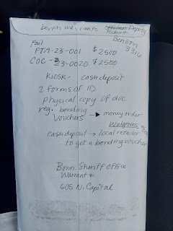

Thankfully, we had a relaxing dinner with family following that stressful phone call, and had a pleasant rest of the evening.

Group photo: (L to R) Phil, Scott, Me, Sherra, Breeanna, Kyla, Skai, Audrey, and Remmie in front

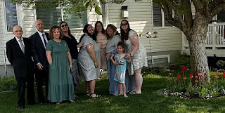

We ate taco salad on the back porch, gave Dad his haircut, and drove back home with this beautiful moody sunset forming to the west.

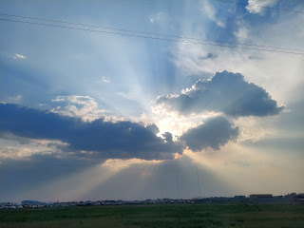

Sunday, May 21:
Scott and I "moved in" with Dad in Rigby. We arrived early in the morning (around 6:50 a.m.), since Ken had to leave even earlier (around 5:00 a.m.) and we wanted to get there in time to make Dad his breakfast. He had already started fixing his breakfast on his own, which is great, but there was some cleaup needed for sure.

We went to church with Dad at 9:00 a.m. and as soon as Scott and I started singing the opening hymn, we both teared up, thinking about his Mom again. We hugged and tried to keep singing as best as we could.

It was a beautiful Sabbath Day, with sunshine and mid-70's. Dad enjoyed some time out on the back porch reading a book where he could hear the birds chirping and get some fresh air.

As Scott and I settled into our room downstairs that first night, I found this embroidered tea towel that I assume Coy had made. It's so true!!

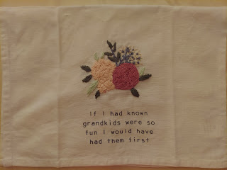

Monday, May 22nd:
I began cleaning out and organizing the pantry, trying to upgrade Coy's longtime system into something more streamlined. Bev, Scott's sister, had mentioned to me how it was difficult to cook in that kitchen because there would be pots and pans in several places, and a few other little annoyances. I agreed, and so I got to work, starting in the pantry. I didn't like how some of the pans were mixed in with foods and snacks. It seemed so far away from where they were needed in the kitchen . . .

Here is the "before" picture . . .

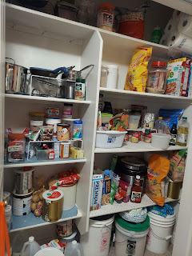

And here is the "after" picture . . .

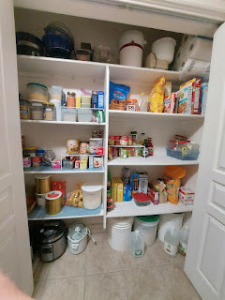

Once I finished the pantry, I began cleaning out cupboards and drawers, rearranging some things, and downsizing as well. I didn't think 20 hot pads were needed at this stage, so I downsized to about 8. Scott helped me vacuum out a drawer and was good to haul stuff out for me, or reach something up high.

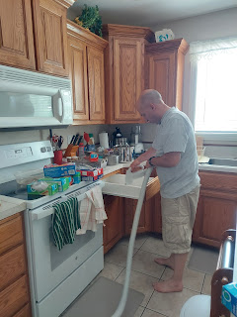

It felt immensely satisfying to clean and organize and make things more streamlined. I broke into tears at one point because I realized that I was finally HELPING COY, something I hadn't been able to do in those final days and weeks of her life. She had been tired and run down for the past few years, but just kept on keeping on as best as she could. Her eyesight wasn't as good anymore, so she didn't notice crumbs or spots that needed cleaning. But I know she was a meticulous cleaner all her life, because I saw her in action for the past 30 years. If she had known things needed a little deeper cleaning, and if she had the energy to clean it during these past few years, she would have done it. But she either didn't know or didn't have the strength. That's where I realized the extent of just how much I was finally helping her. It was a really good feeling and I felt her gratitude warming my heart and melting me into tears.

Tuesday, May 23rd:
Scott picked most of the rhubarb in his mom's garden so that I could make a rhubarb strawberry pie. It turned out delicious, of course. You can't really go wrong with rhubarb.

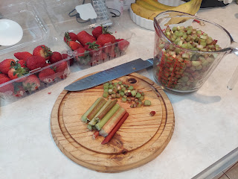

I showed him how to roll out the pastry dough . . .

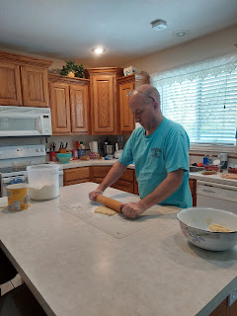

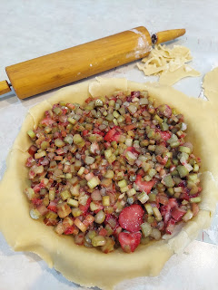

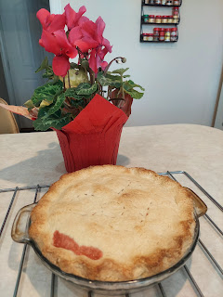

That evening, I showed Phil what the pie "said" before I cut it up into slices. He burst into a smile from ear to ear and clapped his hands with joy!! So precious. We enjoyed a piece of warm pie as we watched some Adam 12 with him.

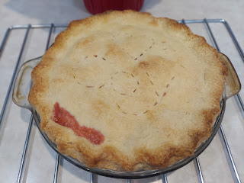

I methodically worked through Coy's abundant supply of spices all during the day, trying to downsize everything, since we just don't need so many spices sitting around anymore. I marveled at how many containers of Ginger she kept, and messaged my kids to ask them to guess what spice she had the most of. Amber totally nailed it in her first guess!! I asked her how she knew it was Ginger, and she replied that Grandma Coy had shown her a few years ago how to make Ginger Tea. She made it quite often for Phil, apparently, since he often has tummy troubles. Amber typed up the recipe as Grandma Coy had shared it with her.

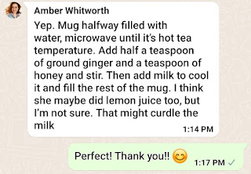

Dad enjoyed another day of reading outside. How lovely.

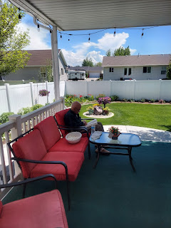

Wednesday, May 24th:
Scott and I worked out in the gardens, trimming all the dying tulips and digging up weeds.

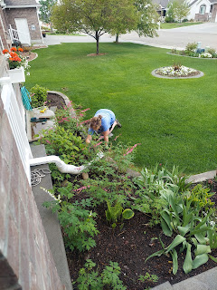

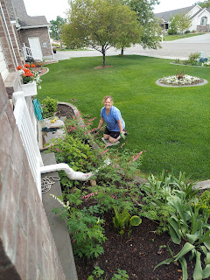

We combined a trip to Idaho Falls to accommodate several things: we dropped off several cans of yard waste and also a few bags of trash to the Transfer Station (Dad's dumpster was at max capacity with all the cleaning and downsizing I'd been doing); Dad drove himself from our house to the optometrist just a couple blocks away and had a good checkup; and Scott got all packed up to go back to Italy by rounding up the things he needed at our house.

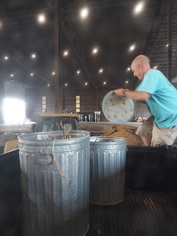

I sat on the front porch to keep Dad company while he read his book and tried to be patient before driving to his eye appointment. He still ended up going 45 minutes early . . .

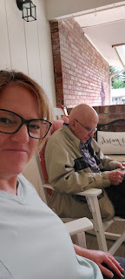

Scott tightened up our large sun shades in the back yard that he had hung a few days earlier. During the summer months, they help so much to keep the heat down in the kitchen and dining room, as well as providing a comfortable space out back to relax. We bought them for Jacob and Hannah's wedding reception (July 2019), but they have proven to be a very worthwhile purchase for so much more.

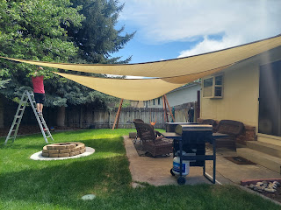

After we got Dad settled in back in Rigby, Scott and I went to the grocery store for a "dinner date". We knew that it was just mostly fast food options in Rigby, so I suggested the grocery store instead. Lo and behold, he found some kumquats!! He was so excited!!

*The shirt he's wearing has a hilarious story. When Amber found out she was pregnant with Abby almost 9 years ago, she hand painted the word "Gramps" on a t-shirt and then she and I took it to his classroom where he was teaching math at Idaho Falls High School. She presented it to him as a way for him to learn that he would be a Grandpa for the first time. The funny thing is that on first glance, it looks like it says "Cramps", instead of Gramps. So every time he puts this shirt on, he doubles over, with a pained look on his face and a sudden groan . . . as if he's got cramps . . . LOL



I found a nice salad for dinner and Scott ate some kumquats and a sandwich. While Dad was reading, we snuck out on a walk, since it would be our last night together for a while. Just a short distance away from the house, you arrive in the "country", with farm fields full of baby corn, cows lazily munching weeds and grass, and even a few horses.

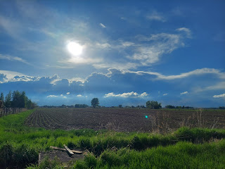

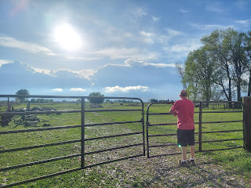

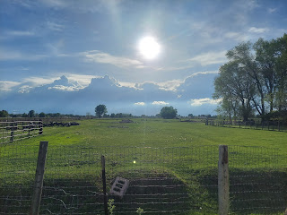

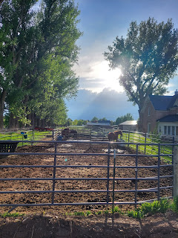

The sun was striking and the clouds were magnificent as we returned home. It was a lovely walk. We held hands for most of it, too. XOXO

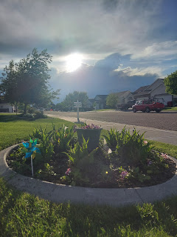

I felt a prompting to suggest to Scott that he offer a priesthood blessing to his father before he left town. Dad appreciated this so much! He shared with us some worries that he had on his mind, which helped Scott to know what to bless him with. He blessed his dad with comfort and strength to move forward, to feel of Coy's love for him, to feel of God's love for him, and to be happy with whatever time he has left on this earth. It was really sweet and we could tell that it meant a lot to Phil.

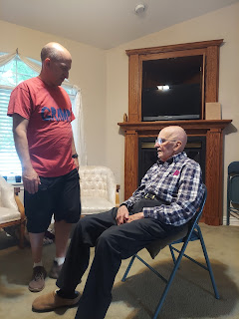

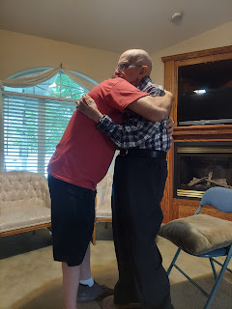

Thursday, May 25th:
We left just before 8:30 a.m. so that I could drive Scott down to the Salt Lake Airport. It's a little over 3 hours each way, but it was still the best option. If he had taken the shuttle bus, he would have had to leave crazy early and then sit for almost 5 hours at the airport. He looked into renting a car one way, but it was $180 to do so. I arranged for a friend to check on Dad during the day so that I could just drive Scott myself. Everything went great and I was home around 4:00 p.m.

When it was time for Scott to hug his father goodbye, Phil didn't want to let him go. He kept saying, "Are you SURE you need to go back to Italy??" It was so heart-wrenching to have to leave under those circumstances. You never know if that's the last hug you'll be giving your Pops in this life . . . and Scott won't be back to the U.S. until next summer.

Scott did the driving on the way down to Salt Lake City. We stopped for lunch at a Wendy's somewhere in Utah, and then all too soon it was time to drop him off. Wahhh.

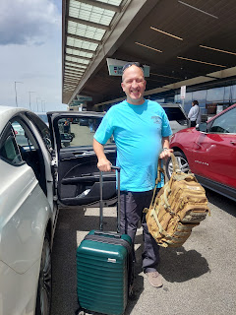

During my drive north, I stopped at the Smith & Edwards Store in Ogden to break up the afternoon. I love that store!! They have so many cool things, from camping gear, to children's toys and puzzles that are unique and fun, to helpful tools and toys for the kitchen. I found a few items to haul home and then I made it to Rigby in good time.

I was able to capture a few photos of the HUGE clouds to the west on my drive north. This area was between Malad and Inkom, about 1.5 hours south of Idaho Falls.

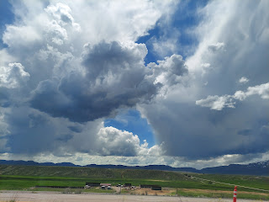

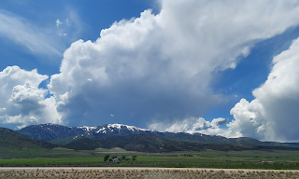

That same evening, the Rigby 5th Ward had a fun Movie Night planned for everyone, with cute "tickets" to get into the gym, along with popcorn, sodas, and candy. Dad wanted to go, so we brought cushions for our seats and settled in to watch "The Lion, The Witch, and the Wardrobe".

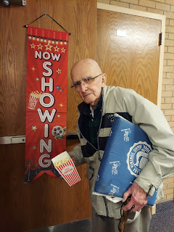

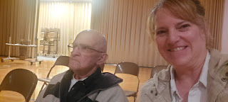

Some people brought camping chairs to sit in, and someone even brought a huge beanbag chair!!

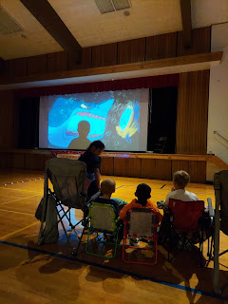

We only lasted about 30 minutes, though. Dad was having a little bit of a coughing fit because of the popcorn, and he was having trouble hearing the movie. It was a bit distracting, too, with children walking or running past us almost constantly. Dad had never seen this movie before, so he didn't understand what was happening. I told him I had a copy of the DVD at my house and that we could watch it at home soon. We will probably watch it this coming week. :)

At the end of the day, I was sad for Scott to leave, but it was also inevitable, yet freeing. I can't be reunited with him if he hasn't even left yet! We recently bought my return flight to Italy, which lifted my spirits immensely. I head back on August 30th so that I can get there in time to spend Labor Day weekend with him.

Friday, May 26th:
I felt tired for most of the day, so I decided to just do some light work around the house. I began sorting through some of Mom's things in her office (files mostly). There were some amazing finds!

Here is a talk that she gave some years ago. I'm not sure when exactly, but it was so wonderful to read her thoughts! (click on each photo to enlarge)

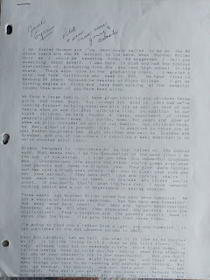

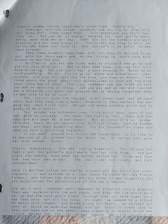

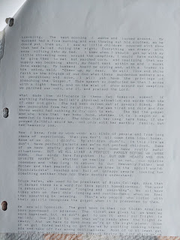

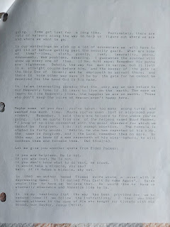

I also found a photo of Coy and Phil on their wedding day - 17 March 1955. They are so adorable!!

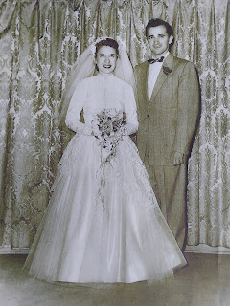

In the afternoon, I drove down to Idaho Falls to help some friends. Chris and Lasina Jensen were in our ward in Vicenza, Italy, but Chris just retired from the military and moved here to be trained as a long-haul truck driver. Their household goods are being shipped to the U.S. but won't arrive until June 12th, so they don't have any furniture or anything!

I was able to loan them a queen size bed with all the bedding, a dresser, a nightstand, a TV, a sitting chair, 2 long tables, 4 dining chairs, bath towels, kitchen dishes and utensils, etc. My friends, Stephen Blatter and his son, Brad, helped us out with their truck to haul everything across town to the Jensens new home.

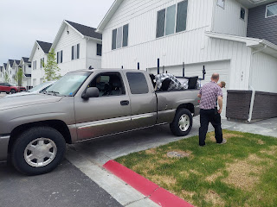

Lasina, laughing as I told her I wanted to take her picture . . . LOL

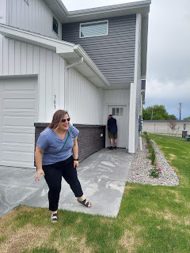

It will be so nice to have her nearby. She is my friend that I always went to lunch with at the NaturaSi health food store in Dueville (Italy). She is a deep thinker and a very kind soul, the kind of friend you want to have.

Stephen (left) and Chris carrying the bed frame upstairs.

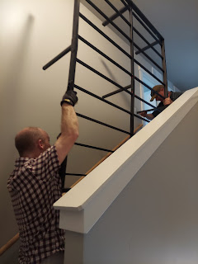

I was so happy to be in a position to help them. I will keep checking on them often as they wait for their things to arrive in a couple weeks.

Saturday, May 27th:
A young man and his mother came to see the organ downstairs that used to belong to Coy. Dad had bought it for her about 5 years ago and recently decided he was ready to sell it. It was such a delight for Mom to go down and play all sorts of songs and hymns regularly (in her socks). :)

Jade told us that he is the organist for his young single adult ward here in Rigby, but since they recently moved to a new building there is no organ now. He has played twice on Temple Square and also for an event down in St. George, Utah near the temple. So naturally, Dad asked him to play something for us . . .

Video of Jade playing "God of Our Fathers" out of the church hymnbook: (2 minutes, 13 seconds)
https://photos.app.goo.gl/XWN8uyGWp8jHAw3W8

While he played, I got a little emotional. Not just because I peeked over at Phil as he seemed to be lost in thought while he listened. It reminded me of the times I heard Coy playing that same organ. I felt like she was there with us, silently cheering that the beautiful instrument would be in good hands instead of sitting there collecting dust.
Jade decided to make the purchase and will be bringing a crew of muscles over on Thursday evening to take it apart just enough to carry it up the stairs. He will purchase it with his own money and then lease it to the Church of Jesus Christ of Latter-day Saints for 10 cents a month, ha ha. Then someday when he moves away, he will be able to take it with him. Seems like a good deal for everyone.

As they left, Jade's mother said something profound: "When we create art or play music here on the earth, we are merely trying to imitate what we knew and saw in Heaven." She had heard that said somewhere, but couldn't recall where she heard it. It makes sense, though. I bet there are a lot of things in Heaven that are so amazing, and we will be so thrilled to see them all in person someday.

After they left, I drove over to the Community Care to have my foot looked at. My pinky toe on my left foot was very swollen and painful and I hoped they could identify the problem and give me something to fix it. I was pretty sure it was athlete's foot again, but a more severe version this time. I'm not sure why I keep getting a fungal infection in between my toes. I wash every day and I don't typically walk around barefoot. It's pretty frustrating when it affects everything you want to be able to do.

The doctor there diagnosed me with a fungal infection and prescribed a cream and a steroid to correct it. I was still pretty miserable at bedtime last night, with my hot and swollen red sausage toe. It was very itchy at times, and the itchiness was spreading across the top of my foot and drove me nuts!! Thank goodness I had some peppermint oil with me, and after a few minutes it allowed me to go to sleep for the night.



I prayed fervently that it would be better in the morning so I could go to church. I was worried I wouldn't be able to put any shoes on or even walk. Thankfully, it was a little better Sunday when I woke up and I was able to attend church with Dad.

Sunday, May 28th:
Church was wonderful! A young lady named Casey Keller spoke about Perfection, and more specifically Perfection in Christ. She quoted from a talk that President Russell M. Nelson gave back in 1995 (before he was our Prophet), entitled, "Perfection Pending".

Here is the link to his talk:
https://www.churchofjesuschrist.org/media/video/1995-10-5070-elder-russell-m-nelson?lang=eng&alang=eng&collectionId=ef9796af66f74ad98faca1ef3b0f79d9

I haven't watched it yet, but Casey shared some really helpful points to ponder.
The word perfection in its original form meant "finished" or "complete". We tend to equate it with being 100% perfect in all that we do.
President Nelson gave a couple of examples for us to think about.
1) A baseball pitcher pitches a perfect game (no hits, no runs, etc), but that doesn't make him a perfect pitcher.
2) A pianist perfectly renders a composition and hits every single note exactly as the sheet music prescribed - but that doesn't make the pianist a perfect musician.
When Christ suffered through the Atonement and being nailed to the Cross, He didn't declare His work to be "finished" until after He was Resurrected. His work was now complete.
We are being molded in this life, through a series of challenges and trials. We become better and better as we navigate through these difficulties, as long as we rely on our Savior to help us. It is through HIS Grace that we are made perfect, or that our work is eventually completed.
While I tend to be a perfectionist by nature, in recent years I have toned that down quite a bit as I have realized that it's okay to be less than perfect as long as I'm trying my best. Her message really resonated with me and I found it to be quite comforting.

Every Sunday, when Dad arrives at church, he always places his hat up on the shelf above the coat rack area. I couldn't resist capturing the moment.

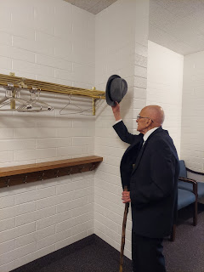

I took a nap after church, which was so nice, and then I've been working on this blog for most of the day. A new friend in the Rigby 5th Ward, Lisa Swanson, came over this evening to look at Dad's CD collection that he wants to downsize. We chatted while she looked through all the CD's (mostly classical music) and when she saw my foot, she got worried. She said that it looked like a serious infection! She has a bit of medical background and recommended an Epsom salt foot bath. Scott had said the same thing earlier, too. Lisa ran back to her house and brought back a bag of salts for me to use, along with some essential oils that she had on hand. (Most of mine are back in Idaho Falls) What an angel!!

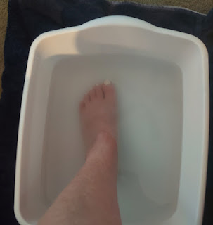

I just finished my 30 minute soaking and now I need to mix up some oils to slather on my foot before bed, along with the prescription cream. Hopefully tomorrow things will be better . . .

