Memorial Days Forever
I am so grateful for a loving Heavenly Father and for His perfect plan for us, His children. I have had some special spiritual experiences this past week that I would like to share. Memorial Day is a day to remember all the service members who have served in the United States military, but has also come to be known as a day that we can honor and remember our loved ones, in general, who have passed.
I love visiting cemeteries. I always have and I always will. They are a peaceful place, a comforting place, a remembering place, and a "I will meet you in heaven someday and get to know you there" place. One of my favorite cemeteries is in Ukiah, California, where I grew up. I have several generations of relatives buried all in one expansive cemetery, where deer slowly wander and nibble up the flowers that have been lovingly placed next to a headstone, seemingly unafraid of all the people who come to pay their respects.

On Memorial Day this past Monday, I drove Dad (Phil) to the Rexburg Cemetery so we could place some flowers on Mom's grave. A new headstone has been ordered, but it takes several weeks to prepare it and then have it placed at the head of a cemetery plot. In the meantime, a small and simple marker is there in its place.

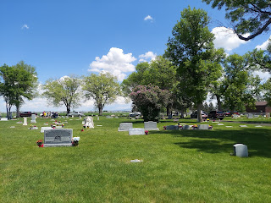

I purposely followed Phil so I could take his picture . . .

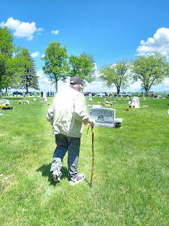

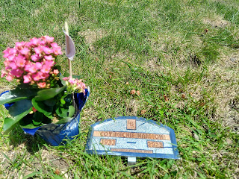

He was tired that day, so we didn't stay very long. He stood briefly and looked on at the headstones of his parents, Wesley and Helen Harmon, just to the right of Coy's grave.

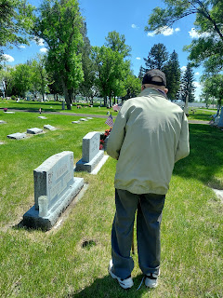

This shows the family grouping, with the weeping angel looking on from behind. Philip Harmon (Scott's brother) is on the far left, then Jonny Whitworth, then Coy (you can see the flower pots on the left below), an empty plot, and then Wesley and Helen Harmon on the lower right.

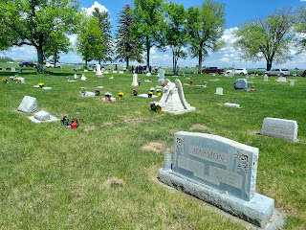

Over the past few days, several things have tenderly connected (in my mind and heart) with this world we live in, along with heaven and all of its promising and hopeful possibilities. Most of us know that life goes on after we die, but some people do not know this. It's possible that they do know it deep down inside, but they just don't understand how it all works. While I do not profess to have all the answers, I do have a basic understanding and an unwavering faith that there is a purpose to all that we do, both now, and eternally.

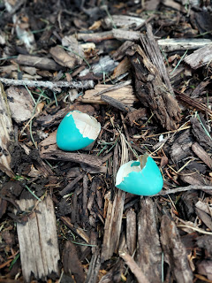

As I was pulling weeds at my house a few days ago, I saw this tiny robin's egg laying on the ground. It encapsulates so much of what I've had on my mind and what I wish to share today. Just as the baby robin had to break out of its shell in order to progress, our human experience is much the same.

We had a sheltered existence in heaven before we came to this earth. Life was so good there, and I'm sure it was hard to leave. But it was necessary to leave all that we knew, to come to earth and receive a body, to learn and grow through our experiences in life, and try to become the best human we can under whatever circumstances we face. We left our knowledge of the spirit world behind, just as the baby robin left his little egg shell behind. If we were to stay where it's so comfortable, we would not be able to grow in the ways that our Perfect Father has in mind for us.

Eventually, when our mortal life is over, we will return home to that same Loving Father who created us. I like to think of it (death) as a Graduation. Yay, we finished high school, and now it's time to go to college (in heaven). There, we can learn and understand in ways that we could never learn and understand while on the earth. My mother-in-law, Coy, just "graduated" a month ago. She is now attending the best University ever. Everything is melding together for her, new understanding is flowing, she is free from a world of woes, free from a body that was failing her, and she is free from the temptations that we all still face daily.

I know that she is happy, because I feel that from her. She is very much alive in the spirit world. I have felt close to her numerous times as I putter around HER house and take care of a few things for her. As I pulled weeds in her beautiful garden this week, one of her GORGEOUS purple iris blooms opened up. I spent several minutes trying to capture just the right angle for a photo . . .

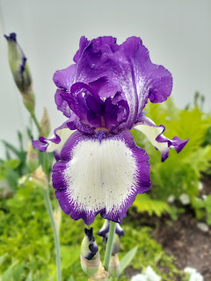

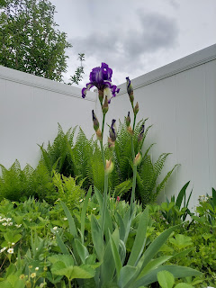

On Saturday morning, I was cleaning out some drawers in the kitchen, downsizing and organizing them. When I got to her drawer full of aprons, I lost it. To me, her aprons represented so much more than just a stained piece of fabric. She LOVED being in the kitchen, cooking for those whom she loved. She would pore over recipe books and magazines in her spare time, looking for something new to try when the next round of company came. She put her LOVE into her food, and we all felt that immensely over decades of eating the meals she put together in our behalf. My kids still rave about the meals she made and what an amazing cook she was.

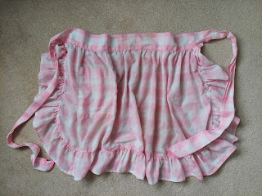

So, seeing her aprons in that bottom kitchen drawer, I realized that they represented her love for all of us, for ME . . . and I cried.

I even took a selfie of myself because I felt it was important to document the moment. Please disregard my gray hairs and how I pulled my bangs up and out of my face so I could get to work . . .

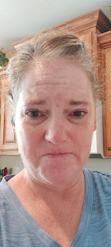

Shortly thereafter, I started cleaning out her kitchen freezer. There were so many jars of odds and ends, and tiny little tupperwares with the tiniest little amount of something miscellaneous inside . . . and they were there because it was her desire to save each of them for "something down the road". But now there wasn't the need to keep many of them anymore.

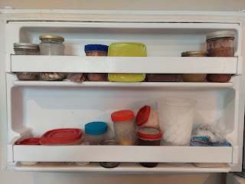

She grew up under the dark cloud of the Depression, which meant she was extremely frugal about every little thing. If there are 3 bites of ice cream left in the carton, and you don't have space for the whole carton, then you save those 3 bites in a little tupperware. She had a small frozen jar of chicken broth, a jar of tomato paste, and several unidentifiable foods. I came across a tupperware with about 2 cups of cookie dough, but I didn't know how good it was anymore, so I tossed it. Scott's sister, Carol, told me on a phone call yesterday that when they were all here in Mom's final days, they cleaned out some things in the freezer, as well. One of those things was a little tupperware that had
3 green beans
in it . . . bless her sweet little frugal heart.

As I felt terrible dumping the things that didn't seem worth saving anymore, and it was also just another layer of my grieving for her being gone, I began to cry in earnest. At this point, I felt a warm feeling envelop me from head to toe, and I heard (and felt) her encouraging words coming into my mind, "It's okay." It was like she was hugging me, comforting me, and telling me it's okay that I'm throwing away stuff that she found to be important at some point.

In addition to her comforting words, I felt an urgent need to go wake Dad up to tell him how much Coy loves him. I knew this was coming directly from her, and there was definitely a sense of immediacy to it. But as I began walking toward his office, my phone started ringing. It was Scott, calling on a video chat all the way from Morocco. I picked up the phone and just stood there in all my tearful glory, letting him see me cry, because I had no words at that point.

He knew that I was already crying earlier about the aprons, so he asked, "You're still crying?" That's when I told him about his mom conveying to me that "It's all okay" and that she wanted me to tell Phil that she loves him so very much. Scott asked, "Did you tell him yet?" I said, "Well I was just about to when you called . . ." He said, "Well hurry up and go tell him! Call me back in a little while . . ."

I walked into Dad's office and found him lightly sleeping in his chair, after he had been reading for a while. I pulled up a chair opposite him and gently touched his knee to wake him up. As I sat there in front of him, with tears running down my face, I let him take a moment to fully wake up, and then I told him everything. He was so happy!! He said he loves her so very much, too, and that he has felt her nearby a few times as well. It was such a precious demonstration of how love lives on and is still vibrant, even in the next world.

I have been so blessed throughout my life to feel close to those who have passed on to the spirit world. I have felt of their love, their comfort, their support, and their genuine care for me and all that is happening to me in my life right now. It makes perfect sense, if you let it. Why would we live for a period of time and then - BAM - it's all done? Like you don't even exist anymore . . . what would the point even be for something like that?

We are eternal beings, infinite beings, divine beings. We are the literal Children of God. When we know WHO we are, we want to do what is right because we understand the significance of our choices and how that reflects back on our Heavenly Parents. When we know WHY we are here on the earth, it puts things into perspective and we understand that our mortal life is temporary, so we really need to make the best use of our time and do as much good as we possibly can for as long as we can. When we understand WHERE we go after this life, it can give us so much hope and joy! We will graduate from Earth Life (hopefully with honors) and move on to the Eternal Life beyond. We will be reunited with loved ones lost, we will teach others about what we know to be true, we will continue to learn and grow in our understanding of the universe and God and "all things that in them are". We will have joy in our family units forever.

It's hard to lose sight of the Eternal Goal when we are stuck in unfavorable circumstances, whatever those might be. But sometimes we just need to stand up, shake off the shackles that try to drag us down, and shout for joy! It will all be okay in the end, so we can't give up now. Never forget that you are a child of God. He loves you, He is mindful of you and all of your struggles, and He wants to bless you and help you.

Okay . . . time to take a deep breath in, slowly exhale . . . and then let's transition to other things. Sorry if all of that seemed a little too intense . . . I just had a lot on my mind that spilled out.

Monday, May 29th:
I had a video chat with Jack, which is always delightful. This particular occasion involved Jack shoving broccoli into his mouth, one after the next after the next . . . Foxy was just watching him incredulously on the sidelines . . .

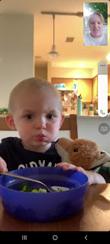

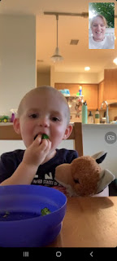

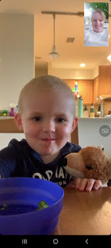

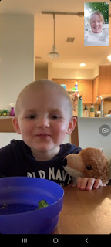

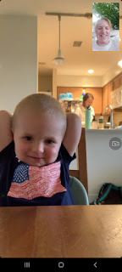

After he ate an entire acre's worth of broccoli, along with a little bit of rice, he hopped up onto the table to do his Fancy Dance, ha ha.



Occasionally, he would ask about Bappa (Scott) and was very somber when I was the only face for him to visit with on the other end . . .

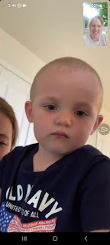

On the other side of the world, Scott went up to Aviano to pay a visit to Benson. They had a good time together and talked about some upcoming plans before Scott took our youngest child out to dinner. They ate some gyros at Marko's, a place that I took Benson not too long ago myself. :)

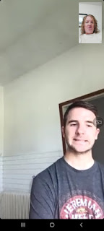

I was able to chat with Benson as Scott was driving to the restaurant. It was good to see my child's face and know that he is okay. He is doing a lot right now to get ready to move to Mountain Home AFB (near Boise). He is feeling optimistic and is getting some good things done over there, checking as many boxes as possible so he can get checked out and fly across the world in approximately 2 weeks.





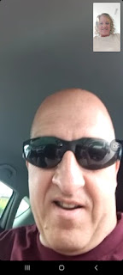

Tuesday, May 30th:
I cleaned all the bathrooms here at Dad's house and did some tidying as I cleaned. On Mom's side of the bed, I found these books that she had spent some time in before she died. I learned from a neighbor that the top book (red), "Minna's Patchwork Coat", was Coy's favorite book. I'll have to give it a whirl soon.

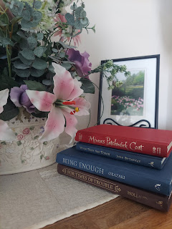

As I stocked up on a few groceries, I noticed a collection of balsamic vinegars in Rigby, Idaho, but they were imported all the way from Modena, Italy!! I had just been studying about Modena because it's a place where I want to take Jake and Hannah next year when they come visit us in Italy again. It's very close to Bologna, which is about 90 minutes south of Vicenza.

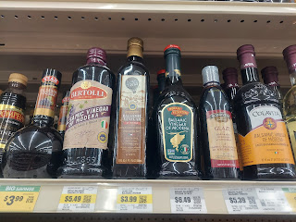

Modena - (pronounced MOH-d'nah) - is where balsamic vinegar originated from. And the vinegar is a very serious business over there. The Bologna area is known as a Foodie Mecca, which is right down Jacob's alley. Something that I DIDN'T know about Modena, is that it's also known as the "Supercar Capital". It's the nearest large town to the homes of Maserati, Ferrari, Lamborghini, and Pagani. (For those of you into cars . . . ahem . . . my Dad) (wink wink)

I also spent two hours on the phone trying to make sure that when we switch to a new internet provider in a few days, Phil won't lose his current phone number in the process. I had to call several different numbers (because no one could transfer me) and once I even got hung up on. It was very draining, but I think we got it taken care of for now.

Wednesday, May 31st:
I drove down to Idaho Falls so I could pull some weeds and check the mouse traps again. They were all clear, but there was one dead mouse just laying in the hallway outside the bathroom door downstairs . . . GROSS!! Pest control had warned me about that . . . they told me that the bait, as it begins to take effect, can make the mouse loopy. He said, "Don't be alarmed if you see what appears to be a drunk mouse meandering around oddly in the middle of the day." Ummm, okay . . .

This was the first time I had to dispose of a mouse by touching it directly. Wait, let me clarify. With disposable gloves on, this was the first time I had to pick up a mouse directly instead of picking up a mouse TRAP with the mouse attached TO it. Disgusting. There was no one else to do it, so I just told myself to suck it up and get it done. So I did. Blech.

I pulled all the weeds out front and then hurried back to Rigby so I could make Dad his supper. A short time later I saw him putting his shoes on so I asked if he was heading out somewhere. He told me that he wanted to take a little drive to see the river nearby because he had read that it was flooding in places. Ummm, could I go with you??

So we took a little joy ride together in his pickup truck with me there to make sure nothing crazy happened . . . it's always a little unnerving when he wants to drive, especially on roads with a higher speed limit.

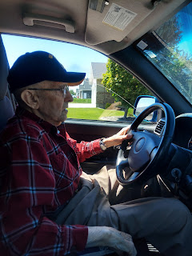

We took the back roads, thankfully, instead of the freeway to get to the nearest section of the Snake River. Yes, it was very full, but this section wasn't flooded yet.

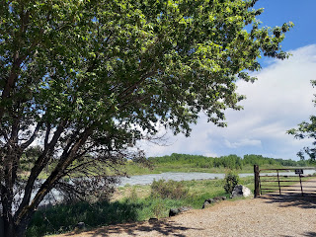

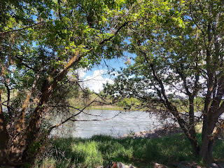

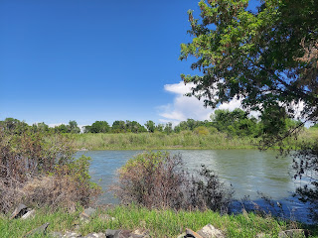

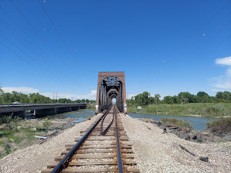

I helped him find a good circular driveway to use as a turnaround spot, and then we made our way home.

I also had a nice chat with Scott. I thought he looked rather handsome in the Hawaiian shirt I bought for him a while ago in the Idaho Falls Target. This was the first time he wore it.

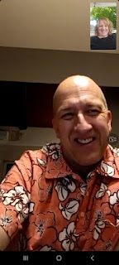

Someone posted this online and I got a kick out of it, so I sent it to Scott.



Thursday, June 1st:
I accompanied Dad to an appointment in Rexburg with his financial advisor at Edward Jones. It ended up taking two hours, plus the driving and waiting time, so more like 3 hours. But we got a lot of important things accomplished.

Doesn't he look so dapper? XOXO

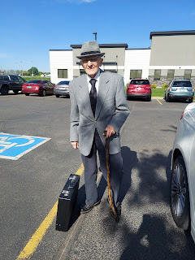

He found a stash of chocolate mints on the counter for patrons . . . tee hee

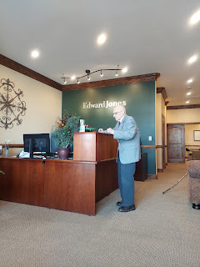

I took good notes during the meeting, and at the end Dad signed some important paperwork before we left to go home. Later, I typed up all my notes and emailed Scott and his siblings the information so everyone could be on the same page with what was going on.

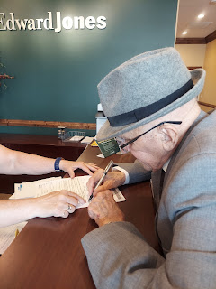

His agent, Brent Esplin, is a good guy. He is straightforward, knowledgeable, and helpful. I recognized his name from several years ago, and I asked him if he was related to Erica Esplin Summers. Turns out he was her uncle! Erica lived at the end of Michelle Street in Idaho Falls and was a kind and joyful friend to me. She had just invited me and the kids to come down the street for dinner at their house about a week before she died. I still remember that she made Hawaiian Haystacks. She felt bad that Scott was gone for some military training and wanted me to come have some good food and socializing with her family.

About a week later, in July 2003, she and her husband, Clint, went climbing up the Grand Teton (one of the three main peaks in Grand Teton National Park). They were with a group of friends and other family members, and weren't too far from the top of the 13,775 foot peak of the Grand when lightning struck with virtually no warning. Clint told me later that they saw one flash, and then the next one hit them. Erica died within minutes. Clint was hit in his leg, which left a large open hole. I learned afterwards that this was one of the largest air rescues that the park service ever administered and their story appeared in the Reader's Digest the following year.

It was crushing that she was taken so young in life, leaving behind a 4 year old daughter, Addison, and a 2 year old son, Daxton. Some months later, Clint remarried to a young single mom named Meadow, which made her new married name "Meadow Summers". Meadow also had a 4 year old daughter and a 2 year old daughter, which meant they were now combined parents of two sets of twins! When Clint later graduated from BYU-Idaho, I was asked to babysit all four kids that evening. I remember this because there was a hefty storm that night, with thunder and lightning, and it was my job to comfort and hold Addison and Daxton when they were so scared. The were young, but they were old enough to understand that lightning kills. I had brought Amber with me that night and we worked together to comfort and hold those little ones, reading to them until they were sleepy enough to close their eyes for the night. It was a powerful experience to comfort my friend's children for her, knowing that she would have wanted to be there for them herself. I have thought of her many times over the years, and I often wonder how the kids are now. They would be 24 and 22 years old this year.

Brent became visibly emotional as we shared memories from 20 years ago. I can tell he is a good guy and I'm glad Phil is in such good hands with his financial investments.

This tells a little of what happened up on the mountain when Erica died and the rescue that ensued:
http://www.southeasternoutdoors.com/outdoors/lightning-strike-grand-teton.html

Here is the link to Erica's obituary:
https://www.findagrave.com/memorial/23452241/erica-joyce-summers

That same evening, Coy's organ found a new home. Jade, the same young man that had come to inspect and play the organ last week, came with a crew of strapping young men to transport it to a nearby church meetinghouse.

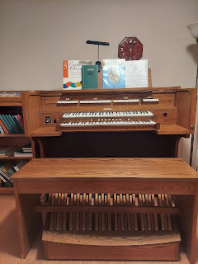

I tucked all of Coy's sheet music away before everyone arrived.

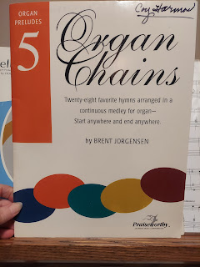

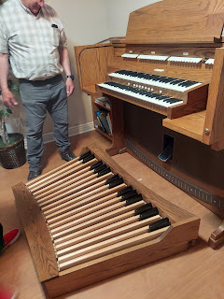

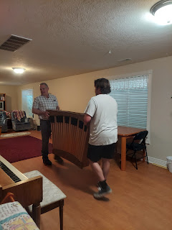

It was a BEAST to get that thing up the stairs . . . Good thing these boys had plenty of muscles.

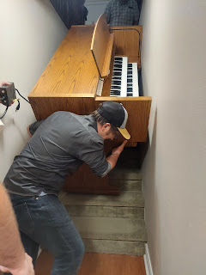

Video of the last big push to get the organ up the stairs: (23 seconds)
https://photos.app.goo.gl/LTcifTPEuy2Pqpyv5

Photo below shows Jade Jensen, the new owner, and Phil on the right . . .

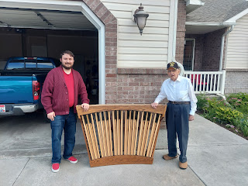

All loaded up and ready for transport to the new home - the Rigby YSA Ward (Young Single Adults)

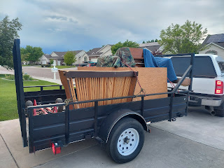

Jade had one final thing to show us: a special ID plate that he made for the organ. The last line, "Soli Deo Gloria" means Glory to God Alone, and is the motto of the Organ Players Guild. This phrase has been used by many composers over the years, including Bach and Handel. I thought it was especially sweet that Jade had this made, so I gave him a big hug and thanked him for being so thoughtful.

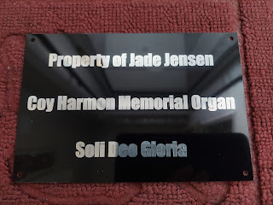

As the organ drove away, I hugged Dad and asked him how he was doing. He told me he was just fine and that he was glad it would be put to good use. He isn't very sentimental, like I am, but is quite practical and logical (like Scott is).

A little bit of sweeping and vacuuming needed to happen before we could go to bed, so I got right on that. What a busy day!!

Friday, June 2nd:
Dad was pretty exhausted that whole next day. After all, we did a LOT the day before. For a 91 year old man who just lost his sweetheart of 68 years, it became a day of MUCH REST.

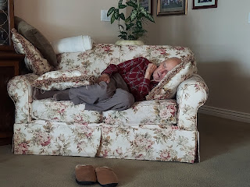

In between the many naps, I accompanied him to close out two of his four local bank accounts.

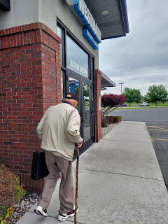

I sent this photo to my kids, telling them that when you're 91 years old, you can park any way you want.

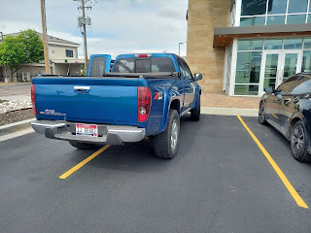

After we got home and Phil laid down for another nap, I went on a few errands in town. First, I went to a little boutique shop, called Rustic Roots, where they have some cute home decor and crafts. The owner shops at yard sales and flea markets for things that she can repurpose and make into something cute to sell. I forgot to get a picture, but I found a darling floral arrangement to hang in my master bedroom along with a rustic wire basket that had three mason jars sitting inside. Each jar had a candle holder down inside. I thought this would look nice on my dining table. :)

Next, I got a few groceries and then stopped for a sandwich at Mrs. Powell's Bakery. Next to where I parked, this 1950 Chevy was sure handsome, so I shared the photo with my Snider family, knowing that my Dad would especially enjoy it.

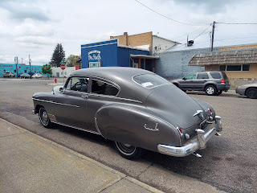

Saturday, June 3rd:
As I mentioned at the beginning, I spent the bulk of the day sorting and cleaning out the kitchen. I also pulled several more weeds in the back yard here. It's about halfway done now.

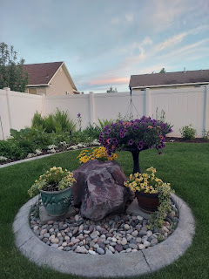

I chatted with Scott in Morocco, and I also made some plans over the phone with Amber, who will be coming back up to Idaho in a few weeks. I ALSO did some research for where we can go this fall during Scott's 4-day weekends once a month. In September, over Labor Day weekend, we will be doing a bit of hiking up in the Dolomites, the Italian Alps. In October, when Amber and the girls are with us, we will most likely go up to Salzburg, Austria to follow in the footsteps of the Von Trapp family (Sound of Music). And in November, we will visit Valencia, Spain over Thanksgiving weekend. I'm so excited!!

I made a tasty dinner for myself at the end of the day, something I have been slacking on lately. It's just so hard to cook for one person. I should say, rather, that it's hard to get MOTIVATED to cook for one person, ha ha . . . Dad likes his half can of soup each day, and I've just been scraping by most of the time. Finally, I made something a little fancier for myself, and it was wonderful.

1. Spaghetti squash, with butter, salt & pepper, and shaved Parmesan on top.
2. Pork country ribs, cut into smaller strips, and pan fried in butter & olive oil, with salt & pepper, Italian seasoning, garlic powder, and sliced garlic. The sliced garlic was amazing because it ended up caramelizing while the pork sizzled and browned. Yum!!

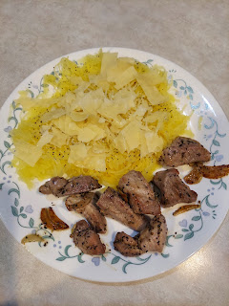

Sunday, June 4th:
Dad had another sleepy morning, bless his heart.

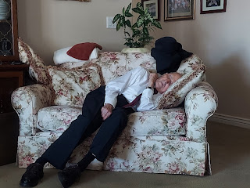

But he was just fine for church. :)

I recorded him singing two hymns during Sacrament meeting this morning, because he has always had such a beautiful voice. I thought it would be wise to document this because he won't be around forever.

The first hymn is called "There is a Green Hill Far Away", referencing the hill where Jesus suffered on our behalf because He loves us so much.

Video of Phil singing - but it only shows Phil's left shoe. Just listen to the singing. (1 minute, 43 seconds)
https://photos.app.goo.gl/iQX2XzdT5jjmiSvQ6

The second hymn is "Nearer My God, To Thee". Again, I pointed my phone at the floor so I could be discreet.

Video of Phil's voice singing: (1 minute, 59 seconds)
https://photos.app.goo.gl/12keSpbht6EfSLFZ8

Today was a good day. I got to work on my blog. We had a nice lunch together. The neighbor, Carolyn Flint, gave us some of her freshly baked rhubarb cake. I had a good visit with Scott's sister, Bev, on the phone. I also had a good chat with Jacob.

Yep, it's been a good day and a good week.

