Weeds, Whiskey, and Well-Groomed Haircuts
This was not the most exciting week on record . . . but there were some definite highlights. I spent my last week with my father-in-law in Rigby and am now back at my own house once again. It feels so nice to be HOME, even though I did have a very nice time with Phil these past several weeks.

Scott has been enjoying himself in Morocco and has made some new friends during their annual military training exercise. This time, he's met some new colleagues from Botswana, Morocco, and a few from Italy. He said the hardest obstacle that they are dealing with during the exercise is the language barrier. Someone from Germany might be trying to relay some important information to the personnel from Botswana, for example. The German might have to relay it first to an Italian who speaks German and a bit of English, and then the Italian relays it in English to someone from Morocco who speaks a little bit of English but then has to relay it in French or Arabic to the person from Botswana. It's doable, but it just takes some extra time for everyone to understand each other and then to move forward with the mission at hand.

Every evening, he calls me from his hotel room that overlooks the Atlantic Ocean and we watch the sunset go down together while we chat.



I like seeing him relax after a long day at work. It makes me happy to know he's doing well and that he's happy.



Here's a silly photo of us scrunching our noses at the thought of me having to clean out the utility room down underneath the stairs this next week. That's the room that I am most afraid to clean after our recent mice infestation . . . (which is now much more under control and 95% resolved)

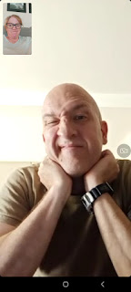

One day, he called while he rode the bus from the base back to his hotel in Agadir. I got to watch the traffic go by out the bus window, and I got to see some nice neighborhoods along the way.

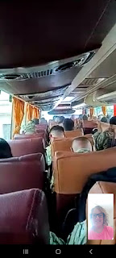

I remember this horse and buggy combo being somewhat common when I was in Agadir last June . . .

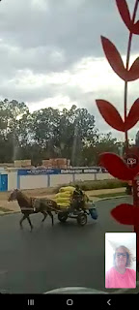

The roundabouts in Morocco don't follow the same rules of engagement as what we have experienced in Italy and even in the U.S. It's hard to say what the rules even are . . .

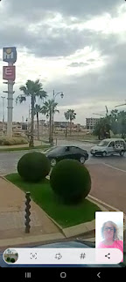

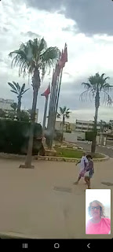

He has one more week down there and then he'll be back up to our home in Vicenza. He is curious to see how many cherry tomatoes are on Timmy the Tomato Plant when he returns . . . thankfully our neighber, Zhanna, is watering all the plants for us and keeping them alive.

WEEDS:
I pulled some weeds in Rigby and I also pulled some weeds in Idaho Falls. Back and forth I went this week, trying to get caught up in both places.





This section of Mom's strawberries still needs some love and attention . . .

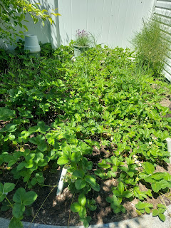

But her irises are blooming even more now. They are so spectacular with the deep purple and white, such contrasting colors.



I remembered to take pictures of the two items I bought at Rustic Roots in Rigby last week. This darling pouch of blooms hangs in my bedroom and I love it so much! It makes the room seem a little more cozy and it softens an otherwise boring wall.

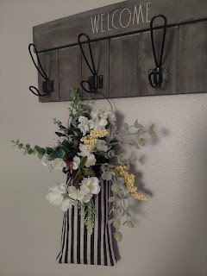

These are the cute rustic mason jars that I mentioned last week. They each have a little candle holder inside. I placed them on my dining table for now. I might add some ribbon to enhance them just a bit . . .

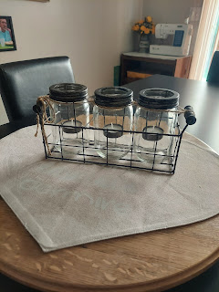

WHISKEY:
Ha ha, gotcha, didn't I? There wasn't much to report from the week, so I tried to think of an attention-grabbing title . . . Truthfully, I came across a few VERY interesting quotes, news articles, etc. as I sorted through Coy's office over the course of a few days.

This newspaper clipping was especially eye-opening!! (click the photo to enlarge)

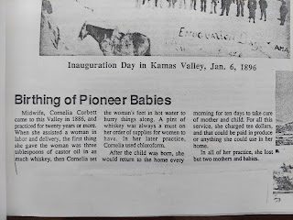

Coy's mother, Delsa Hardman Michie, made her a very thick Book of Remembrance after she got married. It is chock-full of family pedigrees, photos and stories about all of her ancestors. Everything has since been scanned and shared on FamilySearch by now, because Coy was so diligent over the years to keep up with advancing technology. But what a labor of love this book was that Delsa put together so many years ago . . .

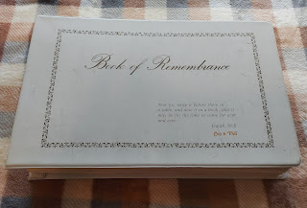

I loved this quote that was just inside the front cover: "Fortunate is the child born into a family with a written history. To have noble ancestors is one of the greatest blessings in this life. But one can neither honor or emulate those of whom he knows nothing."

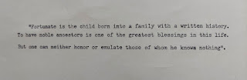

Coy also had a file folder with numerous meaningful quotes regarding the work of family history. I especially liked this one by Henry B. Eyring, a current Apostle in the Church of Jesus Christ of Latter-day Saints.

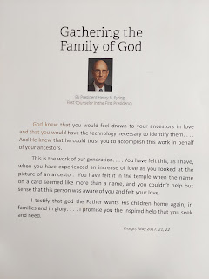

Coy always had a clever sense of humor. I found this funny cartoon clipping in one of her files . . .

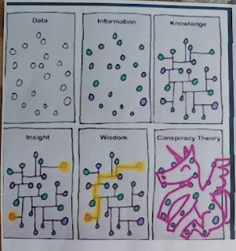

I finally took a picture of this poster that still hangs on the fridge in Rigby. As family members came and stayed for whatever length of time that they could before Coy passed, they each wrote Grandma a note.
How very sweet and thoughtful.

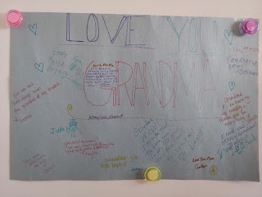

Dad would sometimes come hang out in Mom's office with me while I sorted through files and folders, drawers and shelves. I found a sweet poem to share with him at one point, and then I snuck a photo of him reading it.

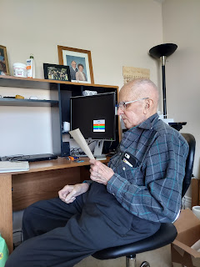

He still found plenty of opportunities to take a nap each day, too. :)

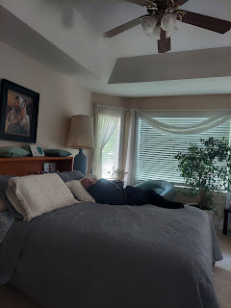

I got Mom's office all whipped into shape so that Vernetta, and later Bev, will have a comfortable place to sleep and settle into.

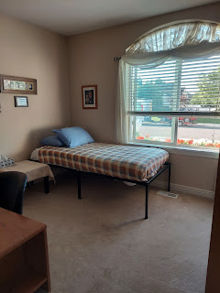

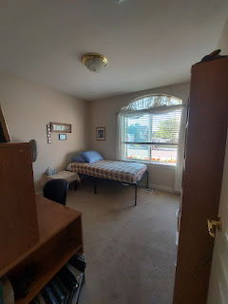

I slimmed down the closet quite a bit, but haven't touched anything up on that top shelf yet. There are a ton of family history binders that will take some time to figure out what to do with all of them . . .

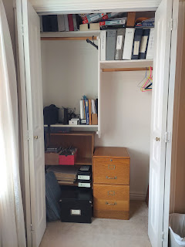

I cleaned up every inch of what used to be her desk, including the drawer filled with several hanging files of old receipts and credit card statements, among other things. I threw away some of her old medications that were sitting on the upper shelf, and then I dusted everywhere once I was done organizing.

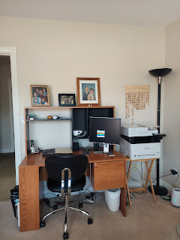

I still love seeing these photos of all her children, both as babies and later in life. The little frame says, "For this child I prayed." These were above her head as she lay in her hospital bed during those final days. XOXO

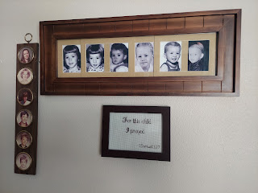

I took Dad to the doctor on Thursday, because he was having some pain and discomfort in the lower left area of his back, which had been going on some time, but had increased to the point that he thought maybe he was about to die. He told me that maybe he had cancer, just like Coy did, and that maybe he was going to die soon. I know he's ready to go be with his sweetheart again, but I had to reassure him that he was probably okay and that we could have a doctor look at it.

I took him to see Dr. Potter, a very nice doctor in Rigby and one that he had never been to before. Apparently, Coy, who had been an RN all her life, didn't trust doctors all that much. Anytime they needed medical attention, they always just went to Community Care because she "didn't want to bother a doctor". (Bev told me how Mom would always say that, even though the rest of us recognize that we aren't BOTHERING a doctor when we need to see one, and that this is what they're getting paid to do.) Dad is now wavering in his trust of the Community Care staff, considering that they never diagnosed Mom's cancer until it was too late. I told him that Community Care is meant to be a temporary relationship between patients and the medical staff, like an urgent care. But if you have a personal family physician, they typically develop an ongoing relationship with each patient, and they keep better track of all the medical conditions going on over time. He was very pleased with Dr. Potter and got a good diagnosis.

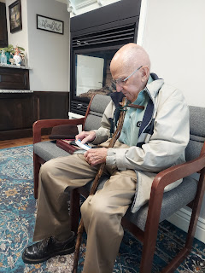

The diagnosis was Sacroilliitis. It's basically an inflammation between the sacrum and the hip, kind of like arthritis. In the photo below, which the doctor pulled up on his laptop, you can see the red inflamed areas. (You are looking from the back of the spine toward the front.)

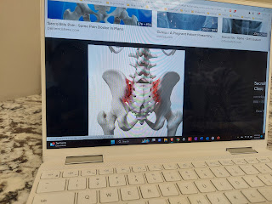

Dr. Potter prescribed Tramadol for the pain and inflammation, ordered an x-ray to be sure that nothing else is going on, and will be setting up a few visits of physical therapy so that Dad can learn some stretching and strengthening exercises to help calm that area down. We were glad to get a confident diagnosis, even though I'm sure deep down, Phil was disappointed that he won't be joining his wife anytime soon . . .

In the middle of the consultation, I broke down into tears when the doctor asked a question that neither of us could answer. Normally, I don't burst into tears when I don't know an answer, but this one carried a lot more weight. Dad and I had filled out the online medical history as best as we could prior to the appointment. The doctor wanted to know more about Phil's arrhythmia and neither of us could elaborate. That's when I tearfully said, "Let me give you a little more background here. Phil's wife, Coy, just passed away one month ago and she was an RN. She knew all of this and could answer all of your questions, but she's not here to do any of this now. I don't know much about Dad's medical history, and he struggles to remember most of it himself. So I'm sorry we don't know how to help you further . . ." I didn't expect to cry, but it happened nonetheless. Dr. Potter very kindly gave his condolences and we moved on as best as we could without all the answers. Fortunately, Bev knows all of Dad's medical history, with details and dates, so when she arrives next week, she will update Dad's health history in the online patient portal so that Dr. Potter is up to speed.

Dad has started using this pocketwatch that he found in his desk a few days ago. He absolutely LOVES it! He uses it all day long to check the time, but he cannot remember which of his grandchildren gave it to him. Well, whoever did, bless their sweet little heart. What a thoughtful gift.

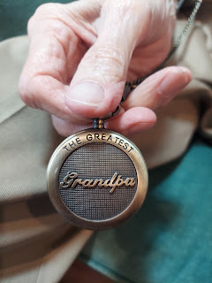

Oh! One more cute thing I found in Coy's desk folders . . . (click to enlarge)

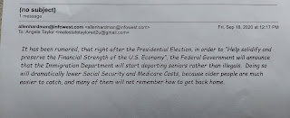

On Friday morning, Vernetta arrived from Orem, Utah to spend the next 10 days with Dad. That meant I could pack up and head home to my house and adjust to another new norm. I unpacked all my stuff from the car, and went out in search of groceries to fill my very empty fridge, and then I settled in for the evening.

Saturday was a day of
WELL-GROOMED HAIRCUTS
.

First, I trimmed the umbrella tree out front, along with the cherry tree and the hydrangea bush (to the right of the umbrella tree).

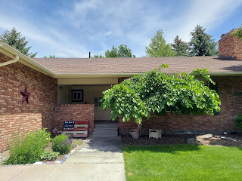

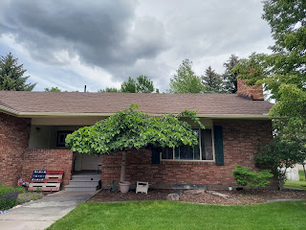

Then I drove back up to Rigby to give Dad a promised haircut. He had gotten a little impatient with the last haircut that Scott and I did together, so this time I suggested he watch his favorite show, Adam 12. It kept him perfectly occupied and he didn't even move an inch during the few minutes it took me to complete the task.

Before . . .

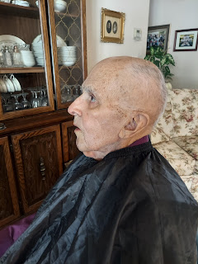

And after . . .

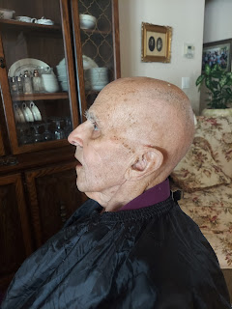

I also cleaned out Benson's old room.

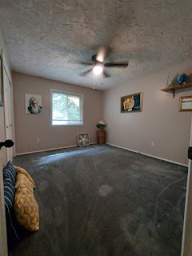

The furniture and bed are still with Lasina and Chris Jensen, our friends that moved here from Italy. Their household goods were supposed to arrive on June 12th, but they recently received an email that things are running behind schedule and now we don't know when their stuff will get here . . .

Benson will be flying in next Saturday, and I'm thinking that he might end up sleeping on a camping cot, ha ha . . .

I'm excited to see his face, though. I'm hoping that we can do a few things together, like a hike or some sort of outdoor recreation while he's in town. I really love that boy, even if he isn't that great with communication, especially by text . . .

This coming week will be very busy, with lots of appointments (haircut for me, massage, switching internet providers, our 31st anniversary, temple, and company coming in . . .)

Lastly, Jacob and Hannah made a BUS CAKE for Jack, to celebrate his 2nd birthday (which was April 6th). Their thinking was, better late than never! :) Things were busy back then, and maybe the weather wasn't the greatest either. But they wanted to have a little party before they move away, so they got it all set up. Jacob reported that the bus cake turned out pretty good, even though the store was completely out of yellow food coloring and they had to use "dreamsicle" color, LOL.

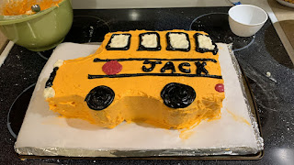

They met at a local park, where 8 of Jack's friends came to play. They had a great time!

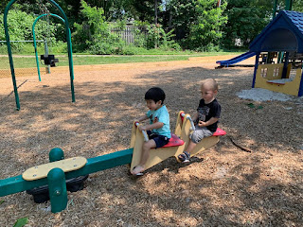

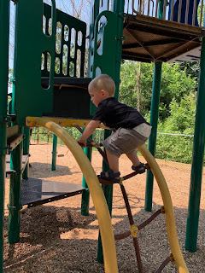

I didn't get any photos of them demolishing the cake, but I assume it was delicious, because Jacob and Hannah made it.

Amber sent this note in our family group chat this morning while I was at church: "Madison said I looked just like my mom today when I walked in smiling (to church in Louisiana). I think it's the space buns, too. It made me so happy to hear that!"



I responded by saying, "I love that she said that, and I love your cute buns (!) and I love that we look alike! You are so pretty." XOXO

Amber will be driving across the country again in a week for another visit to Idaho. I'm so excited because I didn't get to see them very much around the time of the funeral. It will be so nice to spend a bit more time together. I can't wait!

