You'll Feel Better Once You're Riding a Horse
It has been a wonderful week and I am so thankful that more than one of my children successfully drove across the country without incident. Amber, Abby and Gwen arrived safely on Wednesday evening. And Jacob navigated the moving truck like a champ from Arlington, VA to Grand Rapids, Michigan on Saturday. (more on that later . . .)

When Amber was maybe 6 years old, she wrote a very profound statement on a card to our friend, Mistee Lemons. Mistee had been diagnosed with Non-Hodgkins Lymphoma and was recovering from a stem-cell transplant that left her very weak. Amber drew a picture of a horse on her homemade card along with the words, "You'll feel better once you're riding a horse." We've found that to be oh so true ever since. (more on that below)

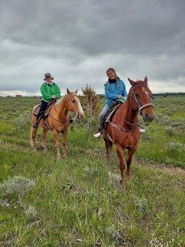

In order to keep everything straight on the happenings of the week, I'll just start at the beginning.

Monday, June 19th:
I hung out in Rigby for several hours, waiting for the new internet company to come and switch Dad over from the old internet company. While I waited, I pulled weeds all around the house, starting in the front. Carol's husband, Mike, came to my rescue mid-morning after they returned from an appointment. Turns out, he has two degrees in horticulture and loves to be in the garden. Fantastic!!

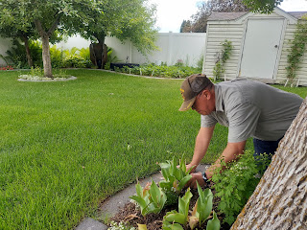

We worked our way over to the area next to the shed, which is where Mom had planted all of her strawberry plants. Carol and I picked two large bowls of ripe strawberries, and then Vernetta and Carol cleaned them and cut them up in the kitchen afterwards. Vernetta prepared a strawberry jello salad, which Dad enjoyed eating for the next few days.

Bev arrived after lunch, which was a relief, since she had driven for 3 days across the country. She told me that she really struggled emotionally the closer she got to her mom's house. All these years, Bev had always come home to "her" (Coy's) house. (Coy was definitely the more social one out of Coy and Phil.) But now, she is not there anymore . . . so that was hard to adjust to.

I enjoyed letting Bev read me several poems that her daughter, Emily, has written in recent years. Emily is an English major and is also a very deep thinker. Some of her poems were just INCREDIBLE.

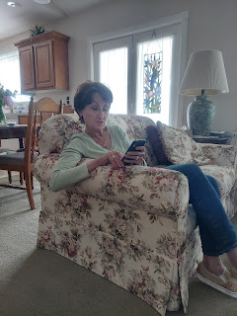

Here is one that Emily wrote, entitled, "Another Perspective for Milton". (It's about the War in Heaven in which Lucifer wanted all the glory and ultimately was banished.) (*I don't know who Milton is . . .)

Another Perspective for Milton

Thunderstruck on that rocky outcropping of hell,
Lucifer gasped for breath and understanding-
His brow knotted in dumbfounded surprise
Probing Heaven (by now a mere pinprick of light)
For answers that would not satisfy.
Trembling, he thrust his arm up in confused desperation,
His fingertips hate-cold.
Brilliant Sons of the Most High,
Tutored in godship at His knee,
The younger fixed his heart on Jehovah
And loved him completely.
Lucifer, expert in our Father’s creations,
Delighted as Brother touched each star,
Flower, stone. Thrilled as he named them,
Clung to every syllable, gesture, glance.
Son of the Morning! Privy to the counsel
Of the Gods. This pleasing primeval world
Would be replicated in dazzling reality-
In paper-thin crystal.
Shattered, only mended through Lamb’s blood-
Wine-red, pressed, wrung-out and perfect.
Father! Surely thy wisdom has not overlooked the folly
In this plan! Great Mercy! What is Agency when set
Against my Brother’s life? If ever thou didst love thy children,
Spare Him now. Thou, who knowest He will obey thee perfectly
In every thing, let that satisfy Thee.
No, Father. Spare Him. Spare Him!
Surely, Father, the betrayal is thine and not mine.
Wait.
Give me Thy glory.
Yes. Let me descend to Earth as Savior.
Give me Thy crown that I may subdue Agency…
And by so doing, all these (the host of heaven) will come to Thee most quickly-
Untarnished, having breathed the breath of Life
Without the shedding of blood most precious-
And two worlds spared thereby.

I beg of Thee…
Do not turn away! Your countenance is removed-
I cannot bear it.
I cannot understand it.
I will not understand it.
I will not.
Will not!
Him? Or Me? Brother, choose You this day.
A blackened dagger pierced Lucifer’s soul, twisted his
Likeness beyond recognition, turned bright devotion
to vapor most bitter.
Against ignorance so eternally profound there was but one choice.
Lucifer donned his battle armor and exhaled his hypnotic breath
Over the host of Heaven.

WOW. If you didn't understand the depth of her words and thoughts the first time through, it's okay. It's pretty deep stuff. I can tell that she spent quite some time considering these things intimately, wanting to maybe figure out how one of our older brothers could turn away from God the Father when everything was so beautifully perfect in Heaven.

Tuesday, June 20th:
I worked on some sewing projects at home, which was so satisfying. I tailored two pairs of pants over the course of two days. The first pair was this one below, made of black and white striped linen. They were too long and too wide in the pant-legs, so I shortened them and tapered them a bit. Now they fit perfectly!

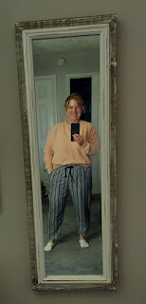

I took my friend Lasina out to dinner because it was her birthday. We went to Texas Roadhouse, one of my favorite restaurants. As we were being escorted to our table, the server asked us if we were celebrating any special occasions, so I volunteered that it was her birthday. Little did we know that they had a most unusual way to sing happy birthday . . .

At the end of our meal, a group of servers surrounded our table and asked Lasina to come sit on the "saddle chair". They announced to the entire restaurant that it was this young lady's birthday and that she was turning "29" and that her biggest wish was to be a COWGIRL . . . They invited the participation of all the patrons and when they counted 1, 2, 3 - everyone gave a huge YEE-HAW!!! She was mortified . . .

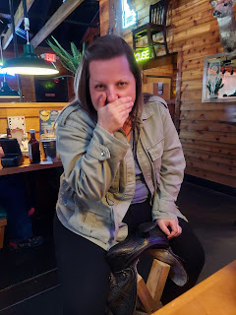

But she was still a good sport and we laughed about it afterwards. I had no idea that this is what they would do for a person's birthday, ha ha . . .

Video of the servers as they first arrived at our table: (15 seconds)
https://photos.app.goo.gl/3L1sNVqmn7cAmckt6

After we finished up, we drove across town so she could show me this new place that has GELATO. It's called Manwaring Cheese Co. They've been around for a while, but not in the form of a restaurant. They offer grilled cheese sandwiches for $2.50, with several different flavors of cheese. (see photo below)

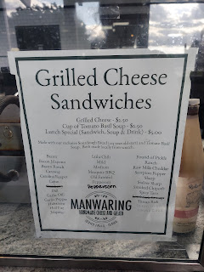

But we came for the gelato . . .

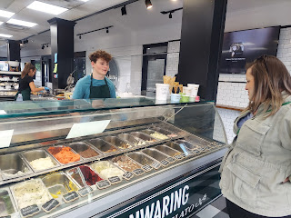

It was wonderful!! I've been telling everyone about this place. Lasina learned from the owners on another occasion that they actually went to Italy to learn the art of making gelato. I'm so glad they did!

Wednesday, June 21st:
I worked on the second pair of pants, overalls actually. It took me a bit longer to tailor them because the bottom section of each pant-leg had a special scalloped section. I had to remove the scalloped section, then cut off about 4-5 inches of length from the main pant-leg, then figure out how to re-attach the scalloped bottom section again. It took a few tries, and finally I had success!!

I also cleaned the Grandchildren Guest Room downstairs, using Clorox wipes to sterilize every single toy, piece by piece.

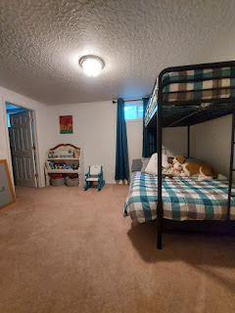

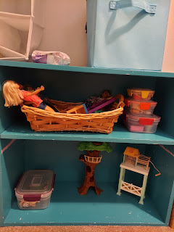

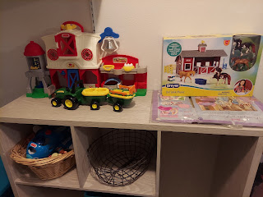

It was a good feeling that the mice fiasco seemed to be over, and that now I could just bring up the rear with a little bit more cleaning.

I made a couple of homemade pizzas while I watched a new show that Benson recommended, called American Barbecue Showdown (on Netflix). It was so good!! It made me want to go down south again just to try all the fun and amazing side dishes, along with some good ol' fashioned cuts of meat that were made with ALL their love and expertise.

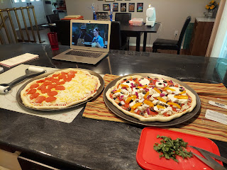



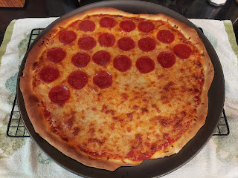

Benson hung out with me on the porch while we waited for Amber to arrive. We didn't have to wait very long at all . . .

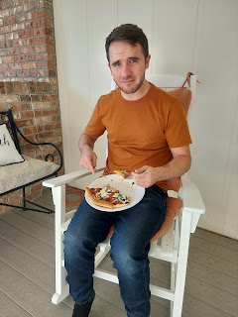

YAYYY!!! After three long days, they finally arrived.

L to R: Gwen, Amber, Benson, and Abby

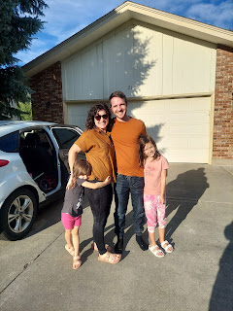

Thursday, June 22nd:
This was a mod-podge day of miscellaneous happenings. A little of this and a little of that. :)

I chose a color of carpet to (soon) be replaced in the Grandchildren Guest Room, once our company leaves. It's been in terrible shape for some time . . . and now is a good time to get it taken care of, especially while Benson is here to help me move some heavy stuff out of the way and rip out the old carpet.
The color for the new carpet is the one on the upper right. It's called Island Spice. It will be installed on July 5th.

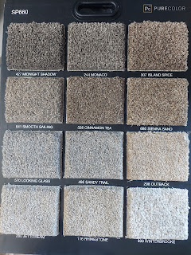

The afternoon got a little warm, which was delightful. It's been quite cold for the whole month of June so far, and this particular day it got up into the mid-70's. Woo hoo!! Abby and Gwen got on their swimming suits to run through the sprinkler. They were very brave!!

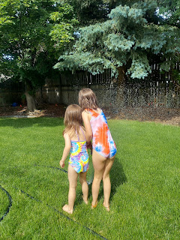

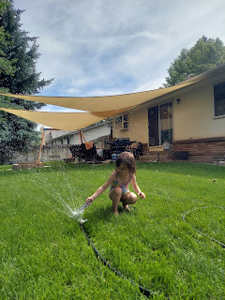

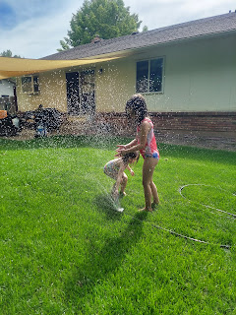

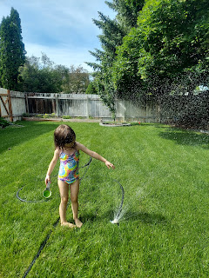

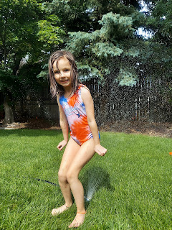

Gwen helped to water the cilantro and the rhubarb . . . what a good helper!

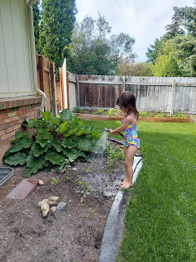

Amber's friends, Lyndsey and her husband Drew, came over to hang out. They were having so much fun talking out on the back patio that I decided to invite them to dinner. I had no idea what to make, but I threw together something that ended up being quite the hit! I defrosted some chicken breasts from my freezer, and then cut them up into bite-sized pieces. I sauteed them in the pan with a little bit of olive oil and butter. The only seasonings I added were salt, pepper, and Buttery Steakhouse seasoning (from Sam's Club) - which is one of our new favorites.

Once the chicken was cooked enough, I threw in some leftover sliced mushrooms and several handfuls of baby spinach. Abby was right there to help me and we had a great time together. I poured in maybe a half cup or 2/3 cup of heavy cream and let it heat through, and the final garnish was to sprinkle some parmesan on top. I didn't get a picture until I was ready to put the small amount of leftovers into a tupperware . . .

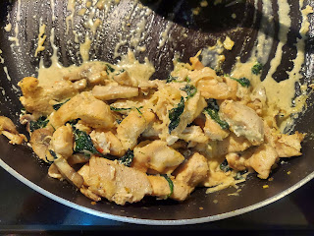

Abby helped me with the garlic cheesy toast . . .

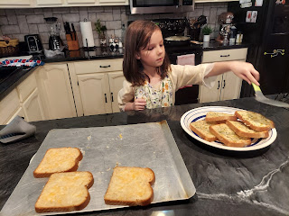

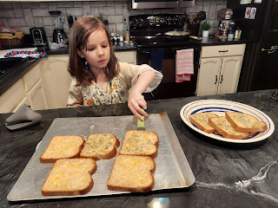

We added some watermelon and it was a wonderful meal. I let Abby sample some of the chicken with me before we served it to everyone, just to make sure it had the right flavors. She exclaimed, "This is the BEST chicken I've ever had in my ENTIRE LIFE!!" Okie dokie, that's all the endorsement I needed . . . ha ha.

After dinner and after everyone left, we hung out in the living room for a while together.

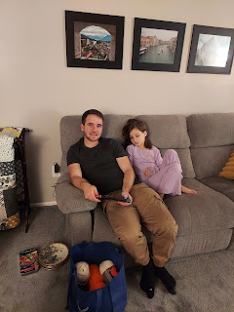

Friday, June 23rd:
I picked up Kylie bright and early at 7:45 a.m. so we could drive 1.5 hours up to Island Park, Idaho to ride a HORSE!! Neither of us has been on a horse in maybe 4 years, since the last time we rode a horse together, so we were pretty excited! Kylie's dad had the day off so he volunteered to watch Avery so she could go.

I booked our ride through Eagle Ridge Ranch, mainly because the Harriman State Park trail rides didn't offer a 2 hour option anymore and that's what we wanted. We checked in at the barn and then we could hang out near the corrals.

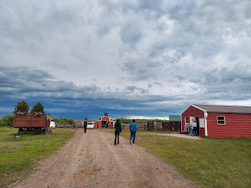

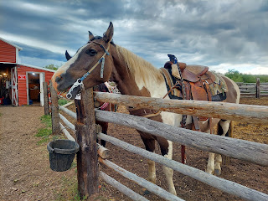

In the hanging bucket on the fence were some cubes of feed for the horses. I fed this handsome guy a couple of cubes. He would have eaten the whole bucket if I'd let him . . .

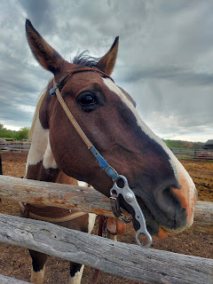

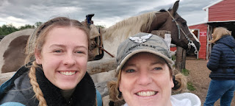

After they divided us up into 3 groups, we got some instructions for the ride from a girl who is a recent rodeo champion. They told us she would be competing in another rodeo later that night up in West Yellowstone.

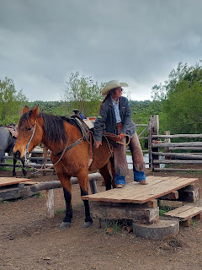

Kylie, on her horse named Striker . . .

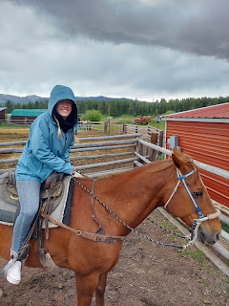

There was also a horse in our group named Spirit . . . I wonder why, ha ha . . .

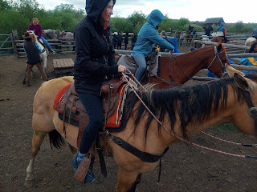

There was a little girl named Aria, and she was the youngest rider in our group. (I think she was 5 or 6) She has been on a horse before and did great on our 2-hour ride. The only time she panicked was when we started leaving our pen and she got separated from her mom. She tearfully cried out for her mom, but Mama was several horses ahead, unfortunately, a result from how we all got crowded into the pen in the first place. I looked back over my shoulder and coached her on how to get her horse going and told her that everything was going to be okay. I reassured her that we could get her caught up to her mom momentarily, which we did. She was such a cutie!

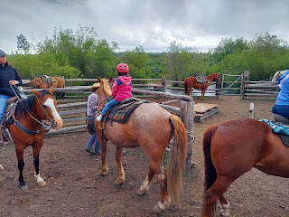

Just as we were leaving, it started sprinkling. It was in the mid-50's for temperatures and I was grateful for all the layers that I had on.

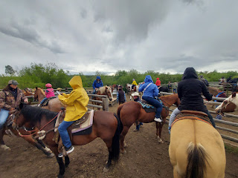

On the ridge below, I loved the scene of another group heading off on another trail with the stormy skies in the distance.

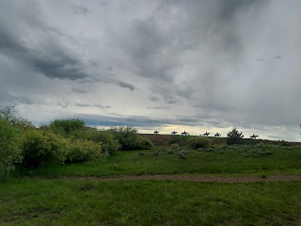

Our guide was named Tukker. He was a very cool young man who was born and raised in Rexburg. His horse was HUGE!! He was a cross between a Belgian and a Percheron, the kind of horse you use for pulling something heavy, ha ha.

I don't know why I took this photo of Tukker and his horse, ha ha. I mean, I know that horses pee and poop . . .

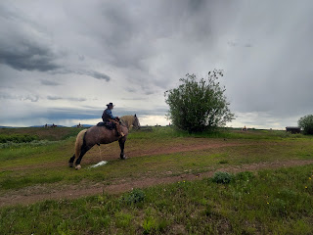

Eagle Ridge Ranch has some additional fun family activities for either before or after your horse ride. For example, there's a mini lake with a few canoes and paddleboards. We passed this on our way out onto the trail.

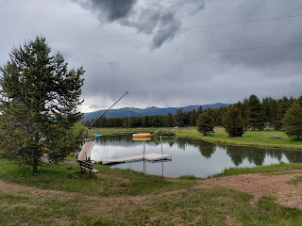

Tukker and his horse again . . . tip-toeing through the wildflowers . . .

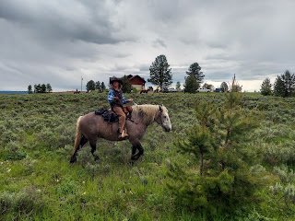

We went through forests and beautiful meadows full of bright yellow and cream-colored wildflowers. It was so peaceful and lovely.

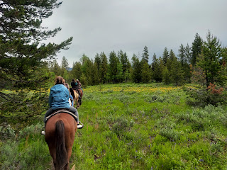

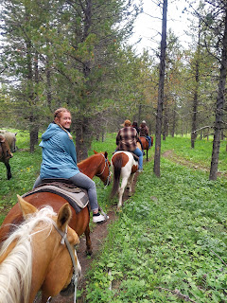

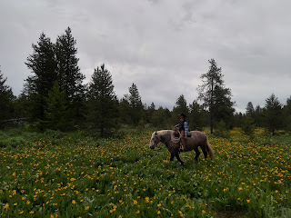

We saw a couple of mule deer in the trees, one here and one a little later on . . .

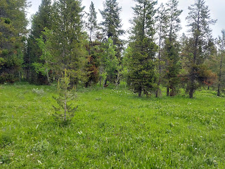

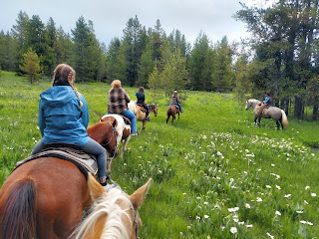

Video of our meanderings through the meadow: (18 seconds)
https://photos.app.goo.gl/4MaUsrDKhbYFP3KG7

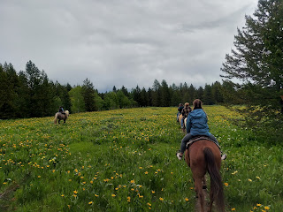

We passed a few houses near the end of our ride . . .

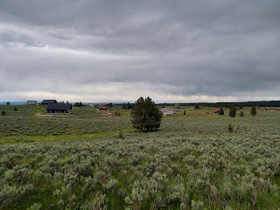

Below: I'm on the left and Kylie is on the right . . .

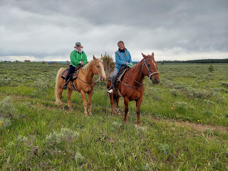

We had a few river crossings, which were pretty fun . . .

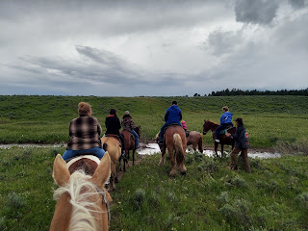

Video of one of those crossings: (29 seconds)
https://photos.app.goo.gl/NfL1Lz9h6kRcqRWu5

While Tukker hopped off to take some requested photos, his horse happily had all the grass to munch on.

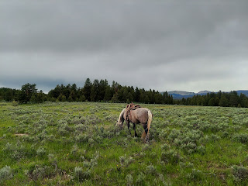

As we got closer to the Ranch, I ended up behind this guy's horse, who was slower than molasses. It was mesmerizing to watch the giant horseshoes plod-plod-plodding along, though.

Video of the horse in front of me with his giant shoes: (16 seconds)
https://photos.app.goo.gl/q2THb5YgghGFncgF8

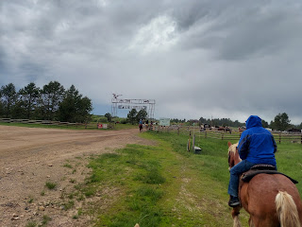

I thought it was so cute as we approached the Eagle Ridge Ranch entry gate, because all the unsaddled horses in the front pen started whinnying a happy welcome to all of us. I could just picture them asking, "Well? How was it?"

Video as we passed the horses staring at us, ha ha: (10 seconds)
https://photos.app.goo.gl/uLWCk37C8DL9eHPe6

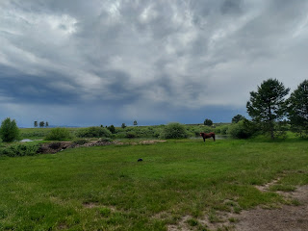

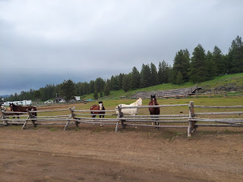

Back to where we started . . .

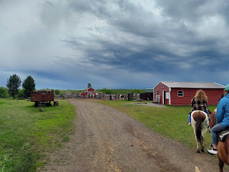

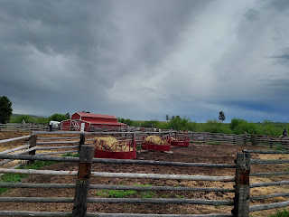

We were all glad they had an elevated platform to help us get on and off our horse.

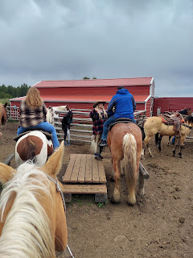

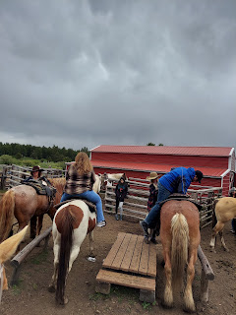

And that was that. It was a fantastic two hours both IN nature and ON nature. Kylie thanked me more than once. While we rode along, she told me that one of the jobs she had in high school was to take care of a horse that belonged to a friend who competed in rodeos. She was able to ride it all the time, too, and she got really good at it. She could race and even jump the horse! What we did up in Island Park was a much slower pace, though, ha ha.

On the way back to Idaho Falls, we stopped at the FrostTop Restaurant in Ashton, with a giant mug of root beer as its signature sign out front. She ordered chicken strips with fries and I ordered a chicken malibu sandwich and tots. She was so sleepy on the way home, so she closed her eyes and tried to rest as much as possible. While Avery has adjusted nicely to the 8 hour time difference, Kylie still struggles with insomnia every night. We talked about getting her hormones checked in the very near future, so hopefully she can get more sleep than 2 hours a night. It's hard when you're a young mother trying to do what you need to do on such little sleep.

Later that afternoon, I walked hand in hand with Abby down the street to Sunnyside Park. I was surprised to see a whole new play center there . . . and it was VERY TALL!!

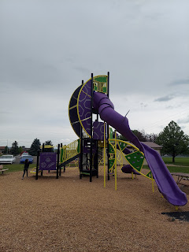

Abby wanted to climb up to the top, but there were a bunch of kids hanging out up there, which meant limited space for her. So she climbed back down.

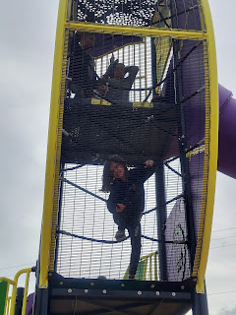

We swung side by side and chatted for a long time. It was precious to hang out with her, just the two of us.

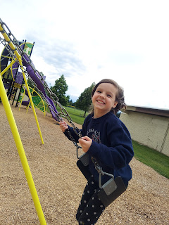

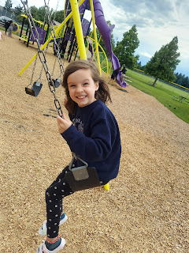

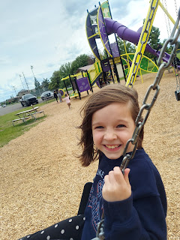

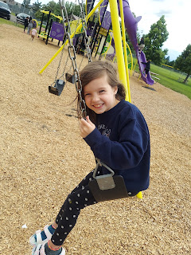

A little while later she climbed back up inside the tower so she could go down the slide.

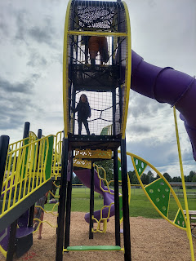

Video of Abby coming down the slide: (25 seconds)
https://photos.app.goo.gl/bKCyVHzZjwhnjxgz7

As we walked back to the house (and yes, we wore COATS at the end of June), Abby told me that she recently learned about the use of pine needles as actual needles. She said you can sew through rose petals with them, for example.

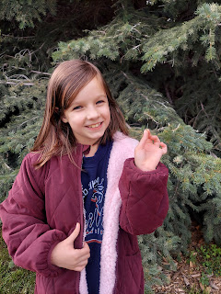

Then she pretended that one of the needles was like a sword . . .

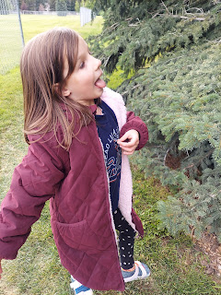

Our neighbor, Kim, told us about a local production of Beauty and the Beast, so Amber and I took the girls that night. It was so fun!! We got seating in the balcony, which was also fun. The upstairs level overlooked the lobby where a giant red rose was suspended in mid-air.

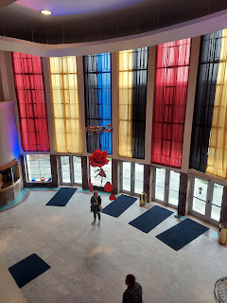

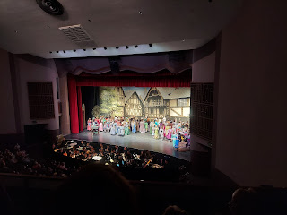

The production crew did a phenomenal job on the set and all the costumes.

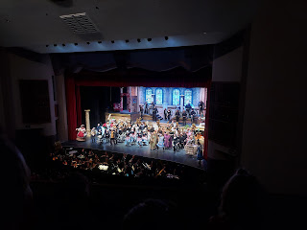

From our balcony seats, we could look down on the orchestra, which was magical for the girls, especially as the harpist strummed some magical notes.

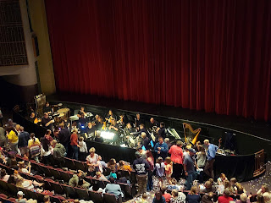

Ahhh, the romantic dancing of Belle and the Beast . . . a tale as old as time . . .

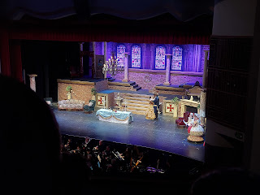

The final bows at the end . . .

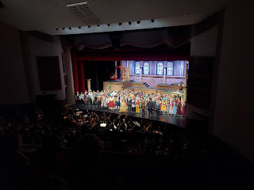

We had so much to discuss animatedly as we skipped back to the car. It was a really fun evening together.

Saturday, June 24th:
We headed out mid-morning to the Farmer's Market along the Snake River in downtown Idaho Falls. I was quite surprised at the variety of all the many booths, perhaps a hundred in all. There were food vendors, booths with local crafts and goods, breads, jams, sweet treats, clothes, wood products, etc.

From where we parked, the first section we saw was devoted to several booths celebrating Pride Month. With help from my daughter Amber in recent years, I have come a long way in my thinking toward our LGBTQ+ brothers and sisters. They are first and foremost children of God and they deserve to be loved and shown respect, just as I would hope for myself and each of my family members. It's okay that we might think differently on some things. I bet we have a lot more in common than not.

In traveling around the world and coming across new and different cultures and peoples, I definitely see a thread of commonality wherever I visit. Individuals, couples, and families want to belong. They want to be loved. They find ways to work hard and earn money to support their family members. They want a roof over their head and something to eat. They want to be happy. They are sad at times, angry at times, and content at times. They want to make something of themselves. They want to try new foods, laugh out loud with loved ones, and watch the latest movie that everyone keeps raving about.

All of these same descriptions apply to those who identify as LGBTQ+. They feel the same feelings and want the same things in life. Just because they appear "different" doesn't mean they don't deserve happiness and love and respect from the rest of us.

As a matter of fact, the two booths that touched me the most at the Farmer's Market were in the Pride section. One was entitled, "Free Mom Hugs", and right next to it was one entitled, "Dragon Dads". Amber told me that the Free Mom Hugs started because some of the LGBTQ+ community had been ostracized from their own families, and no longer had a mother figure. This nation-wide organization is focused on offering education, conversation, and of course - free hugs, to anyone who might need it. Wow. That's so sweet.

The Dragon Dads booth almost made me cry when Amber explained its purpose to me. Similar to Free Mom Hugs, its purpose is to provide a father figure to those whose fathers have estranged them based on their orientation. They also provide support to other fathers who need help to varying degrees with learning that their son or daughter is gay. Their primary purpose seems to be making sure that conversation can be had, respect can be given, help can be administered, and love can be readily dished out. Isn't that what everyone should experience? This was all very enlightening to me and I'm grateful that I have a daughter that I can talk to about such things. I'm also grateful that Idaho Falls is able to show support in kind ways to those who need to know they have a place in this world.

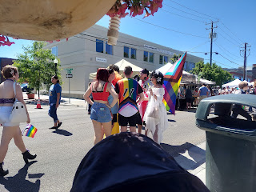

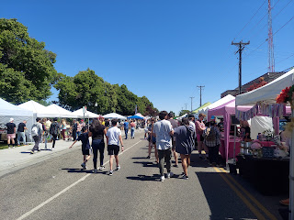

One of the many artisan booths . . .

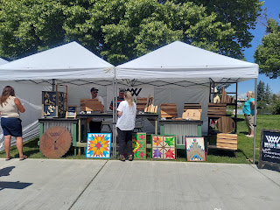

We found a great spot for face painting - and for just $2.00!! This young entrepreneur was happy to paint a rainbow on Abby and Gwen's cheeks.

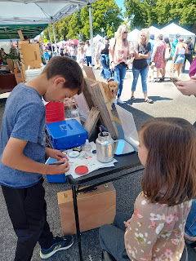

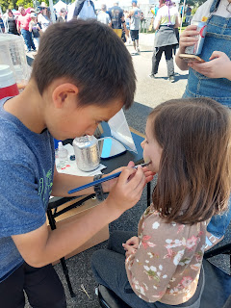

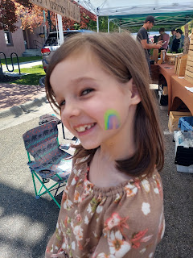

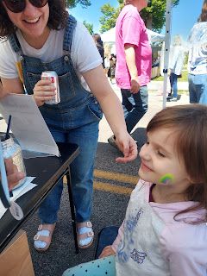

I bought two loaves of sprouted wheat bread and I learned a little about the difference between sprouted wheat and regular wheat. Sprouted wheat is a plant and is considered a vegetable. It is dried and milled to be used in flour form. It does require something to "glom" the dough together, so something like flaxseed can be used for that. Regular wheat is a grain and can be difficult for some people to digest, such as myself. I was excited about the prospects and was happy that they provided samples of the various breads that they were selling. I bought a long loaf of rosemary garlic bread, and I also bought the most amazing sourdough loaf. It was so soft and even a little sweet in taste.

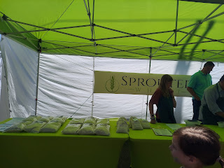

For lunch, Amber and I bought a few Arepas, a Latino dish that was super tasty. Here is the menu (below). I bought a lime chicken arepa for myself, and I bought a house chicken arepa to bring home for Benson.

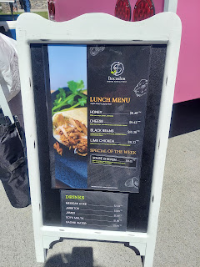

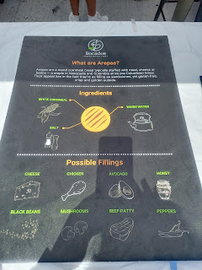

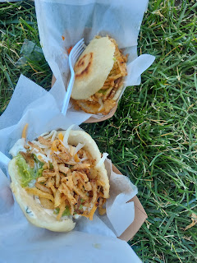

After we all got something tasty to eat (the girls had a corndog and a cupcake), we started back toward the car. Amber wanted to support the Pride artisans in some small way, so they chose a few trinkets in this colorful booth on our way to the Bouncy House before we left to go home.

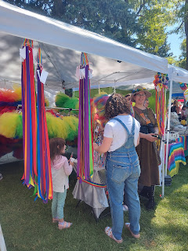

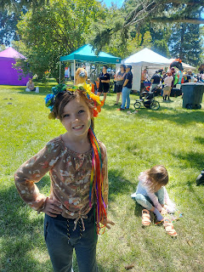

The weather was great and we had a wonderful morning.

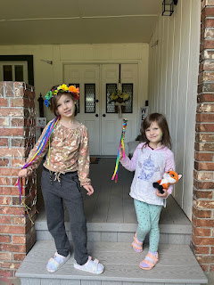

I chatted with Jacob for an hour or so as he drove through Pennsylvania on his way to Michigan. We chatted about arepas, pot pies, and other fun topics. :)

Once I was off the phone, Abby wanted me to accompany her across the street to take some cookies to Kim. We had made the cookies together the day before. (Abby is turning into quite the little baker!) While Kim and I chatted on the front porch, Abby giggled and had a great time with Milo, their 4 month old puppy, and Garfield, their 6 year old cat who thinks he's a dog.

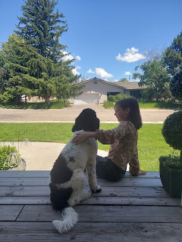

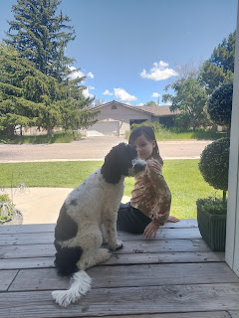

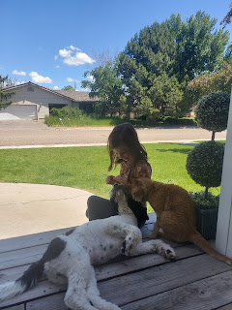

That evening, we all got some grilled cheese sandwiches and tomato soup at Manwaring Cheese Co., along with some gelato.

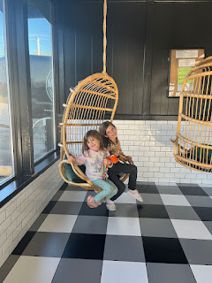

Then we headed a few blocks west to walk along the Snake River once again, but on the opposite side from where the Farmer's Market was set up earlier.

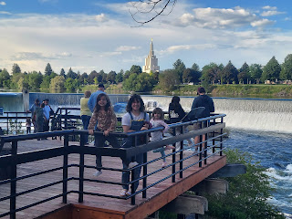

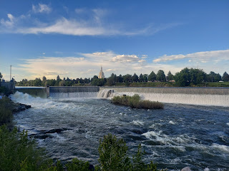

Amber shared that this was the exact spot where Weston proposed to her approximately 10 years ago.

Abby, Amber, and Gwennie

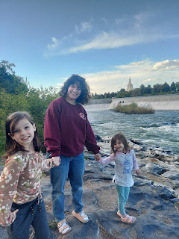

The water level was massively full, so we made sure to hold hands (or hold Gwen) if we were anywhere near the water . . .

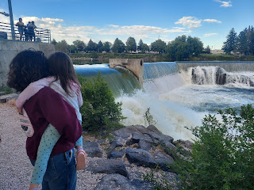

Gwen and Abby

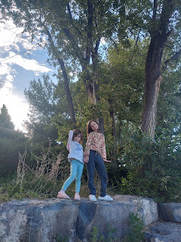

We walked a little ways south to see the Japanese Friendship Garden, something the girls didn't remember very well at first, even though they had been there before. It might have been a couple years since their last visit.

L to R: Benson, Amber, Abby, and Gwen

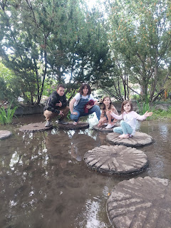

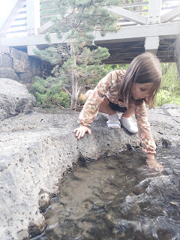

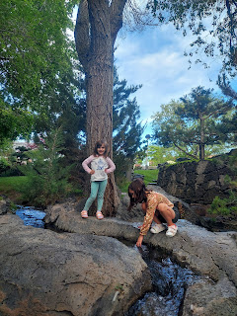

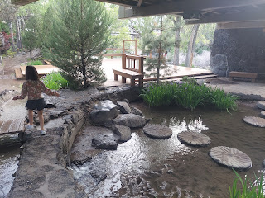

This moment was captured by Amber as I helped Gwen reach across the little stream to touch a mini waterfall.

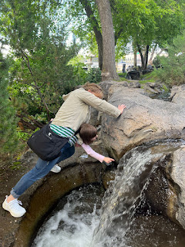

God Bless America! Land of the Free.

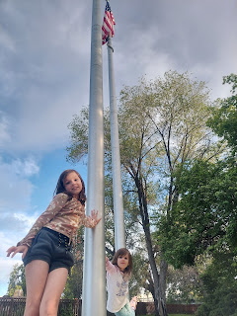

We could have stayed for a few hours more, but it was getting late in the evening and it was time to head on home. The girls were bummed that we had to wrap things up.

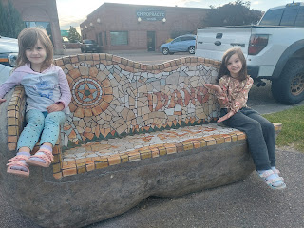

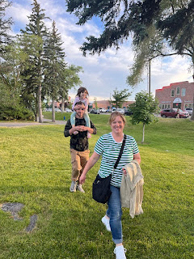

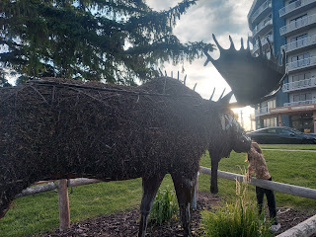

I love this next photo because it looks like the giant moose has eaten Abby's head!!

L to R: Abby (minus her head), Amber, and Benson carrying Gwen on his shoulders

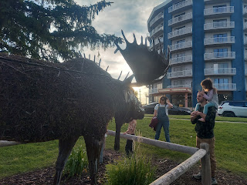

I'm grateful to have two of my children to hang out with for a while. It's been really lovely.

As for Jacob and his family, they arrived safely in Michigan and are currently visiting with Hannah's sister and her family for a few days. Jacob drove that 12 footer Budget truck from Virginia across Pennsylvania, Ohio and eventually into Michigan all by himself. We talked to him twice during that long day and I'm glad we could entertain him a little bit.

Hannah and Jack took the easy route and flew on a 90 minute flight together. In just a couple more days, they will arrive in Minneapolis and settle into their new home there. They are very excited to get to know their new hometown over the next few years.

