Doris Amy Jones: 1921 - 2023
My petite and sweet Grandma Doris passed away this week, bless her tender heart. She was 102 years old.

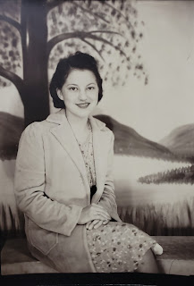

When I stayed with my mom and Grandma Doris for 4 months in the fall of 2019, I would sometimes accompany Grandma on a walk down the street and back. Behind my mom's house is a beautiful vineyard, and this scene seemed very symbolic at the time that I took the photo . . .

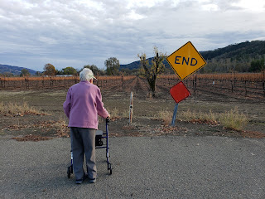

She always loved a beautiful sunset, and would gaze up at it for a long time, pondering and feeling so grateful . . .

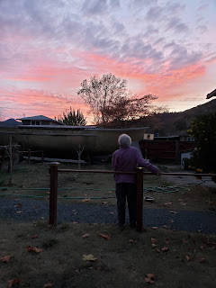

She is spending quality time with a multitude of family members in heaven now, and I know she is full of joy to be reunited with all of them. I'm sure she was overjoyed to see her son, Ronnie, my mom's older brother who passed away at 18 years old from cancer. And I'm sure she was comforted to see her parents again, both of whom were deaf in this life. I'm betting she was happy to see her husband, Forrest Day, who passed away back in 1982. He was a soft-spoken and kind man. And I'm certain she was ecstatic to see her older brother, Earl, who drowned at 1.5 years old, before Doris was even born.

Great Grandma Christina Miller Jones (left) and her daughter, Doris on the right

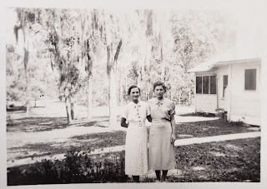

Grandma Doris, roller skating in Florida as a young lady

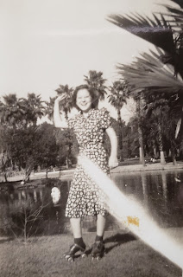

Revealing her sense of adventure by hopping on the back of the motorcycle with her son, Wayne (Ukiah, CA) . . .

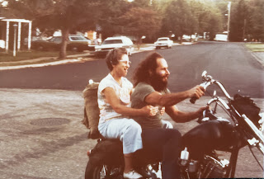

I shared this next photo with my kids during the week, since it shows my uncle Ronnie before he died when he was 18. (click to enlarge the photo) I especially love the photo of Ronnie and my Grandpa Linton, taking the canoe that they built together out on its maiden voyage shortly before he died. (probably in Lake Mendocino) The two lower photos are the last pictures of Ronnie, taken down in San Francisco during one of his final chemo treatments. I think Ronnie is who Grandma Doris might have wanted to embrace first.

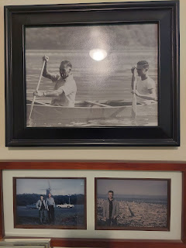

Below: Holding one of her many paintings with those precious and aged hands . . .

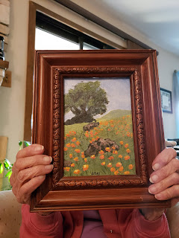

And one of my favorite photos of the two of us - taken at her home on Waugh Lane in Ukiah, CA.
(maybe 2010?)

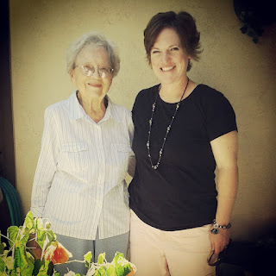

I will miss her, but mostly I am just so happy for her. She lived a good long life, and now she can rest her weary soul. She is probably learning a great deal up there right now, and I can just picture her asking a million really good questions. She was always so naturally curious, so it makes sense that her same sense of wonder would also carry over into the next life.

As we leave this life, it's like a Graduation. We've learned all that we needed to learn here on this earth, and now it's time to move on to bigger and better things in Heaven, sort of like heading off to University. There isn't such a time constraint there, which would be oh-so-nice. Here, we are guided by and pressured to work within a 24 hour time period each day. But in heaven, it isn't like the rush-rush craziness that we experience here on earth. And how nice. Grandma is going to learn some amazing and beautiful truths where she is now, and I look forward to hugging her someday and sitting down to talk about everything together.

Catching Up On The Week . . .

Last Sunday in church, there was a mixed choir musical number that brought me to tears. The song was called, "I Am A Witness", and the choir consisted of young primary aged children, a handful of youth, and several adults. The children would sing a section, then the youth joined in, and then the adults. It was just so beautiful! I wanted to record the whole song, but I didn't. I took a photo as they were about to begin . . .

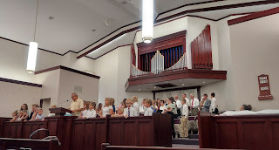

I found a version of the song on this website: (when you go to the link below, you'll see the YouTube video that you can watch at the top of the page)
https://shawnaedwardsmusic.com/pages/i-am-a-witness

Now, imagine hearing that song in Sacrament meeting . . . it was so angelic and moving . . .

After I watched the Barbie Movie with my niece, Ana, in CA a couple weeks ago, my Dad bought me an early birthday present. He could see how much the movie affected me, so he ordered me a T-shirt that says: I Am (K)enough. 'Twas a very thoughtful gift and I was so happy when the shirt arrived this week. I had my neighbor take my picture while I was wearing it so I could send it to him as part of my Thank You.

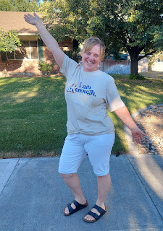

I also talked that same neighbor (Kim) into going to see the Barbie Movie on Saturday with me. She brought her daughter, Mady, who just recently graduated from high school. We laughed and laughed, and we definitely cried. Well . . . Kim and I cried. Mady isn't much of a crier. But she still enjoyed it a lot!!

L to R in the semi-darkened theater: Me, Kim, and Mady

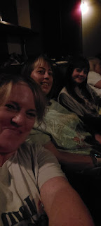

I did a lot of yard work this week. Not only have I been pulling weeds and clearing out the old stuff, but I have been trimming down my perennials and getting them ready for winter. Yes, I know it's a little early, but I leave for Italy in 10 days so I kind of don't have a choice.

My raspberries before weeding . . .

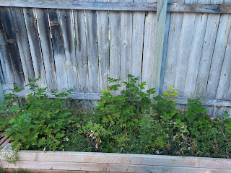

And after . . .

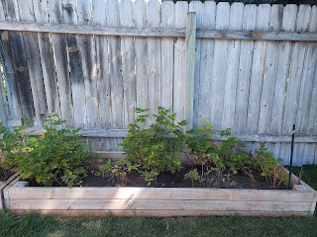

I also picked the entire summer's worth of rhubarb. Usually I pick it 2-3 times from late spring into early fall. But I have not taken the time to go out and pick any of it until now. So it was a LOT . . . I broke off all the giant leafy ends and threw them away, rinsed all the rhubarb stalks with the garden hose, and then brought them inside.

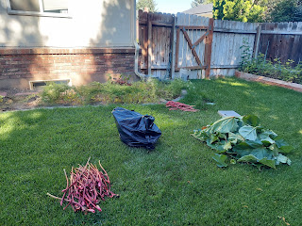

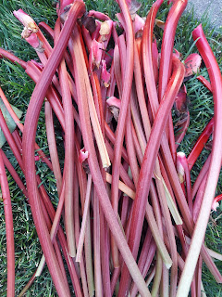

Slim pickens now . . .

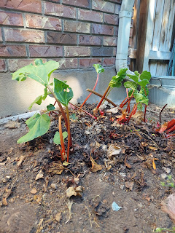

I took all of the rhubarb to the Neighborhood Dinner that evening and "sold" it off to several people in attendance. I hauled it down the street in a laundry basket and invited people to fill up a grocery sack with as much as they felt they could take home. Thankfully, I came home empty-handed. I am running out of days to get everything done before I leave, and besides, it's always nice to share. Kim came with me to the dinner and I was grateful to have a buddy. :)

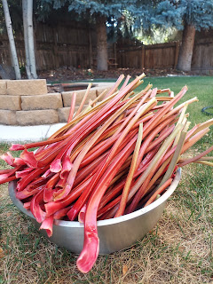

I've been helping my Doctor, Laura Mason, and her husband with their plans to visit Italy this fall. They have never traveled to Europe before, but Laura knew that I go back and forth all the time. They have been to my house three times in the past week or so, and I've helped them figure out where to go, how long to stay and build an itinerary, how to get around, and we even bought their plane tickets in my dining room together. She offered to pay me for helping them, which I immediately declined. Next, she offered to bring me some fresh eggs from her chickens, along with some garden produce. I told her I would be happy to accept those as a gift. :)

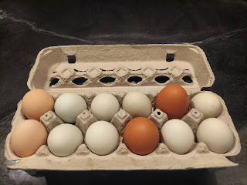

And speaking of eggs, I have been stock-piling egg cartons for several months, so I finally took them over to my friend, Sharina. They typically have about 20 chickens on their ranch south of town, and she is always in need of more egg cartons.

It was a beautiful afternoon when I went over to visit her, and I was enamored with the gazebo and all the pretty flowers next to their circular driveway. I remembered the day I stopped by last summer when they were just laying out all the pieces of the gazebo to begin assembling it. They sure did a fine job!!

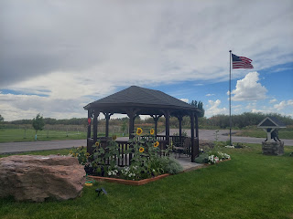

Sickness has been going around the family lately . . . Gwen had a fever and a tummyache out in Louisiana. I chatted with Amber and the girls for a little bit on the phone one afternoon. Even though she didn't feel that great, Gwennie still had some smiles to share. XOXO

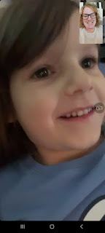

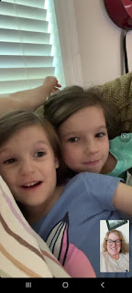

Out in California, my Dad was sick all week long. He had a fever for several days, lots of coughing, and a few other symptoms. Tonight (Sunday), he let the family know that not only did he test positive for Covid, but Michelle tested positive as well . . . Yikes!! He's doing better now that he's at the tail end, but it was a rough week for him. Michelle is supposed to start a new semester of school tomorrow, and she may have to do it by Zoom!

My son, Benson, has also been sick all week. His main complaints have been congestion in his face and throat, occasional sore throat, extreme fatigue, lots of headaches, and just general blahs. I am waiting for him to take his Covid-19 home test this evening and then we'll see what to do from there. I hope I don't get sick . . . and if I do, I hope it's not gonna knock me out for several days . . . I have so much to do to get my house and yard ready before I leave!!

In between all the days of feeling lousy, Benson worked a little here and a little there to put his car back together.

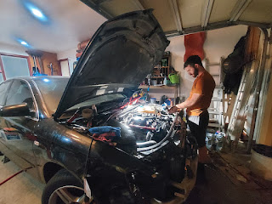

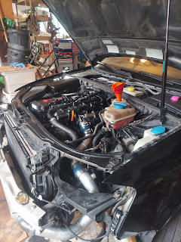

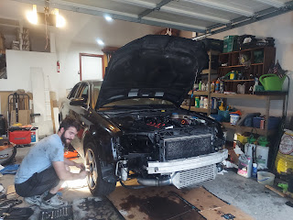

He lowered the jacks and started it up. He pulled it out into the driveway, and even took it for a slow spin around the block. He came back concerned, though, because a new error code popped up on the scanner. It said that the cam shaft sensor was bad. He took the sensor out and cleaned it up, but the error code was still there. He was super disappointed because he spent two entire days recently trying to get the timing just right on the cam shaft before installing it. He ordered a new sensor and it should arrive tomorrow (Monday). We are praying and crossing our fingers that this will be the right solution and that his car will be in working order once it's installed. Our Plan B is that if this doesn't fix the problem, then he will just use my car while I'm gone for the next 90+ days. He'll get his car into the shop somehow and let them get to it whenever they can get to it between now and December.

I had a profound craving for brownies for about 3 days before I finally took the time to make some for myself. Hallelujah, too - because they really hit the spot. Per Amber's suggestion, I added a few dollops of peanut butter on top before baking, and I sprinkled on some chopped walnuts, too. I always love walnuts on my brownies. :)

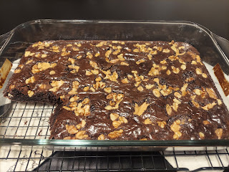

On Friday morning, I went to the temple for the first time in over a month. I was so happy to go and to have my spiritual "well" filled up to the brim. I also had a surprise when I was ready to begin the session, because I saw Weston's mom, Kathy, and we ended up sitting next to each other. It was so nice to be there together, as the two moms of our kids that are married. She is a wonderful woman.

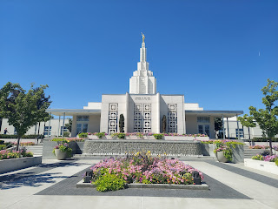

I listened to an amazing podcast a few days ago, as I was pulling weeds and picking rhubarb. It was a review of the Come Follow Me lesson for the week, covering Romans 7-16 in the New Testament. There were so many incredible insights and I felt like some of them were life changing for me. Here are just a few of the things that were discussed in the podcast relating to Paul's letters to the Saints in those final chapters of Romans.
Act
VS being acted upon. Choose to act, to do what you can, rather than letting life somehow take charge of your day and then you feel like you're drowning or coming from behind. Be purposeful in all that you do.
10-10-10. When you are feeling anxious or stressed about something, take 10 seconds to slow down and just breathe. Ask yourself, in 10 minutes, will this still be a problem? In 10 years, will this still be a problem? You can't do it all, so try to prioritize your day. Ask the Lord for help in shaping your day so you don't fill it with too many things that are inconsequential and that end up cluttering your mind and your spirit (which leaves you with less emotional and spiritual strength to deal with everything else).
Instead of asking yourself, "Why is this happening TO me", try telling yourself that this is happening FOR me. Our trials, they help us to become closer to Christ and to become more LIKE Christ.
We cannot become like God without suffering.
Many times we have a "Customer Service Mentality". We get upset because we didn't get WHAT we wanted, WHEN we wanted it, and HOW we wanted it.
Going through trials VS Growing through trials. If we just GO through a trial, we may not be learning what we need to learn, or feeling what we need to feel, or becoming what we need to become. If we adopt the attitude of GROWING through our trials, then we are opening up some great opportunities to become closer to and more like Jesus Christ.
Better vs Bitter. Am I going to be better because of what I'm going through? or will I become bitter?
A lot of these conversation starters came from Romans 8:16-18.

Here is a link to the Scripture Central episode that I am referring to above:

https://www.youtube.com/watch?v=fEV1ZB_H0H4&ab_channel=ScriptureCentral

The portion that I got the most out of is roughly between 20 minutes in and 40 minutes in. But DANG, the whole lesson was incredible. I listened to it on Spotify, so it was just the audio version. But for those of you who don't use Spotify, then YouTube is a great alternative. I haven't been super regular about listening to these podcasts, but I am more like a sporadic and occasional listener. I just got SO MUCH out of this one episode, and I felt like I should share it with y'all.

Time to Catch Up on Grandchildren . . .

Jack has had a great summer. He's been all over the country, as a matter of fact. From DC to Minnesota to Utah and Idaho.

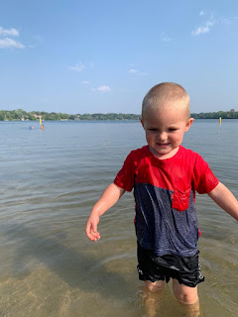

Jake reports that Jack LOVES to spend hours perusing the Richard Scarry book that's all about construction vehicles and trucks, etc. I am not surprised, ha ha.

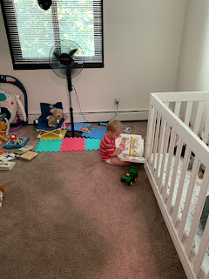

They also couldn't help buying him this shirt that says, "I dig BYU", ha ha.

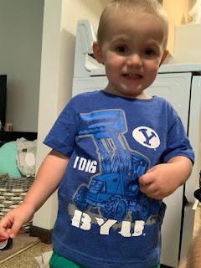

And they've been teaching him to answer the question, "How old are you?" (2 years old)
Video: (11 seconds)
https://photos.app.goo.gl/FAcK4xzecAquzsjd7

Abby and Gwen have had a great summer, alternating between lazy days and doing some educational pursuits as they transition into home schooling. Abby also happily modeled the pioneer girl bonnet that I sent to her from the CA Trail Center in Nevada.

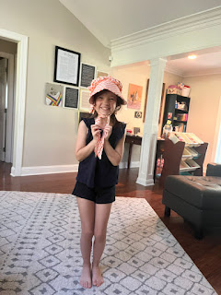

Short video of Abby in the bonnet: (6 seconds)
https://photos.app.goo.gl/VrwPuHKLtsL6B39F7

Amber also found a steal of a deal in a local grocery store with this cute outfit . . .

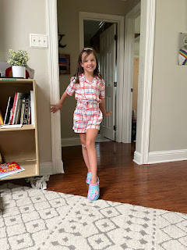

Unfortunately, I haven't heard a peep since Kylie went back to Italy with Avery a couple weeks ago. Hopefully, I'll get some pictures soon of Miss Avery . . . I sure miss her a lot.

UPDATE: Benson's Covid test came back negative. I bought the 2-pack testing kit that the CDC endorses, but I also know that the home tests are not 100% accurate. So he might really have it, or he might not. Oh well. He does seem to be feeling a little better tonight, so that's good.

