So Now I'm a Crunchy Granola Homesteader
First off, my time of quietly hiding in the background is over, I'm sad to say. It was a wonderful month. RIP

The young single soldiers figured out that I can make food that is a little better than something out of a box or the stuff that shows up all too frequently in their chow hall line . . . At our Ward BBQ on Tuesday evening, they were very skilled (Morgan, mostly) in asking all the right questions in rapid succession so that I found myself inviting them over for dinner on Friday night. And then it turned into, "Can we invite the elders?" "Can the sister missionaries come, too?" "And how about Elder and Sister Sim?" (the senior missionary couple serving here now)

So . . . Friday night, we ended up hosting 9 guests + Scott and me = 11!! We did purposely buy a dining table from IKEA that could extend and seat lots of guests, so I'm glad the seating arrangement all worked out. We extended the table a little further by setting up my sewing table down at the far end, too.

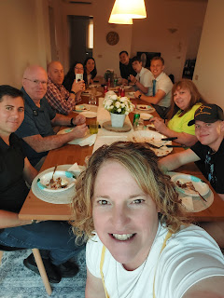

From L to R: (Me), Shayne Ramon, Elder Sim, Scott, Sister Crowther, Sister Santana, Morgan Kethley, Elder Thompson, Elder Searle, Sister Sim, and Cooper Peterson (?).

The main dish turned out good, but it was a little different than what I had set out to do . . . I had some ideas earlier in the week on what to feed such a large group, but then I learned that Sister Sim can't have gluten. I sent her a few options to see what she thought, and she ended up choosing Smashed Sweet Potato Pizzas. She thought they looked amazing! And they are. Scott and I made them once a few months ago, and they were so tasty.

The things I did not take into consideration ahead of time were:

~ We have a smallish kitchen
~ We have a teeny tiny oven
~ The teeny tiny oven can only fit teeny tiny sized baking pans
~ I only have 2 teeny tiny baking pans
~ The process for making the pizzas required 3 separate rounds in the oven
~~~~ 1) To bake the sweet potatoes
~~~~ 2) To crisp up the smashed sweet potato rounds so they can serve as a pizza "crust"
~~~~ 3) Add all the toppings and then let it get nice and melty

This is what I was working from . . .



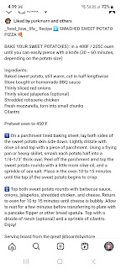

I began early in the afternoon, baking 12 hearty sweet potatoes on my two teeny tiny baking pans. That's when we started questioning how we would fit everything in our smallish kitchen. Once we smash one sweet potato flat, where are we putting all the rest afterwards?

We could only bake one large smashed potato on each teeny tiny baking pan, so . . . this was going to take a lot longer than we realized. And by we, I mean ME. I'm the one who offered this as a possibility to Sister Sim and I'm the one who went and purchased all the groceries to make it!

Another issue popped up pretty quickly: as each pan came out of the oven, where do we put the crisped ones while we put the next pans in?

Hohh boy . . . Scott encouraged me to just skip the crisping up part and to just put the toppings directly on the smashed sweet potatoes. I didn't see much of an alternative, so that's what I did.

The Sims arrived 40 minutes early (at 6:20), at the height of our stress, ha ha. They thought dinner was at 6:00 and
they
were stressed, thinking they were LATE. But in fact, Sister Sim ended up helping me quite a bit in the kitchen, so I'm glad they arrived EARLY.

Scott handled the almost constant buzzers for all the guests arriving. Each buzzer meant that he needed to open the gate so they could come down the long driveway and then he'd direct them where to park next to our building. I felt bad that I was so wrapped up in the kitchen at this point that I couldn't visit much - until we finally sat down to eat about 30 minutes late.

As each "pizza" came out of the oven, Sister Sim and I used two spatulas to carefully transfer them onto dinner plates and set them on the table. When it was finally time to eat, everyone raved over how delicious the pizzas were. I had made a homemade BBQ sauce earlier and it was so flavorful! Even I loved it! And I don't usually like BBQ sauces . . .

This is the recipe I used:

https://natashaskitchen.com/bbq-sauce-recipe/

The main course was more like a casserole, but it still tasted really good. For our side dishes, we had a green salad, watermelon, and Italian bruschetta bread to dip in your own uniquely designed oil/vinegar sauce. I set out a basket with the following options: olive oil, balsamic vinegar, S&P grinders, oregano, red pepper flakes, coarse ground pepper, rosemary olive oil, and a lovely (and light) rose' balsamic vinegar. Each person had an extra side plate to build their "concoction". Then you mop it all up with your bread. It's really yummy and everyone enjoyed building their little science experiments, ha ha.

After dinner, we went downstairs to play some Frisbee in the yard area. I was happy to just take some video clips of the action while the "young-uns" were having a great time.

Video #1: Morgan teaching everyone how to play "10,000" as Elder Searle caught the frisbee.
(4 seconds)
https://photos.app.goo.gl/ua6KAzZVEzjMAD6LA

Video #2: Sister Santana caught it and was so proud of herself! Then she accidentally tossed it way off to the side instead of back to Morgan . . . (7 seconds)
https://photos.app.goo.gl/WSjMd9gAJAzNUyT98

Video #3: Cooper wrenches the frisbee from Elder Thompson, ha ha. (5 seconds)
https://photos.app.goo.gl/gJWJbGEyuPE4j6Fm6

Just moments after this, Elder Searle became the new "launcher", taking Morgan's place. After just a few tosses to the group, he inadvertently sent the frisbee over the hedge and into the watery ditch on the other side . . . let me be clear - - the water is very much pea-green, thick, and covered in algae.

Nevertheless, we all went on a small hike together to retrieve it. We had to walk down the street a little bit, before turning onto a side street that connects to the trail behind our house.

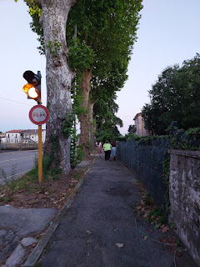

Elder Searle found a long stick to work with, and then a human chain was formed so he didn't fall into the nasty green water . . .

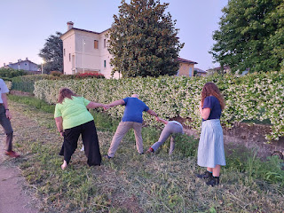

I just happened to capture the very moment when Elder Searle was getting bit by several tiny ants simultaneously . . . yikes!! The stick he was holding was covered in them, but he didn't notice at first. The bites turned into small hives pretty quickly, and even though he was clearly concerned, he was a man on a mission to retrieve our little frisbee that he had accidentally - and temporarily - lost.

Video of Elder Searle realizing he was being eaten alive: (3 seconds)
https://photos.app.goo.gl/YMAJJzHZENANVgtW9

Video of Elder Searle using a different stick, but in another futile attempt: (5 seconds)
https://photos.app.goo.gl/fJVAiHUnr2TNv6wA9

Scott and the Elders ran home to look for something in the garage that could be more useful. They ended up tossing an old broom over the hedge to us, and Cooper was able to retrieve the frisbee this time. YAY!!

It was kinda gross, all covered in green sludge, but the LED lights still work on it - a happy little miracle!! It's currently sitting down in the garage, waiting to be properly cleaned and sterilized. I'll take care of that very soon. (*Update: it's been thoroughly cleaned and is ready for the next adventure.)

The fun was over by that point, since it was after 9:00 p.m. and the missionaries needed to get home by their 9:30 curfew. I gave my tube of Benadryl extra-strength anti-itch cream to Elder Searle along with a few Benadryl pills and some instructions on the correct dosage. He put the anti-itch cream on before he left, and reported that it felt amazing and was already helping, so that's good!

The missionaries were so grateful that I had taken some photos and videos of what happened so they'll have something "exciting to share" in their next email home. LOL

**NOTE:
Scott received two very meaningful awards a couple days ago. He forgot to tell me that he would be getting them, so I wasn't there when they had a little ceremony in his honor during the work day. Details are at the bottom of this post.

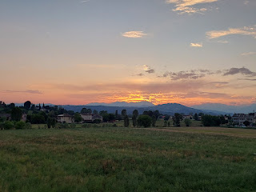

The sunsets are still sunsetting over here, and they are still just as breathtaking as ever . . .

Video of the sunset with rare views of the Dolomites, too: (12 seconds)
https://photos.app.goo.gl/Dkmbiv1usXrUsJe7A

I finished the second patriotic heart for the community quilt . . .

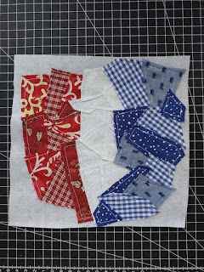

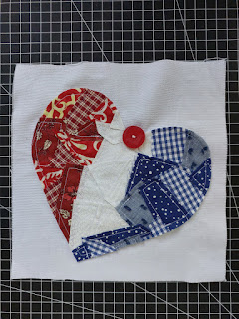

I do still want to make a set for myself and put them in frames to hang in my entry way . . .

Abdel (our Moroccan son) reached out with a video call one afternoon. It had been a couple months since our last chat, so it was nice to connect and visit again. We tend to text more regularly than phone calls. Abdel was hanging out with his friend, Mohammed, whom I have talked to once or twice before. Mohammed has been working for some time now to get Abdel over to Qatar where he works in the palace. The timing has been off this whole time, but now everything is falling into place.

(Mohammed is on the left, Abdel is on the right)

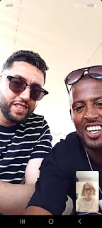

I have written previously about the earthquake in Marrakech and how it affected Abdel at the time. It happened on 8 September 2023 and was rated 6.8 on the Richter Scale. 2,900 people died and 5,500 people were injured, including Abdel, but his situation was unique.

He was too afraid to run down the stairs from the second floor because he thought the house might crash down on top of him, so he jumped out the second floor window instead. In his bare feet.

He sustained a horrible breakage in his lower leg, which led to more than one surgery and many, many months of therapy and recovery. This was also around the same time that Mohammed was working hard to bring Abdel up to Qatar, but obviously Abdel wasn't fit to work for a while. Eventually, when Abdel was healed enough to go to work, the position had long since been filled.

The stars have finally aligned now, where Abdel is in good health AND there is a position open for him. We sent him some money a few weeks ago to help pay for the documents and the visa that are needed. Now he's all set and will make the big move up to Qatar in early August.

Mohammed went home to Agadir for a short break and that's when they called me. They are both such good men and I love them. I'm so grateful that Abdel will have an opportunity to leave the nest in Agadir and make some good money for himself and for his family. He will serve as a waiter in the palace, at least for now. He has worked in this capacity before and he's very good at it. Plus, he enjoys it, too.



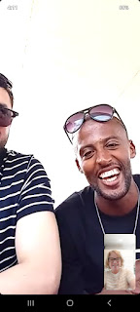

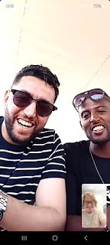

We had a really good turnout at the Ward BBQ on Tuesday evening, the day after Memorial Day. Rain had been falling for much of the day, and I was worried that the event would be a flop and no one would show up. But - alas, the rains stopped, the skies cleared, and it ended up being a really lovely evening. I would estimate that maybe 100 people came, which is outstanding!

We arrived extra EXTRA early, because Scott is in the Elders Quorum presidency and they were in charge of the main dish: BBQ chicken. I didn't think to get any other pictures because I was having so much fun visiting, but I did get this one as I hit the food line.

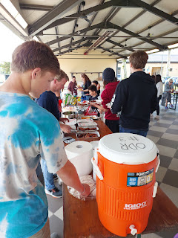

A large covered pavilion behind the USO housed several long picnic tables and benches for everyone to gather and eat. A full sized - (giant) - BBQ grill pit on wheels was reserved for the evening, decked out with several fun features like a smoker chamber, a chimney stack, and multiple grilling racks. Our Elders Quorum president, Matt Wilson, used to work for Outdoor Rec on Ederle for several years, so he's really good at knowing about these kinds of things. He also did all the work to marinate the boneless skinless chicken thighs ahead of time, and then Cameron Preece made sure they cooked appropriately. Everything turned out so tasty.

The rest of us were asked to bring a side dish - sweet or savory. I brought a pan of my mom's famous Mac & Cheese Casserole, because I figured it would be a hit with the kids as well as the adults. And it was.

The following day, I rode with my new friend, Lexi Fillmore, to the mall in Verona. Lexi is a young mother of Scotland (4) and Cooper (20 months). They call their daughter "Scottie". How adorable is that!!

This whole trip came about because I wore a certain blouse to church on Mother's Day Sunday and it caught the attention of several other ladies. I've had it for a while . . . but Lexi asked where I got it from and I told her the H&M at the mall in Verona. One thing led to the next, and when she said she's been wanting to go there, I offered to accompany her whenever she wanted to go - so that I could help tend her darling little boy, Cooper, whenever needed. Scottie is in an all day Pre-K school, so she didn't come with us this time.

Cooper did so well in his stroller for 3 hours. What a trooper! If Lexi wanted to try something on, I'd take Cooper on a little explore around the store and we'd find all sorts of treasures like the stuffed animal section, or the clever drinking mugs that were tall and filled with beads or glitter that moved around when we tipped it upside down.

I got a short video of him - just the once - because he was doing a full-on belly laugh as I made a giant frog say "Ribbit Ribbit".

Video of Cooper: (He didn't laugh quite as hard as I was filming him, dang it.)(But he's still SO CUTE!)
(10 seconds)
https://photos.app.goo.gl/reGGDhbPdMBA6PhZA

Lexi and I ordered the same exact Caesar Salad with grilled chicken for lunch, while Cooper ate a whole slew of ravioli from a different restaurant in the food court. He fell asleep within one minute of starting the drive home. XOXO

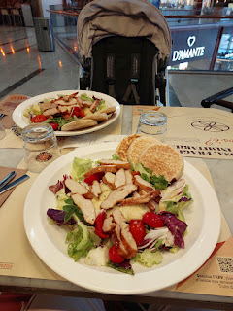

The next morning, my dear friend Marnie Parker came over so we could go on a walk together and catch up on life. They are moving up to Germany in July, but I will be up there pretty often to see them and to stay with them while I visit Avery and/or do some family history sightseeing in the area.

We walked past the cemetery and the church in Maddalene, finding a new extension of path to explore just beyond the church. I had recently read about this famous footpath while studying about the church. This path has many Nativity-related sights during the Christmas season and it's right near our house! People come from all over to visit this amazing spiritual trail, so I'm looking forward to sharing it with anyone who comes to see us during November and December.

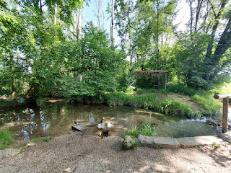

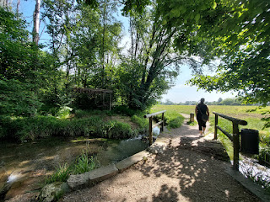

This sweet old lady was working in her gardens and she waved to us as we walked home. I hollered out, "Bellissimo!" as I indicated her beautiful garden. She laughed and mumbled something (I think) about the weeds not being so "bellissimo", ha ha. It was her hand gestures that helped me understand the gist of what she said.

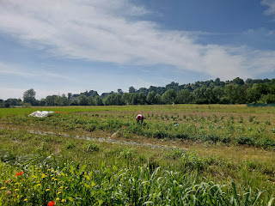

This interesting yogurt caught my eye in the Iper Tosano grocery store last week, so I gave it a try. It was really good!

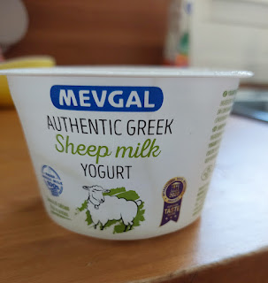

I added a drizzle of Italian honey, some bloobs, and a sprinkle of cinnamon and nutmeg. :)

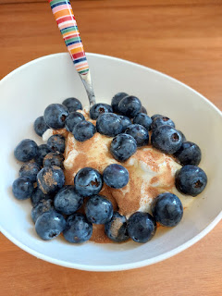

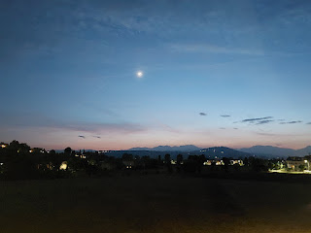

I've been observing Carlo the Contadino for many days now . . . (Contadino = Farmer) (And I've decided to name him Carlo). He always wears his orange t-shirt and drives his little orange tractor. The field behind us looked like a giant mess of 4-foot tall weeds for the longest time, but then he came through and cut it all down one day.

A couple days later, he came through and "fluffed" all of the cuttings.

Video here: (7 seconds)
https://photos.app.goo.gl/36N9CPL7AjQX1Ywv8

A day or so later, he brought out his trusty little orange tractor again and gathered all the "fluffings" into organized rows.

Video here: (8 seconds)
https://photos.app.goo.gl/6sHccFvRZfsNQ3zC6

The hydrangeas are coming into bloom behind the house and next to our garage entrance . . . XOXO



Maisie called me while I was doing some dinner prep for the large group that I mentioned above. She is such a cutie!

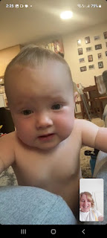

She got hungry because it was first thing in the morning in Minneapolis, so her Papa foraged for something she could nibble on while we chatted some more.

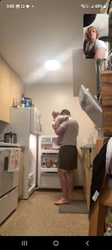

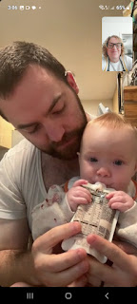

Jake says that Maisie will devour raspberries as fast as you can set them out for her, ha ha.

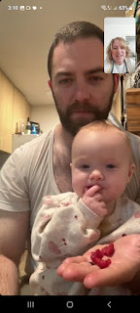

This brings me to why I named this post "So now I'm a crunchy granola homesteader" . . .

I am trying to eat more protein these days. And it's working! I'm actually starting to lose the first couple of stubborn pounds that I've been cracking down on for the longest time!! I think it's helping to kickstart my metabolism a bit and I couldn't be happier.

I love a good cottage cheese for snacking: it's delicious, it's low-carb, and it's got a hefty amount of protein. The problem is that Italy doesn't make cottage cheese. I've only seen it in two places during the last 3 years: Conad (which is now closed) and Iper Rosetto - about 25 minutes across town from our new house. But I didn't even like their one brand of cottage cheese that was offered - it has way too much extra protein added in, and it just ends up tasting like thick chalk. Gross.

Yes, the Commissary sells some cottage cheese, but it's kinda weird and I don't really like it.

When I complained about the cottage cheese famine and my extreme heartbreak over it, someone suggested that I just make my own.

Hmmm . . . the thought had never occurred to me. So I did a little research until I landed on this website, run by a family of farmers.

https://sevensons.net/blog/how-to-make-cottage-cheese?srsltid=AfmBOoomnGN2rjclvmkw_SMEMxkPrkQSSz8Wv_kKoO2I6Ek7fs-MC7DR

It seemed pretty straightforward. All I needed was to find some cheesecloth . . . something that turned into a lengthy pursuit over several days. None of the stores had any! I even asked the store workers, but nope. I tried the home goods/kitchen supply stores, big grocery stores, all of the ones on our side of town. I even looked in the Commissary, but nope.

Guess who had cheesecloth? Amazon Italy. We had it delivered to an Amazon storage locker inside the Pam grocery store one day later.

Now I had all the supplies to get started . . . so on Saturday, the day after our big dinner party, it became my Homesteading Debut Day.

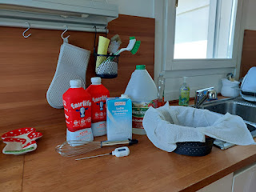

I only have one large pot, and that gallon of milk filled it up pretty convincingly . . .

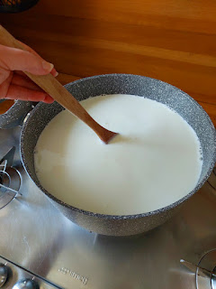

I stayed with the pot of milk the whole time as it slowly heated up to 190 degrees. With a gas stove, I knew that things tend to cook a little faster and I didn't want the milk to scorch and burn. So I stirred and stirred, occasionally checking the temperature of the milk.

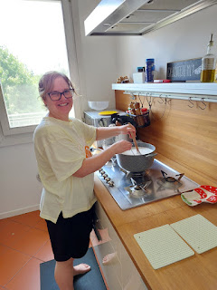

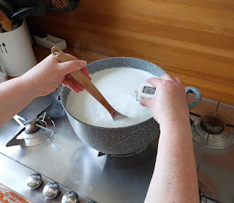

It took maybe 10-15 minutes for it to reach the designated 190 degrees. Then I added in the vinegar to help it curdle muy rapido.

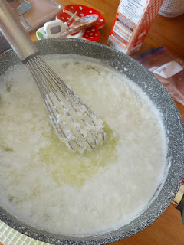

After letting it rest for 30 minutes, this is what it looked like in the pot.

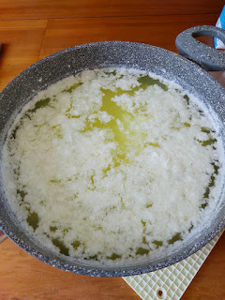

Time to scoop out the curds using a slotted spoon . . .

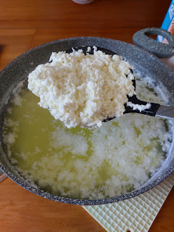

The cheesecloth worked magnificently . . . I let the curds hang out in the colander for another 30 minutes to fully drain.

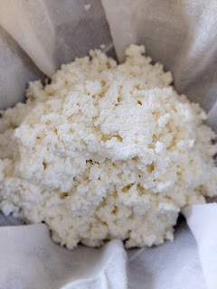

Next, I gathered up the cheesecloth and twisted it, while gently squeezing out the liquid as I rinsed the curds several times. It quickly turned into a round ball of "cheese" inside the cloth.

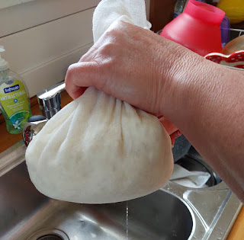

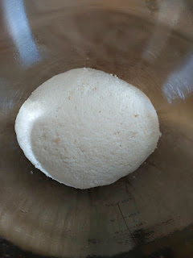

It didn't take much to break the ball up into curds again with a spoon. The recipe suggests adding in some heavy cream to make it creamier if you prefer - and I do prefer a more creamy result. The issue that I ran into was that the curds just soak up the cream without making the overall product any creamier!! I saw that someone else had reported the same issue in the comments below the recipe, too. Oh well. I added the prescribed amount of salt and tasted it a few times along the way. It was delicious!

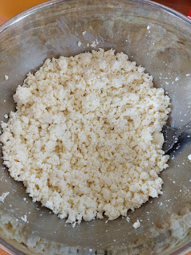

The recipe suggests inverting the containers to store in the fridge, supposedly to help diminish the chances of it growing bacteria and spoiling faster.

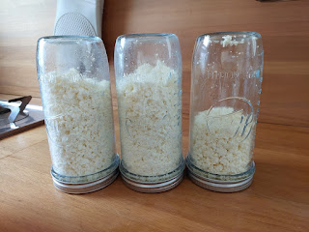

There was a whole lot of whey leftover - NO WHEY!! - and I didn't know how I could possibly use all of it. I saw in the recipe blog that you can use it as extra protein in smoothies or soups, so I froze some into ice cubes for future use. My freezer is the teeniest tiniest freezer you've ever seen, so I reached out to a couple friends and they were super excited to have some extra whey for their families. They even said, "No whey!!" ha ha

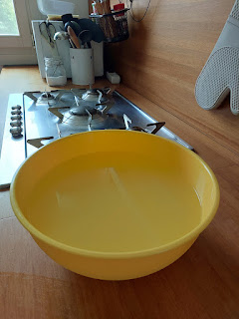

One of my friends, Emily Thompson, said she's used liquid whey previously as a substitute for buttermilk when she made pancakes for her large family. Later that afternoon, we drove all the way across town to take a gallon ziploc bag of whey to her.

The cottage cheese that I made tastes delicious, even though it's not creamy. The texture reminds me a little bit of cheese curds, even though these curds are much smaller. I would definitely make it again.

On Sunday after church, we had a relaxing afternoon here at home. We worked on a little family history, I worked on my blog some, and it was great. Especially after such a big gathering on Friday night and then working around the house on Saturday.

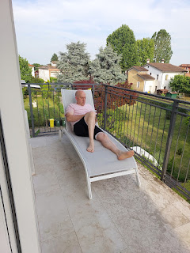

In the evening, when it cooled down a bit outside, we walked over to the Maddalene Cemetery to add a few more names into Find-a-Grave. I liked how these bales of hay were wrapped in the colors of the Italian flag.

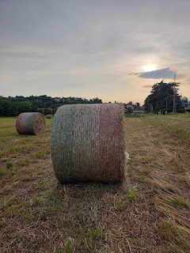

On my side of the cemetery (I'm working the left side while Scott works on the right), I worked my way to this memorial while using the app. This is the same last name as our landlord, Daniele, and his father Bruno, who lives underneath us. As I looked more closely at the photo on the headstone, I immediately recognized the similarities to Bruno and I wondered if this might be his FATHER.

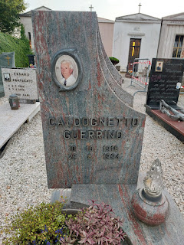

We shared the photo with Bruno that evening, but it turned out to be his uncle! He responded with this sweet text:

"Troverai la tomba di mia moglie, di mia madre, di mio padre. Quando vuoi ti portero io."

Translated it says: "You will find the grave of my wife, my mother, my father. When you want I will take you."

We are excited to work our way through the cemetery and find his wife, his mother, and his father. It only takes about 1-2 minutes to add each memorial into the Find-a-Grave app.

It goes something like this: (once you've selected the actual cemetery you'll be working in - and in our case we had to ADD the cemetery because it wasn't even listed!)

~ Choose the + sign (on the main screen, but also specific to the cemetery you've chosen) to add a new memorial
~ Type in the information in the fields provided (name, maiden name, birth date, death date, etc)
~ Hit the save button
~ Choose the + sign to add a photo of the headstone
~ Take the photo and press the upload button
~ Choose the + sign to add GPS coordinates. Be sure to choose "existing location" to be more accurate.
~ Done.
~ Move to the next headstone and repeat.

As we were almost finished for the evening - our goal was to work for about 15 minutes or so - I noticed the cemetery gates starting to close!! I hollered to Scott, who was closer to the entrance, and he ran over so that the motion detectors would "see" him and stop the gates from closing. As it turned out, the cemetery closes at 8:00 p.m. on summer evenings and the gates will just automatically shut when it's time. Yikes!! I can't imagine what would have happened if we were further into the cemetery and couldn't reach the gates in time before they shut . . . would we have had to climb up and over those tall iron gates? Or is there a button to push somewhere on the inside to open them up again? I have no idea. I'm just glad we got out when we did!

There was a sign on the outside wall that said summer hours are 7:30 a.m. to 8:00 p.m. and in the winter months it closes at 6:00 p.m. This is gonna make it harder for us to come work in the cemetery in the new few months, for sure. It's getting so hot right now and we were already a sweaty mess by the time we got there. It's about a 20 minute walk from our house. By the time we would actually WANT to go for a walk, it would be well after the cemetery is closed. We'll figure something out . . .

On the way home, these pretty flowers caught my eye . . .

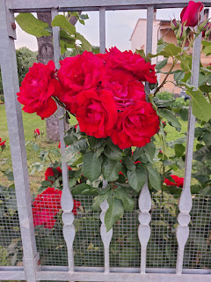



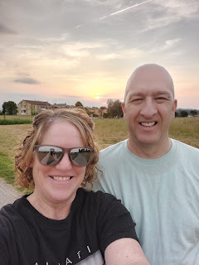

June 2nd is a national holiday here in Italy. It's called Festa della Repubblica, or Republic Day. Italians celebrate a very important date in their history that took place on June 2-3, 1946. After WWII and the fall of fascism, voters went to the polls to decide what type of government they wanted going forward: monarchy or republic. 54.3% voted in favor of a new republic, while 45.7% voted for a monarchy.

After 85 years of being known as the Kingdom of Italy, the new Italian Republic was born. It's a really big deal here, similar to July 4th in the United States. The biggest festivities take place in Rome, but parades and other activities take place throughout the entire country.

I mention this because it also means most of the stores are shut down throughout Italy on June 2nd. This was a problem for me, because I had accidentally procrastinated getting a very important item for my medical appointment early this morning (Tuesday).

I needed - - -



All the pharmacies were closed - well, at least the independently run ones were. After I drove to the nearest one and saw that it was closed, I panicked for a second. But then I had the thought to run over to Emisfero - like a Super Walmart - because they have a pharmacy
inside the store
. Thankfully it was OPEN!!!

I am beginning the process of several medical appointments over the coming days. This first one was to get my blood drawn, but I was also instructed to collect the first "pee" of the morning and bring it to the lab when I came for the bloodwork at 8:00 a.m. today.

Later this afternoon, I have an appointment to see a cardiologist. Tomorrow I get two ultrasounds, etc.

Bloodwork ordered: Celiac screening, among several others - including genetic testing. They took a total of 10 vials of blood today!!

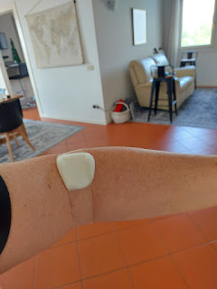

Allergy skin testing will be later this summer: They want to see if I am still allergic to penicillin and erythromycin. How fun!

I might have to do my first colonoscopy at some point, too. Yay.

The ultrasounds are for my throat/neck area (for the difficulty in breathing lately) and my abdomen (relating to possible Celiac disease).

The cardiologist appointment is to get a better understanding of my "extra" beat, or arrhythmia. There's really nothing concerning going on. Again, it's good that we have double insurance right now.

Carlo the Contadino was back at it last night. This time, he had a different tractor as he scooped up all the rows and made them into giant hay bales. It was fascinating to watch!!

Video here: (1 minute, 6 seconds)
https://photos.app.goo.gl/7W2UxG2QkAx31McD6

And another view of his process here: (46 seconds)
https://photos.app.goo.gl/g5sFhe4bH8BJBiUi8

It's like he "poops" them out, LOL.

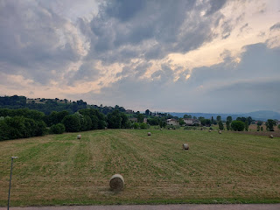

And now, to bring up the rear, I'll share some of the things my kids are up to lately . . .

Amber posted these sweet and deep thoughts yesterday and I just loved everything she wrote.

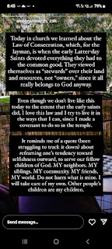

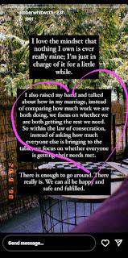

Amber and Weston have the silliest cat ever named Jellybean. I woke up this morning to a hilarious limerick poem that Amber wrote to go with this picture of Weston and Jellybean . . .

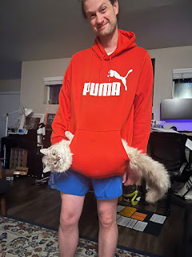

"The jellybean cat is a very good cat;
A very good cat is she.
For when thou bendest to kiss her head,
She will headbutt thee."

Abby got her ears pierced recently and she's doing great! I'm relieved that she isn't allergic to every single metal that's ever been created on this earth like her mother and I both are.

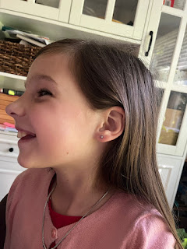

Amber and Abby on ear piercing day . . .

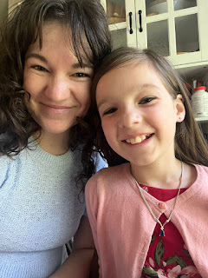

Jake and Hannah recently flew down to Florida to visit Hannah's sister Kaitlin and their family. They had the best time. Her sister has a swimming pool in their back yard, so they spent a lot of time splashing around. They also visited Sea World and some other fun places during their stay. It was also Hannah's birthday weekend (April 26th).

Jack, Hannah, and Jake (holding Maisie)

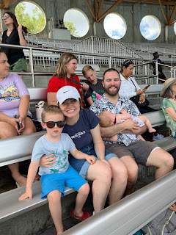

It was plenty toasty warm down there, and they had to be strategic about when to head out for an activity during the hot temperatures . . .

Jake and Maisie . . . XOXO



Little Peanut with her sweet rosy cheeks . . .

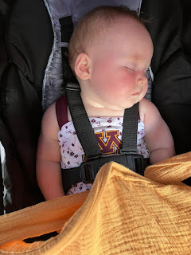

Back in Minneapolis, life is pretty good for their family, and Maisie is no exception. She can make herself into a giant blueberry mess and not even care. She can even put her feet up right where she's eating. She don't care one bit, ha ha.

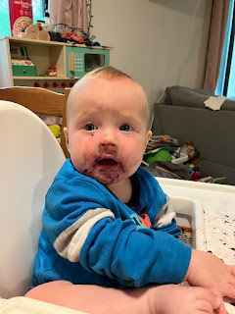

She likes to try to fix stuff, like bikes and things . . .

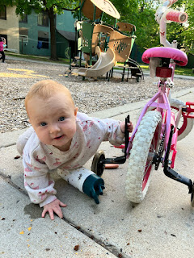

She figured out how to climb up the stairs - because wherever Jack goes, that's where she intends to go, too.

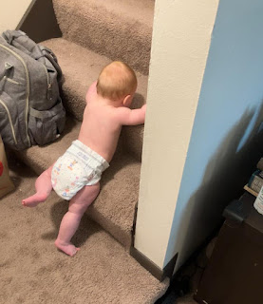

Whatever Jack does, that's what she wants to do.

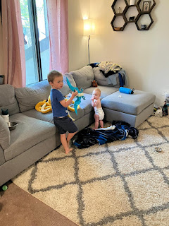

Jack is very patient with her, bless his little heart.

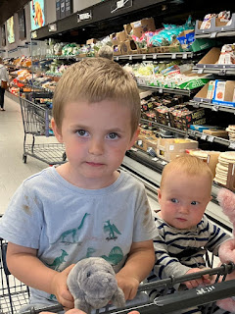

Yep. She's growing up fast. What a precious.

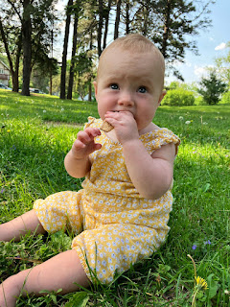

Benson has had some incredible adventures recently. First of all, he has really taken off with his photography skills and has had so much fun with his new camera. His Air Force buddies pooled together to purchase this Nikon camera for him (not sure the model, Dad, but it was around $1500).

He's been on several outdoor adventures with his friends where he can also practice a variety of skills and techniques on his camera. Here are a few of the photos that he's shared with me - - Enjoy!!





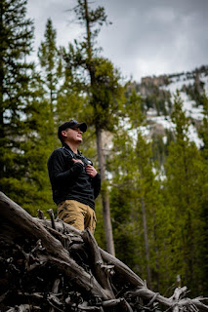

One of his friends on the base asked if Benson could come along when he wanted to propose to his girlfriend - to capture the moment, of course. It was dark, so Benson had to ask them at one point to freeze and hold still for about 20 seconds in order to get this beautiful photo.



The spot that was chosen for the proposal was Bruneau Sand Dunes, away from all the light pollution of Boise and Mountain Home, and where the stars could literally shine.

Meanwhile, Kylie and Miles have found a house to move into up in Kaiserslautern, Germany. They'll move in later this week and they're so excited. It's a pretty big house, too! It has five bedrooms and 1.5 baths, plus a nice big back yard.









Last but not least . . .

Scott was honored with two incredible medals, the Meritorious Service Medal and the Army Commendation Medal. He really has such an amazing brain and works so hard to make things more efficient and more savvy for everyone at SETAF (Southern European Task Force - AFRICA). They really appreciate everything he does. Plus, he comes home every single day and says, "I love my job SO MUCH!!" So, that's a win-win. :)

