A Prussian Map, St. Alfege Crypt, and The Royal Observatory
Last Saturday morning began nice and slow after seeing Lionel Richie in concert. We had arrived back at our hotel around midnight the night before, so it was nice to roll out of bed at a sloth's pace once we finally did wake up. Scott and I didn't have to be anywhere until 11:45 a.m.

We walked to Bill's Greenwich Restaurant just around the corner and had a lovely breakfast. I ordered the poached eggs on sourdough toast, with hollandaise sauce. Sides included mushrooms, grilled halloumi cheese, country potatoes, diced avocado, mushrooms, and beans. Microgreens are draped across the top of a tiny little metal pitcher with the beans inside. I also ordered some smoked salmon on the side because I'm trying really hard to add more protein into my diet each day. Scott ordered a big breakfast sandwich that looked like a hamburger. He was quite happy.

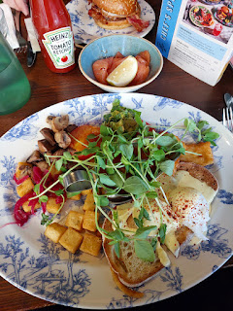

After our tummies were very full and happy, we walked back around the corner to visit the Greenwich Market.

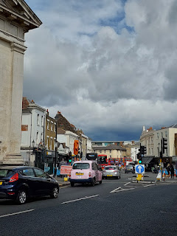

We passed by the St. Alfege Church, which is where my tour would begin in a little over an hour.

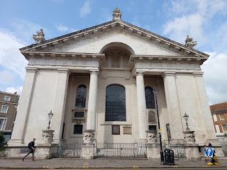

Greenwich Market has been around since 1737. It used to be located closer to the Old Royal Naval College before it was moved here around the year 1800.

Brief video of the Market: (6 seconds)
https://photos.app.goo.gl/sPckwcygqGwNLkBT7

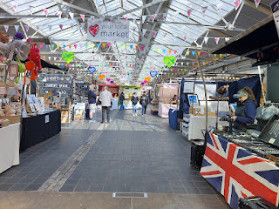

In the Market, you can find everything from international food vendors to artisans selling jewelry, art, puppets, soaps, honey, homemade baby clothing, etc.

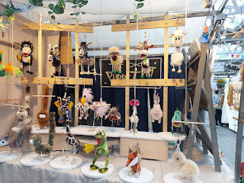

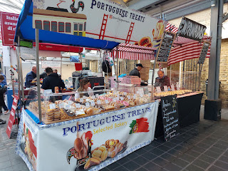

Video of all the multicultural food vendors: (14 seconds)
https://photos.app.goo.gl/pnPqYEcREawAvTdN7

I bought a couple of cute outfits for my little granddaughter, Maisie, and then a little shop selling old maps caught my eye.

I spent a few minutes perusing the smaller maps in front of the shop first, hoping to find something small enough that I could bring home with me. I have a huge passion for maps - I could seriously study any map for hours. Maybe that's why family history and traveling are right up my alley. And that's how I discovered Abraham Lincoln's boyhood home (now a State Park) and Santa Claus (the city) in Indiana. They were on the atlas map that I was studying, and happened to be close to where I would already be - for some family history sightseeing.

I didn't see anything that sparked my curiosity, but I didn't walk away either. I went further into the shop. I looked through another section of maps. I didn't exactly know what I was looking for, but I figured I would know it when I saw it.

Soon, the shop owner struck up a conversation with me. We made small talk, chatting about this or that, including where our ancestors came from. I was a little bit surprised when the words, "Do you have a map of Prussia?" came out of my mouth. He said, "Yes, as a matter of fact, I do," and walked a little further back into the shop to open a large dresser that appeared to be made for holding large blueprints in its wide, but shallow, drawers.

A couple of minutes later, he found it and pulled it out. He laid it on top of a table stacked with several other maps. I noted that it was dated 1843, which was maybe 50-75 years after my Schneider/Snider family immigrated to the United States. As soon as I picked up the corners to look at it more closely, I had the strongest feeling that came over me from head to toe. It almost felt like electricity . . .

Tears immediately flooded my eyes and I found myself literally BAWLING right there in the shop - and in front of HIM. In his perfect British accent, he worriedly inquired, "Oh love, are you alright? Oh love, would you like to sit down for a minute?" I tried to pull myself together as I squeaked out that yes, I was okay, and that I just KNEW that I needed to have this map.

It didn't even matter the cost at that point. However, I think I might have been struck down by lightning if I DIDN'T buy it and take it home. Maybe not, but it was very clear that this map was important and that I NEEDED to have it. The price on the back of the map was 125 pounds (pounds usually looks like a fancy "L" with a line through it). 125 pounds = $169 in USD. But because he was so surprised at the emotion that came out of me and the special attachment that I had with it, he sold it to me for 100 pounds. ($135)

I asked him to hold it up so I could take a picture of it before he packaged it up for me.

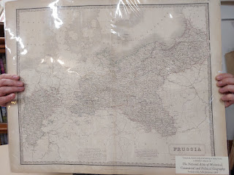

My Snider family immigrated to the U.S. from Prussia, a historical region whose borders changed repeatedly before it eventually became Germany, Austria, Poland, etc. I am on a mission to figure out where they came from and I'm hoping that while I'm over here on this side of the world I will find the answers I'm looking for.

I think that this map may hold some important clues and I can't wait to uncover them!! (And by the way, the packaging job was absolutely perfect and it fit nicely into our medium suitcase to bring back to Italy.) :)

Scott had been patiently waiting for me elsewhere in the Market - he's not one to enjoy browsing in a bunch of shops - but I found him quickly and related what just happened in the map shop. I cried again because it was such a special (and fresh) experience. Thankfully, he didn't ask how much it cost . . .

He walked me across the street and together we wandered around the churchyard of St. Alfege until we found the main doors on the back side. It was almost time for my tour!

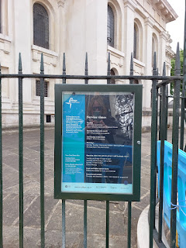

St. Alfege Church is named in honor of Alfege, the Archbishop of Canterbury, who was martyred on this site in 1012. The ancient medieval church that sprung up to commemorate him needed to be rebuilt in 1710 when a storm caused a roof collapse. The current church was completed in 1718.

Several famous people have ties to St. Alfege Church:
~ Thomas Tallis (1505-1585), the famous Elizabethan composer was an organist at the church, and is also buried beneath the chancel.
~ General Wolfe (1727-1759), the hero of Quebec, is buried in the crypt.
~ John Flamsteed (1646-1719), the first Astronomer Royal, worshipped at the church.

However, the reason why St. Alfege Church is special to me is because my 13th great grandparents, Nicholas Lanier and his wife, Lucreece Bassano, are both buried here. They lived and worked in the Greenwich area in their later years, and there are records indicating that Nicholas acquired a lot of property in Greenwich and Blackheath locales. (more on that in a minute)

My sister Charmaine and I visited this church in 2018, but on this second visit I got to go underground and see the crypt for the first time.

A description of the architect and the architecture of the church . . . (click photo to enlarge)

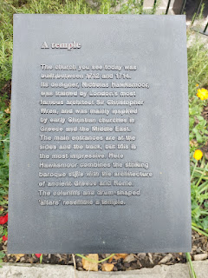

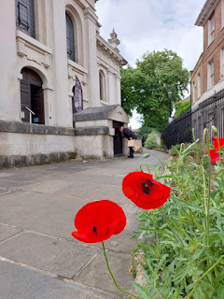

The tiny little side door to the crypt below that I would enter a short time later . . .

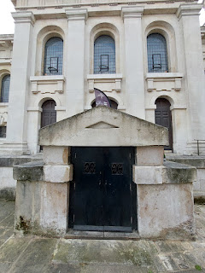

Entering the main doors into the church . . .

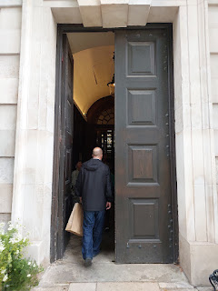

To our surprise and joy, a young lady was rehearsing for a performance later that afternoon and we got to listen to her for a bit.

Video of her singing here: (24 seconds)
https://photos.app.goo.gl/f5ZMqjfLJ81RWuBK7

A sign describing the details and history of the church . . .

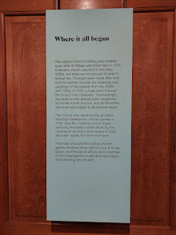

Another short video of the beautiful opera-style of the young lady singing: (19 seconds)
https://photos.app.goo.gl/tg1HW9K8R98pVctJ7

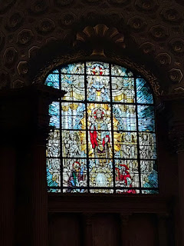

A description of the crypt and some of the famous people who are buried down there . . .

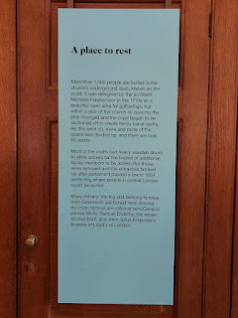

Video of the steep steps going down to the crypt: (3 seconds)
https://photos.app.goo.gl/yfJ7ZkpNKyUN7b3U6

Our tour guide's name was Suzy - in the blue jacket below. She works as a historian for some London museum (I can't remember which one), but she said THIS is one of her favorite things to do - leading tours like this.

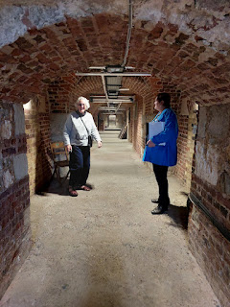

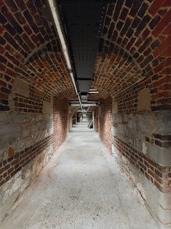

Caption: The Church Vault A.D. 1750 . . .

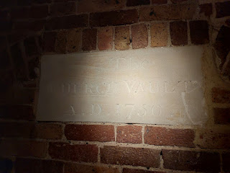

Suzy told us stories about several of the people who are buried down in the crypt. She looked to see if Nicholas Lanier and Lucreece Bassano Lanier were buried in the crypt, but there is no mention of them. She did say they are on the list of burials, but they would have been buried somewhere above in the gardens surrounding the church.

A glowing tribute to William Ellis, who used to work at the Royal Observatory, written by his loving wife . . .

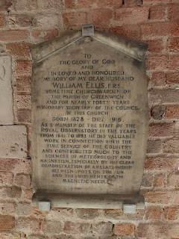

Peering through the bars to see what I could see in one of the vaults . . . not much was the answer.

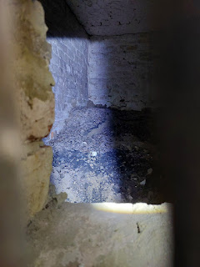

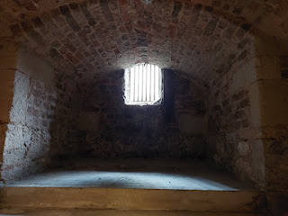

The crypt became a bomb shelter during WWII, particularly in this corner underneath the church. Suzy told us how up to 400 people - men, women, and children - huddled together for days down here. The children later reported that it felt like a "tea party" on many occasions, because it was so pleasant and they did not feel deprived at all.

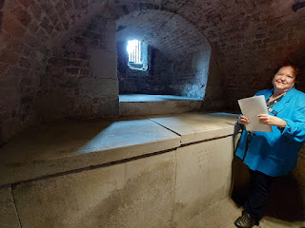

She showed us a photo of several of the locals who stayed down in the crypt, and what a nicely dressed table they had to eat their meals upon.

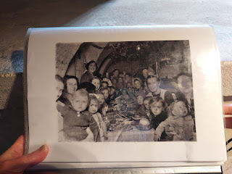

Suzy told us that the crypt was so quiet and protected that nobody knew the church had been bombed above. It wasn't until water started spewing in from the street-level window grates that somebody went up to investigate. Turns out that the firemen were trying desperately to put out the blaze, and they were spraying water everywhere. Those who had previously huddled together in the shelter below were absolutely gobsmacked when they came outside to see all the chaos with their own eyes. The noise of air raid sirens, the crowds of people, the firemen hard at work . . . and the red glow of the fire that was threatening to destroy the church . . . what a shocking difference from their quiet little existence underground with thick cement walls to mute the whole world outside.

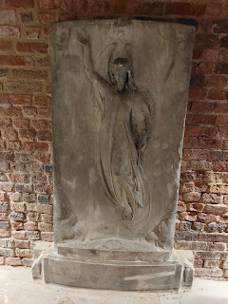

Next, we went all the way up into the balcony of the church for the final portion of our tour.

Video from the balcony: (10 seconds)
https://photos.app.goo.gl/SFk2rgucpoUNcdq37

A large list of some major benefactors to the church and also to those who were poor and needy, going back as far as 1558 . . .

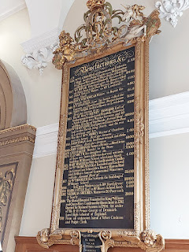

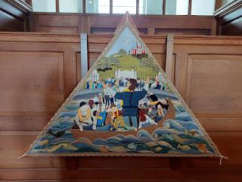

I liked these needlework and quilted murals that showed scenes from long ago . . .

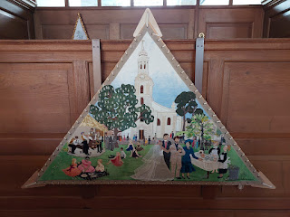

Video overlooking the chapel below: (7 seconds)
https://photos.app.goo.gl/TccGSZdyBAHVAeiA7

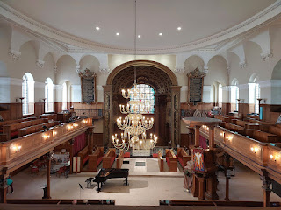

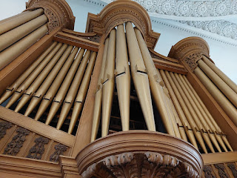

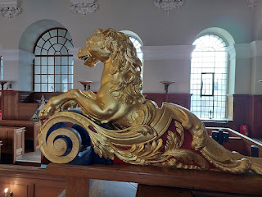

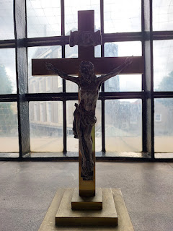

A description of Thomas Tallis, the great English composer . . .

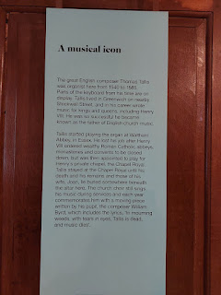

You might be interested to know that some of his compositions live on in our LDS hymnbook . . . specifically these three:

~ "Evening Hymn"
~ "Lord, I Would Follow Thee"
~ "O, Thou Rock of our Salvation"

This is a portion of his old keyboard on which he used to play the organ . . .

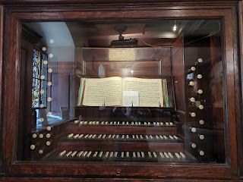

A description of the land and the area where St. Alfege was built . . . it used to be a Palace at one point.

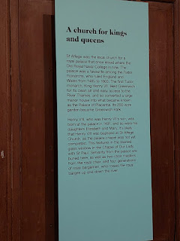

Mr. Pigeon was happy to pose for a photo on our way out . . .

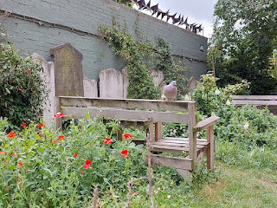

Cherubs on one of the columns in front of the church, next to the street . . .

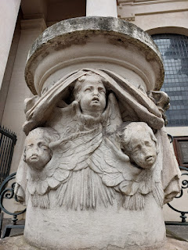

For lunch, we walked back over to the Greenwich Market and found a vendor near the entrance that sells crepes and galettes. Galettes are basically a savory version of the typical dessert-y crepes. Mine was called The Goatfather, filled with goat cheese and a couple other cheeses, plus a variety of vegetables. It was super yummy, all warm and gooey and healthy. It was conveniently wrapped up in two hardy paper plates and some napkins, to prevent an accidental disaster.

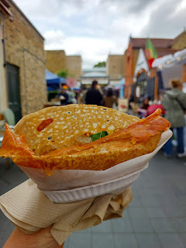

Suzy, the crypt tour guide, helped me to learn something new about my ancestor, Nicholas Lanier, before the tour began. She told me that he was a substantial landowner in the area (something I already knew) and that many of those properties were on Crooms Hill Road (something I did NOT know). When I looked to see where Crooms Hill was, it was adjacent to the huge park that leads up to the Royal Observatory, which is where we would be going next!! How convenient!!

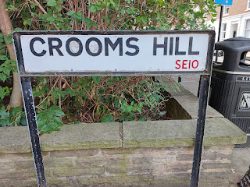

As I was preparing to take a photo of the sign, two ladies were standing next to it while waiting for the bus. They offered to take a photo with us in it, and they were super interested as to why we even cared about this random street sign. They thought it was so cool that we had this information and that we came to Greenwich in the first place.

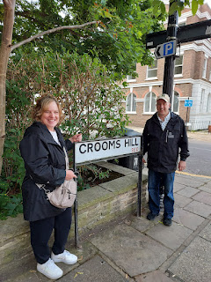

This building was one of the oldest looking buildings on our way up the hill to the Observatory . . . it was fun to wonder if maybe my ancestor had some connection to it, or perhaps to the land underneath where it was built.

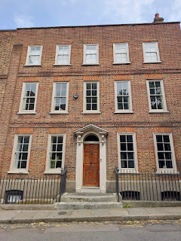

When I was researching for this weekend getaway, like I said earlier, I'm always studying the surroundings on a map to see if there's something interesting nearby that we could visit. When I saw the Royal Observatory, I did some reading about it and learned that in 2025, they are celebrating their 350th year since it was founded!!

This is where the Prime Meridian was first assigned, and this was home to many of the world's finest astronomers, scientists, and mathematicians. Scott was 100% interested in going for a visit.

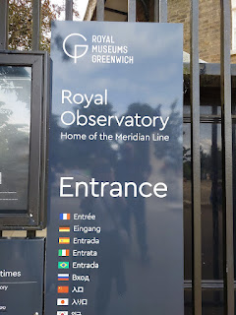

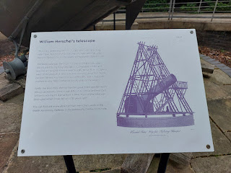

Description (above) and a portion of the old telescope (below) used by William Herschel when he discovered Uranus in 1781 . . . (located just outside the entrance).

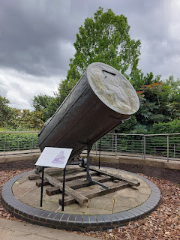

Most of these signs you can peruse at your leisure. In the interest of getting this blog ready to publish, I won't be giving a description of every single thing.

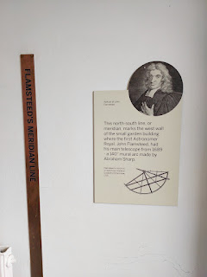

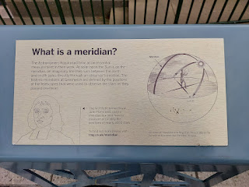

I highly advise clicking on the next photo to learn what all the big landmarks are. We stood on a balcony of sorts that overlooks the vast Greenwich Park that leads down to the Old Royal Naval College. In the distance on the right, you'll see the interesting large white dome shape with rods sticking out of it. On the landmark sign, they refer to it as the Millenium Dome, but it's also known as the O2, and that's where we attended the Lionel Richie concert the previous night.

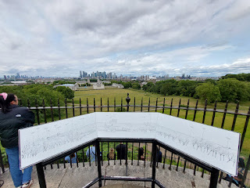

The views were simply magnificent . . .

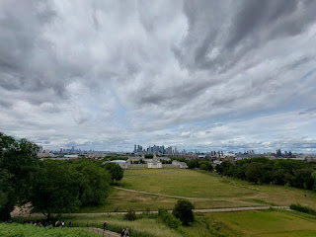

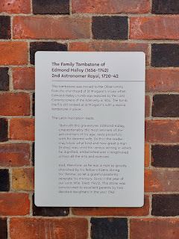

The Family Tombstone of Edmond Halley (1656-1742) . . . Halley's Comet was named after him.

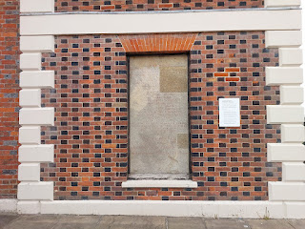

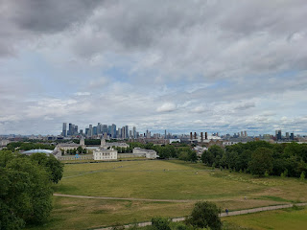

Video of the park and the views: (13 seconds)
https://photos.app.goo.gl/vtAnWzFmYhZu8Ctb8

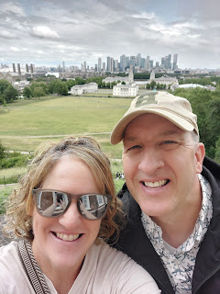

Below: John Flamsteed, whose achievements included cataloging 3,000 stars and creating a star atlas.

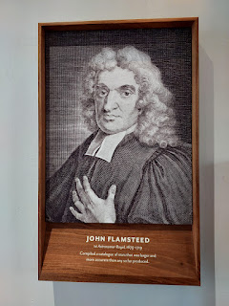

Below: James Bradley, known for discovering the aberration of light and also discovering that the earth had a wobble on its axis.

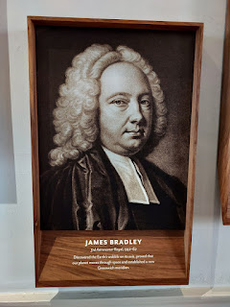

Below: Edmond Halley, who was mentioned above.

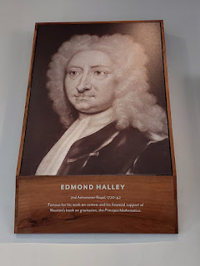

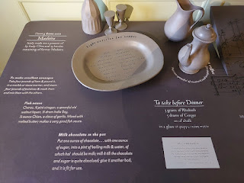

This menu made me happy . . .

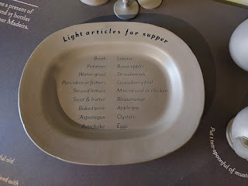

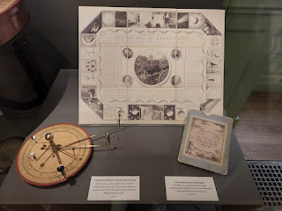

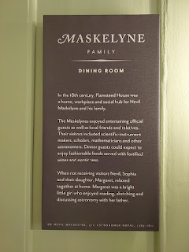

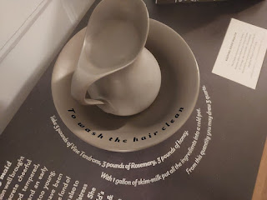

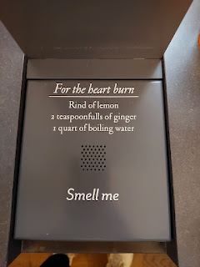

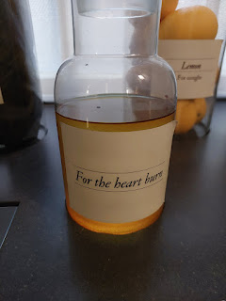

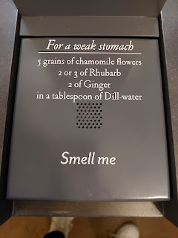

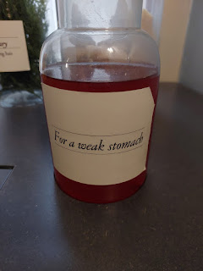

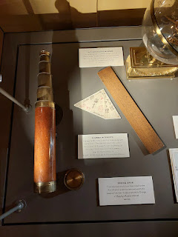

This was very touching - a family who lived in the Royal Observatory lost two children to scarlet fever in 1839. The boys' grandmother wrote a beautiful poem as she dealt with their loss.

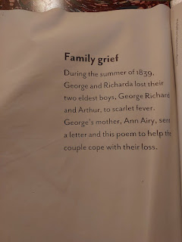

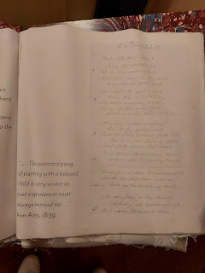

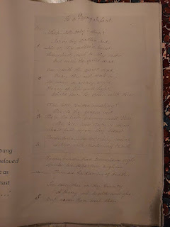

Richarda Airy was the mother of the two boys who died young . . .

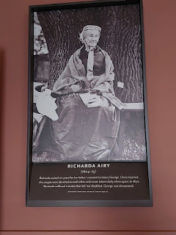

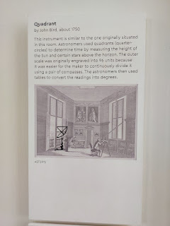

Scott was in heaven with all the math, science, and physics at the Observatory . . .

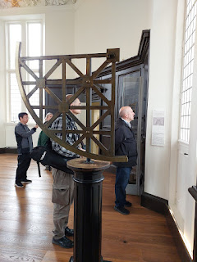

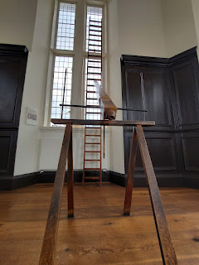

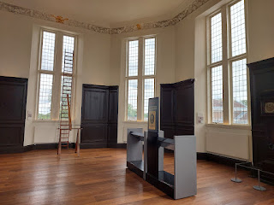

Video of the octagonal room and the view of London from the window: (19 seconds)
https://photos.app.goo.gl/JUbYUHdmtAuiTRcdA

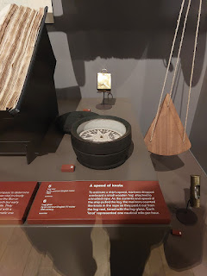

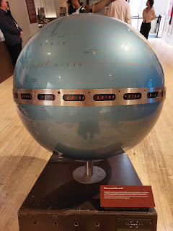

I thought of my cousin, Valorie, when I saw the info relating to star charts, so I took a few extra photos for her . . .

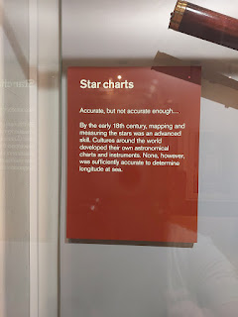

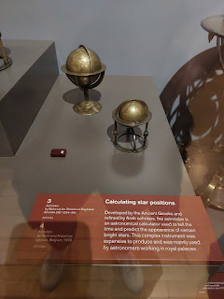

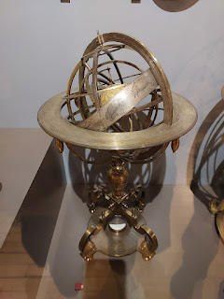

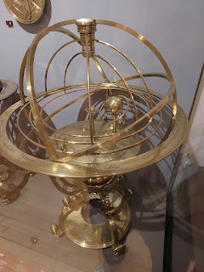

Figuring out where you are - using little more than the sun - has been a years' long project of Scott's. He's been working on improving the navigation programs that the military uses and he's learned a LOT.

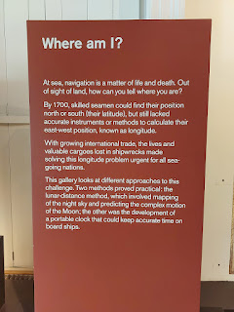

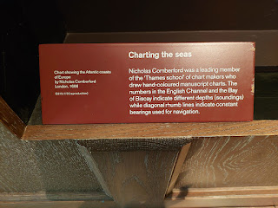

I enjoyed seeing all the notations on the map that they enlarged for us on the wall. If I had been a sea captain, I would have done much the same - taking detailed notes for future navigation.

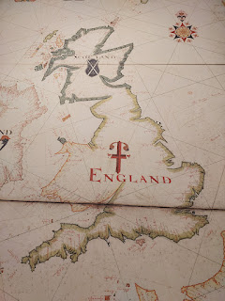

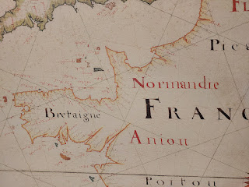

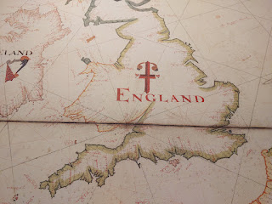

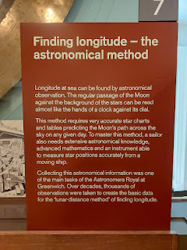

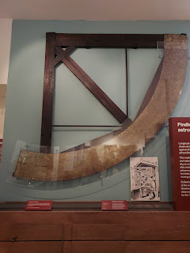

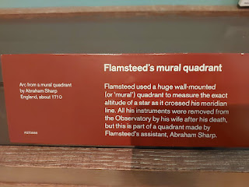

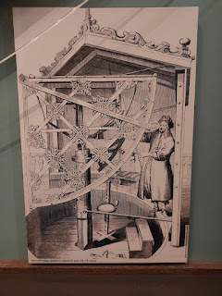

Video of one of the early prototypes of a clock that could keep time while on a tempest-tossed ship. Pendulums weren't able to function in such conditions, so scientists kept working on the next best model and then testing it out. Scott stood here watching this prototype for quite some time . . .

(6 seconds)
https://photos.app.goo.gl/kWZAZRcys52EtbV86

There were some handsome smaller versions, too . . .

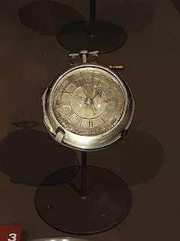

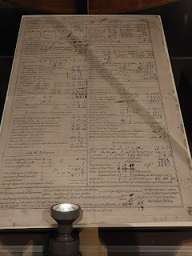

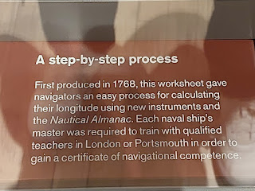

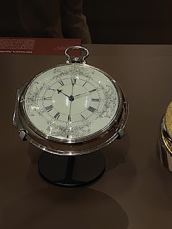

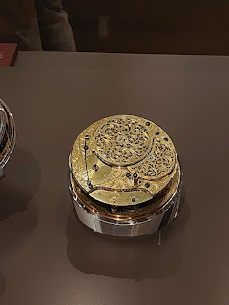

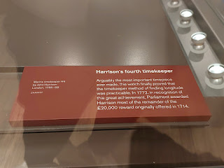

If I could get inside this guy's brain some day, just think of all the exciting synapses I would see hard at work . . .

Video of him standing there thinking about every detail of what he's looking at: (5 seconds)
https://photos.app.goo.gl/AVeVSHcZhBpGRtKF6

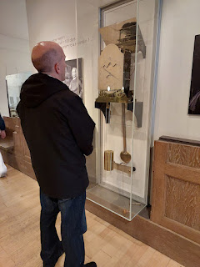

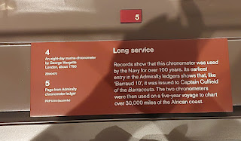

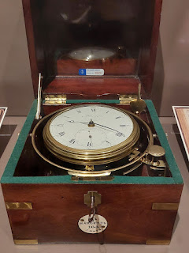

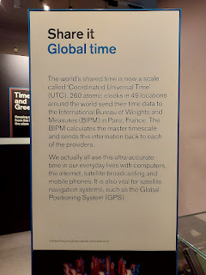

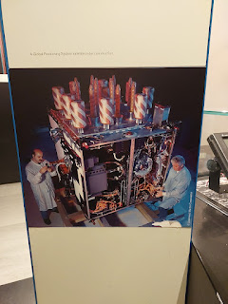

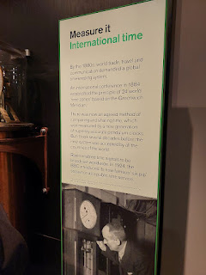

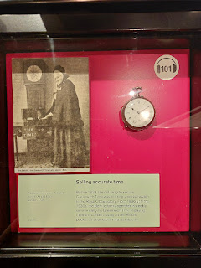

Outside, we got to stand with one foot on either side of the Prime Meridian . . . two hemispheres at the same time!!

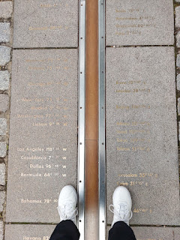

Video of the length of the Prime Meridian line: (15 seconds)
https://photos.app.goo.gl/j2u2y7X47Anb3mc79

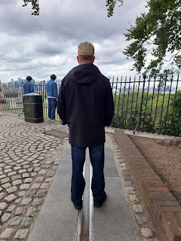

We took a photo of each other at the same time, ha ha . . .

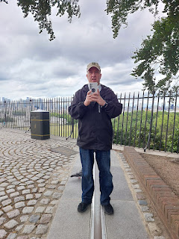

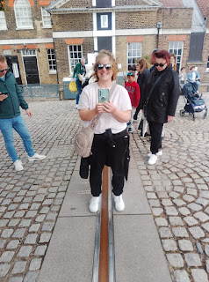

The original prime meridian was slightly off to the left of where we stood. The one in the photo is also slightly different from the "actual" current one. I guess with time and more advances in technology, they sometimes have to adjust things a little.

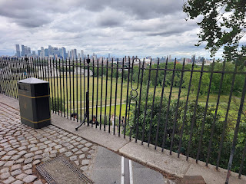

A massive telescope that is no longer in use . . . but sorry - I didn't take a picture of an information sign for it . . .

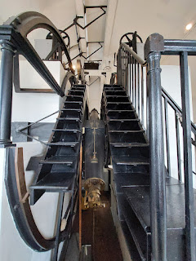

If you're looking for an excuse to go to England this year, I would highly recommend visiting the Royal Observatory. It was chock full of information and history.

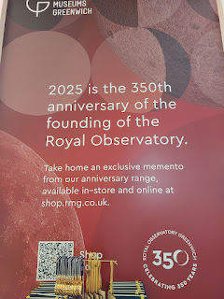

Before we went to the Planetarium Show at 4:00 p.m., we stopped for a little snack and a drink in the cafe. They sell CANS of water - I've never seen that before. I bought a little slice of carrot cake with pistachios on the icing. It was delicious. I was so thirsty that I chugged the entire can of water in maybe 6 seconds.

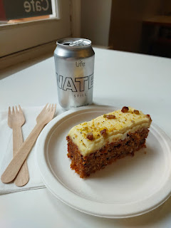

The planetarium show was wonderful. Those were the most comfortable seats I've ever had the pleasure of sitting in. They lean waaaay back so you can see the starry heavens above you. Our host was a young lady with a vibrant storytelling gift and she made it all so interesting. The show lasted about 30 minutes, but she taught us how to identify a few stars and constellations in the night sky before it was over. We loved every minute.
As we walked back down the hill to our hotel, we chose to walk down Crooms Hill Road a second time. We started much further up than the section that we saw earlier, and had to go out of our way to get over to Crooms Hill as we exited Greenwich Park. It was pouring rain, but my thinking was, "When will I have the chance to walk on this road again?" So in the pouring rain, it was.

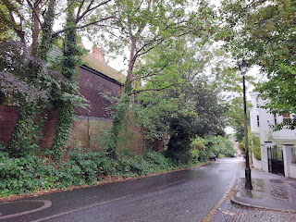

These are just a few of the views of properties on Crooms Hill Road . . .

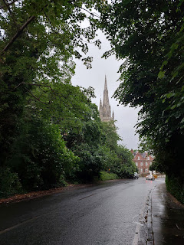

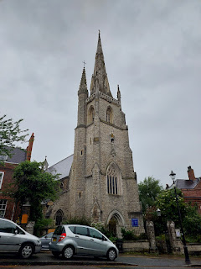

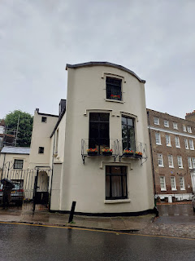

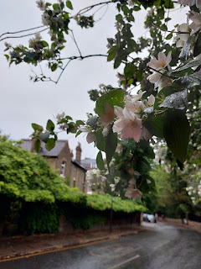

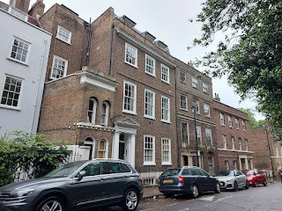

Bright orange flowers greeted us back at the Ibis Hotel . . .

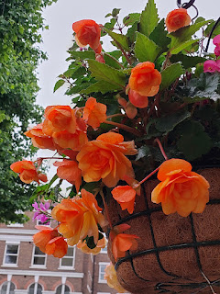

We found a simple dinner and then went for a walk over to the River Thames, about 5 minutes from our hotel. The most unique public toilet sat near the Cutty Sark public square . . .

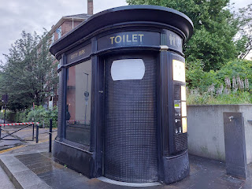

It was currently closed, maybe for maintenance, but here are the instructions on the outside . . .

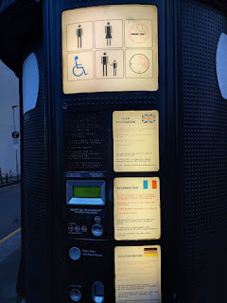

This is the Cutty Sark - a British clipper ship that was built in Scotland in 1869. It was one of the fastest of its time! Now it's available for tours and sits close to the River Thames as a museum of sorts.

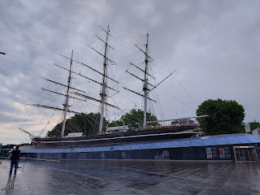

View of London from the Greenwich side of the Thames . . .

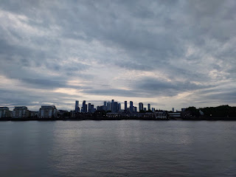

Video of the River Thames: (12 seconds)
https://photos.app.goo.gl/Nt8EEPmX8Lecm38JA

My sister Charmaine and I found this little nugget back in 2018 and I took Scott to see it for the first time. There are two matching domes - one on each side of the river. You go in and then down several steps to get to the walking path that goes UNDER the RIVER!! After about 10 minutes, you go up the steps on the opposite side and you find yourself in London!!

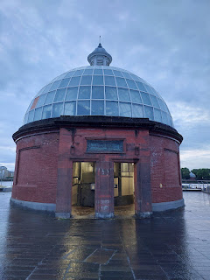

Video as we went down the first steps: (5 seconds)
https://photos.app.goo.gl/f3DSvn1iWzNuR7Yv6

This is the tunnel once you get down the steps . . .

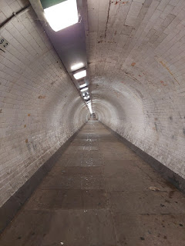

View from the London side, looking back at the Cutty Sark and Greenwich . . .

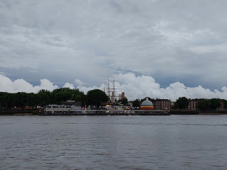

And that brings our London adventure to a close for now. We had the best time in 4 days and now it was time for us to head on home.

As we waited in the central area of London Gatwick Airport to learn where our gate would be, we sat near this cute older guy wearing a Scottish kilt . . .

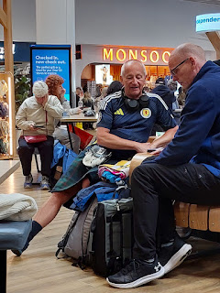

We arrived in Verona with no problems and drove ourselves home safely, too.

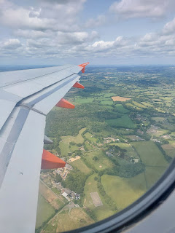

That same night, I started putting sticky notes on some important locations on my new Prussia map. We are hoping to get it into a frame soon . . . maybe after all of our company is gone by the end of June.

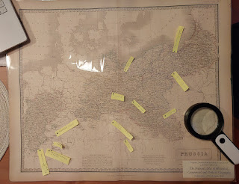

In the days since . . . Scott built me a new hutch for the dining room and a beautiful dresser for our guest room.

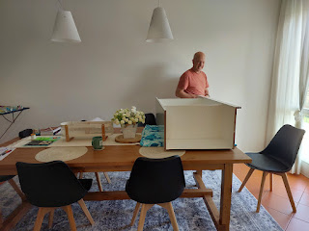

I built us some tasty dinners while he built the furniture . . .

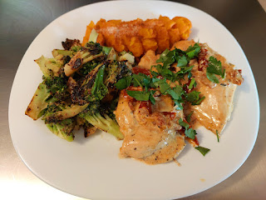

I also worked on Maisie's quiet book and was able to crank out a couple of pages in a short amount of time. This is the cooking and counting page - with chocolate chip cookies. XOXO

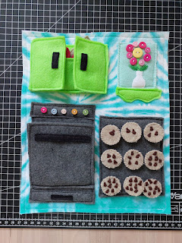

The cupboard doors open up and there's a little pocket to hold a mixing bowl, a wooden spoon, and a set of oven mitts. The oven door also opens up for her to put the cookies inside and pretend to bake them.

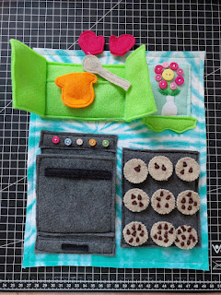

I also worked on the rainbow abacus page and I got it all finished in ONE DAY!!

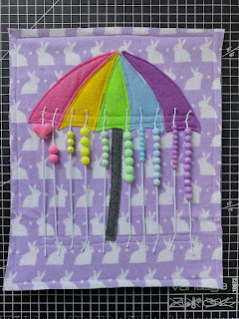

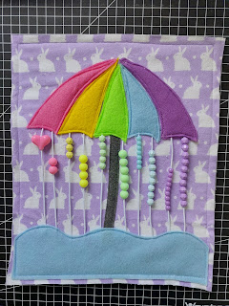

I have 3 more pages to finish and then I can start assembling the whole book. I need to get it finished in the next few weeks before I fly back to Idaho, where I will be going on lots of road trips.

But in the meantime, I am playing with lots of company and having a wonderful time. :)

