Company Round One & Paragliding Off the Italian Alps (Again)
On Friday, June 20th, we said goodbye to the Crofts - our friends from Idaho Falls, and had just enough time to get everything cleaned and washed before my younger sister, Melanie and her husband Mike arrived in Venice the following day. It's been a wonderful month of June so far!

Greg and his 17 year old daughter, Anilyn, puttered all over southern and central Italy for two weeks before making their way up to us in Vicenza. "Ani" wanted to do a backpacking trip abroad for her senior trip, and her father graciously agreed to accompany her. Greg's wife, Brittany, flew in to join them for their third and final week.

We picked Brittany up from the Venice Airport last Saturday morning, and with less than an hour to spare, we then drove to the Vicenza Stazione (train station) to meet up with Greg and Ani. What a happy reunion it was for them!!

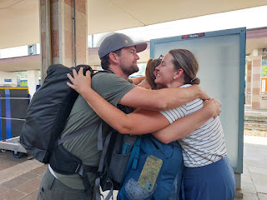

I made a charcuterie board of sorts to tide us over until dinner and then we had a relaxing afternoon of chatting, sharing photos, and letting Greg and Ani wash their clothes and hang them out to dry on the balcony.

After dinner, Ani helped to narrow down all the choices for gelato, settling on this one in downtown Vicenza - Capo di Latte.

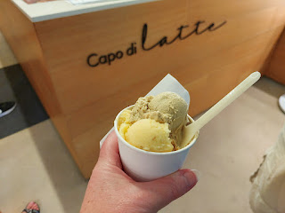

She and her father had taken part in a gelato demonstration (in Florence I think) where they learned about the differences between ice cream and gelato. She told us that when you're looking online for gelato, scroll through some of the photos that people have shared for each establishment. If you see deep rectangular bins that are heaped with all the assorted flavors, you can be reasonably sure that it's ice cream. However, if you see photos that show smaller metal bins (usually circular) with a metal lid on top and you can't even tell what's inside, then you can be 100% certain that it's gelato.

I did a Google search to learn more about this:

Gelato is traditionally stored in metal bins with lids for several reasons, mainly to preserve its
texture, flavor, and freshness
.
Here's why covered, metal containers are preferred over large, lidless mounds:
Temperature Control:
Metal containers, especially those with lids, help maintain the optimal, slightly warmer serving temperature for gelato. Gelato's lower fat content and slower churning process results in a denser, creamier texture compared to ice cream. Serving it slightly warmer (-12 to -7°C or 10-20°F) makes it easier to scoop and enhances the flavor experience, which might be dulled by colder temperatures.
Protection from Air and Light:
Lids protect gelato from light and air, which can negatively affect its freshness and consistency. Air exposure can lead to oxidation, freezer burn, and a decline in quality.
Preserving Natural Flavors:
Quality gelato is made with fresh, natural ingredients, and storing it in lidded containers helps to preserve those delicate flavors.
Sign of Quality:
Gelaterias that use covered containers often demonstrate a commitment to using high-quality ingredients and traditional methods, as these techniques protect the integrity of the gelato.
Lower Quality Indicators:
Gelato piled high in displays without lids can be a sign of lower quality. Such gelato may contain additives like vegetable oils or emulsifiers to maintain its shape, indicating it has been frozen or is not made with traditional methods. It can also be above the legal serving temperature, posing food safety risks.
In essence, using metal bins with lids is a traditional and practical way to store gelato, ensuring it remains at the proper temperature, protected from detrimental elements, and delivering the best possible flavor and texture.
Ani also taught us that if you see a gelateria with shallow and open rectangular bins - but without the heaping mounds of creamery on top, that
should
be a pretty good place, too. If the cream is kept at lower "heapy" levels, it can be a relatively good sign, she said. I guess the "heapiness" is an important thing to consider for quality.

The gelateria that she chose on the first night with us had the metal bins with lids on top. :)

All five of us in downtown Vicenza - me, Ani, Greg, Brittany, and Scott . . .

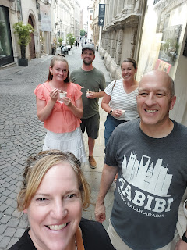

After church last Sunday, we changed clothes and drove to Spiazzi to share the Santuario Madonna della Corona with our friends. I didn't take very many pictures because we've been here 3 other times. On the walk down the steep trail, there are several exquisite bronze statues that depict the stages leading up to Christ's Crucifixion and Resurrection.

I thought this one was especially poignant because someone had taken a yellow rose and laid it in Jesus' hand . . .

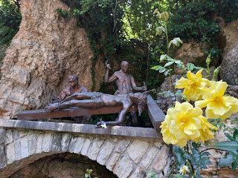

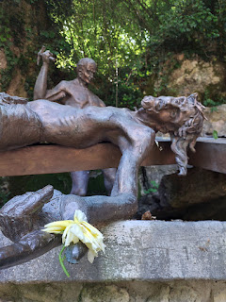

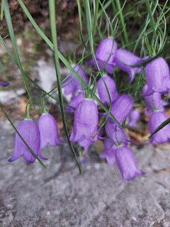

This scene is always my favorite, I think. Many religions focus a lot on the fact that Jesus died for us, but not so much on the fact that He also overcame death. I love the focus on Jesus being resurrected and that the artist chose to create a holy angel to keep Him company, too.

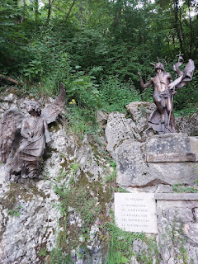

The sanctuary is built into the cliffs, which makes it so spectacular and special. There is a small tunnel to walk through on your way, as you get close to the church and the outlying buildings.

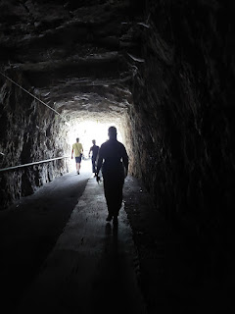

The Holy Steps are allegedly the same ones that Jesus walked on 2,000 years ago . . . and we happened to come into the area at the same time that several visiting nuns were ascending the steps one at a time, while praying on their knees.

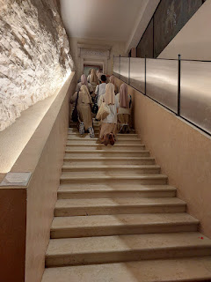

There was also a session of Mass going on and so we weren't able to go inside the main chapel this time - they had it roped off just inside the entrance and you were only admitted if you were committed to participate and stay the entire time. So we just observed for a few minutes in the doorway and then we left.

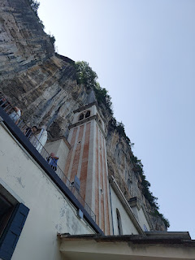

Video of the chapel filled with people and singing a congregational song: (27 seconds)
https://photos.app.goo.gl/iPywhzUg6BrDPsZD8

The Crofts really enjoyed visiting the Sanctuary, even though we could not go inside. Everything there has a reverent attitude towards Jesus Christ, and you can't help but feel a beautiful spirit as you walk around and see the paths, the chapels, the statues, etc.

Early Monday morning, I drove Greg, Brittany, and Ani across town to a car rental place. Greg had reserved a car so they could drive up into the Dolomites and do some hiking together. Ani did some research in advance and they made plans to hike to Lago di Sorapiss on the first day, and then over to the Adolf-Munkel-Weg trail the following day. I had never heard of either of these hikes, but the photos they showed us when they got back down to Vicenza were pretty incredible. I would love to get up there and try them with Scott in the near future!

We did lots of loads of laundry this past week, both "ours" and "theirs". Because they traveled with backpacks only, they needed to wash their clothes more often. Thank goodness for warm weather right now (I can't believe I just said that) - which dries everything SO FAST.

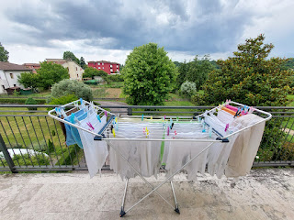

While the Crofts were hiking up north, I started working on the next page of Maisie's quiet book. I used a little bit of rick rack that used to belong to Scott's mom, Coy, who passed away in 2023. The date on the packaging said 1980, so she obviously had it for a while. She donated several colors of rick rack to me a few years ago when I was making a quiet book for Avery, and I still have all of them. I shared this photo with my kids to let them know that a little bit of Grandma Coy's supplies and love were being added to this new project. They sent lots of sweet sentiments and comments in return.

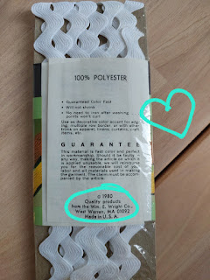

I marveled at the slow and gentle formation of yet another beautiful sunset on the night that the Crofts were gone.

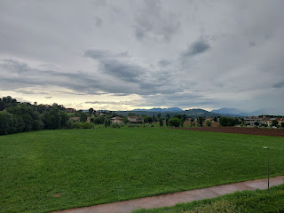

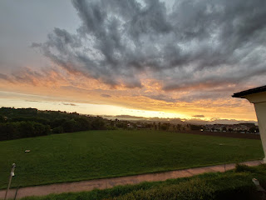

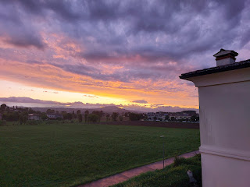

I sent a couple photos to them, asking if they had a pretty sunset up there, too. Brittany sent me this video of the Lago di Sorapiss - -

(15 seconds)
https://photos.app.goo.gl/BSdMb8ZfRXicg11U9

Lago = Lake. Sorapiss = Above the waterfall.

Per Wikipedia: "There is a legend about a peace-loving king named Sorapiss, who turned himself into a rocky mountain during a course of unexpected events. A witch had bewitched the king's impulsive daughter, Misurina, by promising her a magical mirror as a reward for providing shade to her house.This was honored by her doting father, who turned himself into a mountain. At a later date, Misurina, demonstrating a sense of gratitude toward her father, cried and shed tears - which formed Lago di Sorapiss, at the foot of the large cliff of Sorapiss, which was the immobilized form of her father."

On Tuesday afternoon, Scott drove me to Verona for my eye exam that I've been waiting for. They instructed me to have a driver because it was very likely that my eyes would be dilated and I shouldn't drive afterwards. I didn't end up having my eyes dilated after all, so he didn't need to come. But I was still grateful for his company anyway.

The office of the opthalmologist was on the 4th and top floor of what appeared to be a very large and converted shopping mall, now just occupied by a small number of offices.

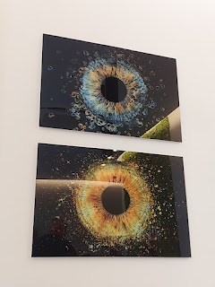

I sent photos to my son-in-law, Weston, who is an optometrist. He really enjoyed seeing what the office looks like in Italy and how the Dr. had everything arranged. It didn't take very long before I had a new prescription and we were on our way home. I'm looking forward to an updated pair of glasses in the near future!

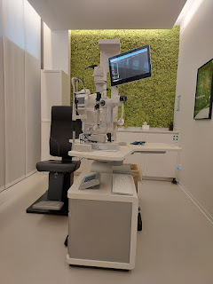

On Wednesday, I drove the Crofts over to Chioggia and Sottomaria, about an hour east of Vicenza. Yes, I've been there many times now, but I never tire of visiting. There are elements that remind me of Fort Bragg, CA - both places being a fishing town, with lots of beauty and charm everywhere.

We arrived just in time to go on the boat tour around Chioggia, through a few canals and then out into the harbor and into the bay itself. It's always so relaxing and is one of my favorite things to do right away. The tour lasts about one hour and costs 10 euros per adult, and 5 euros per child.

Video as we passed by the fish market and all the subsequent seagulls: (7 seconds)
https://photos.app.goo.gl/B697axgg8YGoWbv96

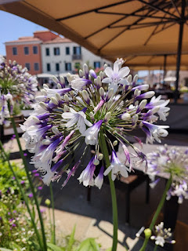

After we got off the boat, we made our way down the cute little main street that runs through town (Corso del Popolo) and found a restaurant for lunch. The place I usually like to go was closed on Wednesday, so we got a recommendation for a different restaurant called Ristorante Antico Toro. It wasn't quite as good as where I usually go, but it was adequate. I ordered clams and mussels, plus a plate of grilled vegetables on the side.

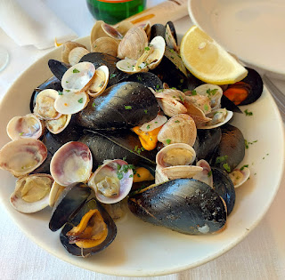

Next, I drove us across the bridge that connects Chioggia and Sottomarina so that we could "beach". (a reference from the Barbie movie) It felt so good to get in the water of the Adriatic Sea on a hot summer's day. We brought a waterproof picnic blanket with us, along with some fruit, chips, etc. Greg took a little nap on the blanket while listening to a podcast, while the three of us girls went out into the sea.

You can wade out for the longest time and the water is only up to your thighs. We went all the way out to where the water hit our ribcage, and then we did a 1-2-3 dunk at the same time, ha ha. (Ani's idea, of course) We made our way back to where we could just sit in the sandy bottom while the waves lapped around us and pushed us (gently) around. We just hung out, talking and having the best time.

At one point, I felt something like a shell underneath my left thigh. I reached down to pick it up, only it wasn't a shell . . .

It was a CRAB!! All I saw was his underside before I let out a tiny scream and chucked him far away from me and into the sea. He was about the size of the palm of my hand, including his little legs that were flailing all over, ha ha. I've been researching what type of crabs live in the Adriatic and close to Sottomarina. There are essentially 3 species, but I've eliminated one of them.

~ Mediterranean Shore Crab (Pachygrapsus marmoratus). I don't think this was what I caught.
~ Blue Swimming Crab (Portunus segnis) A likely candidate.
~ Harbour Crab (Licarcinus depurator) Also possible.

As soon as I squealed and tossed him into the sea, Brittany and Ani asked what had happened. When I told them it was a crab, Ani was out of the water and back onto the beach in 0.2 seconds, ha ha. We didn't go back into the water after that, even though I wanted to.

I've seen people diving and snorkeling for crabs nearby in the past, but the crabs seemed to be mostly in and around the rocks of the massive dyke that is adjacent to the beach. I guess this is all just part of Life Near the Ocean . . .

However, I do think that I will pick up a little inflatable raft for next time, so that I can just float on TOP of the water . . . :)

That evening, with Ani's help, we chose another gelateria to visit in nearby Costabissara. What a cute little town! When I say "little", I really do mean tiny. It feels like the size of Hopland, CA or Shelley, Idaho. Everyone seems to know everyone, even though there weren't a lot of people at all. The streets felt quiet and almost like it was a secret . . . There is a nice sized public square across the street from Da BrrrUNO Gelati e Torte Artigianale, the gelato shop. They have a large billboard outside the City Hall with photos of all the recent babies that have been born in their community, all the way back to 2020.

There is a paved walking trail that leads from the public square, with trees lined along both sides and outdoor lights strung up above. At the other end of the lane, there's a small park with whimsical statues on top of a fountain.

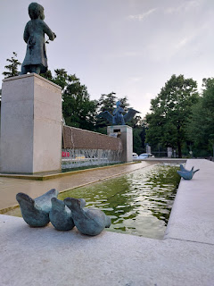

Thursday, Juneteenth, Scott had the day off. Hooray! We all piled into our car and drove to Sirmione, situated on a peninsula at the southern tip of Lake Garda.

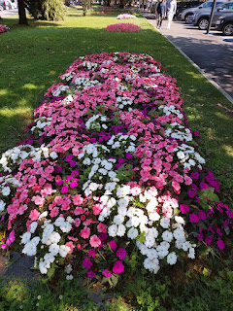

Video of the lemon vendor outside the castle and next to the harbor: (4 seconds)
https://photos.app.goo.gl/KFsG7TF7sVAKxQLq7

We let the Crofts tour the Scaligero Castle by themselves while we wandered around nearby and tried to stay in the shade as much as possible. It was HOT.

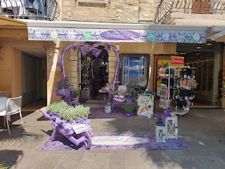

Because it's a peninsula, there are many spots to see the lake . . .

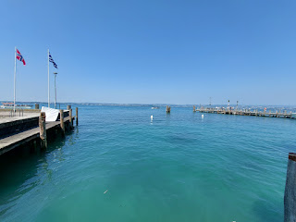

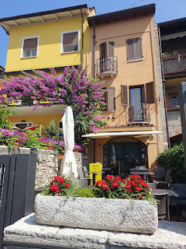

We spent a few minutes scouting out a spot for something special that Brittany wanted to do after their tour. (more on that in a minute)

Video walking past the side of the Castle: (4 seconds)
https://photos.app.goo.gl/FuVPEpADqC2tmG2E6

Video of a special pink creature floating in the moat: (4 seconds)
https://photos.app.goo.gl/pArAKYhkmwJZFA7i6

Video of the waves crashing up onto the steps near the Castle: (6 seconds)
https://photos.app.goo.gl/8D5Gh2njinpep5oe8

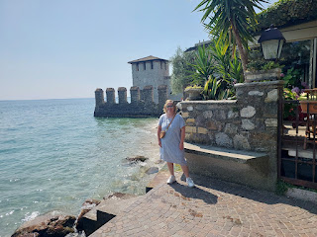

Italy is great with offering places to fill up your water bottle as you travel around. My favorite feature about the water fountains is that the water is ICE COLD.

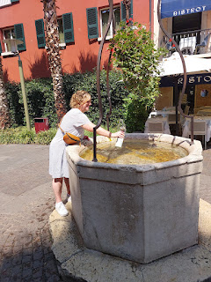

The Crofts were in need of a cold beverage when they finished their castle tour. They were so sweet when they brought me an ice-cold lemonade from the lemon vendor that we saw earlier, and who was just a few steps away. Oh boy, though! The lemonade was super sour and made my face pucker up something fierce, but it was still 100% refreshing and amazing.

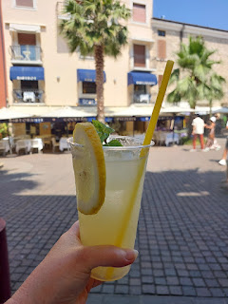

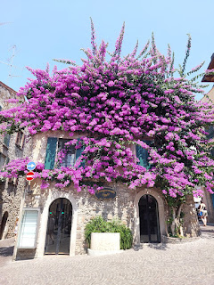

Brittany wanted to share a family history experience while we were at Lake Garda. Her Grandma was named Garda, so we were eager to hear more about her. When Brittany mentioned a few days earlier that one of her favorite childhood memories was eating Nilla Wafers every time she visited her Grandma Garda, I made a trip over to the Commissary to pick up a box for her. We brought it with us and we found a little corner in the shade all to ourselves where Brittany could share a few special memories of her Grandma. It was an honor to be there and to take part in their little family history moment.

Video of Brittany (part 1): (1 minute, 45 seconds)
https://photos.app.goo.gl/GD6wUMHg9uRrNpp5A

Video of Brittany (part 2): (1 minute, 36 seconds)
https://photos.app.goo.gl/5gQ3PHyw4s6WbF828

From L to R: Scott (near the W), Me (N), Ani (E), Greg and Brittany (S).

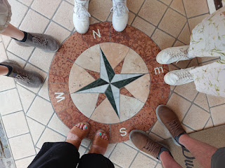

Video of a convertible driving down the narrow little lanes of Sirmione: (5 seconds)
https://photos.app.goo.gl/Z7QCJG7DMaFNqnpS7

We are always shocked and amazed to see cars squeezing past all the pedestrians in such tight quarters!

Walking to the very northern tip of the peninsula, we made our way to the Roman ruins known as Grotte de Catullo, about a 30 minute walk from where we were. The last time (and the first time) that I came here was with the Garners last October. It was an incredible place to explore, and October was definitely more preferred over the heat of summertime! Scott wasn't with me when I took the Garners, but he found it quite interesting on this first visit with the Crofts.

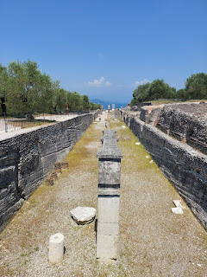

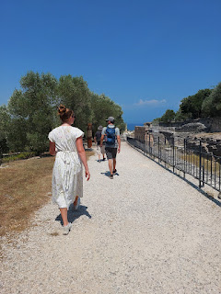

Greg, Ani, and Brittany . . .

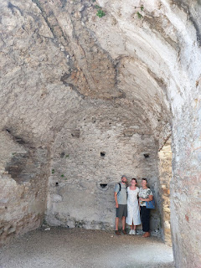

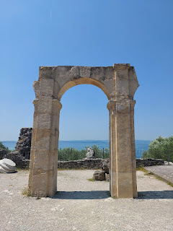

Looking towards Lake Garda, facing north . . .

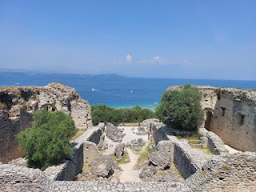

Background to this selfie: We were DRIPPING with sweat, so much so that I could barely take the picture, ha ha. My sweaty finger kept trying to push a button on my screen and it just wasn't working! After wiping my hands a few times and keeping my patience in check, we finally got it to work . . .

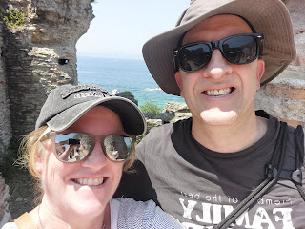

It was about 94 degrees with high humidity and it was just scorching . . . I can't believe we survived the afternoon, but we DID.

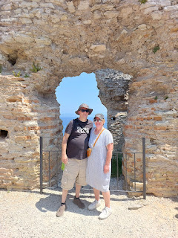

Lunch was enjoyed at the closest restaurant that we saw when we came out of the ruins. (Hotel Ideal Sirmione) I ordered the grilled vegetables again - it's an easy and lovely way to get some veggies into my day. Eggplant, zucchini, and roasted red peppers are typical, with a drizzle of olive oil and some kosher salt.

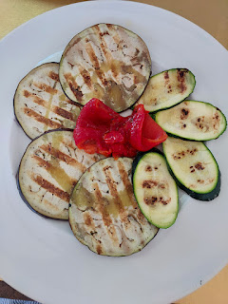

I also ordered the mixed seafood platter, with calamari, sardines, shrimp, and cuttlefish. I wasn't a fan of eating entire sardines with their eyes looking at me, but Scott wasn't afraid . . .

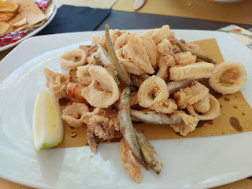

Video of Scott eating a sardine like a champ: (5 seconds)
https://photos.app.goo.gl/3jm2yTKWL5hC1JsV9

I did eat ONE, but then I gave him all the rest . . .

It was extremely refreshing to rest and recover in the shade at the restaurant for a while. When our server brought us some perfectly chilled 1-liter glass bottles of water, I put one up to my cheeks and used it to help cool off a little more.

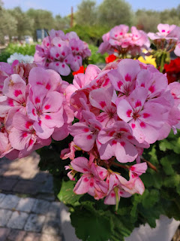

After a solid hour of food and resting in the shade, we were ready to trek the 30 minutes back to where we parked.

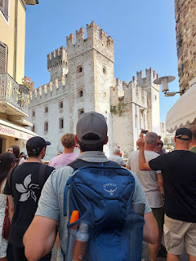

My two favorite flowers are hydrangeas and ranunculus, so of course I was delighted to walk alongside flowerbeds filled with hydrangeas FOR DAYS as we got close to the car park . . .

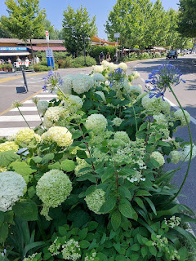

Video of the gorgeous hydrangeas: (10 seconds)
https://photos.app.goo.gl/z8BrTQXMtNDaJbnB9

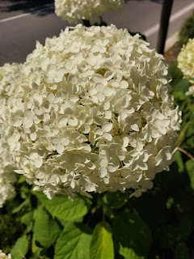

Our last stop of the day was the Adigeo Mall in Verona. Greg and Ani had done so well with their budgeting for the whole 3 weeks, so they wanted to squeeze in a little shopping before heading home soon. Scott found a comfy spot to set up his laptop on a table with a nice squishy bench to sit on. He cranked out his upcoming Sunday School lesson while I shopped with the Crofts. :)

Last Friday morning, June 20th, I drove the Crofts over to Borso del Grappa (just outside Bassano del Grappa) for a special adventure. PARAGLIDING!!!

When I told them about my previous experience of paragliding in the fall of 2021, they were astounded and very interested. Greg said it was one of his bucket list items and Ani was suddenly full of questions because she wanted us to commit right then and there!

I've worked with the Mt Grappa Tandem Paragliding Team previously and I really appreciate their professionalism and the ease of communicating through WhatsApp, so I reached out to see if they had any openings (even though we only gave them 3 days' notice). They were able to juggle a few things around and make room for the 3 of us (Me, Greg, and Ani). I think Brittany would have gone, too, but when we mentioned it would be nice to have someone on the ground to video our landing, she stepped right up to the plate and volunteered for that.

It only took about 45 minutes to get to the meeting place by car and we arrived just before 9:00 a.m. We signed our waivers and then had to wait a bit for one of the pilots to arrive - he had had some car trouble and was running a little late.

This is a map of the mountains just to the north of Bassano del Grappa and Borso del Grappa . . .

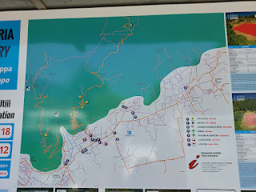

If you can find the red #1 (in the photo below), this was our starting - and meeting - point. When I flew for the first time in 2021, we began the flight from yellow #2, up on the dominant peak of Monte Grappa (5,823 feet). We landed back at red #1.

But this time, they told us that because the wind was coming from the east, we would be driving up to yellow #1 and then landing down at red #2.

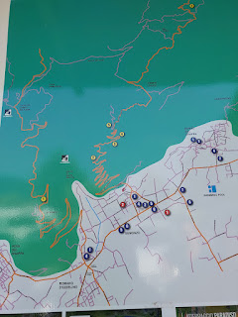

We all hopped into the company van with our 3 pilots, plus the 4 of us, and an extra driver. We dropped Brittany off at the red #2 landing zone and then continued on the road up the mountain, which included several switchbacks. I learned that Manuel was from Argentina and spoke Spanish as his native language. I was so happy to converse with him in Spanish as we drove up to the launching place. I thought he was one of our pilots, but it turned out that he would be the driver for the way back down. The first driver, Alessandro, became Greg's pilot. Fabio was Ani's pilot, and my pilot was named Julio (pronounced with the ~J~ like in "juice").

Julio took some group photos of all of us before we took flight . . .

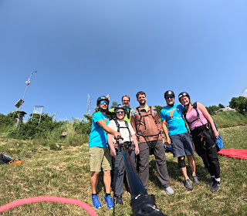

L to R: Julio (turquoise shirt), Alessandro (green jacket behind me), me - next to Julio, Greg, Fabio, and Ani on the far right.

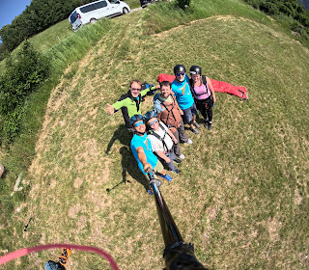

Ani and Fabio went up first - her canopy was mostly a red color.

Greg and Alessandro went up second - their canopy was a lime green color.

Julio and I went up last - there were some tangled cords that needed to get taken care of first. Our canopy was pink.

Video once all 3 of us were in the air: (25 seconds)
https://photos.app.goo.gl/RqoZcphfaRS21FHY7

It was kinda funny when we took off because the instructions are to walk when he tells you to walk, run when he tells you to run, and then stop when he tells you to stop. When he told me to walk, I barely got 2 steps in when whoosh, we were sucked up into the atmosphere! When he told me to run, I laughed and said, "I'm not even on the ground anymore!"

Overhead view looking out toward Venice . . . and Bassano del Grappa is down on the right . . .

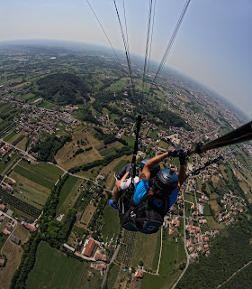

Monte Grappa is mostly out of view, but the edges of it can be seen beyond my left shoulder . . . we swooped back and forth in the canyon for a while and it was so fun!!

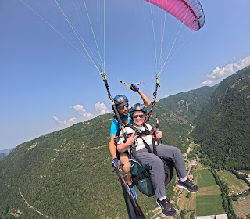

If you can zoom in on the next photo, look at the very tippy-top of the mountain where there is a green and grassy bald spot, along with a radio tower. That's where we launched from. Bassano del Grappa is behind us, we are facing toward Treviso, along with Borso del Grappa and Crespano del Grappa in front of us. Crespano del Grappa is where my 17th great grandfather was from - Andrea de Crespano is how he was known. He is the great-great grandfather to Lucreece Bassano, who married Nicholas Lanier and immigrated to England. I wonder what they would think of me now . . . :)

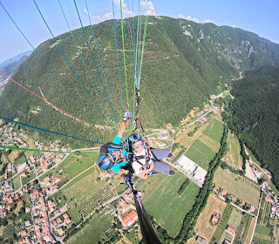

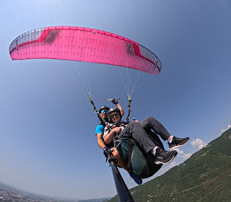

Facing toward Treviso, Borso del Grappa and Crespano del Grappa, with Monte Grappa on the left . . .

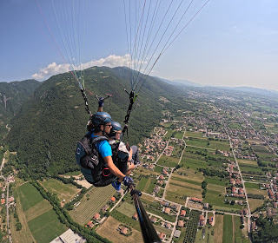

Monte Grappa on the left . . . still facing northeast . . .

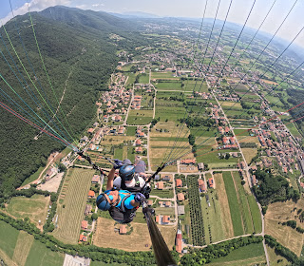

Julio told me to put my arms out like a bird and to put my legs out straight . . . and then he took us into a tight 360-degree spin, ha ha. It felt similar to being on a roller coaster, but it wasn't too horrible. There was definitely a lot more excitement on this flight, compared to the one back in 2021. Back then, I flew in late October when the weather was much cooler. I didn't realize that in the heat of the summer, there is more of an updraft, thus making things a lot more interesting.

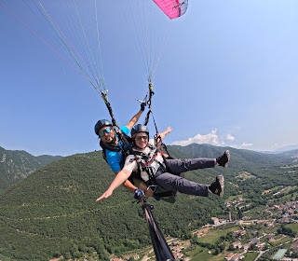

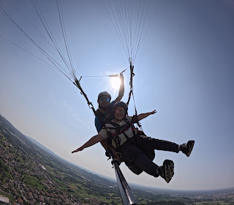

After a good 15+ minutes up in the air, it was time to make our way to the landing field . . .

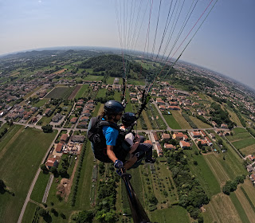

Video of Julio and me flying: (2 min, 34 seconds) *You'll hear him telling me a little bit about places we can see below. He had already told me about the famous "grappa" drink from Bassano earlier, but I told him I don't drink alcohol. So when he mentioned prosecco in this video, he remembered that I don't drink and even said, "It's healthy." (meaning, it's healthy to NOT drink)

https://photos.app.goo.gl/U5uG6hSAsyxBRUTU7

Video of the preparation for and then our subsequent landing: (1 minute, 46 seconds)
https://photos.app.goo.gl/5fxpBnC6umB7AKW49

We landed super close to Alessandro and Greg and it wasn't long before I learned that Greg threw up just before they landed. He does suffer from some motion sickness, but he really wanted to go paragliding anyway! I thought of this too late, but I should have had him apply some of my peppermint oil mix ahead of when we drove up the mountain. It would have significantly helped to alleviate any of his potential nausea.

Alessandro had given him a barf bag and I saw Greg carrying it across the field to get over to Brittany, who was waiting for us in the shade. Once I got over there myself, I saw both Ani AND Greg sprawled out flat on the grass trying to recover. While the paragliding team of men organized and packed up the equipment into their van that Manuel had waiting for us, we just let the two of them rest and get their bearings.

When it was time to load into the van, Greg felt better, but Ani not so much. Poor thing. They put her in the seat closest to the sliding side door of the van, and they just kept the van door open as we made our way back to the starting point just a few minutes away. She didn't throw up, thank goodness, but it still took quite a while for her to recover afterwards.

Julio told me more than once, "You are a very strong woman! 53 years old . . . Wowww." He was super impressed that I didn't barf, ha ha.

While Brittany ran inside the hotel cafe/restaurant to get us all some ice-cold Cokes (Coke Zero for me), I dashed over to my car to retrieve the peppermint oil for Greg and Ani. I also gave them a piece of spearmint gum, which helped. So between the oil, the gum, and the Cokes, they began to perk up after 30-40 minutes and then we drove home.

Greg needed to shower and clean up a bit after his embarrassing episode, and then he was ready for lunch. Ani really wanted to eat at the NaturaSi place that I had mentioned to them earlier as one of the things my sister, Melanie, was looking forward to when she arrived.

Everyone was in much better spirits by this point and we all enjoyed a delicious lunch at the cafeteria-style buffet of NaturaSi in Dueville.

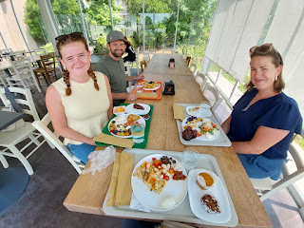

After lunch, I took them over to the huge Decathlon store in Torri de Quartesolo so they could do a little bit more shopping. It's a giant sporting goods store with fantastic Italian prices. Brittany has been training to participate in a triathlon this fall, and Ani wants to run a half-marathon as well. So they wanted a few clothing options from Italy. Everyone found something they liked and we all drove home happy.

Scott ended up driving everyone down to Bologna to drop them off at their last hotel before flying home the following day. Greg had gotten a notification about 3 days prior that all the trains would be on strike and would not running at all on the day that they needed to get down to Bologna. After researching some options, which were basically zero, we ended up offering to drive them down. It's only about 90 minutes each way, so not too bad.

While Scott drove down and back, I cleaned the house and got some things ready for the NEXT round of company that would be arriving the NEXT day: My SISTER and her husband!!

Stay tuned for the second round of adventures in the next post . . . :)

