Switzerland on July 4th: Yodelayheehoo!!
What do yodeling, huge cheese wheels, epic mountains, Ricola, the most colorful wildflowers
ever
, and ginormous cowbells have in common?

Switzerland!!

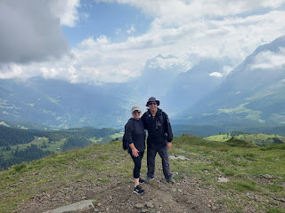

Yodeling is a well-known part of Swiss culture. It originated in the central Alpine region as a form of communication, particularly for calling cows and communicating between villages. I made sure to yodel TWICE up in the Swiss Alps, once for each hike.

For ALL the photos and videos from our trip, click here:
https://photos.app.goo.gl/CXoAjwgK9mSeVqTv7

With the intense heat that kicked in during the month of June in Northern Italy, we were SO GLAD to be heading up into the mountains where cooler temperatures awaited us. When Scott got off work on July 3rd, we drove over to Uboldo, about 20 km northwest of Milan, to spend the night and to position ourselves one step closer to Bern.

Uboldo is a very small community, but huge on local pride. As we walked into town to get some dinner, I kept seeing all of these red and white banners everywhere . . .

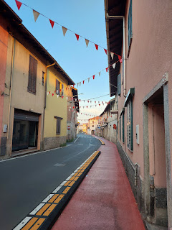

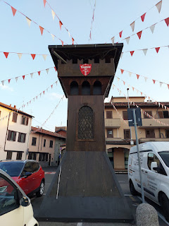

My curiosity led me to ask ChatGPT and I learned that there is a huge festival held every June in Uboldo, called the Palio delle Contrade. The beloved festival features games, historical costumes, and community celebrations. One of the four neighborhood teams is called Contrada Taron, and their colors are red and black. Each contrada elects a captain and a castellana (a symbolic female leader).

Contrada Taron has won the Palio 5 years in a row, and thus they went all out on their decorations throughout town. (Most of what I saw was a red/white ensemble, but some of the posters had red/white/AND black.)

Friday, July 4th:
We stopped at a local McDonald's for breakfast as we headed out of town. It was a pretty easy decision to make, actually. McDonald's tastes surprisingly good over here, compared to the U.S. It's affordable, quick, and we wanted some actual protein for breakfast. Italians typically only offer pastries and coffee for breakfast, and we wanted some EGGS.

While we waited for our food, I had Scott pose for a picture with one of the new ties he received for Father's Day. Amber sent this handsome one to him, with fun mathematical artwork all over it. We were dressed up because we were driving straight to the Bern Switzerland Temple for an afternoon session.

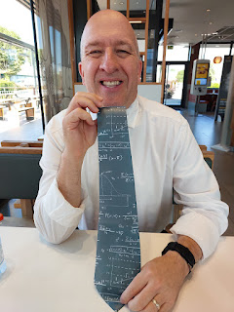

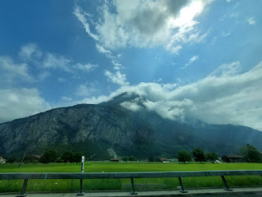

We passed by Lake Como . . .

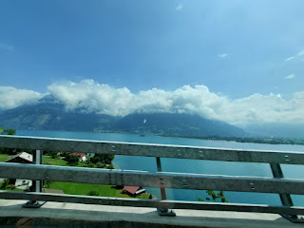

As we cruised along toward Como, I made a couple of videos for my cousin, Suzanne (Slay) Smith, who will be coming to stay with us next week, along with her friend Kelley. Suzanne will be driving and I thought it would be helpful to share a couple of tips with her. While the phone sat on the dash and recorded our maneuvers, I did the narrating. I wanted her to know that it's not hard to drive here, especially on the freeways. They'll be flying into Milan and then driving up to Lake Como for the first few days before they come over to stay with us in Vicenza.

She was super grateful for the videos. She said, "These videos were brilliant! They actually helped alleviate some apprehensions I have about driving. You need to become an American tour guide for travelers."

We made it to the Bern Temple almost an hour early, which was nice. It allowed us some time to stretch, walk around, use the bathroom at the temple patron housing, and eat a little snack before going inside.

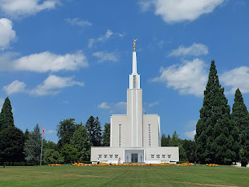

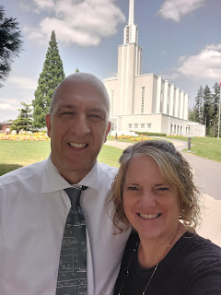

The flowers were bright and densely colorful in front of the temple . . .

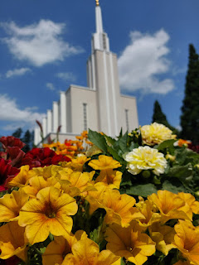

On every temple throughout the world, the words, "Holiness to the Lord, the House of the Lord" are inscribed above the entrance door. In this case, the words were in Swiss German.

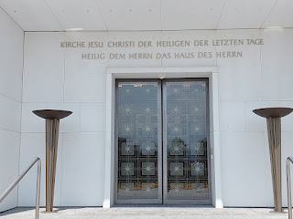

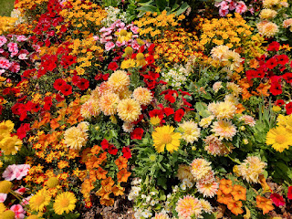

We wore headsets during the temple session for an English translation. The instructions and video were all in French this time. I wanted to hear the French a little more than the English, so I turned my headset down a little bit so the French could be more dominant. There's also closed-captioning on the screen (in French), so it was helpful to see the words and to hear the words being spoken at the same time.

I had super sleepy eyes while in the temple, and I had to fight to stay awake. Focusing on the language and pronunciation helped somewhat.

The weather was perfectly lovely outside afterwards. We ate some grapes from our snack stash while we looked on our phones for a place to eat dinner. Ultimately, we opted to just head toward our AirBnB and eat in the same town where we'd be staying. There was a highly rated restaurant closeby, so we headed in that direction. It took about 45 minutes to get over to Aeschi bei Spiez. (pronounced "eshee by shpeetz") Interestingly, Spiez IS a nearby town, so for Aeschi to be called Aeschi by Spiez is very fitting.

It made my heart so happy to see the freeway signs for Thun and Steffisburg. These are places that hold significance to some of my Mennonite ancestors on my Snider line. I visited Thun (pronounced like "toon") back in 2021 and I really want to go back again someday.

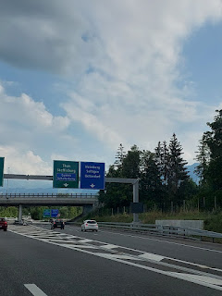

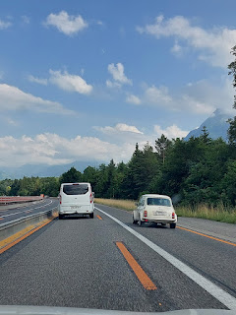

One of the many mountains surrounding Aeschi bei Spiez . . .

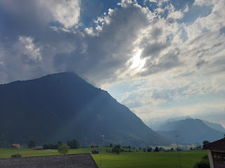

We parked the car and walked across the street to the restaurant called Niesenblick.

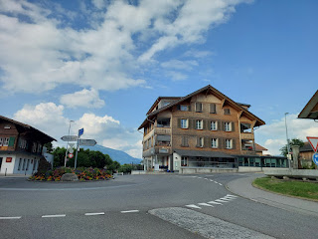

I don't know if this is an issue every summer or if it's more sporadic, but there were flies everywhere. The young lady that was our server apologized more than once, even though it was not her fault. We chose to sit outside at her suggestion, even though neither place would have offered much protection from those pesky flies, especially when restaurants tend to keep their main doors wide open to appear more inviting. I had to fight to eat my food as they tried to land either on my plate, or they'd land on the same hand that was bringing a bite to my mouth. It tickled my skin and disgusted me at the same time, but I had to fight the urge to not fling my food across the table onto Scott as I tried to flick the fly away, ha ha . . .

Take a look at the menu . . .

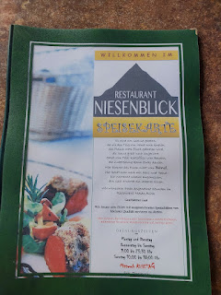

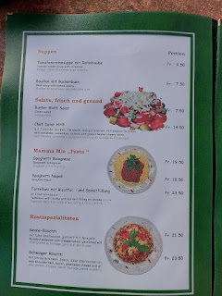

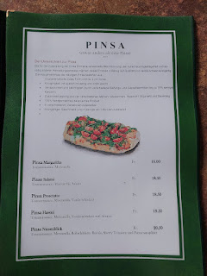

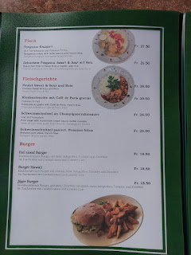

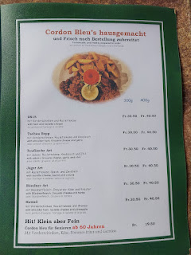

I ordered the tomato cream soup with croutons . . . it was absolutely perfect.

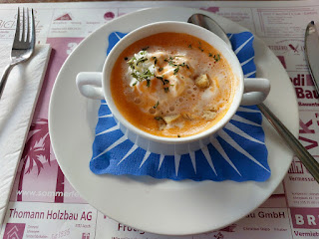

And a traditional Swiss dish called Schwinger Roschti - basically hash browns, with a slice of cheese, a fried egg, and a sliced pickle as a garnish. :) It was very good.

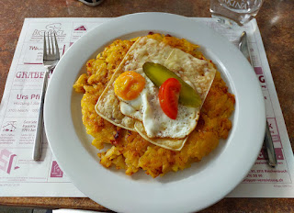

Scott ordered a hamburger and fries, of course. 'Twas a very manly meal . . .

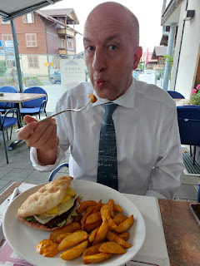

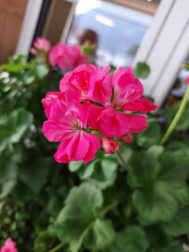

Switzerland has a long history of national pride and wanting to protect their customs and their way of life. They are not part of the EU and they are not part of NATO. They work hard to maintain a strict neutrality amid any wars or conflicts. We wondered how this was done, especially during WWII.

We asked ChatGPT how Switzerland managed to stay out of the war with Germany, and this was a portion of the answer:

1. Geographic advantages: With the mountainous terrain, the Swiss Alps made invasion difficult and costly. Any military campaign through Switzerland would have been slow and treacherous.

2. Switzerland sat between Axis and Allied powers, making it more valuable to both sides as a neutral territory than as a battleground.

3. Switzerland had an armed neutrality by maintaining a well-trained citizen militia and mobilized hundreds of thousands of troops at the outbreak of the war.

4. In case of invasion, the Swiss military planned to retreat into the Alps and make any occupation extremely difficult, destroying key infrastructure along the way.

5. Switzerland has a long-standing tradition of neutrality, officially recognized in the Treaty of Paris (1815).

6. During the war, the Swiss gov't worked hard to avoid provocation and maintain cordial relations with both Axis and Allied powers.

7. Switzerland traded with both sides during the war, including selling arms, machinery, and financial services to Nazi Germany. It allowed Germany to use its railways for transit to Italy, though it maintained limits. They also housed German assets and conducted currency transactions that helped Germany evade some economic blockades. This economic cooperation was controversial, especially post-war, but it was part of Switzerland's strategy to avoid invasion.

8. Switzerland became a hub for espionage by both Allied and Axis powers due to its neutrality and location. The country gathered and shared intelligence with the Allies, which may have contributed to Allied willingness to tolerate Swiss neutrality.

9. Swiss voters have very strong public opinions about maintaining their independence, neutrality, and control over their own laws. They have not joined the EU for this very reason. They don't want someone else to be in charge of their country and their way of life.

They even have their own currency that is nowhere else in Europe (except Lichtenstein). It's called the Swiss Franc and was instituted in 1850. Right now, the currency rate of exchange is: 1 franc = 1.25 USD. In other words, things in Switzerland cost about 25% more than they do in the U.S. They don't typically accept euros, which is super inconvenient, and some places only accept cash, which is a further inconvenience. So basically, you have to have some cash on hand - but only the Swiss francs - and then they're no good anywhere else once you leave Switzerland, so you don't want a bunch leftover. Unless you intend to visit Lichstenstein next . . .

After we learned that we couldn't pay for dinner with our credit card, we had to go across the street and pull some money out of the bank ATM. We wanted a little bit extra, just in case, so Scott got 100 francs. These are the front and back of the bills.

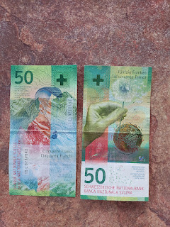

When we got some change back from our server, we received some coins and some smaller banknotes. She gave us a 10 and a 20 banknote (paper), and then we also received a 5-franc coin (larger than a silver dollar), a 1-franc coin (about the same size as a 1-euro coin), and a cute little half-franc coin. FYI: By the time we left Switzerland, we spent everything down to the half-franc coin. That's the only thing we brought home. Good job, us!

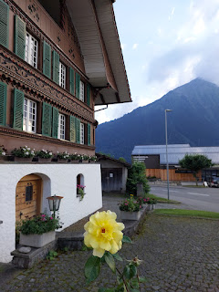

I think this was possibly a hotel across from the restaurant, but it was so cute. I took several pictures.

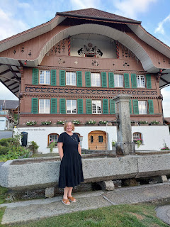

It was only a 3 minute drive to reach our lodging for the next two nights. It was an interesting process on how we chose to stay on a farm . . .

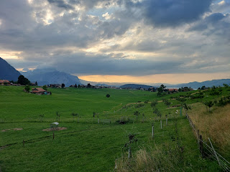

When I was looking for lodging a few weeks ago, I was shocked at how expensive everything was!! I've stayed in Switzerland twice before, but they were both during the "off-season", which helped keep the costs down. But in the summertime, sheesh, maybe the whole world comes to Switzerland so they jack the prices up. The cheapest hotels I could find were $300-$500 per night, with several listed at $700 - $1200.

I looked on both Hotels.com and then AirBnB. I was getting really worried that we wouldn't find a reasonable place to stay . . . but then I found a listing for a tiny little shepherd's hut for just $115/night.

The hut looked shockingly small, but the price tag was very tempting. The reviews were all glowing and full of praise for the peaceful surroundings, the fun of being on a working farm, and for the close proximity to hiking in the Alps. But I knew I had to sell the idea to Scott . . .

When he got home that evening, I knew he was either going to love it or he would hate it. Sure enough, when I showed him the first photo, he said, "I'm not staying in that thing." I begged him to just hear me out, lol. When he began to understand that we could either spend 3x as much (or more) for a basic bed to sleep in, OR we could spend just $115 per night for a UNIQUE experience . . . then his ears perked up. I read him all the reviews and showed him the photos on the listing, and eventually . . . he caved. :)

If you're curious and would like to see the listing, here is the link to AirBnB:
https://www.airbnb.com/rooms/49417196?adults=2&check_in=2025-07-04&check_out=2025-07-06&search_mode=regular_search&source_impression_id=p3_1749725515_P3KCKJNJHjrpvfIa&previous_page_section_name=1000&federated_search_id=e19c6779-2d5f-45fc-8419-2ea876b2d077

You can also read the reviews, including the one that I just posted, too.

There is a parking area in front of the main house, and we were greeted by the host's daughter-in-law, Corinna, since the main host, Christina, was out of town for the first day that we were there. We received a tour of the farm, which included learning where the showers are, the bathrooms, and the breakfast room/community room.

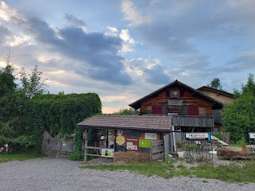

We arrived just in time to see the beautiful sunset behind our little hut . . . if you zoom in, you can see Lake Thun in the distance on the right.

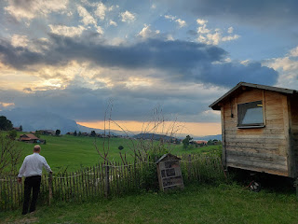

We puttered around for a bit, saying hello to all the animals before getting ready for bed.

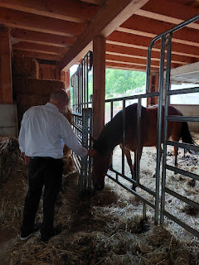

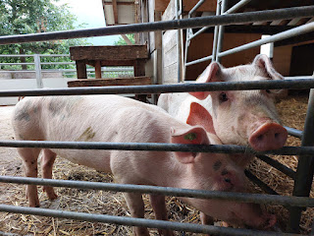

This was some sort of shelter for the sheep, I think, with hay inside. Maybe it's used more in the winter months . . .

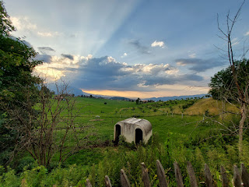

We opened up half of the roof, which greatly improved the temperature inside the hut. We ended up leaving it open for the entire night and it felt absolutely amazing. The air was crisp and fresh, and we could hear the crickets chirping and the chickens occasionally squawking nearby.

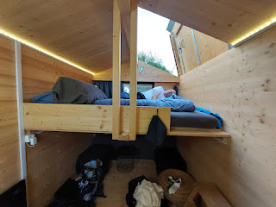

Sunset from the tiny porch . . .

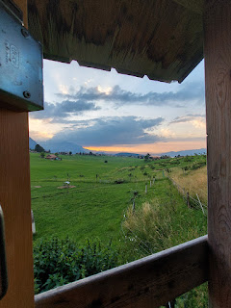

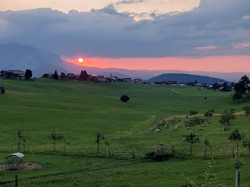

Peeking through the roof to say goodnight to the sheepies down below . . .

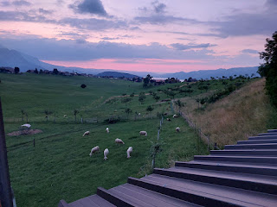

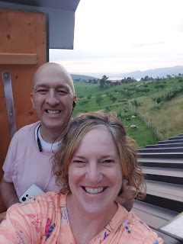

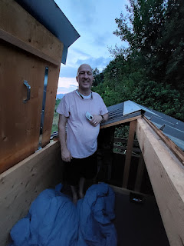

We decided that if one of us needed to go to the bathroom during the night, we would wake the other person up and we'd both go at the same time. We dubbed ourselves "Battle Buddies". (or potty buddies)

Reasons were:
~ The plyboard underneath our mattresses was very creaky, so it would probably wake the other person up anyway.
~ Climbing down from the loft bed was a bit precarious. With my short stature, I had to be extra careful to make sure my first foot landed on the little wooden stepladder.
~ We weren't sure if we would get lost or disoriented in the dark since we were in an unfamiliar place.
~ I was worried about all the what-if's that might happen in the dark if I were by myself. Like what if a bear jumped out?

When we got back from our nighttime field trip to the potty and back, I took a picture of the night sky above us. If you look really carefully, you'll see the Big Dipper.

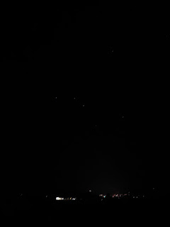

Saturday, July 5th:
Scott went to the grocery store super early (they open at 6:30 a.m.) and then he came back and cooked us a hearty breakfast in the little farm kitchen meant for guests. What a lovely way to start the day!! He prepared some fried eggs, a slice of ham, and a banana for me. XOXO

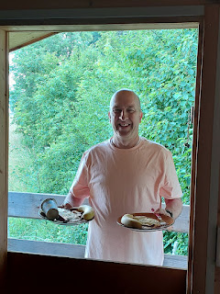

Types of teas (and coffee) in the hut, labeled in Swiss-German . . .

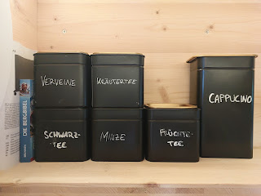

The sheep and goats were being milked by hand first thing in the morning. Scott asked the young man (our host Christina's son) if it would be faster to do it with a machine. He replied that by the time he finished cleaning and sterilizing the machine parts, which can be very tedious, he would have been done doing it all by hand. So that's what he continues to do, bless his heart.

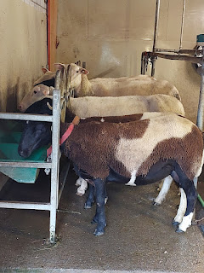

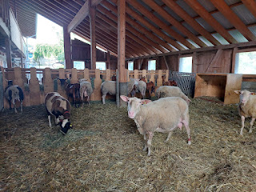

We drove about 40 minutes east to park in the Grindelwald Terminal, a large parking garage with multiple levels. We fussed for a few minutes, trying to decide which layers to wear now and which ones to just pack in our backpacks, and then we headed upstairs to the main floor.

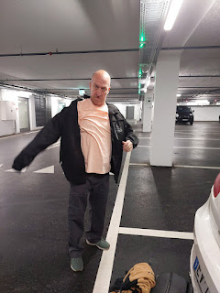

Inside the terminal, it was bustling with all the people who were preparing to enjoy the Swiss Alps that day. Some were large groups of Chinese tourists, others were obvious and experiened hikers. Old and young, multiple countries and languages, all shapes and sizes. The terminal had bathrooms, a few shops, and plenty of corner spaces to make sure you were ready to hit the mountains with all your gear.

You could either stand in line to get your tickets for the cableway, or you could use the lineless kiosks instead. We, of course, opted for a kiosk. It was very simple to use, especially when you can change the language to English first thing! We chose one-way tickets from Grindelwald up to Mannlichen, which cost roughly 36 Swiss Francs (CHF) a piece.

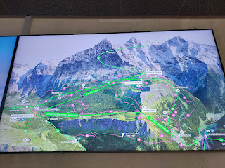

Above: This was a very helpful map in the Terminal, and with a photo of it stored on my phone, we referred back to it a few times throughout the day.

You can see on the map where the green line goes from the Grindelwald Terminal up to Mannlichen. From there, we would hike on the pink trail #33 over to Kleine Scheidegg as our first leg. Next, we would take the train from Kleine Sheidegg around the bend to Eigergletscher (pronouced like Eye-ger Glacier). Our last and longest leg would be to hike the pink trail #36 down to Alpiglen, followed by a short train ride back down to Grindelwald.

Notice that Jungfraujoch, considered to be the highest peak in Europe, is just a smidgey above our Eiger Trail hike. (Jungfraujoch = yung-frow-yok)

The cablecar up to Mannlichen (man-licken) took about 19 minutes. Each car can hold up to 10 passengers, but not very many people were headed to the same place as us, because most cars were empty and we got this one all to ourselves. I think more people were heading up to Jungfraujoch than to any other peak.

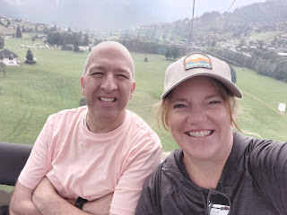

Views of Grindelwald behind us . . .

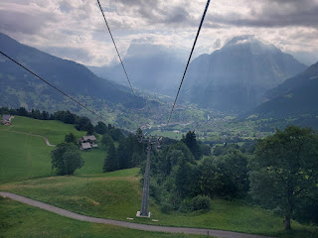

Again, you can refer to the complete album that I put together for more photos and videos than what I'm including here.
https://photos.app.goo.gl/CXoAjwgK9mSeVqTv7

At the top of the mountain where we got off at Mannlichen, there is a massive and very whimsical playground for the kids. "Toys" include a giant cow slide with mini trampolines, a bowling alley, a fun merry-go-round, and so much more.

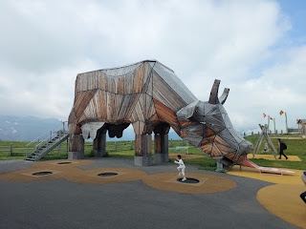

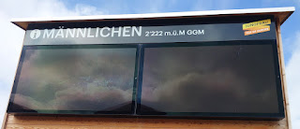

Mannlichen stands at 2222 meters, equal to 7290 feet above sea level. Below is a small portion of the mountains surrounding Mannlichen and their elevation. Eiger stands at 3970 meters, equal to 13,024 feet above sea level.

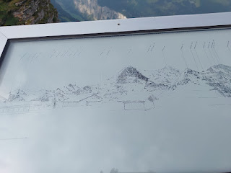

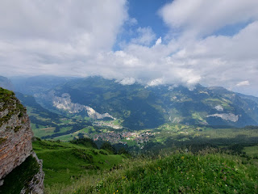

Trails on the Swiss Alps are very clearly marked, which helped immensely. Plus, I had studied the EarthTrekkers blog carefully and repeatedly for important details to help us have a successful day.

https://www.earthtrekkers.com/mannlichen-to-kleine-scheidegg-panorama-trail/

https://www.earthtrekkers.com/best-hikes-to-do-in-the-bernese-oberland-switzerland/

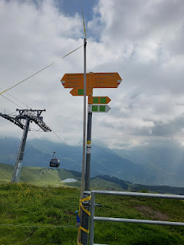

Wildflowers were in serious abundance everywhere on this hike. Some of them were colors and hues that I had never seen before - particularly the blue ones.

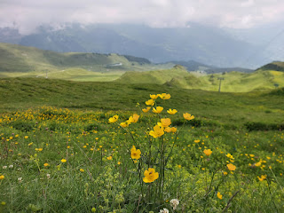

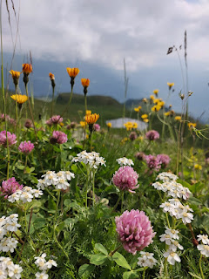

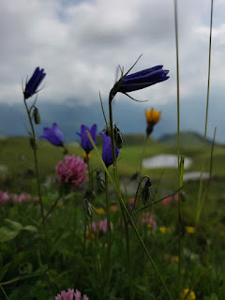

We sent our drone up a couple times that day . . .

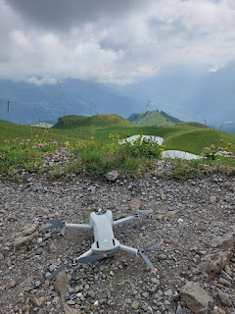

These little blue flowers were so vibrant and such a brilliant blue - like nothing I'd ever seen before . . .

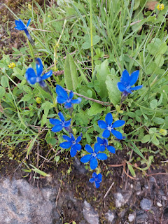

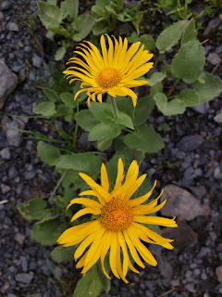

That's me over on that ledge!! Scott had to wait a few minutes to take my picture because several passersby wanted me to take THEIR picture first, ha ha.

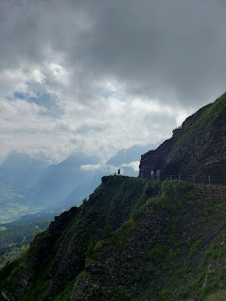

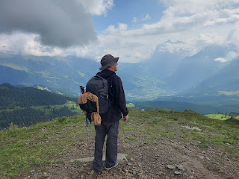

The weather was absolutely perfect for hiking the entire day. Yes, it was cloudy and you couldn't fully see the mountains for the most part, but the cloud cover also protected us from getting sunburned and kept the temperatures down. I would say it was around 65 degrees up there, with a mix of blue skies and partial clouds. Absolutely delightful.

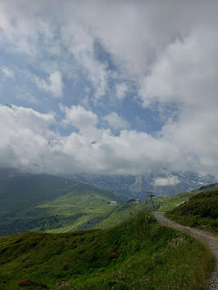

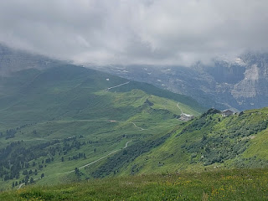

A few more unique flowers that I was not familiar with . . .

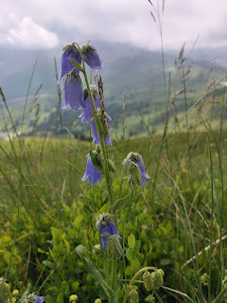

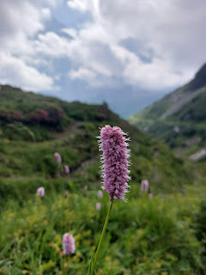

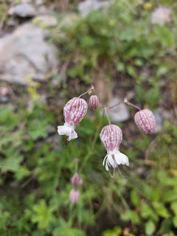

The hike was 3 km and took about 1.5 hours, maybe 2 hours with all the stops for photos, ha ha. We loved every minute of this hike! And I would highly recommend it to ANYONE. It's an easy hike, with just the slightest downhill most of the way. The path is wide and comfortably safe so that you can spend most of your time looking all around at the scenery instead of just looking down at the path beneath your feet.

Off in the distance, we started seeing some buildings that belong to the very small community of Kleine Sheidegg . . .

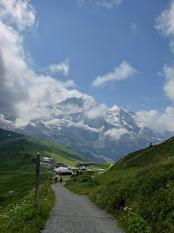

A lake? A reservoir? Not sure, but Kleine Scheidegg has got it going ON!!

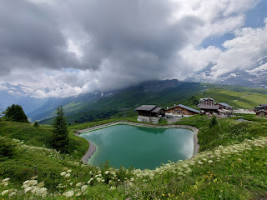

In both German and Swiss-German, if you see two vowels next to each other, then you will pronounce the sound of the second vowel. In this case:

Kleine > "ei" > long i sound = Kline
Scheidegg > "ei" > long i sound = Shy-degg

After using the bathroom at the train station, we bought the tickets for our next leg at a kiosk outside. Same easiness of use as what we used down in Grindelwald. This leg cost us 8 Swiss Francs (CHF) each. It was a little bit confusing to figure out where we needed to be when the train pulled up, but after asking 2 separate station workers, we finally got into the right line.

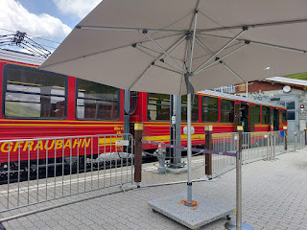

We munched on our two giant pears that we had brought with us all the way from the Pam grocery store in Vicenza. If I could still eat apples, I would have packed apples for our hike. But the pears were great and they traveled well in our backpacks.

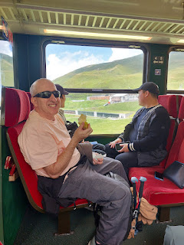

Eigergletscher Station - sits at 2320 meters, or 7,612 feet in elevation.

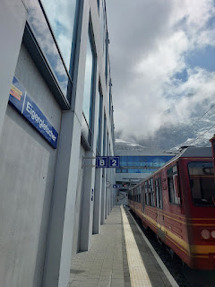

The breeze would sometimes move the clouds out of the way so we could see the mountain peaks . . .

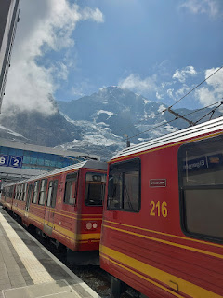

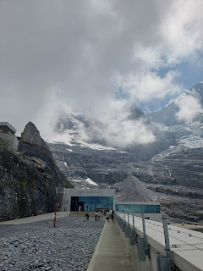

Again, clearly marked trail pointers help you to get going in the right direction . . . For us, we were headed down to Alpiglen, with an estimate of 2 hours. On the EarthTrekkers blog, they said it was more like 2-3 hours with stops for photos.

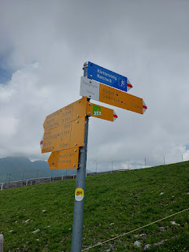

We passed directly underneath the path of the Eiger Express Cableway at the beginning of the trail.

Video here: (6 seconds)
https://photos.app.goo.gl/wQ4fsGxttzhbH7sc7

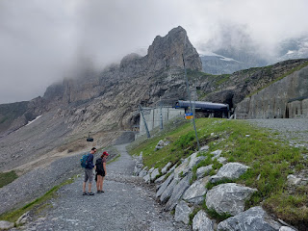

On a small ledge, we saw several granite markers that gave some historical background for how difficult it's been to ascend these massive peaks during the last century. (Click to read each one - and yes, there's an English translation on each one, too.) I only took photos of these three markers.

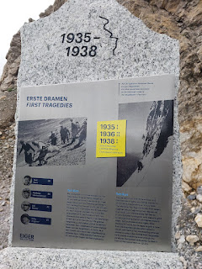

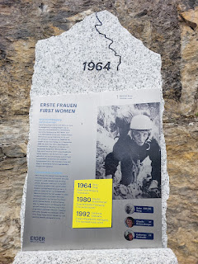

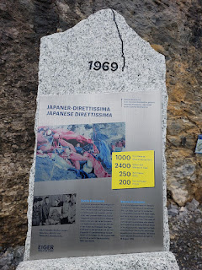

The Eiger peak loomed in the fog above us on the trail . . .

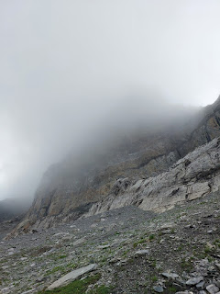

There are three main peaks: the Eiger, Monch (munk), and Jungfraujoch. We were hiking about halfway up on the north face of the Eiger.

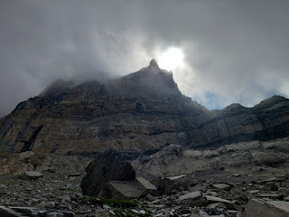

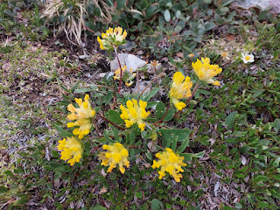

This trail was definitely more treacherous than the Mannlichen trail. We had to look down to watch our footing 99% of the time, and could only look up occasionally to enjoy the views.

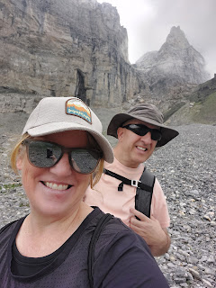

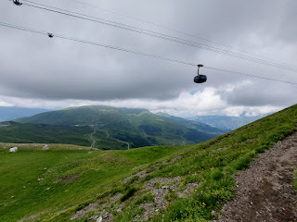

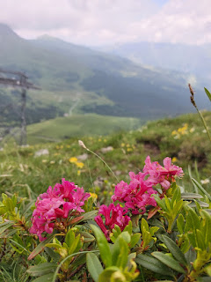

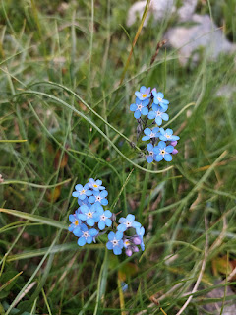

We tried to pause from time in order to soak it all in, to take a rest, and to take some photos.

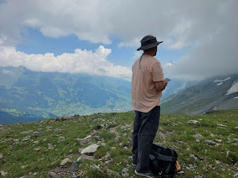

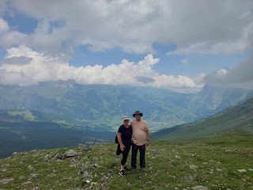

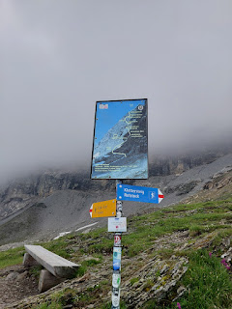

It was always reassuring to see another sign to verify that you're still going the right way . . .

We could not see the Eiger very often, as it was enveloped in cloud cover for most of the afternoon.

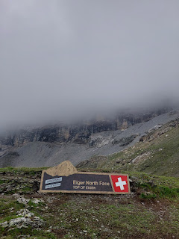

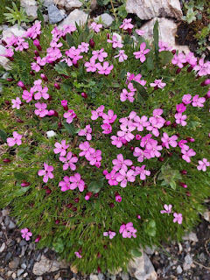

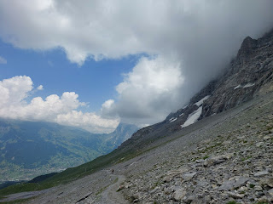

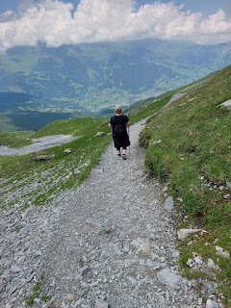

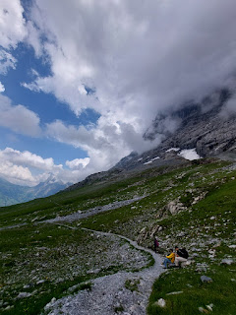

Can you see where the tiny trail leads off to . . . ?

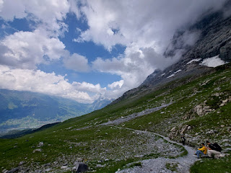

We made several friends along the way down to Alpiglen.

~ We took photos more than once for a young couple from Cincinnati. They were on their first trip - just the two of them - since having children. They have two little ones back home, in the care of grandparents, ages 3 and 1. They were super cute and super nice. They offered to swap and take photos of us after we took photos of them. We leapfrogged along the trail, interacting with them on multiple occasions.

~ We chatted with two ladies from Stuttgart, Germany while Scott brought his drone down to land. One of them has a drone, too, and she wanted to know all sorts of information about ours compared to hers.

~ We met a family from China and interacted with them numerous times on the trail, up until my knee began to slow me down and then we never saw them again. They'd pause to rest and eat a snack while we passed them. Then later, they'd pass us while we rested next to the trail. Their son, who I would guess was in his late 20's or early 30's, spoke perfect English. I asked him how he learned to speak English, and he said he had to learn it for an internship that he did in NYC a few years ago. He's been to the U.S. on one or two other occasions, as well. His parents were older, maybe in their early 60's, but fiercely independent. Especially his mother. When we needed to do a water crossing that looked a little iffy, I offered her a hand from the opposite side, but she waved me off, speaking Chinese, but with a smile on her face. Her husband offered to help her, too, but she had stronger Chinese words for him, ha ha, and then navigated across the rocks perfectly without any assistance.

The young man had also been to Yellowstone National Park, which is very close to Idaho Falls. We chatted about Grand Teton National Park for a bit, as I put in a big plug for it once I learned he had never been there, even though he was RIGHT THERE next to Yellowstone. We had such a good time visiting about this or that for several minutes on the trail, before we parted ways while Scott set up to fly his drone again.

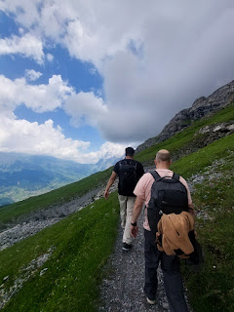

We saw several waterfalls, of varying flows, coming down the mountainside. Sometimes it was just a trickle, but then we had the joy of seeing a real humdinger a little later on.

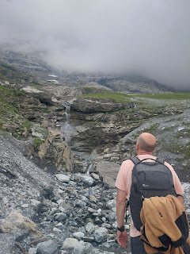

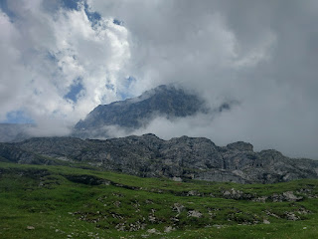

We crossed a patch of snow at one point, too . . . it was pretty slick because the sun had melted the very top layer and made it more like wet ice. I was glad I had my poles in hand.

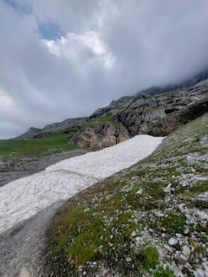

Scott, setting up to launch his drone one final time, while I munched on some Pringles chips on a nearby rock . . .

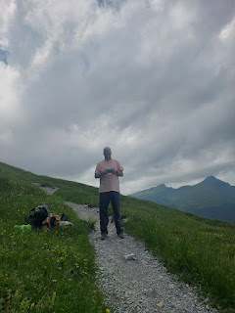

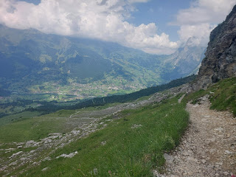

Yep - this is the whopper that I mentioned a minute ago . . .

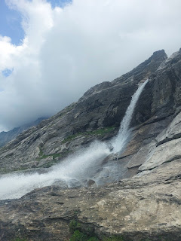

Video of the turbulent waterfall: (13 seconds)
https://photos.app.goo.gl/wamsWjQ2QxP8rmV9A

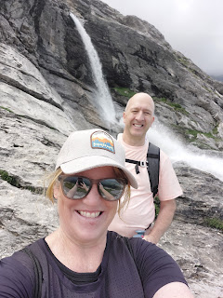

As the trail curved around and descended below the waterfall, we had a magnificent perspective looking back up . . .

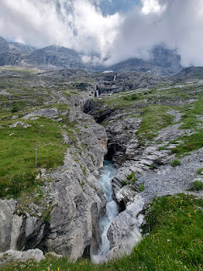

The last portion of the trail should have taken us less than 1 hour, but it took us more like 2 hours because of my bum knee. It was seizing up pretty bad and I couldn't hardly bend it at all. I had to get creative to allow for some relief on the neverending and steep downhill terrain. One thing I did was to step sideways for a while, and then switch to the other side so I could lead with the other leg. Another suggestion from Scott was that whenever possible - meaning whenever the trail let up a bit and wasn't so precarious - then I should walk backwards to use some different muscles. That also helped.

Video of me going backwards down some steps: (11 seconds)
https://photos.app.goo.gl/nfcViy9FAH42k5X68

We had also stopped to say a prayer at one point, because I was almost in tears from the relentless pain. Neither of us had brought any ibuprofen with us, but we did have some back at the farm to look forward to. As Scott prayed for me, I immediately felt a sort of handheld hug around my left knee, accompanied by a feeling of peace that all would be well. With grateful tears in my eyes, we started off again, and this time I made it a much longer ways down the trail before needing to pause for a rest.

We caught up to and then passed a group of 4 ladies, which included an injured hiker. They mostly spoke German, but they could handle a bit of English as we asked if they needed any help. It was a mother - who had a broken ankle, and her 3 incredible daughters who meticulously and patiently helped her traverse every single roadblock all the way down to Alpiglen. The daughters looked like they were in their 20's.

There was one section of trail where you had to go down these huge chunky rock ledges, and there was a cable on the left side to hold onto for safety. This poor momma, with her broken ankle, needed to use her poles to get close enough to grab onto the cable so that she could sit down and then carefully work her way down the rocky steps on her bottom while holding her leg out in front of her.

Scott and I waited the whole time to make sure she got down through that section safely. We both wished that we could just carry her on our back all the way down, but she had a huge team of support with her daughters and they were nothing short of amazing.

FINALLY, I could see Alpiglen and the train station. What a massive relief that was.

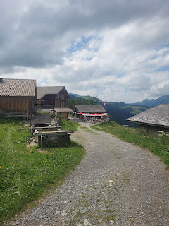

Alpiglen basically consists of maybe 5 buildings and a tiny train station. And that's it. But it was enough.

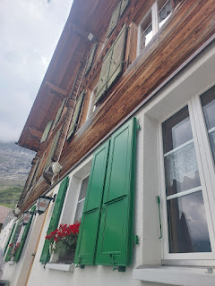

We found a table at this cute little alpine restaurant and began perusing the menu. Or, I should say - I'm the one that began perusing the menu, while Scott went to find a bathroom and then to investigate the train station. He wanted to know the timetable for when the next train would be coming through. Turns out that it was every 30 minutes.

Bless his heart . . . I still cannot convince this guy to eat any lunch. He gets stubborn, like his father, in that way. Once Scott *decides* that he doesn't need or want lunch, then it becomes fact. Even though we didn't have a very big breakfast, and all we ate was a pear and some chips as we burned through a good 2,000 calories while hiking, he refused to order anything.

I tried my psychology trick on him again, by slightly over-ordering and then looking at him with Bambi eyes for help in finishing the food. But he wasn't a very cheerful participant as he has been other times. Maybe he was just tired from the 10 km we had just finished up. But I do wish he would eat more.

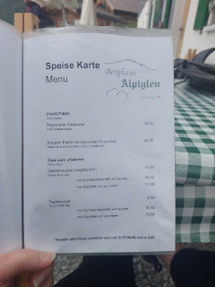

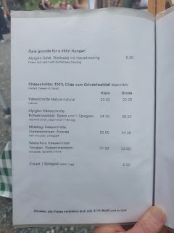

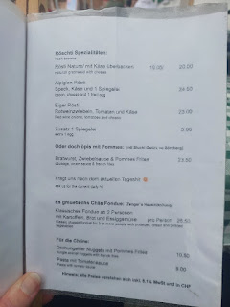

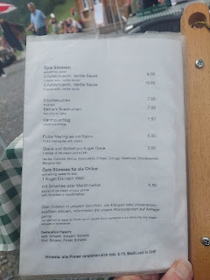

What I ended up ordering was the Alpiglen Kaseschnitte - which consisted of homemade bread absolutely drowned in fondue-like cheese, then layered with bacon, a fried egg, and 3 little pickled pearl onions that were super fun and exciting. How's that for a hearty protein-packed meal?!

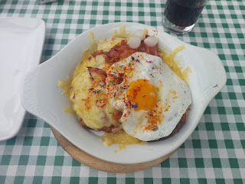

I also ordered their Gerstensuppe mit Alpkase . . . a DELICIOUS barley vegetable soup with cheese on the side.

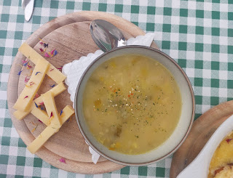

Yeah. That's a lot of cheese. When the server told me that there's a lot of cheese on the bread, I didn't know that he meant a LOT of cheese on the bread. I didn't have any context for what his perception of "a lot" meant. I ate 2/3 of it and all of the soup, before turning over the final 1/3 to Scott. He was a little bit annoyed at me because I didn't finish what I had ordered, but all was well in the end with something hearty in our tummies.

From Alpiglen, it was hard to imagine that we had just come down from where that giant patch of snow was up above . . .

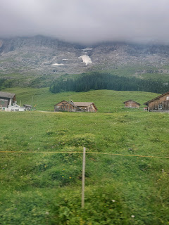

On the train ride down to Grindelwald, we struck up a conversation with two young men that were sitting by us. They were on a weekend adventure from Ramstein, where they both work on the Air Force base up there. I was curious where they were staying and how much it was. They told me that they were staying in a hotel right next to the Grindelwald Main Station and that they split the cost between them - are you ready for this . . . $360 x 2. *cough cough*

I lamented with them about the cost for lodging - especially during the peak summer season, and then I showed them the listing on AirBnB for the shepherd's hut. They scrolled through the pictures of the farm and the hut and declared that THIS was where they'd like to stay next time. The one young man even said that his girlfriend would absolutely love to stay there.

As we got off the train at Grindelwald, we both noticed that it didn't look anything like where we had started the day. That's because Grindelwald Terminal only offers cable cars and not a train. This was the TRAIN station . . .

We ended up having to walk another 2 km to get over to the actual place where our car was parked. And wouldn't you know it, there were a couple more steep paths to go down in order to get there. Thankfully the path was paved this time, and I walked backwards the whole way down, even when people were looking at me curiously.

For future reference, the train that comes down from Alpiglen does offer a stop at Grindelwald Gund, but we didn't know anything about it so we skipped it altogether. Only actually, it turned out to be right across the street from Grindelwald Terminal . . . and it would have saved us 2 km of walking. Darn it.

At least we know for the next time, though.

Back on the farm, we hobbled from the car to the hut on the far side of the farm to get some supplies and fresh clothes for a hot shower. The shower room was a little sketchy, and I did write a note to the host on AirBnB to make a couple of suggestions. We brought flip flops for the shower because I had seen photos on the listing ahead of time, but it was still pretty uncomfortable to be showering with so many spiders and mosquitoes all around us. The water drained along the floor and under the sink trough, but we made sure our bags were up off the floor. At least the water was hot and we had brought our own soap and shampoo.

I was glad to have a shower buddy.

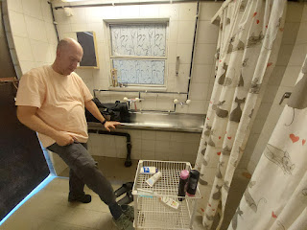

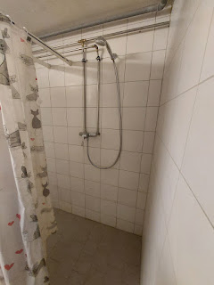

Another tremendous sunset to wrap up an incredible day in the mountains . . .

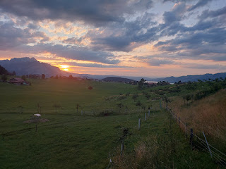

Sunday, July 6th:
Our host, Christina, prepared several farm-fresh offerings for breakfast. We met her in the community room at 7:30 a.m. where she showed us around.

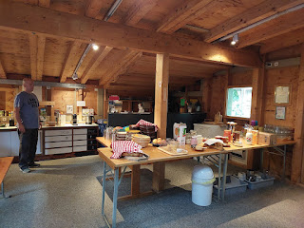

Fresh cheese from her goats' milk . . .

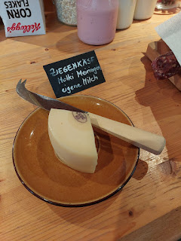

Sheep sausage from her own sheep . . .

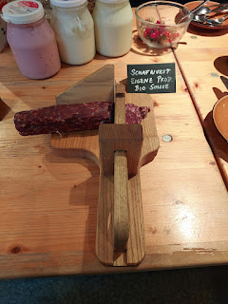

Either goat or sheep milk from her own farm . . .

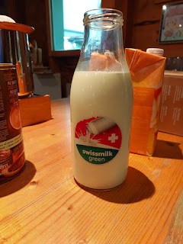

Homemade bread, which was still WARM . . .

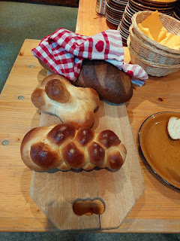

Skyr yogurt - berry flavor, plain, and vanilla . . .

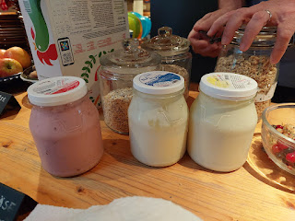

We made some poached eggs in her little egg maker, and then we had a nice assortment for breakfast.

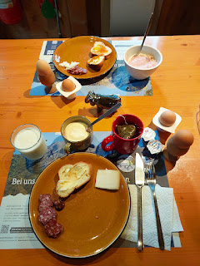

Alas, it was time to say goodbye to all the animals, the sunsets, the farm, and to our host . . .

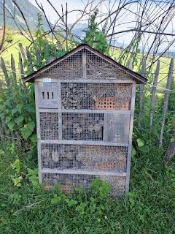

We drove about 20 minutes down from the hills of Aeschi bei Spiez down to Interlaken below, where the nearest LDS church service would be held at 9:30 a.m.

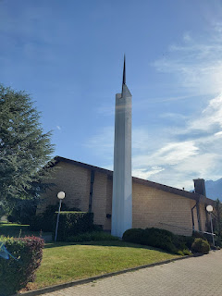

In the front window, there was a sign tucked into the corner that answers some questions about "What is the Book of Mormon?"

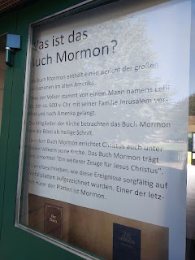

The chapel was small, but efficient . . .

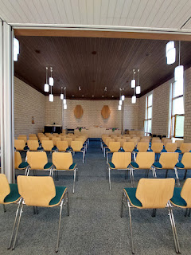

There were several other visitors from America that showed up to church that morning, including several families from Utah. This little branch is used to larger numbers during the summer season, and they were prepared with a translation headset for everyone.

The hymnbook . . .

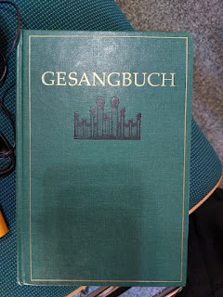

The opening hymn was "I Need Thee Every Hour" . . .

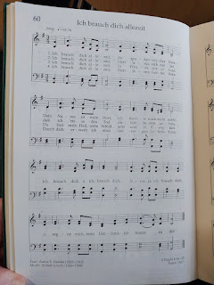

The closing hymn was "For the Beauty of the Earth" . . .

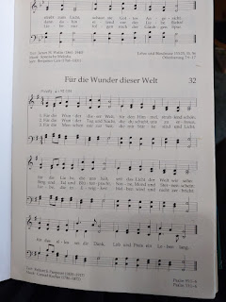

Our drive home was supposed to take us a little over 5 hours but ended up taking closer to 7 hours. There is a tunnel on the way that just started a 5-year long project, which only began a little over a month ago. Gotthard Tunnel wants to expand by adding another tunnel through the mountain, which will consist of drilling a little at a time, clearing out all the debris, drilling some more, etc. FOR FIVE YEARS.

In the meantime, the current tunnel is just one lane in either direction and with all the summer traffic, it meant that we were backed up for a long, long time before getting to the green light to even enter the tunnel. The tunnel is 16 km long. The work crew is anticipated to reach halfway through the mountain in two years' time. WOW.

I spent some time embroidering some words on one of Maisie's quiet book pages during our long day in the car. This page will soon be a lion's mouth that opens up for her to brush his teeth, lol.

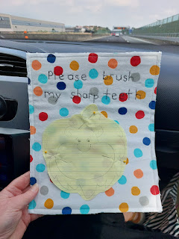

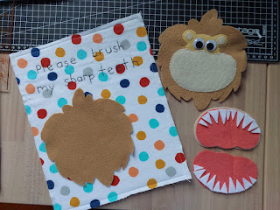

Eventually, we made it home. I loaded myself up like a sherpa guide with every possible bag, backpack, suitcase, etc. so that I only had to make ONE trip up the 3.5 flights of stairs. I knew I would not be able to go down and then back up again.

Just getting up to go potty in the middle of the night was quite an undertaking . . . it took me a long time to get from my side of the bed around to Scott's side, and then I had to be brave enough to take a few steps without holding onto anything until I reached the doorframe to steady me. I felt like the oldest of the oldest ladies.

Thankfully, it only took me 24 hours before I bounced back to my old self. I can go up and down the stairs just fine again, thank you very much.

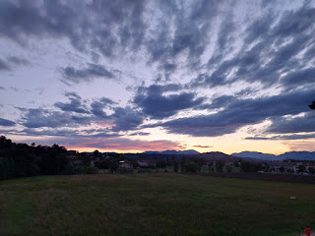

I already miss Switzerland.

