I Love My Nipotini
Nipotini, you ask? What is this? Que es este? Cos'e questo?

Nipotini means "little grandchildren" in Italian.

They have been having lots of fun this summer, and I thought now would be a good time to share some of their delightful escapades and adventures.

I'll start with the youngest and cutest little hooligan: Maisie. She's 10 1/2 months old now and still has the most beautiful strawberry blonde hair, even if it's a little bit sparse.

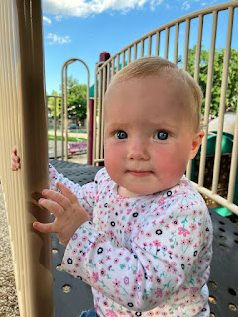

She's who I've been making the Quiet Book for in recent weeks, and I'm happy to report that it's in the FINAL STAGES. I've got all the pages finished, with bias tape as a trim around the edges. I've got the outer cover completely finished now, too. All that's left to do is to secure the pages inside, which should be done in the next day or so.

Maisie is a great little cheerleader for everything her older brother, Jack, is doing. Whatever it is, she wants to be right in the thick of it. Here, she's holding onto a spare baseball while Jack is in the "lineup". And she has what looks like a blueberry-covered pair of bottom teeth in that big toothy grin of hers . . .
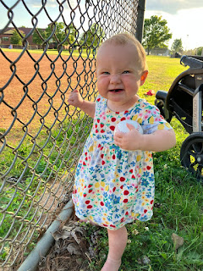

She looks a little disturbed here . . . maybe football isn't really her "thing" . . .

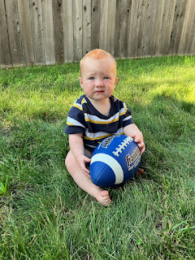

She recently enjoyed eating several fries at the Minnesota Twins game with her family . . .

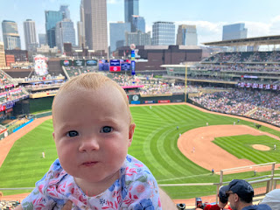

And she loves the United States of America. It's been a pretty great place, in her vast experience.

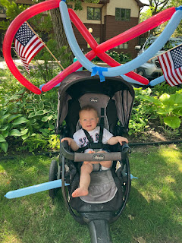

I woke up to a darling and silly video of Maisie this morning. What a delight she is!
(22 seconds)
https://photos.app.goo.gl/gdgAHoFs5DL6KQ1v8

Maisie's older brother, Jack, has been checking all the adventure boxes this summer. So far, he's been casting his net far and wide as far as interests go. He loves to tinker around the yard with tools and water. He loves baseball and going for bike rides. He loves books and going to the library. He can tell you just about any fact about sharks, fish, sea creatures, dinosaurs, and many other forms of life.

He has also been very curious lately about cemeteries and death because they have a cemetery right across the street. He's been asking his parents lots of questions. I got a text recently from our son, Jake, asking for a photo of Grandma Helen Harmon's funeral back in 2005. Jake had the special responsibility of filling in for his father as a pallbearer when Scott was serving across the world in Iraq at the time. Jake had just turned 9 years old when Grandma Helen passed away in September 2005.

We were able to dig up these photos on my Google photos account - BECAUSE THEY HAD BEEN SCANNED and saved at some point. Hooray!!

The pallbearers for Grandma's funeral were . . .

L to R: Scott's father, Phil Harmon, Michael Whitten, Jacob Harmon, Gordon Harmon, Mike Whitten, and Brandon Whitten. (Scott's oldest sister, Carol, married Mike Whitten.)

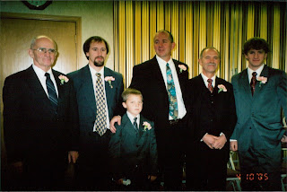

Jacob had quite the responsibility to carry, literally, when his father wasn't able to be there.
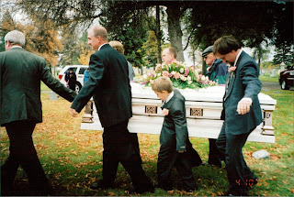

Jack has been practicing his baseball skills pretty much daily . . .

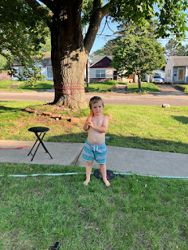

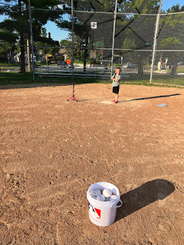

With the patient help of his "coach" (a.k.a. his mother, Hannah), he's been learning how to connect his bat with the baseball: (5 seconds)
https://photos.app.goo.gl/QmH7ZLzmvdsHCgHV9

And going to see the big league games from time to time probably keeps his baseball spark well lit.
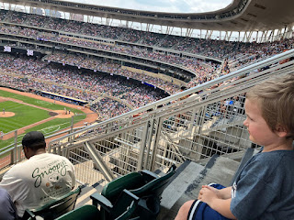

When I talked to Jack the day after the big Twins game, he excitedly told me all about the fries that he ate, ha ha. Apparently, they were very memorable!

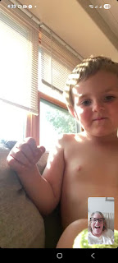

When Jack arrives at my house in Idaho Falls next week, he wants me to show him how to sew something with my sewing machine. How cute is that! We'll have to discuss ideas on something to make for him. I was thinking maybe a tool belt, or a satchel for odds and ends, or even a fun patterned pillowcase. We'll see what he decides . . .

Up in Portland, Abby and Gwen have been enjoying summer by going to the pool, attending some birthday parties, regular trips to the library, and most recently they went to the recycling place where Abby earned $10 by cleaning and hauling 2 large trash bags of soda cans (not smashed) and water bottles.

At a recent birthday party for a mutual friend, the girls got to visit the Lego area of the OMSI (Oregon Museum of Science Institute?) and they had a great time.

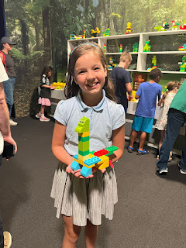

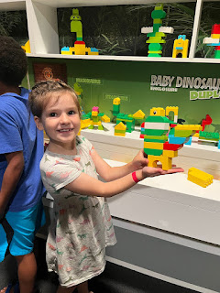

Abby and Gwen also happily modeled some of the clothes that I sent them from Italy. I love picking things out for them and they love receiving them! So it's a win-win. :)

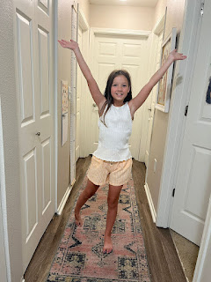

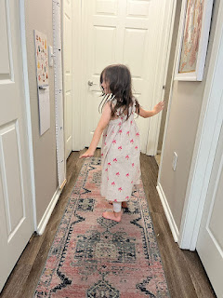

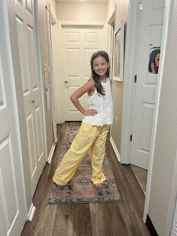

They will be traveling to Idaho Falls this weekend so that Amber can attend her friend's baby shower on Sunday. Thankfully, they'll stick around for a few extra days so that I can see them, too, once I land on Wednesday.

Meanwhile, Avery is settling in nicely up in Germany. Her mother, Kylie, has started babysitting 5 children to earn a little extra money. Avery is enjoying the gift of having playmates every day!

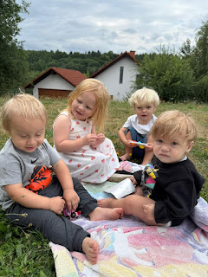

Avery (on the right) and one of the little boys that Kylie is taking care of . . .

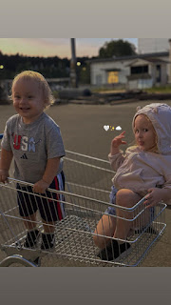

Kylie and Avery . . . XOXO



Lastly, I'm 99% done with Maisie's Quiet Book . . .

These are the 8 pages, with a few tiny little details that were finished AFTER this photo was taken.

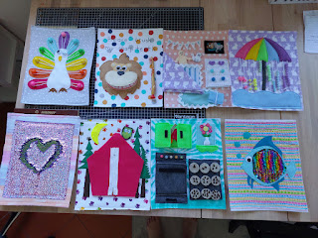

On Monday and Tuesday, I spent a good amount of time thinking and brainstorming how to assemble the cover to the book, and then how to attach the pages inside. Scott and I discussed several options, folding things this way and that as we walked through different ideas together.

Ultimately, it just started to feel overwhelming. I've made these books before, but I didn't have so many things going on in my life all at the same time. I just wasn't sure how to proceed, or even how to begin, frankly.

So I decided to pray.

Heavenly Father cares about me, and He cares about the things that I care about. Small, medium, and big. I asked for help so that I could know how to BEGIN. I had done lots of research, maybe so much so that my brain was now swirling. But I just didn't know what the first step should be. So I asked for help with that.

Once I ended my prayer, I had a very clear impression on what Step 1 should be. So I did that. And then Step 2 became clear in my mind. So I did that. And then Step 3.

Soon, the cover was coming together beautifully . . .

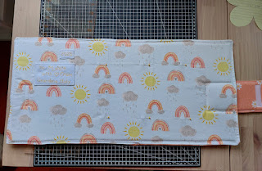

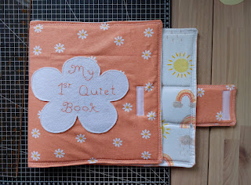

As of this writing, I have placed 2 of the 4 pages into the book. I say 4 pages because I attached the 8 pages back to back, which made 4 front/back pages.

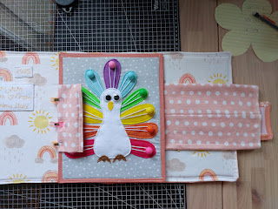

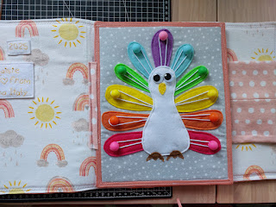

All that's left to do is to sew in the LAST two pages and then it's DONE!!! I have paused on the sewing because I've been having way too much fun playing with my Cousin Suzi and her friend Kelley this week. But they leave Saturday morning to head back to Milan, and then they fly home on Sunday - back to Oregon.

I will finish the book on Saturday and then I'll start packing to fly back to Idaho. I leave on Tuesday, with an overnight layover in Dallas, and then I arrive in Idaho Falls on Wednesday to a house full of children and grandchildren! Yay!!

