Food, Shopping, Padova, & Verona with My Cousin
Three very fun days recently flew by with my Cousin Suzi and her friend, Kelley. I was quite impressed when I heard more about their back story as teachers and all the many trips they hosted for young students over the years. They've been chaperones for groups of 40 children (middle school age) to places like: Australia (4x), Costa Rica, Paris & Normandy, England, Wales, Scotland, Ireland, Germany, Rome, Italy, South America, etc.

Kelley, me, and Suzi . . .

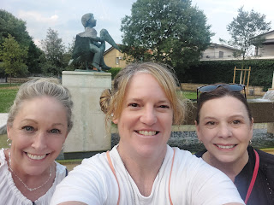

They told me lots of stories from their many years of adventures and I hung on every word. For the first several years, they worked with People to People, a company that featured opportunities to travel and to be an ambassador in other countries around the world. There was a real sense of building relationships during that time, something that was considered very important after the Cold War . People to People really sought to build a few bridges between countries where things were still a little tense (and timid). Suzi and Kelley mentioned several occasions where they really felt the spirit of unity as they connected with new people, customs, and cultures.

People to People came to an unfortunate end, though, when the leadership changed hands and - according to Suzi - the new owners were more money-hungry than they were interested in building international friendships. I can't remember the name of the company that Kelley and Suzi have worked with most recently . . .

It's always interesting to hear how people use ChatGPT. I primarily use it for information, similar to how I used to ask my questions in a Google search. Lately, however, it feels like I don't get the specific answers that I'm seeking when I ask Google, often having to click on the links provided and then do all the reading and sifting through vast amounts of information myself. But ChatGPT answers my questions very specifically, even citing sources for where I can click to get further information.

Something that Kelley shared with me is that they used ChatGPT to formulate an itinerary for their trip to Italy. They put in the cities where they would be going, and asked for sights to see, activities to do, and even restaurant suggestions for each place. Some of the locations worked out well for them, but a few were questionable - as in, they were remote, or obscure to where even the locals didn't know what they were trying to find.

Other people have told me that they use ChatGPT to design a room in their house. I'm curious what you might use it for . . . if you use it at all. My favorite use so far is to hone in on specific details relating to my family history research.

Our first evening in Vicenza with Suzi and Kelley was pretty low-key. We had a nice dinner together, we chatted until really late, and we also popped over to that new gelato spot in Costabissara, about 5 minutes away by car.

The following day, we spent most of the morning just talking and hanging out at home. We talked about some deep stuff, and we bonded over some of the hardest things that we've gone through in our lives. It was so nice to learn more about my Aunt Juanita, Suzi's mom, whom I was very close to before she passed away several years ago.

We drove over to Dueville where I introduced them to NaturaSi, the health food store and cafeteria that I've recently taken the Crofts and my sister, Melanie to for lunch. They had a lot of fun sampling little bits of this or that, many of which they may never have gotten the chance to try anywhere else. By the time I sat down to eat, I noticed that I had almost all the colors of the rainbow on my tray this time! On the side plate, I chose a tiny little amount of thinly sliced tuna, and it needed to get weighed separately from everything else. It was so light in weight that the lady at the register didn't even charge me anything for it, ha ha. The most interesting thing that I tried for the first time was fennel, I think. It looked like a leek or something similar, but when I bit into it, I realized that it had a slight licorice taste. It was pretty good, actually. The vegetable pasticcio was fantastic, as always. And the apricot tart was super yummy, too.

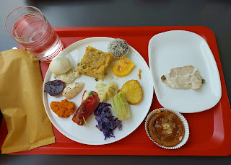

Next, I drove the ladies to Nove, about 10 minutes NE from Dueville. We had discussed MANY options to spend our time over the next few days, but they ultimately made the final decisions each evening, so that we'd have a plan in place for the following day as we went to bed. These are the first guests that have stayed with us so far that really love to shop. From someone who also loves to shop, I was happy to take them to a few of my favorite places.

We stopped at the mom-and-pop owned pewter shop first (on the outskirts of Nove), but the co-owner (and my friend) Carla wasn't there this time. Her husband was much less demonstrative than his wife typically is, ha ha. She usually greets me with hugs and cheek kisses, like I'm one of her favorite friends. On that day, she was up in Aviano with a booth for a summer bazaar of some kind up there.

I've still got my eyes on a chess set from their store. One of these days . . . but I need to save up some nickels first.

From there, we drove into the town of Nove, a place famous for their ceramics. I took them to two of my favorite ceramic stores, where we perused colorful arrays of everything from salt & pepper shakers, to spoon rests, to pitchers, bowls, plates, and platters. I found a pretty rectangular platter on the clearance rack for just $7. (seen below)

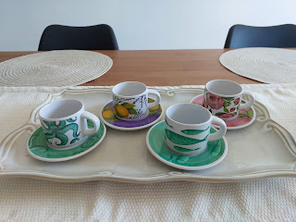

At the next ceramic store, we found some cute little tiny fork and spoon sets (Abby and Gwen will be over the moon!). I also found the most beautiful bowl - a large one that could be used for a family-sized salad - with gorgeous hydrangeas painted on the exterior. So I bought it. The only large bowl that I have in our kitchen in Italy so far is a cheap yellow plastic bowl, great for mixing up some cookie dough in, but not very pretty for serving company.

It was a great afternoon and we came home happy with our loot, hauling it up the stairs to tuck away before making dinner together. I made a shrimp stir-fry that night with lots of colorful veggies, including homemade "zoodles". (Curlicue noodles made from zucchini, cut with our spiralizer.)

The next morning, I took the ladies to downtown Vicenza where we could visit the Farmers Market and see the downtown area. They found some fun items to take home, including a tablecloth, a scarf, and a new blouse.

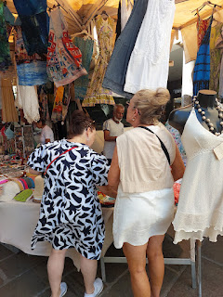

We stopped in a cute little cafe so that they could get their morning coffee. They brought instant coffee with them, which worked well, but they decided that they needed something a little more potent, ha ha. I remember Charmaine (my sister) and her Scott brought French roasters with them. I'm not sure how they work exactly, but I think you put your coffee grounds in before you go to bed and the water soaks it up overnight. I do love the smell of coffee, as it reminds me of my Grandma Zoe. Suzi was worried that it would offend me, since I don't drink coffee as a religious preference, but I assured her it was no problem. :)

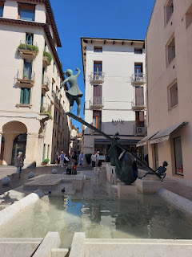

Next, we stopped at Kiabi so that Kelley could grab a few things for her grandson back in Portland. He's not quite one year old and is the cutest little roly-poly thing.

And then we drove about 35 minutes east to Padova. There are a lot of historical things to see in Padova, but for some reason, I never seem to carve out the time to go here. I think the last time I drove into Padova for sightseeing was when my son Jake and his little family came to see us in 2023.

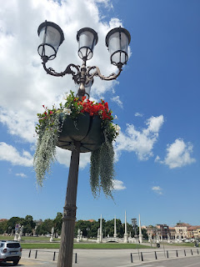

We found a place near the Prato della Valle for lunch before we began our adventures. Here's the menu from Memmo Bistrot.

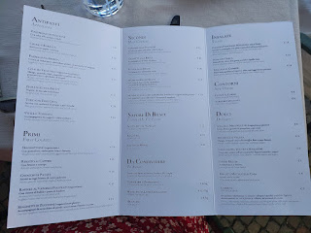

I ordered the Spaghetti di Zucchine, with zoodles, pine nut stracchino, toasted seeds, lemon, and mint. It was cold and it was AMAZING.

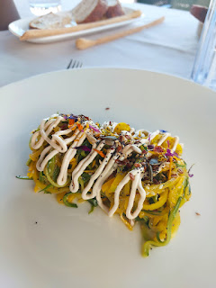

I also ordered the Galletto alla Brace (guy-etto allah brah-chay), or spatchcocked chicken, where it's smashed flat and then grilled. At first I was worried I wouldn't be able to eat it all, but then it turned out to be mostly bones so I only got a little bit of chicken meat . . .

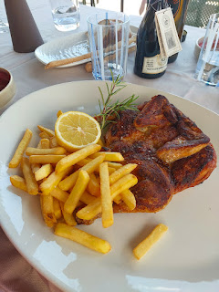

This felt like the hottest day of the whole week, and there weren't many places to hide . . . thankfully we didn't have far to walk to our first spot: the Basilica of St. Anthony, the patron saint of Padova.

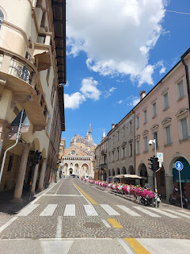

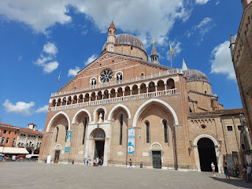

I've been here twice before: the first time was when the Benvenuti Class for military spouses took us on a field trip to Padova in the fall of 2022, and the second time was with Jake and Hannah. The Basilica is huge and quite lovely.

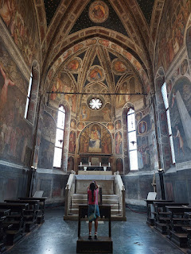

St. Anthony was known for his eloquence of speech, particularly as he taught people about Christ and helped bring them into the "fold". I've mentioned this before, but an unusual Italian custom is to try to preserve body parts of the person who was dubbed a saint - specifically, body parts that were associated with the gifts or talents of that person, or even a miracle that was connected to him/her.

In the case of St. Anthony and his eloquence of speech, they preserved his teeth, his tongue, and his vocal cords. They are now on display in one of the chapels within the large basilica. There was also a jar with the finger of St. Lawrence. Ewww. It didn't look much like a finger to me.

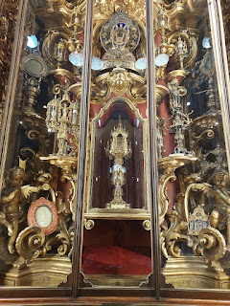

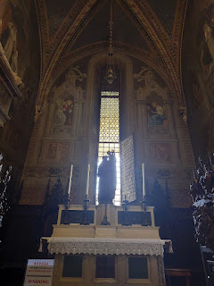

There was no choir rehearsing in the main chapel this time. And there was no kind little priest to offer us a blessing, to which I would have politely declined - since I belong to a different faith. But it was quiet, and surprisingly there were only a few dozen people inside the church while we were there.

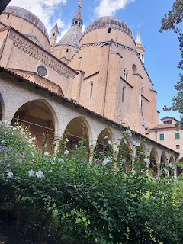

The cloister outside was peaceful and quiet while I waited for the ladies to use the restroom . . .

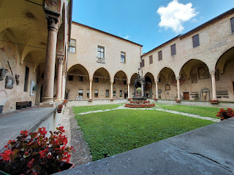

Our next stop was the Botanical Garden, less than a 5 minute walk from the Basilica.

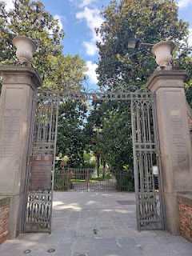

Yes, you're reading the sign below correctly. This is the oldest botanical garden in the world, established in 1545 by monks. Benedictine monks, I think. Later, the garden became associated with Padova University for research purposes and has remained so ever since.

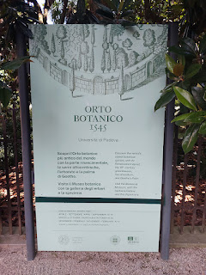

We received a map with our entry tickets, but it was a bit difficult to get oriented while using it. I gave up and just enjoyed wandering the many circular and intersecting paths, taking photos of any greenery that was pleasing to my eyes.

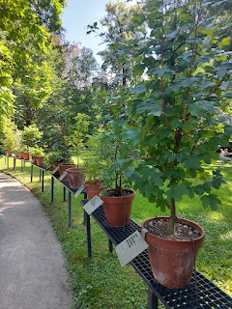

A baby olive tree . . .

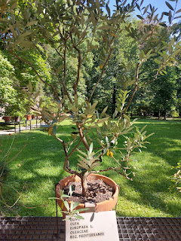

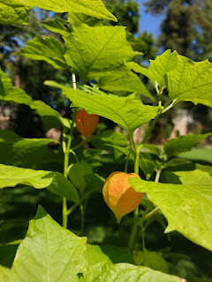

There were at least 2 trees that had been spliced down the center from what appeared to be a lightning strike some time ago. One of them was identified on the map, but I think this is what disoriented me from the start. When you walk out of the ticket office, there is a hollowed out tree, with dark black down its core. I mistakenly thought this was the one shown on the map, which got me all mixed up with where the other points of interest were located. But in actuality, the tree mentioned on the map was further into the garden and was identified by an
actual
sign in front of it.

This is
that
tree . . .

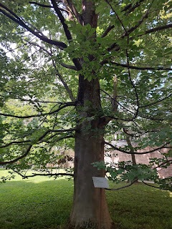

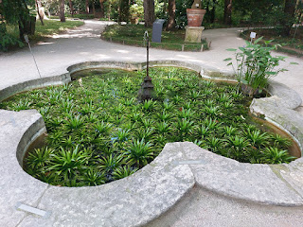

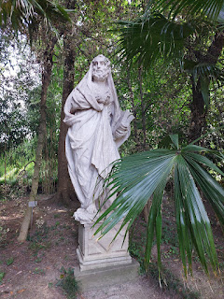

We crossed a little bridge and made our way toward the greenhouses in the far eastern portion of the garden . . .

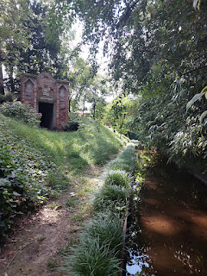

The greenhouses housed several sectioned off areas of plants and flowers, each with its own climate.

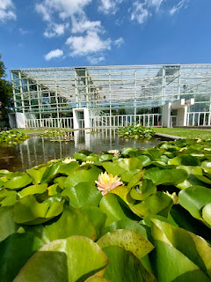

From the driest climate all the way to the most humid one . . .

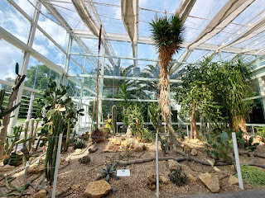

This would be a great place to bring schoolchildren on a field trip, as there are many illustrations and interesting bits of information on signs, along with several interactive doors, drawers, and open-the-flap treasures.

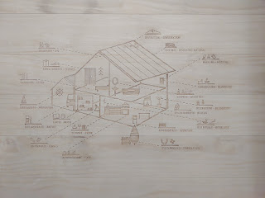

I liked this quote by Leonardo da Vinci: "Endeavor to vary the colour of meadows, stones, trunks of trees, and all other objects, as much as possible, for Nature abounds in variety ad infinitum."

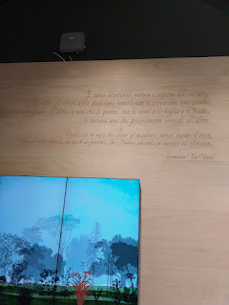

A description of the plants that have helped us to create aspirin . . .

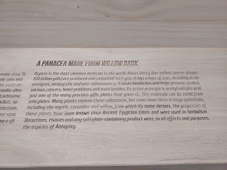

The Pacific Yew plant has proven to be a mighty sword in the battle against cancer . . .

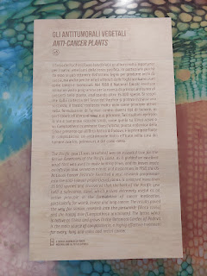

I think this might have been a simple lime, but it looked so happy and plump that I "needed" a photo . . .

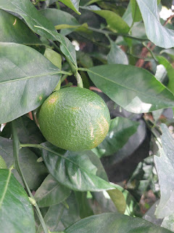

I had never heard this funny story before - about a gift that Columbus received from the people of San Salvador in 1492 . . .

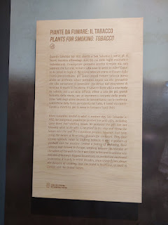

I 100% agree with the idea that cocoa is a food of the Gods, but chocolate-coated chicken?? (read photo below for more)

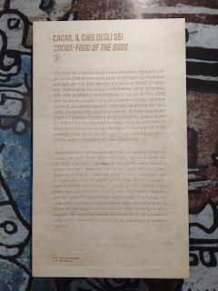

A bit of history regarding spices around the world and where they originated from . . .

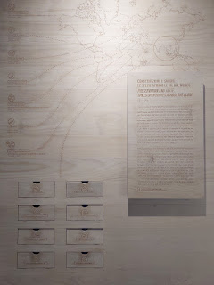

How and why legumes and potatoes are such an important part of the human diet . . .

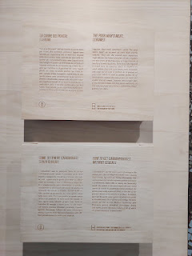

Wine: "Quite an achievement for some mouldy old grape juice."
Olive oil: "...more than just a food. It was used to treat the skin, burnt as fuel, and ... used as a religious symbol." (read more in the photo below)

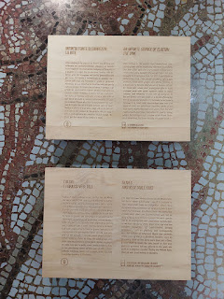

Several fascinating points in the sign below:
~ Our food and drink come mostly from plants.
~ We stimulate and calm ourselves with plants.
~ We enjoy sugar and chocolate.
~ We use plants to make ourselves more beautiful, to smell nicer, to wash ourselves, and to color the world.
~ In some respects, plants domesticated us!

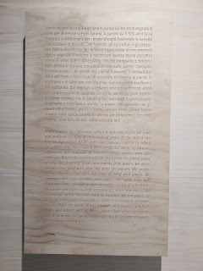

A recipe for Beetroot Brownies . . . (let me know if you try it!)

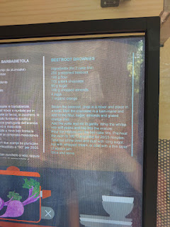

The origins of Coca Cola . . .

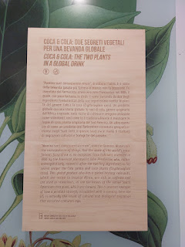

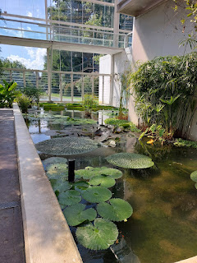

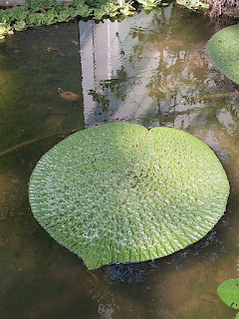

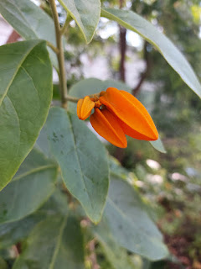

I imagined my grandchildren wanting to hop into these hardy lily pads and then using them as a flat-bottomed boat . . .

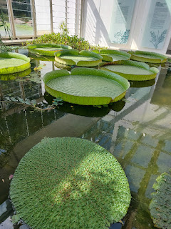

There were some really beautiful tropical plants in the last greenhouse, many that I'd never seen before.

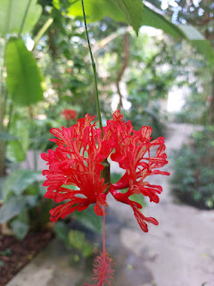

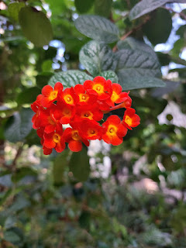

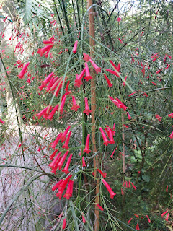

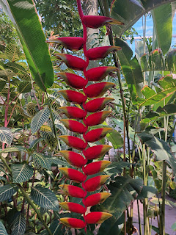

Even the short movie clips that were playing on a few screens had English subtitles at the bottom of the screen, which helped me so that I could actually understand and learn something. Again, this would be a great place to bring your whole family.

Outside the greenhouses, you can see the Basilica of St. Anthony in the near distance . . .

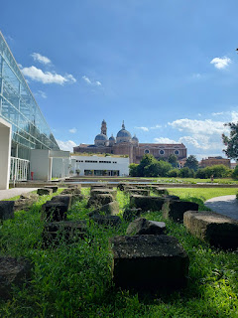

There are gated herb gardens and other featured gardens to explore if you don't mind the heat, which I was starting to mind at this point, ha ha. One of the gardens holds some of the world's most poisonous plants, and another section has rare plants that have almost gone extinct.

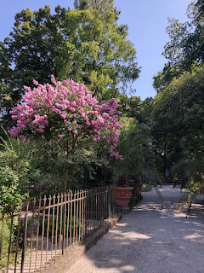

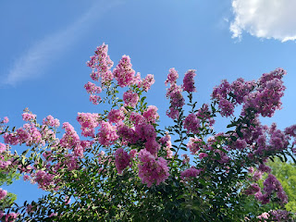

This palm-like tree inside its own greenhouse tower was called Goethe's Palm . . . and until we actually saw it, we had been speculating on what it might end up being. Suzi thought it might have something to do with the artist known as Goethe. I thought that we might end up seeing a giant palm statue (as in, the palm of a hand). Neither of us was right, ha ha.

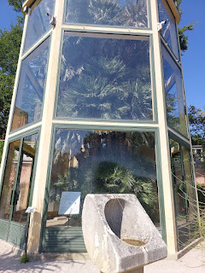

A lily pad "pod" . . .

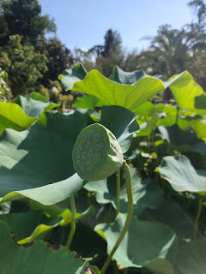

There was a generous section of succulents near the exit, too. I really liked the shape of this one. It reminded me of a handcrafted bonsai tree.

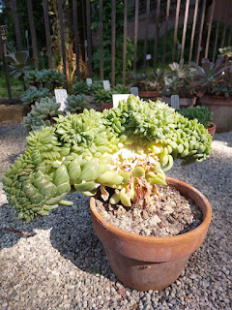

One thing that we really enjoyed about being in the garden was that it was a good 15 degrees cooler than everywhere else we had been in Padova that day. The trees, plants, and shrubs really helped to cool things off and provided some much-needed shade. Thank you, nature!

I worry that when my sister Charmaine comes to Italy for a second visit next year, she will need an entire day to explore this magnificent botanical garden. We may need to just drop her off while the rest of us do something else nearby . . . lol.

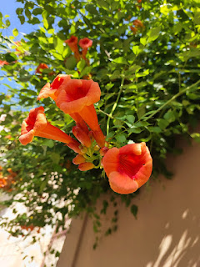

Something we hadn't taken the time to explore yet was the Prato della Valle. Everything that we visited that day was all relatively close in proximity, but we started the afternoon with lunch and had just walked right by this oval-shaped park.

The Prato della Valle was developed in the late 1700s. It used to be a marshy area, but there are records that describe it as being an open market as early as 1077. It is the second largest "square" in Italy and is one of the largest squares in Europe. I love the canal that surrounds the oval-shaped park. They do a good job keeping the water clean, and we even saw a city worker with a long-handled skimmer to scoop out any floating debris as he walked alongside the length of it.

There are several statues of influential people with some historical connection to Padova through the centuries. The only name I recognized - when I looked up the list of everyone (78 to be exact) - was Galileo Galilei.

And here he is . . .

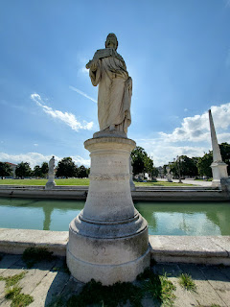

He was born in Pisa, Italy, and later became a professor at Padova University from 1592 - 1610. He taught geometry, mechanics, and astronomy. I've been told that his office chair is still kept at the University to this day.

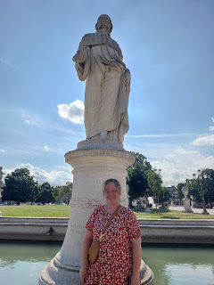

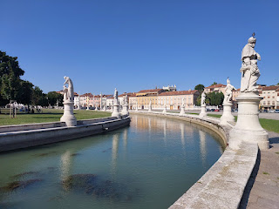

Suzi, Me, and Kelley . . .

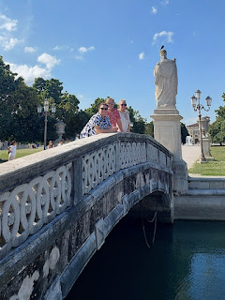

Our last stop of the day was to the Abbey of St. Justina (also spelled Giustina), which is across the street from the Prato della Valle and adjacent to the parking lot where we began. The initial basilica was built in the 6th century, but the one standing today was reconstructed in the 17th century.

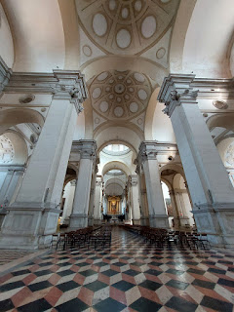

The Abbey claims to have the ancient remains of St. Luke, one of Jesus' original disciples. Scientific testing took place several years ago, corroborating the original designation from whoever the Pope was at that time.

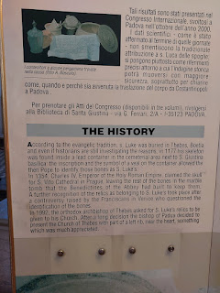

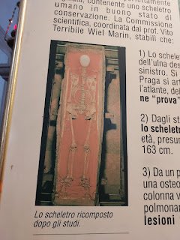

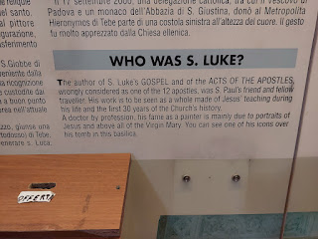

This is the Chapel of St. Luke within the Abbey . . .

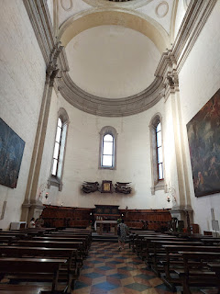

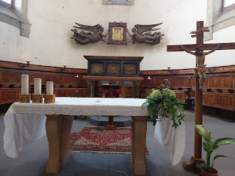

I couldn't get any closer than this, but behind the table and the Cross is the tomb of St. Luke . . .

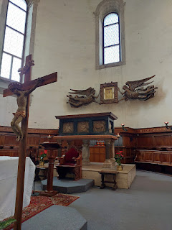

Other chapels within the Abbey . . .

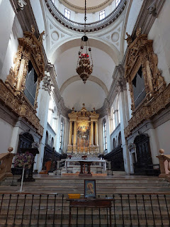

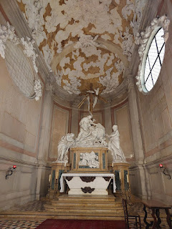

The Corridor of the Martyrs was built in 1564 on the ruins of the ancient abbey church of the Middle Ages. It was designed to be a passageway to a nearby Sanctuary. In the center of the Corridor is the Well of the Martyrs, where the bones of several Christian martyrs during the Diocletian era were discovered in 1269.

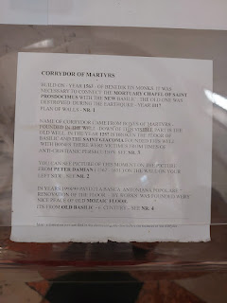

Peeking down into the Well of the Martyrs . . .

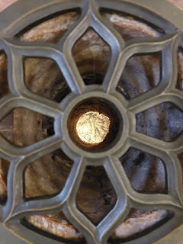

Just past the well and around the corner in the Corridor, is a large iron cage. This is the cage that was used to transport the body of St. Luke from Constantinople to Padova during the Middle Ages.

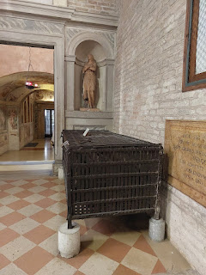

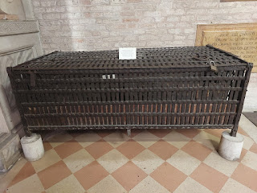

A description of the mosaic floor tiles in the Oratory of the Abbey . . . (click photos to enlarge)

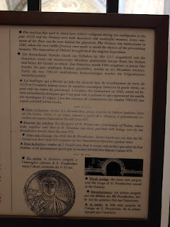

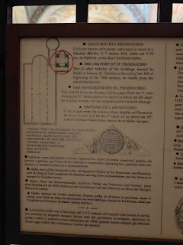

The little chapel of the Oratory of St. Prosdocimo was both beautiful and simple . . .

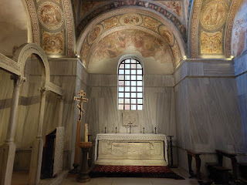

In the second descriptive sign just above these two photos, it mentions that "This is what remains of the buildings erected by Opilio to honor St. Giustina at the end of the 5th or beginning of the 6th century." Wow.

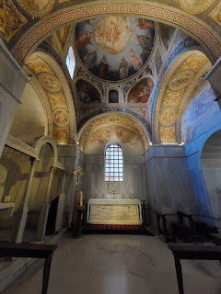

Our little feetsies on the mosaic tile floor in the Abbey . . . Suzi's feet are on the far left, mine are at the bottom, and Kelley's are on the far right.

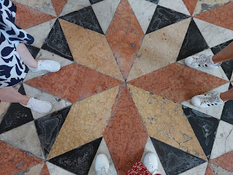

We made it through a very hot day in Padova, arriving home in time to make a simple and tasty dinner together. We took some thin chicken breasts, dredged them in egg and flour, then fried them up in a hot pan. Each chicken breast was then topped with arugula, cherry tomatoes, Parmesan cheese, and a little "blob" of fresh mozzarella on top. A little drizzle of olive oil on top to garnish, along with some salt and pepper, and they were ready to be devoured.

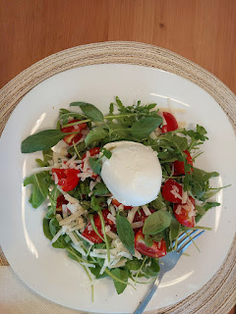

The following day, we drove to Verona. The ladies wanted to see the Arena for starters. I decided to go with them this time because if I didn't, I'd just be sitting somewhere outside by myself and that didn't sound as appealing to me.

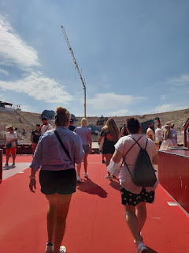

A crew was working steadily in the hot sun to set up all the backdrops for a peformance of the famous Italian opera, "Carmen" that night. It IS on my bucket list to eventually see an Italian opera. I wouldn't mind going to a performance here in the Arena di Verona!

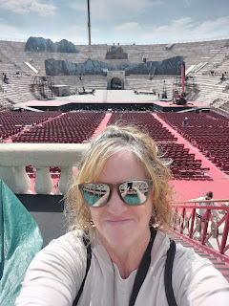

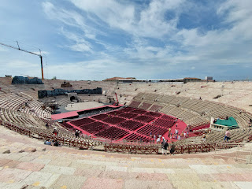

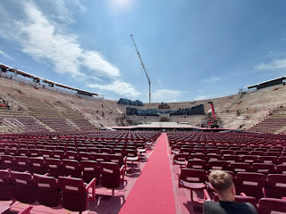

Suzi and Kelley hoofed it up to the tippy top of the Arena . . .

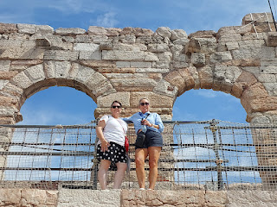

Even though I've been here a few times, it IS a very cool place no matter how often I walk past these ancient walls.

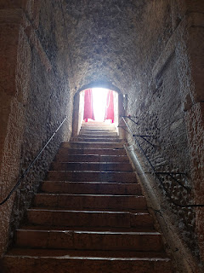

After our tour, we started walking toward the Museo Maffei, which is housed in the Palazzo Maffei. It was maybe a 5 minute walk from the Arena. We had never heard of it before, but there was a huge banner hanging across the plaza from the Arena, advertising the artwork on display of several famous painters. A little fun fact about Suzi and Kelley is that they are both teachers, but they both also have quite an extensive history of teaching art to middle schoolers. Kelley has even been involved with the Art Institute in West Linn, just south of Portland, teaching art there, as well.

It made good sense to go see something that none of us had ever seen before, and even better - it would be indoors with plenty of air conditioning to beat the heat . . .

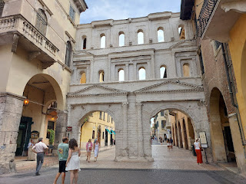

During the short walk to the Museum, we paused to get a refreshing cold beverage at a little cafe.

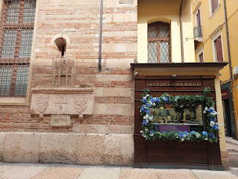

I grabbed us a table outside, while Suzi and Kelley waited in line inside the tiny cafe to purchase our slushies. There was a young family at the next table over, with a tiny newborn baby. As an older lady (with pink hair) walked by, she stopped to make conversation with the parents and admire the precious little baby, as many Nonnas do in Italy. Everyone just loves babies and little ones in Italy.

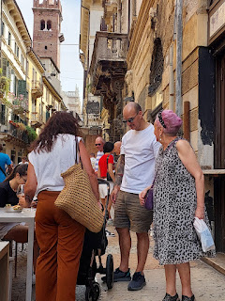

Refreshed and rejuvenated, we finished our walk to the Museum, which sits right across the street from the large market area of Verona.

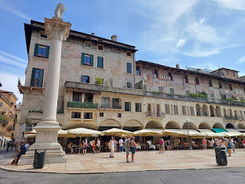

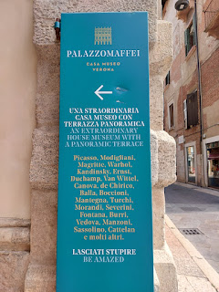

This sign describes a Venetian chair that caught my eye because it was made in the same time period as when my Bassano ancestors lived and worked for the Doge in Venice.

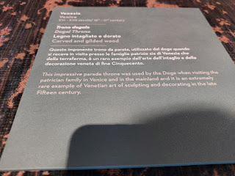

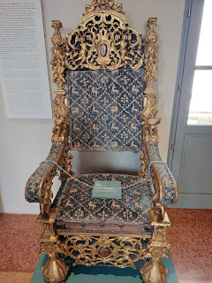

And don't worry, I didn't take a million photos at the museum this time. Just a handful . . . :)

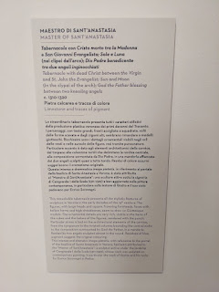

Limestone sculpture with Christ, who is deceased, in between his mother and St. John the Evangelist, with God the Father offering a blessing between two angels. Circa 1310-1320.

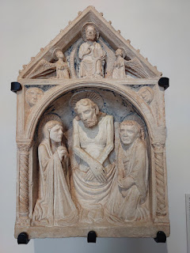

Video of some of the paintings and sculptures in a room that was dedicated to the Virgin Mary and her son, Jesus: (11 seconds)
https://photos.app.goo.gl/GZtadidkJ9vpNjSv7

Both Suzi and Kelley, with their art backgrounds, generated some interesting discussion in this room.

Suzi noticed the next to last painting (in the video above) and how the artist painted Mary and Jesus with dark skin. She liked this one the best because she felt it was the most authentic, since they lived in the Middle East and the climate would have rendered a darker skinned people. Plus they were Jewish, which typically produces darker features. So many paintings of Mary and Jesus are shown with fair skin, almost a white-white.

Kelley pointed out to us that depending on the time period when the artists created their paintings, they may show the subjects looking AT you - or looking AWAY from you. She gave us a mini art history lesson on the spot.

I felt a little more educated as I looked at the paintings a second time.

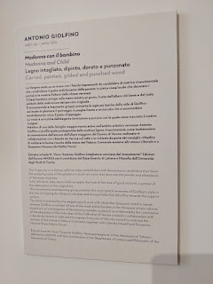

This next piece was intriguing, as the sculpture was made with a punched wood technique. Punched wood is created with a punch tool to create a textured surface. The woodcarver uses a punch, which is a small, shaped metal tool, to tap into the wood and create decorative patterns or textures. These can be simple dots (stippling), or more elaborate shapes like stars, crosses, or floral designs.

This sculpture is called: Madonna and Child, created sometime between 1437 - 1515, during the artist Antonio Giolfino's lifetime.

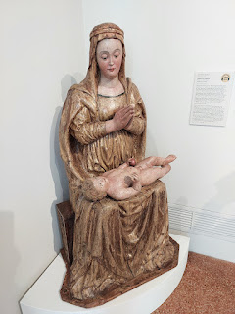

A closeup of the punched wood technique on Mary . . .

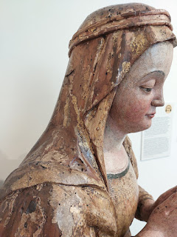

Views out the window of Piazza Erbe and the lively market across the street . . .

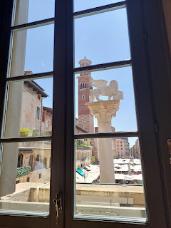

I thought it was hilarious when, after seeing so many thoughtful and skilled paintings, I came across this "work of art" by Picasso. Really? That's all you've got?

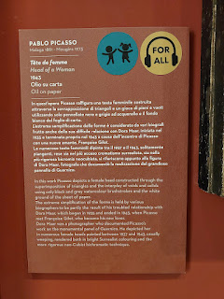

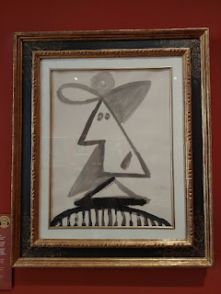

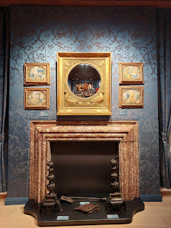

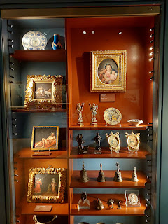

This next painting is super famous - and I had never heard of it (or the artist) before. Kelley recognized his name on the giant banner across from the Arena earlier, and she said she really wanted to see this one in person.

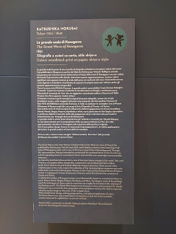

Entitled, "The Great Wave", the artist Hokusai painted the piece in 1831. It depicts a stormy wave menacing small boats off the Japanese coast, with Mt. Fuji in the background. Hokusai "intended to convey both the ancestral terror of man for the sea and its impending desire to overcome his fears and overtake even seemingly insurmountable obstacles."

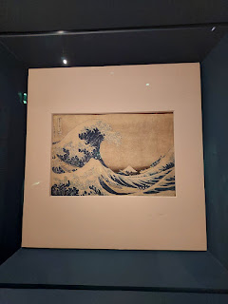

Apparently, Hokusai's painting has influenced several other world-renowned artists, including Claude Monet and Vincent van Gogh. And the description (above) of "The Great Wave" states that this piece has received more Google hits than the Mona Lisa!

And then, there's Pablo Picasso . . . lol

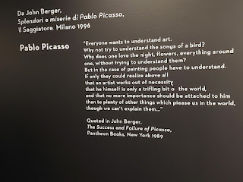

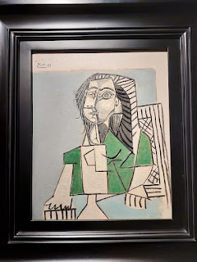

The spiral staircase in the Palazzo was especially beautiful . . . we climbed all the way up to enter the museum, and marveled a second time as we climbed back down afterwards.

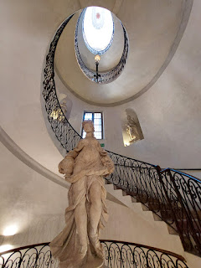

In the market of Piazza Erbe across the street, Suzi and Kelley found a few last gifts for loved ones back home, and Kelley filled up her water bottle next to one of the booths.

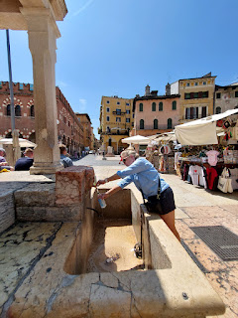

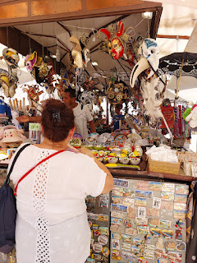

Soon, we made our way back to the car and drove over to Lazise on the shores of Lake Garda. Something new that I learned later that afternoon is the correct pronunciation for Lazise. I've always called it "lah-ZEE-say". But it should be pronounced like "laht-ZEE-zay". (At least I hope I remembered it correctly . . .)

We found a cute restaurant next to the tiny little harbor to grab a late lunch. I splurged and bought a sparkling lemonade - something I don't usually do because of the carbs. But I feel like the drinks in Italy are far less sugary than similar offerings in the U.S. Plus, I was hot and sweaty and thirsty, and it just sounded amazing. And it was.

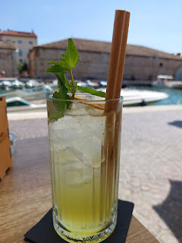

We ordered 2 personal pizzas and then we split them 3 ways. It was the perfect amount of food for all of us, especially since we didn't want to get too full at 3:00 in the afternoon, when we also had plans to go out to dinner at 7:00 that evening back in Vicenza.

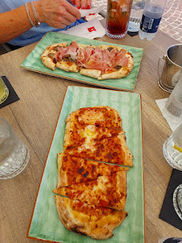

Lots of people were taking their boats out onto the lake from the small harbor: (10 seconds)
https://photos.app.goo.gl/bFraxAD4XY5QrPpX9

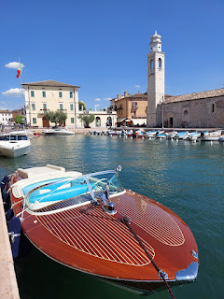

I told the ladies the story of how my grandson Jack wanted milk when we visited Lazise 2 years ago, and how the gelateria was so kind to share some milk with him. They brought it over to where we sat on a park bench next to the lake, and he happily slurped all of it down from the cute metal pitcher with a straw. I will forever bring guests to the same gelateria every time we visit Lazise.

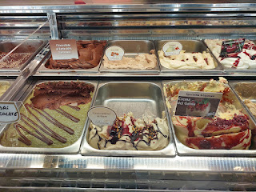

This time I chose a chocolate and pistacchio mix and I absolutely loved it.

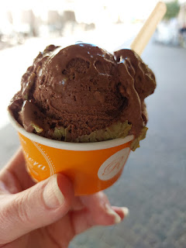

On our way back to Vicenza, we stopped at the family-owned Frantoio Bonamini olive oil farm near Soave. We sampled a few olive oils and vinegars before making our selections. It was when I was chatting with Rebecca, the grandaughter of the owners, that I learned how to pronounce Lazise. :)

Ever since we moved to our new house back in February, we have driven past a restaurant that sits on the corner of a busy roundabout approximately 1 km from home. I always see lots of Italians eating lunch there, and I've been wanting to try it for dinner some day. When Kelley and Suzi offered to take us out to dinner and they asked for a recommendation, I immediately suggested the Due Fogher.

Here are some pictures of the menu . . . and yep - it's all in Italian. That's when you know it's good.

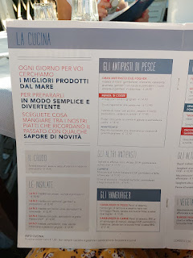

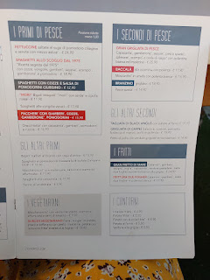

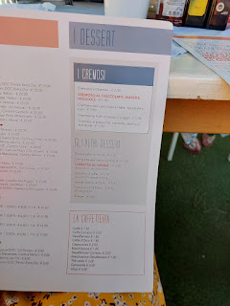

I ordered the bowl of mussels - no surprise there - and they were super yummy.

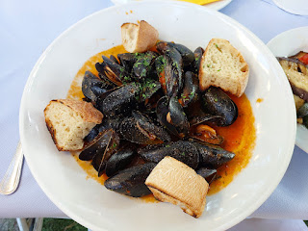

And yep, I also ordered the traditional grilled vegetables on the side.

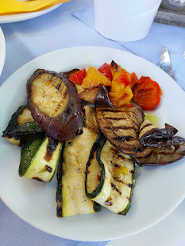

Scott ordered the "USA Pizza", with both FRIES and HOT DOG slices on top . . . what a guy.

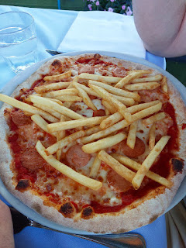

We got there at a great time (7:00), when hardly anyone was there. But by 7:30, the whole garden area was packed with patrons and the parking lot was full. I also loved how we could book a table on their website, which was very user-friendly.

With happy tummies, we drove home for their last night in Vicenza with us. While I helped Kelley pack up some items and place them carefully in a USPS flat-rate box to ship home, Scott sat down with Suzi and helped her learn how to use FamilySearch. She had been asking me several questions earlier about what we do in the temple (as members of the Church of Jesus Christ of Latter-day Saints), and she wanted to know how to build up her tree and make a few corrections that she had struggled with recently on the FamilySearch website.

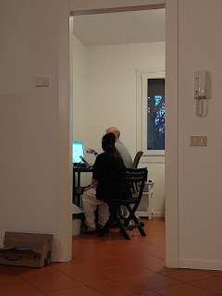

Once Kelley's box was packed, I hopped onto Newspapers.com to find some older articles and a few juicy news bits about her parents and her paternal grandparents. We had a good ol' time with that.

The following morning, I made an elaborate breakfast for all of us that I didn't originally intend on making. I saw some fruit in the fridge and decided to make a little bowl of fruit salad that we could share, with diced mango, grapes, and berries. Then I noticed some leftover French bread that was 2 days old and wasn't getting softer with age . . . I thought to myself, "That would make some really nice French toast!" I also saw some pancetta in the fridge (Italian bacon) and decided to continue the elaborate breakfast trend by making some scrambled eggs with bacon. Pretty soon, we had a beautiful brunchy spread on the table.

Suzi and Kelly were all packed up and ready to go by this point, so we took some last photos together before they left. I was sad to see them go. I learned a lot from hanging out with them.

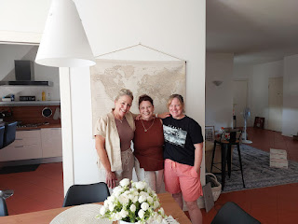

Sunset that evening . . .

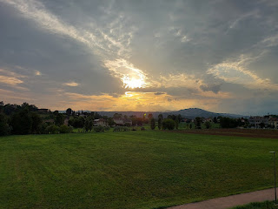

I know this blog post is a little late in getting out, but since I last wrote, I flew to the U.S. and enjoyed an entire week with all 3 of my children, plus 4 grandchildren at my house in Idaho Falls. Currently, I am in a hotel room in Winnemucca, Nevada as I make my way out to CA for a family reunion this weekend.

Lots more to share in the coming days . . .

