Party at the Harmon Rancheria
When I flew into Idaho Falls two weeks ago, I hit the ground running. My house was chock full of people that I love - from age 53 (me) all the way down to age 11 months (Maisie). It was a special feast to be with so many family members, plus a grandchildren extravaganza!

I took far more videos than I did photos, but it's too tedious to link each one here in a blog post. Instead, if you want to see ALL the action and candid moments, click here to take a peek:
https://photos.app.goo.gl/4ypRvEacrHorUazW6

Maisie loves to eat, and she makes the cutest smacking noises with her lips to let you know how much she's enjoying everything. Her parents would - on occasion - set her up to eat outside on the patio.
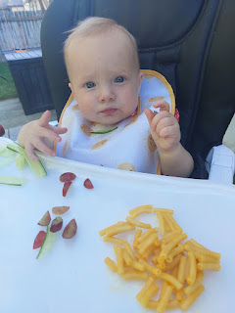

Video of cousins running around Maisie while she quietly munched away: (9 seconds)
https://photos.app.goo.gl/43ramfBLkCMCrpk59

First thing the next morning, I recruited all 3 of the older grandchildren to help me with a special job: To give "Scottie" the Scottish Elm a much-needed haircut.

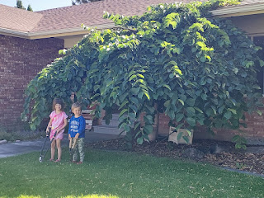

The branches were hanging down almost touching the ground, and anyone trying to get to the front door had to duck and maneuver around those long and leafy tendrils.

I gave Gwen and Jack my two sets of pruning shears and with explicit instructions to be careful, don't run, and watch out for people around you . . . they joyfully began chopping all the lower branches off.

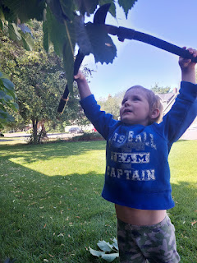

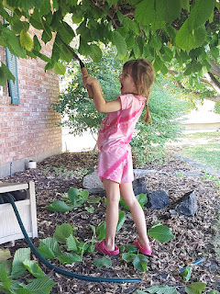

Jack especially enjoyed "attacking" the branches with his pruners: (9 seconds)
https://photos.app.goo.gl/yoEsQu2ZySuaczgV7

Take a look at the expression on his face here: (8 seconds)
https://photos.app.goo.gl/j73xDCFHDGxMN8v8A

Jack was definitely experiencing some masculinity during the job: (13 seconds)
https://photos.app.goo.gl/VCs6ULnXt6z7dWFWA

I captured several faces Jack made while trimming the tree . . .

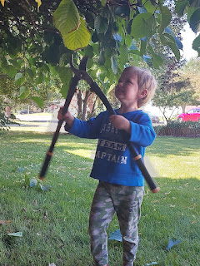

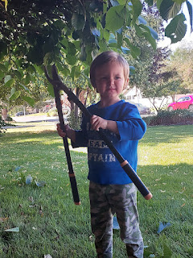

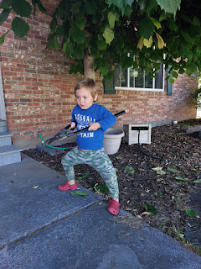

They did such a great job!! I didn't trim one single branch! They did all the work!! Gwen and Jack tackled the lower branches, and then Abby took care of the finishing touches. I showed her how to keep a straight line - sort of like cutting your bangs - and then she didn't need any further coaching.

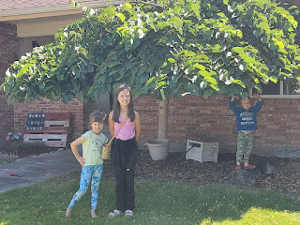

Jack fell asleep on my bed later that afternoon while watching a TV show. What a sweetie . . .

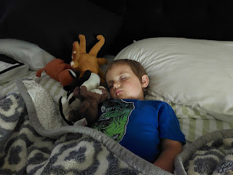

Abby and I worked together to make some zucchini brownies, using a ginormous zucchini that Helma (our backyard neighbor) brought over. We traded off shredding the zucchini and gathering the rest of the ingredients. After the brownies finished baking in the oven, Amber and Abby made the icing for the brownies and then the rest of us relished in the warmth and gooeyness of the finished product. They were amazing!

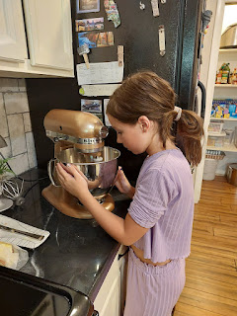

Here's the recipe we used:
https://www.crazyforcrust.com/zucchini-brownies/

Later that afternoon, the kids were getting a little restless and wanted to play in the water outside. I set up some options in the front yard so that the back yard could stay dry for when William (our neighbor Kim's son) would be coming over to mow.

We hauled out some chairs for the grownups to lounge in the shade and keep an eye on the kids. We set up a sprinkler and brought out some snacks to munch on. Pretty soon, the kids wanted to make "Nature Soup", so I found them some buckets and containers to use. Nature Soup consists of whatever you can find in nature + water.

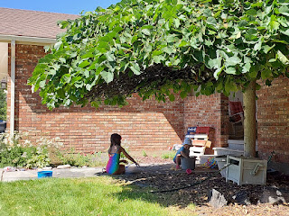

Gwen and Jack spent quite a while making mud together, adding a few extra touches like leaves, grass, bark, plus some faded flowers in the garden bed next to the porch (with permission of course).

I even got out a few older paintbrushes from the garage so Jack could "paint" on the sidewalk. He kept wanting to dip the colored sidewalk chalk into his soupy sludge so that it would turn into paint, but his parents kept steering him away from that. With the paintbrushes, he could dip them into the water and then paint over the chalk drawings that were already on the sidewalk. He enjoyed making the chalk disappear, ha ha.

Meanwhile, I got the cutest picture of Hannah and Maisie who were sitting next to me in the shade. I rarely get a photo of Hannah, but this one turned out so cute of the two of them!

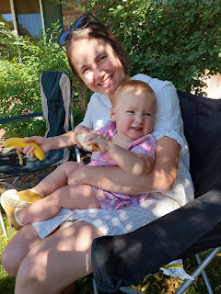

Maisie found Jack's leftover bell pepper and started munching on it . . . they all love raw veggies in their family.

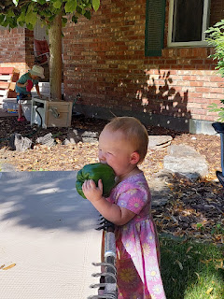

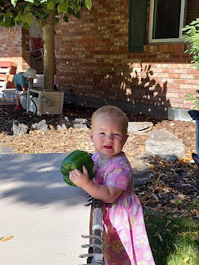

Two days after I flew into Idaho Falls, Amber drove me down the street to Teton Radiology so I could get a CT scan of my neck and throat. This appointment had been scheduled clear back in April, and would prove to be very informative. I've been struggling to breathe for several months now, and the best way to describe it is that it feels like I'm breathing through a tiny straw right next to my vocal cords. I'm real "breathy" when I talk, and it's really hard to sing because I'm having to force more air out through my tiny windpipe. I can do moderate exercise on most days - as long as I'm not having to talk at the same time. But some days, I have to stop whatever exercise I'm doing because I just can't get enough air. I'll share more about the results down at the bottom of this post . . .

In the middle of all the hub bub of having so many family members at my house, it felt weird to step away and go to that medical appointment. But it was important, and I knew that the kids would still be playing with or without me. I had also scheduled a lengthy hair appointment some time ago, and it fell right in the middle of everyone hanging out at my house. I didn't know when I set it up that this was when everyone would be coming. At least they could hang out with each other while I was MIA at the salon! Amber dropped me off, and then 3 hours later, Jacob and Jack came to pick me up. :)

On our last full day together, we walked over to Shamrock Park, about 1 mile from our house. We pulled Jack in the wagon, Maisie rode in her stroller, and the rest of us walked. The weather was overcast and mild, which was perfect for our outing.

Abby and Gwen ran clear to the top of the giant hill in the middle of the park as soon as we got there.

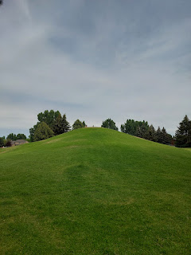

We played and played for at least a couple hours before Maisie fell asleep in the swing, ha ha. Jake tucked a little blanket into the swing so her forehead could rest on something softer. He waited until she was really "out" before he stopped the swing and brought her over to the blanket to sleep more comfortably.

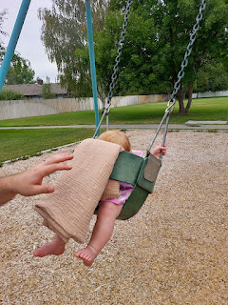

He laid next to her for a few minutes to make sure she didn't wake up and get distressed. He's such a thoughtfuly daddy.

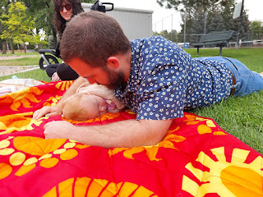

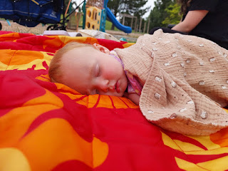

At one point, a middle aged couple came over to talk to us while they were on a walk with their huge chocolate labrador. At first, they seemed very nice, but then they started grilling us with questions like:

Do you live in this neighborhood? (No, but we live one subdivision over.)

Well, this is a private park. Are you here visiting someone who does live in Shamrock Park? (No...)

Then technically, you're not supposed to be here. There are signs posted that say that this park is only for the residents of Shamrock Park. (Wow, okay, well we've been coming here for years with our children and now they wanted to bring their own children to play.) (I didn't say that, but it's what I was thinking)

Blah blah blah . . . there's been some recent vandalism so we've had to tighten up security around here.

This is when I point blank asked, "Do you want us to leave right now? Like this minute?"
"Not necessarily . . . but just keep this in mind for next time."
Pleasantries were exchanged and then they continued on their walk.

A few minutes later, I saw them across the park as they entered into their back yard with their dog. They didn't have a wooden plank fence surrounding their yard, but they had a see-through iron fence instead. That's when I realized that they probably saw us playing at the park, maybe they even got some binoculars out to see if they recognized us, and then decided to go on a "walk" through the park to talk to us. The whole encounter was just odd and uncomfortable. Jake and Hannah were in awe of my bluntly asking if they wanted us to leave right then and there. I told them that it's better to be direct in a situation like that, rather than assume that they wanted us to grab up our little ones and vacate the premises immediately - which would create a scene and a lot of resentment. OR, if we just stayed for hours and hours, maybe THEY would be upset and full of resentment that the communication hadn't been clear enough. It's best to be upfront and direct, but to also be as polite as possible.

So we stayed a while longer.

The girls found some flowers to place in each other's hair . . .

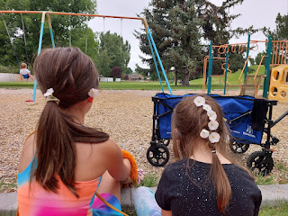

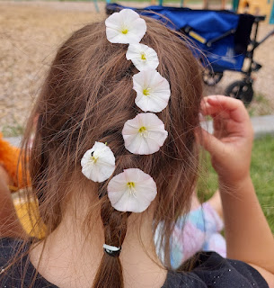

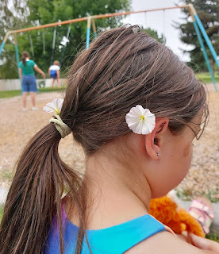

Eventually, we walked home and had lunch along with a nice, quiet, nappy afternoon.

Benson arrived from Mountain Home with my car (YAY) just in time for dinner, and while Maisie munched on some broccoli, the rest of us sat around to visit on the back patio plus get a fire going in the fire pit.

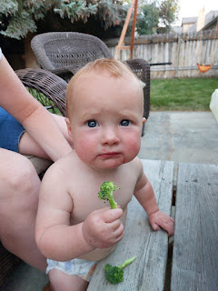

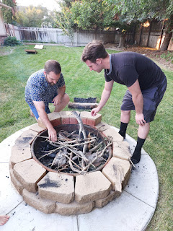

Jake had this idea that if he lit a piece of wood in the propane grill, then he could get the rest of the fire going with that as a start. But it proved to be a challenge and eventually had to be abandoned altogether.

Video of Jake trying to carry his starter kindling over to the fire pit, but it kept burning out: (17 seconds)
https://photos.app.goo.gl/xHz5JVqezJCVyHfh7

I suggested that we create a chain of people where Jake could transfer his flame to Amber's stick, and then she could transfer her flame to mine, etc. But that didn't work either . . .

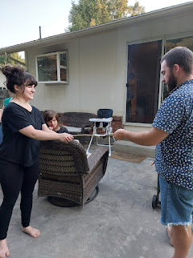

We finally just resorted to the standard method of lighting a fire: with a "clicker".

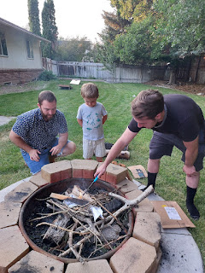

And of course, that worked. Jake just had an interesting idea and he wanted to try it out first. Also, you may hear Abby humming in one of these videos - she's singing the one line of a song that I remembered from when I went to Girls Camp as a young girl. I told everyone that I remembered sitting in a circle around the fire with maybe 50 or so people, and as we sang this song, we would use our lit candle to light the candle of the person next to us. We would "pass on" our light to those around us. Was it cheesy? Yes, but was it also effective? Yes.

My kids were dying with laughter as we tried to pass the flame from person to person and to the fire, because I was singing the only line that I could remember:
"It only takes a spark to get the fire going . . ."

Here's a link to a lady singing the whole thing at a Billy Graham special back in 1976:
(You're welcome)
https://www.youtube.com/watch?v=OcRJ5aDDBVc

Jake helped Jack to add some kindling to the fire: (7 seconds)
https://photos.app.goo.gl/1mUz3fL1WaX25y8D8

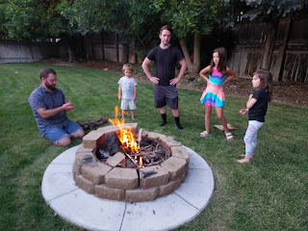

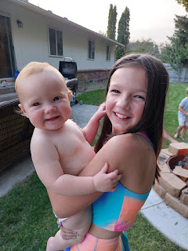

Maisie loved it when Abby held her for the first time. She was very curious about Abby's long hair...

Jake and Benson set up one of the tents that we somehow still have - so the kids could all play inside.

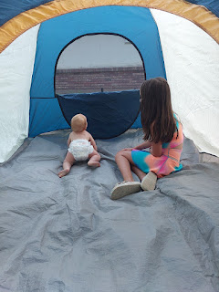

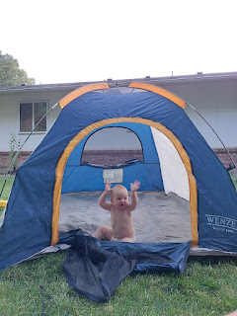

Maisie thought it was the coolest thing ever . . .

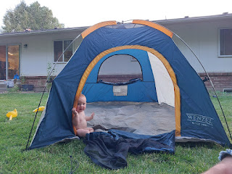

We roasted marshmallows over the hot coals and had s'mores . . .

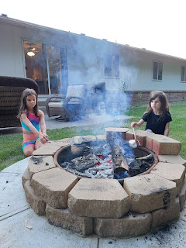

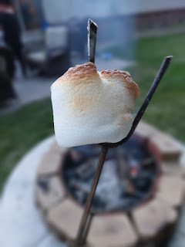

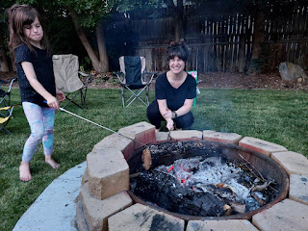

Gwen's face says it all . . . LOL

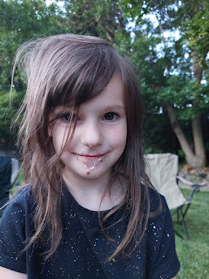

I love how Maisie is so comfortable hanging out on her dad's shoulders. Most of the time she uses his hair to hold on, even when he's galloping around the yard with her. He doesn't seem to mind, either!

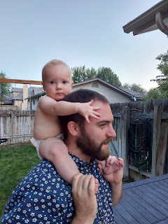

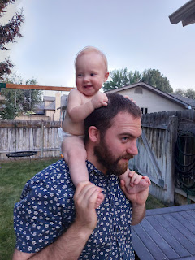

Before we went to bed that night, Hannah helped me to get some family photos, since it's not very often that I have ALL 3 KIDS in the same place at the same time!

Jake, Amber, and Benson . . .

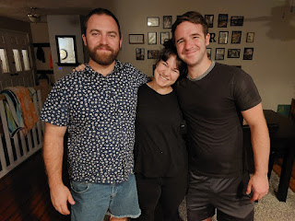

Jake, Amber, Me, and Benson . . .

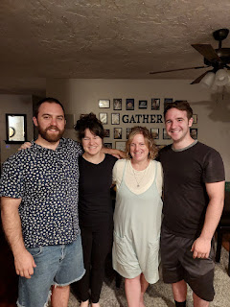

Plus, I thought it would be cute to get all of our feet together, too. Amber told us to spread out our toes as far as we could (because she thought it would be funny), but as much as I tried, I could not get mine to spread out!! I think she has a special skill here, but clearly, I do not.

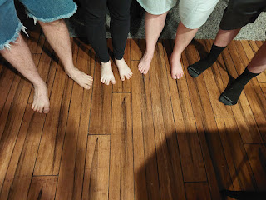

Early the next morning, it was time to say goodbye to Benson and also to Amber, Abby and Gwen. We convinced Maisie to let Benson hold her - just for a quick minute . . .

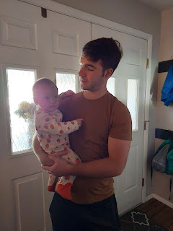

Jack didn't feel like giving hugs, but he was happy to let his Orca whale give Auntie Amber a high-five.

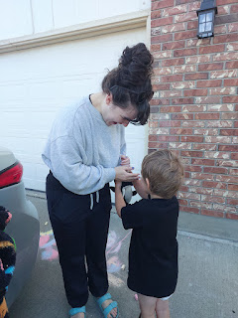

Abby wanted to hold Maisie one more time . . .

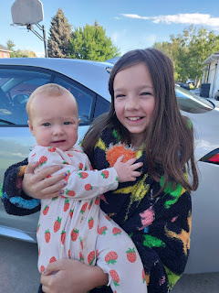

With a full car, they were ready to go. Weston had already driven back to Portland with their Rav4 a few days earlier in order to get back to work, so Amber rented a car to get the rest of them home. They would be dropping Benson off at Mountain Home AFB on their way, and Benson happily offered to drive for those first 3.5 hours to take some of the load off Amber. (10 hours total for her)

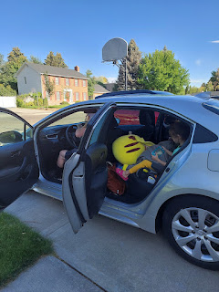

Before they drove away, I offered to say a prayer since we were all together. As soon as I said the words, "Dear Heavenly Father", I couldn't even speak. I was sobbing because I felt the spirit so strongly. What a beautiful thing it was to be with all of my kids and to pray WITH them and FOR them. I just wish Scott could have been there, too. And Avery.

It was a lot quieter when we came home from church that morning, with only half the number of people in the house. We were all so tired from the late nights and lots of partying, so we found a quiet place to lay down after lunch while Jack and Maisie were napping.

Jack discovered that he loves waffle cones, ha ha. Of all the things . . .

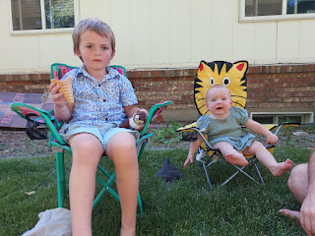

And it turns out that his stuffy named "Ottery" loves them, too!

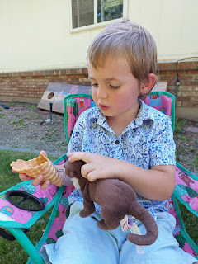

Look at how Ottery is gobbling up that waffle cone . . . my oh my . . .

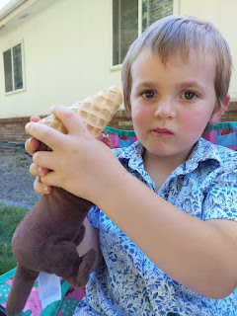

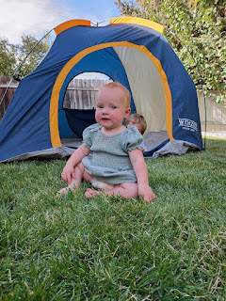

Jack wanted me to be the big scary bear again, like I had done the night before. The kids would "hide" in the tent with the door zipped up, and I would prowl around the outside, growling and pawing on the tent. A couple of times, I even unzipped the door just enough to get my "paw" inside, which sent them all scrambling and screaming to the opposite side. They wanted me to do it over and over, until I had to tell them that the Bear was too tired and needed to go back into hibernation, ha ha.

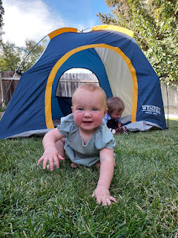

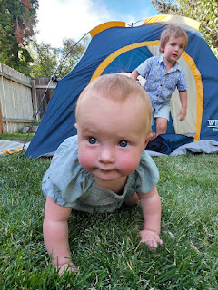

On Monday (July 28th), the day before they left, I noticed that one of the fence posts needed some attention, so Jake and Jack teamed up to fix it for me.

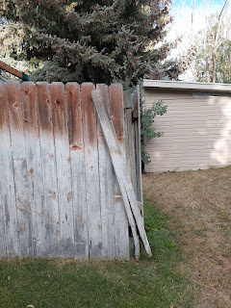

Jack was so excited to use the drill for a "real job" . . .
Video here: (5 seconds)
https://photos.app.goo.gl/9TNpHZNxjX599H6Q9

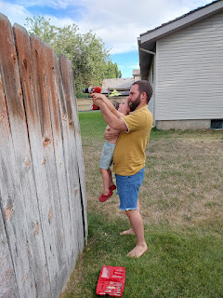

Jack always has something going on in his head. If he's awake, he's got a story, a scenario, a question, etc. to act out/tell you about/ask you about. I had a good time puttering around the yard with him, just letting him chatter away about this or that.

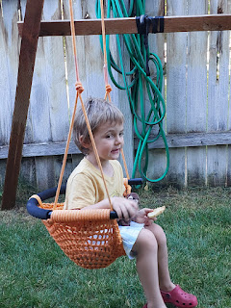

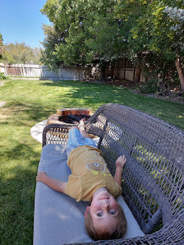

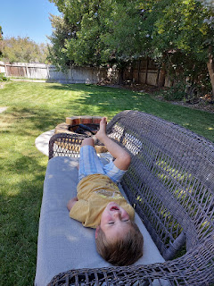

Something I really love about Maisie is that she's snuggly and sweet. (She can also be spicy, too!) Jack has never been all that huggy or affectionate with me, but it was really heartwarming to see Maisie reach out to me so that I would pick her up.

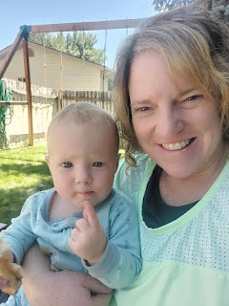

I say "spicy" because - well, she does have red hair. She's also teething. HARD. She's 11 months old and still only has 2 bottom teeth!! She will occasionally get a low-grade fever, and she wants to chomp and bite down on anything and everything, but she still has nothing to show for it. I guess Jack was slow to get his teeth, too, so maybe it's a genetic thing from Hannah's side of the family.

Maisie has started biting Hannah while breastfeeding - ouch! And one evening when Hannah was gently cleaning Maisie's face with a damp paper towel after dinner was over, Maisie chomped down super hard on Hannah's finger and it drew blood!! When Hannah yelped in pain, Maisie started to cry because she felt so bad. I hope for all their sakes that Maisie gets some teeth in soon . . .

Jake gave Maisie a stalk of rhubarb to chaw on, hoping that might help her with the teething. But I was worried about her getting poisoned from the rhubarb leaf at the opposite end! They didn't know that it was poisonous at all, so I found them some information using ChatGPT. They broke off the leafy end and got rid of it right away.

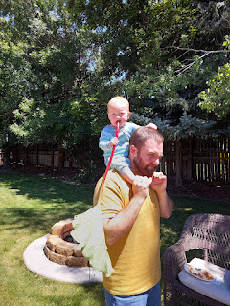

THIS is why I nudged Scott so hard to replace the banister and railing at the top of the stairs, so that our grandbabies would be safe. Previously, they could all fit their heads and entire bodies through the brass poles. It was always so scary when one of the little ones would crawl over and pull themselves up. But now we know they'll be safe. :)

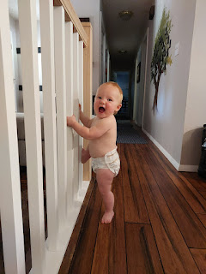

Hannah wanted to try Orange Leaf, a cute locally-owned frozen yogurt shop close to where we live. We put the two kiddos into the wagon and walked the 3/4 mile on our last evening together. Jack doesn't like creamy textures AT ALL (yogurt, ice cream, melty chocolate chips on a cookie, peanut butter, etc.) but he happily munched on the fresh waffle cone "disc" that the cashier gave to us for free. Usually they break the thin circular waffles into chunks so they can be used as a FroYo topping, but they gave us a whole one and Jack had the biggest smile when Hannah gave it to him. :)

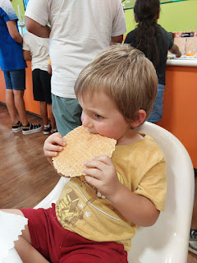

My favorite topping is always the fruity "bobas", which are little flavor-filled balls that pop and dissolve in your mouth. Hannah was so glad we came and she enjoyed every bite.

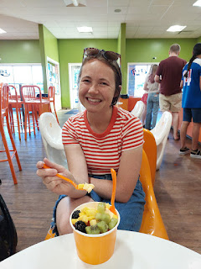

Maisie ate some FroYo, too. And I bet the cold felt good on her gums . . .

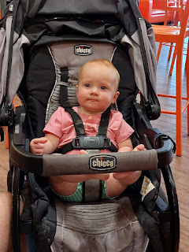

Before they left the next morning, I got some pictures of Maisie playing with her new birthday gift that I spent so much time making over the past few months.

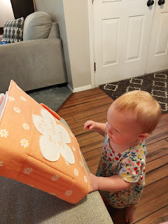

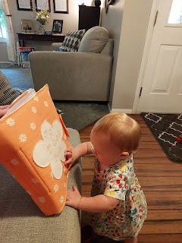

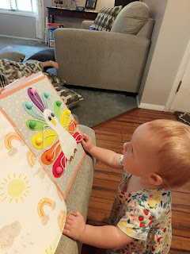

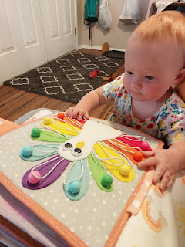

Jack loves it, too, of course. Plus, he looks so big next to his little sister . . . wow.

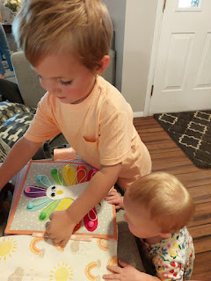

Video of the entire Quiet Book and what's on each page: (7 minutes)
https://photos.app.goo.gl/6WRxZqjomqeaYMch6

Time to say goodbye . . .

Goodbye sweet Maisie! I loved your silly personality, your sweet hugs and snuggles, and watching you learn about the big world around you.

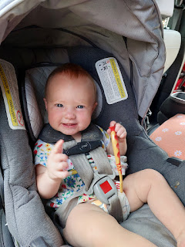

Goodbye silly Jack! I will miss your incredible imagination and ability to retain so much information about dinosaurs, sea creatures, and everything else you have been learning about. I will miss seeing how kind and patient you are with your sister, and I will also miss exploring around the house and yard with you.

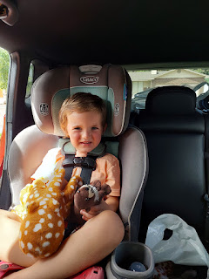

They drove down to Utah to spend 2 more days with Hannah's family before they flew home to Minneapolis.

Meanwhile, I need to finish the rest of the story about my throat. I went to see my primary care doctor, Laura Mason (technically she's a NP) a few hours after Jake and Hannah left. She looked through all the medical notes from the doctors I had recently seen in Italy and she picked up on something in my bloodwork results that was quite worrisome to her.

D-dimer is what it's called, and essentially it's a protein fragment that is produced when a recent blood clot is broken down inside the body. Elevated D-dimer levels can indicate that a blood clot has formed and is being dissolved, but it doesn't pinpoint the clot's location or type.

Normal range for D-dimer is LESS THAN 500. My result showed 1019. That's more than twice the normal level!! Dr. Laura was worried that maybe I had a clot in my lungs and that this was the cause of my shortness of breath. When she learned that I was leaving the next day to drive to CA to help my mom with mold mediation and cleanup, she about fell out of her chair. She said absolutely not - and that an N-95 mask would not be safe enough, nor would a respirator mask. She was anxious to hear what the ENT would share with me the following morning in regards to my recent CT scan.

An hour later, I got a call from my friend and neighbor, Peter Vance, who partially owns Teton Radiology, the place where I got my CT scan. He told me that both he and a colleague looked at my CT and they both saw the same thing. There is a dark webby area near my vocal cords, but they didn't know what it was.

I was out running errands at the time, and now I started freaking out a bit. Between having a possible blood clot and then a dark mass in my throat, I was beginning to question my mortality. When my sister, Charmaine, called that evening so we could discuss details for our trip out to Ukiah, CA to help our mom, I couldn't keep my worries to myself any longer and I spilled the tea. We both cried over the phone, worried about what the future might hold.

She suggested that maybe I should cancel my trip to CA, but I didn't want to do that. Instead, I forged a plan to slim down the trip without canceling everything. I really wanted to help with the work at my mom's house, but Charmaine said NOPE. She cried, "You're one of my favorite people in the whole world, and I need you to be around for a long, long time!!"

At the ENT office the following morning, Dr. Baker told me that what I have is called Subglottic Stenosis. A normal windpipe is a long, open tube with plenty of room for air to flow throughout. Subglottic Stenosis creates scar tissue near the vocal cords that thickens over time, creating a windpipe that looks more like an hourglass. If left untreated, it can eventually close off the windpipe completely.

Dr. Baker referred me over to a colleague of his, Dr. Hall, for further evaluation and most likely to get a recommendation for surgery. As I was already trying to slim down my trip to CA, I set up the consultation with Dr. Hall for Wednesday, August 6th, which meant that I would only be in Ukiah for 3 days. Two days of driving to get there, and two days to get home, with just 3 days in the middle. But I didn't want to NOT go.

When I got home from CA (details will be in the next blog post), I went to see Dr. Hall. He wanted to put another camera up my nose and down my throat - blech. I wasn't mentally prepared for that, thinking that I'd never have to do that again!! He explained that he felt it was necessary to help him prepare for surgery, which is what he recommended during our visit. He tried to ease my anxiety by saying that his equipment was smaller than Dr. Baker's and that he would be done in 60 seconds or less. Still blech.

What I learned from him is that I have 25-50% constriction in my trachea. Some patients have come in with 90% constriction, and yes, the throat can eventually close off completely. Scar tissue has formed in my throat - and we don't know the cause. (also known as idiopathic) He's pretty sure I don't have an autoimmune disease, and I haven't had a recent infection, and I didn't meet any of the other possible causes either. Maybe we can blame it on all the times I've had Covid . . .

For surgery, he will put me to sleep and then put a metal pipe down my throat. He will use the center of the pipe to conduct his work in trimming out the scar tissue. He will inject a steroid while he's down there to reduce the risk of recurring inflammation, and the whole precedure is pretty quick - only about 30-40 minutes. As for recovery, I will feel like I have strep throat for a couple of weeks. Not fun, but doable. I'll be on soft foods until my throat feels better. (a.k.a. gelato - once I get back to Italy)

Surgery is scheduled for this coming Friday, August 15th at noon. My neighbor Kim will take me to the hospital and pick me up afterwards. She's so sweet - I told her I could just walk over before the surgery since the hospital is right across the street from our neighborhood, but she just gave me THE look . . . before announcing that she would be dropping me off anyway. :)

My dad gave me a priesthood blessing while I was in Ukiah, and I have been feeling a lot of peace and reassurance from that blessing. A priesthood blessing is not the same as saying a prayer, but it is similar. Priesthood authority allows God's power to bless us here on earth - for both men and women. Worthy men who are baptized by proper authority into the Church of Jesus Christ of Latter-day Saints can give a priesthood blessing for healing or comfort to anyone in need of one. However, we all have access to God's priesthood in other ways, such as the covenants we make and keep as we attend the temple.

I have a strong faith in the ability to be healed and guided through priesthood blessings. Usually, as soon as hands are gently placed on my head, I feel a warm feeling like Heavenly Father is giving me a hug and letting me know that He's both aware of me and my needs, and also that He is pleased that I would ask Him for extra help with something that's worrying me.

I'm sure I'll get a little anxious the night before and the morning of the surgery, but I can't imagine not doing it. Dr. Hall said that most patients report a huge improvement in breathing immediately after surgery, and I'm hoping for a similar outcome. I want to be able to move, exercise, talk AND sing without feeling like I can't get a big enough breath.

If you're willing and able, I would love any extra prayers in the coming days. XOXO

