Labor Day Weekend at Lake Bohinj, Slovenia
Slovenia has become one of my favorite places in the world, a bold statement considering I've only been there a total of three times. However, I think it's safe to say that with this most recent visit, Slovenia is now in my Top Two. (Switzerland is the other one)

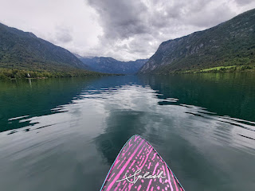

We parked ourselves at Lake Bohinj (pronounced Bo-heen) for Labor Day weekend. As I was researching where we could go for a 3-day getaway, first I was thinking we could go up to Innsbruck, Austria - which has a similar driving time. We knew we wanted to drive somewhere instead of flying, especially because I just barely flew all the way to Italy and I didn't really want to fly again so soon.

But the more I researched Innsbruck, I just wasn't feeling it. Not because it's a bad place to go . . . but it was more like a restless feeling that let me know I needed to keep looking for somewhere else. Without even thinking too hard, I quickly moved my focus to Slovenia. I always love to visit this country "next door", with its many diverse landscapes and nature opportunities.

In the past, we visited Ljubliana (Loob-lee-onnah) and Lake Bled, as well as the Predjama Castle built into the side of a mountain and Skocjan Cave - the largest underground cave system in Slovenia. If you're interested in revisiting the blog post about this trip, you'll have to search back to March 2023 . . .

The second trip to Slovenia was when I drove my sister Charmaine and her husband Scott to Croatia and Piran, Slovenia on a shorter trip last September. We only spent part of one day in Piran, but it was still a great experience to see such a prominent coastal city.

On this third trip, Lake Bohinj stood out as a nature-lover's paradise and this was very appealing. We found the perfect AirBnB that was located about 200 steps from the edge of the largest lake in Slovenia, and it felt like everything was coming together nicely. That's when I knew this was where we were meant to be. :)

Friday, August 29:
While Scott was at work for 2/3 of the day, I finished packing and getting things ready for our trip. I even spent some time figuring out how to add pockets to this romper that I bought in Morocco a few years ago. I had to watch several YouTube videos first, to learn about which technique would work the best for my project. It required a lot of brain power and I was very mentally fatigued by the time I was all done! But the pockets turned out great, so it was a success.

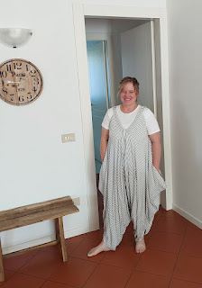

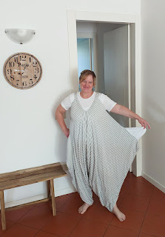

The drive took just over 4 hours to get to Lake Bohinj. There are two similar routes to get there: the recommended route (a few minutes shorter) would have taken us over the border into Austria for just a few miles but would have required us to get a vignette to drive on their roads without getting in trouble. The other route would take us through Trieste, Italy and over to Ljubliana before circling back up to Lake Bohinj.

Video near the Italy/Slovenia border looking toward the Julian Alps as we came out from a tunnel:
(7 seconds)
https://photos.app.goo.gl/AbTKvoqM9K2inD1g6

We opted to take the Austria route on the way over, and then we took the Ljubliana route on our way home on Monday. Scott figured out a clever workaround to avoid being on the Austrian roads at all. He set our GPS to go to a little town called Ratece, just over the border into Slovenia, and then on to Bohinj from there. This route took us through Tarvisio, Italy - a super cute city that appears to be a winter and ski-lover's paradise. It reminded me of places in the U.S. like Park City, Utah or Truckee, CA.

Short video driving through the tiny, but colorful town of Ratece, Slovenia: (6 seconds)
https://photos.app.goo.gl/iAqno3dbpdCq4nis9

Even though we came REALLY close to Austria, we never went across their border.

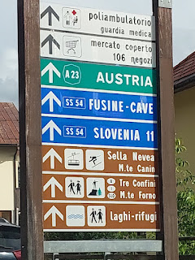

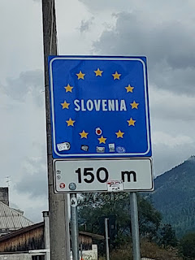

This next photo truly captures the essence of Slovenia: lush green valleys, tall mountain peaks, forests, and charming villages sprinkled around like an elegant garnish on an already gloriously prepared Michelin-star plate of food.

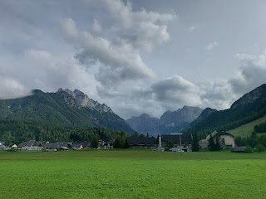

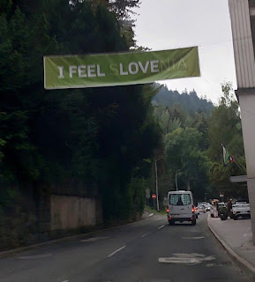

This was our AirBnB, hosted by Lenka and her mother, Zdenka. We interacted primarily with Zdenka during our stay - and what a lovely woman she is. I would guess she is in her late 60's or early 70's and we learned that she was born in the house next door. She lives here year-round in the flat upstairs, while her daughter, Lenka, primarily lives and works in Ljubliana but catches the train home to stay with her mother on the weekends.

We stayed in the apartment downstairs and it was super cute . . .

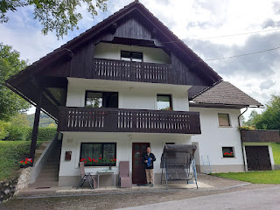

Every single window was decked out with the most vibrant geraniums . . .

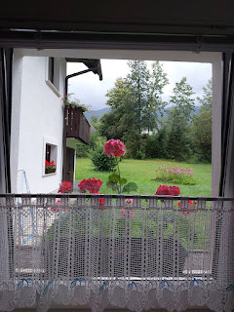

There was one bedroom with a double bed, which consisted of two twin mattresses next to each other on a queen-sized frame. There was also a couch/single bed in the room.

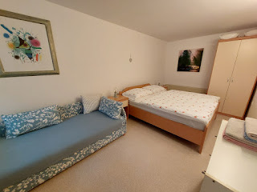

The bathroom was tiny but super cheerful with bright colors. The shower was the cutest shower I've ever seen! It was like a mini soaking tub in the bottom with a showerhead above.

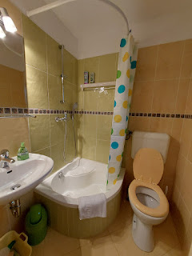

All of the features in the apartment were so inviting, cheerful, and well thought out . . .

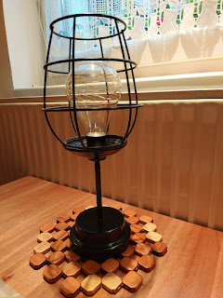

I especially loved the little lamps on our bedside tables with a dimmer switch . . .

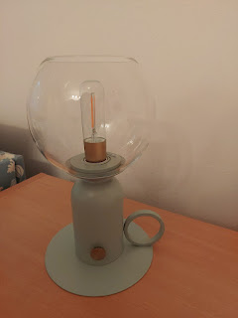

When we first arrived into Bohinj, it was POURING RAIN. We had to wait a few minutes to even unpack the car because it was so intense! Scott was the "runner" and I was the "receiver" just inside the door. That way, we weren't both tracking in muck and making puddles everywhere.

A tiny glimpse of the powerful rain as we came into town a few minutes earlier: (6 seconds)
https://photos.app.goo.gl/HxZR8XzYK54mRdcj8

A short time later, the rain let up enough so that we could go on a little explore. Just behind the trees on our property - and you would never know it because everything was so quiet in the house - was a little shopping center. There was a Mercato grocery store, a souvenir shop, a handful of restaurants, and even a large hotel! We chose to eat dinner from a little wooden booth-like shack in the plaza, called Divja Jaga. (Deev-yah Yah-guh) I ordered the pulled pork bowl and Scott chose the chicken bowl. Each had a small mound of rice, some creamy sauce, the meat that we chose, shredded cheese, and a variety of pickled cucumbers, beets, and a few other unidentifiables down in the bottom. It was all very tasty.

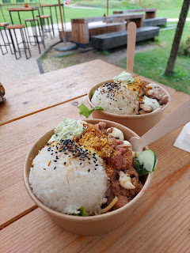

Across the street was a perfectly manicured "Bohinj" shrub, surrounded by walking trails . . .

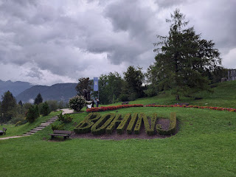

A few steps to the left (or north) of the shrubby Bohinj spot was the Lake itself . . .

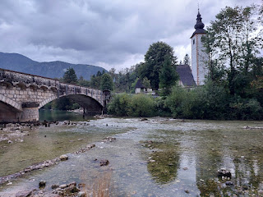

I realized after we left to go home that I never took a photo of this church up close, so take note of it here because I'll be mentioning it again in just a bit. :)

Video as we walked under the arched bridge to see the lake on the other side: (12 seconds)
https://photos.app.goo.gl/wrunf9mPvaqVeUfDA

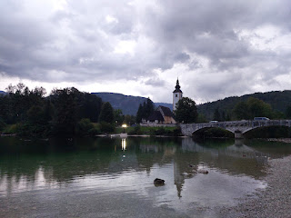

We did not doctor up this photo to make the lake water somehow match with our outfits, ha ha.

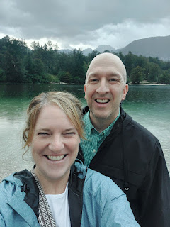

We didn't spend too long down at the lake's edge, because we knew another round of rain was on deck. We walked the 3 minutes back to our AirBnB to grab a shopping bag and pay a visit to the Mercato. This little artsy crane stands as a welcoming butler at the end of the lane leading to the AirBnB. :)

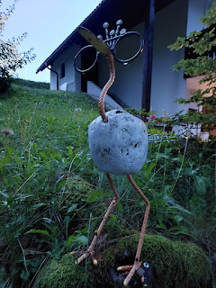

The Mercato was very small, but had just enough offerings so that you could feed yourself. I picked out some pears - and look at what they're called in Slovenian . . . (also, that price is per kilogram)

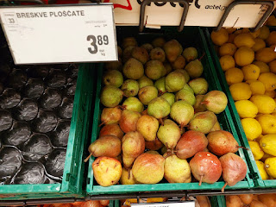

We also picked up some items for breakfast, along with a few snacky treats (like a can of Pringles and some chocolate). XOXO

We barely made it home without drowning, as the dark skies had opened up her floodgates again. When we arrived to our front door, there was a GINORMOUS TOAD in our way . . . He was so fat and huge and I found him to be a bit unnerving . . .

Video of Mr. Toad here: (16 seconds)
https://photos.app.goo.gl/23rs8tXQNh6NdRVE8

The storm lasted into the wee hours of the night, with plenty of lightning, thunder, and torrential rain. We somehow managed to get a reasonable night of sleep. Yay.

Saturday, August 30:
As we were preparing our breakfast, we could hear a man's voice filtering through the trees. It sounded like he was an announcer at a rally or something, but we couldn't quite tell what was going on. At first, my mind jumped to thinking it might some sort of political event, where something bad might end up unfolding. I know that sounds crazy, but we WERE in Slovenia, a country that both stood up to Germany's Nazi invasion AND they were the first country to secede from Yugoslavia and become an independent nation.

But once we got outside and walked over to the lake, we learned that it was something very different altogether! Bohinj, as it turns out, is the host for the annual Steelman competition, known as Triathlon Steelmen Bohinj. In the U.S., it would probably be called an Iron Man competition.

This Triathlon Steelmen consists of the following events: swimming, cycling, running, AND either kayaking or SUP (standup paddleboarding).

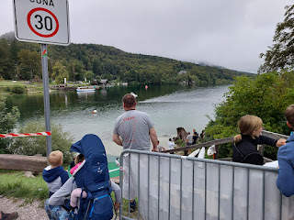

I took a bunch of videos as we began to figure out what was going on.

Video #1: I think this is the first swimmer that finished, and he was miles ahead of everybody else.
(16 seconds)
https://photos.app.goo.gl/3Hx2XdSkWkMAL5257

Video #2: Some of the other finishers coming in, and you can see how far they've come from. Technically, they originated from this spot, swam 1.6 km diagonally across the lake, and then back to where they began.
(22 seconds)
https://photos.app.goo.gl/kZxmicyggydue9FdA

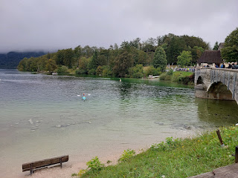

After several minutes of watching the swimmers come ashore, we started our official walk along the lake's edge. But only a couple of minutes later, we came across another group of competitors preparing for the kayak portion of the race.

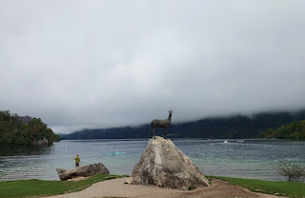

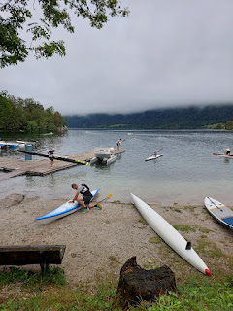

They had the skinniest kayaks we had ever seen, barely wide enough to fit a human bottom inside the hole! They probably glide lighter and faster on the surface, but Scott felt like he would just tip right over if he were brave enough to try it out.

Video of one of the contestants carrying his skinny little kayak down to the water: (6 seconds)
https://photos.app.goo.gl/8CdKv7aQXQykcBi97

Video of a kayaker leaving the dock and heading off to warm up: (22 seconds)
https://photos.app.goo.gl/CF848nfFTD4o4g2G9

Finally, we peeled ourselves away from watching the kayakers and started on our OFFICIAL walk around a portion of the lake. We decided to go for a while on the trail, and whenever we wanted to turn around and head back, we would. The lake is roughly 12 km if you were to circumnavigate the entire length, but we did not want to go that far . . .

The trail had plenty of shade, dense forest, and interesting features to enjoy along the way . . .

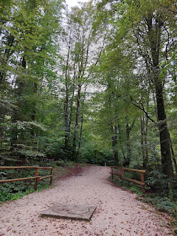

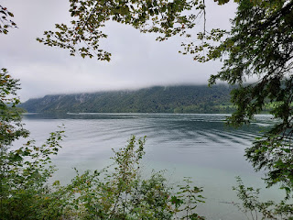

We came across a church on the southern edge of the lake . . . A Roman Catholic church called Cerkev sv. Duha, or Church of the Holy Spirit. It was built in 1743 and has a large fresco on the exterior with St. Christopher. The doors were locked, so we could only admire the outside.

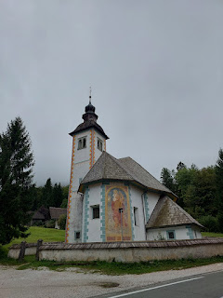

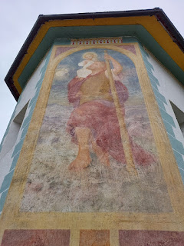

With all the mountains that surround Lake Bohinj and the cold winters that frequent the area, they must get a lot of snowpack and eventual runoff when the snow melts. We figured this was the case when we came across a giant hole in the forest that was reinforced with a dam. We could not find a drain or an outlet, but the hole was substantial . . .

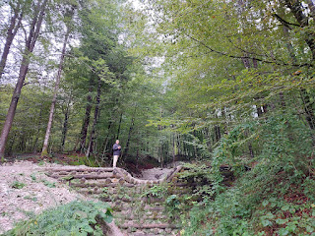

As the morning warmed up, the fog began to lift from the tops of the Julian Alps to the north and northwest.

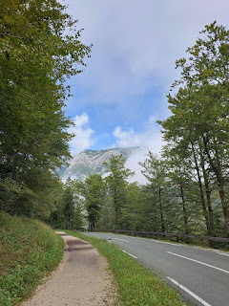

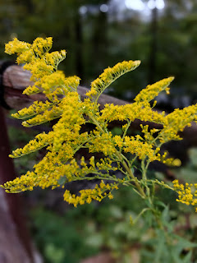

After some encouragement as to a few new techniques he could try, Scott sent the drone up and followed a boat across the lake for a little bit. I've been wanting him to branch out and do some new maneuvers, but he usually gets nervous when he thinks about all the "what ifs".

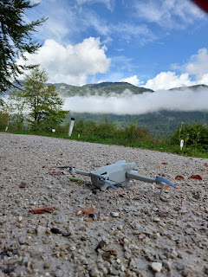

When we got back to our AirBnB, we rested and had some quiet time before heading back over to the lake for some water fun. We had chatted with a guy running a watercraft booth on our way home earlier, asking what he rented out and for how much. With his permission, I took a picture of the open shack door. It was smothered with dozens of paper money bills from a variety of countries.

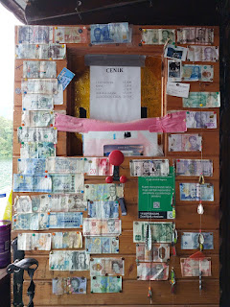

I rented a SUP (standup paddleboard) and Scott rented a kayak. He would have preferred a canoe, but I convinved him to go smaller and told him that these kayaks were wide and very stable compared to the ones we saw earlier.

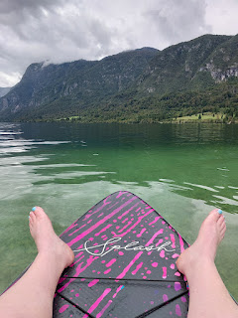

The water was so smooth and peaceful after all the morning action had ended from the Triathlon Steelmen events.

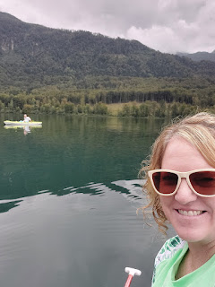

Video of "almost" a 360 view from "almost" the middle of the lake: (12 seconds)
https://photos.app.goo.gl/HTqiksi7Gx5ARHFQ6

We hung out for a bit in that spot, linked up to each other's "boat" so we could enjoy the peaceful location. I even laid down on my back on top of my paddleboard for a while. I could have stayed out there for hours . . . but alas, my husband needs a purpose for everything he does, and "hanging out" does not compute in his brain as a purpose.

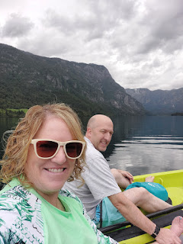

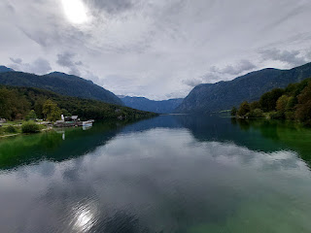

We paddled over to a beachy shore at the eastern edge of the lake, where Scott docked his kayak and sent the drone up to take some footage of me paddling around. I'll share the links soon to what he recorded at the lake and on our hike, once he has a chance to edit them in the coming days.

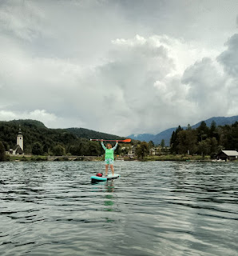

SUPing is one of my absolute favorite things to do in the whole world!! I have a special one back in Idaho Falls called an Origami Paddler, but unfortunately it's too far away to use right now . . . It got its name from the ability to fold it up into thirds so it will fit into your car's trunk. It's made out of fiberglass and also has a kayak feature with a seat that folds down or up, depending on what you want to do.

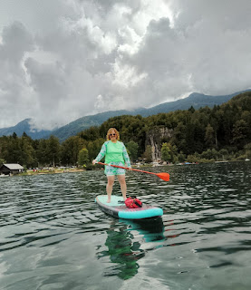

A look back at when Amber and I took the girls out on the Origami Paddler back in July 2022 . . .

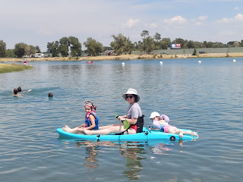

Video of Gwennie paddling us along - Man, I miss times like these: (12 seconds)
https://photos.app.goo.gl/JAYVhYAuZJ5PNePd9

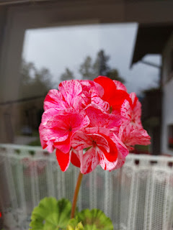

When the fun came to an end on the lake, we went on another walk - this time to go see the church that was super close to our apartment. Remember when I said I forgot to take a picture of it earlier? Well, here it is again.

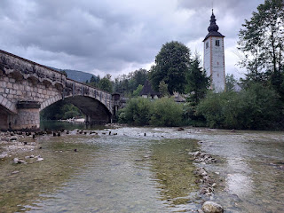

Turns out that I did take a short video of the front of the church. I forgot all about that! Ha ha
Watch it here: (9 seconds)
https://photos.app.goo.gl/Nm91NEV7dcxnzNJj6

The church is called Church of St. John the Baptist. It was built in the late 10th century into the first part of the 11th century.

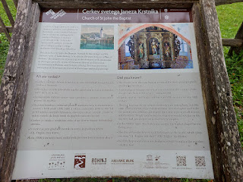

Video of the interior (which was quite small): (17 seconds)
https://photos.app.goo.gl/Njd6Kk3xx7CpW7Vv5

Description of the history of the Chancel . . .

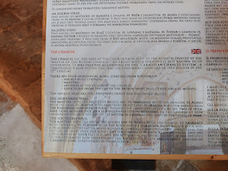

Description of the walls of the Nave . . .

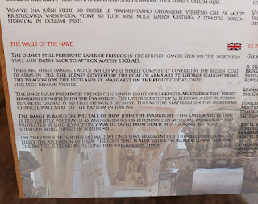

This was the weirdest church I've ever visited. There seemed to be an odd obsession with John the Baptist having been beheaded. The scene was recreated in a variety of ways inside the church, painted on the walls, sculpted out of wood, etc.

Even this painting of Jesus felt dark and macabre . . .

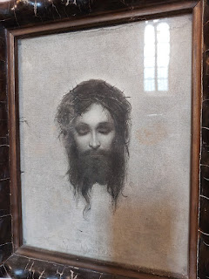

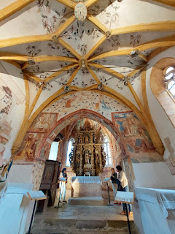

This next bit of information about the wooden head, carved to memorialize John the Baptist, was surprising and even a bit comical (although they were very serious about it at the time) . . .

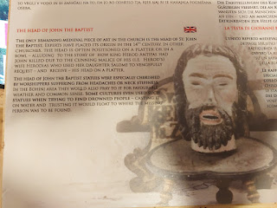

Fascinating that they sincerely believed that a wooden head could prove to be so miraculous . . .

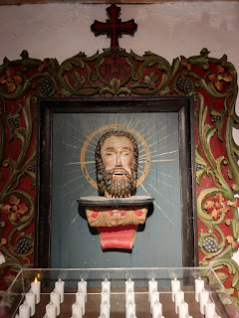

I would much rather pray to God Himself than to a wooden head.

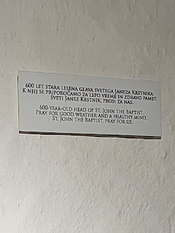

View from the balcony upstairs - after a short but very steep set of wooden stairs (with no railing) . . .

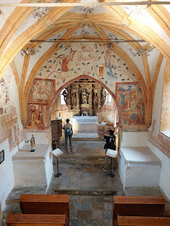

Again, the fascination with John's beheading . . . WHY???

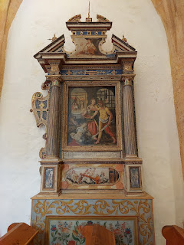

On a lighter note, Jack and Maisie tried to video call me while I was inside the church. After messaging them that I would call them back in a few minutes, I finished my tour of the church and met up with Scott outside. We used Whatsapp for the video call and had a wonderful visit with them.

The little ones were eating breakfast for the first few minutes, and then we watched them play while we chatted with Jake for a bit. Maisie wished that she could climb into the phone and reach me, ha ha. What a sweetie. She was very vocal about this issue, with grunts and fervent fists opening and closing in rapid succession. There was no mistaking about what she wanted. Meanwhile, Jack entertained us with all the clever tricks that his stuffed otter could do. (His name is appropriately - "Ottery")

We showed them the lake across the street, and when we walked down to the water's edge so they could see a family of ducks swimming by, we also saw a school of fish (probably trout) swimming in the crystal clear water. It was surprising to see them in such shallow water and so close to all the people on shore, but even more surprising was how big they were! I estimated that they were a good 10-12 inches long. Jack and Maisie were both able to see the fish through my phone screen - oh the wonders of technology.

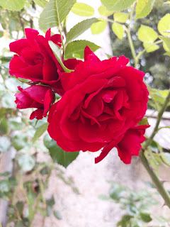

A few feet away, Scott noticed this memorial - dedicated to the local resistance during WWII. The translation says: "4 April 1945. It was in this place that the Jesenisko Bohinj Department won its great victory over the German occupators and prevented the attack of the Upper Bohinj Valley."

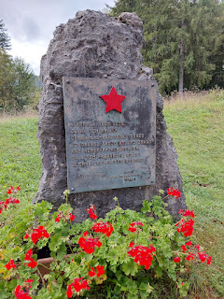

Next, we hiked up the little path near the sculpted "Bohinj" shrubbery to see the bronze statues behind it. The first photo shows the Triglav mountain range off in the distance, and each peak's height. For comparison, Triglav is the tallest peak in Slovenia at 2864 meters, which is equal to 9396 feet in elevation.

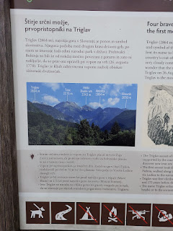

This next part describes the four brave men who were the first to ascend Triglav in 1778. This was 8 years before anyone climbed Mount Blanc (the highest peak in the Alps and Western Europe, near Chamonix, France). Their success was also 175 years before someone finally conquered Mount Everest.

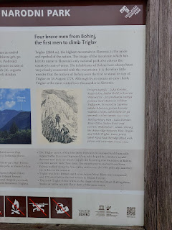

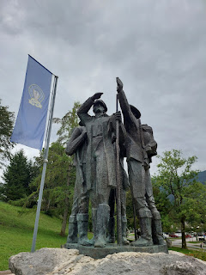

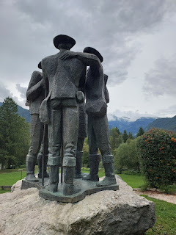

Next up was to pay a visit to the restaurant next door, "Karakter Bar", an outdoor hamburger joint with some fun music. We shared an order of sweet potato fries with our burgers. :)

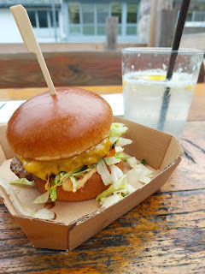

Sunday, August 31:
We left at 8:30 a.m. to drive approximately one hour east so we could attend church in Ljubliana. Their building was HUGE, with multiple levels and was much larger than the building we use here in Vicenza. Even more surprising was how they had such a massive building with only a tiny group of members in what is called a "Branch". A Branch consists of a smaller number of members of the Church of Jesus Christ of Latter-day Saints, with a Branch President instead of a Bishop who oversees the smaller congregation. The hope is always, of course, that the branch will grow into a ward at some point.

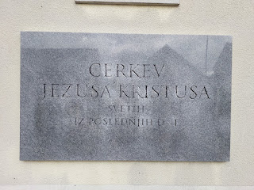

As we entered the building, we were greeted multiple times with friendly smiles and happy faces. I started losing track of all the missionaries we saw . . . later we learned that there are 6 elders (male missionaries), 2 sisters (female missionaries), plus TWO senior couples serving in this ONE BRANCH!! They have very high hopes for missionary work in the area, this is very clear.

One of the ladies in the branch spoke really good English and she was happy to explain what was on this poster in the hallway just outside the chapel. Her name was Bojana (pronounced like "boy-AHN-ah").

Dang it, try as I might, this photo ended up blurred for some reason. The upper left lists the speakers for Sacrament meeting that day. The lower left mentions a "Thank you" for help in cleaning the building recently. The upper right has all the announcements, including an upcoming temple trip in October. And the lower right shows what the lessons will be from the Come, Follow Me manual.

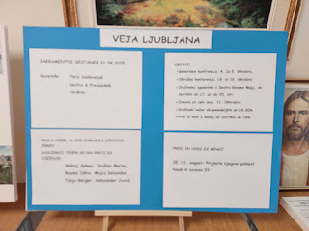

This is what the Book of Mormon looks like in Slovenian . . .

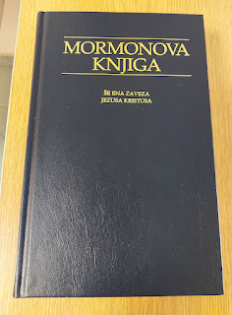

Various pamphlets for any visitors and those new to the church . . .

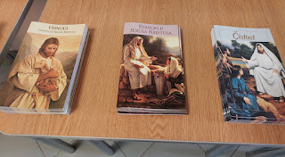

And this was a poster with recent news of a young man from their Branch who is serving a mission in Brazil right now . . .

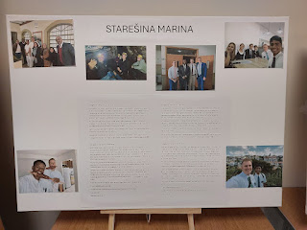

This was a plaque of all the missionaries from their little branch who have gone out into the world to serve in another country. I noticed that several of the assigned locations were in London, England!

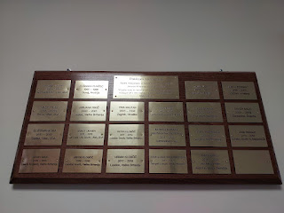

We totally butchered trying to sing in Slovenian, but I learned some important things while listening to everyone singing around us. I don't have the capacity to type certain characters in Slovenian, but here are a few notables:

~ When you see a word like "cez", and the "c" has a little mark over the top of it, it makes a "ch" sound. Example: "cez" = cheez.

~ When you see the letter "s" with a mark over the top, it makes a "zh" sound.
Example: "nas Kralj" (which means our King) = nozh Krawl. The "zh" sort of sounds like "sh + z" blended together somehow.

The language sounds a little bit like Russian, mixed with every other language that is Eastern European. It was hard to work with!!

This was the opening hymn - in English we would know it as "Redeemer of Israel".

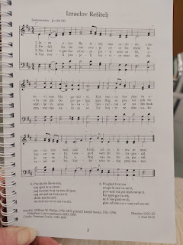

The Sacrament hymn - "Behold the Great Redeemer Die". (oops, I only got one page instead of 2)

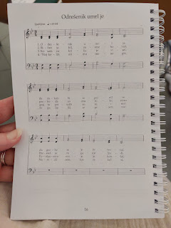

The rest (or interim) hymn - "I Am A Child of God".

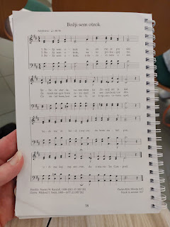

The closing hymn - "How Firm a Foundation".

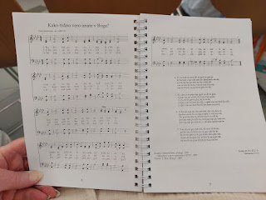

The meeting was absolutely incredible. First, we had been given a translation device and one of the elders did the initial translating for us. But when the speakers delivered their message after the Sacrament was passed, we didn't need the devices at all! This was because the speakers spoke primarily in English, and the same lady who was so friendly and conversational with me earlier, stood next to each female speaker and translated their English into Slovenian for the congregation. A member of the branch presidency translated for the male speakers.

First, we heard from the Mission President's wife, Sister Angelika Cordray, with translation given by Bojana. Then we heard from the Mission President, Brian Cordray. They both spoke about the power of forgiveness, but President Cordray had a special story that he shared. He talked about a time when he was serving as a Bishop in Germany (Scott wondered if he was in the military and working in Germany at the time). They were having a ward council meeting where the leaders of each auxiliary meet together to discuss needs within the ward. (Sunday School, Primary, Young Men and Young Women, Relief Society presidents, etc.)

They were discussing a potential "linger longer" coming up, where everyone stays after church and brings food to share, sort of like a potluck. The relief society president expressed some serious concerns, feeling that the bulk of the burden would fall on her shoulders to make the event successful. Bishop (at the time) Cordray tried to be funny, saying something like, "We all just need to put our big boy pants on and get to work". (!!) Well, a few weeks went by and he noticed that this woman's husband was at church, but she seemed to be missing each week. Finally, he asked the man where his wife was and if she was sick. He said, "Why don't you ask her yourself?" So he did. He paid her a visit, where she carefully divulged how hurt she had been by his words all those weeks ago. He had no idea that he had even hurt her feelings at all, but he quickly apologized and asked, "Will you ever be able to forgive me?" She did forgive him, and he made a more concentrated effort from that point on to not say things that could be so offensive. He was a very humble man, with a great desire to do what is right in the eyes of God.

Here is a little info about President and Sister Cordray: (They began serving in this calling in 2023, so they are 2/3 into their 3 year assignment.)

Adriatic North Mission
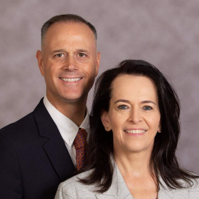
Brian E. Cordray and Angelika Cordray, Adriatic North Mission Leaders.
2023 by Intellectual Reserve, Inc. All rights reserved.
DOWNLOAD
Brian E. Cordray
, 51, and
Angelika Cordray
, four children, Frankfurt 2nd Ward (English), Frankfurt Germany Stake: Adriatic North Mission, succeeding President Kevin C. Field and Sister Dianna M. Field. Brother Cordray is a Sunday School teacher and former stake president, high councilor, bishop, bishopric counselor, ward mission leader, seminary teacher, temple ordinance worker and missionary in the Austria Vienna Mission. He was born in Gatesville, Texas, to Allen L Cordray Jr. and Catherine Elizabeth Cordray.
Sister Cordray is a Sunday School teacher and former stake Young Women president, stake Primary president, stake Relief Society secretary, ward Relief Society president, ward Primary president, temple ordinance worker and missionary in the Germany Hamburg Mission. She was born in Munich, Germany, to Johann Friedrich Laur and Gabriele Maria Laur.

After church, Sister Cordray came over to talk to us. As we asked some questions regarding the mission boundaries, we learned that the mission office is in Zagreb, Croatia, but the missionaries serve in several countries - Croatia, Slovenia, Serbia, Bosnia and Herzegovina, and Montenegro. She told us that the missionaries typically just learn one of two main languages in the Missionary Training Center (MTC) - either Slovenian or Croatian. Either one of those languages will work in any of these countries, plus or minus a few specific dialect changes.

She shared that a problem that they used to have was how the districts within the mission were set up. Missionaries who learned Croatian were sent to one of the countries that primarily spoke Croatian. And missionaries who learned Slovenian were sent to one of the countries that primarily spoke Slovenian. They stayed in that one country the whole time and hardly moved. There might have been only 8 missionaries in all of Slovenia, for example, so when they switched to a new companionship (or duo), the pool of possibilities was pretty "slim pickens". There were only a handful of other missionaries to be a companion with. The missionaries were struggling with boredom, depression, and other issues that come from lack of moving around/having new friendships/meeting new people/etc. Eventually, the Mission President came to realize that these missionaries are very capable - and if they can learn the one language, they can most certainly learn the other language, too! This has opened up a lot of exciting possibilities, and the missionaries are much happier now (and therefore more productive). They get to move around to more new areas and they get the opportunity to serve with a larger pool of companions, too. Very insightful for him to have made this discovery! And it was fascinating to get a glimpse into some of the logistical issues that a Mission President has to deal with and how they are inspired to find a better solution.

Next, we heard from Sister Cziesla (I think it's pronounced like Cheezlah), brand new wife to Bernhard Cziesla, who serves as an Area Seventy in the Europe Central Area. Sister Cordray told us after the meeting that Elder Cziesla's first wife passed away a year ago, and that he just married his second wife one week ago!! I think her name was Jayne Bingham before she married Bernhard. Sorry for all the nitty-gritty details, but she had the most powerful testimony of the Savior and her heartfelt words moved me to tears during the meeting.

With the help of Bojana who translated the English into Slovenian, Sister Cziesla shared the following:

She was on assignment in Madrid, Spain recently (before she got married), and hopped into a taxi to get a ride to the Madrid Temple. She asked the driver if he belonged to a church. He didn't. She asked if he had heard of The Church of Jesus Christ of Latter-day Saints. He didn't know much about the church, either, but he would often transport people to this same temple. He asked, "What is so special about this temple? Why do all of you want to go there?"

She told him that while we do call the building a temple, technically it is the LITERAL House of the Lord. He can come to visit us inside HIS house if He chooses to. It is a place of instruction where we learn about God's Plan for us - His spirit children. It is a place of peace where we can feel the Holy Spirit, be uplifted and edified, and receive revelation to help us better navigate our journey through life on this earth.

When she asked him if he would like to know more about our Savior Jesus Christ, he said, YES! And then he asked if he could go inside the temple with her that very day! She replied that if he would like, she could put him in touch with some local missionaries who could teach him more about the House of the Lord and God's plan for us. He was so excited he could hardly keep his eyes on the road . . .

When she spoke, she spoke with the power and the Spirit of God. I felt it from my head to my toes.

Elder Bernhard Cziesla spoke last. I don't recall much of what he said, because his wife's words were still playing and replaying in my mind. I learned after church that the two of them were on vacation (i.e. a honeymoon), and because they were in the area, they were asked to speak. Normally, they live in Germany and they will continue to serve over there.

Someone - I can't remember who it was - announced in Sacrament meeting that there will be a special Fast this next Sunday, September 5th for missionary efforts in Ljubliana. Fasting is an opportunity to go without food or drink for a spiritual purpose. We set aside the things that our mortal bodies need and, instead, we focus on something higher for 24 hours - or as long as we are able to. I decided right then and there that I want to participate in this special Fast, even though I'll be in Vicenza, Italy.

I truly felt the energy and excitement of the missionary work for the Ljubliana area and I want to be a part of something so amazing. Here they have this huge building - just waiting to fill it up with people and new friends who want to know more about Jesus Christ. They have 12 - TWELVE - missionaries on deck, just waiting to teach people about the Savior and how He can bless their lives for the better.

As I was researching some of the background for this blog post, I came across an article that was published back in April of this year. It talks about how members of the Church in Slovenia were able to watch General Conference - LIVE - for the first time EVER. Mission President Cordray adds his comments as to the incredible occasion, and there is a really sweet spirit about the Gospel in this article as it pertains to Slovenia.

https://newsroom.churchofjesuschrist.org/article/latter-day-saints-in-slovenia-rejoice-with-first-tv-broadcast-of-general-conference

I came out of that Sacrament meeting with profound gratitude in my heart. Even just now, as I read the above article out loud to Scott, I could hardly speak at times because my eyes were overflowing. I am so grateful to have seen just a tiny little glimpse of the possibilities within the Ljubliana Branch of Christ's church. It is all just so incredible and beautiful and special and exciting!!

Below: A photo of me standing next to the sign that says "The Church of Jesus Christ of Latter-day Saints" in Slovenian . . . XOXO

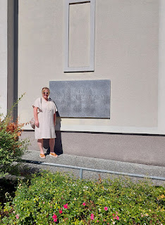

After church, we went to a restaurant in downtown Ljubliana for a light lunch. Ordinarily, we do not go out to eat on Sundays, but when we're traveling away from home, we do still need to eat. I chose a cute little French place called "Le Petit Cafe". It turned out to be a very popular place, and we were lucky to find a table inside. Most of the patrons had already chosen to eat outside under the canopies, but in Europe it's always a crapshoot. Yes, eating outside allows you to enjoy the fresh air when it's not too hot, but then smokers are also allowed to smoke at any of the outdoor tables, too. Inside the restaurant, the atmosphere might not offer the fresh air you were seeking, but at least you can be free of inhaling someone's tobacco at the next table over.

For those of you who know some French, here are a few pages from their menu. Our server did give us an English version . . . so it won't be quite as stimulating - if you were looking forward to exercising your brain somewhat, ha ha.

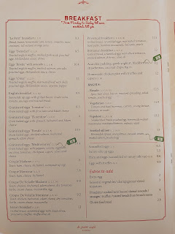

I chose the Eggs Royale from the menu page above, plus a smoothie from the menu page below. Scott, who is still convinced that he "doesn't eat lunch", surprised me by ordering a yoghurt! (And yes, that's how it is spelled on their menu.) Interestingly, his yoghurt came in a glass with a straw . . .

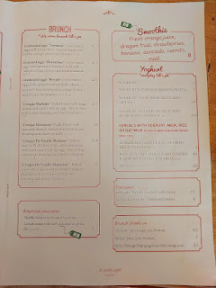

I thought this menu page was a little disconcerting, if not entertaining . . .

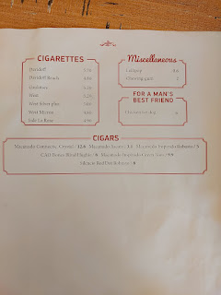

Here are some of their offerings if you came to eat a fancy dinner . . .

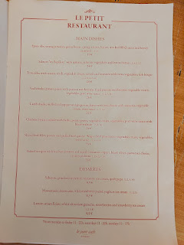

Everything was delicious, especially the smoothie. The smoked salmon underneath the hollandaise sauce could have been a little fresher, but it wasn't horrible either.

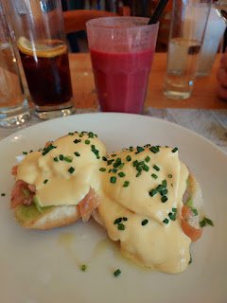

On the drive back to Bohinj, we passed Lake Bled for the third time on this trip. It is one of the most picturesque lakes, if not THE most picturesque, in Slovenia. Therefore it is VERY touristy. Each time we passed, including the final time on our way home on Monday, there were lots and lots of people walking along the paths and very minimal parking to be found.

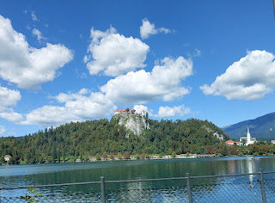

I had seen this pretty little patch of sunflowers on our way into Bohinj on Friday, so I kept my eyes peeled in hopes of spotting it again. Scott asked me to please give him plenty of warning so he could find a place to safely pull over while I dashed across the road to take some pictures. I was happy that the sun was out on this occasion, compared to the dreary grey skies and powerful rains that watered down the potential opportunity for photos two days prior.

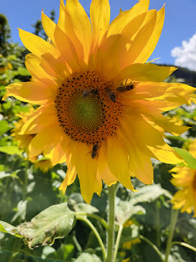

We spent an hour or so having "quiet time" once we got back to the AirBnB. I chose to lay down for a while, and Scott went outside to sit on the porch swing and practice his Italian with the Mango app that he's been so diligently using for several weeks now.

Our last big adventure was to visit Mostnica Gorge, approximately a 7 minute drive from our lodging. Zdeka, our host, pronounced it like "Most-NEE-tzah Zhorzh". The best way I can describe the Slovenian way to say "Gorge" is this: pretend you're saying George, but with a very thick French accent. LOL

We found an excellent place to park, which saved us an additional kilometer of walking (x2 - there and back). I made sure to save it in my Google Maps because this is definitely a place that we want to come back to, and hopefully bring some family or friends with us, too!

It was a short distance from the parking lot to the toll booth, maybe a 5-8 minute walk through the forested trail. We paid a few euros per hour to park there, and it cost us 4 euros each to access the trail.

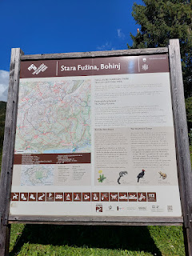

We were now in the Triglav National Park, the only one in all of Slovenia. The Mostnica Gorge (see, you're getting the Zhorzh with the thick French accent now, aren't you) is a deep gorge that has been carved out over the course of many years by the Mostnica River. You can walk to various points that are included on the map, or you can just walk until you feel fulfilled, and then you can turn around and head back whenever you want. This is what we chose to do, mainly because we got such a late start in the day. We were hitting the trail after 4:00 p.m. and we knew we only had so much time until it would start getting dark.

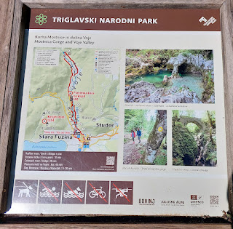

The trail is mostly flat, with a few uphill slopes - none of which were too taxing or too long. I was super happy that I could breathe much better for the first time in a long while.

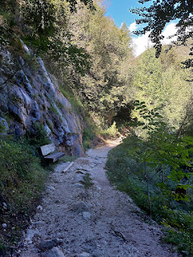

There is a lot of diversity along the route. Most of it consists of a wide white gravel lane that makes it easy to trudge along, but occasionally you will pick your way over intricate root systems, man-made steps, footbridges, and little baby streams that cut across the path.

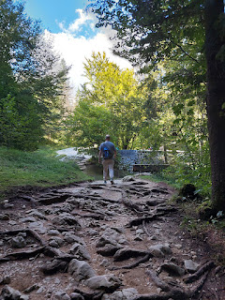

Video as I crossed over a little footbridge: (9 seconds)
https://photos.app.goo.gl/rAWQjkAuGLg8rYUR7

Even as I was poised to take some of these photos, I knew that it would not even come close to capturing what we were seeing. These photos do not offer much depth perception, but the canyons were pretty epic and deep.

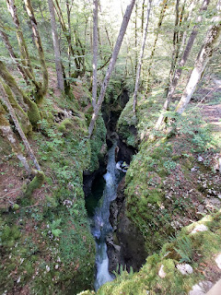

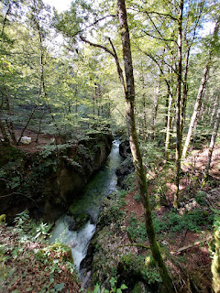

The interesting shapes of the numerous white boulders that were sprinkled all around reminded me of a scene in the Frozen movie when the rocks turned into trolls, ha ha.

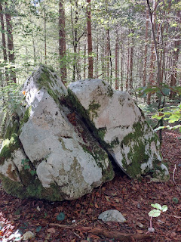

I sent this picture to my kids and asked them what shape they saw on the rock . . . What do you see?

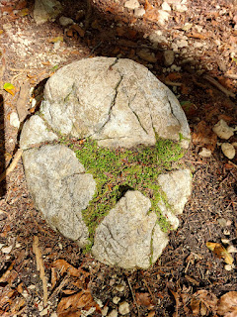

(Both Amber and I saw a star, while Jacob saw a velociraptor!)

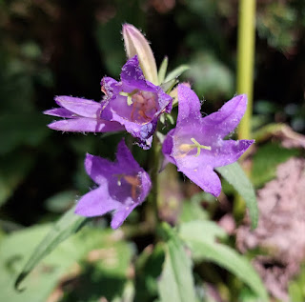

For those of you who love the sound of a cascading stream: (5 seconds)
https://photos.app.goo.gl/q9DzcSw8w32x93LE8

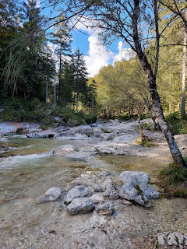

This was a really beautiful part of the river, with a waterfall, lots of cascades, and plenty of rocks to scramble over.

Video of this spot: (11 seconds)
https://photos.app.goo.gl/sxoVKpojqTfyMCnd9

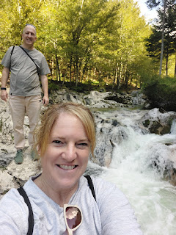

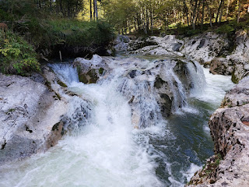

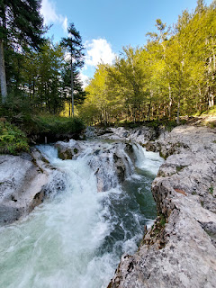

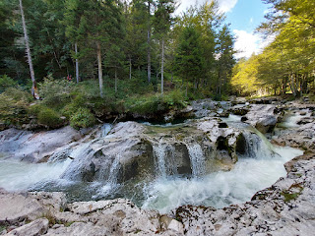

A video of the beautiful Mostnica River and cascades: (9 seconds)
https://photos.app.goo.gl/ip5bseJnnP1yzy1j9

One more video of this same area: (11 seconds)
https://photos.app.goo.gl/EXsYQN4i8C9oomeLA

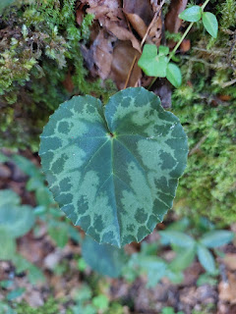

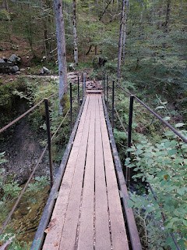

There were so many waterfalls and cascades to enjoy in the 2 hours we spent on the trail. We could have gone farther to the Hut and then on to a much bigger waterfall, known as Slap Mostnica, or Mostnica Waterfall. But because it was so late in the day, we opted to make our way back on the other side of the river by crossing one of the footbridges that straddles the gorge.

They have some funny words in Slovenia:
~ Pot = way or route
~ Slap = waterfall
~ Jama = cave (but the "J" is a "Y" sound)
~ Prosim = please
~ Hvala = thank you
~ Lep dan = have a nice day
~ Dobrah dan = good day (a more formal greeting)
~ Most = bridge

For a lighthearted view into the world of Slovenia, with its funny words PLUS some great recommendations for places to see in their incredible country, click here:
https://www.lipizzanerlodge.com/2022/02/148150/handy-slocal-lingo/

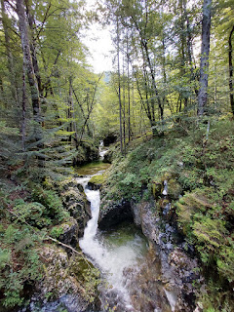

We 1000% enjoyed the Mostnica Gorge. This was one of those places that we can picture bringing people back to again and again.

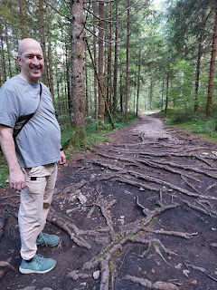

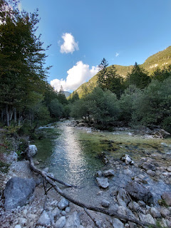

I bet there would be a lot more varieties of flowers to see in the months of May and June, but these were some of the few that were still around at the end of the summer . . .

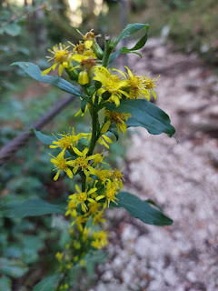

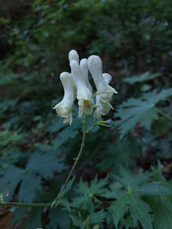

Thankfully, Zdeka had told us when we first arrived that all the stores are closed on Sundays and that we should be sure to pick up some groceries in advance. So that's exactly what we did. We planned ahead by shopping on Saturday, and then after our hike we put a very hearty (and delicious) meal together that consisted of: beef & pork mixed patties on a bun, with melty gouda cheese, Scott's favorite type of lettuce called Valerian/Valeriana, thick slices of a beefsteak tomato, and a new(ish) condiment called Hellmann's Burger Sauce. I also made some Brussels sprouts as a side dish. After we assembled our plates, it not only looked like something we could order in a restaurant, but it tasted every bit as good as something we DID order in a restaurant!

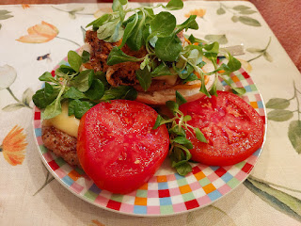

We played games every night before bed, and I'm glad I thought to bring a couple with us because the internet was pretty weak and we couldn't watch any movies on our laptop. We either played Sequence or Phase 10. With Sequence, we always play toward the best out of three rounds. Usually we are tied heading into the final round, with me predictably announcing something like, "Okay, whoever wins this next round is the winningest, winnery winner of ALL TIME."

Monday, September 1:
Our drive back to Vicenza was pleasant and seemed to go faster than the drive over to Slovenia did on Friday. We crossed the border with no problems - assumingly because we actually paid for the vignette this time, ha ha.

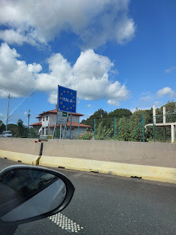

We are now settling into a rhythm again, with Scott teaching early morning seminary (at 5:30 a.m.!!), going to work each day, and squeezing in some time to exercise in the evenings. He likes to run over to the cemetery, take several photos of the headstones, and then run back and upload them to Find-a-Grave for others to transcribe. The photos are usually snatched up and transcribed within 24 hours, so that tells us that people are chomping at the bit for something to do!

As for me, I have been working on this blog post for 3 days straight now (I don't want to say how many hours each day) . . . I've been doing several loads of laundry and hanging them out on the balcony to dry, planning and cooking our meals, making future plans for the fall, doing some family history research, and continuing to clean and organize our stuff that came in the shipment of household goods. Very soon, I should be all done with that hefty task.

Next blog post - I will be sure to share lots of photos of the grandkids because I've got SEVERAL!!

