Behind the Scenes in Italy
It feels like I am finally 98% nested in our new home for the next few years. We've been hanging up several pieces of artwork and special items on the very white walls - a big shout-out to 3M command strips and hooks (and thanks to Amazon for shipping them) . . . so I am finally ready to share our home with you. :)

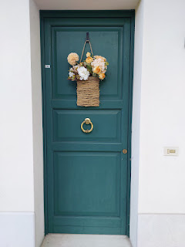

You may recall that upon entering our building at ground level, there are 3.5 flights of stairs to get up to our flat at the top. The first level consists of 2 garages, both ours and Bruno's, that sit side by side.

The second level is Bruno's flat. He is 81 years old and is our landlord Daniele's father. He is such a sweetheart. He is also very active and hard working. Last Saturday, with his girlfriend Bruna, he hiked up to the top of one of the distant mountains that we see out our kitchen window - one of the really tall, pointy ones. The hike was roughly 10 km he told us. Yesterday, he was outside mowing the lawn, trimming the hedges, weed whacking, etc. for hours. Wow.

The third level belongs to us.

At the top of the stairs, I felt that this location was very appropriate to hang up a sign - one that came from Hobby Lobby in Idaho Falls and then took 13 weeks to ship to us. It says, "Yay! You're Here." It feels like the biggest pat on the back - "Congratulations, you made it up all those stairs!" And I love to see it every single time I get up to the top floor with however many bags of groceries I've got on me, like a little pack mule. It literally makes my day, ha ha.

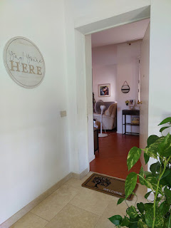

We inherited this plant from Benson's ex-wife Kylie a few years ago. Scott has been very diligent in watering it just once a week and finding a rotation of sunny locations for it. When I came back from the States in August, he had moved it out into the stairwell . . . I questioned the location and the aesthetics of such a mop of green foliage sitting in a blob right there. His response was, "But it looks so happy!"

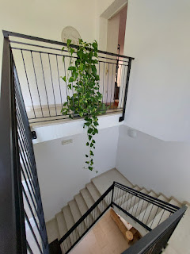

To my plant friends
(especially you, Jenn) - I need help with this giant green blob. How can I make it look more attractive? Any tips would be appreciated. I'm inclined to give it a haircut for starters. I'm just not a huge fan of letting it take over the entire area, turning it into a tangled jungle of unkempt vines. I just don't know what to do with it, though.

Upon entering through the front door, the space opens right up into the living room and dining room. I recently got a cute basket for the top shelf of our entry table, where Scott can drop off all his stuff as he walks in the door: his wallet, his car key and house keys, his badge for work, etc. He has definitely made this a diligent habit and he hasn't been forgetting anything or losing anything lately, either, so that's a giant win! It's so handy for him to just reach in and grab everything the next morning as he heads out the door.

The little sign on the top shelf says:
This is the Life
.

I like to use the larger basket on the bottom shelf for some of my miscellaneous items: bug spray, a handy accordion fan, a couple of smaller handbags, and my coin purse, for example.

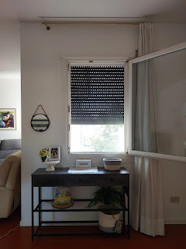

Next to the entry door is a coat rack and bench that came over in our shipment of household goods. We couldn't ship it directly to Italy, but we could ship it first to Idaho Falls and then let the company pay for it to be shipped with the rest of our furniture and stuff from there. I was so happy to see it when it finally arrived! Scott built it right away and now we have a place for my purse, handy umbrellas, shoes, etc. Today, there is also a letter that's ready to be mailed to my granddaughter, Abby, sitting next to my water bottle. I love visual reminders and a place to keep things organized . . .

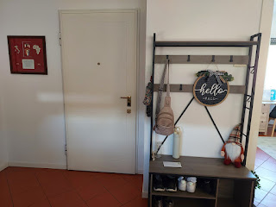

Scott's recent plaques and retirement gifts adorn our entry way, which I love. If it weren't for him, we wouldn't even be here in the first place . . .

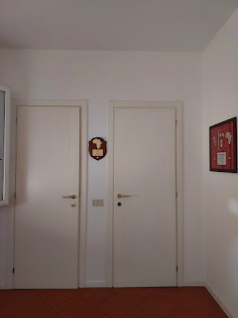

The two closet doors in the photo above consist of:

1) The door on the right = the water heater and the boiler for radiant heat and the heated floors.

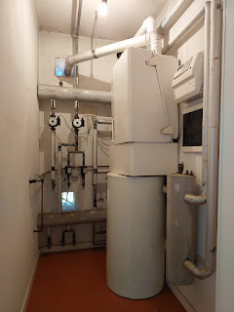

2) The door on the left = storage and also the breaker box. The piles of stuff on the floor are items that I still need to figure out a better arrangement for. On the right, I have some large bags full of "stuffins" for shipping packages to all of my favorite people. Plus my yoga mat. On the left is a stand mixer that I bought from a friend in the ward who was moving to the U.S. this summer. She used it a lot for baking bread, and I am hoping to start using it this fall and into the winter.

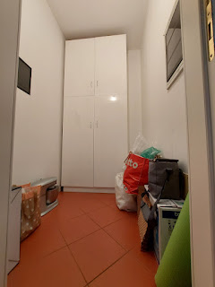

The storage cabinets inside this room are being put to very good use. Scott uses the left side for all his manly tools and cords and zipties and fixer-guy stuff. I use the right side for things like cute cards and envelopes, packing tape and other materials, adapter plugs, a beach blanket & an insulated lunch bag, etc.

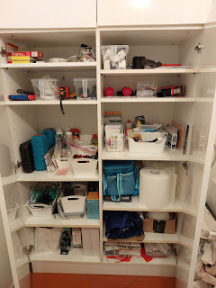

The upper shelves go all the way up to the ceiling and I can hardly reach them, even when standing on our step-ladder. Therefore, this space is a bit underused because of accessibility.

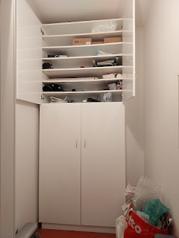

As you stand in the entry way, if you were to turn left, there is a decent-sized room that we use in multiple ways. It is first and foremost Scott's office. Secondly, it's my craft/sewing room. Thirdly, it's a guest room with a single bed. Right now, we have a plush mattress topper sitting on top of it that needs some "doctoring". It transferred over from our old house and was meant for a larger bed, not a twin size bed. As we inspected the topper recently, we noticed that there is a zipper opening that would allow us to perform a minor "surgery" by trimming down the width of the stuffins and then stitch a new seam down the length. It's on the to-do list, but it might be a minute or two before I can get to it.

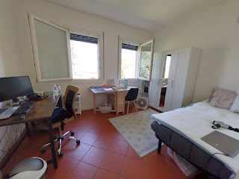

This is the view from the dining area looking back toward the front door and the office/guest room . . .

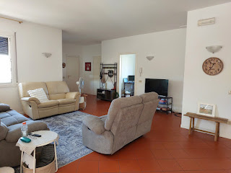

We were so happy when our two grey couches arrived from Idaho Falls. They are so soft and comfy, plus they have the ability to recline with footrests. Amber's beautiful painting of Jesus hangs lovingly on the far wall.

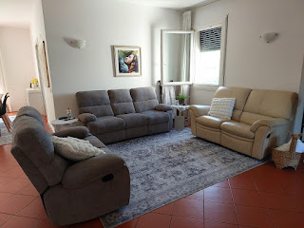

Below: This is where I spend a lot of my time. I sit next to the window, with the footrest up and my laptop open while I research and work on a variety of endeavors (family history, places to go, this blog, etc.) I always have an ice cold drink on the table next to me. Also - note my little "friends" on the floor under the window . . . my kettlebells of varying weights. I enjoy using them for my morning exercise several days a week.

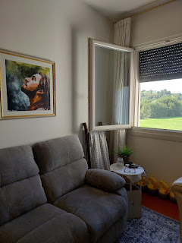

We do not have a dryer, and we might not ever get one. We tried to find one, but after looking in several stores and not seeing anything but washers, we kind of gave up. However, it's been working really well to just dry our laundry with the drying rack - seen in the photo below. It usually sits in this spot to rest, until we haul it out onto the balcony to dry our clothes in the sunshine.

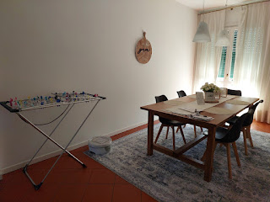

I love having a giant map of the world so handy for reference. I look at it often, especially since I am such a huge fan of maps.

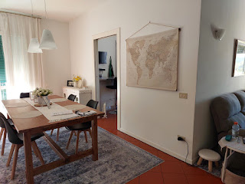

My vision for the giant wall next to the dining table is to hang 5x7 photos of our family members. XO

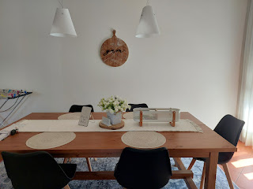

See if you can guess where I typically sit at the dining table, based on a small stack of papers, notepads, and things that I'm working on . . .

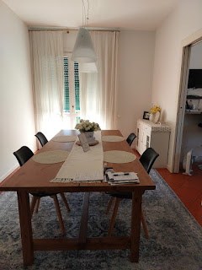

This is our darling little kitchen. It has everything we need (except for a larger fridge/freezer). I love the butcher block countertops. It feels very much like a farmhouse style, which just happens to be my favorite.

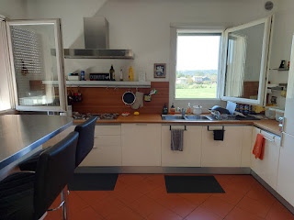

This is the view through the kitchen window, a view that I relish every single day. In the morning, I can see all the early walkers, bikers, and those taking their dog for a stroll. Mid-day it tends to be pretty quiet. Late afternoons and evenings is when all the people come home from work, school, shopping, etc. and pass by once again on their way home. I love the routine of it all.

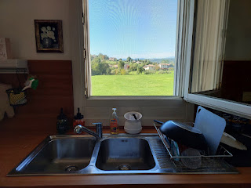

I keep most of my spices on the open shelves near the sink, along with some IKEA bins for storing flour, sugar, etc. I also have a couple of large mesh baskets for loose items such as potatoes, onions, etc.

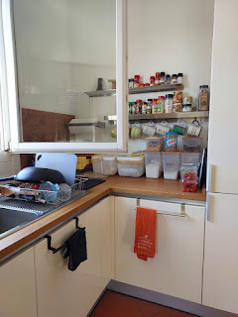

We have a gas stove, which I have definitely gotten used to in Italy. It took some bravery on my part because for years I was terrified of starting up any gas burners. (Too many close calls in past experiences) I especially love the deep drawers under the stove - for utensils or pots and pans. We also have a DISHWASHER now!! Yay!!

*Also, note the little circular hole in the wall under the window. This is one of 2 vents in the kitchen in case of excess gas when trying to light the stove. Scott used this particular hole to thread a line into the house for his new Starlink system (which provides our internet). He got a swinging deal with Starlink - a deal that was just within Italy - it came with a free starter kit.

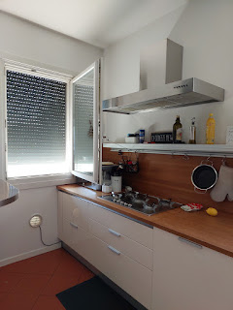

I made a huge mistake in thinking that chalk markers could be used the same as regular chalk. Unfortunately, chalk markers are more permanent . . . Above the little phone/intercom system, I wrote a short list of things that I wanted to do to improve my health - - in chalk marker. Eventually, I figured out that I couldn't erase it. When my cousin Suzy was here visiting in June, she drew a fancy ~ AirBnB Welcome ~ on the wall, but with regular chalk, ha ha.

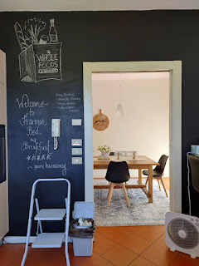

Behind the kitchen bar is where we stash our recycle bins and my little stash of Coke Zero . . .

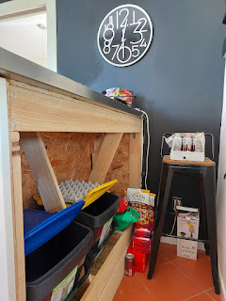

Mom - this one's for you, ha ha. A peek into our tiny little fridge. A recent Mexican casserole is hogging a ton of space on one of the shelves, but typically I have to stack everything up so tightly and then move everything around like a slide puzzle to get the things that I need.

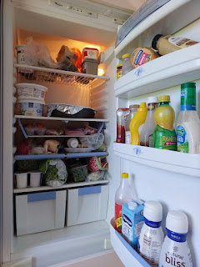

The freezer is even tinier . . . there are three very slender drawers that barely hold 2 ice cube trays and a couple bags of frozen fruit each. Oh, how I wish I had more freezer space . . .

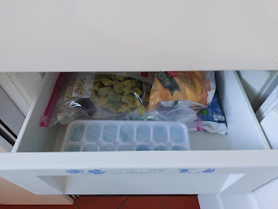

We bought a cute "hutch" of sorts earlier this summer from Amazon Italy. While I would have liked something with more vertical storage, we settled for this one because it fits well between the exterior wall on the left and the entrance to the kitchen. It is very handsome, but each door or drawer can only hold certain items that aren't too tall or too wide.

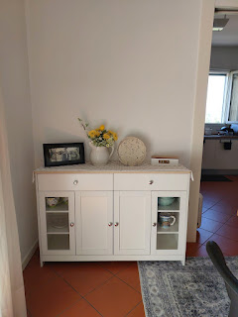

I made one of the drawers into my "Tea Station", which I look forward to dipping into once the weather cools off again.

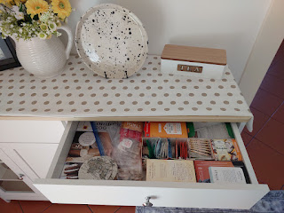

The other drawer houses a few more spices that I brought to Italy from the U.S. - my favorites from Penzeys and Trader Joe's mostly . . .

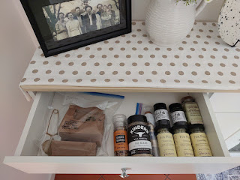

And the cupboards underneath house a few specialty items for now, but there is still a little bit of wasted space . . .

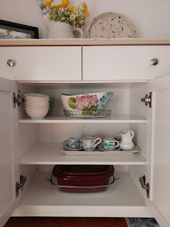

The "shower bathroom" is just off the living room and next to the office/craft room. It is very spacious and we love it.

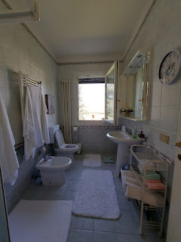

One of the pieces of art that we shipped from Hobby Lobby over to Italy in our shipment of household goods - is Mr. Giraffe reading the newspaper while seated on the pot. LOL

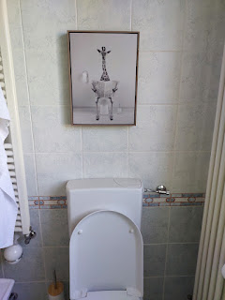

This is the only "meh" thing in our whole flat . . . the shower stall. It's old, it's got a little bit of mold in a few places and though try as we might, we just can't get it sufficiently clean. We met with our landlord, Daniele, on Saturday and he agreed that we can get a new shower stall very soon. He came back over yesterday and took some measurements, so he seems to be taking this very seriously! Unfortunately, we won't be able to make it any bigger, he said. He doesn't want to tear up the floor and the area around it. But we can get a new frame, shower pan, and new doors that will sit on top of the lower "foundation" at the base.

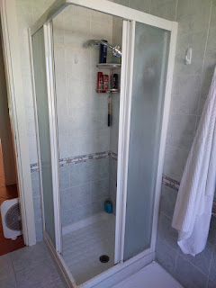

There is a fantastic foyer between the living room and the "shower bathroom", with tons of storage space.

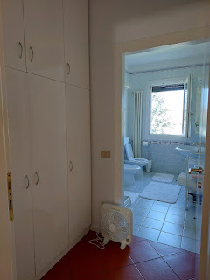

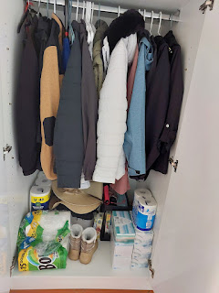

Winter coats, paper goods, extra towels, and an assortment of baskets filled with First Aid, cold medicines, etc. line the conveniently deep shelves . . .

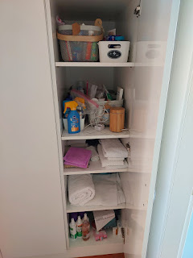

From the living room, there is another off-shoot where the guest room, tub bathroom, laundry room, and master bedroom are tucked away slightly. A pocket door seals off these rooms from any unwanted sounds or disturbances. It has become a lifesaver for when Scott is getting ready and heading off to seminary and then work by 6:00 a.m. most days. I can continue to sleep like an oblivious log. :)

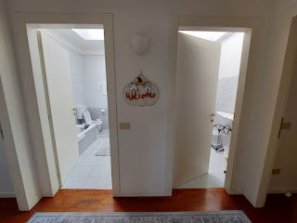

This is our guest room, a place where you are welcome to come anytime . . .

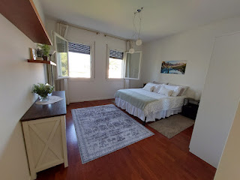

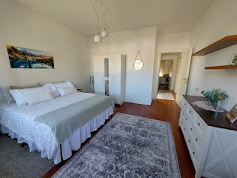

We call this the tub bathroom, because, well, it has a tub in it . . . It's very spacious and is well-lit with a skylight.

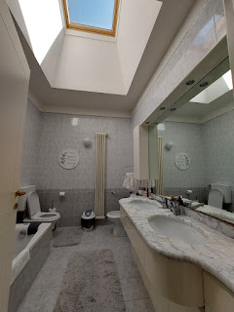

The laundry room has a large skylight in it, too . . .

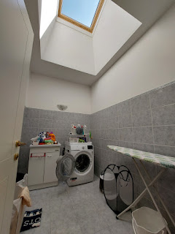

We have a comfortably sized master bedroom with plenty of storage in the tall wardrobes . . .

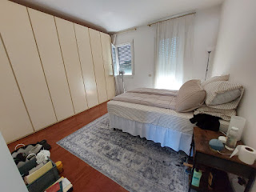

As I took a few photos of our bedroom, I noticed that we don't have anything on our walls yet. I'll have to find some decor to add some color in the very near future.

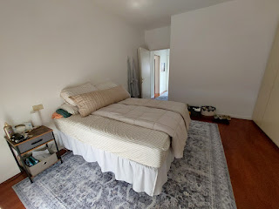

We really love the storage capabilities in those floor-to-ceiling wardrobes . . .

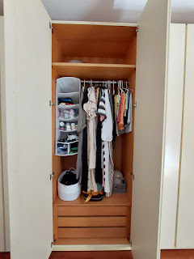

And surprisingly, I am able to reach the upper tier of clothes in this closet because there is a long-handled pole that I can use to pull the entire upper rack down to my eye-level. How clever!

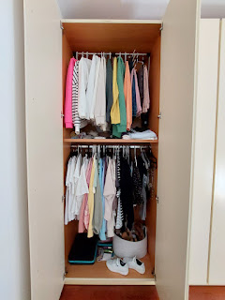

And that's it. That's the whole apartment. In recent posts, I've already shared photos of our balcony where I hang the laundry to dry and where we like to admire the sunsets every evening. Here are a few recent ones . . .

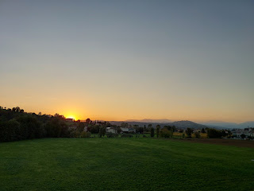

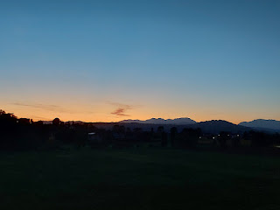

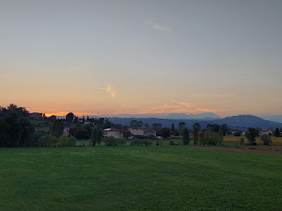

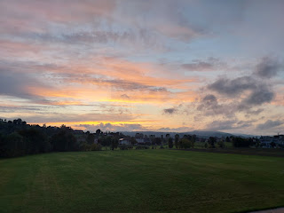

In other news . . .

Scott and I have begun taking more evening walks again, now that the weather is slowly coming down in temperature. It's been way too hot for several months, but now it's hovering around 75 degrees when we head out around 7:00 p.m. for a spin around the neighborhood.

We haven't been over to the fields by Del Din for a long time, but there was a lovely evening last week, so off we went.

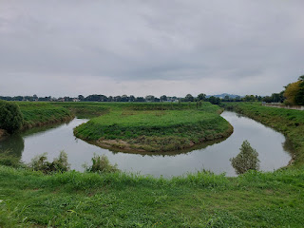



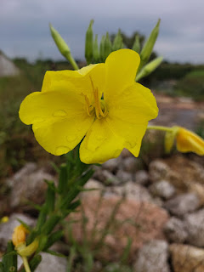

Funny story about the beautiful yellow flower above: As we walked across a small bridge, I saw several bright cheery blooms below and I wanted to take a picture. There was a gravel path that led down, so that was no problem. I had to carefully traverse across the tops of some large boulders to get close enough to capture this particular flower. I also had to be a little pushy with some of the weeds that were in my way. By the time I got back across the rocks and onto the path, I noticed that I was COVERED in sticky burrs all over my clothes and shoes. They did not brush off with a flick of the hand. I had to hand-pick every single burr off of me . . . It took a good 10 minutes to get them all off.

There is always a back story to every photo that gets posted online. Now you know mine. :)

I'm not sorry I made the effort though. But I was super happy that the photo turned out - with the moisture on the flower petals and all. XOXO

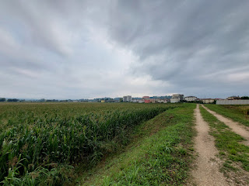

We've had a praying mantis or two hanging out on the balcony recently . . .

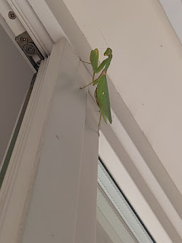

Sister Terri Sim, one of the military relations missionaries here in Vicenza, wanted to go check out some thrift stores in town but she wanted a "buddy". Her husband did NOT want to be that kind of buddy, ha ha, but I was happy to go! We each found some great items from the 3 stores we visited last Friday morning. My favorite finds were some gorgeous linens - table runners, doilies, pillow cases, etc. They were very inexpensive, which added to the joy in finding!

We ate lunch together at an Indian restaurant called Om Ganesh. The food there is very good! And the server was very patient to help Terri choose a dish that could accommodate her gluten-free needs. She ended up choosing a grilled chicken kebab dish, with saffron rice on the side. I ordered butter chicken with garlic naan.

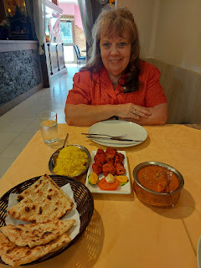

Later that evening, Scott and I went on a dinner date with some of his coworkers, including his new boss, Will. (Will told me that Scott was the easiest hire he's ever made. They love him so much.) Everyone brought their wife to the dinner and we had a fun time getting to know each other. The restaurant was way out in the middle of nowhere, about 25 minutes from our house and near Lago di Fimon (the oldest lake in Italy). Jason and Chiara have been here several times before and were excited to share it with the rest of us. It's called Da Pierina and is classified as an Agriturismo, or a farm stay. All of their dishes are made from local foods that came from within 1-2 km of the restaurant itself.

Unfortunately, we thought the food was just "okay". The noodle dish was the best one of the multi-course meal, and neither of us are very much into pasta!! We shared this bowl by splitting the portion in half.

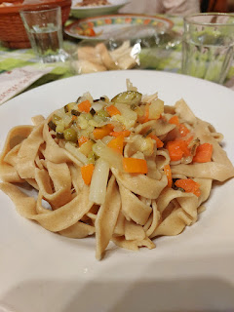

The restaurant's specialty was supposed to be grilled meats, but the meat was overcooked and the short ribs only had maybe 1% meat and the rest was just fat and bones.

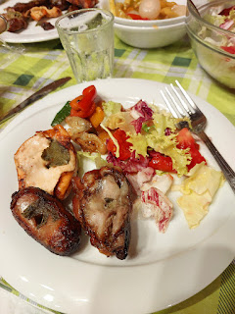

Also, we haven't been out to eat in a long time. It was unusual for me to eat out twice in the same day.

I tried a new walk a few days ago and it was so enjoyable that I invited Scott to join me for Round 2 on Saturday morning. We followed the usual walking path that is behind our house - on the other side of the fields that we can see out our kitchen window. We went past the cemetery and past the old church in the township of Maddalene. Then we turned onto a footpath just north of the church and it follows a few scenic farm fields for a while before reaching the main road in town again. The whole walk takes about 50 minutes.

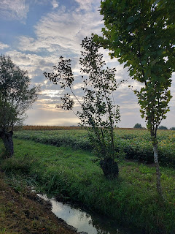

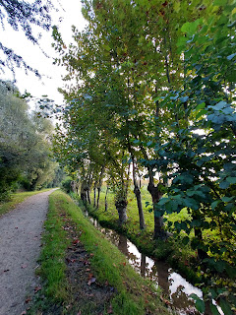

I've been trying out some new recipes in the kitchen, including these egg "muffins". After blending eggs, cottage cheese and some good old fashioned S&P, you can stir in whatever "this or that" to add some oompf. (cheeses, bacon, chopped spinach, diced red pepper, green onions, etc.) The trick to making them fluffy and airy is to place a pan of hot water underneath while it bakes in the oven. This has given us a great option for when we need more protein to start the day - especially if we're in a hurry, or for when we just need a healthy protein-packed snack at some point.

*Note: That same day I also made a yummy frittata with a variety of mushrooms, spinach, and two types of cheeses. Frittata is just a fancy way of saying Quiche - but there's no crust ( = lower in carbs).

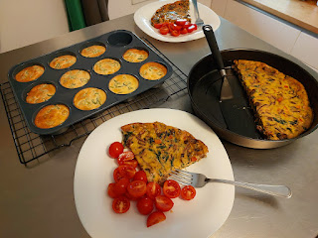

Recipe for the breakfast muffins:
https://madaboutfood.co/oven-baked-starbucks-egg-bites/

I captured a photo of this gorgeous bloom on a recent walk, and then I used AI to help me identify it. It's called "Cockscomb". The large bloom is very velvety and supposedly resembles a rooster's comb, ha ha.



We finished Step Two of preparing to sell our little buddy, the red car, included taking it to a place in Vicenza that will detail your vehicle for a NOMINAL fee. My friend, Terri Sim, told me about it. It's a business that shares the lot with a gas station, but they have a crew of maybe 6-8 guys that work HARD and non-stop. They cleaned out every single nook and cranny of my car, inside and out, even using a scrub brush to clean the rims after it went through the car wash . . . all for just $25!!! It took about 1.5 hours, but I was able to sit comfortably in a chair in the shade the entire time. I read conference talks on my phone (in preparation for my recent talk in Sacrament meeting) and played a few games to pass the time.

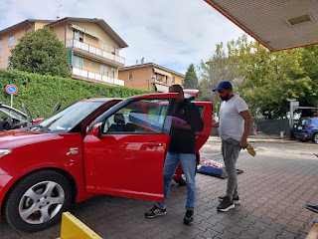

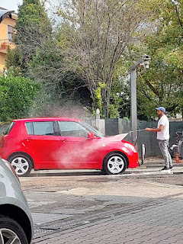

I took roughly 20 photos of the inside and out when it was a nice sunny day . . .

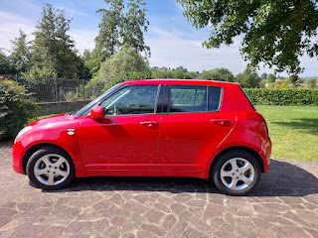

And then Scott listed the car for sale on Saturday. There are several local groups on Facebook Marketplace that cater to US military families, including one called Vicenza Beaters!!. By Sunday morning (yesterday), we already have a serious buyer on board. He is a U.S. military personnel who lives and works in Milan, but he wants to come all the way over to Vicenza (about 2.5 - 3 hours of driving) just to buy OUR CAR!!! Something we learned is that there is only one place for registering a car to a U.S. military owner in Northern Italy - and it's here in Vicenza. So, I guess this guy figured that if he has to come to Vicenza to get it registered, he might as well shop for a car in the same place!

He's been asking Scott a million questions about the car, and wanting to make sure that it's actually a GOOD CAR (which it is). He got screwed over once before, and he's not looking to have that happen again. Scott went through all the paperwork in the glove compartment and found some good documents to send to this guy to reassure him. These included a recent safety inspection report (you have to get these regularly if you're associated with the US military over here) and the details of our last oil change.

They seemed to satisfy the guy . . . so hopefully when he comes over on Wednesday FROM MILAN, he will see what a cute car it is and then we will bid Miss Zippy Red a fond farewell.

Dad - this next bit is for you:
I've been shopping on a cool website called AutoScout24.com for a new car, and there are a few good options that we will be pursuing in the coming days. Right now, the standouts are the Citroen C3 AIRCROSS (a little larger than just the C3), an Opel Crossland (newer than the Crossland X), and my personal favorite - the Fiat 500X (which is a little sportier than the 500L).

We want a diesel car (purely so it aligns with our primary car - also a diesel - and the use of our NATO fuel card which eliminates the 22% VAT tax here in Italy).

I don't care if it's manual or automatic, it makes no difference to me.
I want a non-smoker car. (Recently, I found this option to filter the results down. That's when the list went from 96 options down to 40, ha ha. Smoking is definitely an issue in Italy and I don't want any part of that!)
I don't care about the color.
I don't care about the make/model, as long as it's a little bigger than the Citroen C3/Opel Corsa/etc.
We want it large enough to comfortably transport 5 people and all their luggage, but also small enough to fit in tight spaces here in Italy.
Good gas mileage is a plus.
Navigation & back-up cams are fantastic, too.

Our Bishop recommended this AutoScout24 website to us and told us to be
picky
in using the filters. At first, we said we wanted a car with:
~ less than 90,000 km
~ newer than 2019
~ max price $12,500
~ within 100 km drive to get to it

We got like 90,000 results . . .

But when we got "pickier", we changed our criteria to:
~ less than 70,000 km
~ newer than 2020
~ max price $15,000 (because there were several in the $13,000-13,500 range)
~ within 100 km drive to get to it

Now we're dealing with less than 50 results on a regular basis. Much more doable!!

Anyway - hopefully, soon we will have a new car joining our little Italian family!! Crossing fingers...

