Courage to Try New Things
While life has been somewhat slower the past couple of weeks, at least on the surface, there have been plenty of things simmering underneath. September has been a good month to reset, organize, get caught up, and get ready for October, which is going to be BUSY.

I'm doing kettlebell workouts 3-4x per week and I absolutely love them. I'm also trying to go on more walks on the days in between. One of those walks took me out on a long lane and up a slight hill behind our house (see photos below). I've also been trying to jog for small stretches during these walks. Before you start thinking things like, "She's so cool", (which I
hope
to be someday) - - I'll just put in a disclaimer right now that my jogging speed is only comparable to a fast walk. If you are that fast walker, you might even have to slow down a bit to match my *jogging* speed, ha ha.

Here are some views from that recent walk . . .

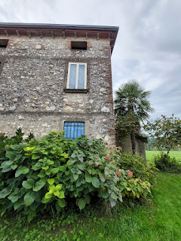

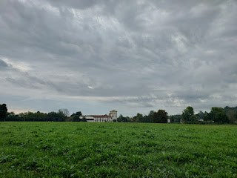

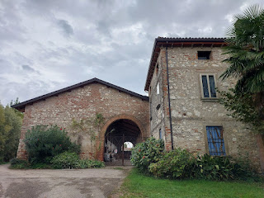

This past Tuesday, Scott and I both went to an Italian dentist for the first time. I went at noon and had an "interesting" experience, while Scott went later that same afternoon and had an uneventful experience.

Whenever either of us does something new and it has the potential to affect the other person, we always make it a point to relay as much information as we can so the other one of us has a more confident experience. Sort of like a re-con mission or something . . .

The dentist was located in Montecchio Maggiore (mon-TEKK-ee-yoh mah-JOR-ay), about 20 minutes south of our house. I always make it a point to scout it out on Google Maps before I just drive off, and I try to find a street view if possible. I also look for where to park before I ever leave home, because you don't want to be late for your appointment because you couldn't find a parking place. Things are just different here. It's not like there is a dedicated parking lot to go to the dentist. And there is hardly ever a dedicated parking lot for many of the shops in Italy. Grocery stores - at least the larger ones - do tend to have a parking lot, so that's nice. Otherwise, you better do your re-con ahead of time . . .

As I arrived to the street where the dentist was located, I took a few photos to share with Scott so that he would have a better visual on where to park, where was the entrance to the building, how to get in, etc. I made sure to explain what he was seeing in each one.

This is the view as you turn onto the one-way street. It was reassuring to see that there were several parking options right there.

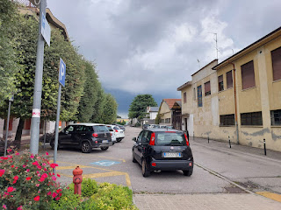

The sign that caught my eye right away was the bright green one - which also happened to be the sign for our dentist. When I pointed this out to Scott, he told me later that it really helped him to identify where he needed to go. It was next door to the Farmacia (far-ma-CHEE-yah) - or Pharmacy.

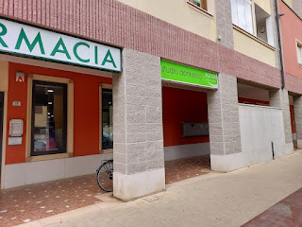

And, unlike the U.S., you can't just open the door and walk in. In this case, you have to first find the right door to enter. It might be really obscure. Then you have to find their business name on the plaque with all the buzzers and ring their buzzer. They will then buzz you in and the door will unlock. In some places, they can see you on video from inside their office and they can choose whether or not you can come in by asking what you need . . .

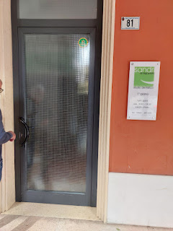

I went up 2 flights of stairs to arrive in this very pleasant waiting area, where I got to fill out some lovely new patient paperwork.

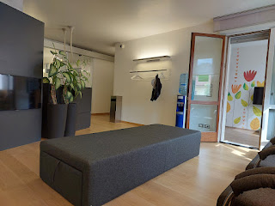

And, because it was a rainy week, patients were expected to put some little shoe covers on so we didn't track in any unwanted muck from outside . . .

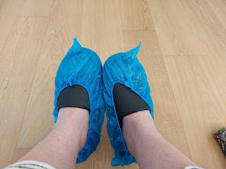

The hygienist that took care of my cleaning was named Samantha. I'd say she was probably in her mid-20's. As she used a water laser tool to clean the plaque on my teeth, I had a gentle - yet constant - spray of water all over my face. I closed my eyes for the whole procedure because it was so messy. Occasionally, she would use a folded piece of gauze to gently blot all over my face as she attempted to absorb the excess moisture that was giving me a second shower for the day. I don't think she realized, though, that after the second time using the same piece of gauze, it had no further use. She would dab and blot ever so gently on my face, but it just felt like a cold and very wet mop that did nothing to soak up any of the sprayage.

The second round involved a pick-like tool that was motorized. I think she had a foot pedal on the floor to make it go. It sounded like someone was scraping a set of keys all over your car the entire time. I wished that I had some ear plugs . . . Also, she was not the most gentle hygienist I've ever had the pleasure of being victim to, but I survived.

The third round involved a pick tool that was just handheld - the typical tool that they use to scrape your teeth. Yummy . . . the best feeling in the world. (!!)

The final round, after she flossed in between all of my teeth, was pretty gross. She explained that she would be applying a sort of "mousse" to the top and bottom rows of my teeth and that I needed to let it sit for 5 minutes. Normally, I have enjoyed this part in the past, as my U.S. hygienist typically uses a gently whirring applicator to buff on a minty pink polish.

Not so in Italy. It felt like she was slathering Vaseline all over my face, on the fronts of my teeth, the back sides, etc. and it ended up all over my lips and was quite disgusting, to be honest. And then I had to sit there and take it like a man for 5 whole minutes. The worst part is that it had no smell and no flavor at all. Just a disgusting Vaseline smeared all over me. At the end, I couldn't even rinse it out of my mouth and down the drain. I could only spit once or twice into the sink next to my chair and that was it. I was all done.

I will say, though, that my teeth did feel nice and clean on the drive home. I'm not looking forward to the next visit in 6 months, but at least I have a while to forget some of the details . . .

Scott ended up with a different hygienist named Esther, and he never experienced any of the shower-all-over-the-face part like I did. Good for him. I'm super happy for him, ha ha. He was, however, grateful for all the photos I sent to him earlier, which made everything much easier for him.

The weather has started to turn Fallish lately, which I am in love with. Hoodie weather is my absolute favorite weather. Some might call it sweater weather, but I call it hoodie weather. I have started heating up some lovely tea on most days this past week, and that's been delightful as well.

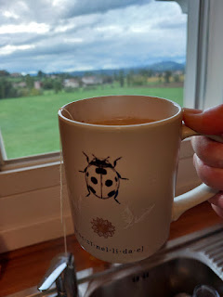

And I have begun making more soups, too, another favorite of mine. I could literally eat soup every day of the year.

I didn't set out at first to make the soup shown below . . . instead, I had started off by slow-coooking a large pork roast in the crockpot, and everything smelled really good. But the meat turned out to be a little dry, probably because in Italy they tend to have pretty lean cuts of pork. I did a little research the following morning to see how I could use all the leftovers and freshen them up a bit. I found a great soup recipe that I used and wow, was it tasty!! Scott kept raving about how delicious it was every single night for the next 3 nights as we finished it off, one bowl at a time . . .

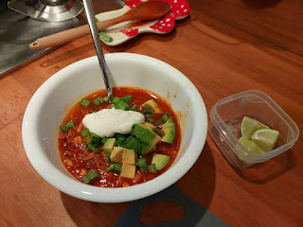

Recipe for the pulled pork here: *Note: I made up my own spice rub to mimic the one in the recipe.
https://www.yourhomebasedmom.com/crockpot-pork-roast-only-five-ingredients/

Recipe for the soup that used up our leftover pulled pork here: *Note: I did not add any beans.
https://www.recipetineats.com/taco-soup-pork-carnitas/

The soup was perfect for the stormy night that we had at the same time . . . and wow, it stormed for hours!! Lightning, thunder, pouring rain, etc. When I woke up the next morning, I saw that nearby Schio (a very tiny town NW of Vicenza) had even more of a whopper that hit . . .

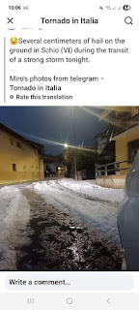

Italian grocery stores sell shelf-stable eggs, like most places in Europe do. We like to get a 30-pack from the Pam Superstore because it's the best deal, which makes Scott ULTRA happy. :) 30 eggs = 5.80 euros.

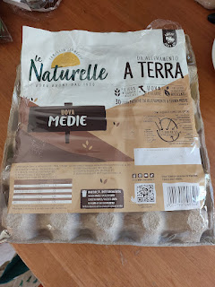

They are not very clean, though . . .

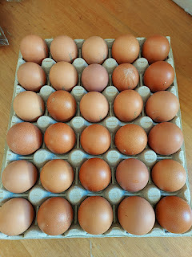

Most of the time, there are crusted remnants from Miss Henny's poop and occasionally some feathers still attached . . .

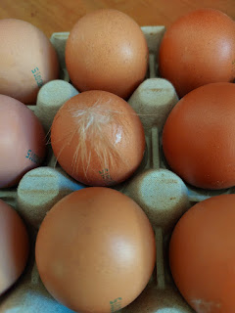

In the U.S.:
Eggs are cleaned, foods have preservatives added so they last a little longer, and you can buy a week's worth, two weeks' worth, or a month's worth of groceries and they will usually make it. Cheese can generally make it a long time once you've opened the package.

In Italy:
Eggs are not cleaned, and foods generally don't have any preservatives - so they don't last very long at all. We typically only buy 2 day's worth of groceries and then we have to go back again and again. It feels like the moment we open a package of cheese, we have like one day to eat all of it before it starts growing mold. With such a small fridge, we don't have the space to accommodate more than a couple days of food at a time. The fresh produce is exactly that - super fresh. I haven't seen the fruits/veggies spoil quickly once we bring them home, so that's nice. And they're not loaded with chemicals that need to be washed off, either.

I've started working on Gwen's dress for her baptism, marking where the pockets can be created on the side inseams. I've also begun embroidering a scripture to attach inside one of those soon-to-be pockets.

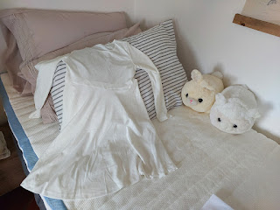

I've also started working on some future Christmas gifts, since they take a bit of time. I'll be coordinating a heart with a USA flag on the left half of a piece of fabric, and an Italian flag on the right half. When the quilt block is done, I have some frames for them to go into, ones that I ordered from Amazon (US). I want to make the combination heart as a memento for a few friends, to remind them of their time serving in Italy.

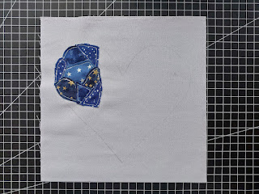

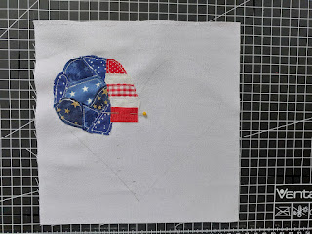

All this one needs is the last bit of red on the far right and then it's all done . . . the finished square will measure 8x8 inches.

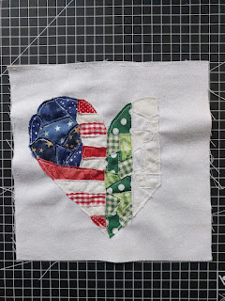

I have been thinking these past few days that Scott and I are pioneers. We are regularly figuring out how to do things here in Italy, and some of those things are much bigger than the rest. Right now, for example, we are figuring out how to buy a car. It hasn't been easy, and it has taken a great deal of our time and energy for several days.

The easy route would be to go to one of the US car lots that are either on or near the main base (Ederle). They either have cars on site for purchase, or they can special order something for you from wherever in the world. Lots of people do this because you don't have to deal with the language barrier, and you also don't have to deal with any extra steps - such as converting the registration from Italy to America. Buuuut, you will end up paying quite a bit more for these conveniences. Scott knows several people who have purchased a car or an SUV for over $30,000 by using these services.

But being married to someone whose top priority is to get the best deal, we are going the much more difficult route in order to save a lot of money. So far, we have done a LOT of driving to this place or that, and most of the time it's about 45 minutes in any given direction. When we finally get there, the car is not even on their lot, or they don't even know what we're talking about.

We decided to do some more double checking before we set out, and I have taken the lead on this because I'm at home during the day. I've been emailing and texting different dealerships to inquire about a specific car, so we can make more targeted plans about where to go.
I barely managed to catch this cute stripey house on our way to a dealership in San Giorgio in Bosco last Friday night . . .

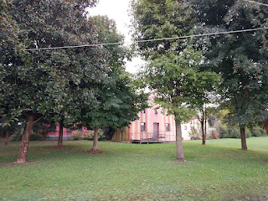

As we drove home, the sun was setting and the clouds were abundant . . .

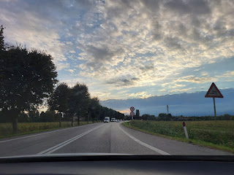

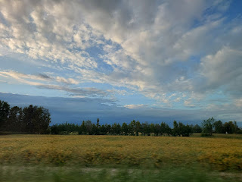

On another occasion, we got really excited about this car, an Opel Mokka, in nearby Verona. The price was good, the miles looked good, and the bells and whistles looked really fun. I was hoping for a *unique* color of car to make it easier to find in a parking lot, and this one sure took the cake! ha ha

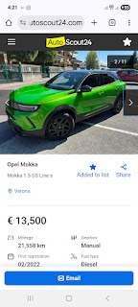

But unfortunately, after several back and forths of messaging and emailing, we came to find out that it was a scam. Someone had listed this car on the reputable AutoScout24 website, and had categorized it as a private seller. But upon further investigation, we realized that it was more than likely a scam and we had to abandon the pursuit. I was really sad because I was planning on calling the car "Elphie", short for "Elphaba" from the movie Wicked.

On another quest for a car . . . We had the BEST customer service for the place we went to on Tuesday - in Bassano del Grappa - but then the car ended up being a little tough to drive. The clutch was super stiff and I had to press really hard each time to engage it, but when I applied the brake I had to be super gentle with my right foot!! I only drove the car for about 5 minutes, but my left hip was feeling pretty sore as we drove home in our own car.

This was the car that we had such high hopes for on that day - a 2023 Citroen C3.

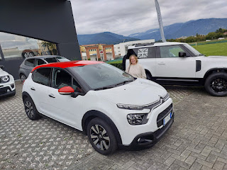

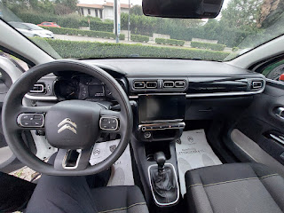

As of this writing, we are now pursuing a Citroen C3 Aircross here in Vicenza. It's a little bit roomier and has a larger trunk, which will be nice for when people come to visit us. It's also a deep royal blue color. I was a little leery of driving it because of the C3 experience in Bassano, but the clutch engaged more easily in this model, so I think it will be okay. I'm hoping that it all works out soon (finding a car), because it's exhausting to hunt and pursue and hunt and pursue all across the land.

The Aircross just arrived at the dealership yesterday - with a low battery - and they hadn't had time to let the mechanic check it over yet. The agent that we spoke with, named Paolo, was super nice and spoke reasonably good English. He's worked with the US military before and is very familiar with how to proceed if we do end up purchasing this car. The mechanic is supposed to be inspecting the car today and then we will go see it once Scott gets home from work - as long as it's ready for us. Paolo said he would keep us informed.

On a separate note, I've also been wanting to find some apple varieties in large quantity so that I can make some applesauce. Our landlord, Daniele (Daniel), pointed us toward a place called Orofruit S.R.L. It's only about 6 minutes south of our house. Scott and I drove over there together on Saturday morning to see what they might have.

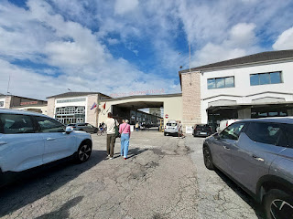

It's a huge open air farmers market, available 7 days a week but only until noon. We saw so many fruits and vegetables for sale, and the place was bustling with lots of Saturday morning shoppers. Eventually, we spotted some apples - these two varieties. I think the one on the left is like a golden delicious - they are very crispy and flavorful. The reddish ones on the right were a bit old, but we didn't discover this until we got home and then they sat through the weekend. You can't just reach in and feel the apples yourself. The person manning their stall does all the "touching". Although, if we were more comfortable and knew the language a little better, I'm sure we could ask to sample one of the apples before we buy. I saw other stalls where they had cut a slice of apple or whatever fruit/veg for a customer to try first.

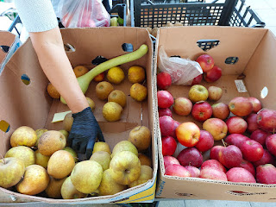

Our third and last purchase was to buy a flat of beautifully huge red and yellow apples. Scott had to place the box on the scale first, and then the lady in the booth gave him a paper with the weight and price on it. Then he had to walk over to the ticket booth next door to pay for it.

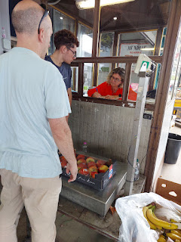

This is the main row of vendors . . . there was at least one additional row on the right that we didn't explore.

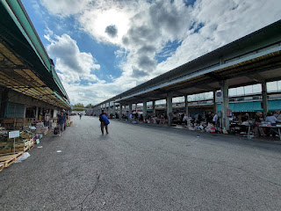

I was very pleased with our purchases. The mushier apples were 1.50 euros per kg. The golden delicious ones were 2.00 euros per kg. And the prettiest ones of all (in the flat) were 2.50 euros per kg. The flat ended up weighing 4 kg, so we paid 10 euros for those beauties. Our total for the day was 20 euros for 10 kg of apples. *10 kg = 22 lbs, in case you were wondering.

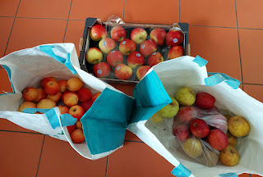

I wanted Swedish meatballs for dinner that night, and I spent a fair amount of time in the kitchen in order to get them. I used a ground pork/beef mixture to make the meatballs and I fried them up in my new cast iron pan. They turned out to be quite scrumptious. In lieu of lingonberry jam, we opened up a can of cranberry sauce and that worked out great. We served them over some mashed potatoes.

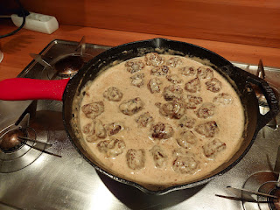

I also made another round of zucchini brownies that same evening because we would be having some company over for dinner the next day and I wanted a nice dessert.

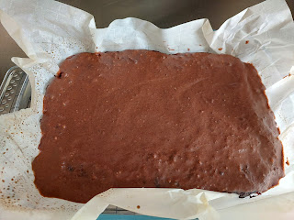

On Sunday morning before church, I put together a French bread dough of sorts, with bits of caramelized garlic in the dough. After searching for a warm spot to let the dough rise while I went to church, I decided to place the bowl in front of the balcony window with faces the south. The sun was hiding behind a cloud at first, but then it popped out and helped the yeast to do its job while I was gone for a couple of hours.

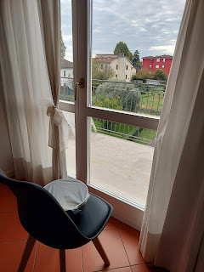

I forgot to take a picture of the finished bread, but it was really yummy. I used my Pampered Chef Deep Covered Baker (similar to a Dutch oven) to bake the bread. For the second "proofing", the recipe said to place a bowl of boiling water next to the bread in a cold oven. Shut the door and let the dough sit until it's doubled in size.

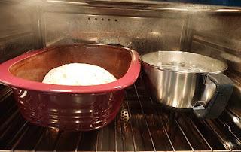

The one thing I would change for next time would be to maybe wait to add the caramelized garlic until after it has risen the first time. The black garlic bits (from Trader Joe's) were almost completely dissolved, and the bread dough turned slightly brownish and streaky because of it. The bread came out looking more like an artisanal wheat bread, rather than a French bread.

I'm happy to report that my applesauce is complete. (At least it will be soon.) Round One was completed yesterday and everything went swimmingly. Today (or tomorrow), I will finish up with the last of the apples and then I can move on to other things. :)

These are the ingredients that went into the applesauce, along with the apples, of course . . .
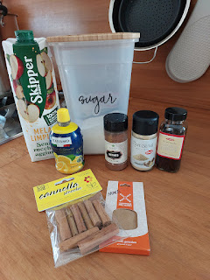

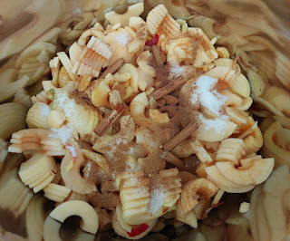

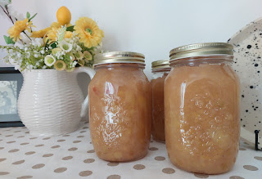

Speaking of apples . . . Jack and Maisie visited an apple orchard and fall festival over the weekend back in Minneapolis.

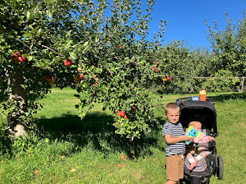

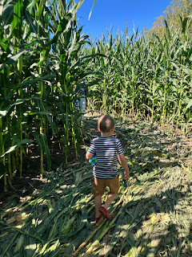

Maisie makes that apple cider donut look so yummy, ha ha . . . (I've never actually tried one, but Amber says they're amazing!!)

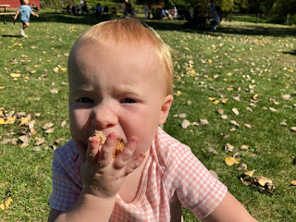

Look at this beautiful sweet girl . . . with her baby doll . . . Omigosh she is so adorable!!

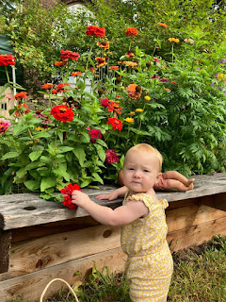

Jacob sent us this video of Jack vacuuming the stairs, with the caption, "Not a chore if it's fun."
(9 seconds)
https://photos.app.goo.gl/c3NzNxBxpCV1kCZC6

Maisie has recently gone from walking while holding onto one adult hand: (10 seconds)
https://photos.app.goo.gl/paAkTpmLfnzFpZ677
*Note: I love how she's waving to Jake as she walks.

To THIS: (6 seconds) Hooray Maisie!!! XOXO
https://photos.app.goo.gl/DXk8SXK3dz79WRNL7

Also, Maisie still likes to be right in the thick of whatever Jack is doing, much to his frustration at times. After getting an explanation from Jacob, it seems that Jack was set on putting dinosaurs into his bucket, and he was getting frustrated that Maisie wanted to put MAMMALS in. Of all the things . . . goodness me, ha ha.

Video of them here: (27 seconds)
https://photos.app.goo.gl/UECB3ZqyXUzAA6FQ9

A few last random items . . .

We saw our first deer while we were on a walk last night. I had heard that deer were in the hills and fields near our house, but I've never seen a single one until now.

Video of the deer nibbling some grass in the vineyard: (16 seconds)
https://photos.app.goo.gl/rFicyMT2FvU65NYX6

Amber has been testing out how to dye her hair pink - and this is a super cute video of her and the girls as they share their new hair colors: (33 seconds)
https://photos.app.goo.gl/dcBTSir59jm29cRn6

And lastly, out in CA, my mom recently hired someone to disassemble the "Noah's Ark" in their backyard. Her late husband, Frank, built it with his own hands, but it was never fully completed and unfortunately, was showing signs of rotting. Now, after being taken apart, it has been reduced to a sort of "canoe".

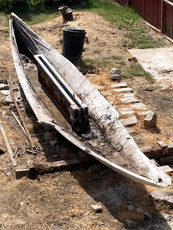

Video of the project early on: (12 seconds)
https://photos.app.goo.gl/jRacopZ7EvzZ32cL9

**NOTE:
I am heading up to Germany for 6 days next week, so I might be a little late in writing the next blog post. I'm so excited for this trip!!

