Germany: Part Two
This is a continuation of last week's post regarding my trip up to Germany during early October. In case you missed it, the first half of my adventures is in the previous blog post. :) I traveled up to Frankfurt so that I could see my granddaughter Avery, visit my friend Marnie Parker, and spend some time in a few towns where my ancestors lived a few centuries ago. It was a wonderful week with lots of variety in the activities.

The Parkers left for France on that Thursday evening (Oct. 9th), as part of the typical 4-day weekend each month for all of the military families that are serving in Europe. They went over the border to spend a few days in Metz, France - which was only about 1.5 hours from their house. Their daughter wanted to check out the famous flea markets, so off they went.

They had given me a house key when I first arrived, so even though I was all alone for the last two days, I could get in and out okay by myself.

Friday, October 10th:
With the entire day to spend any way I wanted, I changed from my original plan of visiting Bingen on the Rhine - which was quite a ways north, and instead I decided to go to a couple of towns south of the Parker's. These new towns had never popped up on my radar before, but as I perused my family tree on FamilySearch, I cross-checked them on a map and was surprised to see how close I was!

I drove to the first town: Thaleischweiler-Froschen. Yeah. That's a doozy. The pronunciation would be something like this: TAH-lye-sh-vy-ler FRO-shen. My 5th great grandfather, Hans Georg Pabst, was born here in 1731. Several of his siblings were born here, as well.

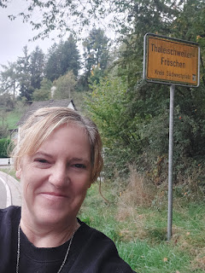

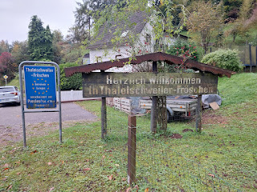

Video as I entered the town: (30 seconds)
https://photos.app.goo.gl/7dHtnXg8fz8tvoW18

I had studied the map of Thaleischweiler-Froschen before I drove down there, so I could know where to go and where to park. I chose to park at a grocery store where I could just go on a little explore on foot from there. I'm not exactly sure why I chose to walk the length of Froschener Strasse, but it just felt like something I should do.

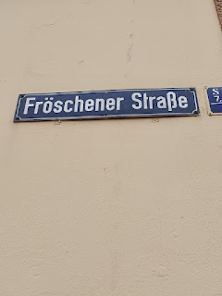

I walked nearly to the end of the street in a westerly direction, before turning around and walking all the way to the other end. I passed a few houses that looked like they were built a long time ago, but had received some updating in recent years.

Take this next photo, for example. Closer to the street, the building appears to be newer. But behind it, those could have been old barns or outbuildings from the 1700's or 1800's.

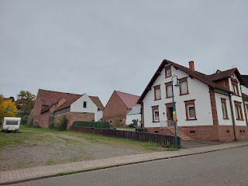

The houses seemed to be a lot more interesting as I headed down to the eastern end of the street . . .

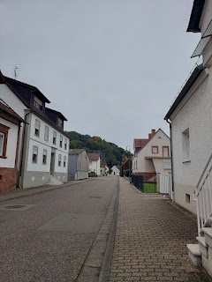

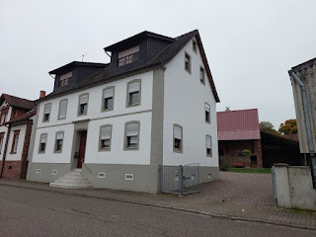

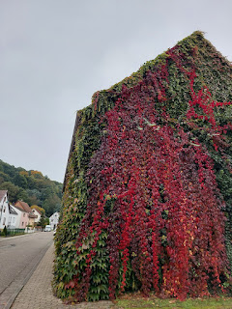

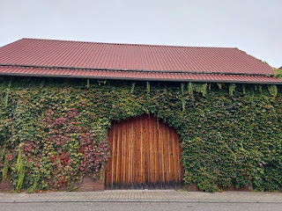

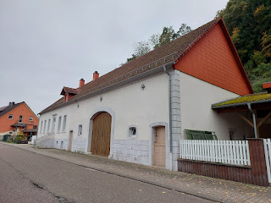

This one was especially interesting, with all the various layers and textures on the exterior . . .

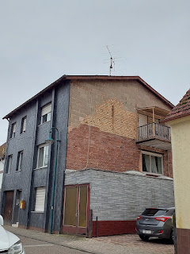

I had planned to visit their local bakery, hoping to bring something home with me. But they didn't have any good travel options inside . . . just large loaves of bread mostly. But it all smelled really good!

Just outside the bakery, there was a monument dedicated to those who had served during the First World War from this area . . .

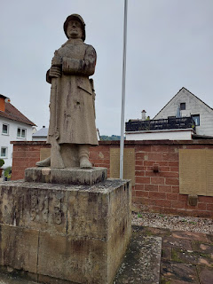

I walked back to the CAP grocery store where I had originally parked, bought a few things inside, and then I headed off toward the next ancestral town of Annweiler am Trifels.

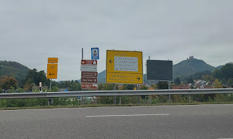

Pronounced like "Ahn-vy-ler om try-fels", the name means Annweiler at the Trifels, or threefold rock. Annweiler is surrounded by mountains and nature trails, picturesque hills, and many opportunities to explore outdoors. It is much larger than Thaleischweiler-Froschen, but still feels comfortably small and very walkable.

I paused to take a photo of their welcome signs as I drove into town. Annweiler am Trifels has the "Sister Cities" of Ambert, France and Gorgonzola, Italy.

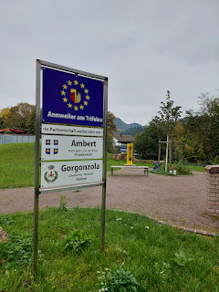

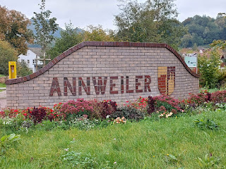

Video as I drove into town: (26 seconds) *I parked in the ONE spot outside the Thai restaurant at the end of the video clip. I was able to stay here the entire afternoon and everything was close by for sightseeing on foot.
https://photos.app.goo.gl/5gkaQXnv2fxwk99D9

Once I figured out what to order, the food at the Asia Wok was great. I ordered a coconut chicken soup, similar to what I ate when I visited Framersheim the day before.

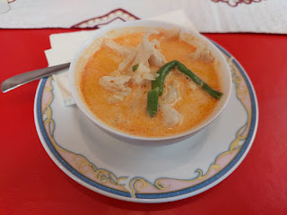

Here is a peek at the menu for their sushi rolls . . . a THAI restaurant in GERMANY . . .

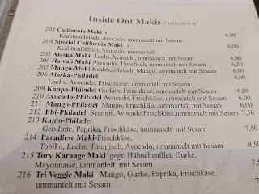

The sushi was pretty heavy on the sticky rice, so I ended up using my chopsticks as surgical instruments to pick off as much extra rice as I could without completely annihilating each piece. Then, with a little dunk into the soy sauce, they went down the hatch!

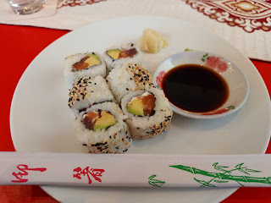

With a very happy tummy, I began exploring the old town in the center of Annweiler. It was unexpectedly stunning!

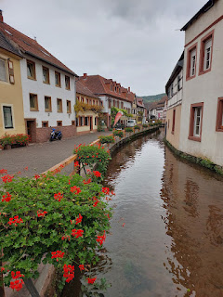

With waterways and water mills in multiple places, it was one of the most joyful discoveries to be here in this beautiful town!

Video of one of the water mills near the Asia Wok restaurant: (4 seconds)
https://photos.app.goo.gl/FsxfYpDwyt4VHRWJ8

This is a very old church in the town square just up the street . . .

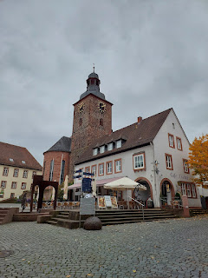

The Protestant Church is called:
Stadtkirche - Prot. Kirchengemeinde Annweiler am Trifels.

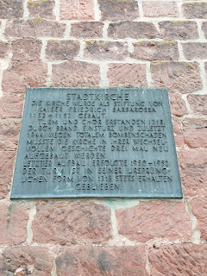

The translation and explanation of the church is:

Town Church

The church was built as a foundation by Emperor Frederick Barbarossa in 1152-1153.
The tower and chancel were built in 1318.
Due to fire, collapse, and most recently in 1944 due to total bomb damage, the church had to be rebuilt three times in its changing history.
The last reconstruction took place in 1950-1952.
The tower has always been preserved in its original form from 1318.

The magnificent doors on the opposite side were closed, and unfortunately I was not able to go inside this time.

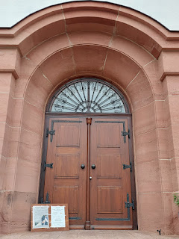

There was a beautiful courtyard in front of the church with a fountain, and I couldn't resist smiling when I saw these gorgeous hydrangeas still in full bloom . . .

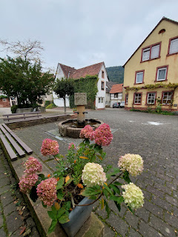

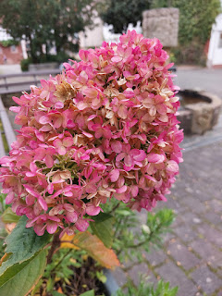

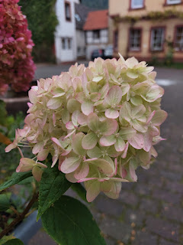

Continuing my walk, I found that just about everything was picture-worthy. To my left, to my right, everywhere there seemed to be something charming or intriguing.

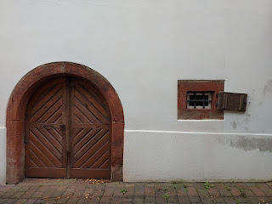

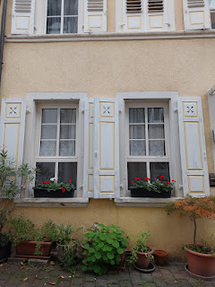

There was an informative sign that explains this next photo, ha ha. It said:

Prangertshof
(Pranger = Pillory. Hof = Courtyard.)

In the Middle Ages, the pillory was used to publicly punish people who had committed minor offenses. Placed in the pillory, the convicted were subjected to public insults. Often, the people were also pelted with all kinds of rubbish. This public disgrace was intended to deter others from committing similar misdeeds.

Presumably, there was also a pillory in the town of Annweiler in the Middle Ages, more likely near the town hall and not here on this square. There is no reference to an exact location in the archives. How this square got its name can be read in the report written by Gunter Frey.

Lucky for me, there was a small group of youngish men who were taking photos of one of them getting locked up in the pillory. I asked if they would take a similar photo of me, and they were happy to oblige.

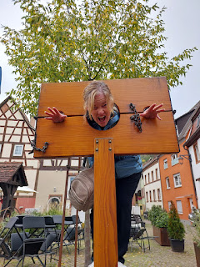

Germany is well-known for their half-timbered houses and buildings . . .

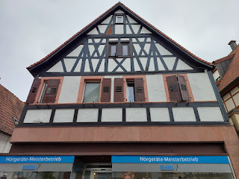

Everything just felt so lovingly artsy here, like that there was great care in every little detail.

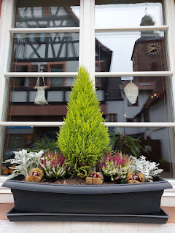

This house looked quite old from the outside . . .

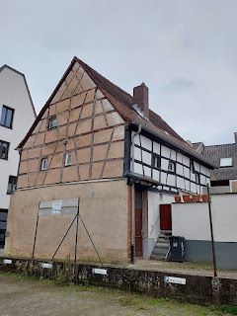

I made my way over to the Museum, just a couple blocks away. Everything reminded me of the little village where Belle (from Beauty and the Beast) came from, even though I know she lived in France. And yes, I know she was fictional . . . :)

Video of the cute houses near the Museum: (11 seconds)
https://photos.app.goo.gl/jLEMZodUXR6nJWmc7

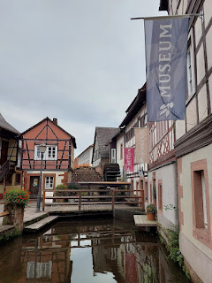

I couldn't pay to enter the museum with a credit card, it was cash only. So I was directed to a nearby bank with an ATM, just a few paces away. I was happily surprised to learn that the man working inside the museum was AMERICAN!! He was from San Diego, in fact, and his name was Mike. His wife is from this area, so eventually they settled back down here. He told me that most of the visitors come to Annweiler for the hiking and nature experiences that surround the town. That's good to know!!

I would love to come back and explore Annweiler more, including the Burg Trifels - an ancient castle that was first mentioned in a deed from 1081. After many centuries of use, it fell to ruins shortly after The Thirty Years War (1618-1648). The rebuild began in 1840 and has received numerous updates since then. It sits high above Annweiler and is visible for miles around.

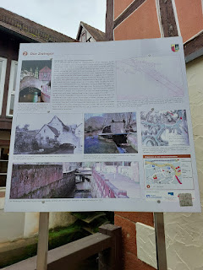

Just outside the museum entrance, there is a collection of signs and photos that describe some of the history of Annweiler am Trifels. The large paragraph on the sign above states the following:

Der Zwinger
(refers to a defensive tower)

The Queich River as a Defensive Means - -

The most vulnerable side of the city's fortifications was the north side, as the terrain rises sharply towards Adelberg and Wingertsberg, and an attacker could exploit the elevation. The construction of a second wall at this location took this into account. This second fortification wall likely dates back to the 15th century, as the "new moat" is first mentioned in 1493. This north side of the city wall was specifically protected by a moat.

This moat was fed by the Queich River, which, in times of war, was diverted into the moat by sluice gates in the west of the city. Maps from the 18th century show floodplains, as if there were also plans to submerge parts of the outer area. Around 1750, plans matured to specifically secure the threatened northern side with artillery redoubts on the elevated ground. These considerations were never implemented.

The outer city moat was stocked with fish, clearly indicating it was a wet moat. The right to catch and sell fish from the moat was granted by the city council. He also ensured that fingerlings were placed in the moat. The other city moats were likely dry ditches.

The city contracted out the maintenance of the moats to workers who had to shovel out the fallen soil, as was the case in 1660 at the western moat. The Queich River flowed through two openings in the city wall. The eastern one is preserved and is located at the so-called Schipkapass (site). The double-shell construction
technique used for the entire city wall is still clearly visible in the wall built over the river.

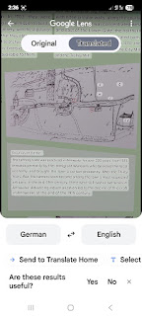

The translated description above talks about the tanning trade in Annweiler. The translation says:

The tanning trade was practiced in Annweiler for over 300 years, from 1593 onwards. Primarily by the immigrant Walloons, who boosted the local economy and brought the town a certain prosperity. After the Thirty Years War, the tanners soon became among the town's most respected artisans. In the mid-19th century, there were still twelve tanneries in Annweiler. Advancing industrialization led to the decline of this craft in Annweiler at the end of the 19th century.

For some context within our family history, this is why Annweiler matters:
The Pape/Babst/Pabst branch connects to our Snider line way up high on our tree.

Isaac Snider (my 3rd great grandfather) married Julia Ann Oatman
Julia Ann Oatman was the daughter of Joseph Oatman and Christina Pope
Christina Pope was the daughter of Hans Georg Pabst and Maria Christina Hill

If you continue to follow the Pabst line further, you will see that they came from Stavelot, Belgium over to Annweiler in the late 1500's ~ early 1600's. They stayed in Annweiler for close to 100 years, including through the duration of the Thirty Years War, which must have been terror-inducing while they tried to raise their children and watch over their grandchildren. Near the end of the 1600's or early 1700's, they migrated over to Froschen, or more specifically, Thaleischweiler-Froschen.

Hans Georg Pabst, the father of Christina Pope, immigrated with his parents (Heinrich Pabst and Gertrud Kieffer) and older siblings to the U.S. in 1732, when he was just one year old. They first arrived in Pennsylvania, and later settled down in Lincoln County, Kentucky. Hans Georg, who went by George Pope later in life, died in Lincoln County, KY in 1812.

So, if you think about those years that the Babst/Pabst family lived in Germany during such a tumultuous period of time, it's kind of a miracle that they made it through any of that. The Thirty Years War alone was enough to eradicate roughly 50% of the German population. Holy Schnitzel!! I'm so glad they made it all the way to America and helped to lay a foundation for the life that I am now living. XO

This is one of the moats that flows through Annweiler . . . this one happens to be right in front of the museum.

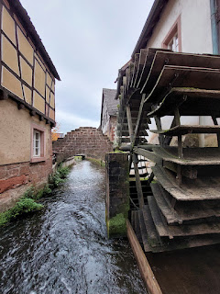

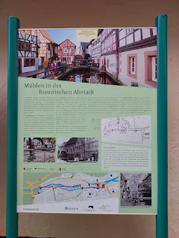

Translation of the sign above - that sits in front of the museum:

Annweiler was home to numerous mills. The town mill was a grain mill, and there was a bark mill located at the present-day Hotel-Restaurant "Zum Alten Wasserrad" at the end of Gerbergasse, as well as opposite the Museum unterm Trifels. This is why the watercourse through the town center is also called the mill ditch.

In the Middle Ages, the town mill was a compulsory mill, meaning that farmers from the surrounding area were obligated to have their grain milled there. The sovereign, in turn, levied a tax on the miller of the town mill, the water tax. The town mill was still in operation until the 1950's. It is located at the entrance to Gerberstrasse and was last used to generate electricity for the building.

The tanneries testify to the importance of the tanning trade in the Trifels town. The Walloons brought it from France in the late 16th century. Running water was an important prerequisite for settling and practicing the craft. At times, up to 36 tanners resided in the town. The tanneries can be recognized by the stepped roofs, which served as drying lofts for the hides. The guild sign of the tanners' guild, a tree trunk with a crossed swordsman, can also be found on some houses.

In the Hotel-Restaurant Zum alten Wasserrad (At the Old Waterwheel), the still-functioning waterwheel was used to power the machinery of a shoe factory.

The bark mills were mostly operated cooperatively. In 1703, the applicants for the construction of a bark mill in the city received permission, with the stipulation that they obtain the necessary bricks free of charge from the nearby old Trifels Castle. The required timber was also provided to them free of charge.

The tanners' quarter was located within the ring walls, along the course of the millrace, for the sake of uniformity. It was concentrated west and east of the Lower Gate, the northern city gate. Bark mills were located both inside and outside the city. Around 1770, the city mill and the wagon mill are mentioned as the only remaining gristmills.

Okay, I'll stop digressing and just go inside the museum now . . .

I thought this was very interesting, especially because you don't see the last name Hartung very often. We just happen to have the name Hartung on our family tree! Christian Hartung was my 6th great grandfather. He was born in Germany in 1725 and immigrated to Pennsylvania in 1750. He married Margaretha Weinhold and they are the parents of my 5th great grandmother, Maria Catherina Hartung. Maria married Michael Perkheiser, and their daughter, Elizabeth, married into the Hockman line.

I'm not sure if my Hartungs are related to this guy, but that would be really cool if they were . . .

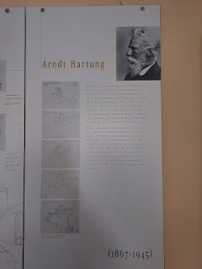

The English translation about Arndt Hartung is in the photo below. (click to enlarge)



In the museum, there was an entire room dedicated to a very talented photographer/artist named Benedikt Hild. He has a huge following on Instagram and has published several "coffee table" books with his clever photos. Essentially, he finds a way to weave the tiniest scene imagineable into everyday human-sized settings.

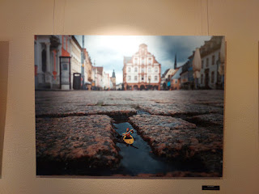

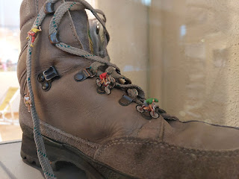

I ended up buying one of his books. I'm glad I flipped through the pages first, though, because once in a while he will throw in a very inappropriate page. I ended up ditching the first book that I was about to purchase, in favor of a different one. There were two much less inappropriate pages in the second book, but I knew of a great artist in Portland, Oregon who could "doctor" the scenes with her creative talents, which she did just one week later. She (my daughter, Amber) got a kick out of fashioning a bathing suit for one of the ladies by using her paint pens. No one will ever know that anything was amiss in this fun little book. She did a great job, and now my grandchildren are enjoying all the fun scenes on each page.

I was intrigued by the unique wax seals that were used by various leaders in Germany back in the late 1500's and 1600's. My eyes latched onto anything that would have taken place around the same time that my Babst/Pabst ancestors were in the area.

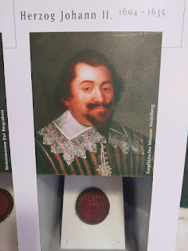

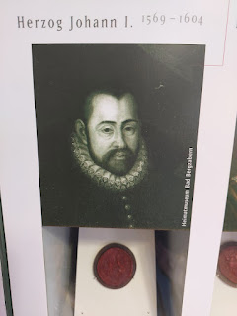

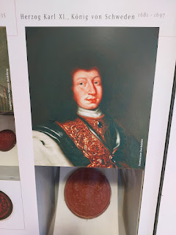

These next 3 frames describe some difficult scenes from various wars that took place in the 1600's . . . (click to enlarge and read)

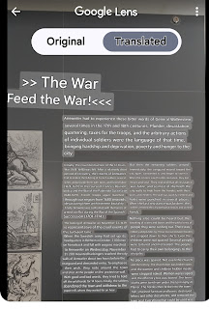

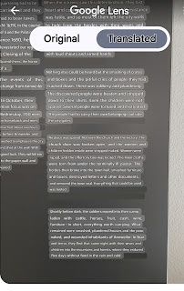

This next frame talks about how some of the Belgium people came to the Annweiler area, which may have included our Babst/Pabst ancestors. There are a few records on FamilySearch that mention how the Babst family was known as Pape and Le Pape in Belgium and that they came to the Annweiler area in the late 1500's or early 1600's.

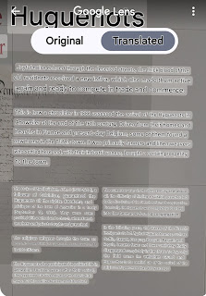

This room was very interesting as it had models of all of the castles in the region . . .

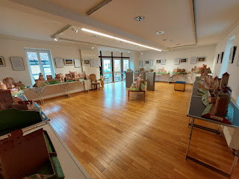

My favorite thing in the whole museum was this . . . a model of what Annweiler would have looked like in 1750.

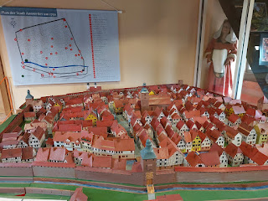

Next to it was a simple sketch of the town's layout, which included the old Protestant Church right in the center of it all . . .

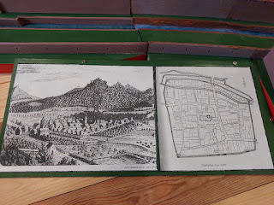

This next photo describes the history of the chestnut in the Annweiler area . . .

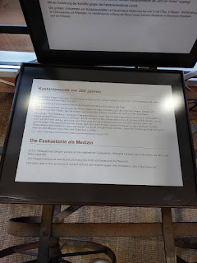

Translation is as follows:

Chestnut Harvest 200 Years Ago

The Wurttemberg theologian and pomologist (fruit expert) Johann Ludwig Christ (1739-1813) dedicated himself to fruit growing in addition to his parish duties.

He vividly describes the chestnut harvest 200 years ago as follows:

"The chestnuts are swung down like nuts, and the people who show skill climb the tallest trees with crampons on their feet, like cats, as if they were climbing a ladder. Most of the chestnuts that are knocked down are still in their spiky shells and are stuffed into sacks and carried home, where they are poured into old barrels in the cellar or into a corner, where they all ripen, that is, what is still partly white, turning brown, and one can take the time to beat them out. This is done by pouring a pile of such chestnuts in their shells onto the floor of the room, then beating and threshing them with sticks so that the fruits fall out of the capsules, but one must take precautions against mice."

The Sweet Chestnut as Medicine

Hildegard von Bingen already knew about the healing power of the sweet chestnut. Hildegard valued the sweet chestnut as a medicinal and foodstuff:

"The chestnut tree is very warm and has great strength and signifies wisdom. And everything in it, and also its fruit, is very useful against every weakness that is in man."

Every year in Annweiler, they have a Chestnut Festival, usually during the first weekend of October. In addition to all of the food, music, and merriment, they crown a new Chestnut Princess, as well. :) There was an entire room in the museum devoted to all the Chestnut Princesses that have been crowned over the years!

After my self-guided tour of the museum, I visited with Mike down at the front desk for quite a while. We talked about the history of Annweiler, and he gave me some good tips for future return trips. When I mentioned that I would love to find something at a local bakery that I could take home with me, he directed me to the Escher Cafe, just behind the bank where I had used the ATM earlier.

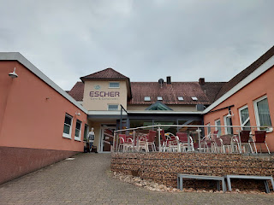

Inside, there was a large cafe section where you could order more of a hearty meal and sit down to eat at one of the numerous tables. There were several customers in that area. But I found the bakery section in the center of the building, and that's when I had a hard time deciding what to buy . . . everything looked so cute and fun!

Video of some of their offerings: (5 seconds)
https://photos.app.goo.gl/y86FSMBY6QkcFM7P7

I ended up buying some chocolate dipped shortbread cookies in the shape of a chestnut. I gave a set to Marnie and Kevin as a thank you for letting me stay at their house. I gave a set to Kylie for her birthday when I saw her the following day. And I took a set home to share with Scott.

More cute architecture on my way back to the car . . .

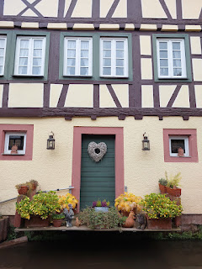

My last stop in Annweiler am Trifels was to visit the cemetery on the outskirts of town.

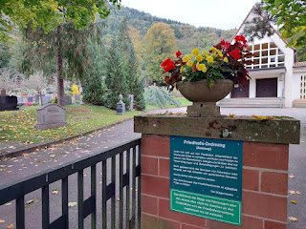

This simple yet elegant chapel at the front of the cemetery has a sign on the opposite side that says, "Chapel to Our Lady, built 1429."

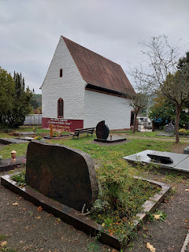

Someone had died recently - 25 April 2025. There did not appear to be a casket. Just a mound of dirt.

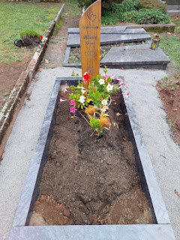

The chapel door on the other side . . .

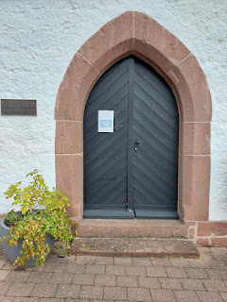

Built in 1429 . . .

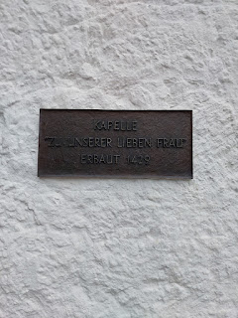

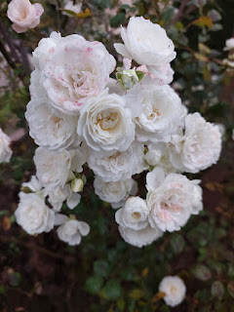

I really loved the military section in the cemetery. This was not something I have come across before in Germany . . . but this one was pretty substantial. In the middle of this protective statue are the words, "They died for the Fatherland."

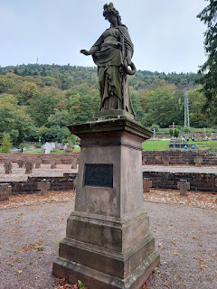

Video of the crosses that mark the final resting place for those who gave their all: (23 seconds)
https://photos.app.goo.gl/uV4c2rXjiGMyV33p6

This headstone says that Erich Lambertus was an officer. He was born in 1922. He died in 1944.

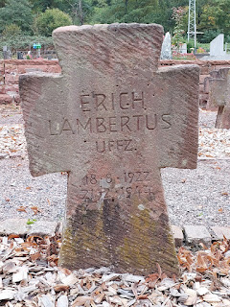

I didn't see any familiar names as I walked through the large cemetery. The further back you go, you find yourself on a terraced level that is higher than the one you were just in. Eventually, near the back end, you can see quite a bit of Annweiler down below. Such a beautiful way to end my visit to such a beautiful town.

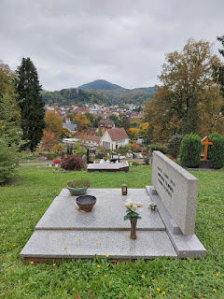

Saturday, October 11th:
I drove down to see Avery one more time before making my way back up to Frankfurt. There was a thick fog in places, including a layer that sat over the top of Knopp-Labach where she lives.

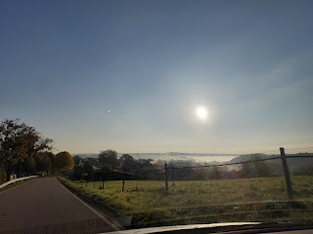

We had fun drawing pictures together on her little I-pad . . .

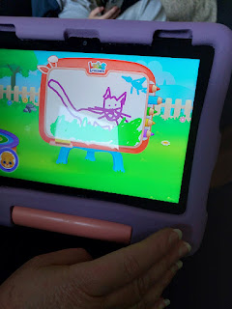

And she wanted to take some photos using my phone . . .

*This was only like my 2nd day trying a new hairstyle that Amber had suggested. She told me to try pulling my bangs back as I begin the process of letting them grow out. I wasn't super comfortable in the new look during those first few days, especially when I saw how big my forehead was in the photo that Avery took, ha ha.

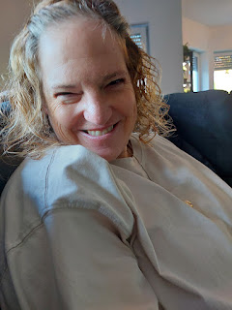

Avery is always such a ham . . . XOXO



She snuck several pictures of her mom, Kylie, too . . . LOL

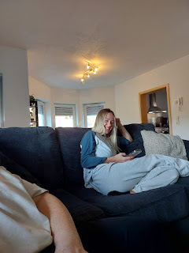

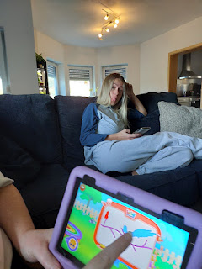

I didn't stay too long this time, since they had to go to an activity on the base and I needed to get myself closer to the airport. I was only there visiting for maybe an hour. To distract her from crying, Kylie helped Avery finish getting dressed. Then we went out to their car and I helped her get buckled into her carseat. I will miss that little peanut. BUT - Scott and I are flying back up there for Thanksgiving weekend and we will see her again
together
. Yay!!

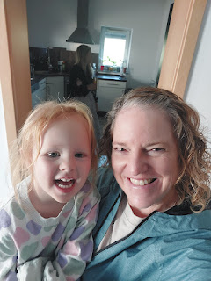

I drove directly to the FamilySearch Center up in Frankfurt. I wanted to meet with someone and discuss some ideas for me to research where my Snider family may have originated from. I spent an hour with the lady that was running the facility that day, and I took some good notes.

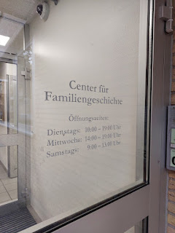

I have finally decided that this will not be a quick fix . . . And I am humbly reconciled to the fact that it is going to take some serious time and effort. It will be like looking for a needle in a giant haystack . . . the haystack being GERMANY. Since I got home from that trip (and home from the next week's trip to Portland, OR), I have begun looking at Haystack #1: Passenger lists. I am making detailed notes and will continue to hunt through this haystack until I have nothing left to peruse. Then I will move on to the next haystack. And so on . . .

Prayer is real, and it really does help. The Holy Ghost is helping me with feelings of urgency in certain areas of the haystack, and even a few promptings occasionally to "move to a different area". I feel confident that He is helping me make the best use of my time, and I really appreciate that.

With the rental car successfully returned, and my suitcase successfully checked in, I made my way through security and over to the area near my gate to find a place for a late lunch before boarding my flight home.

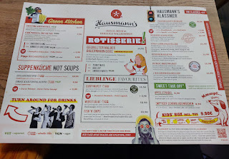

I had not had any of Germany's traditional Schnitzel during this trip, so I decided it was high time . . .

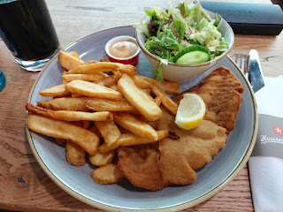

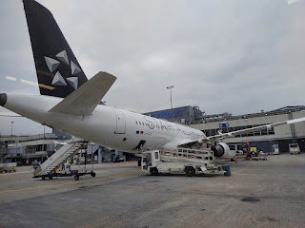

My flight was a little late in departing, but not too bad. We chased the sunset all the way back to Venice.

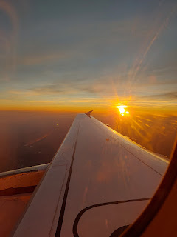

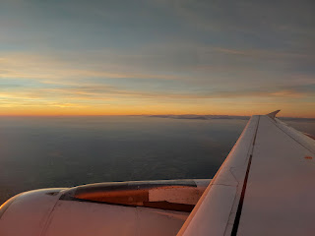

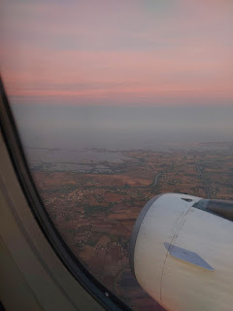

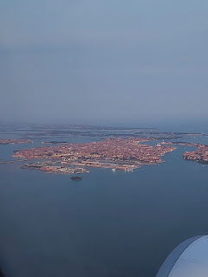

Scott picked me up in Venice. He was so happy to see me. Wuv. Twue wuv.

We had some weird detours we had to figure out on the way home because a portion of the freeway was shut down while they were putting a new layer of asphalt on top. It was a little hairy at times, because Google really wanted us to get back on the freeway but we literally COULDN'T. I was doing my best to piece together some back roads for Scott to follow while he navigated bumper to bumper traffic, pedestrians, and bicyclists in the dark and rainy end-of-day in Italy.

What would have normally taken us 55-60 minutes to get home, ended up taking us more than 1.5 hours. Blech.

It's all okay though. Sometimes you just gotta chalk those things up as "Part of Life" and then move on.

Next Blog Post:
My trip to Portland, Oregon with Scott two days later. We flew to the U.S. for ONE WEEK to see family and to be there for Gwen's baptism. XOXO

