A Baptism in Portland
We had the most wonderful trip to Portland, Oregon a few weeks ago. The main event was our granddaughter Gwen's baptism, but we made it into a very memorable family reunion and so much more.

Day One (October 14th):
I had only been home from my trip to Germany for 2 full days when we set off for the U.S. I was excited to see even more family, so I just tried to get as much sleep as I could along the way.

We flew from Venice to London Heathrow - about 2.5 hours. This was my first time in Heathrow. We knew it was a huge airport ahead of time, so we did a little bit of research before we left home by studying a map and estimating which terminal(s) we would likely fly in and out of.

Turns out that Heathrow is kinda weird . . . There are 5 large terminals, but within those terminals, there are "sub" terminals (A, B, C). We landed in Terminal 5A, but it was a long time before we figured out which terminal we needed to fly out of (Terminal 5B). Scott guessed that it was going to be 5C because so many flights to the U.S. originated from 5C, so we made our way over there. But then . . . there were no restaurants or any amenities in 5C. Only departure gates. And lots of quiet. So we hung out there for a while and relished in the relaxing atmosphere with only a handful of other travelers.

It proved to be difficult to make our way back to 5A where all the amenities were. We ended up having to walk about 20 minutes underneath the tarmac to get there . . . We hadn't eaten any lunch and I had only eaten a banana for breakfast, so I was ready for something substantial. Yes, they give you a meal on the airplane, but it's typically a smallish meal and doesn't really fill you up for the length of the flight.

We ended up going upstairs in 5A to check out the Gordon Ramsay restaurant, "Plane Food". LOL
I ordered a burger with avocado and bacon on it, plus some delicious green beans on the side. Scott helped me devour the fries, since he didn't order anything of his own.
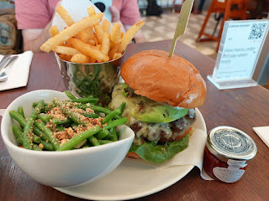

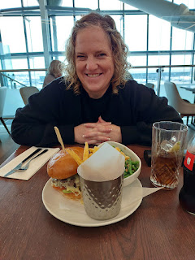

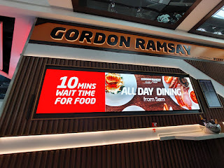

The British Airlines app was pure garbage, and we didn't love the airline either. When we bought our tickets a while ago, we didn't realize that you have to pay extra for every single little thing - on top of paying for your ticket, your luggage, your seat, etc. The app was a total bust on my phone. I could never get myself logged in before we even left the house. I couldn't get logged in on my computer either. They never sent us an email prompt to check in for the flight, and there were no updates or helpful messages along the way either.

The only way we ended up figuring out which terminal to go to was through the British Airways app on Scott's phone. He somehow got in, and that's how we got the
one crumb
of information that we needed.

5B was the only terminal out of the three where you had to go through security AGAIN. The whole thing was just so weird. As far as England goes, I love the London Gatwick Airport, and have flown in and out of there a few times. But neither of us liked Heathrow. At least we made our flight to Portland, though.

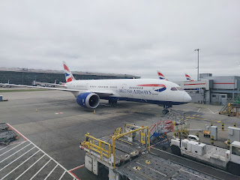

Dinner consisted of Chicken Tikka Masala with green beans and rice, cheese & crackers, a peas & beans salad, a roll (which I never eat - - the carbs), and a tasty little dessert of British Apple & Blackberry Crumble & Custard.

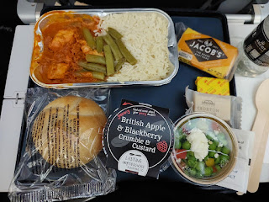

I watched a couple of movies and got a little bit of shuteye on the 10 hour flight . . . It wasn't too bad, especially since there was an empty seat in between us, so we had plenty of extra space.

When we landed in Portland, it was dinner time. We grabbed our rental car - which was an adventure of its own, ha ha. Scott didn't realize that when he booked the car, he had booked an electric car, so this was a FIRST for us. The car drove just fine, but we laughed every time he'd take his foot off the gas pedal and it would come to a very quick stop all on its own. He commented that it felt like a bumper car at the county fair: as soon as you take your food off the pedal, it just completely stops. It was the same with the electric car. :)

We drove straight to Amber's house where she had bowls of soup and sourdough bread waiting for us. The girls squealed with delight as they ran out to greet us, and we had a nice visit before we left to check into our hotel down the street and go straight to bed.

Day Two (October 15th):
My foot was bothering me, so I didn't go with Scott that next morning to walk the girls to school. I was pretty sure it was plantar fasciitis again, even though this time it felt like I had a lump in the arch of my right foot. After curing it with regular and targeted stretches back in the winter of 2022, I haven't had a single problem for over 3 years. But something must have set it off recently, because it was quite painful for several days. (3 weeks later it is much less noticeable, but it's not 100% gone yet either.)

Mid-morning, we scooped Amber up in our rental car and she directed us to a cute downtown area of Lake Oswego near the Willamette River. There is an artsy downtown vibe there, with lots of cute shops and cafes everywhere.

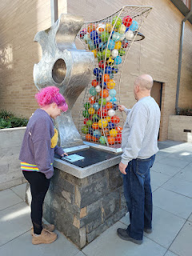

And yes, Amber has bright pink hair now. It actually looks super cute on her - and she did it all herself!

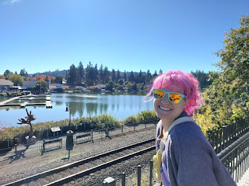

Near the river, there was a large group of people doing a Tai Chi class. We walked past them to take a look at this plaque and the associated art next to it. The artist created his own interpretation of the Flight of Icarus, as explained below . . .

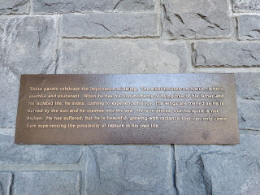

This scene is entitled, "To Dare" . . .

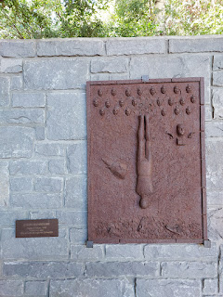

"I Will" . . .

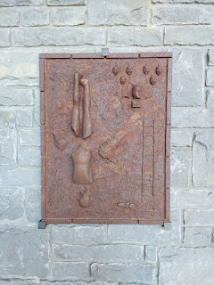

"Breathe Deeply" . . .

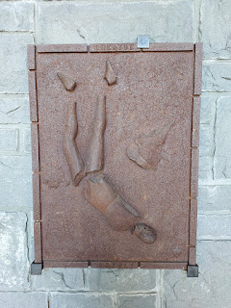

"As Deep as Heaven" . . .

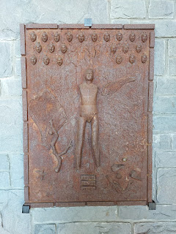

Our three little sets of footsies . . . (Amber - upper left, Scott - upper right, and me at the bottom)

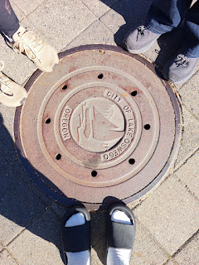

We foraged for ice cream at this incredible little shop next to the river. It's called Salt & Straw. They've got flavors like: Apple & Cheddar Cinnamon Rolls, Pear & Bleu Cheese, Strawberry Honey Balsamic w/ Black Pepper, along with the more traditional flavors of Sea Salt w/ Caramel Ribbons, Chocolate Gooey Brownie, Freckled Mint Chocolate Chip, etc. I can't remember the exact flavor that I ended up getting, but I just know that it had everything to do with pumpkin and cheesecake. And it was amazing.

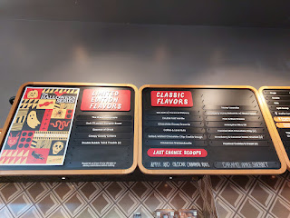

When the girls got home from school, Amber showed us some fun math puzzles that she subscribes to, and Scott jumped into action with Gwen to help solve them all. :)

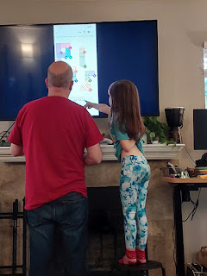

In the huge apartment complex where Amber and West live, there is a swimming pool in the center, along with a hot tub, a spacious gym, and this outdoor patio with all the barbecuing bells and whistles you could ever want. Amber had been marinating some chicken all afternoon, and we marched over with the girls in tow so she could throw them onto the huge grill.

Video of Amber "hard at work": (16 seconds) *She makes most things look so easy. :)
https://photos.app.goo.gl/h9uZAALFGE7DajzG7

Scott found a remote control for the big screen TV and started trying to figure out how he could watch something during the 5 minutes it took to BBQ the meat.

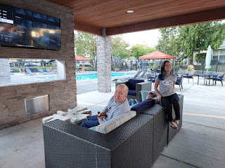

Video of Scott giving Broski a face massage: (13 seconds)
https://photos.app.goo.gl/KXYUs6DqsLH3m9S88

We didn't know it at the time, but I think Scott was starting to come down with an unknown sickness that ended up being quite a whopper for the next 2.5 weeks. I just thought he was having jet lag, which he very well may have also had at the same time.

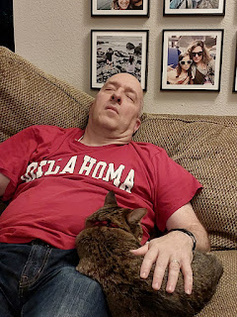

While he napped with Broski curled up next to him, I played Ticket to Ride with Amber, Abby, and Gwen. This was my first time ever playing the game. It turns out I really like it!

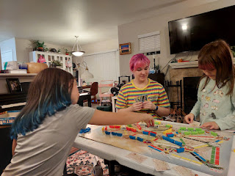

Day Three (October 16th):
My foot was feeling a little better, so I decided to go with the group and walk the girls to school. What a fun little jaunt! A while ago, Amber discovered that it was about a 20 minute walk to get them to school. The girls enjoy the exercise, and so does Amber. It also gives her a chance to chat with the girls and connect with them every day, which I think is wonderful! I was super happy to be a part of the morning hike. The girls wanted to hold hands with me most of the way. XOXO

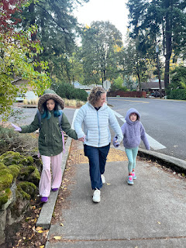

Something Scott and I were intrigued by were these interesting berries near Amber's apartment. They were so colorful! They were all over the sidewalks, as well as hanging in the bushes above. Scott used Google Assistant on his phone to determine that they are a variety of strawberries, called a Strawberry TREE! The plant is an evergreen shrub native to the Mediterranean region and western Europe, although I've never seen anything like it before over here. And how unusual for them to be growing so abundantly in Portland, Oregon . . . We decided to eat one - all three of us did on the way home - Scott, Amber, and me. Google was right that they are a bit mealy and bland. But they sure are pretty!

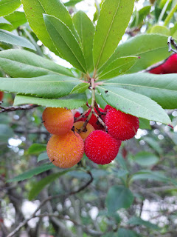

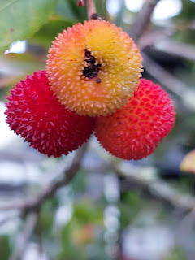

Later that morning, the three of us went to the Portland Temple together.

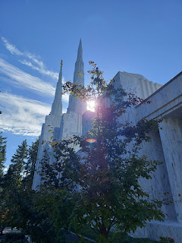

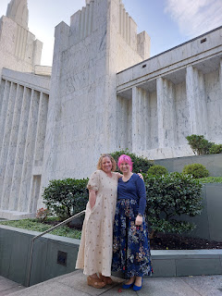

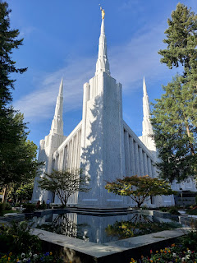

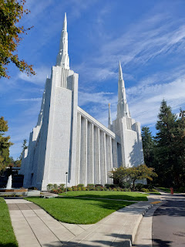

It's not every day that I get to sit with my daughter in the House of the Lord and feel enriched by the spirit together. I'm so glad we were able to do this. It's such a big and beautiful temple, too. And I have fond memories of bringing my Grandma Lillian to the Visitor Center a couple of times many years ago. She always had a special connection to the temple and she told me she felt something holy and reverent there.

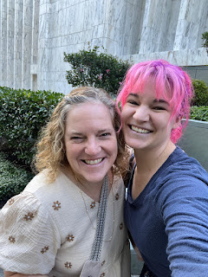

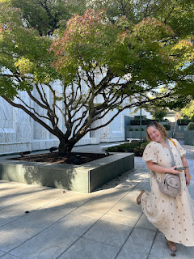

Amber and I squeezed in a trip to a local fabric store while Scott "held down the fort" as the girls came home from school. They have plenty of friends who live in the same complex, so there is never a shortage of kids knocking on the door wondering if Abby or Gwen can play.

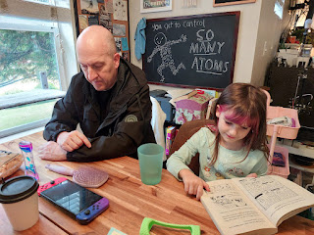

I hit the jackpot with this darling fabric store in Lake Oswego. It's right across the street from the yummy ice cream shop we went to the day before. I found all the fabric that I needed in order to finish a couple of upcoming projects, and I even found a couple of extra pieces that just made me super happy. :)

This is a tiny model of the shop that currently sits on the counter next to the register . . . So cute.

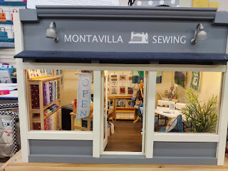

Day Four (October 17th):
After walking the girls to school, Amber wanted some help planning out the details for Gwen's baptism and the small reception afterwards. She also wanted us to come with her to check out a couple of houses in Portland, as they are looking to move into something bigger in the very near future.

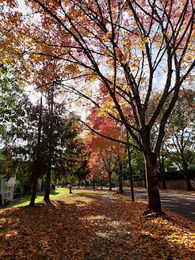

The day was just gorgeous, and the fall colors were every bit as vibrant and eye-popping as they were up in Germany the week before. Traffic was a little gnarly, though - once we got out to house hunt, so we ended up only being able to see one place before needing to head home to greet the girls when they got off the bus. The listed house was a little sketchy, unfortunately. It was in a nice enough neighborhood, but it was clear from the outside that it needed a great deal of work. Amber was interested in it because the price was within their range, but she admitted that the sellers really didn't have any photos of the interior on the listing . . . But now she could cross that one off the list of possibilities.

Currently, they are still on the hunt. Houses have been difficult to come by in their price range, without being weird, wonky, and even wretched. They are looking for a craftsman style home from the 1920's or thereabouts, in a safe neighborhood, close to well-rated schools, comes with a yard, and is less than $500,000.

We got home with only minutes to spare before the girls got off the bus. Gwen wanted to help her mom by spelling some words on the letter board that would soon be set up for her baptism. You can see that Amber was laying out letters for a scripture verse, while Gwen decided to spell "Blah". Cheeky monkey.

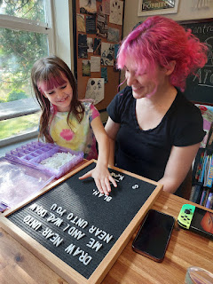

Gwen also wanted to practice being baptized with Papi. He was so sweet as he explained everything to her. "I'll hold your one hand right here . . ." "Hold onto my arm with your left hand like this . . ." "Use your right hand to plug your nose . . ." "Bend your knees as you lay back into the water like this . . ."

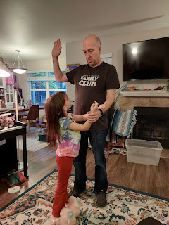

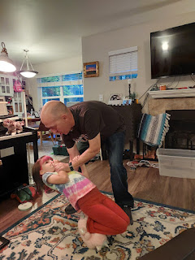

Scott was feeling pretty tired and blah, so after dinner, we drove over to our AirBnB that we had reserved for the weekend. It was located in West Linn and was about 20 minutes south of Amber's home, but it ended up being so perfect in so many ways for the next few days.

We had a huge master suite upstairs . . .

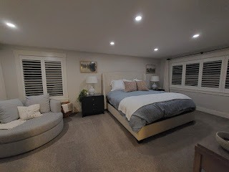

The kitchen, dining area, and living room were open and very spacious for the amount of people that would soon gather here . . . It was possibly the only home that we've ever rented on AirBnB where it instantly felt like HOME.

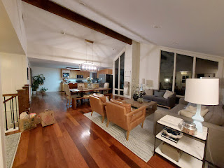

I loved the front entry and the wide staircase going downstairs. The front door even had a special feature where you can open up the top half, or the full door. Your choice. It's called a Dutch door. I want one of these some day . . .

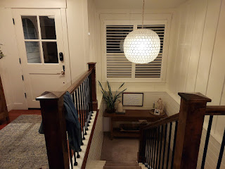

The family room downstairs was huge . . . And the couch was quite substantial, too. There was also a door that leads out to the back yard from this room.

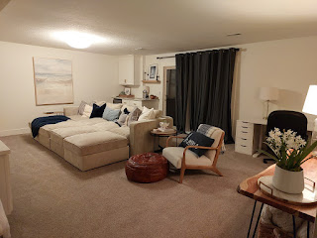

There were two additional bedrooms downstairs, with plenty of space for when Jake and Hannah would arrive the following day.

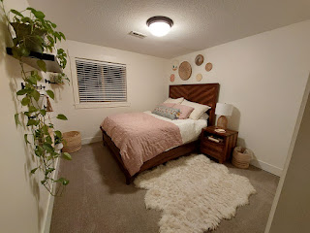

And while Scott started getting ready for bed, I did a little more snooping around and found a large game closet downstairs in the family room. Perfect for those in between moments when the grandchildren might need some entertaining . . .

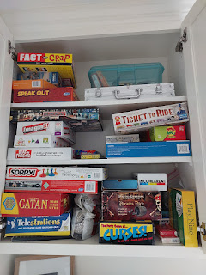

Day Five (October 18th):
Bless his heart, Scott was snoring like a freight train in the night, along with some serious coughing. I didn't know this until the next morning, but he had quietly taken his pillow downstairs at some point so that I could sleep better in our bed. Poor honey.

We spent a lazy morning at the AirBnB so he could take another hardcore nap. I made a grocery list and drove to the nearest grocery store, Safeway, about 5 minutes away. As I got close to the shopping plaza that included Safeway, there was a huge crowd of "protesters" lining both sides of the street for as far as I could see. Their signs were very pro-American from what I could tell, and they seemed very happy and enthusiastic. This was part of the No-Kings-Day protest that President Trump had predicted would be unpatriotic and unAmerican, but I liked what I saw. It was a large bunch of people that wanted to make it known how much they love America and their high hopes for the future. Several cars were honking in favor of the crowd, which made the "protesters" cheer even more in response. The whole thing made me very happy.

I didn't honk, but I waved at them while I turned into the parking lot. This produced even more cheers.

While President Trump has been advocating to send National Guard Troops to Portland to take care of the "chaos" and "violence" up there, Amber has been keeping us appraised of the goings on and it has been quite the opposite of the stories that the White House publishes to whoever will listen.

I know, I know . . . people feel very strongly about their political views and I'm not trying to open a big can of worms here. I'm just telling you what I saw - and I liked it. Amber has been reporting for weeks now that for the most part, things are calm and orderly in the Portland area - which is great. And just to clarify, I don't identify as Republican or Democratic . . . I find myself firmly in the middle.

For those who bleed red . . . I see you, I hear you, I can understand many of the things that are important to you, and I agree with some of it.

For those who bleed blue . . . I see you, I hear you, I can understand many of the things that are important to you, and I agree with some of it.

And that's all I'll say about that.

I picked up enough groceries to get us through the weekend, including some cold/flu medicines for Scott. Holy cow, things are expensive in the U.S. Maybe it was just super expensive in Portland, but wow. I don't remember a time when cold meds cost that much . . . but my sweetheart was worth every penny. I just decided to never divulge to him how much any of it cost - or he would literally not even use it. Seriously. He wouldn't.

As soon as I got back to the house, I started peeling the sweet potatoes and chopping a couple of ingredients to get a jump start on the dinner prep for later that evening. But just a few minutes into my efforts, I got a text from Jake that they had landed at the Portland Airport. YIKES!! This was way ahead of schedule!!

Somehow our communications had not calculated the time difference between Minnesota and Oregon (2 hours), so now we needed to jump into action immediately!!

The original plan was for Scott and me to return the electric car at the airport and swap it for the minivan that we had also reserved for when Jake and Hannah arrived with their little ones. We would then swing around and pick them up outside the baggage claim area and drive back to the new AirBnB.

With Scott not feeling well, I did all the driving for the rest of the weekend. We scurried up to the airport, turned in the electric car, and hustled into the terminal to meet up with the kiddos at the baggage claim carousel. Then we all hiked back over to the rental car center together and secured the new minivan. It was a pretty sweet ride - a Chrysler Town & Country, with all the bells and whistles.

Jake and Hannah were taking some serious notes on how roomy it was and how easy it was to get the kids buckled in with the two captain chairs in the middle section of the van. They rode in the way back, while Scott and I took over the front.

Unfortunately, we got stuck in some horrible traffic partway down to West Linn. What should have taken us about 30 minutes ended up taking 90. It did allow for Maisie to take a nice long nap, though, which her parents were grateful for. Jack slept for maybe 15 minutes, but it was enough for him and he was happy.

By the time we got back to the house, Amber and her family were there waiting for us. I had left the door unlocked for them earlier. The house was in a very quiet cul-de-sac and I could tell that everything would be okay in our absence.

Maisie began to snap out of her sleepy haze once Jake brought her out to the back yard, where the grassy lawn was huge and lined with big spruce trees everywhere. She sat there and just blinked in the bright sun for a while, as the rest of us exchanged hugs and mapped out our next plans for the afternoon.

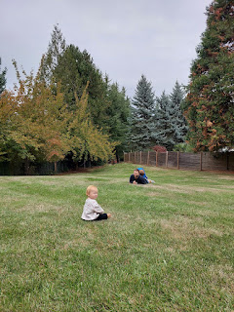

Amber had researched for a fun fall adventure spot where we could take all the kids once the Minneapolis crew arrived. With just a short 15 minute drive to the west, we made our way over to Lee Farms - a family owned farm in Tualatin since 1869. They had animals to pet and feed, carnival rides, a dark indoor maze where flashlights were needed to navigate your way through, hayrides, and APPLE CIDER DONUTS!!

Because it had taken so long for us to get home from the airport earlier, we didn't have as much time to play at Lee Farms. Therefore, we had to divide and conquer. Amber and I got in the long, slow line for the donuts, while everyone else went off adventuring with the kids. Oh, and Scott decided to stay home to rest some more.

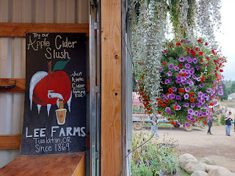

After almost an hour of standing in line to get our goodies, we finally scored the prized donuts and a handful of apple cider slushies to share with the rest of the group. They were AMAZING!! I have never had an apple cider donut before, but I am now a huge fan.

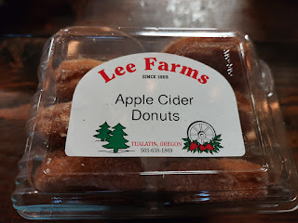

What makes them so special is that reduced apple cider is used in the batter, which creates a more intense apple flavor. Often, fall spices are incorporated in as well, such as cinnamon, nutmeg, etc. Sometimes buttermilk is used in the dough, which helps the donut become nice and tender on the inside, with a crispier exterior. It was just so perfectly yummy. :)

Hannah and Maisie on the swing . . . (Off camera, Maisie did not want to let go of the apple cider slushie. She considered it
hers
as soon as she had her first taste.)

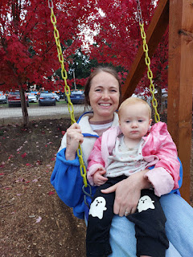

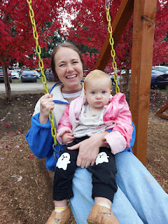

I guess I did have some proof of this, ha ha.

Short video of Maisie and HER slushie: (2 seconds)
https://photos.app.goo.gl/MBtR9ZQ55M9rcHKX9

Meanwhile, Jack was thoroughly enjoying the larger hammock-style swing next to his sister: (4 seconds)
https://photos.app.goo.gl/UxCkVQwiZkK4r9pV9

Maisie was walking pretty well on the uneven terrain at the farm: (4 seconds)
https://photos.app.goo.gl/FNnvKB6w5LTTU4w46

And one of the mini horses desperately wanted to lick her little fingers, ha ha: (4 seconds)
https://photos.app.goo.gl/dBtx76BXzGwigLCu5

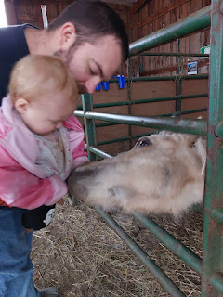

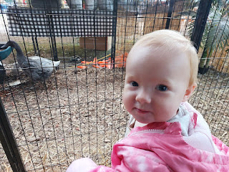

While Jake and Hannah sat down to eat their donuts, I happily followed Maisie all over the place for a while. She would toddle from the mini horses to the baby cow and then back over to the ducks. I think the ducks were her favorite. She would do her best to squawk little "quack quack quacks" every time she toddled over to where the ducks were in their pen.

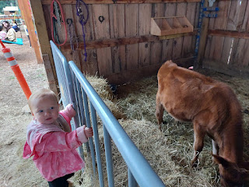

Jack created for himself the perfect job of chunking up small mounds of dirt and making them into a pile. I can't remember exactly what his logic was, but I can just barely make out a few words of explanation in this video - something to do with dinosaurs, I think. :)

Jack and his important dirty work: (14 seconds)
https://photos.app.goo.gl/KsXj2m3U2zs2Ru267

Just below him on the hill was a rabbit pen where Gwen and Abby were hanging out.

Video of Jack realizing that he needed Gwen's help, so he ran pell mell down the hill to fetch her:
(12 seconds)
https://photos.app.goo.gl/DBm5Yrx8tzuu1Rk78

Gwen told me later that this was her favorite thing at the farm - she said the bunnies were SO SOFT.

Video of Gwen petting the black bunny: (5 seconds)
https://photos.app.goo.gl/d6anE8LKKasxeknYA

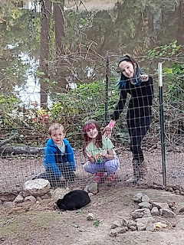

After a fun couple of hours of swinging, mazeing, donut-ing, digging, petting, and running from activity to activity, the farm was closing up for the day and we had to make our way back to our respective cars.

Abby - posing, and Jack . . . with one final excavation attempt . . .

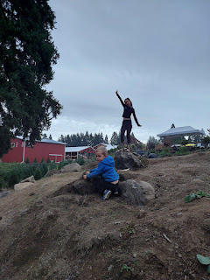

Back at the house, Scott was feeling a little better because of his extra nap and the quiet solitude that he enjoyed while we were gone. The kitchen soon turned into Grand Central Station as dinner prep began. I made Cozy Autumn Wild Rice Soup, with some alternatives for the kids in case they didn't want a slurpy, messy soup. Earlier, I had purchased two rotisserie chickens, which allowed plenty for the soup and some extra pieces for snacking and eating. For the kids, we made bowls with rice, chicken, and some raw veggies. For the adults, we gobbled down almost all of the tasty soup.

Recipe here:
https://www.gimmesomeoven.com/cozy-autumn-wild-rice-soup/

After dinner, we just hung out and played for a while before it was bedtime. Between the board games and a large back yard, there were plenty of options for everyone. West even brought his portable disc golf set, which includes a pop-up goal to throw your discs into. It was so nice to let the kids all play together and for the grownups to laugh and visit while supervising the little ones.

Day Six (October 19th):
This was a big day for the Whitworth family.

First, there was the Primary Program at church. This is where the primary children (ages 3-11) all participate in a program that encompasses the doctrine that they've been learning all year. They each have a speaking part, mixed in with lots and lots of songs. Amber is the primary chorister, and she did a fabulous job directing everyone from the bench where I sat next to her. She had already told the kids that she dyed her hair bright pink so they would be able to see her leading them from our pew during the program, ha ha.

Some of the songs were so tender and beautiful that they brought tears to my eyes. Both Abby and Gwen did a great job with their assigned speaking parts. I was very proud of them. Sometimes a couple of children are just too shy to speak on the day of the program. They get stage fright, and that's okay. Usually someone else will step in to read their part, as quiet reassurances are extended to the frightened child.

I snuck one photo during the program . . . If you look closely, you can see Abby behind the podium on the left. She is wearing light pink and has a white headband on her hair.

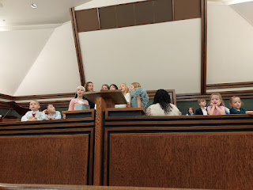

During Sunday School class, I had the privilege of entertaining Maisie in the hopes that she would fall asleep. She did not . . . but I had fun trying. For a while, I just walked very, very slowly around the hallways of the church building with her in my arms. Later I walked really slowly around the empty gymnasium. But eventually she decided that she needed to get down to walk, so I just followed her around after that. My hope was that Jake and Hannah could have the opportunity to listen and participate in Sunday School without the additional responsibility of tending to a one-year old. But they ended up out in the foyer on a couch with Jack, because he didn't want to go to his primary class. Maybe primary was a bit rowdier than usual - which is usually the case after the yearly program is finished and everyone is so relieved.

After church and as we piled into the minivan, Jake asked if we could take the scenic route back to Amber's apartment in the hopes that one or both children would fall asleep. It took longer than we thought it would for Jack to fall asleep, but Maisie was out almost immediately. I just quietly drove us around different neighborhoods for about 45 minutes before Jack was finally "out", and then we headed back to Amber's (which was only less than a mile from the church, ha ha).

Jack woke up pretty quickly and wanted to come with me into the apartment while Jake and Hannah stayed in the van with Maisie. Soon, though, they decided to carefully transfer her car seat to the stroller and just park her outside Amber's kitchen window, Scandinavian style, to let her continue to sleep (and where we could also keep a close eye on her). It's relatively quiet out there most days, and it would have been peaceful for her to sleep with the gentle sounds of birds chirping and leaves swaying in the trees overhead.

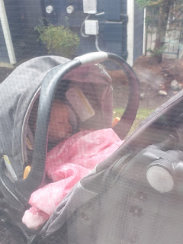

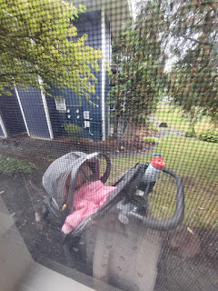

It is customary in the Nordic countries for parents to let their babies sleep outside for naps. They are bundled up in toasty sleeping bags that attach to the car seat or stroller, and then they get to sleep in the fresh and frosty air outside. Many times, you might see babies all parked in a row next to each other as they sleep outdoors together.

I would have loved this as a child for sure. How do I know this? Because as an adult, I absolutely love an Arctic cold room to sleep in, while I snuggle down under the covers. Most nights I will sleep with the window fully open, cracked open, or perhaps even just a ceiling fan on. And yes, I do this all winter long. Scott protests nightly that I will likely find him frozen to death by morning, but so far, this has proven to be quite false.

Amber made broccoli and cheddar soup with bread bowls for lunch and it was so perfect. It really hit the spot!! Between all of us, we practically licked the pot completely clean.

West's parents, Mike and Kathy Whitworth, had driven all the way up from Camp Liahona Redwoods, CA to join us for Gwen's baptism. They drove 10+ hours on Saturday in order to spend the full Sunday with the family, and then they would drive all the way back down on Monday. They have been serving a full-time mission by working at the Girls Camp facility deep in the forest near Annapolis, CA. It is more than halfway to the coast - west of Cloverdale - and is very remote. But this was an important family event and they wanted to be there. It was so good to see them! They've been on their mission for just over a year now, and they will continue to serve through next August before they return home to Rigby, Idaho.

Gwen's baptism was scheduled for 2:00 that afternoon, which gave us just enough time to get home from church, eat, relax for a little bit, and then head over to the church again. Amber has many friends who serve in the Primary organization and who offered to bring some refreshments so she didn't have to do everything by herself. Kathy helped, too, by organizing some goodies onto trays and platters for the guests.

Scott and Gwen before the baptism, and standing in front of the font . . .

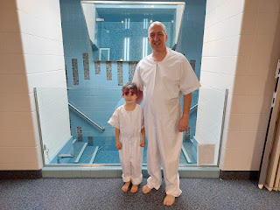

I had purchased a variety of flowers for the occasion, and Amber and Kathy arranged them into vases that were placed around the room . . .

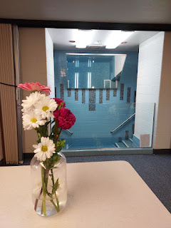

The scripture that Amber had selected a couple days before, minus Gwen's word "blah" . . .

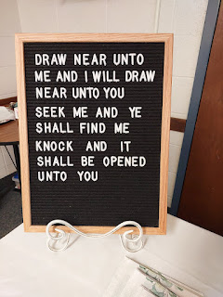

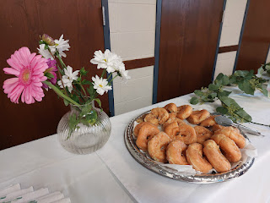

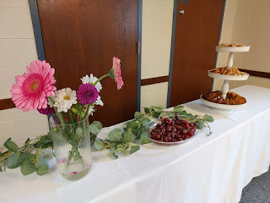

Plenty of goodies for afterwards . . . including these rice crispy treats shaped like the number 8!!

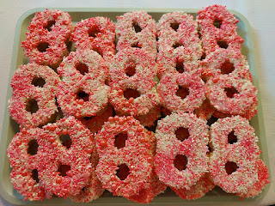

There were roughly 25 people in attendance by the time it began.

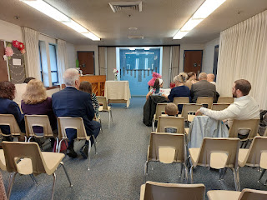

Two sweet girls with bright pink hair . . .

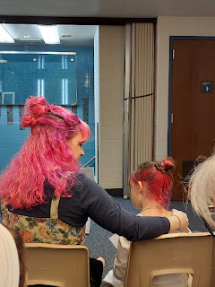

Kathy gave a talk about the subject of baptism and she did a great job. Abby and I had the honor of being witnesses during the baptism. It was our job to make sure that Gwen went completely under the water, and that no toes popped up or hair floated up. It is important to make sure that every whit of her body goes under the water.

An explanation for why this is important can be found here:
https://www.churchofjesuschrist.org/study/new-era/2011/07/to-the-point/why-do-we-have-to-be-completely-under-the-water-when-we-are-baptized?lang=eng

After Scott and Gwen had a chance to change into dry clothes and rejoin us, I gave a talk on the subject of the Holy Ghost. I bore testimony that the Holy Ghost is one of the greatest gifts we are given in this life. Oh, how I love having a member of the Godhead with me every day! He helps me to remember important things, He helps me to feel God's love for me and through His still, small voice, I am able to hear God's voice in my life. It might be a voice reminding me that I am loved, or sometimes I might hear a voice of gentle chastisement - that I need to change or do better in some regard.

I mentioned that I felt the love of our Father in Heaven through the Holy Ghost as soon as this meeting began. I found myself crying multiple times as we sang the opening song and a few other times, too, before it was my turn to speak. When I finally figured out why the tears were flowing so abundantly, I realized it was because I felt the spirits of a few other family members in that small room with us. Spirits of loved ones who had passed on, but who were with us at that very moment in spirit form. I felt that her older brother, Jonny, was one of those who had come to be part of such a special occasion. I also felt like Grandma Coy was there, too.

I shared a tender teaching moment in my life where the Holy Ghost taught me an important lesson several years ago when Benson was a teenager still living at home. We had gotten into yet another argument, and I was so mad at my son that I stormed out of his room and down the hall to my bedroom where I remember slamming the door shut. I recall fumes coming out of my ears as I desperately tried to find a way to calm down. I distinctly remember the Holy Ghost whispering to my mind, "Go apologize."

I was like, "What?!! No way. HE'S the one who needs to apologize!!"

The Holy Ghost did not ignore me, He just simply invited me yet again, "Go apologize."

I continued to refuse, citing multiple references where I was right and Benson was oh so wrong.

A third time . . . "Go apologize."

Hmmm. What would I even apologize for, I wondered.

Finally, I began to feel some remorse that I had lost my temper so profoundly and I decided that this was something I could apologize for. I prayed for the ability to do so, and then I made my way back to Benson's room down the hall.

As I gently opened his door, I humbly told my son that I was sorry for losing my temper and for not setting a very good example. The most remarkable thing happened! Benson was instantly tempered by my modest and earnest attempt at reconciliation. Because I apologized, we were able to move forward in a much more productive way, unfettered by anger, steam, and raised voices.

The Holy Ghost taught me the importance of taking that first step in a better - more holier - direction. He taught me that relationships are important. They are more important than being RIGHT.

I had coordinated with Amber ahead of time, and she was able to procure a kayak paddle for me as a visual aid that I could use in my talk. I invited Gwen to come up and join me, which she happily did. She stood in front of me and we both had our hands on the long, double-ended paddle.

I told her that the Holy Ghost will be there in her life to help her get through anything. Everything He helps us do or become will bring us one step closer to being like Jesus Christ, our ultimate goal in this life.

If she needs a reminder to put her game down and go help mom . . . the Holy Ghost will gently nudge her to do this. (we dipped in our paddle and pulled hard)

If she feels a prompting to be nice to her sister, the Holy Ghost will put that thought into her mind and into her heart. (we dipped in our paddle on the other side and pulled hard)

If she forgets to say her prayers, the Holy Ghost will remind her to do so. (we dipped in our paddle and pulled hard again)

We came up with a few more examples of how the Holy Ghost will teach us, prompt us, remind us, and encourage us to be more Christlike - and with each one, we dipped in our paddle and pulled hard.

I told her that with each stroke of our paddle - or each time that we listen to the Holy Ghost, we will get closer and closer to Jesus.

She loved the whole thing, of course. And I was happy that it went so well, because things had been pretty busy leading up to this moment and I didn't feel as prepared as I would have liked.

Gwen's other Grandpa (Mike) gave her a priesthood blessing as he confirmed her a member of The Church of Jesus Christ of Latter-day Saints and invited her to receive the gift of the Holy Ghost through the laying on of hands. After the prayer, Gwen gave hugs to everyone in the priesthood circle.

This included Papi (Scott) . . .

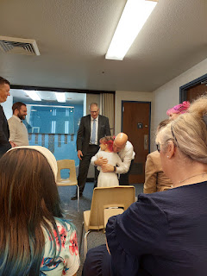

Grandpa Mike . . .

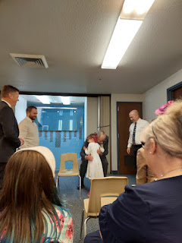

And Uncle Jake . . .

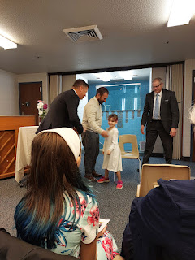

It was so wonderful for us all to be there to support Gwennie on her special day. This was definitely the highlight of our entire week in the U.S.

After cookies and sugary treats, and after we helped clean everything up, we drove back to the house in West Linn. A short time later, everyone else caught up and joined us down there. The space at the AirBnB was more conducive for 12 people to hang out, compared to the snug and cozy quarters of Amber's apartment.

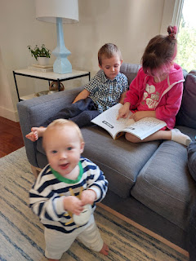

Gwen - reading a story to Jack . . .

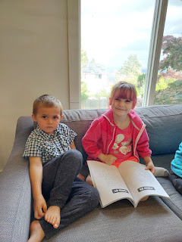

Video of Maisie charming all of us as she waddled around the big coffee table: (8 seconds)
https://photos.app.goo.gl/CEzBsXXo74ArBT2C6

We played at the playground just past the edge of the back yard, and we found a short little trail that led down the hill a bit and into the forest.

FYI: Maisie has mastered the stoic stare.

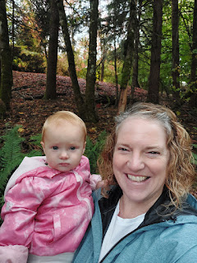

The kids had a blast tromping around in the forest . . .

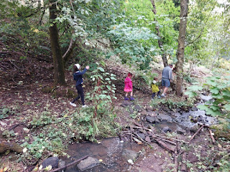

There was a section of trail completely covered in red maple leaves. It was quite stunning!
Video here: (4 seconds)
https://photos.app.goo.gl/Bgs8xqUjBYUUBy5j7

Video of Maisie and Hannah tandem-sliding: (18 seconds)
https://photos.app.goo.gl/bEg91r8zds1B2TGY9

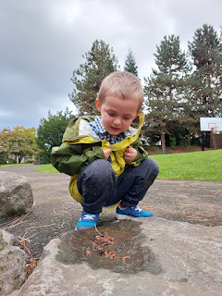

In case you didn't know, Jack has quite the imagination! He spouted all kinds of facts and information about these caterpillars/worms that he carefully placed in the water on top of a rock. Technically they were just seedlings from the nearby trees, but to him, they were creatures that deserved a representative story.

You can watch him tell the tale of the "brown wigglers" here: (40 seconds)
https://photos.app.goo.gl/c4Mu6FZG3kEcRnXu8

Right about the time we were about to head back up to the house for dinner, we spotted a large deer walking by. He had come through our back yard and through the opening near the back fence. He was not afraid of all the families playing at the playground, but he was clearly intent on getting over to the next forested section - the one where we had just been on the trail below a short time before.

I took 3 videos in a row of the young buck.

(7 seconds):
https://photos.app.goo.gl/QfAY5GkCyowfreHz8
(11 seconds):
https://photos.app.goo.gl/6r9Zjbddd8GQq79n7
*I didn't see HIS antlers at first.
(15 seconds):
https://photos.app.goo.gl/BgT4BpV4a98xDwbX6

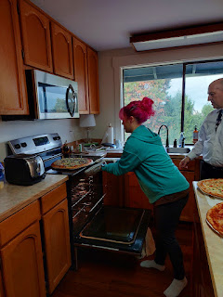

Amber and Kathy had been busy preparing dinner in the kitchen while the rest of us played outside. Amber and West had bought several Papa Murphy pizzas on Saturday and I stashed them in our fridge until Sunday. When we came inside, the house smelled so amazing! We had pizza and salad and then it was time for Gwen's birthday celebration.

In the millions of details that Amber was trying to navigate for such a busy weekend, she had accidentally forgotten to bake a birthday cake until the last minute. She hastily put her artist skills to work and cranked out this cute little cake for Gwennie.

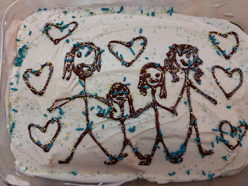

One of Gwen's birthday gifts was a soft, furry robe. She was so happy to zip it up and wear it. We gave her a pair of winter boots that are waterproof and lined with fleece for the moist and very cold Portland winters. We also gave her some socks and an activity book with puzzles, codes, and math to sink her teeth into. (She is a math WHIZ, in case I haven't mentioned this before.) Mike and Kathy gave her a beautiful set of scriptures and a journal. Amber and Weston gave her a gift certificate to get a video game of her choosing - which she squealed with joy over!

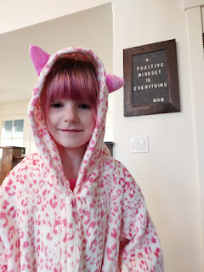

Jack was so excited for us to sing Happy Birthday to Gwen and for us to light the candles . . .

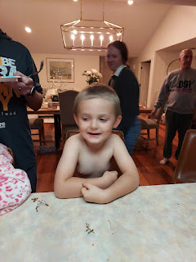

Video of Gwen blowing out her candles: (51 seconds) *Abby wanted to be the videographer.
https://photos.app.goo.gl/FEo8UKYVwq9HUfsV6

Day Seven (October 20th):
Our last full day with the family . . . sigh.

We got out the door pretty quickly in the morning, which was impressive with two small children in tow. I did all the driving for the day so Scott could rest in the seat next to me. Jake and Hannah really wanted to do some tidepool exploring with Jack, so Amber and I had done some extensive research in advance on which beach had the best tidepools - but was also close to West Linn and Lake Oswego.

The number one suggestion was Haystack Rock in Cannon Beach, Oregon. When we chose a parking lot ahead of time, we didn't realize that it would be such a long walk down the beach to get to the Haystack Rock, which you can just barely make out in the distance below . . .

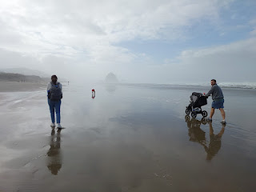

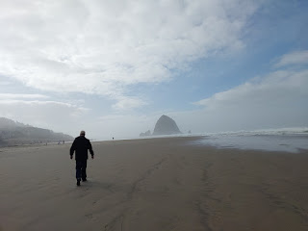

We arrived ahead of Amber's crew, and as I texted Amber as to our location while we made our way down the beach, Jake quipped, "Just tell them to follow our stroller tracks." Abby and Gwen were happy to do that!

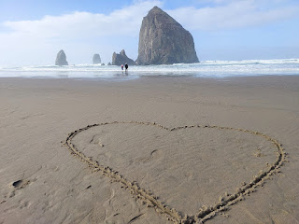

I found some sticks so that Jack and I could draw in the sand while we waited for the others to catch up and find us . . .

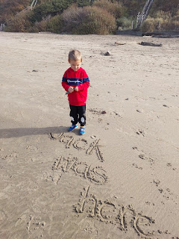

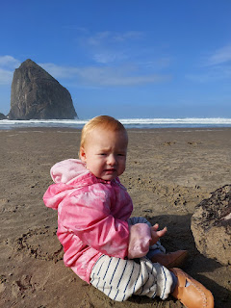

Maisie saw all the "big kids" walking straight out toward the waves, so she decided to try the same thing.

Video of her here: (8 seconds)
https://photos.app.goo.gl/3qPnKg2AXHnqSTiG6

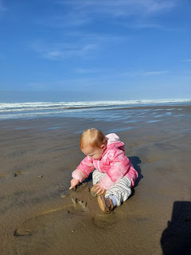

She happily dug and smeared and flung sand everywhere.
Video here: (5 seconds)
https://photos.app.goo.gl/73UDg1xEqqCtN2A97

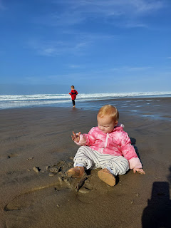

Her mother decided maybe it would be best to remove her socks and booties . . .

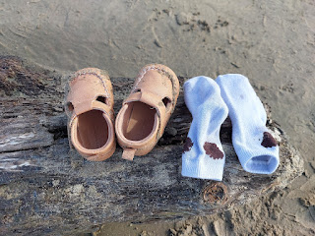

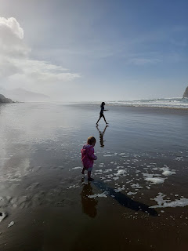

Video of Maisie trying to keep up with everyone: (8 seconds)
https://photos.app.goo.gl/2ypshim7Jup7RAcn9

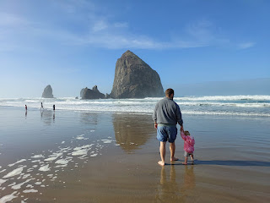

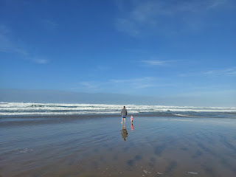

The kiddos had tons of fun letting the waves chase them: (18 seconds)
https://photos.app.goo.gl/Qc3MKz4DeJCXc9Lc7

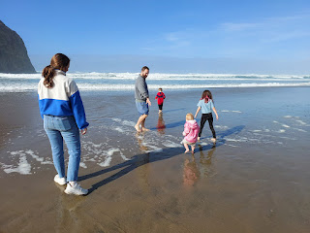

Unfortunately, we arrived close to high tide, so we were not able to get out to Haystack Rock for any tidepool adventures this time. In fact, shortly after I took these last videos, a lifeguard truck was slowly making its way down the beach to warn everyone to get to higher ground. He announced over the loudspeaker that sneaker waves were all too common, and could carry you out to sea. He said high tide would take place within the hour and that this entire beach would soon be underwater.

Our last videos:

Maisie (9 seconds)
https://photos.app.goo.gl/sto8RZffJ3spv4RP7
Hannah and Maisie (5 seconds)
https://photos.app.goo.gl/ADvsbhjM2rKyrtwE8
Jake and Maisie (9 seconds)
https://photos.app.goo.gl/uaAvskp8CyEZ5t5E9
Jack and Gwen (8 seconds)
https://photos.app.goo.gl/vw4y94r6KcLUo49B6

After we left the beach, we made our way back through town this time. Some of us were
really
hungry (*cough cough AMBER), so we ended up choosing the first restaurant we passed. It ended up being a really great choice because they could immediately get our large group of 10 seated, and they had clean bathrooms for us to wash off and enjoy our meal without gritty sand on our hands, ha ha.

The restaurant was called, "The Wayfarer". They had the BEST clam chowder!!

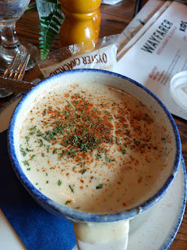

But the chicken sandwiches were just "okay". Not a lot of flavor, sadly. I shared my sandwich with Scott.

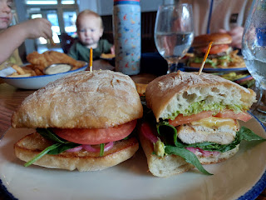

We asked the waiter to take some photos of us, since this would be the last time we'd all be together for a while. He took photos from both ends of the table. And Jack, true to form, gave his trending pouty face instead of a smile. LOL

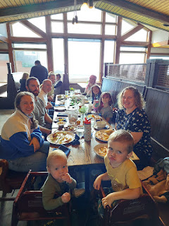

L to R: Amber, Abby, Gwen, Me, Jack, Maisie, Hannah, Jake, Scott, and West.

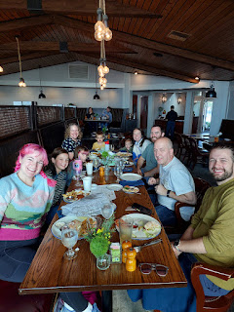

In between naps, I asked Scott to take a short video of the beautiful fall foliage on the drive back to West Linn: (5 seconds)
https://photos.app.goo.gl/nH9YqCmcQafP2w5F9

We made sure in advance that Jake and Hannah would have enough food in the fridge to make it through that evening and the following morning, since we would be taking the rented minivan back to the airport right away.

It also helped that Amber and West joined them later for dinner (bringing supplies), and the kids played games and hung out for a while that evening after we left. Amber also came back down in the morning to pick them up and take them to the airport. What a good sister.

I was worried about leaving the AirBnB in the care of my two children and their families, since I would not be there to make sure the place was left clean and as close to spotless as possible. But Amber reassured me that everything looked amazing when she arrived to pick them up. And the host of the AirBnB complimented us in their customary review, stating that, "They left the house in impeccable shape and you can tell that they took care of our home. We would recommend her highly to any other hosts."

I'm so grateful to my children for helping to maintain our good reputation. XOXO

We had an uneventful flight back to Heathrow and then on to Venice. Scott slept for probably 98% of the time, bless his heart.

My gratuity meal on the way to London was similar to the first flight: a bean salad, rice/green beans/chicken, cheese & crackers, another wasted roll, and some key lime pie ice cream.

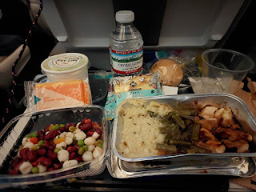

I am so incredibly grateful that we were able to spend that week with our children and grandchildren. We missed having Benson there, knowing that he really wanted to join us but couldn't leave his military responsibilities. I look forward to February when he will fly over to spend 2 weeks with us here in Italy, and we will be watching some of the Winter Olympics in person together.

All in all, it took almost 3 weeks for Scott to finally stop all the coughing that came with his mystery illness. He was so tired every day and felt pretty lousy during most of that time frame. I never caught it (*knock on wood*), and nobody else in the family caught it either. What a miracle.

Next blog post:
I'll be sharing the details of the most wonderful 4 days that I spent at the Rome Temple with a couple of lady friends at the end of October. It was truly life changing.

