A Successful Surgery
I am so relieved to be on the other side of this surgery. Everything turned out fine, thank goodness. Some anxiety kicked in the morning before, but there were a few things that helped me to fight off that old beast. First, Scott and I said a prayer together over a video call. Then we did a little more research into the specifics of this type of surgery (laryngoscopy with dilation) so that I didn't have to wonder so much. Next, on a phone call with my ENT surgeon, Dr. Hall, he really helped me a lot by giving me more context and confidence. And lastly, I truly felt the prayers of so many people these past few days. Their love and their heavenly pleadings in my behalf were almost tangible. So thank you. Thank you from the bottom of my heart!! XOXO

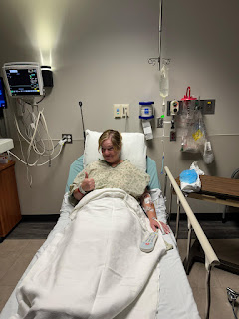

Some of the things that Dr. Hall helped me to understand the day before my surgery were:

~ He's the only surgeon in the entire state of Idaho who performs this type of surgery. Anyone with my same problem also comes to see him.
~ He always uses the same team at EIRMC (Eastern Idaho Regional Medical Center) for every one of these surgeries. This ensures that everyone in the surgical room is comfortable with each other and comfortable doing what has now become a routine surgery.
~ He trained at the Mayo Clinic and shadowed under a surgeon who performed this exact same surgery 4-5 times a day, so he got a lot of experience.
~ He was good about giving me the whole spectrum of possibilities so that I had more context ahead of time. Some people report zero sore throat afterwards, some experience mild to moderate soreness, and a few end up with more of a "strep-throat" level of soreness.
~ He was matter of fact, had a calm demeanor, and smiled easily. His approach was just what I needed.

On Friday (yesterday), Kim - my wonderful friend and neighbor across the street, drove me over to the hospital that's literally just around the corner. We arrived at the appointed time of 8:30 a.m. I signed the last bit of paperwork, we were taken upstairs to a room, and I changed into the "fashionable" hospital gown. One of my nurses, Sukey, was the sweetest and most beautiful lady. She looked like she was maybe in her late 30's or early 40's. We learned that she had been left in a basket at an orphanage in Korea when she was just a baby. A note was attached that said that when she was ___ years old, the family would come back for her. But they never did. Maybe they didn't have enough money . . . or maybe they got sick or passed away.

In the meantime, there was a military family that was also stationed there (from the U.S.). The soldier's wife and daughter came often to the orphanage to bring food, and to help hold and play with the little ones. They took a liking to Sukey and ended up adopting her. Because of local laws, and because the birth family was unknown, the orphanage (or maybe the military family) ended up paying some lady to pose as the birth mother so they could legally allow Sukey to be adopted and leave the country.

She's taken a DNA test, but the only result she's seen so far is that she has a 4th cousin, which is pretty distant and hard to glean much information from. I told her some of my story and it warmed her heart to hear from the point of view of a birth mother and the difficulty it was to let my baby go. I wasn't ready to be a parent when I was just 17 years old - matter of fact, I was still in high school at the time! Abortion wasn't an option at all for me, so only that left adoption. Chelsea has had a good life and we keep in regular contact with each other.

What a special connection to share our stories with each other while we waited for the surgical team to be ready.

I also told her about a really heartwarming documentary on Netflix called "Found". It's about a small group of sisters from China who were adopted separately, but ultimately went in search of their roots by traveling back to China together with a guide. Not everyone's ending was rosy and beautiful, but it was a story of humanity, poverty, and powerful connections. I highly recommend it. In fact, I might just watch it again while I rest and recover this weekend.

Video of me being wheeled down the hall toward surgery: (16 seconds)
https://photos.app.goo.gl/ciFF9T2MMSwVrSAeA

The surgery was quick. Kim hardly had time to get settled in the waiting room with a coffee and some chips from the cafeteria before Dr. Hall showed up to tell her that I was in recovery and that everything had gone really well. I did much better coming out of the anesthesia this time. I *think* the last time I had surgery was 20 years ago when I had a hysterectomy, but it's possible that I'm wrong and that I've had a more recent one. Anyway, I remember it took me forever to wake up the last time. In my mind, I can still hear the nurse telling me, "Honey. Honey! Try to open your eyes and take a bite of applesauce." I think it took me like 2+ hours to be awake enough to eat and qualify for discharge. But this time, it went much faster.

Just after 1:00 p.m., I was ready to go home. I was still a little woozy, but at least my eyes could stay open!

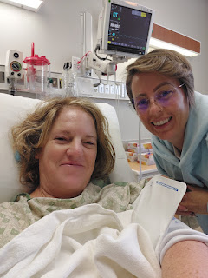

Kim was such an angel. She stayed with me while I rested all afternoon, and she made me my favorite soup: a packet of Lipton's Double Noodle mix + frozen peas and carrots + a scrambled egg. It felt so good going down my throat!

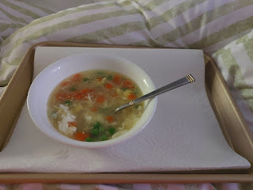

I am in awe of how everything ultimately came together for the surgery. First of all, if it weren't for my friend Peter Vance, I would probably still be suffering in silence for who knows how long. He's the one that politely interrupted me back in March, as he was asking me lots of questions about our plans for the year and I was super breathy just trying to answer him back. He said, "Why are you so out of breath? That's not normal. You should go get that checked!" He's a radiologist and knows something about medical issues, so of course I trusted in his expertise.

I went to my doctor, Laura Mason, in April.
She referred me over to an ENT the following week.
Dr. Baker put a camera up my nose and down my throat to take a look. He said my vocal cords were fine, but he couldn't tell for sure if there was some narrowing in the trachea. He recommended I get a CT scan. But I was out of time to do it before I left for Italy at the end of April.

In Italy, the doctors there thought that maybe I had an enlarged thyroid and they had me do an ultrasound of my throat and neck. The thyroid was a little undersized, but other than that, they couldn't see anything out of the ordinary.

I set up a CT scan for when I returned to Idaho in July. The results showed Subglottic Stenosis, a narrowing of the throat, similar to an hourglass shape instead of a long, open tube for breathing.

Dr. Baker referred me over to Dr. Hall, another ENT, who is considered an expert in this area.
His recommendation was to do surgery. And we had to act fast before I left for Italy again.

The other issue was that Laura Mason also discovered that I had an elevated level of D-Dimer with some recent labwork. D-Dimer indicates a protein in your blood that often is an indication of a blood clot, or a recent blood clot. Their office dropped the ball for almost 2 weeks because they thought they told me to go get a current blood draw to see if the level was still elevated, but I didn't know about this. When I called to check in about this concern two days before surgery, all of a sudden there was a mad scramble.

I had to run over immediately and get the blood drawn so that it would be available the following morning to Laura Mason's office. The day before my surgery, they called to say that the level was still a bit elevated, but not horrifically so. They were going to: a) reach out to my insurance company to ask for another CT scan, and b) contact Dr. Hall's office to let him know what was going on.

A few hours later, Dr. Hall called me personally.

It was taking longer than expected to hear from my insurance company as to whether they would cover another CT scan. Dr. Hall said we could:
a) Postpone surgery until we got the CT and learned whether I had a blood clot or not.
b) Send me over to the ER to get a CT there instead. Apparently, this is a common thing when the situation is desperate enough. When done through the ER, insurance HAS to cover it. The only downside is that it can be more expensive, since you'd be paying for the staff at the ER to see you, too.

Scott was asleep on the other side of the world, and I had to make a decision on my own. I told Dr. Hall that I was "in the zone" and I just wanted to get this surgery done and over with. I told him I would head over to the ER in the next few minutes. He said he would call and talk to one of his colleagues at the ER ahead of my arrival so they'd know what we were trying to accomplish.

This is the same conversation where Dr. Hall also helped me understand the context of his expertise and how this procedure is routine for him. Ultimately, it was this conversation that helped me the most I think, as I mentioned above.

After I got off the phone with him, I remembered that our out-of-pocket maximum with insurance is $1,000. So, that was a huge relief to me. In Italy, Cigna covers all of my medical expenses 100%. In the U.S., they will cover 85% of everything, but no more than $1,000 out of our pockets in total. Plus, we have Tricare as a secondary insurance still. I feel like this will all turn out okay in the end.

I spent a little less than 3 hours at the ER in total, which was pretty good in my opinion.

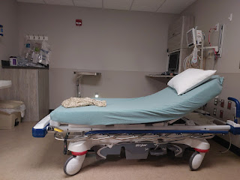

They hooked me up with an IV so that I could do the CT scan with contrast (a dye that is injected into the bloodstream so they can see how and where it travels).

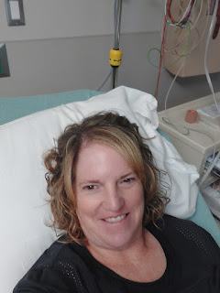

Everyone was super nice and I just kicked back and watched TV in between whatever they needed me to do. It was a HUGE RELIEF when I finally got the results back. NO CLOTS. And no evidence of any recent clots either. Hooray! So surgery was back on for the next morning.

I had already arranged to go on a picnic with my niece, Mari, the evening before my surgery. I'm glad it worked out after such a crazy afternoon. It was so peaceful where we found a spot next to the Snake River in downtown Idaho Falls. We were directly across from the waterfalls and it was just absolutely lovely. It was exactly what I needed after the stress and anxiety that I had woken up with.

There was a breeze flowing, which kept the heat in check. We sat in the shade and just relished in the sound of the birds cawing above us, the river flowing in front of us, and the sun sparkling on the water.

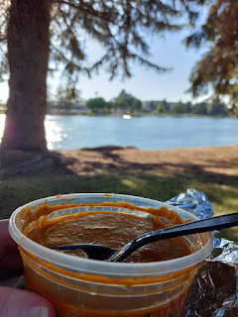

We ordered Indian food at the Himalayan Flavor restaurant and slurped it up while sitting in our camp chairs.

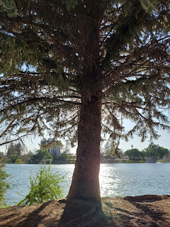

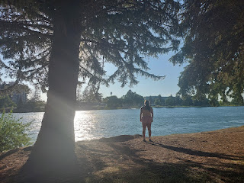

With our luscious hair billowing in the breeze, we took a selfie before we packed up to leave.

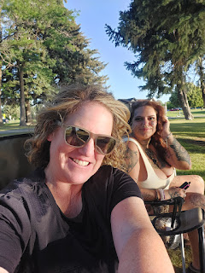

When I got home, I found a care package from my mom on the porch . . .

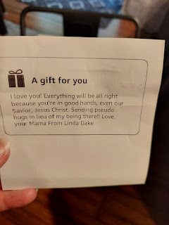

It was filled with all sorts of thoughtful things: an eye mask, an insulated mug, a candle, a bath bomb, a face massage set, and a little blankie. What a sweet surprise this was!

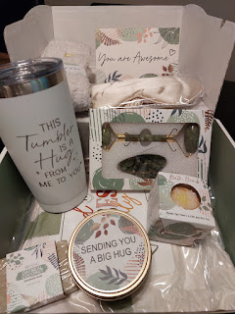

The sunset that evening said it all. I am loved. I am blessed. I will be okay. All will be well.

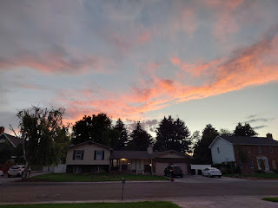

I fly back to Italy next Friday, August 22nd. I am really looking forward to being with Scott again! I'm so glad I wasn't "forced" to be gone from him this time, and especially for the typical 90 days that I've had to do for the past 3 years. This was an optional trip for one month. And it included so many important things!!

~ Time with my children and grandchildren
~ Time with my siblings and my parents
~ Time with my niece
~ Time to get all my medical things taken care of
~ And time to rest before traveling back
home
again. Yes, Italy is now HOME.

I'll write another post before I leave the U.S. and I'll share all about my trip to CA and a surprise set of visitors as soon as I got back to Idaho.

