1800 Miles of Family Visits
Yes, 1800 miles! I drove from my house to Meridian, Idaho; then to Goldendale, WA; then to West Salem, OR; then to Fort Lewis, WA, then to Rathdrum, Idaho; then across Montana and finally back to my house again. All in one week. :)
But the most exciting thing of all is that Scott got to meet our granddaughter, Avery, for the first time on Saturday in Italy! Yay!!
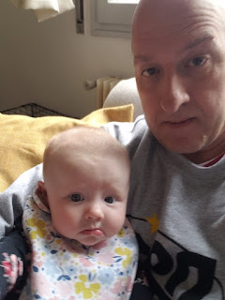
Even though this photo looks very concerning, ha ha, everything is really okay. I think Scott was very focused on taking the perfect "selfie", and who knows what Avery was thinking . . . but seriously what a cutie!! He had a good time with their little family in Aviano and stayed for several hours. He took 2 trains to get up there and then Benson picked him up at the station. Later, he took 2 trains back home again. He said Avery has a very cheerful disposition and he enjoyed getting to know her in between her naps. He was also happy to be in the same country now as Benson and Kylie. :)
Last Sunday:
I left Grandma Lillian's house in West Salem after lunch and headed north to Fort Lewis, WA. Our nephew, Brandon, is stationed in South Korea right now and is working on getting all the paperwork approved for his family to join him there. But in the meantime, his wife, Ashley, is single-momming it with 5 kids (ages 10 down to 10 months) and is doing an awesome job!!
We had a tasty spaghetti dinner and played some games with the kids before they went to bed. Then Ashley and I stayed up and talked until after midnight!!! We talked about everything under the sun: racial issues in America, politics, emotional difficulties in our past, our families, and even shared uplifting spiritual testimonies with each other. Even though I was tired the next day, it was worth every minute that we visited into the wee hours of the morning!
She is so organized and fun - and while she has clear command of her home, she does it with love and laughter. Her kids are adorable and precocious and smart and entertaining.
Holland - "Hollie" (or as some of the siblings call her, "Ha Ha")
She is the yummiest and sweetest baby you'll ever meet!

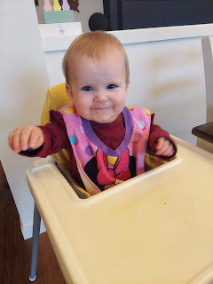

Selfie time

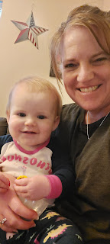

Maggie - 2 years old, with fresh stitches on her forehead. She is a bundle of energy and a whirlwind of ideas, many of which are not the best sorts of ideas . . .

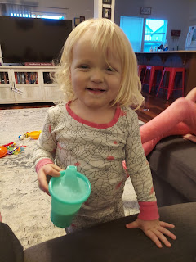

Ashley - seriously she is just the coolest mom

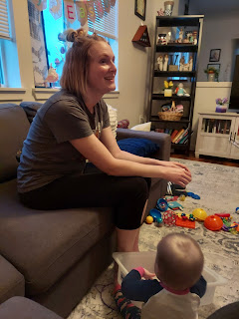

Beautiful evening on base (with Emmett in the foreground). I have such a profound gratitude for all of our military families around the world. Driving down the streets on Fort Lewis, in my mind I was saying "Thank you" to each house (and its occupants) as I went along.

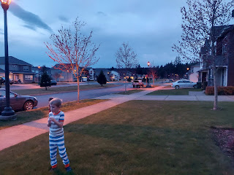

After Ashley went upstairs to get ready for bed, I snuck a few pictures of some of my favorite areas in their home downstairs.

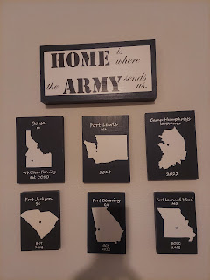

Toys all organized, home schooling supplies all neat and tidy . . . I just love it!

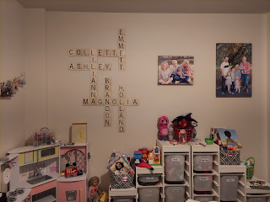

And I love how she displays her children's artwork on the wall, too.

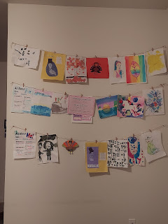

In the half bath downstairs . . .

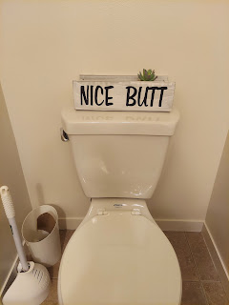



Monday:
After about 6 hours of sleep, it was time to get up and prepare for my drive to Northern Idaho. First, I wanted to show them the quiet book I made for Jack, which I brought along to show Grandma Lillian. The kids loved it!!

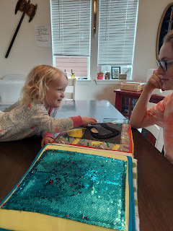

Lily (5) is in the red/black plaid pajamas and the oldest is Collette (10) in the pink dress.
Emmett is 8 and is the only boy.

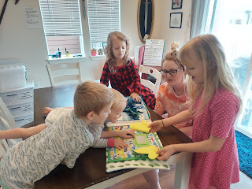

While I was sad to say goodbye to their fun little family, I was eager to get to my brother's house, too. I hadn't seen them in about 2.5 years and that's just way too long.

5.5 hours later, I arrived safely at their new home near Rathdrum, Idaho (near Coeur d'Alene). The drive was very beautiful, especially as I passed through the mountains of Mt. Baker in Washington. (Look it up) Quite stunning. I wish I could have gotten some photos. I did, however, take a short video of the drive coming up to Michael and Stephanie's house. (39 seconds)

https://photos.app.goo.gl/tKYFEXrDYDCsvdnYA

It was apparent right away that Logan, their youngest, was struggling with having a stranger come into their home. The fix: Bring in the quiet book. :)

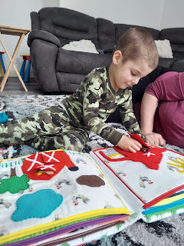

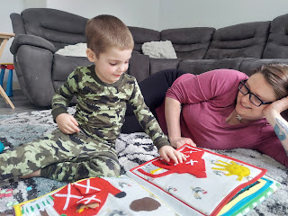

Now that the ice was broken, we were buddies after that. While Stephanie finished up her work for the day (she's been working from home for the past month), I happily entertained Logan for a bit.

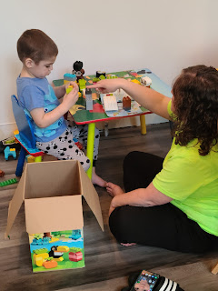

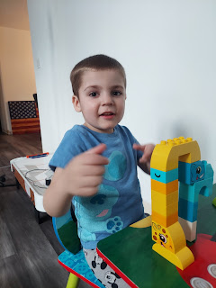

I asked him to do a "thumbs up" for a photo with his Lego creation, but he chose to do an "Aaaayyy" from Happy Days, his brother Jaxon's favorite show, ha ha.

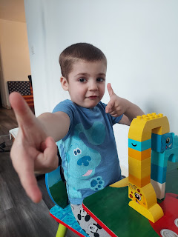

Logan ("LoLo") is almost 5 now, and was diagnosed a couple years ago with Lennox Gastaut Syndrome, a rare form of epilepsy. Some days are more of a struggle than others, but while I was there, he did pretty good. He vacillates between being snuggly and lovey, to having sudden bursts of energy, and with those bursts of energy - sometimes the Hulk comes out. The medications that he's on are part of the problem, but he needs them to control his seizure activity at the same time, so it's a balancing act for everyone in the family.

What I was truly impressed with was how much love and patience that Michael (my brother) and his wife, Stephanie have with both of their boys. But most especially with Logan. They are consistently teaching him what is right and what is wrong and how to help him calm down and even to say he's sorry when he grabs his brother's toys and Hulk smashes them across the room. They speak to him in a calm voice, but they are very direct with helping him realize that what he did was not okay.

There were times when Logan wanted Stephanie to carry him everywhere and just hold him, all the while planting kisses all over her face, telling her he loves her over and over, and nestling his face down into her neck. There were also times when he wasn't able to control his anger and would grab her hair or try to punch her or push her. She is a saint though. 100%. She is such an amazing mom and I learned so much from watching her loving and consistent example.

When she finished up her work for the day, we took LoLo outside to go on a little explore. He loves to be outside and it helps him to calm down if he's having a rough time.

There are a couple of very large bunnies that live out front, and we think they used to belong to the previous owners of the house. I guess they just let the bunnies out into the wild when they moved out.

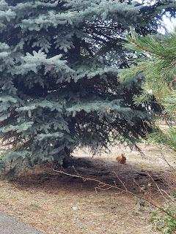

Logan enjoyed tracking one of the ones we saw at the end of the driveway. Here is a short video of him carefully tip-toeing over to see it up close: (18 seconds)

https://photos.app.goo.gl/ftTcMoNcSwWknn367

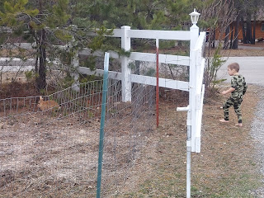

It was such a beautiful day outside!

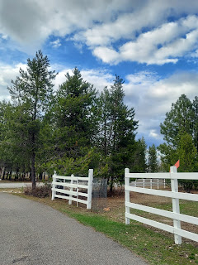

And their property is huge! Almost 5 acres . . .

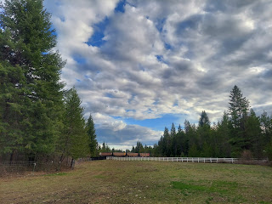

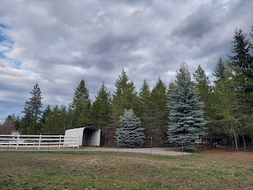

Jaxon was on spring break for the whole week, and while Mom and Dad were busy working, he spent the day at his Noma and Papa's house (Grandma and Grandpa). I had to wait until Michael got off work (which ended up being pretty late that night) and could pick up Jaxon and bring him home. Unfortunately, Jaxon came home with a tummy-ache and came into the house carrying a bowl (just in case). He had eaten waaay too many fruit snacks with Papa all day long . . . so he went to lay down.

Meanwhile, we threw some big fat steaks on the grill and Logan didn't want to leave his daddy's side.

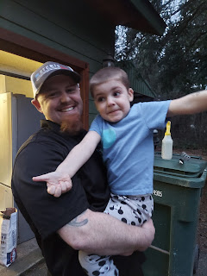

I love this photo! I was trying to get a different photo, but this one somehow happened and I'm so glad it did! Michael has the best laugh. :)

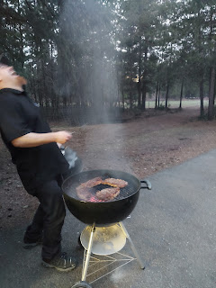

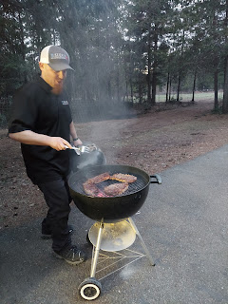

Here, Logan was helping to cook some noodles for his brother's dinner. What a sweetie!

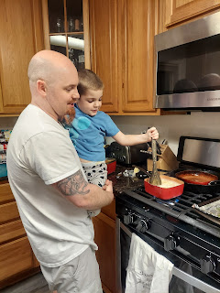

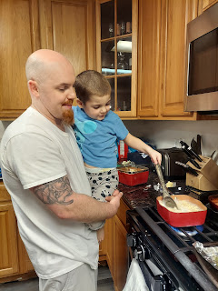

We had fun visiting after the boys went to bed, and Michael was especially interested in seeing photos of our recent home improvement projects (like the kitchen counters and our master bathroom). They bought this 3-bedroom/2 bath house, knowing that it needed some renovations, and have been steadily working on project after project after project. All the while they are still working full-time and raising two energetic boys, one of which has special needs. I don't know how they do it all! Michael kept apologizing to me that their house was a "mess" and that there was only one working toilet and one working sink, etc. I told him, "It's fine! We're just glamping, that's all! And we have running water and a toilet, so that's fantastic!"

They had only just moved in a week before I arrived, so there is still much to do. But they are doing some great things so far! They've replaced all the flooring (before they moved in) and painted everywhere. They even added a fancy new hot tub to the back patio, too. What else do you need?

Tuesday:
Jaxon was feeling much better and wanted me to go on some adventures outside, which I was more than happy to do! He showed me all around their beautiful property. We found all the trails and even found a few treasures along the way. (a whiffle ball, a tennis ball, a random cereal bowl, etc.)

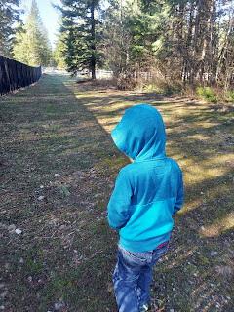

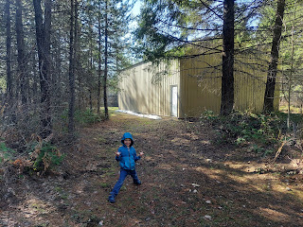

Logan's caregiver helped build the boys the beginnings of a tee-pee out in their "forest".

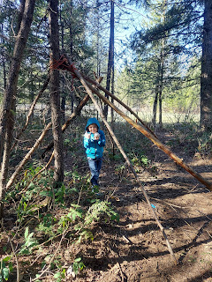

Logan wanted to take the training wheels off his bike, so with his mom's permission, I helped show him how to use an adjustable wrench and then he figured out how to remove the nuts and bolts. He is so smart!

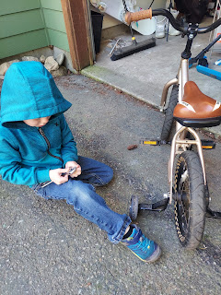

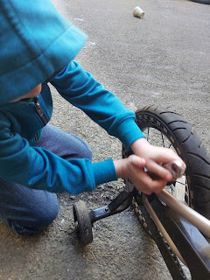

I showed him a technique that worked well with our kids when they wanted to learn how to ride a bike for the first time. The idea is to put them entirely in charge of their own process, rather than the usual method of holding on to them (or their bike) and running alongside them until you want to die, ha ha. I hopped on his bike and showed him how to practice walking along, then going faster and eventually picking up your feet and balancing with your feet in the air for maybe one second at a time, then using your feet to steady yourself or slow down/stop if needed. The goal is to be able to lift up your feet for longer stretches while still steering accurately, and then later - once you get the hang of balancing and learning how/when to plant your feet for support - to eventually put your feet on the pedals and make it go . . .

He did pretty well at first, but his enthusiasm got him ramped up to where he wanted to advance to Level 3 too soon instead of sticking with Level 1 for an appropriate amount of time first. Then he got a bit scared and decided to park his bike for a few hours. Later that afternoon he asked if we could just put the training wheels back on. Absolutely! I told him that now that he knows how easy it is to take them on & off, he can choose to do whatever he feels comfortable with and that there's no rush. He seemed relieved.

We took a break and came back inside for a while. He had a brilliant idea for us to draw dinosaur eggs on paper, cut them out, and then hide them for each other to find around the house. We played that for a while! He was getting really good at doing the hot-cold game as he got closer or farther away from where I hid the eggs.

I loved it when Logan felt snuggly. Here I was trying to make him smile . . . and it eventually worked. :)







Michael was lucky enough to finish up work early, which meant that we had 2/3 of the day to spend together! Yeehaw!! We took Jaxon on some errands with us in the truck. First stop: Lowe's. They wanted a new farmhouse kitchen sink. I thought this photo with Jaxon was hilarious but he hates it, ha ha. He's Abby's age by the way - he'll be 7 in August.

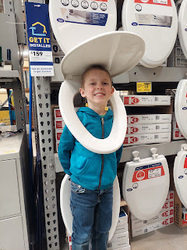

After a tasty lunch at Firehouse Subs, we took Jaxon to his favorite indoor play place, "Soft Play" for an hour. If only we could just bottle up his energy and sell it . . .

Here is a two-part video of him showing me the rounds that he likes to do at "Soft Play".

Video #1: (1 min, 25 sec) His socks were so darn slippery, LOL.
https://photos.app.goo.gl/6uJEiPBWjKpwonGx7

Video #2: (54 seconds)
https://photos.app.goo.gl/aKzrP5hxJpyKxWcv7

Video 3: When we got home, he wanted to help drive the truck. Again, what a cool dad Michael is. He was SO patient with Jaxon and let him drive all over the pasture. (1 min, 5 sec)

https://photos.app.goo.gl/827cHqYkoTm6BFg26

I was happy to be Michael's assistant as he installed the new sink. I did things like: help him lift it out of the box and set it into place, read the instructions to him, etc. And he even let me smooth out the silicone caulk around the edge of the sink as part of the finishing touches!

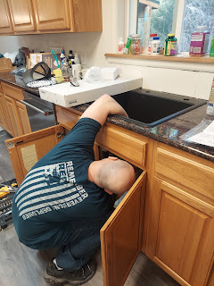

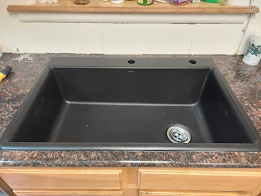

By the next day, (after I left) he had gotten the new disposal installed and the plumbing up and running. Nice work!

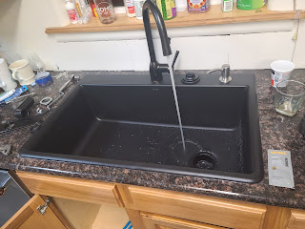

While Logan was settling down to sleep, Jaxon got to hang out with us in the living room. We did some yoga stretches together . . .

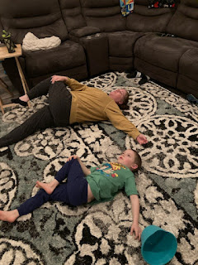

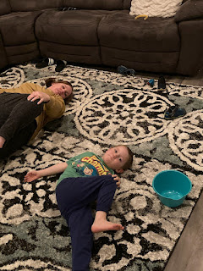

After all that hard work, we decided that hopping into the hot tub would be the perfect ending to a fantastic day. We ended up going to bed waaaay too late again . . . (almost midnight) . . .

Wednesday:
When I woke up around 7:00 a.m. and went to the bathroom, I found Logan sleepily standing outside the bathroom door when I came out. I whispered, "Did you sleep good?" He nodded. I whispered, "Are you cold?" He nodded again. So I invited him to climb into my bed while I put my makeup on and did my hair. He was happy to be someplace warm, but also to be a part of what was going on. I thought the whole scene was so sweet and I'm glad that he wanted to hang out with me.

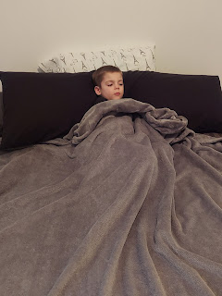

When it came time to leave right after breakfast, Logan was getting upset as he saw me taking a load of my belongings out to the car. I decided to bring Jack's quiet book back in one last time, especially since Jaxon hadn't seen it yet. We happily went through each page together as a final activity before I had to leave. (I didn't know my brother took this photo of us until later) :)

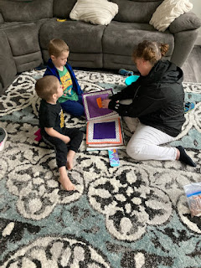

I drove all the way to Missoula before stopping for lunch at a place called Calypso Cafe, where I ordered this (below): It's called "The Heap", and rightfully so! I hardly put a dent in it before I was plenty full . . . and sadly I couldn't take any of the leftovers home in a box because I still had about 5 hours of driving left to go.

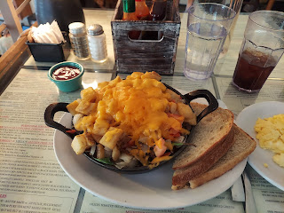

This beautiful scene was next to the exit for a rest stop in Lima, Montana.

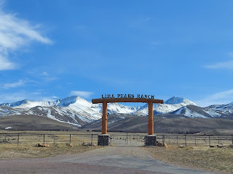

The drive home was long - about 8 hours in all - but I kept myself busy by listening to music and podcasts, and making phone calls. One of the podcasts that I listened to was life-changing for me. It's on Spotify, but it's possible you can find it elsewhere if you know what to look for. The podcast is titled: Far From Home, on the series entitled This is the Gospel. It's about 42 minutes long.

*I just found a link for you non-Spotify users:
https://www.ldsliving.com/this-is-the-gospel/far-from-home

When I shared it with a couple of family members and a friend, this is what I wrote to introduce what they were about to listen to: One of the most powerful things I've ever listened to. It has 2 separate stories about how a USO worker found a way to help several Afghan refugees (mostly women and children); and then a dedicated man in the Air Force pulled off a miracle at Ramstein AFB for thousands of refugees.

As I listened to these stories, I couldn't help but compare them to the experiences of all the Ukrainian refugees fleeing their homeland right now and in the past several weeks. As I listened to General Conference this morning, I wept as Elder Stevenson described how several Polish women, who wanted to help, found a way to serve the Ukrainian mothers. They rounded up several baby strollers and loaded them with supplies, then parked them all in a line at the train station for the travel-weary mothers, who I'm sure felt instantly loved and even relieved as they disembarked with their children in tow. That is a powerful way to serve!

The other thing that kept me awake and alert was the vigorous wind that was constantly pummeling me as I drove south from Butte, Montana down to Idaho Falls. There was one time when - thankfully I had both hands on the wheel - a burst of wind shoved me left and then right! I could feel the entire car move over and then back again! From that point on, I was afraid to take one hand off the wheel, even to get a sip of water. I did so, of course, but very warily and as quickly as I could. My forearms are still a little cranky a few days later from gripping the wheel so firmly.

But I made it home! I got home around 6:30 p.m. and unloaded the car. I grabbed a few groceries and then settled in for the night.

Thursday:
I launched into hyperdrive to accomplish as much as possible, since I had been gone for a week. I worked on loads of laundry, getting all unpacked, and getting all caught up. I went to the grocery store to get some pricing for all the ingredients for girls camp in July so that the young women leaders could have an overall food budget before I head to Italy. (*I will be the camp cook 2 weeks after I get back at the end of June) After lunch, I had a Dr. appointment, a check-up basically, since I had a few questions about a thyroid medication that I've been on for a while now. She ordered some blood work to be drawn, which I did the following morning.

Amber shared this cute video of Gwen participating in a preschool "Book Parade" presentation. Her preschool is in a Baptist Church and everyone there is just so sweet and they love all the little children. Amber is very happy with the school, and Gwen loves it too.

Video of the Book Parade: (57 seconds) *I LOVE how she smiles and waves at Amber as she walks by.
https://photos.app.goo.gl/xtpsF55jiePy8xHH7

Here she is afterward.



That evening I went to the temple to do some initiatory work, which only took about 30 minutes inside. But it was still lovely to be there again and to feel the spirit and the peace within.



Friday:
Abby turned 7 years old!! And it was April Fool's Day!! Amber cleverly froze a bowl of cereal and milk overnight, and set them out for Abby early the next morning. Keep in mind that Abby wakes up at 6:15 a.m. and right away has to methodically go through her routine in order to be ready for the bus that comes at 6:35 a.m. She's still a little sleepy-eyed in the video, which is very understandable. But what a good sport she is when she realizes that it's an April Fool's prank. Her parents have trained her well!

Here's the video: (53 seconds)
https://photos.app.goo.gl/1QXZxjB7g3JMqGYv6

I got to have a little video chat with Abby later in the afternoon, once she got home from school, where I could wish her a very happy birthday and remind her that I will be there so soon!!

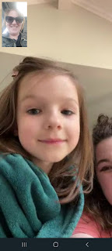

At each birthday, Amber gives the birthday person a fun little interview. Here is what she asked Abby.



First thing in the morning, I had already gotten my blood work done so next I ran several errands, and then picked up Jasmine to celebrate her birthday a little early. Her birthday is on April 7th, but I will be in Louisiana, so we went out to lunch together. I let her pick whatever restaurant she wanted, and she chose Fuji, a Hibachi and Sushi/Steakhouse nearby.



She's doing great working at the Super 8 here in town and enjoys what she's doing. She is a good listener and a good conversationalist, too, so we always enjoy talking together and getting all caught up.

I had a lovely chat with Scott before he went to bed in Italy. He was on his way back from the chow hall when I called, so he sat down at a picnic table to chat with me. It's funny, but they have a rule that you can't walk and talk on a cellphone at the same time. So since he couldn't walk and talk to me . . . it was handy that there was a picnic table right there . . .







His next appointment with the Housing Office is on April 8th. When he called to ask if they could move it sooner, they responded by saying that his appointment was soon enough and that he should be grateful. Apparently things move a bit slower in Italy. So he is trying to be patient in the meantime. When I asked him about some of the things that I've been thinking about and what items I should bring with me to help supply our new house, he said let's just wait until after that meeting on the 8th to make any big plans. I've been rounding up some extra dish towels that I have on hand, making a list of all the rest of the potential things I could bring in my suitcase, and I've been putting some items in our Amazon cart, too, for when we're ready to place an order.

After lunch with Jasmine, I got my hair cut and colored by my friend, Tessa, who has taken care of my hair for the past several years. She did a great job!

After my hair appointment, I hurried to take Jack's quiet book up to Rigby so Scott's mom could see the finished book before I shipped it to the east coast. Jack's birthday is in just a few days! She and Dad enjoyed playing with each page together. :)

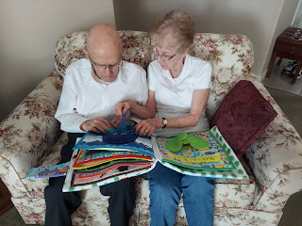

As soon as I got back to Idaho Falls, I packaged up the book and hauled it off to the UPS store to mail it off to Jack. I was shocked to hear that the estimated delivery date would be next Thursday, April 7th! That's the day AFTER Jack's birthday!! Why in the world would it take almost a week to get there? Every other time I've mailed something to them in Washington DC it only took 2-3 days . . . and when I asked how much more would it cost to get it there by the 6th - - - $79.00. Gross! I reluctantly decided it would be okay to have it arrive one day late, since Jack wouldn't know the difference anyway. I just felt bad because I could have mailed it a week ago, but I wanted to bring it on my trip up north so I could share it with Grandma Lillian.

Speaking of Jack: here's what he's up to lately . . . (learning how to climb up on things)
(1 min, 1 sec)
https://photos.app.goo.gl/CFrqpDm4NUvBUd8k6

I could finally slow down and relax for the evening, but only AFTER I finished crunching numbers for the girls camp food budget and then emailed it to the young women's president and the camp director. I watched some TV and ate a quiet dinner and then went to bed.

Saturday:
While Scott was busy finishing up his visit with Benson, Kylie and Avery, I was waking up and preparing to watch the first session of General Conference by 10:00 a.m. We got the cutest picture of Jack sending his smiles first thing in the morning from the east coast. Good morning, Jack!

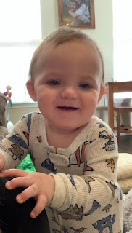
Before the conference began, I hurried off to the grocery store to pick up some items needed for girls camp. Yes, I know, it's not until July . . . but I'm worried that the prices will go up substantially by then. I wanted to save some money by getting a few things now: all the pasta, granola bars, etc.

While I listened to the two-hour morning session, I cleaned the bathrooms, swept the floors, and dusted the upstairs. I took a lot of notes and really enjoyed listening to all of the spiritually uplifting talks. I especially loved how our prophet, Russell M. Nelson, said that with the increasing amount of spiritual darkness in the world, we all need the light of Christ more than ever. He invited all who could to serve as a missionary.

I drove up to Rigby again to watch the afternoon session with Phil and Coy. Here is a sweet photo of Dad, warming his body in front of the fire, and warming his heart with the beautiful music of the conference.

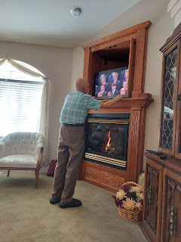

There were a couple of hilarious things that Elder Holland shared: One was this letter that a young girl wrote to her bishop. In translation it says: Dear Bishop, General Conference was boring. Why do we have to do it? Tell me why. Sincerely, Marin Arnold.

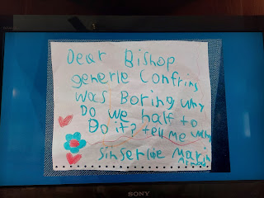

And then, just as we were sitting down to eat supper together (note the broccoli), Elder Holland said, "Stay for the whole feast, even if you're not sure about the broccoli . . ." ha ha ha

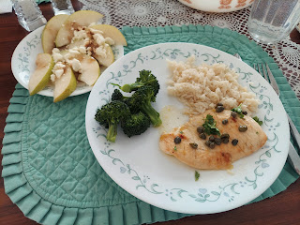

Seriously though, Elder Holland had some pretty amazing things to give us counsel about, including the reminder that we have SO MUCH to be glad about, in spite of everything going on around us.

I felt really inspired to prepare to do some family history projects in the coming months. I've been running around like a chicken with its head cut off for too long, and it's time to slow down and dig into something meaningful. Elder Gong's talk really spoke to me and I plan to go back and listen to it again soon.

I also felt inspired to share Elder Patrick Kearon's talk with a couple of people whom I love very much. Stay tuned. He spoke at great length about victims of abuse and various offenses and how we matter SO MUCH and that God and our Savior Jesus Christ are with us through it all.

Here's cute little Gwen with her little mischievous grin.

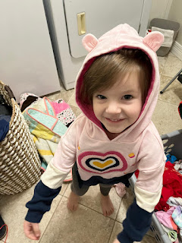

Sunday:
I didn't want to get out of bed. At all. But I finally did. I've been trying to wake up earlier and earlier in preparation for when I move up a time zone tomorrow (Monday) and have to get up at 6 a.m. each morning to help get Abby ready for school.

I am thoroughly enjoying listening to the final sessions of General Conference today. I am listening for what the Holy Ghost is prompting me to do, since that is the question I had on my mind as the weekend began. I am starting a new chapter of life, due to Scott's new military assignment, and my time allowances are changing because of this. I will have more time to dig into deeper time commitments and I have been wondering what I should aim to do. Listening to conference has helped to clarify what my goals should be, and for that I am very grateful.

LASTLY: If any of you are interested in writing or sending a package to Scott, please message me and I will give you his new address.

